Key factors to develop hybrid photoactive materials based on mesoporous carbon/TiO₂ for removal of volatile organic compounds in air streams
I. Jansson¹, F. J. García-García², B. Sánchez¹, S. Suárez^{1*}
(1) CIEMAT, Renewable Energy Division, FOTOAIR: Group of Analysis and Photocatalytic Treatment of Pollutant in Air, Avda. Complutense, 40, 28040, Madrid, Spain
(2) ICTS-CNME, Universidad Complutense de Madrid, Av. Complutense S/N, 28040-Madrid

* To whom all correspondence should be addressed:
e-mail: silvia.suarez@ciemat.es; Tel.: +34-913466177 Fax :+34-913466037

Abstract
The performance of a series of adsorbent-photocatalyst hybrids (APHs) based on graphitized mesoporous carbons and TiO₂, for the photooxidation of formaldehyde and trichloroethylene in gas phase has been studied. TiO₂ was incorporated to different carbonaceous materials including a commercial mesoporous carbon, Starbons with different hydrophobicity and micro-mesoporosity and activated carbon. However, the actual performance of the APHs is strongly affected by the nature of the carbonaceous material and the synthesis route selected to prepare the carbon/TiO₂ hybrids. The results obtained show the importance of the preparation route for the optimum distribution of the TiO₂ nanoparticles on the porous carbon and the influence on its photocatalytic properties. The photocatalysts prepared via mechanical mixing exhibit higher activity than those synthetized by incipient wet impregnation. The hybrid based on the hydrophobic Starbon ST-800 and TiO₂ achieved total removal of formaldehyde at high gas flow, improving by a 15 % the degradation rate of bare TiO₂, without formation of undesired by-products. Moreover, in the case of the organochloride compound, both the reaction rate and the selectivity to CO₂ were promoted over ST-800/TiO₂, being the most photoactive material of the series with a great stability over reaction time.
Keywords: Photocatalysis; mesoporous carbon-TiO₂ composites; Starbons; air treatment; volatile organic compounds.

- Introduction
Air pollution is a major environmental health problem affecting society in developed and developing countries in different ways. The current levels of air pollution are responsible of numerous diseases, including lung cancer and chronic and acute respiratory diseases, therefore posing a significant threat to health worldwide. According to the latest World Health Organization (WHO) report, air pollution causes about seven million premature deaths [1], resulting in addition in serious economic costs.
The state-of-the-art methods for pollution control are based upon adsorption, incineration, or catalytic oxidation; however, these methods have serious inherent drawbacks. The main disadvantage of the adsorption is the need for adsorbent regeneration once is fully saturated. In the case of incineration, the pollutants are oxidized to CO₂ and H₂O at high temperatures therefore requiring a stream of additional fuel and releasing others harmful oxidation products. This feature is minimized, to some extent, in the catalytic oxidation, since the temperature is decreased compared to incineration process. Nonetheless, temperatures above 150 ºC are usually required [2]. The use of Advanced Oxidation Technologies such as heterogeneous photocatalysis, offers a cleaner alternative for the treatment of gases under a wide range of conditions, being suitable for the abatement of a huge number of pollutants in an environmental friendly way [3]. This technology is especially attractive for the oxidation of volatile organic compounds (VOCs) precursors of the tropospheric ozone. Amongst the plethora of VOCs, formaldehyde is very important since it is responsible of the poor indoor air quality. Formaldehyde is mainly present in the construction sector, decorative elements and cleaning products [4]. Even at low levels, formaldehyde can cause irritation of skin, eyes, nose and throat. More importantly, formaldehyde has been classified by the International Agency for investigation Against Cancer (IARC) as group I carcinogenetic [5]. Trichloroethylene is a halocarbon commonly used as an industrial solvent and classified as a carcinogen R45 [6]. In addition, there are many trichloroethylene-containing products such as stains and varnishes, adhesives, typewriter correction fluids, paint removers, and cleaners to which we are exposed daily.
The development of Adsorbent-Photocatalyst Hybrids materials (APHs) comprising both an adsorbent and a semiconductor functions, is recognized as a suitable approach for the improvement of the photocatalytic activity of bare semiconductors [7, 8]. Previous studies carried out in our group demonstrated that natural silicates or zeolite/TiO₂ hybrids display significantly higher photocatalytic performance for the abatement of VOCs than that of benchmark TiO_{2.} Parameters such as photoactivity, stability, mineralization and suppression of the formation of undesired byproducts are promoted by these composites [9, 10].
Due to properties such as high surface area, porosity and electrical conductivity, which can reduce the recombination of electron–hole pair generated in TiO₂ carbonaceous solids are amongst the most promising materials to preparing APHs with very high photocatalytic activity [11, 12]. Moreover, carbonaceous materials can extend the photocatalytic response of TiO₂-based APHs into the visible range of the solar spectrum [13]. Carbon/TiO₂ composites have been employed in different areas including water splitting [14, 15], disinfection [16, 17], reduction of CO₂ [18] and degradation of dyes and organic pollutants in water [19, 20]. However, studies dealing with carbon/TiO₂ for air purification are less common and are focused on the photooxidation of nitric oxide, BTEX, SO₂ or some alcohols [21, 22]. Huang and coworkers studied the effect of the interaction between TiO₂ and the carbonaceous phase for formaldehyde photo-oxidation. Authors reported an improvement of the photoactivity with TiO₂ crystallite–activated carbon composites, compared to the ones obtained by the simple mixture of activated carbon and TiO₂ granules [23].
The presence of micropores in the adsorbent usually results in severe mass transfer issues, which have a negative impact in the overall performance of the APHs. This feature could be minimized by preparing APHs using mesoporous materials as the sorbent phase. Graphitized mesoporous carbons (GMCs) are promising materials for a wide range of applications. GMCs have a graphite-like structure composed of parallel graphite sheets, low amounts of functional surface groups, low fraction of imperfections and a high surface area, resulting in a high adsorption capacity and good conductivity [24]. The synthesis of GMCs requires the use of structure directing agents such as mesoporous silica insoles [25]. A new family of carbonaceous materials with high surface areas and a high fraction of mesopores has been developed recently. These carbons, referred to as Starbons (ST), are usually synthesized by using mesoporous expanded starch as precursor, without the need of using silica or other structure directing agents. The synthesis of Starbons benefits from the natural ability of the amylose polymer and the amylopectin starch chains to assemble into organized structures, giving rise to mesoporous carbons with modular hydrophobicity [26]. Therefore, the Starbon/TiO₂ hybrids may display a high surface area with a high degree of mesoporosity, which can remediate internal mas transfer issues. Thus, these materials are ideal adsorbents to synthetize AHPs composites [27]. Although there are numerous studies in the literature reporting the properties of carbonaceous/TiO₂ materials, a comparative analysis of the photocatalytic performance of carbons of different nature is yet required.
Different methods for the synthesis of carbon/TiO₂ composites have been reported, including physical vapor deposition (PVD), chemical vapor deposition (CVD), electrophoretic deposition (EPD), hydrothermal synthesis or the sol–gel technology [28-30]. Although these methods result in the formation of interfaces between both components of the APHs, these synthetic routes are usually complex and the costs of the precursor materials and of the equipment can be high. Other authors have opted for the incorporation of the carbonaceous materials directly into the reactor system, generally suspended the material in the aqueous phase [31]. A previous study in our group about the synthesis of ZSM-5/TiO₂ hybrids unveiled the importance of the preparation method in the final photocatalytic properties of the APHs [10]. The ZSM-5/TiO₂ composites were successfully prepared either by incipient wet impregnation starting from a TiO₂ sol, or by mechanical mixing of the commercially available materials. The arrangement of the two phases in the photocatalyst should be optimized, reaching a maximum advantage of the adsorption and photocatalytic features.
Based on those considerations, the objective of this work is to study the influence of the carbonaceous material nature selected as adsorbents for the incorporation of the TiO₂ phase and its relevance for the photocatalytic performance in the abatement of model VOCs in air streams at demanding operating conditions.

- Experimental
2.1. Preparation of APHs
Three commercial carbonaceous materials namely, Graphitized Mesoporous Carbon from (GMC 699624- Aldrich) referred to as C₁, hydrophilic mesoporous carbon (Starbon™ 300) referred to as C₂, and hydrophobic graphitized mesoporous carbon (Starbon™ 800) referred to as C₃ have been used for the synthesis of the carbon/TiO₂ APHs. An activated charcoal from wood chemically activated powder (Norit, named AC) was used as a reference microporous material. Hybrid materials were prepared by two methods: i) incipient wet impregnation of a TiO₂ sol onto the mesoporous carbon and ii) mechanical mixture of the mesoporous carbon with commercial TiO₂. The TiO₂ sol was synthesized by following a method described elsewhere [32, 33]. Briefly, the TiO₂ sol was synthesized by adding titanium isopropoxide dropwise (titanium (IV) isopropoxide, TIP, 97%, Sigma Aldrich) into an aqueous solution of nitric acid to a final volumetric ratio of 900:6.5:74 (H₂O:HNO₃:TIP). The resulting suspension was stirred for 3 days at room temperature until peptization was completed and dialyzed to a final pH of 3.0. A TiO₂ xerogel was obtained by evaporation and drying of the TiO₂ sol, and treated at 350°C during 3 h. For economic reasons and simplicity in the preparation method, commercial TiO₂-anatase powder (G-5 Millenium) with a surface area of 320 m² g⁻¹ was selected for the mechanical mixing procedure.
For the preparation of the carbon/TiO₂ based composites by incipient wet impregnation (C_{x}Ti-i), a fixed volume of the TiO₂ sol was added dropwise onto the adsorbent. The total volume of the TiO₂ sol added in each step was calculated by taking into account the total pore volume of the carbons. The TiO₂ loading on the hybrids was set to 8 wt.%, which, is the optimum loading as reported in previous studies [10]. To achieve this TiO₂ loading, several impregnation steps were required. After each impregnation process, the samples were thermally treated at 100°C for 1 h in air. In the mechanical mixing method, commercial carbonaceous materials were grounded and mixed with commercial TiO₂ G-5 powders. A certain content of a nitric acid solution was added into the carbon-TiO₂ mixture to obtain the slurry with optimum rheological properties to be extruded. Finally, the samples were extruded into cylinders with a syringe. The optimum amount of TiO₂ in the samples was set to 50 wt.% according to previous studies [34]. With the aim of removing the solvent from the preparation process, all samples were thermally treated between 200-350ºC; the actual temperature was identified from the TGA-DTA analyses of the samples (SI-Fig. 1).
Samples were named as C_{x}Ti-y where C_{x} indicates the type of carbonaceous material selected (x = 1-3 or AC for activated carbon), and -y indicates the preparation method (-i: for incipient impregnation method, -m for mechanical mixture). The main characteristics along with the textural properties and HCHO or C₂HCl₃ adsorption ability of the materials under study are shown in Table 1.
2.2. Characterization techniques
The APHs synthesized in this work, and the raw materials were characterized by different analytical techniques. The nitrogen adsorption-desorption isotherms were measured with a Micromeritics Asap 2420 Analyzer at -196°C. Before measurement, the samples were outgassed at 120-250 °C to a pressure of < 1.33·10² Pa overnight to remove the adsorbed water. The BET surface areas were calculated using the Brunauer–Emmett–Teller method, the average pore volume was measured using t-plot analysis and the pore size distribution was measured by using Barrett–Joyner–Halenda (BJH) analysis from the desorption branches of nitrogen isotherms. Micropore volume and mean pore size were calculated from the N₂ adsorption-desorption isotherms. The desorption branch at low partial pressure range (P/P₀ = 0- 0.1) and DFT calculation were selected. Mesoporous contribution has been calculated using BJH analysis. Similar results were obtained with the DR methodology.
X-ray diffraction (XRD) measurements were carried out using Cu Kα radiation on the PANanalytical X´Pert PRO ultrafast detector operating at 45 kV and 40 mA. Bragg´s angles (θ) in the range of 20-80° were recorded at a scan rate of 0.02° per step and 50 s per point. The crystalline phase identification was carried out by comparison with PDF database from the ICDD-JCPDS. The average crystallite size of TiO₂ phases were determined by the Scherrer´s equation.
Thermogravimetric analyses were performed on a Mettler Toledo TGA/SDTA851e thermobalance. Samples were analyzed at a heating rate of 10 °C min⁻¹ from 25 to 1,000°C, in an atmosphere of air flowing at 75 mL min⁻¹.
The hydrophilic-hydrophobic nature of the carbonaceous materials was determined by the analysis of the contact angle. These measurements were carried out using a Krüss DSA1 drop shape analyzer. The powder sample was placed into a borosilicate slide and a sessile drop of water was deposited on the sample surface using a syringe. Previous to the measurements, the carbonaceous materials were dried during 24 hours in order to remove adsorbed water. Five measurements for each material were performed. The Young-Laplace method was used to calculate the contact angle [35].
Diffuse reflectance spectra of the materials were recorded between 200-900 nm using a double beam UV-Vis spectrophotometer PerkinElmer Lambda 650 UV/Vis equipped with a diffuse reflectance accessory. The powders were filled in a holder and the surface was smoothed. The layer can be regarded as infinitely thick, as required by the Kubelka-Munk theory.
Scanning electron microscopy (SEM) combined with energy-dispersive X-ray spectroscopy (XEDS) was performed using a JEOL JSM-7600F equipped with an OXFORD INCA detector. An aliquot of the sample under study was placed onto a clean surface graphite sample holder. High Resolution Transmission Electron Microscopy TEM studies were performed in a JEOL JEM 3000F, attached to a GATAN ENFINA spectrometer for Electron Energy Loss Spectroscopy (EELS) analysis. The spectra were recorded in diffraction mode (image coupling to the spectrometer) with an acquisition time of 1 s, and energy dispersion of 0.1 eV/pixel. Typically, the energy resolution achieved was of ≈ 1.2-1.3 eV and a collection angle close to ≈ 0.9 mrad was used. This collection angle was chosen to be as close as possible to the so-called “magic angle” [36] for the C–K edge. The reason is to avoid as much as possible the orientation effects which affect the shape of the fine structure of the edges. The samples were prepared by ultrasonically dispersing the powders in butanol and one drop of dispersion was deposited onto a copper grid coated with a thin holey amorphous carbon layer.
X-ray photoelectron spectra (XPS) were acquired with a SPECS customized system for surface analysis equipped with a non-monochromatic X-ray source XR 50 and a hemispherical energy analyzer PHOIBOS 150 9MCD. X-ray MgKα line (1253.6 eV) was used as excitation (operating at 200 W/12 kV), and the medium area mode of the lenses was used for the detector. The energy regions of the photoelectrons of interest were scanned at increments of 0.1 eV and fixed pass energy of 20 eV until an acceptable signal-to-noise ratio was achieved. Atomic abundances were estimated by calculating the integral of each peak, determined by subtraction of the Shirley-type background and fitting of the experimental curve to a combination of Lorentzian and Gaussian using the appropriate sensitivity factors for each element. Binding energies (±0.2 eV) were determined by setting the C 1s peak at 284.6 eV. The energy regions of the photoelectrons of interest: Ti 2p, O 1s, and C 1s were analyzed.
2.3. Photocatalytic activity tests and adsorption ability
The photocatalytic performance of the APHs for the degradation of formaldehyde (HCHO) or trichloroethylene (C₂HCl₃) was studied using a continuous flat stainless-steel reactor (120 mm x 50 mm x 10 mm). A continuous air flow containing the pollutant is passed through the photoreactor containing the sample. The top of the reactor consists on a rectangular borosilicate glass window (37 cm²). This surface was irradiated with two UV-A lights (8 W Philips) with 6.5 mW cm⁻² irradiance. The photocatalyst was dispersed on a borosilicate glass plate (19 cm²), preparing a suspension of the powder in isopropanol. The glass plate with the photocatalytic material was placed inside the reactor. With the aim to minimize the adsorption step 30 mg of sample were used in these experiments. The air flow containing the selected pollutant was continuously flown through the reactor. The concentration of the pollutant, either HCHO or C₂HCl₃, was set at 15 ppm or 25 ppm, obtained from a gas cylinder (Air Liquide) of 100 ppm HCHO/N₂ and 250 ppm C₂HCl₃/N₂. Photocatalytic activity experiments at different contact times (t_{r} 0.3-1.3 s) changing the total gas flow between 300 and 1,000 mL min⁻¹ were performed. Neither photocatalytic nor photolytic processes were observed with the raw carbonaceous materials under the reaction conditions used in this study.
The adsorption ability of the raw materials and carbon/TiO₂ composites for the targeted pollutants, HCHO or C₂HCl₃, was measured under dynamic conditions, as reported previously [10]. Before the experiment, the sample under study was pre-treated under air flow and UV-A radiation during 12 h, to remove water and the possible impurities from the sample preparation.
The gas phase composition was continuously monitored by using a FTIR Thermo-Nicolet 5700 spectrometer with a temperature controlled multiple-reflection gas cell (optical path 2 m) maintained at 110°C. Infrared spectra were obtained by averaging 64 scans with a resolution of 4 cm⁻¹ within the 4,000 to 800 cm⁻¹ spectral range. The evolution of the photocatalytic reaction was followed with the representative vibrational bands of the reaction products. The evolution of formaldehyde degradation was assessed by monitoring the HCHO representative band at 1,842-1,623 cm⁻¹ and the CO₂ bands at 2,435-2,233 cm⁻¹. For the trichloroethylene photooxidation studies, the bands at 965-903 cm⁻¹ corresponding to C₂HCl₃ along the ones for COCl₂ at 1,873-1780 cm⁻¹, C₂HCl₃O at 1,144-1,037 cm⁻¹ and CO₂ were monitored. Pollutants degradation rate was calculated by considering the amount of pollutant removed during the photocatalytic process at steady-state conditions and the amount of the photoactive phase. The HCHO and C₂HCl₃ conversions were calculated as previously reported [10]. The experimental error for these analyses was ±5%.
3. Result and discussion
3.1 Characterization of the carbon/TiO₂ composites
The calcination temperature for the preparation of carbon/TiO₂ hybrids was selected as the minimum temperature needed for the elimination of the organic residues, without oxidation of carbonaceous material. According to the TGA-DSC analyses, the temperature treatment for AC, C₂ and C₁ based materials was 200 ºC, whereas that for C₃ was 350 ºC. Thermal treatment duration was 3 h in all cases (SI-Fig.1). TiO₂ was incorporated into the mesoporous materials by two easily scalable methods: incipient wet impregnation (C_{x}Ti-i) and mechanical mixing (C_{x}Ti-m). The optimum TiO₂ contents on each type of samples are 8 wt.% of TiO₂ in the C_{x}Ti-i series and a carbon:TiO₂ ratio 1:1 in the C_{x}Ti-m series, as determined elsewhere [34]. The textural properties of the materials obtained are shown in Table 1. The surface areas of the reference semiconductors (commercial TiO₂ and TiO₂ xerogel) are ca. 150 m² g⁻¹, both of them exhibiting Type-IV isotherms, with well-developed hysteresis loops and distinct condensation steps characteristic for mesoporous materials [37]. C₁ shows a Type IIa isotherm characteristic of non-porous materials where the sharp increase of the adsorbed volume at high partial pressure indicates the presence of macropores (SI-Fig.2). This material presents the lowest BET area of the series of 85 m² g⁻¹ with a mean pore size diameter around 50 nm. C₂ and C₃ Starbons show similar isotherms, that can be defined as a mixture of Type I and IIB isotherms, combining a micro-meso structure. According to the producer´s indications, these mesoporous carbons were synthesised from the same precursors. The difference between both materials is the temperature treatment; 300 and 800 ºC for C₂ and C₃, respectively. The notable increase of the BET area from 180 m² g⁻¹ to 440 m² g⁻¹ with the temperature treatment could be related to the degree of elimination of residues remaining adsorbed on the materials after their synthesis. According to the pore size distribution, micropores of 0.5 nm and mesopores of 15 nm are present in these carbons. On the other hand, the activated carbon (AC) displays a Type I isotherm, typical for microporous materials with a well-developed sharp ''knee'' at the low relative pressure, combined to Type IV, characteristic of mesoporous materials [38]. This material is the one with the highest surface area (1,300 m² g⁻¹) and micropore volume (0.5 cm³ g⁻¹) in the series. This material is characterised by a micro-mesopore structure similar to C₂, with mean pore sizes of 1 and 7 nm. The BET area of the carbonaceous precursors follows the order: C₁ < C₂ < C₃ < AC. The incorporation of TiO₂ to conform the hybrids has no significant impact in the BET area of the hybrids, which seems to be dominated by the specific surface area of the carbonaceous precursor (Table 1). The N₂ adsorption-desorption isotherms of the APHs combine the features of the isotherms of the raw carbonaceous materials and the semiconductors used for the preparation of the APHs (SI Fig. 2). In the case of the carbons with microporosity (C₃ and AC), the BET area of the hybrid is decreased due a blockage of a fraction of the microspores by titania particles. This fact is more pronounced in the composites prepared with higher amounts of TiO₂.
The morphology of the carbonaceous materials was studied by SEM (Fig. 1). C₁ shows aggregates with a globular form, made by small spherical particles with a mean particle size between 15-50 nm. Thus, the mesopore structure deduced from the N₂ adsorption-desorption isotherms might arise to the voids generated by the interparticle space rather than to the intrinsic particle porosity. On the contrary, large porous spherical particles in the order of microns, between 2-10 μm, can be observed in C₂ and C₃. Pores of sizes between 50-100 nm can be distinguished in the micrographs. AC consists on irregular large particles of about 20 μm length.
The carbonaceous supporting materials were characterized by transmission electron microscope at two different levels: (i) high resolution transmission electron microscopy to characterize the samples at the atomic scale and (ii) electron energy loss spectroscopy to assess differences in bonding. Representative images are presented in Fig. 2. Figure 2a depicts a representative image of C₁, showing how this sample is composed almost uniquely by graphite ribbons. The typical interlayer spacing of 0.34 nm for graphite materials is observed in the picture as fringes. As shown in Figures 2 b-d, C₂, C₃ and AC materials display a graphite like structure, what it is concluded in conjunction with the EELS experiments, vide-infra. In all these three images, open and curved disordered graphite-like sheets at the thinnest areas of the particles are clearly observed. Some insets are included to stress further this peculiarity [39].
The corresponding EEL spectra are shown in Fig. 2 e) and f), where the low-loss and high-loss spectra are included, respectively. In the former, the zero loss peaks have been subtracted from the raw spectra. The latter is the energy loss near edge structure, ELNES, which is very sensitive to differences in bonding. Thus, it can be used as a finger-print of the atomic structure. The peculiarities found in the EEL spectra according to the structural differences in carbon samples have been extensively described in the literature. For clarity reasons, we here just itemize these main characteristics. In the low loss region one or more peaks corresponding to plasmons are expected to show up. The bulk plasmon peak is situated at ≈ 27 eV in the case of graphite and at ≈ 33 eV in the case of diamond. When the materials present disorder, a wide range of values are observed. Due to the fact that this peak is related to the valence electron density it is also related to the mass density of the material. The other main characteristic in the low-loss region is the π plasmon peak, which it is only present in graphite and graphite like materials and it is situated at ≈ 6 eV. The intensity is related to the number of unsaturated bonds. The core-loss spectra display two well separated peaks at 284 and 291 eV corresponding to the electronic transitions 1s → π* and 1s → σ*, respectively. The low-loss spectra of all samples show the π plasmon peak revealing that the atomic structure should be composed by graphite layers, a feature further supported by the observed energy position for the bulk plasmon peak [40]. Note that this peak presents no differences in the energy scale between different samples. In the core-loss spectra these interpretations are further clarified. For C₁ a clean graphite spectrum with all peculiarities reported for this compound is observed. The rest of samples are so-called “graphite like materials”. That is, materials composed by graphite layers in different extensions and more or less ordered. The extension and the degree of order is therefore the difference found between the C₂, C₃ and AC sample but difficult to quantify.
The quantification of the amount of HCHO and C₂HCl₃ adsorbed by the raw materials was analyzed under dynamic conditions (Table 1, Figure 3). Regardless of the actual surface area of the carbonaceous materials, the amount of HCHO adsorbed is low, between 20-50 µmol g⁻¹ and depends on the BET area of the carbonaceous material. As shown in Table 1, TiO₂ presents a great capacity to adsorb formaldehyde, with values of ca. 500 and 2,000 µmol g⁻¹ for Ti-Xg and commercial TiO₂ respectively. On the other hand, carbonaceous materials are able to adsorb large C₂HCl₃ amounts, following the order C₁< C₂ << AC < C_{3.} A good correlation between the microporous area/external area ratio with the C₂HCl₃ adsorption ability was found (inset to Fig. 3). The HCHO adsorbed on carbon/TiO₂ is higher than that on the carbonaceous materials due the adsorption properties of TiO₂. Obviously, this effect is more pronounced for the C_{x}Ti-m samples due to the higher titanium oxide content of this series. As expected, the nature of the carbon material strongly affects the C₂HCl₃ adsorption properties for C_{x}Ti-y.
The XRD patterns of C_{x}Ti-m and C_{x}Ti-i series are shown in Figs. 4a and b, respectively. The carbonaceous materials selected for this study have an amorphous structure (Fig. 4a). The powder patterns exhibit high background intensity, indicating that the material has a high degree of disorder or even that it is amorphous. In addition, the carbon also contains some graphite-like structures (crystalline carbon) responsible of the broad diffraction peak at ca. 26º and a well-defined peak for C₁. The diffraction peak at 26º corresponds to the (002) reflections of graphite carbon [41]. The commercial titania used for C_{x}Ti-m only contains the TiO₂ with the anatase structure type.
The average crystallite size of TiO₂-anatase in the hybrids was determined from the position and breadth of the (101) diffraction peak. Using the Scherrer´s equation, the mean crystallite sizes of TiO₂-anatase in the hybrids ranged between 6 and 7 nm; a smaller value than the 15 nm of crystallites in the commercial TiO₂ used as precursor. The unresolved peaks at 2θ values around 26 and 43º for the carbonaceous materials, which are overlapped with the diffractions belonging to anatase, are assigned to amorphous carbon [42].
The XRD patterns of the samples prepared by incipient wet impregnation and TiO₂ xerogel are shown in Fig. 4b. The TiO₂ xerogel is characterized by the presence of TiO₂-anatase (JCPDS, No. 21-1272) with (101) (004) (200) facets, TiO₂-rutile (JCPDS, No. 21-1276) with (110) (101) facets and TiO₂-brookite (JCPDS, No. 29-1360) with (121) facet [43]. Nevertheless, TiO₂-anatase phase is the main crystal phase detected in the XRD patterns of the C_{x}Ti-i series. Again the intensity of the XRD peaks of TiO₂ in the hybrids is significantly smaller, after being incorporated into the carbonaceous materials, attributed to a dilution effect the by means of the presence of coals [44].
In order to determine the hydrophilic-hydrophobic nature of the carbonaceous materials, the contact angle of a sessile water drop was measured. The images obtained for C₁, C₃ and AC are shown in Fig. 5. The contact angle was determined using the Y-L method. Contact angles ranging between 0º and 146º were calculated, the actual value depending on the nature of the carbonaceous material. Small contact angles (< 90°) indicate high wettability, while large contact angles (> 90°) are indicative of low wettability surfaces [45]. C₂ is the most hydrophilic carbon, since the drop is fully adsorbed in the material very fast. In fact, is was not possible to determine the contact angle. Activated carbon (AC) showed an angle of 51º and it is therefore considered as a hydrophilic material. On the other hand, C₃ is a hydrophobic material with a contact angle of 143º. Thus, the hydrophobic nature follows the order: C₂ < AC < C₁ < C₃.
  - Influence of the preparation method on the photocatalytic activity
The photocatalytic performance of the hybrid materials prepared by mechanical mixing (C_{x}Ti-m) and incipient wet impregnation (C_{x}Ti-i) for formaldehyde abatement was evaluated. The results are shown in Fig. 6 for 700 mL min⁻¹ total gas flow. In all experiments, HCHO was completely mineralized to CO₂, which is the only product detected in the reactor outlet. The results reveal the highest photocatalytic conversion of the samples prepared by mechanical mixing as compared to those prepared by incipient wet impregnation. In fact, C₁Ti-i and ACTi-i do not show any photocatalytic activity, in spite of the high BET area of the latter. The materials studied display low HCHO adsorption values. This feature can be related to the low TiO₂ content on the materials, since HCHO is preferentially adsorbed on TiO₂ anatase (001) surfaces [46]. It is worth to remark the high HCHO conversion value obtained with the C_{x}Ti-m samples, with values near 90 % for most of the samples. The higher TiO₂ content in the C_{x}Ti-m materials compared to C_{x}Ti-i should be considered to explain these results. Due to its low surface area and HCHO adsorption ability, C₁Ti-m displays the lowest photocatalytic activity in the series. Higher HCHO reaction rates were observed for ACTi-m, C₂Ti-m, C₃Ti-m. C₃Ti-i hybrid exhibited the best photocatalytic performance for HCHO removal. Neither the actual BET areas nor the amount of HCHO adsorbed on the hybrid appear to be the most relevant features to inform the photocatalytic activity for the composites. For instance, whereas ACTi-m, displays the highest surface area and higher HCHO adsorption ability in the series, records a moderate HCHOH mineralization activity, ca. 25 % lower than that of C₃Ti-m. These results suggest that surface area and adsorption ability are not main parameters affecting the photocatalytic reaction. A recent study reported in the literature, shows the good performance of carbon cloths supported TiO₂ for HCHO indoor air abatement, reaching conversions near 90 % [47]. Obviously, for a proper comparison of the photocatalytic efficiency, differences in the operating conditions should be taken into account. The apparent constant k_{ap} was calculated by considering a pseudo first order reaction. Thus, Ln (1- (C₀-C/C₀)) vs. the residence time (t_{r}), was represented in SI Fig. 3, where C₀ is the initial pollutant concentration and C is the concentration at steady state conditions at the different gas flows studied in this work. k_{ap} values of 3.27 s⁻¹ and 4.07 s⁻¹ were obtained for C₂Ti-m and C₃Ti-m hybrids, respectively. A value of 2.08 s⁻¹ was found for bare TiO₂. The reaction kinetics could be explained by considering the Langmuir-Hinshelwood (LH) model [48]. Based upon this model, the adsorption of the HCHO molecules onto the active sites is considered the rate-limiting step. Nevertheless, diffusion phenomena of reactive and reaction intermediates to the carbonaceous materials-TiO₂ and vice versa cannot be ruled out.
All carbon/TiO₂ hybrids were analysed by SEM-XEDS microscopy. Representative micrographs for C_{x}Ti-m and C_{x}Ti-i hybrids are shown in Figs. 7 a, c, e, g and Figs. 7 b, d, f, h, respectively. Spherical carbon particles with some TiO₂ clusters heterogeneously distributed on the surface can be observed in the images for ACTi-i, C₂Ti-i, and especially for C₃Ti-i. In the case of C₁Ti-i no titania particles were detected at the carbon surface, even though XEDS analysis indicate the presence of titanium (Fig 7b inside). These findings suggest that a fraction of the titania nanoparticles could be located inside the pore structure of the mesoporous carbons, therefore preventing the photons from reaching those titania particles. The adsorption of the UV-A photons by carbons should be also considered in order to explain the photocatalytic results, especially for C₁Ti-i.
On the other hand, TiO₂ nanoparticles of about 20 nm aggregate rendering agglomerates of 500 nm, are observed in C_{x}Ti-m (Fig. 7 a,c,e,g). These large TiO₂ clusters are located at the surface of the carbons and cannot penetrate inside the porous structure of the carbon probably due to steric factors. Micrographs for C₁Ti-m and C₂Ti-m hybrids also show a homogeneous distribution of TiO₂ aggregates of ca. 1 μm and 500 nm average sizes.
In a previous work, zeolites/TiO₂ hybrids prepared with TiO₂ nanoparticles by incipient impregnation method were studied. These materials showed HCHO conversion values ca. 90 % [10]. Due to the hierarchical microporous structure of the zeolitic materials, TiO₂ nanoparticles remain on the zeolitic surface, well outside of the zeolitic structure. Moreover, and in contrast to carbonaceous materials, siliceous materials are transparent to the UV radiation, and therefore they can adsorb a great fraction of the UV-A radiation. These results indicate that mechanical mixing is a simple and economic method to prepare carbon/TiO₂ extruded cylinders.
The UV-Vis light adsorption properties of the raw materials and composites were analysed by diffuse reflectance spectroscopy. The incorporation of an 8 wt.% of TiO₂ on the carbonaceous materials (C_{x}Ti-i) does not modify the UV-Vis spectra of the carbonaceous compounds, see Fig. 8a. The low TiO₂ content and the location of a fraction of titania nanoparticles inside the porous structure, could explain this behaviour. Fig. 8b shows the Kubelka-Munk function for C_{x}Ti-m samples along with that of commercial TiO₂. Carbonaceous materials present adsorption bands in the UV-visible region of the spectra. The incorporation of 50 % TiO₂ leads to a visible peak between 300-400 nm characteristic of titania. The strong adsorption of carbonaceous materials prevents the accurate determination of the band-gap energy of the composites. None of the samples display photocatalytic activity under low Vis light, in spite of the adsorption of light in the visible region.
A key fact to understand the photocatalytic results obtained in this work is the location of the TiO₂ particles with respect to the carbonaceous material. Obviously, there are three possible locations of the TiO₂ particles: i) on the surface, ii) inside the porous structure or iii) in both places. In order to determine the location of TiO₂ particle, HRTEM analysis were carried out. A representative example of the results obtained for C₁Ti-i and C₁Ti-m hybrids are shown in Fig. 9. Regarding the dispersion of the TiO₂ particles, HRTEM images showed differences, sometimes very faint, between the samples. Even through electron microscopy is extremely powerful for the analysis of the atomic structure, the connection of the observed local structure with the properties at macroscopic level must be done carefully and the present case is a good example. To discern between these possibilities, the images from the transmission electron microscopes side by side, have been compared (Fig 9). In Fig. 9a and 9b, HRTEM images for C₁Ti-i and C₁Ti-m, respectively are shown. At it is seen in Fig. 9a the TiO₂ nanoparticles (some of them are arrowed in the image) are located in the internal part of the carbon structure. No fringes at all from TiO₂ are observed in them, while the typical fringes from the graphite like structure are clearly observed. This is nonetheless difficult to infer just by looking at the image in Fig. 9a. It helps to compare with the image in Fig. 9b where the particles (see the arrows) show the expected fringes from the TiO₂ crystalline structure. However, the final proof is that when working with the microscope, the fringes never appear when changing the focus condition of the objective lens. That is due to the carbon particles have above and below with respect to the incident beam of electrons. In the case of having a number of nanoparticles right at the surface we should easily find them in the very same way as we see in Fig. 9b. This is rarely found for samples prepared by incipient wet impregnation and always observed by the ones prepared by mechanical dispersion. Nonetheless, this conclusion was supported by studying the images out of the scanning microscope. The image in Fig. 7b shows clean surfaces while in Fig. 7a, TiO₂ nanoparticles are observed. Note that the XEDS analysis in Fig. 7b shows the presence of titanium.
The C 1s and Ti 2p core-level spectra for C₂Ti-y and C₃Ti-y series have been analysed by XPS. All samples display similar C1s core-level spectra, showing an intense peak at 284.6 eV ascribed to graphitic carbon (SI Fig. 4). In addition, the spectra for each sample shows less intense peaks centred at 485.8 eV and 488.0 eV ascribed to C-O and C=O species, respectively [49]. The Ti 2p region shows two peaks at 458.0 eV and 464.0 eV corresponding to the Ti 2p_{3/2} and Ti 2p_{1/2} core-levels. The Ti/C surface atomic ratios calculated for C₂Ti-i and C₃Ti-I are 0.03 and 0.12, respectively. Higher Ti/C surface atomic ratios of 0.12 and 0.66 are found for C₂Ti-m and C₃Ti-m, respectively. These results are in line with the higher TiO₂ content of the C_{x}Ti-m series observed by SEM analysis. Composites prepared with the hydrophobic carbon showed higher Ti/C atomic ratios, explaining the photocatalytic activity results.
Based on the results, a scheme of the effect of the preparation method on the TiO₂ distribution on the carbonaceous materials and the influence on the photocatalytic activity is proposed (see Fig. 10). For the C_{x}Ti-i series, a high fraction of TiO₂ nanoparticles is located inside the mesoporous structure of the adsorbent, preventing photons to reach the active phase, and therefore being inactive for the photocatalytic process. Moreover, and according to the UV-Vis spectra, photons can be also adsorbed by the carbonaceous materials thus limiting the photoactivation of the TiO₂ active sites. On the other hand, the C_{x}Ti-m hybrids display TiO₂ aggregates located on the surface of the carbonaceous materials, thus can be easily activated by the UV-A light. These results are opposite with the ones obtained with zeolite/TiO₂ composites, where the hybrids prepared by incipient wet impregnation promote the photocatalytic activity comparing to the ones prepared by mechanical mixing.
  - Effect of the carbon on the photocatalytic activity
Finally, the effect of the nature of the carbonaceous material in the degradation of HCHO and C₂HCl₃ over the C_{x}Ti-m series was studied. The experiments were carried out at different total gas flow, between 500 and 1100 mL min⁻¹, corresponding to a residence time of 0.78 and 0.35 s. The relationship between the concentration of pollutant and the photocatalyst loading was kept constant in these experiments. The experiments were performed in the absence of water vapour in order to properly understand the reaction between carbon/TiO₂ and the pollutants. Note that the enhancement of the photocatalytic reaction rate by the presence of water vapour has been reported previously, and ascribed to the ability of hydroxyl groups or water molecules to act as hole traps to form surface-adsorbed hydroxyl radicals [50].
Fig. 11 shows the HCHO degradation rate with the C_{x}Ti-m hybrids prepared by mechanical mixing, at different total gas flow. All of the selected carbon/TiO₂ materials showed photoactivity under the reaction conditions studied. Starbons based hybrids were the ones displaying the best photocatalytic properties. Thus, C₁Ti-m recorded HCHO conversion values of 80 % with C₃Ti-m showing near total degradation of formaldehyde at 500 mL min⁻¹. As explained above, C₁Ti-m prepared with highly graphitic C₁ material, presented the lowest BET area and HCHO adsorption capacity. In spite of the high surface area and HCHO adsorption capacity of ACTi-m, C₂Ti-m and C₃Ti-m showed higher photoactivity. Moreover, the C₃Ti-m showed ca. 10 % higher conversion than the C₂Ti-m. Thus, AHP based on the hydrophobic carbon, was the most active material amongst the hybrids studied, with a photocatalytic conversion of around 18 % higher than commercial TiO₂. This result seems to indicate that neither the BET area, HCHO adsorption ability nor the graphitization degree are parameters influencing the HCHO reaction rate. Nevertheless, the ratio between micropore area and external surface area seems to be a factor to be considered, controlling the adsorption and further diffusion of the pollutant and reaction intermediates in the porous structure of the carbon. This parameter was 1.26 for C₃Ti-m and lower than 0.6 for the other materials. This factor, along with the hydrophobic nature of the carbon could explain at least partially, the high photoefficiency of the C₃Ti-m hybrid material.
One of the proposed mechanisms explaining the photocatalytic decomposition of HCHO is through the formation of formic acid as an intermediate. Shiraisi and co-workers conducted a study to analyse the possible formation of formic acid during the reaction. They identified a small fraction of formic acid at high formaldehyde concentration and concluded that HCHO is rapidly decomposed to CO₂ via formic acid [51]. In our case, no secondary reactions products were observed. The interphase between the two materials could improve the diffusion of contaminant and reaction intermediates to the active sites resulting in the enhancement of the photocatalytic activity.
The C₂HCl₃ photocatalytic oxidation reaction proceeds through a series of complex reactions and the formation of chlorinated compounds. The trichloroethylene is photooxidised to CO₂ and HCl with adsorbed water or surface hydroxyl groups [52]. Moreover, other chlorinated by-products can be produced. Dichloroacetyl chloride (Cl₂HCCOCl) is a reaction intermediate that can be photooxidised yielding COCl₂, CO, and HCl. The presence of water vapour leads to an enhancement of the CO₂ yield and a decrease of the formation of chlorinated compounds [53]. In this study, the experiments were performed in the absence of water in order to study the influence of the carbon nature in the mineralization process. The behaviour of the hybrid systems for the organochloride removal at high gas flow was studied (Fig. 12a). The C₂HCl₃ reaction rate and the CO₂ and COCl₂ selectivity results, the main reaction by-products, are collected in this figure. In line with the results obtained for the photooxidation of HCHO, C₁Ti-m presents the lowest C₂HCl₃ degradation rate of 0.6 µmol s⁻¹ g⁻¹_{TiO2} with a C₂HCl₃ conversion near 50 %, similar to that of bare TiO₂ but with higher CO₂ selectivity. C₂Ti-m and ACTi-m showed similar results, with degradation rates around 0.7-0.8 µmol s⁻¹ g⁻¹_{TiO2} corresponding to a 55-60 % C₂HCl₃ conversion at steady state conditions. The hybrid materials studied in this work record lower COCl₂ selectivity values than bare TiO₂. Moreover, it should be highlighted the lower formation of chlorinated by-products by the hydrophobic C₃Ti-m composite. Again, the most active composite of the series was C₃Ti-m, with a 15 % higher efficiency than titanium oxide. It is worth to be remarked that the mineralization process is greatly enhanced over C₃Ti-m, displaying a CO₂ selectivity near 75 % and the lower formation of COCl₂. A similar trend can be observed from the experiments conducted at 500, 700, and 900 mL min⁻¹. These results seem to indicate that the incorporation of TiO₂ to C_{3,} promotes the adsorption of C₂HCl₃ and photooxidation of reaction intermediates directing the reaction to CO₂ formation.
Finally, the stability for C₃Ti-m photocatalyst over time was studied. As it can be seen in Fig. 10b, C₃Ti-m showed a good stability not suffering any deactivation phenomena. After, near three days of continuous reaction, the C₂HCl₃ conversion and CO₂ selectivity were maintained. Only small periodical fluctuations, assigned to changes in the reaction temperature during the day-night cycle, were observed.
Other studies in the literature report the reversible adsorption of contaminants and reaction intermediates for activated carbon based composites, avoiding the TiO₂ deactivation and promoting the photocatalytic activity [30]. Moreover, the effect of carbonaceous materials in the electron-hole separation properties, particularly in avoiding the recombination effect, should be considered. This effect has been reported for carbon nanotubes or graphene-based composites. The electric resistances reported by the suppliers for C₃, C₂ and AC are 0.07, 56.500 and 137.500 ohm m⁻¹, respectively. These values are in line with the results reported in Figure 11 and 12. Thus, C₃ displays the higher conductivity of the series. This property could modify the charge delocalization, avoiding the electro-hole recombination phenomena, enhancing the photocatalytic activity. Our results show the superior performance of hydrophobic ST800/TiO₂ composites over activated carbon based composites promoting the photocatalytic activity and selectivity to CO₂. Thus, this carbon is the most suitable adsorbent to obtain highly active carbon/TiO₂ hybrid for the degradation of both HCHO and C₂HCl₃. This study opens the possibility to the application of this composite to indoor air treatment units, operating at high gas flow and with one single pass reactors.
4. Conclusions
Carbon/TiO₂ hybrids were synthetized and studied for the photocatalytic oxidation of formaldehyde and trichloroethylene. Carbonaceous materials (mesoporous carbon, activated carbon, and Starbons) with different textural properties, graphitization grade and hydrophobic-hydrophilic nature were selected. The preparation method has a strong influence in the distribution of the semiconductor in the adsorbent and as a consequence in the final photocatalytic performance. Mechanical mixing starting with commercial TiO₂ is a simple and effective method for the development of highly photoefficient carbon/TiO₂ composites. On the contrary, incipient wet impregnation through TiO₂ nanoparticles was not recommended to prepare these composites, contrary to what it was previously reported for zeolite/TiO₂ hybrids. Incorporation of TiO₂ nanoparticles inside the mesoporous structure of the carbonaceous materials and adsorption of the UV-A photons by mesoporous carbonaceous materials, are parameters that should be taking into account for selecting the proper synthesis method. Finally, the correct selection of the carbonaceous materials turns out to be essential to improve the photocatalytic efficiency of bare TiO₂ in terms of pollutant degradation rate and selectivity to CO₂. The results obtained showed the superior performance of ST-800/TiO₂ composites, for both the photooxidation of aldehyde and organochloride compounds, compared to the other graphitized carbons under study. Moreover this composite shows excellent photocatalytic stability with reaction time. The improvement on the pollutant photooxidation reaction rate and the mineralization process respect to bare TiO₂ was clearly observed.
- Acknowledgment
The authors acknowledge the Centre for the Development of Industrial Technology CDTI (Project IDI-20180347) for the financial support. The authors thank to the Research Support Unit from the ICP-CSIC for XRD and BET analysis and Dr. M. Yates for the discussions in the interpretation of the textural properties.
- References

[1] WHO, World health statistics 2019: monitoring health for the SDGs, sustainable development goals, Genova, 2019.
[2] G.R. Parmar, N.N. Rao, Emerging control technologies for volatile organic compounds, Crit. Rev. Environ. Sci. Technol., 39 (2009) 41-78.
[3] O. Legrini, E. Oliveros, and A. M. Braun, Photochemical processes for water treatment. Chem. Rev. 93-2 (1993) 671–698.
[4] G.D. Nielsen, S.T. Larsen, P. Wolkoff, Recent trend in risk assessment of formaldehyde exposures from indoor air, Arch. Toxicol., 87 (2013) 73-98.
[5] I.A.f.R.o.C. (IARC), Monographs on the evaluation of carcinogenic risks to human. Formaldehyde International Agency for Research on Cancer (IARC), Lyon, 2012, pp. 1-36.
[6] S. Karami, Q. Lan, N. Rothman, P.A. Stewart, K.-M. Lee, R. Vermeulen, L.E. Moore, Occupational trichloroethylene exposure and kidney cancer risk: a meta-analysis, Occup. Environ. Med., 69 (2012) 858-867.
[7] F. Fresno, R. Portela, S. Suarez, J.M. Coronado, Photocatalytic materials: recent achievements and near future trends, J. Mater. Chem. A, 2 (2014) 2863-2884.
[8] N. Takeda, T. Torimoto, S. Sampath, S. Kuwabata, H. Yoneyama, Effect of inert supports for titanium dioxide loading on enhancement of photodecomposition rate of gaseous propionaldehyde, J. Phys. Chem., 99 (1995) 9986-9991.
[9] S. Suárez, T.L.R. Hewer, R. Portela, M.D. Hernandez-Alonso, R.S. Freire, B. Sanchez, Behaviour of TiO2-SiMgOx hybrid composites on the solar photocatalytic degradation of polluted air, Appl. Catal. B, 101 (2011) 176-182.
[10] I. Jansson, S. Suárez, F.J. García-García, B. Sánchez, Zeolite–TiO₂ hybrid composites for pollutant degradation in gas phase, Appl. Catal. B, 178 (2015) 100-107.
[11] C.O. Ania, P.A. Armstrong, T.J. Bandosz, F. Beguin, A.P. Carvalho, A. Celzard, E. Frackowiak, M.A. Gilarranz, K. László, J. Matos, M.F.R. Pereira, Engaging nanoporous carbons in “beyond adsorption” applications: Characterization, challenges and performance, Carbon, 164 (2020) 69-84.
[12] F. Rodríguez-Reinoso, The role of carbon materials in heterogeneous catalysis, Carbon, 36 (1998) 159-175.
[13] T.J. Bandosz, A. Policicchio, M. Florent, W. Li, P.S. Poon, J. Matos, Solar light-driven photocatalytic degradation of phenol on S-doped nanoporous carbons: The role of functional groups in governing activity and selectivity, Carbon, 156 (2020) 10-23.
[14] J.H. Park, S. Kim, A.J. Bard, Novel Carbon-Doped TiO2 Nanotube Arrays with High Aspect Ratios for Efficient Solar Water Splitting, Nano Lett., 6 (2006) 24-28.
[15] B. Ahmmad, K. Kanomata, F. Hirose, Enhanced Photocatalytic Hydrogen Production on TiO₂ by Using Carbon Materials, WASET, 8 (2014) 24-29.
[16] V. Krishna, S. Pumprueg, S.H. Lee, J. Zhao, W. Sigmund, B. Koopman, B.M. Moudgil, Photocatalytic disinfection with titanium dioxide coated multi-wall carbon nanotubes, Process Saf. Environ. Prot., 83 (2005) 393-397.
[17] S.-H. Lee, S. Pumprueg, B. Moudgil, W. Sigmund, Inactivation of bacterial endospores by photocatalytic nanocomposites, Colloids Surf. B, 40 (2005) 93-98.
[18] J. Low, B. Cheng, J. Yu, M. Jaroniec, Carbon-based two-dimensional layered materials for photocatalytic CO₂ reduction to solar fuels, Energy Storage Mater., 3 (2016) 24-35.
[19] J.-h. Liu, R. Yang, S.-m. Li, Preparation and application of efficient TiO2/ACFs photocatalyst, J. Environ. Sci., 18 (2006) 979-982.
[20] A. Wanag, E. Kusiak-Nejman, Ł. Kowalczyk, J. Kapica-Kozar, B. Ohtani, A.W. Morawski, Synthesis and characterization of TiO₂/graphitic carbon nanocomposites with enhanced photocatalytic performance, Appl. Surf. Sci., 437 (2018) 441-450.
[21] C.H. Ao, S.C. Lee, Combination effect of activated carbon with TiO2 for the photodegradation of binary pollutants at typical indoor air level, J. Photochem. Photobiol. A, 161 (2004) 131-140.
[22] J. Matos, E. García-López, L. Palmisano, A. García, G. Marcì, Influence of activated carbon in TiO₂ and ZnO mediated photo-assisted degradation of 2-propanol in gas-solid regime, Appl. Catal. B, 99 (2010) 170-180.
[23] B. Huang, S. Saka, Photocatalytic activity of TiO2 crystallite-activated carbon composites prepared in supercritical isopropanol for the decomposition of formaldehyde, J. Wood Sci., 49 (2003) 0079-0085.
[24] M. Sevilla, A.B. Fuertes, Catalytic graphitization of templated mesoporous carbons, Carbon, 44 (2006) 468-474.
[25] W. Gao, Y. Wan, Y. Dou, D. Zhao, Synthesis of Partially Graphitic Ordered Mesoporous Carbons with High Surface Areas, Adv. Energy Mater., 1 (2011) 115-123.
[26] V. Budarin, J.H. Clark, J.J.E. Hardy, R. Luque, K. Milkowski, S.J. Tavener, A.J. Wilson, Starbons: New Starch-Derived Mesoporous Carbonaceous Materials with Tunable Properties, Angew. Chem. Int. Ed., 45 (2006) 3782-3786.
[27] J.C. Colmenares, P. Lisowski, D. Lomot, A novel biomass-based support (Starbon) for TiO₂ hybrid photocatalysts: a versatile green tool for water purification, RSC Advances, 3 (2013) 20186-20192.
[28] A.H. El-Sheikha, A.P. Newmana, H. Al-Daffaeea, S. Phulla, N. Cresswell, S. York, Deposition of anatase on the surface of activated carbon, Surf. Coat. Technol., 187 (2004) 284– 292.
[29] Rowan Leary, A. Westwood, Carbonaceous nanomaterials for the enhancement of TiO₂ photocatalysis, Carbon, 49 (2011) 741-772.
[30] G.L. Puma, A. Bono, D. Krishnaiah, J.G. Collin, Preparation of titanium dioxide photocatalyst loaded onto activated carbon support using chemical vapor deposition: A review paper, J. Hazard. Mater., 157 (2008) 209-219.
[31] J. Matos, J. Laine, J.M. Herrmann, Synergy effect in the photocatalytic degradation of phenol on a suspended mixture of titania and activated carbon, Appl. Catal. B, 18 (1998) 281-291.
[32] A. Sirisuk, C.G. Hill Jr., M.A. Anderson, Photocatalytic degradation of ethylene over thin films of titania supported on glass rings, Catal. Today, 54 (1999) 159-164.
[33] J.M. Coronado, M.E. Zorn, I. Tejedor-Tejedor, M.A. Anderson, Photocatalytic oxidation of ketones in the gas phase over TiO₂ thin films: a kinetic study on the influence of water vapor, Appl. Catal. B, 43 (2003) 329-344.
[34] I. Jansson, S. Suárez, F.J. García-García, B. Sánchez, ZSM-5/TiO₂ Hybrid Photocatalysts: Influence of the Preparation Method and Synergistic Effect, Top. Catal., (2017) 1-12.
[35] S.A.P.S.a.E.T.o.t.R.S.o.L. Philosophical Transactions of the Royal Society of London, Series A: Physical Sciences and EngineeringYoung, Thomas, An Essay on the Cohesion of Fluids, Philosophical Transactions of the Royal Society of London, 95 (1805) 65-87.
[36] H. Daniels, A. Brown, A. Scott, T. Nichells, B. Rand, R. Brydson, Experimental and theoretical evidence for the magic angle in transmission electron energy loss spectroscopy, Ultramicroscopy, 96 (2003) 523-534.
[37] J. Choma, J. Górka, M. Jaroniec, Mesoporous carbons synthesized by soft-templating method: Determination of pore size distribution from argon and nitrogen adsorption isotherms, Microporous Mesoporous Mater., 112 (2008) 573-579.
[38] A. Allwar, A. Noor, M. Nawi, Textural Characteristics of Activated Carbons Prepared from Oil Palm Shells Activated with ZnCl₂ and Pyrolysis Under Nitrogen and Carbon Dioxide J. Phys. Sci., 19 (2008) 93-104.
[39] J. Yuan, L.M. Brown, Investigation of atomic structures of diamond-like amorphous carbon by electron energy loss spectroscopy, Micron, 31 (2000) 515-525.
[40] P. González-García, T.A. Centeno, E. Urones-Garrote, D. Ávila-Brande, L.C. Otero-Díaz, Porous carbon nanospheres derived from chlorination of bis(cyclopentadienyl)titanium dichloride and their electrochemical capacitor performance, Mater. Chem. Phys., 130 (2011) 243-250.
[41] J. Zhao, L. Yang, F. Li, R. Yu, C. Jin, Structural evolution in the graphitization process of activated carbon by high-pressure sintering, Carbon, 47 (2009) 744-751.
[42] W. Wei, Y. Chao, Z. Qingfei, Q. Xufang, L. Guisheng, W. Ying, Synergy effect in photodegradation of contaminants from water usingordered mesoporous carbon-based titania catalyst, Appl. Catal. B, 146 (2014) 151-161.
[43] N. Miranda-García, S. Suárez, B. Sánchez, J.M. Coronado, S. Malato, M.I. Maldonado, Photocatalytic degradation of emerging contaminants in municipal wastewater treatment plant effluents using immobilized TiO₂ in a solar pilot plant, Appl. Catal. B, 103 (2011) 294-301.
[44] A. García, J. Matos, Photocatalytic Activity of TiO₂ on Activated Carbon Under Visible Light in the Photodegradation of Phenol, The Open Materials Science Journal, 4 (2010) 2-4.
[45] R. Förch, A. Tobias, A. Jenkins, Surface Design: Applications in Bioscience and Nanotechnology, John Wiley & Sons, Weinheim, Alemania, 2009.
[46] H. Liu, X. Wang, C. Pan, K.M. Liew, First-Principles Study of Formaldehyde Adsorption on TiO₂ Rutile (110) and Anatase (001) Surfaces, J. Phys. Chem. C, 116 (2012) 8044-8053.
[47] W. Diao, J. He, Q. Wang, X. Rao, Y. Zhang, K, Na and Cl co-doped TiO₂ nanorod arrays on carbon cloth for efficient photocatalytic degradation of formaldehyde under UV/visible LED irradiation, Catal. Sci. Technol., 11 (2021) 230-238.
[48] F. Wang, Y. Feng, P. Chen, Y. Wang, Y. Su, Q. Zhang, Y. Zeng, Z. Xie, H. Liu, Y. Liu, W. Lv, G. Liu, Photocatalytic degradation of fluoroquinolone antibiotics using ordered mesoporous g-C₃N₄ under simulated sunlight irradiation: Kinetics, mechanism, and antibacterial activity elimination, Appl. Catal. B, 227 (2018) 114-122.
[49] C.D. Wagner, W.M. Riggs, L.E. Davis, J.F. Moulder, G.E. Muilenberg, Handbook of X-ray photoelectron spectroscopy, Perkin-Elmer Corporation, Minnesota, 1979.
[50] T.x. Liu, F.b. Li, X.z. Li, TiO<sub>2</sub> hydrosols with high activity for photocatalytic degradation of formaldehyde in a gaseous phase, J. Hazard. Mater., 152 (2008) 347-355.
[51] F. Shiraishi, S. Yamaguchi, Y. Ohbuchi, A rapid treatment of formaldehyde in a highly tight room using a photocatalytic reactor combined with a continuous adsorption and desorption apparatus, Chem. Eng. Sci., 58 (2003) 929-934.
[52] M.D. Driessen, T.M. Miller, V.H. Grassian, Photocatalytic oxidation of trichloroethylene on zinc oxide: Characterization of surface-bound and gas-phase products and intermediates with FT-IR spectroscopy, J. Mol. Catal. A: Chem., 131 (1998) 149-156.
[53] J. Fan, J.T. Yates, Mechanism of Photooxidation of Trichloroethylene on TiO₂: Detection of Intermediates by Infrared Spectroscopy, J. Am. Chem. Soc., 118 (1996) 4686-4692.

Table 1. Properties of raw materials and carbon/TiO₂ composites
Sample | Material | T | BET  Area | Area  micro | Area external | V_{p} |  |  | Pore  size | HCHO  ads |  |  | C₂HCl₃ ads
 |  |  |  |  |  | v_{T} | micro | meso
 |  | ºC | m² g⁻¹ | m² g⁻¹ | m² g⁻¹ | cm³ g⁻¹ |  |  | nm | µmol g⁻¹
C₁ | GMC | rt | 81 | 16 | 65 | 0.33 | 0.01 | 0.21 | 2.5-50 |  | - | -
 |  | 350 | 85 | - | 85 | 0.31 | 0.01 | 0.21 | 2.5-50 |  | 17 | 4
C₂ | ST-300 | rt | 180 | 76 | 104 | 0.37 | 0.04 | 0.22 | 0.5-45 |  | - | -
 |  | 200 | 104 | 36 | 68 | 0.30 | 0.01 | 0.21 | 0.5-45 |  | 26 | 195
C₃ | ST-800 | rt | 442 | 316 | 125 | 0.44 | 0.15 | 0.29 | 0.5-15 |  | - | -
 |  | 350 | 780 | 599 | 182 | 0.49 | 0.12 | 0.37 | 0.5-12 |  | 30 | 542
AC | Norit | rt | 1,374 | 493 | 880 | 1.28 | 0.53 | 0.74 | <1-7 |  | - | -
 |  | 200 | 1,250 | 443 | 805 | 1.16 | 0.45 | 0.71 | <1-7 |  | 50 | 491
TiO₂ | TiO₂ | 350 | 177 | 9 | 167 | 0.33 | - | 0.30 | 7/13 |  | 1945 | 78
Ti-Xg | TiO₂ | 350 | 149 | - | 149 | 0.24 | - | 0.28 | 7/- |  | 535 | 70
Carbon/TiO₂ prepared by incipient wet impregnation
C₁Ti-i | GMC | 350 | 96 | 32 | 64 | 0.42 | - | 0.27 | 50 |  | 40 | 4
C₂Ti-i | ST-300 | 200 | 93 | 21 | 72 | 0.27 | - | 0.22 | 40 |  | 77 | 187
C₃Ti-i | ST-800 | 350 | 472 | 406 | 165 | 0.31 | 0.16 | 0.15 | 0.5-15 |  | 141 | 583
ACTi-i | Norit | 200 | 1,237 | 470 | 767 | 1.10 | 0.41 | 0.67 | <1-7 |  | 98 | 452
Carbon/TiO₂ prepared by mechanical mixing:
C₁Ti-m | GMC | 350 | 126 | 26 | 101 | 0.37 | - | 0.29 | 15-50 |  | 480 | 2
C₂Ti-m | ST-300 | 200 | 162 | 13 | 149 | 0.36 | - | 0.31 | 15-40 |  | 663 | 11
C₃Ti-m | ST-800 | 350 | 352 | 196 | 156 | 0.37 | 0.09 | 0.28 | 0.5-15 |  | 710 | 495
ACTi-m | Norit | 200 | 455 | 145 | 310 | 0.43 | 0.12 | 0.31 | <1-7 |  | 800 | 275

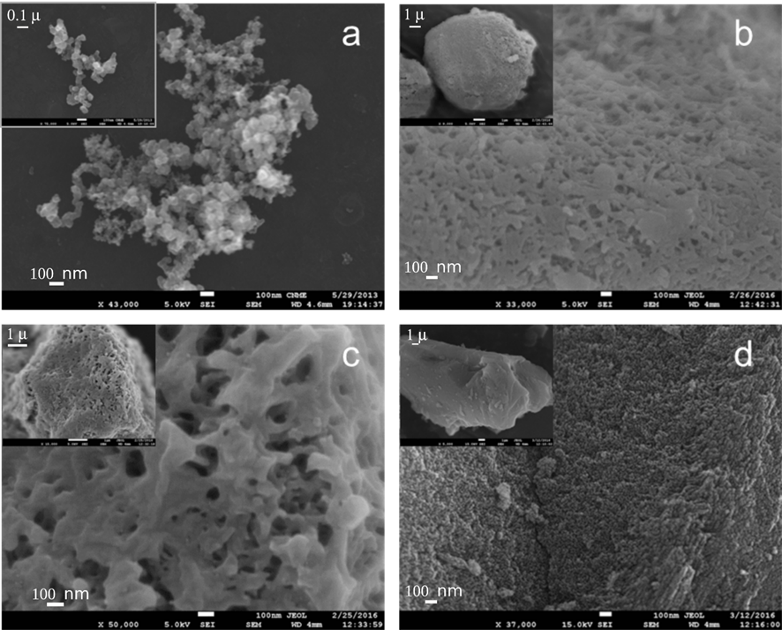
Figure 1. SEM micrographs of carbonaceous materials: a) C₁, b) C₂, c) C₃ and d) AC.
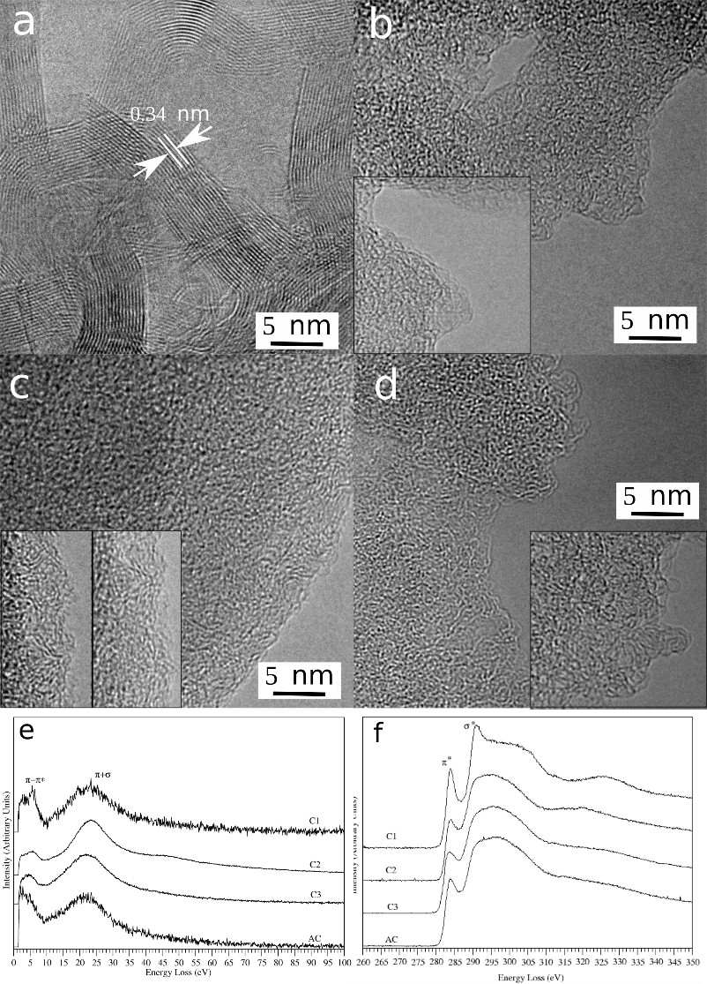

Figure 2. HRTEM images recorded in the specimens C₁, in (a), C₂, in (b), C₃, in (c) and AC, in (d). In (b), (c) and (d) some areas in some other particles are inset to stress the atomic structure details found as important for the subject matter of this investigation. In (e) and (f) the low loss and core loss energy loss spectra, respectively, are presented for all four samples as indicated in the panel.

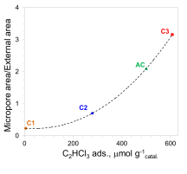
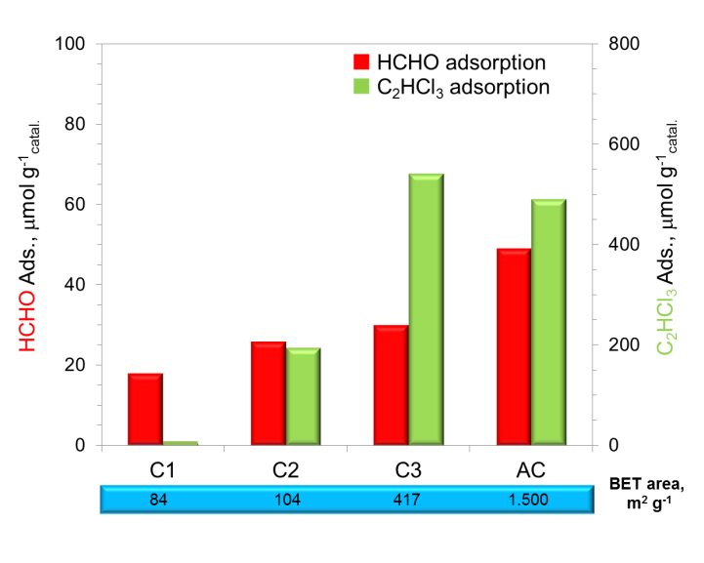
Figure 3. HCHO and C₂HCl₃ adsorption for carbonaceous materials thermally treated.

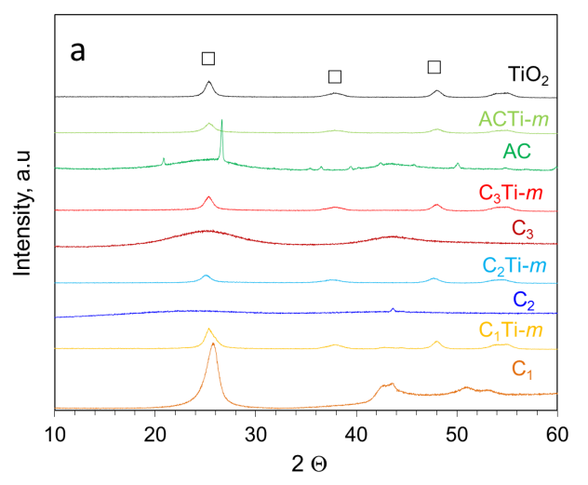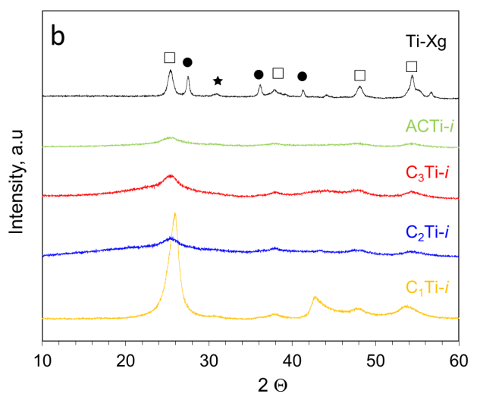
Figure 4. Diffractograms of the synthesized carbon/TiO₂ composites and the reference materials for: (a) C_{x}Ti-m (b) C_{x}Ti-i series: TiO₂-anatase (), TiO₂-rutile (●) and TiO₂-brookite ().

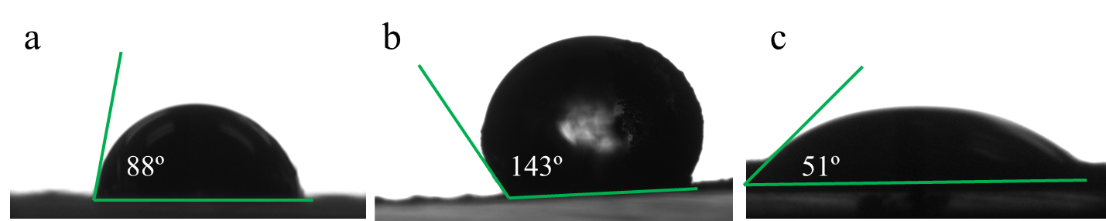
Figure 5. Contact angles exhibited for: (a) C₁, (b) C₃ and (c) AC.

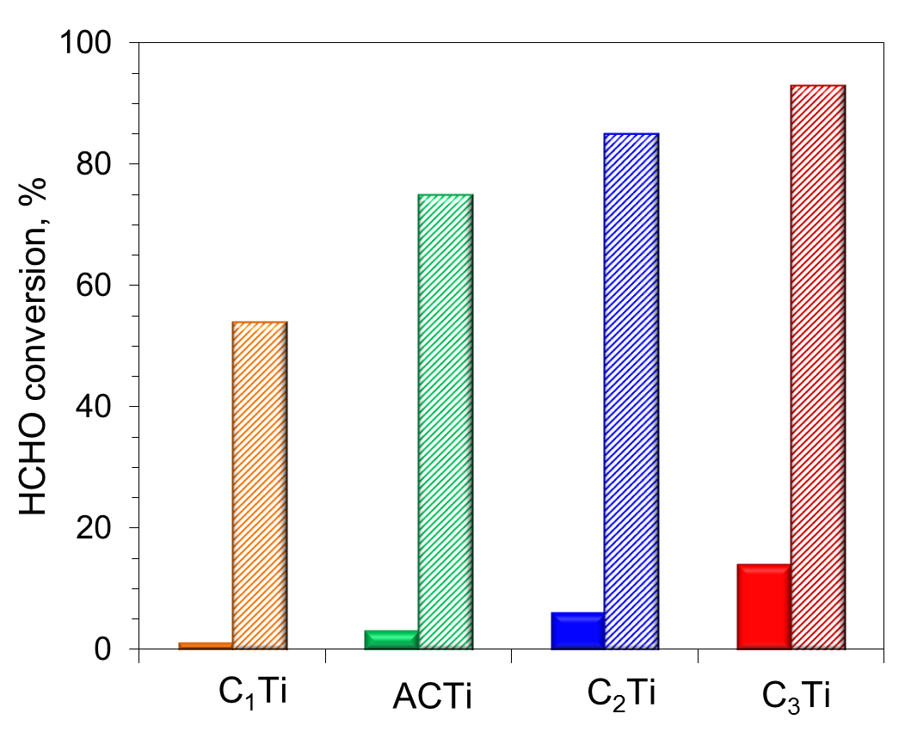
Figure 6. HCHO conversion for carbon-TiO₂ composites prepared by: () C_{x}Ti-i (incipient wet impregnation) and () C_{x}Ti-m (mechanical mixing). Operation conditions: Q = 700 mL min⁻¹, [HCHO] = 15 ppm, residence time tr = 0.55 s, g_{catal.} = 30 mg and irradiance I = 6.5 mW cm⁻².
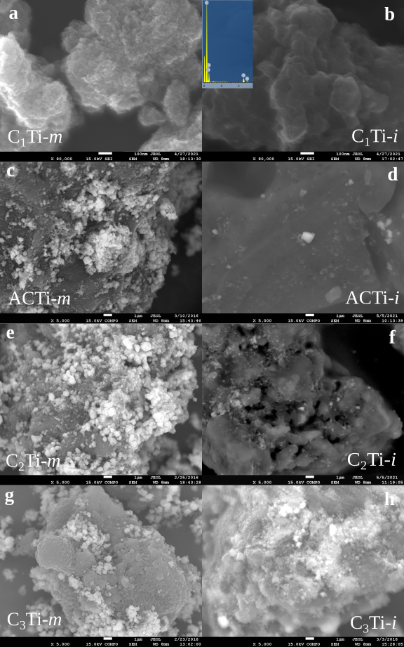
Figure 7. SEM micrographs for C_{x}Ti-y hybrids prepared by different method: a, b) C₁Ti-m and C₁Ti-i; c, d) AcTi-m, AcTi-i; d, e) C₂Ti-m and C₂Ti-i and f, g) C₃Ti-i and b) C₃Ti-m.

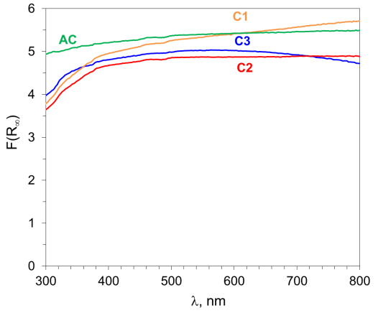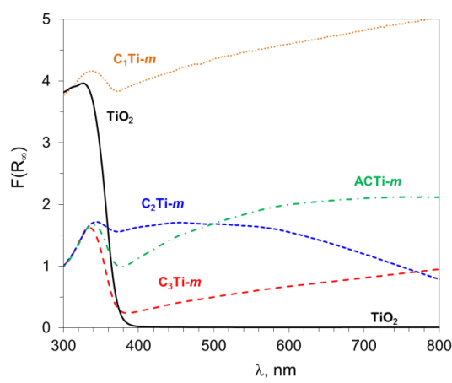
a
b

Figure 8. Kubelka-Munk spectra for: (a) carbonaceous materials and b) C_{x}Ti-m composites prepared by mechanical mixing (b).

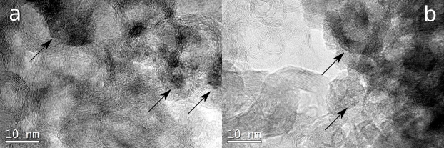

Figure 9. HRTEM micrographs for a) C₂Ti-i and b) C₂Ti-m.

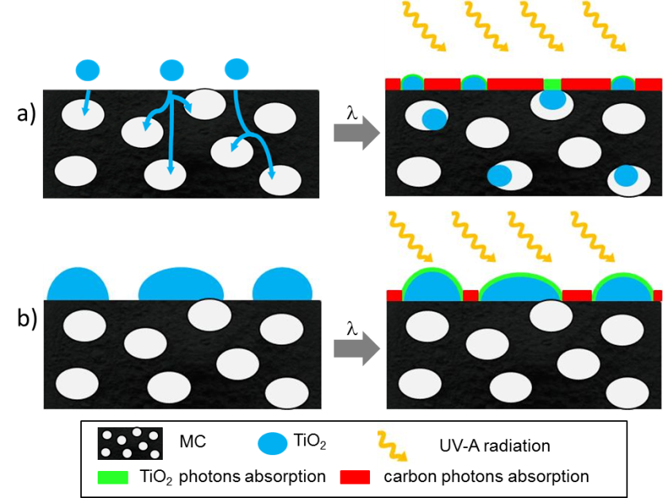
Figure 10. Schema of the TiO₂ distribution and photons adsorption, according to the preparation method: a) C_{x}Ti-i and b) C_{x}Ti-m.

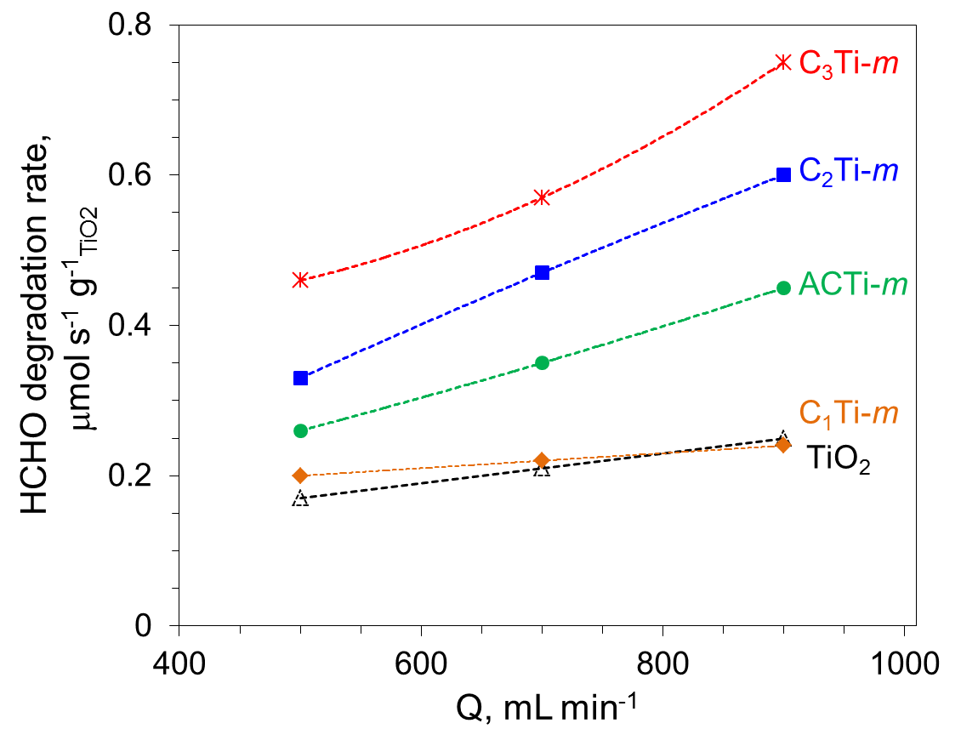
Figure 11. HCHO photodegradation rate for C_{x}Ti-m composites. Operation conditions: [HCHO] = 15 ppm, residence time tr = 0.77-0.43 s.

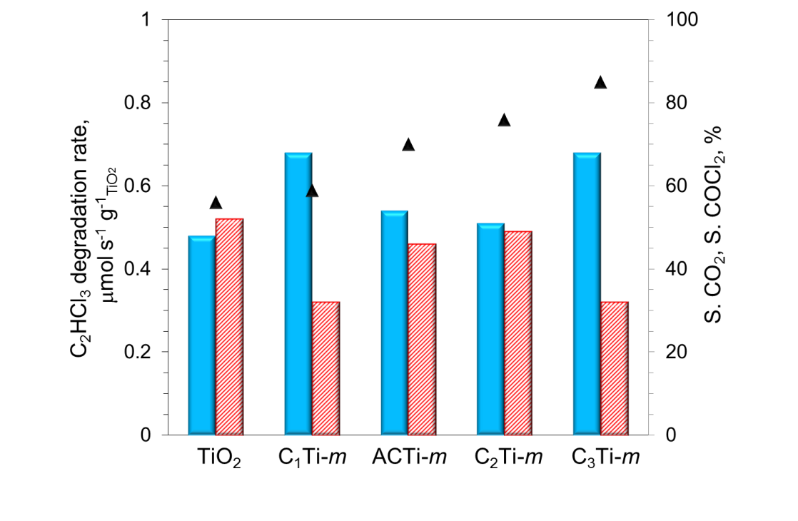
a
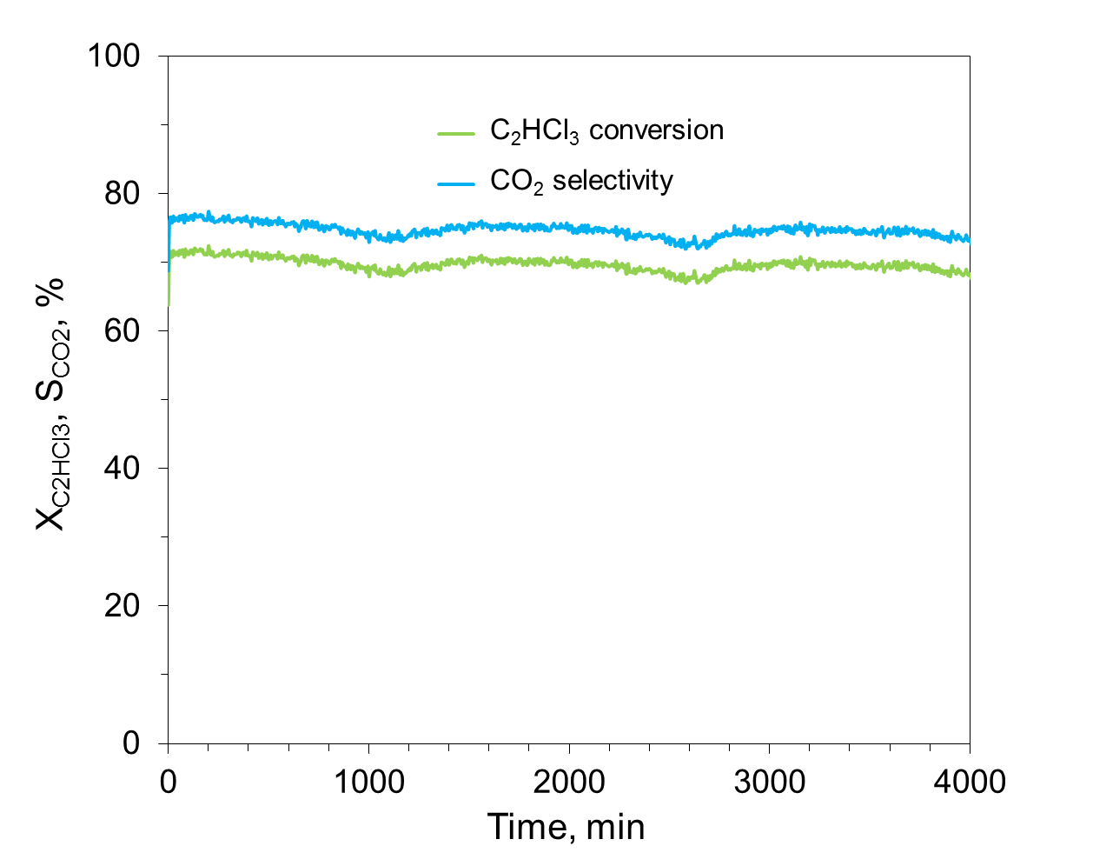
b
Figure 12. a) C₂HCl₃ photodegradation rate (), CO₂ () and COCl₂ () selectivity for C_{x}Ti-m composites and TiO₂ as a reference. Operating conditions: F = 1,100 mL min⁻¹, [C₂HCl₃] = 25 ppm, tr = 0.35 s. b) Photocatalytic stability with reaction time for C₃Ti-m.

