Shutdown Dose Rate Assessment of the Interspace components of Wide Angle Viewing System diagnostic for ITER

F. Mota^{a*}, Y. Peneliau^{b}, J.P. Catalan^{d}, J. Alguacil^{d}, M. Medranoª, E. Rincón^{a*}, S. Cabreraª, R. Carrascoª , F. Lapayeseª , C. Pastorª, A. de la Peñaª, A. Pereiraª, V.Queralª, F. Ramosª, C. Rodríguezª, A. Soletoª, L. Letellier^{b}, F. Le Guern^{c}, J.J. Piqueras^{c},

ªLaboratorio Nacional de Fusión, CIEMAT, 28040 Madrid, Spain
^{b}CEA, IRFM, F-13108 Saint-Paul-Lez-Durance, France
^{c}F4E, Josep Pla 2, Torres Diagonal Litoral B3, 08019 Barcelona, Spain
^{d}Departamento de Ingeniería Energética, ETSII–UNED, Calle Juan del Rosal 12, Madrid, 28040, Spain

*Corresponding author: fernando.mota@ciemat.es

Shutdown dose rate (SDDR) calculations have been performed to give support to the design of the Interspace (IS) VIS/IR WAVS diagnostic components of the Equatorial Port 12 (EP12), in the framework of the F4E-FPA-407 SG04 project. The Vis/IR WAVS comprises the viewing systems in four Equatorial Ports: 3, 9, 12 and 17, reminding that the present results are relative to the EP12 specifically. The Vis/IR WAVS is an optical diagnostic aimed at monitoring in visible and infrared radiation the ITER plasma facing components for machine protection.
This paper describes the methodology used and shows the results obtained. The objective of the assessment is to evaluate whether the design meets the ALARA criteria in the IS area. In this work, once the materials have been selected to contribute as less as possible to the activation, the main criterion is that the contribution of all diagnostics installed in the port should not overcome the target of the biological dose rate of 100 μSv/h in the IS area after 10⁶s of decay time.
The main conclusion of the analysis is that the contribution of the VIS/IR WAVS IS components to the SDDR meets with the ALARA criterion in the IS. The contribution of the VIS/IR WAVS IS components to the SDDR in the IS, concerning the contribution of the whole ITER model, is about 9.6 % in the left corridor and 5.5 % in the right corridor. Besides, the percentage of contribution of the SS316L structure with respect to the total SDDR induced by the IS VIS/IR WAVS components is 99.3 % in the left corridor and 99.5 % in the right corridor. However, it has to be taken into account that these values have been obtained using a local model, therefore these values will be lower than the realistic values. Therefore, these values should be taken only as relative values.

Keywords: ITER, WAVS, diagnostic, Nuclear analysis, D1SUNED

DOI: https://doi.org/10.1016/j.fusengdes.2021.112916

Introduction

Shutdown Dose Rate (SDDR) calculations have been performed to give support to the design of the Interspace (IS) components of the Equatorial Visible/Infra-Red Wide Angle Viewing System (WAVS) of the EP12 of ITER. The Vis/IR WAVS diagnostics is one of the most essential diagnostics of ITER due to its role in machine protection [, ]. This diagnostic is in charge of the monitoring of the surface temperature of Plasma Facing Components by infrared thermography and visible imaging. This purpose is achieved by implementing four Lines of Sight (LoS) (toward the upper target, the divertor and tangentially left and right) in EP03, EP09 and EP17 and three LoS in EP12 (toward the divertor and tangentially left and right). Although the Vis/IR WAVS comprises viewing systems in four Equatorial Ports: 3, 9, 12 and 17, this paper presents the SDDR calculations relative to the IS area of the Equatorial Port 12 (EP12). The calculations have been performed in EP12 because, from the ports mentioned above, the EP12 will be the first one in to be installed.

The VIS/IR WAVS components located in the IS area (Figure 1) are grouped in the following subsystems [, ]:

- The Optical Hinge (OH) and Optical Relay Unit (ORU) assembled on a common structure
- The so-called lenses train, which constitutes the Interspace Afocal Module (IAM).

The OH is the first component of the ex-vessel optical chain located in the IS (Figure 2). It is made up of two folding mirrors per LoS, an upper mirror (OH1) and a lower mirror (OH2). They are assembled on their respective mounts and mechanically connected to a common support structure for the OH and the ORU [3, 4]. The common structure is formed by two parallel plates of irregular shape, internally armed by transversal beams, platens and trays; it supports the OH and ORU transferring the loads to the Interspace Support Structure (ISS) on which it rests [3, 4]. The whole set is installed on the ISS positioned on it by guiding pins and mechanically connected by bolts.

The IAM subsystem accommodates the refractive optic located in the IS. From the mechanical point of view, the IAM is constituted by two elements [3, 4]:

- The support structure common for the 3 LoS.
- A supporting tube (per LoS) which houses the lenses opto-mechanical dressings.

The mechanical arrangement of the IAM can be seen in Figure 2 b).

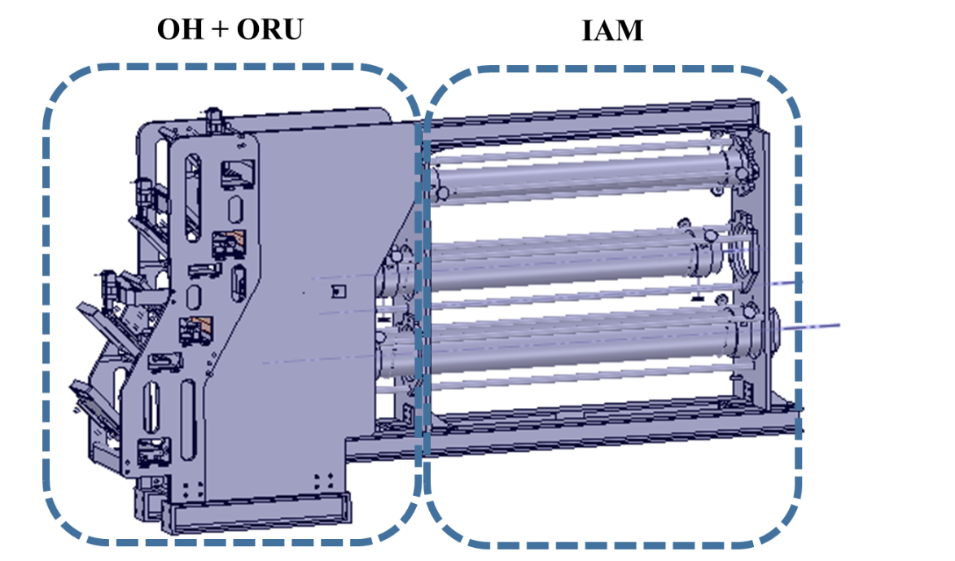
a)
Figure 1.- VIS/IR WAVS IS components of the EP12

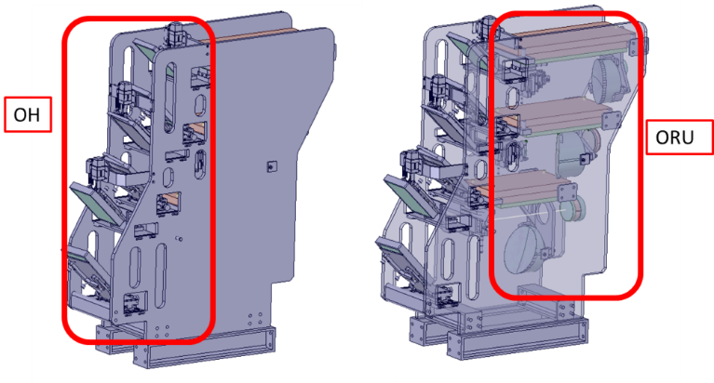  a) | 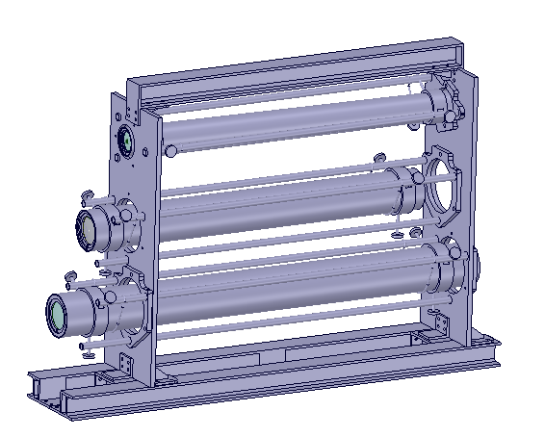  b)
Figure 2.- a) OH and ORU sub-assemblies integrated in the support structure; b) Mechanical arrangement of the Afocal Module in the IS

This paper describes the methodology used to perform the SDDR calculations and shows the results obtained. The objective of the SDDR assessment is to evaluate whether the design meets the ALARA criteria in the IS area. The ALARA criterion is based on minimising the radiation doses by employing the safety principle of time, distance and shielding, as well as limiting the release of radioactive materials into the environment. For the design of the components, the materials have been properly selected in order to contribute as less as possible to the activation in the Is area, following the recommendation of ITER IO for impurities [, ]. The objective of the assessment is to evaluate whether the design meets with the ALARA criteria in the IS area, which means that the SDDR does not have to overcome the target of the biological dose rate of 100 μSv/h in the IS after 10⁶s of decay time.

Methodology

Geometrical model used

This section describes the used model and how it has been simplified and converted into MCNP model. The geometry models of the ITER and EP12 used for this work were the ones also used in the nuclear analyses for the Preliminary Design Review phase, PDR of the in-vessel component of the VIS/IR WAVS [].
The MCNP model of ITER used for this calculation was the same used for the calculations performed for the PDR of the Port Plug (PP)[7], with the aim to be consistent with the previous analyses. The ITER MCNP model used is C-MODEL [] RELEASE 181031 ISSUED 31/10/2018 []. The model of the Port Plug corresponds to the VIS/IR WAVS in Port 12 Version M IO Draft and is characterised by the use of an Optical Relay in the place of the Cassegrain telescope. In this version of the PP only the Diagnostic Shielding Module one (DSM#1) has been modelled. The void spaces for the light transport and the first mirrors units components of the three LoS and H-α diagnostic are included in the DSM#1. Besides, the surrounding shielding to the LoS and H- α, made of B4C, is also dummy modelled. The rest of the DSMs, located in the drawers #2 and 3, are modelled as dummy version (materials average), Figure 3 a). Therefore, only the Drawer Shielding Module one (DSM#1) apertures have been modelled in the closure plate because the objective was to evaluate the impact of our components in the IS area. In addition, previous nuclear analysis [] showed that VIS/IR WAVS had much impact on the left corridor tally. The cross section of the closure flange is shown in Figure 3 b). The upper aperture of the closure flange corresponds to the H- α diagnostic, that although it does not belong to the VIS/IR WAVS diagnostics, as it is located in the same drawer, it has been modelled. The rest of the apertures correspond to, from top to bottom, tangential right (TR), tangential left (TL) and divertor (D) views.

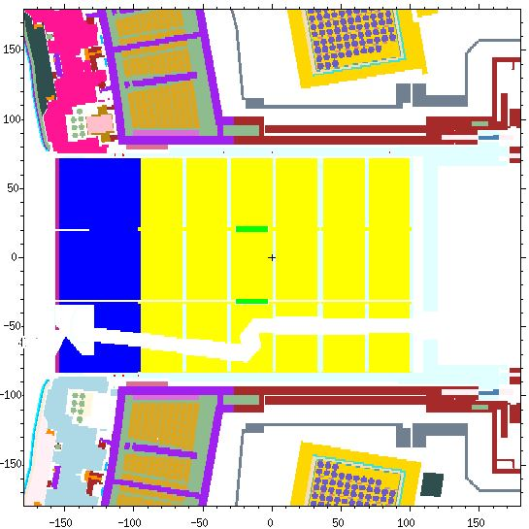
a)
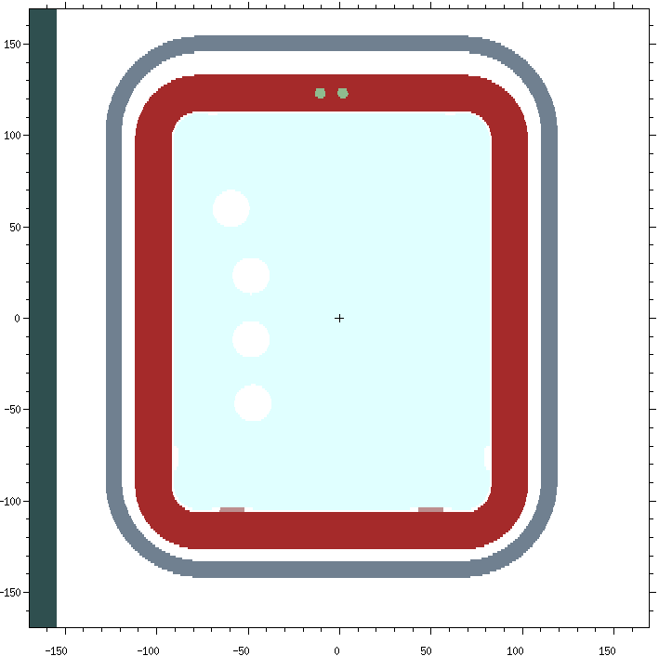
b)
Figure 3.- Cross section of the Closure flange of the MCNP model used

The CAD model of the VIS/IR WAVS IS components was developed at CIEMAT and uploaded to the ENOVIA system of ITER IO, Figure 1. SpaceClaim 2017 [] software was used to simplify the 3D geometrical models of the IS VIS/IR WAVS components to adapt the model to particle transport calculations. The volumes of the simplified model meet with the neutronic guideline requirements [, , , , , ] regarding the volume variation after simplification, which does not have to exceed the 2% of the original volume.
The CAD simplified model was converted into MCNP model using SuperMC 3.2.0 Software [, ] tool developed by FDS Team, China. Several iterations between SpaceClaim and SuperMC code were required in order to get the final MCNP model. This isolated model meets the neutronics guidelines [13], since no particle was lost when 10⁹ particles were run. A vertical section of the MCNP model is shown in Figure 4

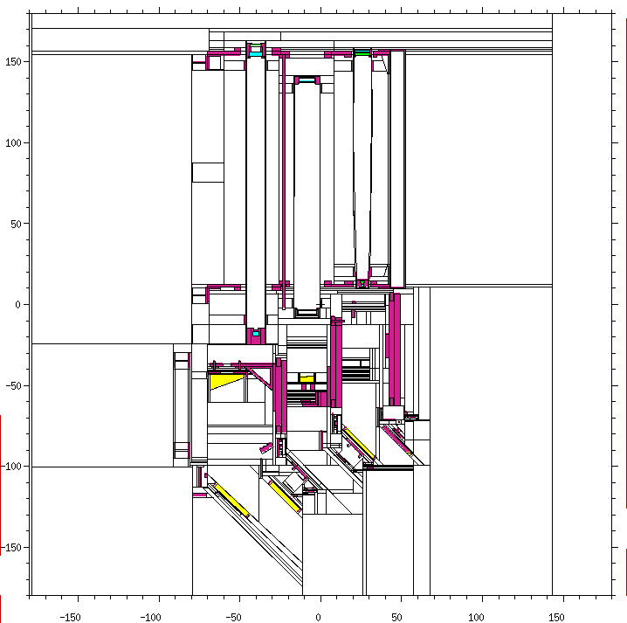
Figure 4.- Vertical view cross section of the MCNP model (Y=-35.29 cm)

The material used for the OH, ORU, and IAM structures is SS316L, considering impurities of Co less than 0.05% and Ta less than 0.01% [5, 6], and with a density of 7.93 g/cm³. The optical components of the different views, Tangential Right (TR), Tangential Left (TL) and Divertor (D), are ZERODUR for the mirrors of the OH and ORU, and CaF₂ and Al₂O₃ for the different lenses of the IAM. The isotopic composition for ZERODUR was taken from reference []. For this phase of design, the pure isotopic composition for CaF₂ and Al₂O₃ was considered.
The material composition considered for the N_216 piezo actuators, which are in charge of the displacement of the OH1 mirrors, are made up of a mixture of materials. As the real composition of the piezo actuator to be used is not provided by the manufacturer yet, as a first approximation, the mixture of materials used for this study was the one used in the piezo actuator proposed by ENEA in the F4E-GRT-282 project [, ]. Although the density specified in the F4E-GRT-282 project is 2.7 g/cm³, the one used in this project has been 5.25 g/cm³, because a corrector factor has been applied to adapt the density to the total weight of our piezo actuator (1250 g) [], taking into account the volume considered in the CAD model.
Once the MCNP model of the IS components was completely finished, it was installed into C-MODEL RELEASE 181031 with the port plug 12 Version M, as it was mentioned above. A vertical cross section of the ITER model in which is observed the IS components of the VIS/IR WAVS installed in the equatorial port is shown in Figure 5. Besides, a zoom of the IS area is also shown in Figure 6. The three views of the VIS/IR WAVS (TR, TL, and D) [1, 2] and the one that corresponds to the H-α diagnostics are observed in these figures.

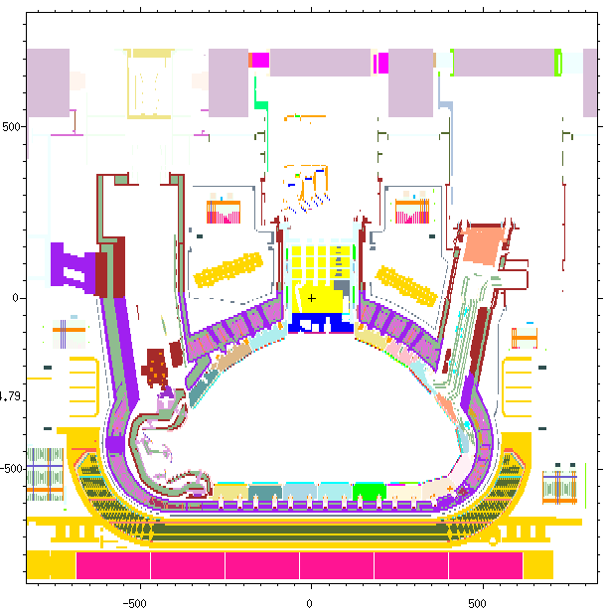
Figure 5.- Vertical Cross section of the ITER MCNP model with the IS VIS/IR WAVS components installed (Y=-45.28 cm)

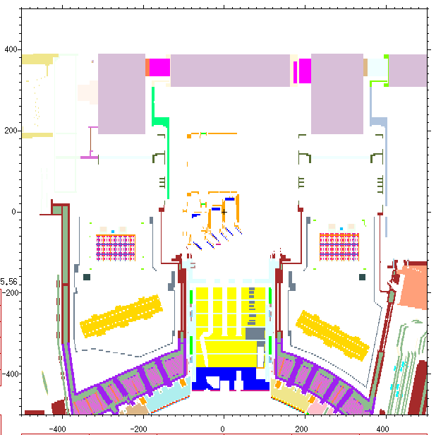  a) | 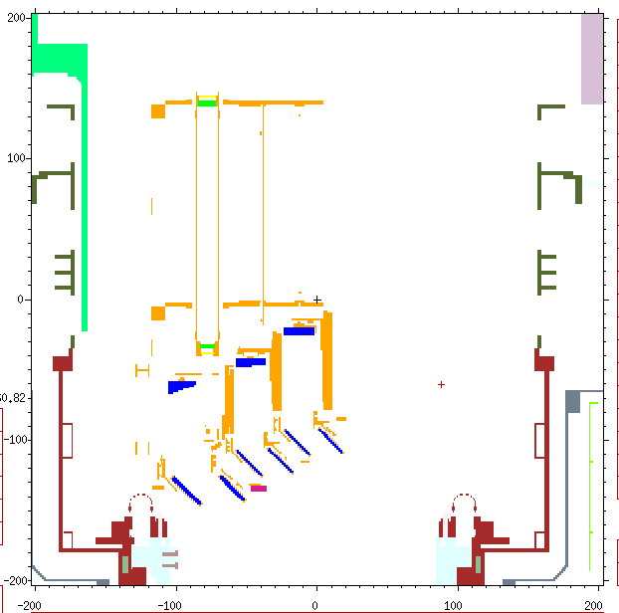  b)
Figure 6.- Vertical Cross section of the ITER MCNP model with the IS WAVS VIS/IR components installed (Y=-45.28); a) EPP and IS area and b) IS area only.

Shutdown Dose Rate methodology calculation

The code used for the SDDR calculations was D1SUNED_V3.1.4, provided by ITER IO in the framework of this contract [, ]. D1SUNED is a code based on MCNP5.1.60 transport code [] able to perform shutdown dose rate calculations using the D1S methodology. In the D1S method, the list of reactions that produce radioactive nuclides is chosen by the user. The considered reactions are listed In Table 1. The nuclear data considered in the SDDR determination was extended from those applied in previous works [7], including the reactions of [], which can be produced in the new materials introduced in the MCNP input.
The nuclear transport calculation has been made using the nuclear data libraries FENDL 3.1d [], while the photon transport calculations were made using mcplib84[] nuclear data library. Regarding D1S nuclear data, a set of hybrid cross-section data, mixing FENDL3.1c [] for transport and EAF2007 [] for activation, was considered for materials for which the activation D1S methodology is applied. The prompt photon production in ACE libraries is modified and replaced by the delayed gamma ray production for these isotopes. The SDDR calculations have been performed considering the local model scenario. In this scenario, the rest of the ports are closed to the radiation.
Regarding the different material allocation during irradiation or shutdown, the water of the cooling pipes is drained during the shutdown. This is implemented in the model allocating a PMT1=0 MCNP card to the cells of the water channels. The card PMT1=0 avoids the decay emission from that cell or lower level cells contained in the case of a universe container and assumes void for that cell for the transport of gamma rays born in other cells. Therefore, the material is considered for neutron transport, but neither for decay gamma rays emission nor transport.

Table 1.- Parent isotope, reaction and daughter isotope considered in D1S-UNED data to compute SDDR
Parent isotope | Reaction | Daughter isotope | Parent isotope | Reaction | Daughter isotope
Na23 | $$(n,2n)$$ | Na22 | Co59 | $${\left(n,γ\right)}^{*}→IT$$ | Co60
Ca40 | $$\left(n,α\right)$$ | Ar37 | Co59 | $$(n,p)$$ | Fe59
Ca46 | $$(n,γ)$$ | Ca47 | Ni58 | $$(n,p)$$ | Co58
Ca48 | $$\left(n,2n\right)$$ | Ca47 | Ni58 | $${\left(n,p\right)}^{*}→IT$$ | Co58
Ti46 | $$\left(n,p\right)$$ | Sc46 | Ni60 | $$(n,p)$$ | Co60
Ti47 | $$\left(n,np\right)$$ | Sc46 | Ni60 | $${\left(n,p\right)}^{*}→IT$$ | Co60
Ti47 | $$\left(n,d\right)$$ | Sc46 | Ni61 | $$(n,np)$$ | Co60
Ti47 | $$\left(n,p\right)$$ | Sc47 | Ni61 | $${\left(n,np\right)}^{*}→IT$$ | Co60
Ti48 | $$\left(n,np\right)$$ | Sc47 | Ni61 | $$(n,d)$$ | Co60
Ti48 | $$\left(n,d\right)$$ | Sc47 | Ni61 | $${\left(n,d\right)}^{*}→IT$$ | Co60
Cr50 | $$(n,γ)$$ | Cr51 | Ni62 | $$(n,α)$$ | Fe59
Cr52 | $$(n,2n)$$ | Cr51 | Cu63 | $$(n,α)$$ | Co60
Mn55 | $$\left(n,2n\right)$$ | Mn54 | Cu63 | $${\left(n,α\right)}^{*}→IT$$ | Co60
Fe54 | $$(n,α)$$ | Cr51 | Zn64 | $$(n,γ)$$ | Zn65
Fe54 | $$(n,p)$$ | Mn54 | Zn66 | $$(n,2n)$$ | Zn65
Fe54 | $$(n,γ)$$ | Fe55 | Ta181 | $$(n,γ)$$ | Ta182
Fe56 | $$(n,2n)$$ | Fe55 | Ta181 | $${\left(n,γ\right)}^{*}→IT$$ | Ta182
Fe56 | $$(n,t)$$ | Mn54 | Ta181 | $${\left(n,γ\right)}^{**}→IT$$ | Ta182
Fe58 | $$(n,γ)$$ | Fe59 | W182 | $$(n,p)$$ | Ta182
Co59 | $$(n,2n)$$ | Co58 | W182 | $${\left(n,p\right)}^{*}→IT$$ | Ta182
Co59 | $${\left(n,2n\right)}^{*}→IT$$ | Co58 | W182 | $${\left(n,p\right)}^{**}→IT$$ | Ta182
Co59 | $$(n,γ)$$ | Co60

The time correction factors used in this work for each daughter isotope were calculated to the SA-2 irradiation scenario and 10⁶ seconds of cooling time (Recommendation on Plasma scenarios, []). The time corrections factors were normalised to a factor of 1.97·10¹⁹ n/s.
The coefficients used to covert the photon fluence rate into Biological dose rate were taken from the reference [] and shown in Table 2.

Table 2 .- Photon fluence to dose conversion factors (pSv/(photons/cm²))
Photon Energy  (MeV) | DF  (pSv/(γ/cm2) | Photon Energy  (MeV) | DF  (pSv/(γ/cm2)
0.01 | 0.0485 | 0.3 | 1.5083
0.015 | 0.1254 | 0.4 | 1.9958
0.02 | 0.2050 | 0.5 | 2.4657
0.03 | 0.2999 | 0.6 | 2.9082
0.04 | 0.3381 | 0.8 | 3.7269
0.05 | 0.3572 | 1.0 | 4.4834
0.06 | 0.3780 | 2.0 | 7.4896
0.07 | 0.4066 | 4.0 | 12.0153
0.08 | 0.4399 | 6.0 | 15.9873
0.10 | 0.5172 | 8.0 | 19.9191
0.15 | 0.7523 | 10.0 | 23.7600
0.20 | 1.0041

The use of different tallies is recommended for ITER IO for neutronics or SDDR studies [12], Figure 7. From the tallies recommended by ITER IO. the most significant ones to evaluate the influence upon the SDDR of the IS components installed in the IS have only been used and are listed in the following points.

- SDDR in the Left and Right Corridors (LC and RC).
- Horizontal cross sections corresponding to planes perpendicular to axis Z have been used, the ones cutting in 140, 60 and -20 cm

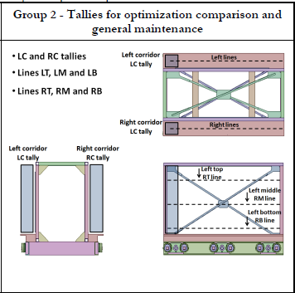 | 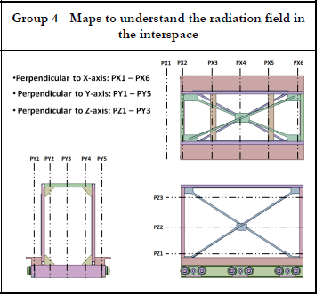
Figure 7.- Description of two groups of the equatorial port interspace tallies exposed in [12]

Besides, Global Variance Reduction (GVR) technique with weight windows map has been used to reduce the statistics relative error as quickly as possible. The GVR weight windows were obtained with ADVANTG code [, , ], using FW-CADIS methodology as reduction variance technique []. As some problems were encountered to reach adequate statistics, an additional MCNP card to force neutron collisions in the cells of the IS VIS/IR WAVS components was used. The card used was FCL. Then, with this card, the increase of the population of the decay photons is obtained because secondary decay photons are produced when neutron collisions occur. This card has been used considering PWT card zero in order to consider exactly the production of one photon for each neutron collision. Besides, the weight windows of photons had to be turned off so this variance reduction technique could work correctly.

SHUTDOWN DOSE RATE CALCULATION

The contribution to the SDDR of IS VIS/IR WAVS components in the IS area to the references tallies for the PDR Figure 7 is shown in this section. The tallies used to evaluate SDDR contribution in this document are the same as those used in reference [7] to make comparison with those previous results easier.

SDDR contribution of the different close flange apertures

The contribution of the IS VIS/IR WAVS components to the SDDR in the Left Corridor (LC) and Right Corridor (RC) as a function of the different apertures of the closure flange is exposed in this subsection. That is, the contribution to the activation of the IS components induced by the neutron coming from the different apertures of the closure flange considered.
The contribution to the SDDR in the LC and RC induced by the activation due to the neutrons which cross the H- α, TR, TL and divertor apertures are assessed separately and shown in Table 3 and Table 4. Besides, the contribution by the activation due to neutrons that crosses the three VIS/IR WAVS diagnostics apertures is also considered. And finally, the contribution to the SDDR induced by the activation due to the neutrons coming from everywhere in the ITER model is considered in the last line of the tables.

Table 3.- Contribution of the SDDR coming from the IS VIS/IR components to the Left Corridor
Left corridor | Biological Dose Rate [μSv/h] | Statistics relative error
Contribution coming from H-α aperture | 2.02 | 0.19
Contribution coming from TR aperture | 2.79 | 0.06
Contribution coming from TL aperture | 1.88 | 0.07
Contribution coming from D aperture | 1.28 | 0.20
Contribution coming from all apertures of VIS/IR | 5.95 | 0.05
Contribution coming from all apertures | 7.97 | 0.06
Contribution coming from the whole ITER model | 87.49 | 0.02

Table 4.- Contribution of the SDDR coming from the IS VIS/IR components to the Right Corridor
Right corridor | Biological Dose Rate [μSv/h] | Statistics relative error
Contribution coming from H-α aperture | 0.97 | 0.21
Contribution coming from TR aperture | 1.09 | 0.08
Contribution coming from TL aperture | 0.867 | 0.1
Contribution coming from D aperture | 0.96 | 0.30
Contribution coming from all apertures of VIS/IR | 2.76 | 0.1
Contribution coming from all apertures | 3.73 | 0.09
Contribution coming from the whole ITER model | 77.23 | 0.02

However, it has to be taken into account that these values have been obtained using a local model, as it was commented in section 2.2, i.e. with the rest of the port closed and using dummy model for the rest of DSMs (2 and 3) of the EP12. Therefore, these values will be lower than the realistic values. Therefore, these values should be taken only as relative values.

SDDR contribution of the different materials involved in the IS components.

The contribution to the SDDR in the IS area of the IS components as a function of the materials involved are given in this subsection. The contribution of the mirrors (Zerodur) has been divided into two: the one from the OH mirrors and the one from ORU mirrors. This consideration has been done as the design of the ORU module was less mature than the OH.
The contributions to the SDDR given as a function of the different materials in the LC and RC are shown in Table 5 and Table 6, respectively. The label “rest of components” means the contribution to the SDDR of the rest of the model except the IS components of the VIS/IR WAVS. Next, the rest of the labels means the contribution to the SDDR of the whole IS VIS/IR WAVS components made up of the materials specified. For example, the row of the label “SS316L” correspond to the contribution to the SDDR of the SS316L IS VIS/IR WAVS structure, which includes the OH, IAM, and ORU structures. The contribution to the SDDR of the lenses is represented in the labels “CaF₂” and “Al₂O₃”. The ones coming from the mirrors correspond to the names Zerodur (OH) and Zerodur (ORU). And finally, the label “Piezo Actuator Mixture Material” correspond to the contribution to the SDDR of the three piezo actuators.
The larger contributor to the SDDR is by far the SS316L structure, as it is observed in Table 5 and Table 6. The percentage of contribution of the SS316L structure of the IS VIS/IR WAVS components to the total SDDR is 99.29 % in the Left Corridor and 99.55 % in the RC. The second contributor, which are the mirrors of the OH made up of Zerodur, is three orders of magnitude lower, being his percentage 0.55 % and 0.31 % in Left and Right Corridors, respectively. However, the possible impurities of the optical material have not been considered in this study, but due to the little amount of them in the whole material, the contribution of these impurities to the SDDR will probably not increase significantly. Nevertheless, in the final design review phase, the optical components impurities will be considered to confirm this assumption, whether the manufacturer can provide this information. With respect to the SDDR induced by the alumina, the value obtained is zero because the mean life of the radioactive isotopes produced by the aluminium or oxygen is negligible concerning the time when the SDDR is measured (10⁶ seconds). The unique significant radioactive isotope is the ²⁴Na, which has a mean life of about 15 h. Consequently, the contribution of the alumina was negligible during the definition of the D1S calculation, as Table 5 and Table 6 show. And finally, the results show that the contribution of the VIS/IR WAVS IS components to the SDDR is 8.39 μSv/h on the LC and 4.26 μSv/h on the RC.
Although the statistic relative errors of the rest of the components, except the SS316L, are higher than desirable, as the statistic relative error for the contribution of SS316L components is acceptable, and steel contribution to the total SDDR in the IS area is higher than 99 %, the quality of the result is satisfactory.

Table 5.- SDDR Left Corridor contribution for materials of the IS_Components (Tally 3004)
Materials | Biological Dose Rate [μSv/h] | Statistics relative error | Percentage of contribución respect to the total of IS components
Rest of components | 7.91E+01 | 0.02 | X
SS316L | 8.33E+00 | 0.02 | 99.29
CaF2 | 3.56E-06 | 0.2 | 4.2E-05
Al2O3 | 0.00E+00 | 0.00 | 0.0E+00
Zerodur OH | 4.59E-02 | 0.07 | 0.55
Zerodur ORU | 9.69E-03 | 0.08 | 0.12
Piezo Actuator Mixture Material | 3.91E-03 | 0.1 | 0.047
Total | 8.75E+01 | 0.02 | X

Table 6.- SDDR Right Corridor contribution for materials of the IS_Components (Tally 3014)
Materials | Biological Dose Rate [μSv/h] | Statistics relative error | Percentage of contribución respect to the total of IS components
Rest of componets | 7.30E+01 | 0.02 | X
SS316L | 4.24E+00 | 0.02 | 99.55
CaF2 | 3.88E-06 | 0.20 | 9.11E-05
Al2O3 | 0.00E+00 | 0.00 | 0.00E+00
Zerodur OH | 1.32E-02 | 0.07 | 0.31
Zerodur ORU | 4.45E-03 | 0.05 | 0.10
Piezo Actuator Mixture Material | 1.43E-03 | 0.11 | 0.034
Total | 7.73E+01 | 0.02 | X

The comparison of the results obtained in the PP PDR [7] with the ones obtained in these calculations is as follows: the total contribution to the SDDR in the LC was 84.6 μSv/h in reference [7] (in-vessel calculations), while the total contribution to the SDDR in the LC in this calculation (out-vessel calculations) was 87.5 μSv/h. Therefore, the difference between both calculations is 2.9 μSv/h. However, the contribution obtained for the sum of the different partial contribution of each material of the IS components (Table 5) is 8.4 μSv/h. This difference could come from the shielding of the gamma rays coming from the port plug by the structure of the IS components. With respect to the RC values, the total contribution to the SDDR obtained in the PDR EP calculations was 77.1 μSv/h [7] (in-vessel calculations), while the contribution to the SDDR obtained in this calculation was 77.3 μSv/h (Table 6, out-vessel calculations), i.e., the values are very similar, only a difference of 0.2 μSv/h. However, the contribution to the SDDR of the IS components calculated in this work was 4.26 μSv/h. Therefore, the total contribution of the PP to the SDDR in the RC could again be affected by the IS components. A resume of this comparison of the results obtained for in or out vessel PDR calculations is shown in Table 7.

Table 7.- Comparison of SDDR results obtained for in or out vessel PDR calculations.
 | SDDR in the IS area [μSv/h]
 | LC | RC
In Vessel PDR | 84.6 | 77.1
Out Vessel PDR | 87.5 | 77.3
Δ SDDR(Out, In) | 2.9 | 0.2
Contribution of the IS components | 8.4 | 4.3

As the contribution of the SS316L components is about of 99 % of the SDDR, then the objective of this section has been reached, i.e. to determine the contribution to the SDDR of the IS VIS/IR WAVS components, in spite of that the statistics relative errors of the rest of components represented shown are higher than desirable.
Biological dose rate maps induced by the SS316L IS VIS/IR WAVS structure is shown in Figure 8. These maps correspond to horizontal sections cutting the axis Z in 140, 60 and -20 cm. The statistics relative errors of each cross section are shown in Figure 9. The biological dose rate maps induced by the whole ITER model, including the IS VIS/IR WAVS components, is shown in Figure 10. These maps correspond to horizontal sections cutting the axis Z in 140, 60 and -20 cm. In these maps is represented the total biological doses rate in the IS area, with the assumption taken in this study. Their statistics relative errors are shown in Figure 11.

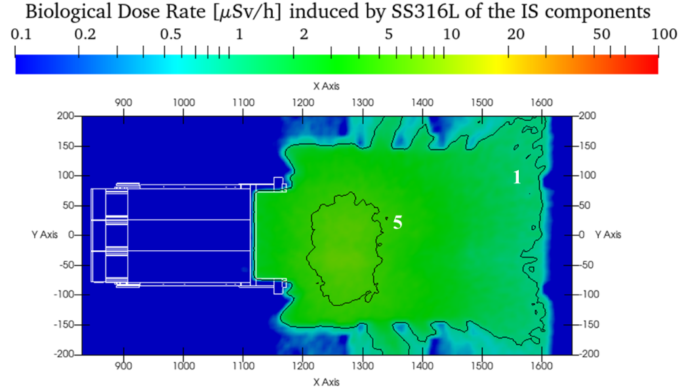
a)
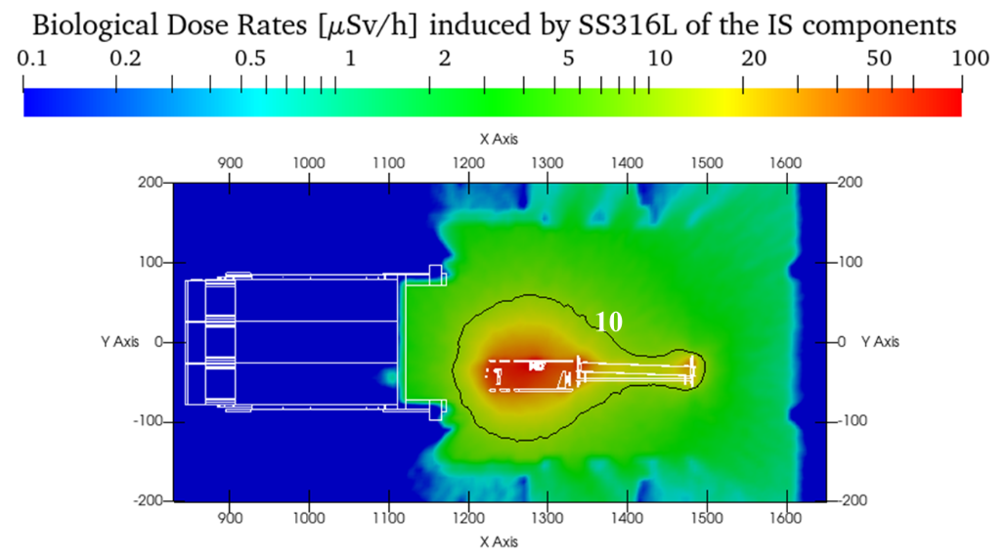
b)
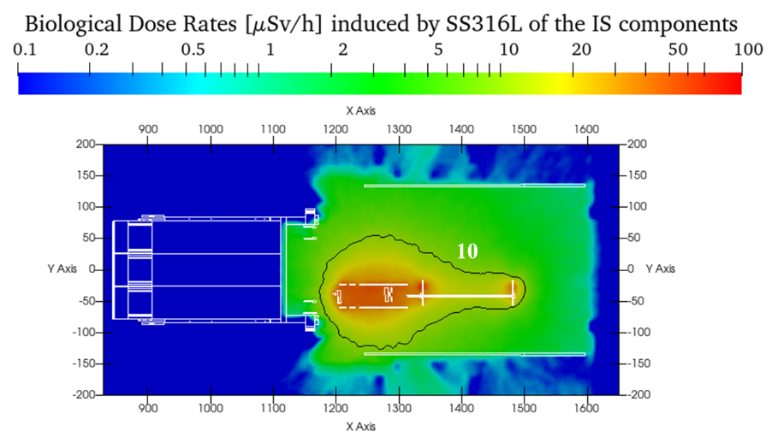
c)
Figure 8.- Biological Doses Rates [μSv/h] induced by SS316L of the IS components; a) Maps Z- PZ=140, b) Maps Z- PZ=60, c) Maps Z- PZ=-20

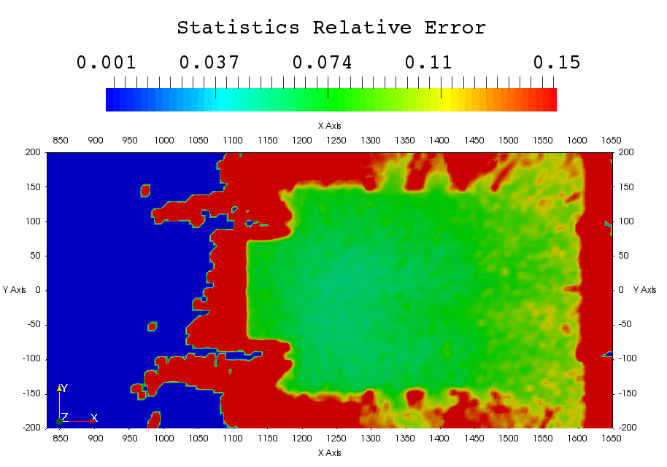
a)
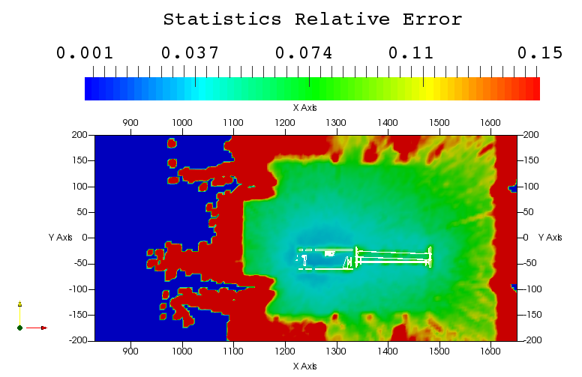
b)
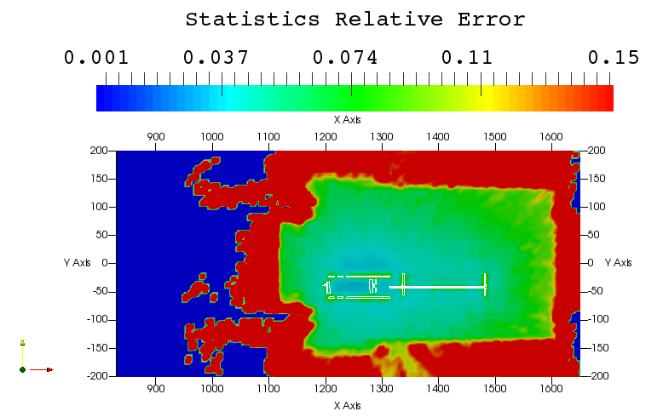
c)
Figure 9.- Statistics Relative Error of the Biological Doses Rates [μSv/h] induced by SS316L of the IS components; a) Maps Z- PZ=140, b) Maps Z- PZ=60, c) Maps Z- PZ=-20.

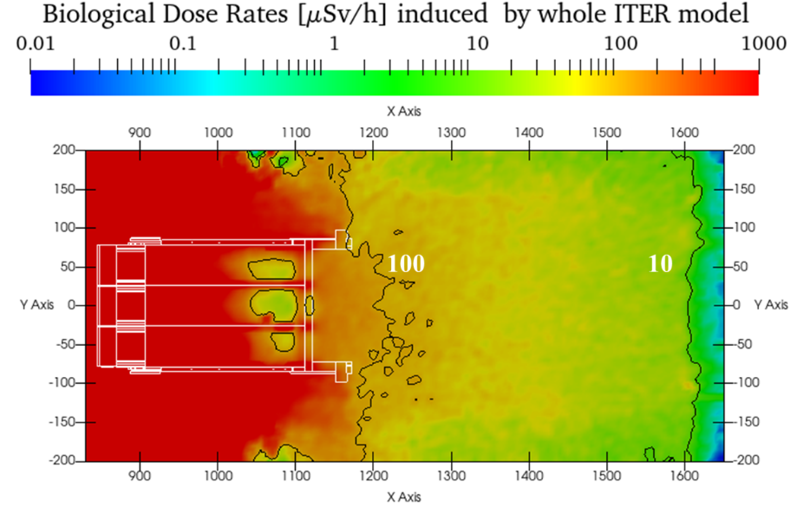
a)
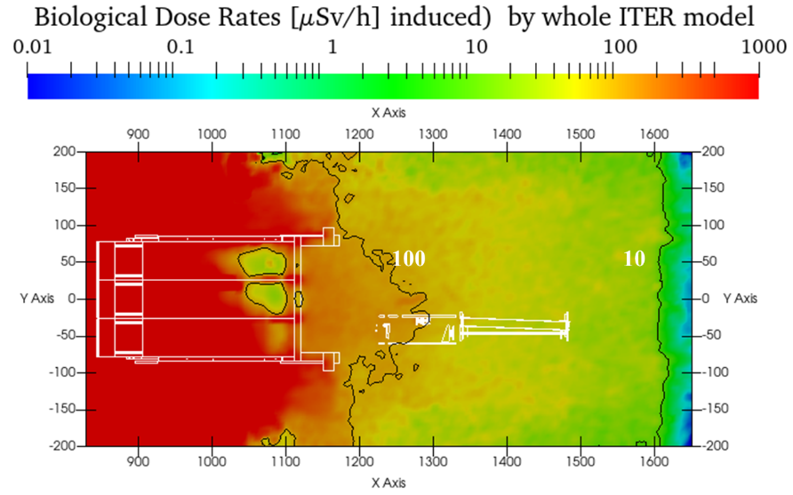
b)
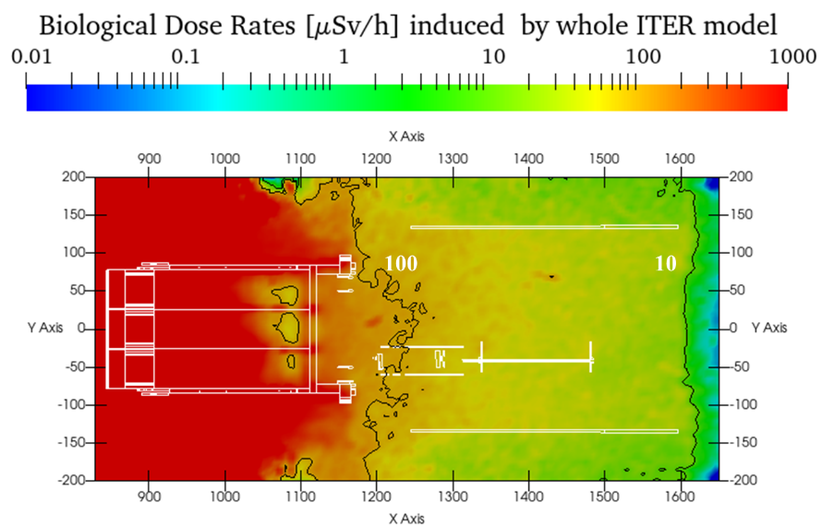
c)
Figure 10.- Biological Doses Rates [μSv/h] induced) by whole ITER model; a) Maps Z- PZ=140, b) Maps Z- PZ=60, c) Maps Z- PZ=-20.

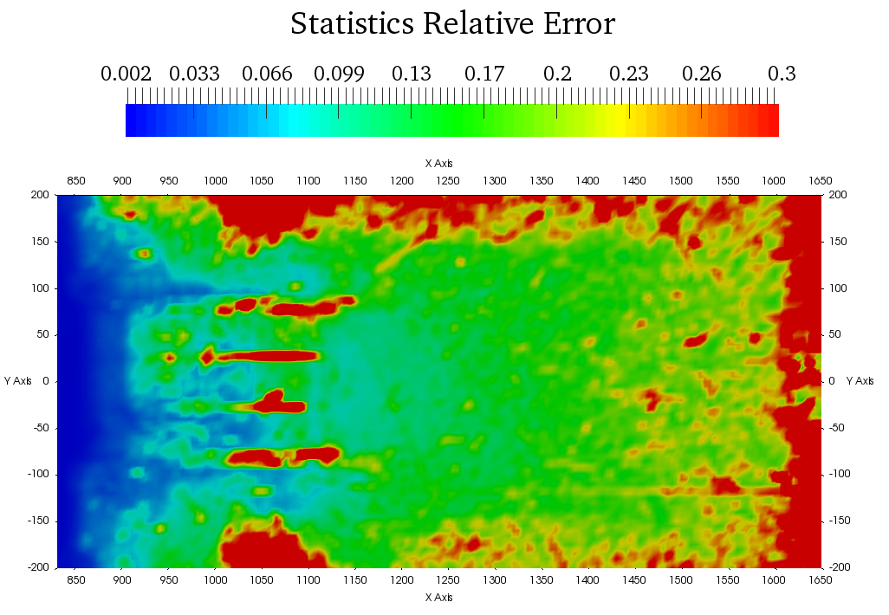
a)
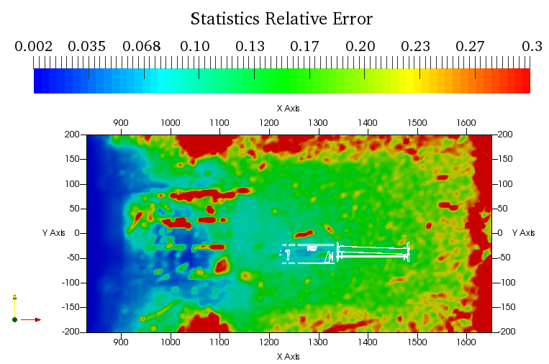
b)
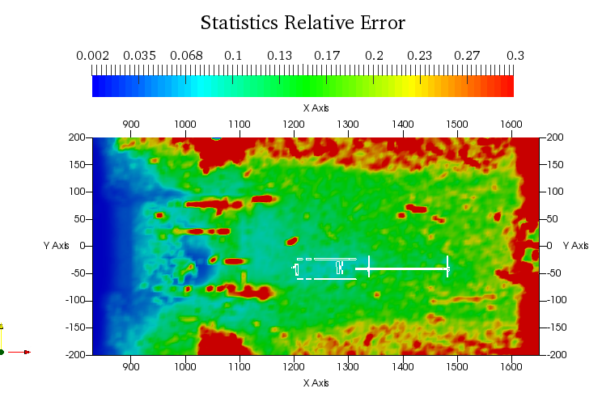
c)
Figure 11.- Statistics Relative Error of the Biological Doses Rates [μSv/h] induced by whole ITER model ; a) Maps Z- PZ=140, b) Maps Z- PZ=60, c) Maps Z- PZ=-20.

Conclusions

Shutdown dose rate calculations have been performed to give support to the design of the IS components of the VIS/IR WAVS diagnostics of the EP12. The assessment of the IS VIS/IR WAVS components designed in this project concerning the SDDR issues has been made.
The contribution to the SDDR of IS VIS/IR WAVS components, at 10⁶s of decay time, to the references tallies for the PDR phase has been described in this paper. On the one hand, the contribution to the SDDR in the IS area due to the activation of the IS VIS/IR WAVS components. On the other hand, the contribution as a function of the materials involved in the design of the IS components has been presented.
As a result of the calculations performed, the contribution of the VIS/IR WAVS IS components to the SDDR is 8.39 μSv/h on the LC and 4.26 μSv/h on the RC. The major contributor to the SDDR is by far the SS316L structure. The percentage of contribution of the SS316L structure with respect to the total SDDR induced by the IS VIS/IR WAVS components is 99.3 % in the LC and 99.5 % in the RC. However, it has to be taken into account that these values have been obtained using a local model, therefore these values will be lower than the realistic values. Therefore, these values should be taken only as relative values.

Acknowledgements

Simulations presented in this paper were performed at HPC Marconi system at CINEACA (https://www.hpc.cineca.it/hardware/marconi). The work leading to this publication has been partially funded by Fusion for Energy under Specific Grant Agreement F4E-FPA 407(DG)-SG04. This publication reflects the views only of the author, and Fusion for Energy cannot be held responsible for any use which may be made of the information contained therein.

Reference

[] Sophie Salasca, Marie-Helene Aumeunier, Fabrice Benoit, Bruno Cantone, Yann Corre, Elise Delchambre, Marc Ferlet, Eric Gauthier, Christophe Guillon, Didier van Houtte, Delphine Keller, Florence Labasse, Sebastien Larroque, Thierry Loarer, Frederic Micolon, Bertrand Peluso, Maxime Proust, David Blanchet, Yannick Peneliau, Javier Alonso, Eduardo de la Cal, Carlos Hidalgo, Piedad Martin, Mercedes Medrano, Fernando Mota, Jose Luis de Pablos, Luis Rios, Esther Rincon, Rafael Vila, Ana Manzanares, Vincent Martin, Roger Reichle, Frederic Le Guern, “The ITER Equatorial Visible/Infra-Red Wide Angle Viewing System: Status of design and R&D”, Fusion Engineering and Design, 96–97 (2015) 932-937, ISSN 0920-3796, https://doi.org/10.1016/j.fusengdes.2015.02.062.
[] Laurent Letellier, Christophe Guillon, Marc Ferlet, Marie-Hélène Aumeunier, Thierry Loarer, Eric Gauthier, Stéphane Balme, Bruno Cantone, Elise Delchambre, Didier Elbèze, Sébastien Larroque, Florence Labassé, David Blanchet, Yannick Peneliau, Luis Rios, Fernando Mota, Carlos Hidalgo, Ana Manzanares, Vincent Martin, Frédéric Le Guern, Roger Reichle, Martin Kocan, “System level design of the ITER equatorial visible/infrared wide angle viewing system”, Fusion Engineering and Design, 123 (2017) 650-653, ISSN 0920-3796, https://doi.org/10.1016/j.fusengdes.2017.06.005.
[] M. Medrano, A. Soleto, C. Pastor, C. Rodríguez, R. Carrasco, F. Lapayese, A. de la Peña, A. Pereira, E. Rincón, S. Cabrera, F. Ramos, E. de la Cal, F. Mota, V. Queral, R. Lopez-Heredero, A. Manzanares, C. Alén-Cordero, L. Letellier, S. Vives, V. Martin, F. Le Guern, J.J. Piqueras, M. Kocan, “Design overview of ex-vessel components for the Wide Angle Viewing System diagnostic for ITER Equatorial Port 12”, Fusion Engineering and Design 168 (2021) 112651, ISSN 0920-3796, https://doi.org/10.1016/j.fusengdes.2021.112651.
[] Carmen Pastor, Carmen Rodríguez, Mercedes Medrano, Alfonso Soleto, Ricardo Carrasco, Fernando Lapayese, A. de la Peña, Esther Rincón, Santiago Cabrera, Augusto Pereira, E. de la Cal, Fernando Mota, Francisco Ramos, Vicente Queral, Raquel Lopez-Heredero, Ana Manzanares, Laurent Letellier, Sebastien Vives, V. Martin, Frederic Le Guern, J. José Piqueras, Martin Kocan, “Optical design of ex-vessel components for the Wide Angle Viewing System diagnostic for ITER”, Fusion Engineering and Design, 168 (2021) 112607, ISSN 0920-3796, https://doi.org/10.1016/j.fusengdes.2021.112607.
[] V. Barabash “Chemical compositions of materials representing the components included into basic model for nuclear analysis of ITER” ITER_D_HTN8X3 v2.1 Section 11.2, 9th March 2016. Private communication.
[] V. Barabash “Chemical composition and impurity requirements for materials (REYV5V v2.3)” ITER_D_REYV5V v2.3, 5th April 2016. Private communication.
[] Y. Peneliau, CD15.2-c (D10) – Nuclear Analysis of 55.G1: Shutdown Dose Rate GEDI P00001179/v1.2 11 July 2019 (F4E_D_2GNMHH_V2.0). Private communication.
[] Dieter Leichtle, Bethany Colling, Marco Fabbri, Rafael Juarez, Michael Loughlin, Raul Pampin, Eduard Polunovskiy, Arkady Serikov, Andrew Turner, Luciano Bertalot, “The ITER tokamak neutronics reference model C-Model”, Fusion Engineering and Design, 136, Part A, (2018) 742-746, ISSN 0920-3796, https://doi.org/10.1016/j.fusengdes.2018.04.002.
[] E. Polunovskiy, “C-model R181031 (Revision 190110), ITER_D_XEU24H_v2, Private communication (2019).
[] R. Juarez, “D5 – Modelling and calculations of the new modular EP#12 – Nuclear analysis of PDR EP#12 design”, ITER_D_VDMBFZ V1.1, 23rd May, 2018. Private communication.
[] SpaceClaim 3D software, http://www.spaceclaim.com/en/default.aspx
[] R. Juarez, L- Bertalot, “Standard tallies for neutrons for ITER Diagnostics Division” ITER_D_RLMBUV version 1.0, 9th December, 2015, Private communication.
[] R. Juarez, L. Bertalot, “ Neutronics guidelines for ITER Diagnostics Division”. ITER_D_RLVRDP version 1.0, 9th December, 2015, Private communication.
[] M. Loughlin, “Instructions for Nuclear Analyses” ITER_D_R7XRXB version 4.3, 12th April, 2018 or v4.4 11th June 2020. Private communication.
[] R. Pampin, “Guideline for nuclear analysis of diagnostic port”, ITER_D_W4WNU5 version 1.1 17th May, 2018. Private communication.
[] P. Wouters, “F4E-QA-114: Instructions for Suppliers Performing Design Analysis” F4E_D_22FR5T_v_3.3 21rt July 2015. Private communication.
[] R. Pampin García, “F4E Guideline - Nuclear Analyses”, F4E_D_26NR86_V3.0 4th February 2019. Private communication.
[] Y. Wu. Multi-functional Neutronics Calculation Methodology and Program for Nuclear Design and Radiation Safety Evaluation, Fusion Science and Technology 74(2018) 321-329
[] Y. Wu, J. Song, H. Zheng, et al. CAD-Based Monte Carlo Program for Integrated Simulation of Nuclear System SuperMC, Annals of Nuclear Energy 82(2015) 161-168
[] A. Esmaeilzare, A. Rahimi, S.M. Rezaei,“Investigation of subsurface damages and surface roughness in grinding process of Zerodur® glass–ceramic” Applied Surface Science 313 (2014) 67–75
[] C. Monti, “RT-IVVS2-08 Report on compatibility with neutrons” F4E_D_268YMY v2.0 or LBSQB4 v1.0 28th January 2014. Private communication.
[] O. Bede, “Neutron Irradiation test procedure” ITER_D_ KS4MKE, v1.0 18 Nov 2013. Private communication.
[] R. Carrasco, “F4E-FPA-407 SG04 CD04.3 Prototyping Plan of the Optical Hinge” F4E_D_2NX9KB 03 Agosto 2020. Private communication.
[] P. Sauvan, R. Juárez, G. Pedroche, J. Alguacil, J. P. Catalan, F. Ogando and J. Sanz, “D1SUNED system for the determination of decay photon related quantities,” Fusion Engineering and Design, 151 (2020) 111309
[] P. Sauvan, J. Alguacil, V. Lopez, R. Juarez, J.P. Catalan, F. Ogando, J.Sanz “D1S_3.14-usermanual” ITER_D_YTFF2M v1.0 (signed) 1st July 2019. Private communication.
[] 13X-5 Monte Carlo Team, MCNP - A General Monte Carlo N-Particle Transport Code, Version 5, Report LA-UR-03-1987, Los Alamos National Laboratory, Los Alamos, NM, 2005.
[] M. Loughlin, R. Juarez, G. Pedroche, J. Sanz, “D1-3 Activation study and D1SUNED v3.1.2 nuclear data set” v1 ITER_D_WDQR2F v1.0 22nd May 2018. Private communication.
[] FENDL-3.1d: Fusion Evaluated Nuclear Data Library Ver.3.1d, https://www-nds.iaea.org/fendl/
[] M. C. White, “Further notes on MCPLIB03/04 and new MCPLIB63/84 Compton broadening data for all versions of MCNP5,” Technical Report, LA-UR-12-00018, Los Alamos National Laboratory, 2012.
[] Fusion Evaluated Nuclear Data Library Ver.3.1 https://www-nds.iaea.org/public/download-endf/FENDL-3.1c/
[] R.A. Forrest, J. Kopecky, J.-Ch. Sublet, “The European Activation File: EAF-2007 neutron-induced cross section library” EURATOM/UKAEA Fusion, UKAEA FUS 535, March 2007, https://www.oecd-nea.org/dbdata/data/manual-endf/EAF-format(Based_on_UKAEA-FUS-535).pdf
[] M. Loughlin, “Recommendation on Plasma scenarions”, ITER_D_2V3V8G v1.2, 10th December 2009. Private communication.
[] M. Loughlin, “Recommendations on Computation of Dose from Flux Estimates”. ITER_D_29PJCT, 1st February 2008. Private communication.
[] CCC-0831 ADVANTG 3.0.3, AutomateD VAriaNce reducTion Generator, https://www.oecd-nea.org/tools/abstract/detail/ccc-0831/
[] J. C. Wagner and A. Haghighat, “Automated Variance Reduction of Monte Carlo Shielding Calculations Using the Discrete Ordinates Adjoint Function”, Nuclear Science and Engineering, 128, (1998) 186-208.
[] T. M. Evans, A. S. Stafford, R. N. Slaybaugh, and K. T. Clarno Denovo, “A New Three-Dimensional Parallel Discrete Ordinates Code in SCALE”, Nuclear Technology, 171, (2010) 171-200.
[] J. C. Wagner, D. E. Peplow, and S. W. Mosher, “FW-CADIS Method for Global and Regional Variance Reduction of Monte Carlo Radiation Transport Calculations”, Nuclear Science and Engineering, 176, (2014 ) 37-57.

