Supplementary material

Tables

Table 1. Chemical composition of Saint-Gobain 30/50 bauxite-based particles.
Particle | Strength degree | Chemistry (wt %) |  |  | Phase (%)
 |  | Al₂O₃ | SiO₂ | Fe₂O₃ | Corundum | Mullite | FeAlTiO₅ | Amorph
SB | High | >75 | <10 | >5 | >70 | <10 | <6 | <20
IP | Intermediate | >65 | <18 | >5 | >60 | <10 | <5 | >20
BL | Light | 55-60 | <20 | <9 | >55 | >10 | <5 | >20

Table 2. Variation in solar absorptance data as Sol B layers are deposited on S.O.A. particles following the two different heat treatments.
Type of particles | Number of  Sol B layers | Method 1 |  | Method 2
 |  | 600 °C | 1000 °C | 1000 °C
BL 16/30 | Bare particle | 0.901
 | 1 layer | 0.946 |  | 0.933
 | 2 layers | 0.966 |  | 0.949
 | 3 layers | 0.952 |  | 0.954
 | 4 layers | 0.960 | 0.917 | 0.958
BL 30/50 | Bare particle | 0.837
 | 1 layer | 0.950 |  | 0.874
 | 2 layers | 0.952 |  | 0.924
 | 3 layers | 0.962 |  | 0.939
 | 4 layers | 0.959 | 0.956 | 0.953
SB 30/50 | Bare particle | 0.835
 | 1 layer | 0.954 |  | 0.893
 | 2 layers | 0.962 |  | 0.928
 | 3 layers | 0.959 |  | 0.940
 | 4 layers | 0.961 | 0.944 | 0.952
IP 30/50 | Bare particle | 0.834
 | 1 layer | 0.927 |  | 0.880
 | 2 layers | 0.943 |  | 0.930
 | 3 layers | 0.948 |  | 0.947
 | 4 layers | 0.953 | 0.938 | 0.956

Table 3. Chemical composition of the absorber coating (Sol B) deposited on the BL 16/30 proppants.
Element | O | Al | Cu | Mn | Co | Fe | Ti | Si
at. % | 60.5 | 22.5 | 5.8 | 5 | 4.2 | 1.6 | 0.3 | 0.2

Figures

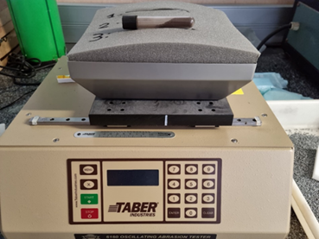 | 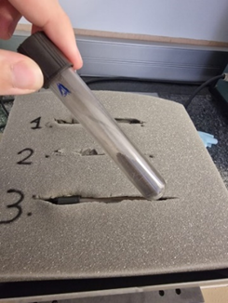
a) | b)
Figure 1. The adapted Taber oscillating abrasion tester used to evaluate the effect of abrasion due to the interactions between the particles a). Test tube containing coated Gen3 particles after 100 abrasion test cycles b).

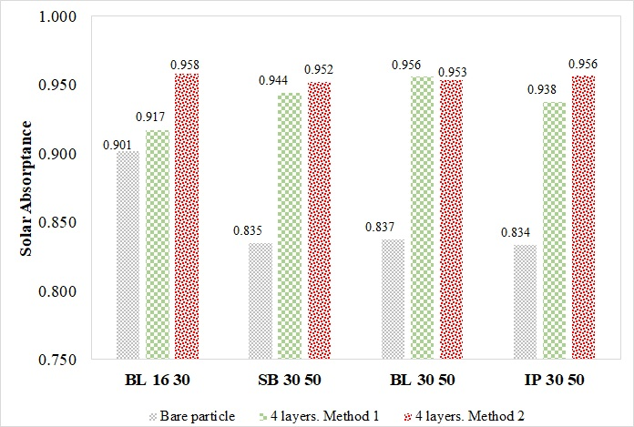
Figure 2. Effect of Sol B curing on the αs values for the porous S.O.A. particles.

Figure 3. Hemispherical reflectance specta and solar-weighted hemispherical absorptance (α_{s}) of three random groups of coated particles taken from the same batch of 3 kg. Good reproducibility and uniformity of coating deposition in the particles.

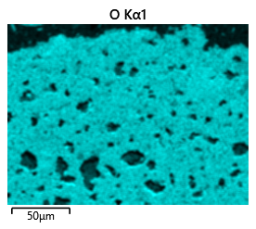 | 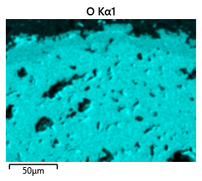 | 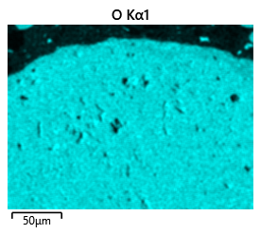
a) | b) | c)
Figure 4. SEM/EDS mapping of oxygen (O) for Sol B_coated BL 16/30 proppant a), Sol A_coated Gen 3 particles b) and Sol B_coated Gen 3 particles c).

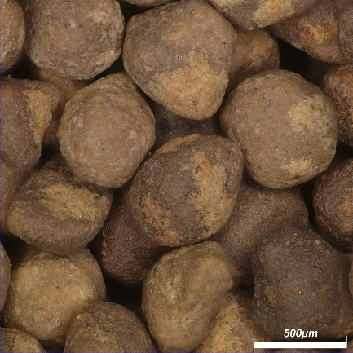 | 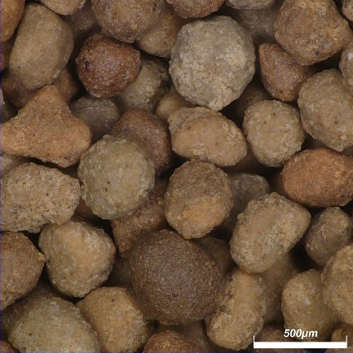
Sintered Bauxite SB 30/50 | InterProp IP 30/50
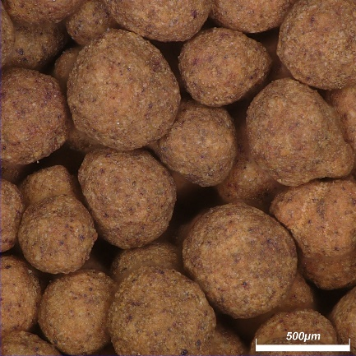 | 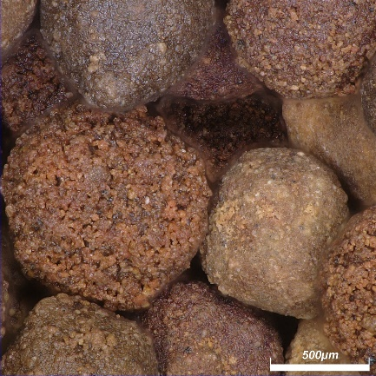
BauxLite BL 30/50 | BauxLite BL 16/30
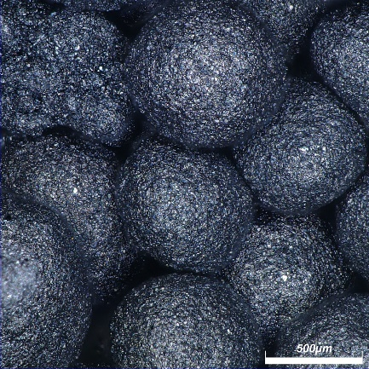
Granulated Gen 3
Figure 5. Photographs of the particles in higher magnification.

