**Supplementary material**

**Acute and Chronic Risk Assessment of BTEX in the Return Water of Hydraulic Fracturing Operations in Marcellus Shale**

Lanting Maa,b, Antonio Hurtadoc, Sonsoles Eguilior c,[1], Juan F. Llamas Borrajod

a State Key Laboratory of Petroleum Pollution Control, Xi’an Shiyou University, Xi’an, China; Malanting2020@xsyu.edu.cn

b Shaanxi Province Key Laboratory of Environmental Pollution Control and Reservoir Protection Technology of Oilfields, Xi’an Shiyou University, Xi’an, China; Malanting2020@xsyu.edu.cn

c Centro de Investigaciones Energéticas, Medioambientales y Tecnológicas - Avda. Complutense 40, Edif. 20, 28040 Madrid, Spain. antonio.hurtado@ciemat.es; sonsoles.eguilior@ciemat.es

d Escuela Técnica Superior de Ingenieros de Minas y Energía de Madrid - Calle de Ríos Rosas 21, 28003 Madrid, Spain. juan.llamas@upm.es

Index

S.1 Modelling the concentration in the unsaturated zone. 2

S.1.1 Flowback concentration 2

S.1.2 Vertical transport model 4

S.1.3 Atmospheric concentration 7

S.1.4 Concentration on the soil surface 10

S.1.5 Concentration in groundwater 10

S.2 Input parameters for the Monte Carlo simulation 12

S.3 Concentration of BTEX 14

S.4 BTEX Toxicity Factors 16

S.5 Sensitivity analysis 17

S.6 Acute risk assessment 30

S.6.1 Acute dermal exposure risks. 30

Reference 32

## Modelling the concentration in the unsaturated zone.

### Flowback concentration

The BTEX concentrations in the return water for well F are shown in Table S1 and the average concentration for horizontal wells C, D, E, G, K and M in the Hayes report is shown in Table S2.

Table S1: Concentrations of BTEX (ppm) in flowback water from Well F (Hayes, 2009) after the operation.

|  |  |  |  |  |
| --- | --- | --- | --- | --- |
| Time (Days) | Benzene | Ethylbenzene | Toluene | Xylenes (total) |
| 1 | 0.280 | 0.0076 | 0.300 | 0.120 |
| 5 | 0.880 | 0.029 | 0.920 | 0.340 |
| 14 | 0.400 | 0.023 | 0.540 | 0.280 |
| 90 | 0.290 | 0.270 | 1.600 | 3.300 |

Table S2: Mean Benzene concentration (ppm) from horizontal well (Locations C, D, E, G, K and M in the Hayes report)

|  |  |  |
| --- | --- | --- |
| Time (Days) | Benzene | TEX |
| 1 | 0.042 | 0.063 |
| 5 | 0.128 | 0.189 |
| 14 | 0.071 | 0.146 |
| 90 | 0.072 | 1.29 |

On the basis of this information, we can determine the evolution of BTEX concentrations in the storage pond and the effects of possible leakage. The trend in concentrations can be described by the two-compartment First Order Rate Constant (TFRC) kinetic model developed in (Ma et al., 2018). In this model, initial fast release (fast desorption described by *kfast*) takes place during the first few days after fracturing and it is associated with the flowback phase. This is then followed by a slower stage (slow desorption described by *kslow*) associated with produced water that can last for months or years.

The concentration of each BTEX compound in the flowback phase (fast desorption) are given by the equation (S.1) and the parameters of the equation (*C0_fast*, *v/Rd* and *kfast*) are obtained by fitting the experimental values for Well F. The values obtained from the adjustment are shown in Table S3.

|  |  |
| --- | --- |
| $$C_{fast}(t)=\frac{1}{2}·C_{0_{fast}}⋅\text{erfc}\left[\frac{4}{\sqrt{(v/{R_{d}})⋅t}}-1\text{.34}\sqrt{(v/{R_{d}})⋅t}\right]×\text{exp}(-k_{\text{fast}}⋅t)$$ | (S.1) |

where *Cfast(t)* is the concentration of a contaminant at time t in the flowback water [Mass·Length-3], *C*0*fast*, is the initial concentration of a chemical in the shale formation that is available for fast desorption [Mass·Length-3], *v* is the average groundwater velocity in the flow direction [Length·time-1], *Rd* is the retention factor, *t* is time [Time], *x* is the spatial coordinate [Length], and *kfast* is the first-order rate constant describing the chemical release rates for the "fast" desorption stages [time-1].

Table S3: Results of the fit with the experimental data of Well **F.**

|  |  |  |  |  |
| --- | --- | --- | --- | --- |
|  | Benzene | Ethylbenzene | Toluene | Xylenes (total) |
| *C0_fast* /2(ppm) | 1.36 | 0.033 | 1.24 | 0.38 |
| *v/Rd* (m/d) | 2.37 | 2.40 | 2.45 | 2.60 |
| *kfast* (d-1) | 0.088 | 0.026 | 0.059 | 0.021 |

The slow desorption phase is described by Equation (S.2). Since the number of experimental data available to estimate the parameters associated with slow desorption was insufficient, we used a value for *kslow* based on representative equations (Ma et al., 2018; Birdwell et al., 2007).

|  |  |
| --- | --- |
| $$\frac{C_{slow}(t)}{C_{0_{slow}}}=\frac{1}{2}⋅erfc\left[\frac{4}{\sqrt{(v/{R_{d}})·t}}-1.34\sqrt{(v/{R_{d}})·t}\right]·exp(-k_{slow}⋅t)$$ | (S.2) |

where *C*0*slow* is the initial concentration of a chemical in the shale formation that is available for slow desorption and it acts as a scaling factor. It can be determined in some cases by using the experimental concentration at day 90, depending on the ratios between *kslow* and *kfast* (Ma et al., 2018).

Thus, the concentration of BTEX in the storage tank can be estimated from these expressions, as can the evolution of the return water volumes (*Vf (t)*). These are obtained through an empirical expression fitted with the return volume data at different times (1, 5, 14, and 90 days), available in Hayes (Ma, 2018).

A representative example of the time evolution of benzene concentration in storage tanks, obtained from the models and Hayes’ experimental data, is given in Figure S1.

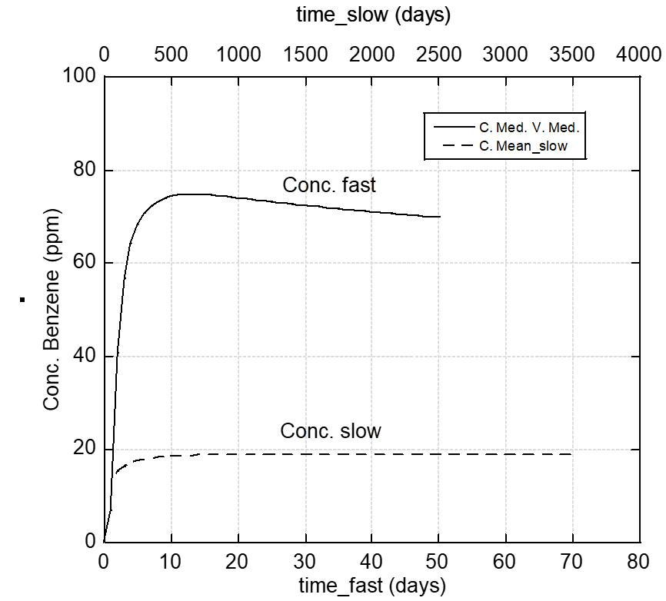

Figure S1: Benzene concentration in the storage pond associated with fast and slow desorption (Conc. Fast and Conc. Slow respectively).

### Vertical transport model

The one-dimensional governing equation can be expressed by expression (S.3):

$D\frac{∂^{2}C}{∂z^{2}}-V\frac{∂C}{∂z}-λC=\frac{∂C}{∂t}$ (S.3)

where *z* is the vertical coordinate taken positive down, *t* is time, *λ* is the decay constant, and *C* is the total concentration, defined as the total amount of chemicals in liquid, gas, and solid phases per unit of soil.

Combining this expression (S.3) with the relationships between variables and parameters associated with the liquid and gaseous phases and establishing the initial and boundary conditions of the problem allows an analytical solution [Shan and Stephens, 1995]. A summary of these relationships and conditions is given below.

The liquid concentration *CL* and the gas concentration *CG*, are related to the total concentration *C* by:

$R_{L}C_{L}=R_{G}C_{G}=C$ (S.4)

The parameters *V* and *D* in equation (S.1) can be defined as the average pore velocity and the dispersion coefficient by the following equations:

$V=\frac{v_{L}}{R_{L}}+\frac{v_{G}}{R_{G}}$ (S.5)

$D=\frac{D_{L}}{R_{L}}+\frac{D_{G}}{R_{G}}$ (S.6)

$D_{L}=α_{L}v_{L}+D_{LM}\begin{matrix} & and\begin{matrix} & \end{matrix}\end{matrix}D_{LM}=\frac{θ^{10/3}}{φ^{2}}D_{w}$ (S.7)

$D_{G}=α_{G}v_{G}+D_{GM}\begin{matrix} & and\begin{matrix} & \end{matrix}\end{matrix}D_{GM}=\frac{(φ-θ)^{10/3}}{φ^{2}}D_{a}$ (S.8)

In addition, the two coefficients *RL* (liquid retention) and *RG* (gaseous retention) can be calculated as follows:

$R_{L}=ρ_{b}⋅K_{SL}+θ+(φ-θ)K_{H}+ρ_{b}K_{H}K_{SG}$ (S.9)

$R_{G}=\frac{R_{L}}{K_{H}}=ρ_{b}\frac{K_{SL}}{K_{H}}+\frac{θ}{K_{H}}+(φ-θ)+ρ_{b}K_{SG}$ (S.10)

$K_{SL}=K_{oc}f_{oc}$ (S.11)

where *vL* and *vG* are the Darcy velocities of the liquid and gas phases, respectively, considered here under steady-state conditions, *DL* and *DG* are the dispersion coefficients in the liquid and gas phases, respectively, *αL* and *αG* are the dispersion coefficients in the liquid and gas phases, respectively, and *Dw* and *Da* are the chemical diffusion coefficients in water and air, respectively. *θ* is the water volumetric constant, *ϕ* is the porosity, *ρb* is the bulk density, *KH* is the Henry’s constant, *KSL* and *KSG* are the solid-liquid and the solid-gas partition coefficients, respectively, *Koc* is the partition coefficient, and *foc* is the fraction of organic carbon. The parameter *KSG* is a function of the water content and is assigned a value of *2·KSL*.

Finally, the initial and boundary conditions are as follows:

$$C\left(z,0\right)= C_{i}$$

with

$\begin{matrix}C_{i}=0 \left(0≤z≤d_{1} and d_{2} ≤z ≤ d_{3}\right) \\ C_{i}=C_{0} \left(d_{1} ≤z ≤ d_{2}\right) \end{matrix}$ (S.12)

and

$$C\left(0,t\right)=0; {\left(\frac{∂C}{∂t}\right)}_{z=d_{3}}=0$$

where *C0* is the initial concentration in the liquid, and *d1*, *d2*, and *d3* (0 ≤ d1 ≤ d2≤ d3 < ∞) represent the depths to the top and bottom of the tank, and to the aquifer, respectively.

Therefore, the analytical solution obtained by Shan and Stephens [Shan and Stephens, 1995] for the different depth intervals is expressed in the following way:

$C_{1}(z,t)=\sum_{n=1}^{8}{(-1)^{n}f_{1}(t,α_{n},β_{n}^{(0)}})+\sum_{n=1}^{8}{C^{(m)}}(0≤z≤d_{1})$ (S.13)

$C_{2}(z,t)=C_{0}e^{-λt}+\sum_{n=1}^{7}{(-1)^{n}f_{1}(t,α_{n},β_{n}^{(0)}})-f_{2}(t,α_{8},β_{8}^{(0)})+\sum_{m=1}^{∞}{C^{(m)}}(d_{1}≤z≤d_{2})$ (S.14)

$C_{3}(z,t)=\sum_{n=1}^{6}{(-1)^{n}f_{1}(t,α_{n},β_{n}^{(0)}})+f_{2}(t,α_{7},β_{7}^{(0)})-f_{2}(t,α_{8},β_{8}^{(0)})+\sum_{m=1}^{∞}{C^{(m)}}(d_{2}≤z≤d_{3})$ (S.15)

With:

$f_{1}(t,α_{n},β_{n}^{(0)})=\frac{C_{0}}{2}\exp{(}α_{n}+\frac{Vβ_{n}^{(0)}}{2\sqrt{D}}-λt)⋅erfc(\frac{V\sqrt{t}}{2\sqrt{D}}+\frac{β_{n}^{(0)}}{2\sqrt{t}})$ (S.16)

$f_{2}(t,α_{n},β_{n}^{(0)})=\frac{C_{0}}{2}\exp{(}α_{n}+\frac{Vβ_{n}^{(0)}}{2\sqrt{D}}-λt)⋅erfc(-\frac{V\sqrt{t}}{2\sqrt{D}}-\frac{β_{n}^{(0)}}{2\sqrt{t}})$ (S.17)

$α_{1}=V(z-d_{2})/(2D)β_{1}^{(m)}=[2(m+1)d_{3}-d_{2}+z]/\sqrt{D}$ (S.18)

$α_{2}=V(z-d_{1})/(2D)β_{2}^{(m)}=[2(m+1)d_{3}-d_{1}+z]/\sqrt{D}$ (S.19)

$α_{3}=α_{2},\begin{matrix} & β_{3}^{(m)}=[2(m+1)d_{3}-d_{1}-z]/\sqrt{D}\end{matrix}$ (S.20)

$α_{4}=α_{1},\begin{matrix} & β_{4}^{(m)}=[2(m+1)d_{3}-d_{2}-z]/\sqrt{D}\end{matrix}$ (S.21)

$α_{5}=α_{2},\begin{matrix} & β_{5}^{(m)}=[2md_{3}+d_{1}+z]/\sqrt{D}\end{matrix}$ (S.22)

$α_{6}=α_{1},\begin{matrix} & β_{6}^{(m)}=[2md_{3}+d_{2}+z]/\sqrt{D}\end{matrix}$ (S.23)

$α_{7}=α_{1},\begin{matrix} & β_{7}^{(m)}=[2md_{3}+d_{2}-z]/\sqrt{D}\end{matrix}$ (S.24)

$α_{8}=α_{2},\begin{matrix} & β_{8}^{(m)}=[2md_{3}+d_{1}-z]/\sqrt{D}\end{matrix}$ (S.25)

$C^{(m)}=\frac{2C_{0}}{π\sqrt{D}}\exp{[}-(λ+\frac{V^{2}}{4D})t]⋅l$ (S.26)

$I=\int_{0}^{∞}{\frac{e^{-ut}}{γ\sqrt{u}}\sin{(}z\sqrt{u/D})\cos{[}(2m+1)(δ+d_{3}\sqrt{u/D})]×\{e^{α_{1}}\sin{[}(d_{3}-d_{2})\sqrt{u/D}]-e^{α_{2}}\sin{[}(d_{3}-d_{1})\sqrt{u/D}]\}⋅du}$ (S.27)

$γ=\frac{\sqrt{V^{2}+4Du}}{2D}$ (S.28)

$δ=\tan^{-1}{(}2\sqrt{Du}/V)$ (S.29)

$\int_{0}^{t}{C^{(m)}⋅dt}=\frac{2C_{0}}{π\sqrt{D}}\int_{0}^{∞}{\frac{1-\exp{[}-(u+λ+V^{2}/4D)t]}{γ\sqrt{u}⋅(u+λ+V^{2}/4D)t}}×\sin{(}d_{3}\sqrt{u/D})×\cos{[}(2m+1)(δ+d_{3}\sqrt{u/D})]×\{\exp{[}V(d_{3}-d_{2})/2D]×\sin{[}(d_{3}-d_{2})\sqrt{u/D}-\exp{[}V(d_{3}-d_{1})/2D]×\sin{[}(d_{3}-d_{1})\sqrt{u/D}]\}du$ (S.30)

$\int_{0}^{t}{(\frac{∂C_{1}}{∂z})_{z=0}}⋅dt=\frac{2C_{0}}{π\sqrt{D}}\sum_{m=0}^{∞}{\int_{0}^{∞}{\frac{1-\exp{[}-(u+λ+V^{2}/4D)t]}{γ(u+λ+V^{2}/4D)t}}×\cos{[}(2m+1)(δ+d_{3}\sqrt{u/D})]×\{\exp{[}-Vd_{2}/2D]]×\sin{[}(d_{3}-d_{2})⋅\sqrt{u/D}-\exp{[}Vd_{1}/2D]⋅\sin{[}(d_{3}-d_{1})⋅\sqrt{u/D}]\}⋅du}$ (S.31)

### Atmospheric concentration

The transport of VOCs from the unsaturated zone to the atmosphere is the result of a number of processes (Waitz et al., 1996):

(1) Evaporation flux from the unsaturated zone to the soil surface. The analytical solution obtained by Shan and Stephens (Shan and Stephens, 1995) in the depth range of interest for this process is represented by the following equation:

$C_{1}(z,t)=\sum_{n=1}^{8}{(-1)^{n}f_{1}(t,α_{n},β_{n}^{\left(0\right)}})+\sum_{n=1}^{8}{C^{\left(m\right)}}(z=0)$ (S.32)

where the function *f1* is given in section ‎S.1.

On the basis of this solution, the model allows the calculation of the flux of the pollutants entering the atmosphere. This flux (*FA*) can be obtained directly from the previous solutions at the unsaturated zone-atmosphere boundary (z=0) and is expressed as:

$F_{A}=-\frac{D_{G}}{R_{G}}{\left(\frac{∂C_{1}}{∂z}\right)}_{z=0}$ (S.33)

(2) Boundary flux. The majority of the BTEX molecules that cross the soil-atmosphere interface will be vaporised into the atmosphere by diffusive transport mechanisms. In this zone, according to the atmospheric boundary layer theory, the flux has a relative velocity of zero at the surface (Schlichting, 1955), so the air in this layer can be considered to be almost stationary (Waitz et al., 1996). Therefore, BTEX is transferred to adjacent layers by molecular diffusion (Waitz et al., 1996). The thickness of the boundary layer is a function of the concentration gradient. The thickness h of the viscous layer is assumed to be 0.01 m (Jiang et al., 2012). The process is described by Fick's law and is shown below:

$Flux=D_{air}×(C_{A}-C_{a})/h$ (S.34)

where *Flux* (mg/(m2·s)) is the BTEX diffusion flux , *CA* (ppm) is the chemical concentration at the vadose zone surface (z=0), *Ca* (ppm) is the chemical concentration in the mixed atmosphere, *h* (m) is the boundary layer thickness, and *Dair* (m2/s) is the gas-phase chemical diffusion coefficient .

(3) Flux to atmosphere. When BTEX are in the atmosphere, they mix and move with the wind (ASTM, 2015). Dilution of BTEX in the atmosphere is calculated under the assumption of horizontal and vertical mixing for an inexhaustible source. Dilution depends on wind speed and mixing height, which depend on atmospheric dispersion and stability (Waitz et al., 1996). The flux in the inhalation zone can be described by (Chen and Wu, 2007), assuming that BTEX are completely diluted in the inhalation zone, resulting in a constant concentration::

$Flux=(V_{air}×H)/W×C_{a}$ (S.35)

where *Vair* (m/s) is the wind velocity in the mixed atmosphere, *H* (m) is the vertical thickness of the mixed atmosphere as well as the inhalation height of the workers, and *W* (m) is the width of the source downwind.

Under steady-state conditions, the fluxes defined by equations S.32 and S.33 must be equal. Therefore, the inhalation concentration, *Ca*, can be expressed as follows (equation S.34). Table S4 gives the default parameters for calculating the inhalation concentrations.

|  |  |
| --- | --- |
| $$Flux=(V_{air}×H)/W×C_{a}=D_{air}×(C_{A}-C_{a})/h$$ | (S.36) |
| $$C_{a}=C_{A}×\frac{D_{air}×W}{V_{air}×H×d+D_{air}×W}$$ |

Table S4: Parameters used to calculate concentrations in the environment.

|  |  |  |  |  |  |
| --- | --- | --- | --- | --- | --- |
| **Parameter** | **Description** | **Organic chemicals** | | | |
| Benzene | Ethylbenzene | Toluene | Xylenes |
| Formula |  | C6H6 | C6H5CH3 | C6H5CH2CH3 | C6H4(CH3)2 |
| *koc*(cm3/g) | Soil-water partition coefficient | 97 | 622 | 242 | 570 |
| *KH* | Henry’s constant | 0.227 | 0.322 | 0.271 | 0.271 |
| *Dw*(cm2/day) | Water diffusion coefficient | 0.864 | 0.795 | 0.734 | 0.855 |
| *Da*(cm2/s) | Air diffusion coefficient | 0.088 | 0.075 | 0.087 | 0.07 |
| *S*(mg/L) | Solubility | 1780 | 150 | 500 | 150 |
| *ρb*(g/cm3) | Bulk density | LN [1.35, 0.8] | | | |
| *vL*(cm/day) | Liquid advection velocity | 0.01 0.1 1.0 | | | |
| *vG*(cm/day) | Gas advection velocity | 0 | | | |
| *ϕ*(cm3/cm3) | Porosity | LN [0.5, 0.05] | | | |
| *θ*(cm3/cm3) | Water content | LN [0.2, 0.05] | | | |
| *αL*(cm) | Liquid dispersity | 0 | | | |
| *αG*(cm) | Gas dispersity | 0 | | | |
| *λ*(d-1) | Decay rate | 0 | | | |
| *foc* | Fraction organic content | 0.0125 [ITRC, 2015] | | | |
| *KSG* | Solid-gas distribution | 2*KSL* | | | |
| *KSL* | Solid-liquid | *KSL=Kocfoc* | | | |
| *W*(m) | Width | LN [40,1] (ASTM, 2015) | | | |
| *Vair*(m/s) | Air velocity | LN [2, 1] (ASTM, 2015) | | | |
| *H* (m) | Breathing height | LN [1.7, 0.1] (US EPA 1996) | | | |
| *d* (m) | Height of retention layer | LN [0.01, 0.001] (ASTM, 2015) | | | |

### Concentration on the soil surface

Once a leakage has occurred, the evolution of the organic compounds present in the wastewater depends on their solubility and volatility. For BTEX, they are primarily adsorbed on the solid phase. This is due to the relatively high fraction organic content (*foc*) in the vadose zone. Soil surface exposure (depth to 0m) can occur by inhalation, ingestion and dermal contact. Therefore, in order to determine the risk posed to the environment and human health, it is essential to estimate the concentration of contaminants present at the soil surface after the evaporation phase.

The analytical solution obtained by Shan and Stephens (Shan and Stephens, 1995) for the evolution of the BTEX concentration profile in the unsaturated zone is represented by the following equation:

$C_{1}(z,t)=\sum_{n=1}^{8}{(-1)^{n}f_{1}(t,α_{n},β_{n}^{\left(0\right)}})+\sum_{n=1}^{8}{C^{\left(m\right)}}(0≤z≤0.5)$ (S.37)

$C_{2}(z,t)=C_{0}e^{-λt}+\sum_{n=1}^{7}{(-1)^{n}f_{1}(t,α_{n},β_{n}^{\left(0\right)}})-f_{2}(t,α_{8},β_{8}^{\left(0\right)})+\sum_{m=1}^{∞}{C^{\left(m\right)}}(0.5≤z≤1.5)$ (S.38)

$C_{3}(z,t)=\sum_{n=1}^{6}{(-1)^{n}f_{1}(t,α_{n},β_{n}^{\left(0\right)}})+f_{2}(t,α_{7},β_{7}^{\left(0\right)})-f_{2}(t,α_{8},β_{8}^{\left(0\right)})+\sum_{m=1}^{∞}{C^{\left(m\right)}}(1.5≤z≤10)$ (S.39)

where the function *f1* is given in section ‎S.1, *C1* is the evolution of the concentration in the unsaturated zone above the top of the discharge and up to the surface, *C2* is between the top and the bottom of the discharge and *C3* is between the bottom of the discharge and the water table.

### Concentration in groundwater

The model also allows the calculation of the BTEX flux through the water table to the groundwater (*FW*). This is obtained directly from the above solutions at the vadose groundwater interface (*z = zL*) and is expressed as:

$F_{W}=\frac{v_{L}}{R_{L}}{\left(C_{3}\right)}_{z=z_{L}}$ (S.40)

The integration of the above equation gives the amount of pollutant deposited in groundwater over time:

$M_{P}=\frac{v_{L}}{R_{L}}\int_{0}^{t}{(C_{3})_{z=d_{3}}}⋅dt$ (S.41)

## Input parameters for the Monte Carlo simulation

Table S5: Input parameters for the Monte-Carlo simulation.

|  |  |  |  |  |
| --- | --- | --- | --- | --- |
| Parameter | Distribution model and parameters | | | References |
| Chronic | | Acute |  |
| Adult | Child | Adult |  |
| Yearly exposure frequency (*EF* - d year-1) | TR [180, 345, 365] | TR [180, 345, 365] | LN [15, 3]  and/or 1 day | Smith, 1994 |
| Exposure duration (*ED* - year) | LN [30, 3] | LN [10,1.5] | 1 | Isreaeli and Nelson, 1992 |
| Average time (*AT* - year) | Non-cancer: exposure duration  Cancer: LN [70, 5] | Non-cancer: exposure duration  Cancer: LN [70, 5] |  | Isreaeli and Nelson, 1992 |
| Bodyweight (*BW* - kg) | LN [70, 7] | LN [20, 3] |  | Arija et al., 1996 |
| Exploration time (*ET* – h d-1) | LN [8, 1] | LN [8, 1] |  |  |
| Inhalation rate (*IR* - m3 h-1) | LN [0.833, 0.1] | LN [0.9, 0.09] |  | Liao and Chiang, 2006 |
| Ingestion rate (*IRd* - m3 d-1) | LN [0.001, 0.0001] |  |  |  |
| Ingestion rate (*IRS* - mg d-1) | LN [100, 5] | LN [200, 10] |  | US EPA, 2011  US EPA 2002 |
| Exposed skin surface area (*SA* – cm2) | Normal: LN  [1000, 200]  Bath:  LN [18600, 1000] | Normal: LN  [625, 100]  Bath:  LN [6600, 600] | Hand LN [491, 40] | US EPA 2007 |
| Dermal absorption factor (*ABS*) | Chemical specific |  |  | Liao and Chiang, 2006 |
| Units conversion factor (*CF* – kg mg-1) | 10-6 |  |  |  |
| Particle emission factor (*PEF –* m3 kg-1) | 1.36*109 |  |  | US EPA, 2002 |
| Fraction absorbed water (*FA -* dimensionless)  *FA* is 1 for most chemicals | Chemical specific |  |  | US EPA, 2004 |
| The dermal permeability coefficient of a compound in water (*Kp -*cm/h) | LN [0.0149, 0.002] |  |  | US EPA, 2004 |
| Event frequency (*EV* - event/d) | LN [5,1] | LN [5,1] |  |  |
| Event duration (*teven*t – h/event) | LN [8.3E-2, 8.3E-3] | LN [8.3E-2, 8.3E-3] |  | Durant et al. 2016 |
| Lag time per event (*τevent* – s/event) | LN [30, 5] |  |  | Durant et al. 2016 |
| Molecular weight (*MW* – g/mol) | Chemical specific |  |  |  |
| Apparent thickness of stratum corneum (*Isc* - cm) | 10E-3 |  |  | Durant et al. 2016 |
| Effective diffusion coefficient (*Dsc* – cm2/h) | Chemical specific |  |  |  |

LN: Lognormal; TR: Triangular

## Concentration of BTEX

Table S6: Atmospheric concentration of BTEX.

|  |  |  |  |  |  |  |  |  |  |  |  |  |
| --- | --- | --- | --- | --- | --- | --- | --- | --- | --- | --- | --- | --- |
| **Mean Concentration air inhalation (ppm)** | | | | | | | | | | | | |
|  | **Benzene** | | | **Ethylbenzene** | | | **Toluene** | | | **Xylenes (Total)** | | |
| **Leaking Days** | *VL*=0.01 cm/d | *VL* =0.1 cm/d | *VL*=0.01 cm/d | *VL* =0.1 cm/d | *VL* =1 cm/d | *VL* =1 cm/d | *VL*=0.01 cm/d | *VL* =0.1 cm/d | *VL* =1 cm/d | *VL*=0.01 cm/d | *VL* =0.1 cm/d | *VL* =1 cm/d |
| 10 | 0 | 0 | 0 | 0 | 0 | 0 | 0 | 0 | 0 | 0 | 0 | 0 |
| 100 | 5.64E-02 | 5.44E-03 | 2.45E-03 | 2.38E-03 | 1.86E-03 | 1.18E-04 | 2.45E-03 | 2.38E-03 | 1.86E-03 | 2.44E-03 | 2.36E-03 | 1.85E-03 |
| 1,000 | 1.56E-01 | 1.50E-01 | 1.48E-02 | 1.48E-02 | 9.65E-03 | 6.12E-04 | 1.48E-02 | 1.48E-02 | 9.65E-03 | 1.48E-02 | 1.48E-02 | 9.60E-03 |
| 10,000 | 2.04E-01 | 1.97E-01 | 2.45E-02 | 2.38E-02 | 1.34E-02 | 8.48E-04 | 2.45E-02 | 2.38E-02 | 1.34E-02 | 2.44E-02 | 2.36E-02 | 1.33E-02 |
| **1 sigma Concentration air inhalation (ppm)** | | | | | | | | | | | | |
|  | **Benzene** | | | **Ethylbenzene** | | | **Toluene** | | | **Xylenes (Total)** | | |
| **Leaking Days** | *VL*=0.01 cm/d | *VL* =0.1 cm/d | *VL* =1 cm/d | *VL*=0.01 cm/d | *VL* =0.1 cm/d | *VL* =1 cm/d | *VL*=0.01 cm/d | *VL* =0.1 cm/d | *VL* =1 cm/d | *VL*=0.01 cm/d | *VL* =0.1 cm/d | *VL* =1 cm/d |
| 10 | 0 | 0 | 0 | 0 | 0 | 0 | 0 | 0 | 0 | 0 | 0 | 0 |
| 100 | 9.02E-02 | 8.70E-03 | 6.53E-02 | 2.48E-04 | 2.42E-04 | 1.89E-04 | 3.92E-03 | 3.81E-03 | 2.98E-03 | 3.90E-03 | 3.78E-03 | 2.96E-03 |
| 1,000 | 2.50E-01 | 2.40E-01 | 1.63E-01 | 1.51E-03 | 1.51E-03 | 9.79E-04 | 2.37E-02 | 2.37E-02 | 1.54E-02 | 2.37E-02 | 2.37E-02 | 1.54E-02 |
| 10,000 | 3.26E-01 | 3.15E-01 | 1.74E-01 | 2.48E-03 | 2.42E-03 | 1.36E-03 | 3.92E-02 | 3.81E-02 | 2.14E-02 | 3.90E-02 | 3.78E-02 | 2.13E-02 |

Table S7: BTEX concentration in surface soil.

|  |  |  |  |  |  |  |  |  |  |  |  |  |
| --- | --- | --- | --- | --- | --- | --- | --- | --- | --- | --- | --- | --- |
| **Mean Concentration surface soil (ppm)** | | | | | | | | | | | | |
|  | **Benzene** | | | **Ethylbenzene** | | | **Toluene** | | | **Xylenes (Total)** | | |
| **Leaking Days** | *VL*=0.01 cm/d | *VL* =0.1 cm/d | *VL*=0.01 cm/d | *VL* =0.1 cm/d | *VL* =1 cm/d | *VL* =1 cm/d | *VL*=0.01 cm/d | *VL* =0.1 cm/d | *VL* =1 cm/d | *VL*=0.01 cm/d | *VL* =0.1 cm/d | *VL* =1 cm/d |
| 10 | 2.85E-02 | 2.79E-02 | 2.31E-02 | 2.40E-05 | 2.09E-05 | 1.98E-05 | 3.79E-04 | 3.59E-04 | 3.12E-04 | 3.76E-04 | 3.57E-04 | 3.10E-04 |
| 100 | 3.53E-02 | 3.40E-02 | 2.38E-02 | 4.71E-04 | 3.62E-04 | 3.58E-04 | 7.42E-03 | 7.33E-03 | 5.64E-03 | 7.38E-03 | 7.29E-03 | 5.61E-03 |
| 1,000 | 2.38E-03 | 2.24E-03 | 1.02E-03 | 8.48E-05 | 5.65E-05 | 4.71E-05 | 1.34E-03 | 1.11E-03 | 7.42E-04 | 1.33E-03 | 1.11E-03 | 7.38E-04 |
| 10,000 | 1.36E-04 | 6.80E-05 | 6.80E-05 | 3.30E-06 | 6.60E-07 | 4.71E-07 | 5.20E-05 | 3.71E-05 | 7.42E-06 | 5.17E-05 | 3.69E-05 | 7.38E-06 |
| **1 sigma Concentration surface soil (ppm)** | | | | | | | | | | | | |
|  | **Benzene** | | | **Ethylbenzene** | | | **Toluene** | | | **Xylenes (Total)** | | |
| **Leaking Days** | *VL*=0.01 cm/d | *VL* =0.1 cm/d | *VL* =1 cm/d | *VL*=0.01 cm/d | *VL* =0.1 cm/d | *VL* =1 cm/d | *VL*=0.01 cm/d | *VL* =0.1 cm/d | *VL* =1 cm/d | *VL*=0.01 cm/d | *VL* =0.1 cm/d | *VL* =1 cm/d |
| 10 | 4.56E-02 | 4.46E-02 | 3.70E-02 | 3.84E-05 | 3.34E-05 | 3.17E-05 | 6.06E-04 | 5.74E-04 | 4.99E-04 | 6.02E-04 | 5.71E-04 | 4.96E-04 |
| 100 | 5.65E-02 | 5.44E-02 | 3.81E-02 | 7.54E-04 | 5.79E-04 | 5.73E-04 | 1.19E-02 | 1.17E-02 | 9.02E-03 | 1.18E-02 | 1.17E-02 | 8.98E-03 |
| 1,000 | 3.81E-03 | 3.58E-03 | 1.63E-03 | 1.36E-04 | 9.04E-05 | 7.54E-05 | 2.14E-03 | 1.78E-03 | 1.19E-03 | 2.13E-03 | 1.78E-03 | 1.18E-03 |
| 10,000 | 2.18E-04 | 1.09E-04 | 1.09E-04 | 5.28E-06 | 1.06E-06 | 7.54E-07 | 8.32E-05 | 5.94E-05 | 1.19E-05 | 8.27E-05 | 5.90E-05 | 1.18E-05 |

Table S8: Aquifer BTEX concentration.

|  |  |  |  |  |  |  |  |  |  |  |  |  |
| --- | --- | --- | --- | --- | --- | --- | --- | --- | --- | --- | --- | --- |
| **Mean Concentration surface soil (ppm)** | | | | | | | | | | | | |
|  | **Benzene** | | | **Ethylbenzene** | | | **Toluene** | | | **Xylenes (Total)** | | |
| **Leaking Days** | *VL*=0.01 cm/d | *VL* =0.1 cm/d | *VL*=0.01 cm/d | *VL* =0.1 cm/d | *VL* =1 cm/d | *VL* =1 cm/d | *VL*=0.01 cm/d | *VL* =0.1 cm/d | *VL* =1 cm/d | *VL*=0.01 cm/d | *VL* =0.1 cm/d | *VL* =1 cm/d |
| 10 | 0 | 0 | 0 | 0.00E+00 | 0.00E+00 | 0.00E+00 | 0.00E+00 | 0.00E+00 | 0.00E+00 | 0.00E+00 | 0.00E+00 | 0.00E+00 |
| 100 | 1.30E-27 | 1.75E-27 | 3.27E-26 | 1.89E-71 | 2.63E-71 | 6.88E-70 | 7.67E-70 | 1.06E-69 | 2.79E-68 | 3.24E-70 | 4.50E-70 | 1.18E-68 |
| 1,000 | 4.67E-06 | 6.19E-06 | 6.81E-05 | 1.43E-11 | 1.98E-11 | 4.27E-10 | 5.79E-10 | 8.02E-10 | 1.73E-08 | 2.44E-10 | 3.39E-10 | 7.30E-09 |
| 10,000 | 8.74E-05 | 9.12E-05 | 3.56E-06 | 6.96E-06 | 8.81E-06 | 1.63E-05 | 2.82E-04 | 3.57E-04 | 6.59E-04 | 1.19E-04 | 1.51E-04 | 2.78E-04 |
| **1 sigma Concentration surface soil (ppm)** | | | | | | | | | | | | |
|  | **Benzene** | | | **Ethylbenzene** | | | **Toluene** | | | **Xylenes (Total)** | | |
| **Leaking Days** | *VL*=0.01 cm/d | *VL* =0.1 cm/d | *VL* =1 cm/d | *VL*=0.01 cm/d | *VL* =0.1 cm/d | *VL* =1 cm/d | *VL*=0.01 cm/d | *VL* =0.1 cm/d | *VL* =1 cm/d | *VL*=0.01 cm/d | *VL* =0.1 cm/d | *VL* =1 cm/d |
| 10 | 0 | 0 | 0 | 0.00E+00 | 0.00E+00 | 0.00E+00 | 0.00E+00 | 0.00E+00 | 0.00E+00 | 0.00E+00 | 0.00E+00 | 0.00E+00 |
| 100 | 2.50E-27 | 3.37E-27 | 6.28E-26 | 3.18E-71 | 4.42E-71 | 1.16E-69 | 1.29E-69 | 1.78E-69 | 4.69E-68 | 5.44E-70 | 7.56E-70 | 1.98E-68 |
| 1,000 | 8.98E-06 | 1.19E-05 | 1.31E-04 | 2.40E-11 | 3.33E-11 | 7.17E-10 | 9.73E-10 | 1.35E-09 | 2.91E-08 | 4.10E-10 | 5.70E-10 | 1.23E-08 |
| 10,000 | 1.68E-04 | 1.75E-04 | 6.84E-06 | 1.17E-05 | 1.48E-05 | 2.74E-05 | 4.74E-04 | 6.00E-04 | 1.11E-03 | 2.00E-04 | 2.54E-04 | 4.67E-04 |

## BTEX Toxicity Factors

Table S9: *RfD*, *RfC*, and *SF* values for BTEX compounds (https://rais.ornl.gov/tools/metadata.php).

|  |  |  |  |  |
| --- | --- | --- | --- | --- |
| Organic compounds | Chronic Reference Dose (*RfD*) (mg/kg-day) Oral exposure | Chronic Reference Concentration (*RfC*) (mg/m3) Inhalation | Slope Factor (*SF*) (mg/kg-day)  Oral exposure | Slope Factor (*SF*) (mg/kg-day) Inhalation |
| Benzene | 0.004 | 0.03 | 0.055 | 0.027 |
| Ethylbenzene | 0.1 | 1 | NA | NA |
| Toluene | 0.08 | 5 | NA | NA |
| Xylenes | 0.2 | 0.1 | NA | NA |

## Sensitivity analysis

Table S10: Sensitivity analysis for the assessment of the chronic risk of benzene (carcinogenic and non-carcinogenic). Results for 10 000 days post leakage for all exposure pathways (adult and child receptors). Precipitation rate considered was 0.1cm/d (semiarid scenario).

|  |  |  |
| --- | --- | --- |
| **Non-cancer** | | |
| Exposure pathway | Adult | Child |
| Air inhalation |  |  |
| Soil inhalation |  |  |
| Soil ingestion |  |  |
| Soil dermal |  |  |
| Water dermal |  |  |
| Water ingestion |  |  |

|  |  |  |
| --- | --- | --- |
| **Cancer** | | |
| Exposure pathway | Adult | Child |
| Air inhalation |  |  |
| Soil inhalation |  |  |
| Soil ingestion |  |  |
| Soil dermal |  |  |
| Water dermal |  |  |
| Water ingestion |  |  |

*Cs* – surface soil concentration (ppm); *Cair-inhalation* – inhaled air concentration (ppm); *Cw* – water concentration (ppm); *Isoil-inhalation* –soil particle intake by inhalation, mg/kg-day-1; *Isoil-dermal* – dermally absorbed soil particle, mg/kg-day-1; *Isoil-ingestion* –soil particle intake by ingestion, mg/kg-day-1; *Iair-inhalation* – inhalation of air contamination, mg/kg-day-1;*Iwater-dermal* – dermally absorbed water, mg/kg-day-1; and *Iwater-ingestion* – water ingestion, mg/kg-day-1. Yearly exposure frequency (*EF* - d year-1); Exposure duration (*ED* - year); Average time (*AT* - year); Bodyweight (*BW* - kg); Exploration time (*ET* – h d-1); Inhalation rate (*IR* - m3 h-1); Ingestion rate (*IRd* - m3 d-1); Ingestion rate (*IRS* - mg d-1); Exposed skin surface area (*SA* – cm2); Dermal absorption factor (*ABS*); Units conversion factor (*CF* – kg mg-1); Particle emission factor (*PEF –* m3 kg-1); Fraction absorbed water (*FA -* dimensionless); The dermal permeability coefficient of a compound in water (*Kp -*cm/h); Event frequency (*EV* - event/d); Event duration (*teven*t – h/event); Lag time per event (*τevent* – s/event); Molecular weight (*MW* – g/mol); Apparent thickness of stratum corneum (*Isc* - cm); Effective diffusion coefficient (*Dsc* – cm2/h).

## Acute risk assessment

Table S11 shows the concentration of BTEX in air used for the acute risk calculation. These values are calculated from the well F data for the different sampling days at Hayes (Hayes, 2009) and are shown in Table S1.

Table S11: Concentration of BTEX in the atmosphere (ppm)

|  |  |  |  |  |
| --- | --- | --- | --- | --- |
| Time (Days) | Benzene | Ethylbenzene | Toluene | Xylenes (Total) |
| 1 | 0.064 | 0.002 | 0.081 | 0.033 |
| 5 | 0.200 | 0.009 | 0.249 | 0.092 |
| 14 | 0.091 | 0.007 | 0.146 | 0.076 |
| 90 | 0.066 | 0.087 | 0.434 | 0.894 |

### Acute dermal exposure risks.

The acute risks, both carcinogenic and non-carcinogenic, for the dermal route of exposure to BTEX in reflux water are presented in Figure S2 and Figure S3.

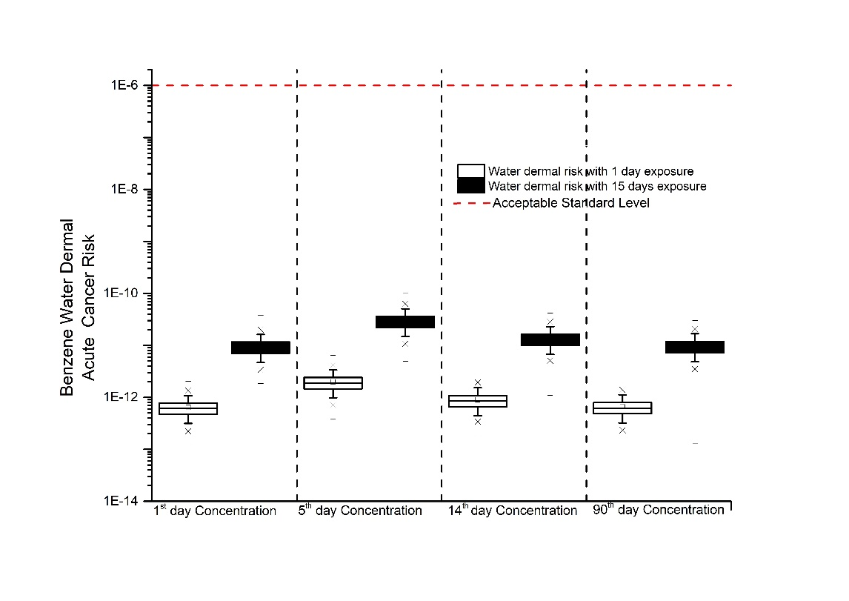

Figure S2: Estimated acute cancer risk from benzene in dermal contact with water. The white and black boxes indicate the cancer risk for 1 and 15 days of exposure, respectively. The red dashed line is the standard acceptable level.

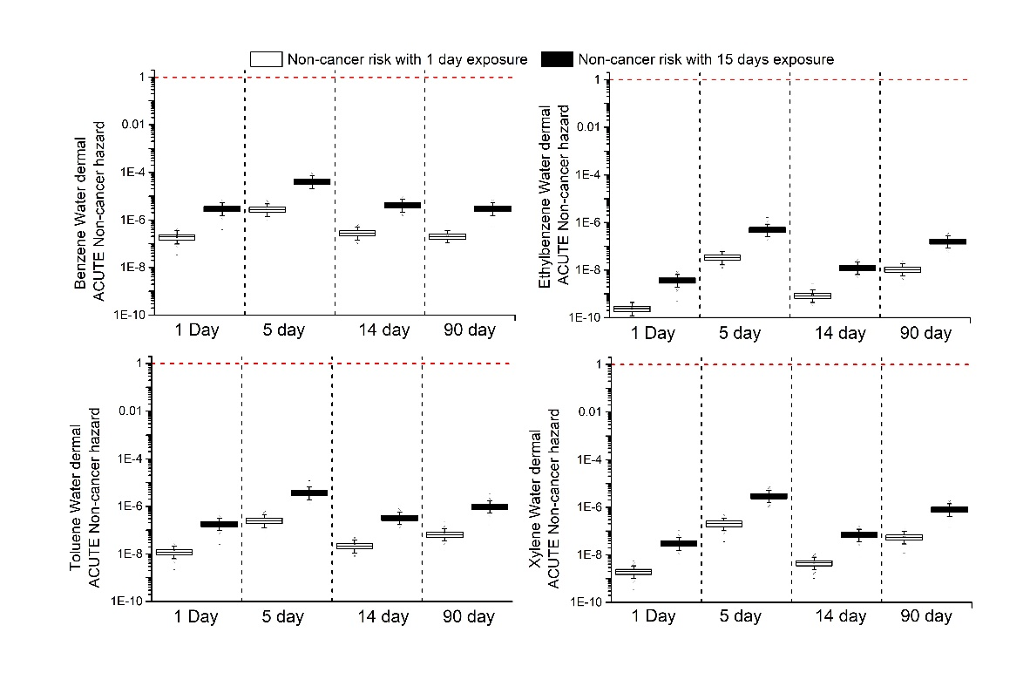

Figure S3: Estimated acute hazard ratios of non-carcinogenic BTEX with the form of dermal exposure to water. The grey and black boxes indicate 1 and 15 days of exposure, respectively. The red dashed line is the standard acceptable level.

# Reference

Arija V, Salas Salvadó J, Fernández-Ballart J, Cucó G, Martí-Henneberg C. 1996 Consumption, dietary habits and nutritional status of the Reus (IX) population. Evolution of food consumption, energy and nutrient intake and relationship with the socioeconomic and cultural level, 1983-1993. Medicina Clinica. 1996 Feb;106(5):174-179. PMID: 8684016.

ASTM, Standard Guide for Risk-Based Corrective Action, 2015. http://www.astm.org/cgi-bin/resolver.cgi?E1739-95(2015)

Birdwell J, Cook RL, Thibodeaux LJ. (2007). “Desorption Kinetics of Hydrophobic Organic Chemicals from Sediment to Water: A Review of Data and Models.” Environ Toxicol Chem. 2007 Mar;26(3):424-34. PMID: 17373505. https://doi.org/10.1897/06-104R.1

Chen, L. and Wu, X. 2007. Assessment Model for Volatilization by Organic Compounds in Groundwater. Environmental Chemistry-Beijing-, 2007, vol. 26, no 6, p. 810.

Durant, B.; Abualfaraj, N.; Olson, M. S.; Gurian, P. L. 2016. Assessing dermal exposure risk to workers from flowback water during shale gas hydraulic fracturing activity. Journal of Natural Gas Science and Engineering, v. 34, p. 969–978, doi:10.1016/j.jngse.2016.07.051.

Hayes T. (2009). Sampling and Analysis of Water Streams Associated with the Development of Marcellus Shale Gas. https://edx.netl.doe.gov/dataset/0af0a64b-ee43-454f-9684-77132253d9d4/resource/4a092e1c-f824-4ecf-8562-0556cd52e353

Israeli M and Nelson CB. 1992 Distribution and Expected Time of Residence for U.S. Households. Risk Analysis Volume12, Issue1 (March 1992) Pages 65-72. doi.org/10.1111/j.1539-6924.1992.tb01308.x

Jiang, L.; Zhong, M. S.; Xia, T.X.; Yao, J. 2012. Health risk assessment based on benzene concentration detected in soil gas: Research of environmental sciences, v. 25 (6), p. 717–723. (in Chinese).

Liao CM and Chiang KC. 2006 Probabilistic risk assessment for personal exposure to carcinogenic polycyclic aromatic hydrocarbons in Taiwanese temples. Chemosphere. 2006 Jun;63(9):1610-9. doi: 10.1016/j.chemosphere.2005.08.051. Epub 2005 Nov 15. PMID: 16293284.

Ma L, Hurtado A, Eguilior S, Llamas Borrajo JF. (2018). “A Model for Predicting Organic Compounds Concentration Change in Water Associated with Horizontal Hydraulic Fracturing.” Science of the Total Environment 625:1164–74. https://doi.org/10.1016/j.scitotenv.2017.12.273.

Ma, Lanting. (2018). “Environmrnyal Risks Associated with Flowback and Return Waters in Shale Gas Projects.”. PhD thesis. https://doi.org/10.20868/UPM.thesis.51678

Shan, C. and Stephens D.B. 1995. An Analytical Solution for Vertical Transport of Volatile Chemicals in the Vadose Zone. Journal of Contaminant Hydrology 18(4): 259–77. https://doi.org/10.1016/0169-7722(95)00011-J

Smith RL. 1994. Use of Monte Carlo simulation for human exposure assessment at a superfund site. Risk Analysis 1994 Aug;14(4):433-9. doi: 10.1111/j.1539-6924.1994.tb00261.x. PMID: 7972953.

US Environmental Protection Agency (EPA). 1996. Soil Screening Guidance : Technical Background Document Soil Screening Guidance : Technical Background Document: no. May, p. 447, doi:EPA/540/R95/128.

US Environmental Protection Agency (EPA). 2002. A Review of the Reference Dose and Reference Concentration Processes. U.S. Environmental Protection Agency, Risk Assessment Forum, Washington, DC, EPA/630/P-02/002F.

US Environmental Protection Agency (EPA). 2004. Risk Assessment Guidance for Superfund Volume I: Human Health Evaluation Manual (Part E, Supplemental Guidance for Dermal Risk Assessment) Final. EPA/540/R/99/005 OSWER 9285.7-02EP PB99-963312 July 2004

US Environmental Protection Agency (EPA). 2007 Dermal exposure assessment: A summary of EPA approaches. National Center for Environmental Assessment, Washington, DC; EPA/600/R-07/040F. Available from the National Technical Information Service, Springfield, VA, and online at http://www.epa.gov/ncea

US Environmental Protection Agency (EPA). 2011. Exposure Factors Handbook 2011 Edition (Final Report). U.S. Environmental Protection Agency, Washington, DC, USA, EPA/600/R-09/052F.

Waitz, M.F.W.; Freijer, J.I.; Kreule, P.; Swartjes, F.A. 1996. The VOLASOIL risk assessment model based on CSOIL for soils contaminated with volatile compounds. National Institute of Public Health and the Environment. RIVM. Report nº 715810014. May 1996. 189 p.

1. Corresponding autor: [sonsoles.eguilior@ciemat.es](mailto:sonsoles.eguilior@ciemat.es)