**Supplementary Material**

**Environmental exposure and risk assessment of pesticide mixtures in aquatic organisms from the Tagus River Basin**

Irene Navarroa*, Silvia Royanoa, Covadonga Alonsoa, Adrián de la Torrea1, María Ángeles Martíneza1,

*aUnit of POPs and Emerging Pollutants in Environment, Department of Environment, CIEMAT, Madrid, Spain.*

*Corresponding author: Irene Navarro

Address: Av Complutense nº 40, Madrid (28040), Spain.

e-mail: i.navarro@ciemat.es

Telephone: +34 913 466 019

1Adrián de la Torre and María Ángeles Martínez share last authorship on this work.

**Table of contents**

|  |  |  |  |  |  |  |  |  |  |  |  |  |  |  |  |  |  |  |  |  |  |  |  |  |  |  |  |  |  |  |  |  |  |  |  |  |  |  |  |  |  |  |  |  |  |  |  |  |  |  |  |  |  |  |  |  |  |  |  |  |  |  |  |  |  |  |  |  |  |  |  |  |  |  |  |  |  |  |  |  |  |  |  |  |  |  |  |  |  |
| --- | --- | --- | --- | --- | --- | --- | --- | --- | --- | --- | --- | --- | --- | --- | --- | --- | --- | --- | --- | --- | --- | --- | --- | --- | --- | --- | --- | --- | --- | --- | --- | --- | --- | --- | --- | --- | --- | --- | --- | --- | --- | --- | --- | --- | --- | --- | --- | --- | --- | --- | --- | --- | --- | --- | --- | --- | --- | --- | --- | --- | --- | --- | --- | --- | --- | --- | --- | --- | --- | --- | --- | --- | --- | --- | --- | --- | --- | --- | --- | --- | --- | --- | --- | --- | --- | --- | --- | --- | --- |
| |  |  | | --- | --- | | **S1. Materials and Methods.** S1.1. Sample collection…………………………………………… | **S5** | | **Table S1.** Details of sampling design and study area.……………………………………….......... | **S5** | | **Figure S1.** Details of sampling point distribution and land uses in the studied area…………………………………………………………………………...……. | **S5** | | **S1. Materials and Methods.** S1.2. Chemical analysis……………………………………….…… | **S6** | | **S1. Materials and Methods.** S1.3. Quality assurance..……………………………………...……. | **S10** | | **Table S2.** UHPLC-MS/MS analysis conditions.…..…………………………..………………..... | **Excel file** | | **Table S3.** HRGC-MS/MS analysis conditions...…..…………………………..………………..... | **Excel file** | | **Table S4.** Validation parameters of pesticides analyzed in water.……….……..………………..... | **Excel file** | | **Table S5.** Validation parameters of pesticides analyzed in sediment............…..………………..... | **Excel file** | | **Table S6.** Validation parameters of pesticides analyzed in fish…………….…..………………..... | **Excel file** | | **S1. Materials and Methods.** S1.4. Calculation of mass flow rate………………..…………….…. | **S11** | | **S1. Materials and Methods.** S1.5. Calculation of partition coefficients and BAFs …...……….…. | **S11** | | **S1. Materials and Methods.** S1.6. Environmental risk assessment calculations………...….......... | **S11** | | **Table S7.** Physicochemical properties of pesticides analyzed in the aquatic ecosystem and the PPP, BP and VMP approval status……………….…………….…..………………...... | **Excel file** | | **Table S8.** Descriptive statistics (median (mean ± SD) min-max of positives and detection frequency (Df, %) of the pesticides obtained in water (ng/L), sediment (ng/g, d.w.) and fish (ng/g, d.w.)……………..……………….…………….…..………….……..... | **S14** | | **Figure S2.** Concentration (logarithmic scale) of fungicides, herbicides and insecticides in water (A; ng/L), sediment (B; ng/g) and fish (C; ng/g) during 2020, 2021 and 2022……...……………………………………………………………………………. | **S17** | | **Table S9.** Matrix of significant differences (p < 0.05, Kruskal-Wallis test) between compounds in water……………………………………....………………...….…………………... | **S18** | | **Table S10.** Correlation matrix (p < 0.01 and p < 0.05, Spearman’s rank correlation Test) of the pesticides in water…...……………………....………………...….………………….. | **S20** | | **Table S11.** Matrix of significant differences (p < 0.05, Kruskal-Wallis test) between compounds in sediment...…………………....………………...….……………….……………….. | **S22** | | **Table S12.** Correlation matrix (p < 0.01 and p < 0.05, Spearman’s rank correlation Test) of the pesticides in sediment..........………………....………………...….………………….. | **S23** | | **Table S13.** Matrix of significant differences (p < 0.05, Kruskal-Wallis test) between compounds in fish……....…………………....………………...….………………….. | **S24** | | **Table S14.** Correlation matrix (p < 0.01 and p < 0.05, Spearman’s rank correlation Test) of the pesticides in fish……..........………………....………………...….………………….. | **S25** | | **Figure S3.** Concentration (logarithmic scale) of fungicides in water (A; ng/L), sediment (B; ng/g) and fish (C; ng/g)…………………………………………...……...………...… | **S26** | | **Table S15.** Correlation matrix (p < 0.01 and p < 0.05, Spearman’s rank correlation Test) of the pesticides detected simultaneously in water, sediment and fish at Tagus basin........... | **Excel file** | | **Table S16.** Sediment-water partition coefficients (Log Kd) of pesticides calculated in Tagus basin………………………………....………………………………………… | **S29** | | **Table S17.** Bioaccumulation factors (BAF; L/kg) of pesticides calculated in Tagus basin…....... | **S30** | | **Table S18.** Statistical differences between pesticide distribution and possible source influences….……………………………………………………………………...… | **S31** | | **Figure S4.** Distribution of ∑Pesticides in water (A; ng/L), sediment (B; ng/g) and fish (C; ng/g) in the study area………….…………………………………………….………....…... | **S32** | | **Table S19.** Concentration of pesticides in water, sediment and fish from Tagus River watershed (median (mean ± SD) min-max)…………………......……………………..……….... | **S33** | | **Table S20.** Estimated mass flow rate (kg/y) of pesticides in Tagus River watershed (median (mean ± SD) min-max)………………………………………………......................... | **S34** | | **Figure S5.** Contribution (%) of some pesticides in water, sediment and fish from each sampling site……………………………………………………………………………………. | **S35** | | **Table S21.** Variables of the principal components analysis (PCA) related to the content of pesticides in the aquatic system and pesticide distribution.…..………………….…... | **S37** | | **Figure S6.** Diagrams of dispersion related to the two components resulting from a principal components analysis (PCA) derived from the content and distribution of pesticides in the aquatic ecosystem. Loading plots (a) contribution of each variable to each component. Score plots markers set by livestock (b) and WWTP influence (c), of all samples on each component…………….…..………………………………...………. | **S38** | | **Table S22.** Matrix of significant differences between content of pesticides and their distribution in the aquatic system………………………...…...………………………….………... | **S39** | | **Table S23.** Comparison of concentrations in Tagus river water with WFD Environmental Quality Standards and other threshold values (ng/L).……...…………….………........ | **Excel file** | | **Table S24.** Compliance with reference values in water……...……………………….………...... | **S40** | | **Figure S7.** Exceedances of reference values in water.……...………………………….………... | **S43** | | **Table S25.** Ecological risk assessment (RQ50 and RQmax ratios) of individual pesticides and mixtures for aquatic organisms……..………….……………...…...…………….….... | **Excel file** | | **Table S26.** Ecological risk assessment (RQ50 and RQmax ratios) of individual pesticides and mixtures for benthic organisms.…….…………….……...…………………………... | **Excel file** | | **Table S27.** Ecological risk assessment (RQ50 and RQmax ratios) of individual pesticides and mixtures for fish-eating predators.………………………….………………...………. | **Excel file** | | **Table S28.** Ecotoxicological risk assessment in different trophic levels (algae, invertebrates and fish) in the water compartment.………………….….………………………………... | **Excel file** | | **Table S29.** List of the top three pesticides of concern for aquatic and benthic organisms and fish-eating predators.…………………………….….…………………………….…... | **S44** | | **Abbreviations and Acronyms**…………………………………………………………...………. | **S45** | | **References**….…………………………………………………………………………………...… | **S47** | |  |

**S1. Materials and Methods**

***S1.1. Sample collection***

**Table S1.** Details of sampling design and study area (WWTP, anthropogenic, land use and livestock farms influence; mean daily flow rates, m3/s).

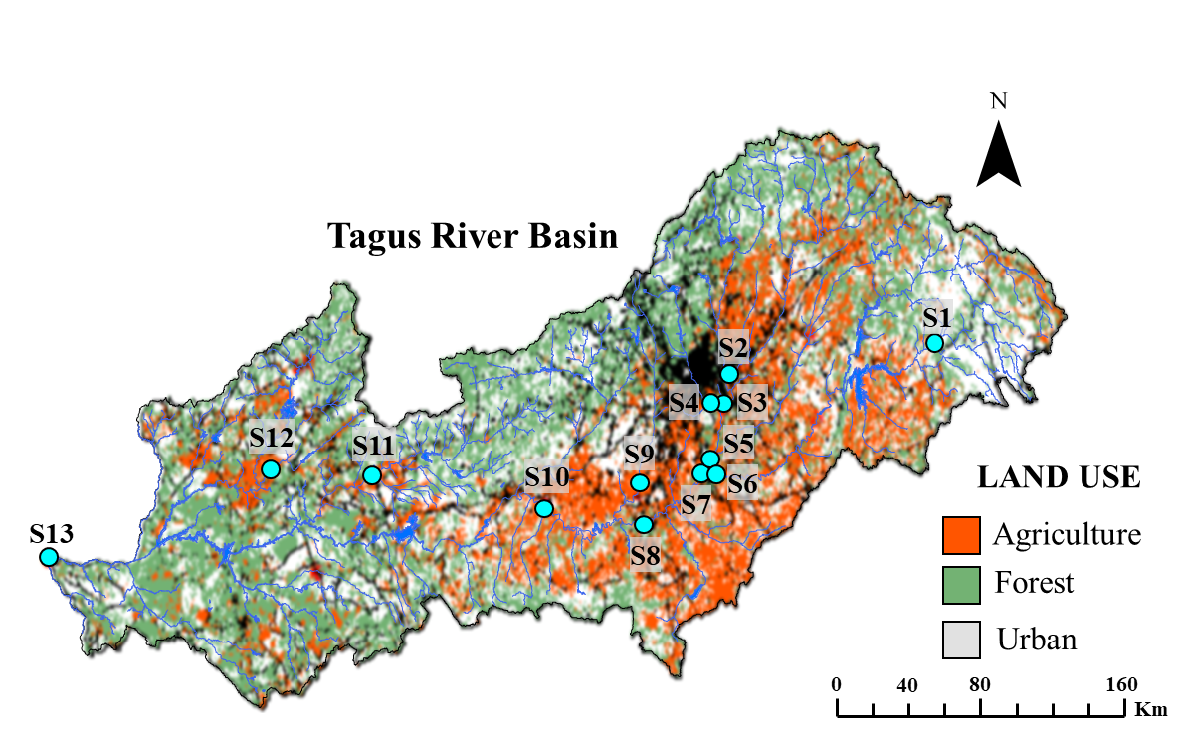

**Figure S1.** Details of sampling point distribution and land uses in the studied area. Image modified from Casillas et al., 2022. Land use is characterized in three categories, as presented in the legend: agricultural land use is orange, forest is green and urban is grey. The light blue dots represent the sampling sites used in the present study.

***S1.2. Chemical analysis***

*S1.2.1. Chemicals*

Solvents and reagents used in this work were of analytical, HPLC (high pressure liquid chromatography), LC-MS (liquid chromatography-mass spectrometry) or GC (gas chromatography) grade: methanol (MeOH; LC-MS, J.T.Baker, SYMTA, Spain), formic acid (99-100%, Scharlau, Scharlab, Spain), potassium dihydrogen phosphate (KH2PO4; Supelco, Vidrafoc, Spain), disodium tretaborate (Na2B4O7; Honeywell, Vidrafoc, Spain), 9-fluorenylmethoxycarbonyl chloride (FMOC-Cl; 99%, HPLC, Supelco, Vidrafoc, Spain), dichloromethane (DCM; GC, Merck, Vidrafoc, Spain), acetic acid (96%, Scharlau, Scharlab, Spain), acetonitrile (ACN; MACRON, SYMTA, Spain), magnesium sulfate (MgSO4, Sigma, Vidrafoc, Spain), sodium acetate (Supelco, Mervilab, Spain), C18 endcapped sorbent (Agilent Technologies, Spain), Bondesil-PSA sorbent (Agilent Technologies, Spain), isooctane (Merck, Vidrafoc, Spain), hexane (Merck, Merck, Spain), acetone (Merck, Vidrafoc, Spain), florisil (Merck, Vidrafoc, Spain), sodium chloride (NaCl; Supelco, Vidrafoc, Spain), ammonium formate (>99%, LC-MS, VWR, Spain), ammonium acetate (Scharlau, Scharlab, Spain) and ammonia (25%, Scharlau, Scharlab, Spain).

Standards solutions were provided from Wellington Laboratories Inc. (Thecno Spec, Spain), Laboratorio A2S (Techno Spec, Spain), Dr. Ehrenstorfer (LGC, Spain), Cambridge Isotope Laboratories Inc. (LGC, Spain), LabStandard (Teknokroma, Spain) and HPC Standards GmbH (SYMTA, Spain).

*S1.2.2. Surface water*

*S1.2.2.1. Multi-residue and organochlorine pesticides analysis*

Filtered surface water samples (1 L) were spiked with surrogate labeled standards (acetamiprid-d3, azoxystrobin-d4, boscalid-d4, dimethoate-d6, diuron-d6, epoxiconazole-d4, imidacloprid-d4, metolachlor-d6, prochloraz-d7, terbuthylazine-d5, thiacloprid-d4, thiamethoxam-d3, cypermethrin-d6 and deltamethrin-d6) and extracted by solid-phase extraction (SPE; CHROMABOND ® , Macherey-Nagel). Samples passed through Oasis HLB (500 mg, 6 mL, Waters, Milford, MA, USA) cartridges conditioned with 10 mL of MeOH and 10 mL of Milli-Q water, dried during 1 h and eluted with 10 mL of MeOH. The extract was concentrated under a gentle nitrogen stream (SuperVap 24 Concentration system FMS), to 300 µL and spiked with internal labeled standards (clothianidin d3, diazinon d10 and 13C12-PCB 70). HPLC analyses were performed on ExionLC Shimadzu-SCIEX Triple Quad 3500 with a Luna Omega C18 (100 mm x 2.1 mm, Phenomenex) analytical column and a mobile phase composed of water buffered with 0.1% formic acid (solvent A) and MeOH (solvent B). GC analyses were conducted with Agilent HRGC 8890-Agilent Triple Quad 7010C and two HP-5MS UI capillary columns (15 m, 0.25 mm id, 0.25 µm film thickness; Agilent Technologies). For all pesticides, two transitions were monitored. See Excel SM for more details related to instrumental analysis Tables S2 and S3.

*S1.2.2.2. Glyphosate/AMPA analysis*

Surface water samples (100 mL) were filtered and spiked with 13C2, 15N-glyphosate and 13C, 15N-AMPA labeled standards and ultrasonicated (Ultrasons-H J.P. SELECTA) with 25 mL of 0.1 M KH2PO4 for 30 min. Then, 25 mL of 0.1 M Na2B4O7 and 15 mL of 6.5 mM FMOC-Cl were added (to reach a pH=9 and the derivatization, respectively). The extract was shaken vigorously and was kept overnight in darkness at room temperature. The reaction was stopped by adding 1 mL of formic acid. Next, the derivatized extract was diluted with Milli-Q water (up to 340 mL) and passed through Oasis HLB (200 mg, 6 mL, Waters, Milford, MA, USA) previously conditioned with 5 mL of methanol and 5 ml of 0.1% formic acid in water. Then, the cartridge was dried for 30 min, rinsed with 3.5 mL of DCM, dried again for another 30 min and eluted with 9 mL of MeOH. The extracts concentrated under a gentle nitrogen stream (SuperVap 24 Concentration system FMS and TECHNE DB-2D evaporator) were analyzed in the HPLC-MS/MS (ExionLC Shimadzu-SCIEX Triple Quad 3500). The chromatographic separation was conducted in a Luna Omega C18 (100 mm x 2.1 mm, Phenomenex) analytical column with a mobile phase composed of 2 mM ammonium acetate in water (solvent A) and MeOH (solvent B). See Excel SM for more details related to instrumental analysis.

*S1.2.3. Sediment*

*S1.2.3.1. Multi-residue pesticides analysis*

Sediments (1 g) spiked with surrogate labeled standards (acetamiprid-d3, azoxystrobin-d4, boscalid-d4, dimethoate-d6, diuron-d6, epoxiconazole-d4, imidacloprid-d4, metolachlor-d6, prochloraz-d7, terbuthylazine-d5, thiacloprid-d4, thiamethoxam-d3, cypermethrin-d6 and deltamethrin-d6) were shaken with 2 mL of water and 4 mL of acidified (1% of acetic acid) acetonitrile for 30 min followed by addition of 0.8 g of MgSO4 and 0.2 g of sodium acetate. After a vortex (Vortex-vib, J.P.SELECTA) agitation and a centrifugation (5 min, 3500 rpm; OrtoAlresa Digicen 21R), the upper ACN layer (2 mL) was transferred and concentrated (SuperVap 24 Concentration system FMS and TECHNE DB-2D evaporator) to 1 mL. This extract was divided into two aliquots for the GC and HPLC analyses. For the HPLC analysis, 250 µL of the extract was diluted with 250 µL MilliQ water, vortexed, filtered and spiked with internal labeled standards (clothianidin d3 and diazinon d10). For the GC analysis, 500 µL were purified with dSPE (dispersive solid phase extraction) material (300 mg of MgSO4, 50 mg C18 and 250 mg PSA) and 1 mL of ACN. After a vortex (Vortex-vib, J.P.SELECTA) agitation and a centrifugation (5 min, 4000 rpm; OrtoAlresa Digicen 21R), the upper layer (400-450 µL) was transferred and mixed with 800 µL MilliQ water and 400 µL isooctane, vortexed 1 min, shaken 5 min, and centrifuged (6 min, 4000 rpm; OrtoAlresa Digicen 21R). The upper isooctane layer was transferred, concentrated (SuperVap 24 Concentration system FMS and TECHNE DB-2D evaporator) to 50 µL and spiked with 13C12-PCB 70 internal standard. Instrumental analyses were performed as mentioned above (section *S1.2.2.1*, see also SM Excel for more details).

*S1.2.3.2. Glyphosate/AMPA analysis*

Sediments (0.1 g) spiked with 13C2, 15N-glyphosate and 13C,15N-AMPA labeled standards were ultrasonicated (Ultrasons-H J.P. SELECTA) with 5 mL of KH2PO4/Na2B4O7 (0.1 M, pH=9) during 30 min and centrifuged (10 min, 3500 rpm; OrtoAlresa Digicen 21R). Then, 2 mL of the supernatant was derivatized overnight (≈15 h) with 2 mL of FMOC-Cl (1 mg/mL) in darkness at room temperature. The reaction was stopped by adding 5 mL of DCM, centrifuged (10 min, 3500 rpm; OrtoAlresa Digicen 21R) and the aqueous phase was filtered (Mendez et al., 2017). See section *S1.2.2.2* and SM Excel for details related to instrumental analysis.

*S1.2.3.3. Organochlorine pesticides analysis*

Sediment samples (0.1 g) spiked with labeled surrogate standards (13C6-hexachlorobenzene, 13C6-gamma-HCH, 13C12-2,4’-DDE, 13C12-4,4’-DDE, 13C12-2,4’-DDD, 13C12-4,4’-DDD, 13C12-dieldrin; ES-5465-5X from Cambridge Isotope Laboratories Inc.) were ultrasonicated (Ultrasons-H J.P. SELECTA) with 4 mL hexane:acetone (3:1) for 5 min and centrifuged (10 min, 4000 rpm; OrtoAlresa Digicen 21R). The extraction was repeated three times with fresh solvent. Then, the extract was concentrated (SuperVap 24 Concentration system FMS and TECHNE DB-2D evaporator) to 0.5 mL and purified by a 1 g florisil column eluted with 16 mL of hexane. Prior to analysis, the extract was spiked with 13C12-PCB 70 internal standard. Instrumental analyses were carried out by Agilent HRGC 8890-Agilent Triple Quad 7010C and two HP-5MS UI capillary columns (see also SM Excel for details).

*S1.2.4. Fish*

*S1.2.4.1. Multi-residue and organochlorine pesticides analysis*

Freeze-dried whole fish pooled samples (1 g) spiked with labeled surrogate standards (acetamiprid-d3, azoxystrobin-d4, boscalid-d4, dimethoate-d6, diuron-d6, epoxiconazole-d4, imidacloprid-d4, metolachlor-d6, prochloraz-d7, terbuthylazine-d5, thiacloprid-d4, thiamethoxam-d3, cypermethrin-d6 and deltamethrin-d6) were shaken with 10 mL of ACN and 9 mL of Milli-Q water for 30 min. Then, samples were extracted with 4 g MgSO4 and 1 g NaCl by vortex (1 min) and centrifugation (5 min, 4000 rpm; OrtoAlresa Digicen 21R). The supernatant was transferred and purified with 150 mg PSA, 150 mg C18 and 900 mg MgSO4 by vortex (min) and centrifugation (5 min, 4000 rpm; OrtoAlresa Digicen 21R). The extract was concentrated (SuperVap 24 Concentration system FMS and TECHNE DB-2D evaporator) to 1 mL, filtered and spiked with internal labeled standards (clothianidin d3, diazinon d10 and 13C12-PCB 70). Instrumental analyses were performed as mentioned above (section *S1.2.2.1*, see also SM Excel for more details).

*S1.2.4.2. Glyphosate/AMPA analysis*

Freeze-dried whole fish pooled samples (1 g) spiked with 13C2, 15N-glyphosate and 13C,15N-AMPA labeled standards were shaken twice (10 min) with 8 mL of MeOH/Milli-Q water (20:80 v/v) and centrifuged (30 min, 5000 rpm, 5 ºC¸ OrtoAlresa Digicen 21R). The aqueous phase (6-7 mL) was transferred, shaken with 2 mL of DCM and 7 µL of acetic acid/Milli-Q water (50:50 v/v, pH= 4-5) by vortex (Vortex-vib, J.P.SELECTA) and centrifuged (30 min, 5000 rpm, 5 ºC¸ OrtoAlresa Digicen 21R). The supernatant was extracted by vortex and centrifuged again with fresh solvent. After that, the extracts were purified by Oasis WAX (200 mg, 6 mL, Waters, Milford, MA, USA) cartridges previously conditioned with 5 mL MeOH and 25 mM ammonium formate in water. The cartridges were dried for 1 h and eluted with 8 mL 5% ammonium hydroxide (NH4OH) in methanol. The purified extracts were evaporated (SuperVap 24 Concentration system FMS and TECHNE DB-2D evaporator) to 1 mL, treated with Na2B4O7 (40 mM, pH=9) and derivatized with 2 mL of FMOC-Cl (5 mg/mL) in darkness at room temperature during 1 h. The reaction was stopped by adding 2 mL of DCM and extract was centrifuged (10 min, 5000 rpm, 5 ºC; OrtoAlresa Digicen 21R) and filtered. See section *S1.2.2.2* and SM Excel for details related to instrumental analysis.

***S1.3. Quality assurance***

According to criteria established in SANTE/2020/12830 (SANTE, 2021a) and SANTE/11312/2021 (SANTE, 2021b) documents, the analytical methodologies developed were optimized and validated in each matrix: surface water (n=5; pesticide residue content <LOD; three concentration levels; Table S4), sediment (n=3; pesticide residue content <LOD; four concentration levels; Table S5) and fish (n=3; pesticide residue content <LOD; four concentration levels; Table S6). The mean recoveries ranged between 70 - 120% with an associated repeatability RSDr ≤ 20% for all analytes.

The limit of detection (LOD) was defined as the estimated lowest level at which the analyte can be identified and detected. LOD was calculated as the level at which S/N for the qualifier is at least 3 in each matrix spiked at LOQ level (Tables S4-S6).

***S1.4. Calculation of mass flow rate***

Mass flow rates (F) of individual compounds (kg/y) were calculated to reflect the discharge of pesticides in surface water considering the river flow in each location (Navarro et al., 2020):

$$\text{F = C × Q}$$

Eq (1)

where C is the pesticide concentration detected in surface water (in kg/m3) and Q is the mean daily flow (in m3/y) measured at the time of sampling campaigns (Table S1).

***S1.5. Calculation of partition coefficients and BAFs***

Partition coefficient (Log Kd) between water and sediment compartments was estimated as the ratio of the sediment (Csed; µg/kg d.w.) and water (Cwater; µg/L) median concentrations measured at the same sampling points (Castaño-Ortiz et al., 2024) (Eq. 2).

$$\text{K}\text{d}\text{=}\frac{\text{C}\text{sed}}{\text{C}\text{water}}$$

Eq. (2)

Bioaccumulation factors (BAFs) were determined by division of the median concentrations of each compound in fish (Cfish;µg/kg d.w.) and water (Cwater; µg/L) at the same sampling points (Castaño-Ortiz et al., 2024) (Eq. 3).

$$\text{BAF=}\frac{\text{C}\text{fish}}{\text{C}\text{water}}$$

Eq. (3)

***S1.6. Environmental risk assessment calculations***

Risk quotients were calculated to estimate the potential ecological risk of pesticides for aquatic (RQwater) and benthic (RQsed) organisms and fish-eating predators (RQoral) at general (RQ50) and worst (RQmax) scenarios (Navarro et al., 2024) (Eq. 4).

$$\text{RQ}\text{50 or max}\text{=}\frac{\text{MEC}\text{50 or max}}{\text{PNEC}}$$

Eq. (4)

where MEC was the measured environmental concentration (MEC50, median; MECmax, maximum) of pesticides in each compartment (water, sediment and fish) and PNEC (predicted no effect concentration; PNECwater, PNECsed, PNECoral) was obtained from the available long-term toxicity data (no-observed effect concentration, NOEC; Table S7; PPBD, 2025) divided by an assessment factor (AF). The most conservative AF was applied according to the available ecotoxicological data following the criteria set by the European Commission (2003): i) AF=1000, when at least one short-term test (LC50 or EC50) from each of three trophic levels of the base set (fish, *Daphnia magna* and algae) is available; ii) AF=100, when one long-term NOEC (either fish or aquatic invertebrates) data is available; iii) AF=50, when two long-term NOECs from species representing 2 trophic levels are available; iv) AF=10, when there are long-term NOECs from at least three species (normally fish, *Daphnia* and algae) representing three trophic levels. (European Commission, 2003).

When NOEC data for sediment was not available, PNECsed was derived from PNECwater, considering the partition coefficient suspended matter water (Ksusp-water) and the bulk density of wet suspended matter (RHOsusp) (Eq. 5):

$${\text{PNEC}}_{\text{sed}}\text{=}\frac{{\text{K}}_{\text{susp-water}}}{{\text{RHO}}_{\text{susp}}}\text{× }{\text{PNEC}}_{\text{water}}\text{ × 1000}$$

Eq. (5)

Secondary poisoning effects on birds and mammals were based on PNECoral (Eq. 6) obtained from NO(A)EL (no observed adverse effect level) for birds or mammals and a conversion factor to NOEC (CONVbird or mammal) (Eq. 7). If NOEC for both birds and mammals was available, the lower PNEC was used in the risk assessment (European Commission, 2003).

$$\text{PNEC}\text{oral}\text{=}\frac{\text{NOEC}\text{bird}\text{ or mammal}}{\text{AF}\text{bird}\text{ or mammal}}$$

Eq. (6)

$${\text{NOEC}}_{\text{bird or mammal}}\text{= }{\text{NOA(E)L}}_{\text{bird or mammal}}\text{ × }{\text{CONV}}_{\text{bird or mammal}}$$

Eq. (7)

Risk quotients for mixtures of pesticides were calculated at general (RQmix_50) and worst (RQmix_max) scenarios (Eq.8).

$$\text{RQ}\text{mix}\text{_}\text{50 or max}\text{=}\sum{\frac{\text{MEC}\text{50 or max}\text{_i}}{\text{PNEC}\text{i}}}$$

Eq. (8)

Toxic units (TU) were estimated with the measured environmental concentration of pesticides (MEC50, median; MECmax, maximum) in water compartment and the most sensitive acute toxicity values (median lethal, LC50, and median effective, EC50, concentrations; Table S7; PPBD, 2025) for the organisms groups of algae, invertebrates and fish (Eq. 9) (Weisner et al., 2021):

$$\text{TU}\text{i}\text{=}\frac{\text{MEC}\text{50 or }\text{max_i}}{\text{EC50 (LC50)}\text{i}}$$

Eq. (9)

The total toxicity of the pesticide mixture (RQSTU) was based on the sum of toxic units (STU) for the most sensitive trophic level (algae, invertebrates or fish) applying an assessment factor of 1000 (Eq.10) (Backhaus and Faust, 2012; Casillas et al., 2022; Rocha and Rocha, 2023).

$${\text{RQ}}_{\text{STU}}\text{= }{\text{max (STU}}_{\text{algae }}\text{, }{\text{STU}}_{\text{invert }}\text{, }{\text{STU}}_{\text{fish}}\text{) × AF}$$

Eq. (10)

In general, RQ < 0.01 indicated a negligible risk, 0.01 < RQ < 0.1 denoted a low risk, 0.1 < RQ < 1 represented a medium risk and RQ > 1 revealed a high ecological risk.

Since ecotoxicological data for the three taxonomic groups were based on dissolved phase pesticide, RQSTU in sediment compartment was not estimated.

**Table S8.** Descriptive statistics (median (mean ± SD) min-max of positives and detection frequency (Df, %) of the pesticides obtained in water (ng/L), sediment (ng/g, d.w.) and fish (ng/g, d.w.). Only pesticides detected have been listed.



**Table S8 (cont).** Descriptive statistics (median (mean ± SD) min-max of positives and detection frequency (Df, %) of the pesticides obtained in water (ng/L), sediment (ng/g, d.w.) and fish (ng/g, d.w.). Only pesticides detected have been listed.



**Table S8 (cont).** Descriptive statistics (median (mean ± SD), min-max of positives and detection frequency (Df, %) of the pesticides obtained in water (ng/L), sediment (ng/g, d.w.) and fish (ng/g, d.w.). Only pesticides detected have been listed.



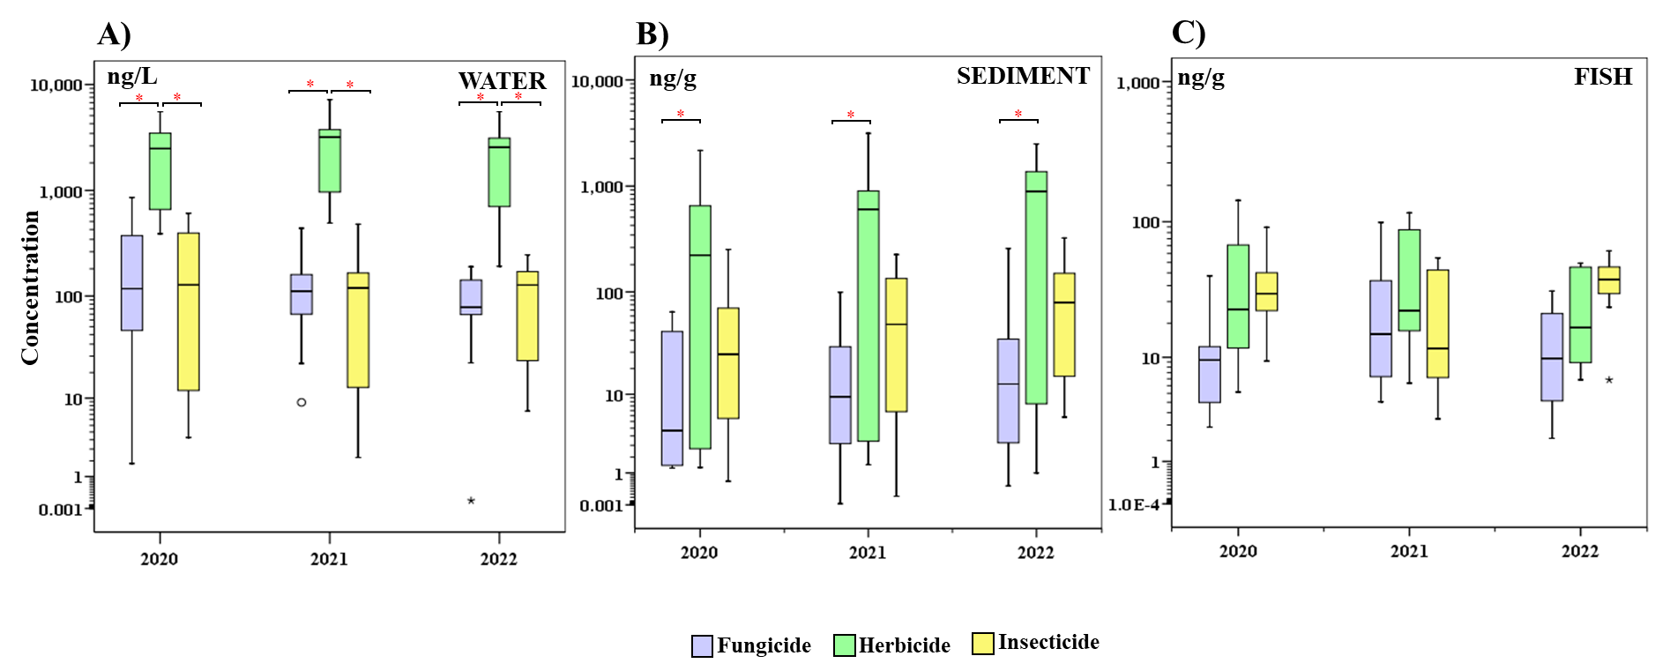

**Figure S2.** Concentration (logarithmic scale) of fungicides, herbicides and insecticides in water (A; ng/L), sediment (B; ng/g d.w.) and fish (C; ng/g d.w.) during 2020, 2021 and 2022. Upper edge of the box, line within the box and lower edge of the box, represent the 75th, 50th, and 25th percentiles. Vertical lines extend from the minimum to the maximum value, excluding outlier (circles) and extreme (asterisks) values. Statistical differences are shown (red asterisks).

**Table S9.** Matrix of significant differences (p < 0.05, Kruskal-Wallis test) between compounds in water. Only pesticides with Df > 30% are shown.

**Table S9 (cont).** Matrix of significant differences (p < 0.05, Kruskal-Wallis test) between compounds in water. Only pesticides with Df > 30% are shown.

**Table S10.** Correlation matrix (p < 0.01 and p < 0.05, Spearman’s rank correlation Test) of the pesticides in water.

**Table S10 (cont).** Correlation matrix (p < 0.01 and p < 0.05, Spearman’s rank correlation Test) of the pesticides in water.

**Table S11.** Matrix of significant differences (p < 0.05, Kruskal-Wallis test) between compounds in sediment. Only pesticides with Df > 30% are shown.

**Table S12.** Correlation matrix (p < 0.01 and p < 0.05, Spearman’s rank correlation Test) of the pesticides in sediment.

**Table S13.** Matrix of significant differences (p < 0.05, Kruskal-Wallis test) between compounds in fish. Only pesticides with Df > 30% are shown.



**Table S14.** Correlation matrix (p < 0.01 and p < 0.05, Spearman’s rank correlation Test) of the pesticides in fish.

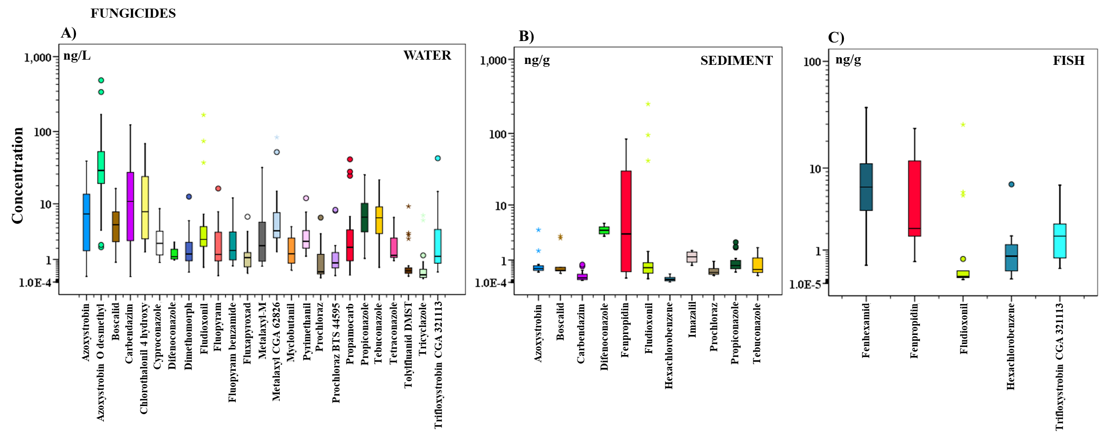

**Figure S3.** Concentration (logarithmic scale) of fungicides in water (A; ng/L), sediment (B; ng/g d.w.) and fish (C; ng/g d.w.). Only compounds with Df > 30% are shown. Upper edge of the box, line within the box and lower edge of the box, represent the 75th, 50th, and 25th percentiles. Vertical lines extend from the minimum to the maximum value, excluding outlier (circles) and extreme (asterisks) values.

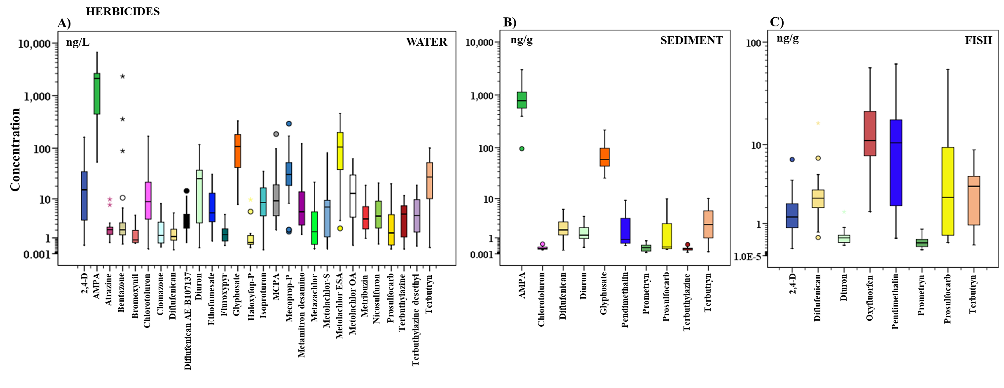

**Figure S3 (cont).** Concentration (logarithmic scale) of herbicides in water (A; ng/L), sediment (B; ng/g d.w.) and fish (C; ng/g d.w.). Only compounds with Df > 30% are shown. Upper edge of the box, line within the box and lower edge of the box, represent the 75th, 50th, and 25th percentiles. Vertical lines extend from the minimum to the maximum value, excluding outlier (circles) and extreme (asterisks) values.

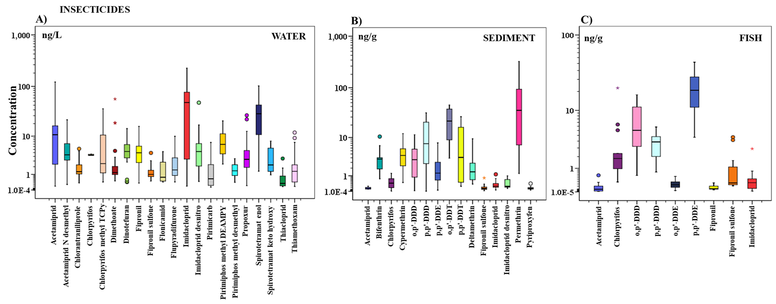

**Figure S3 (cont).** Concentration (logarithmic scale) of insecticides in water (A; ng/L), sediment (B; ng/g d.w.) and fish (C; ng/g d.w.). Only compounds with Df > 30% are shown. Upper edge of the box, line within the box and lower edge of the box, represent the 75th, 50th, and 25th percentiles. Vertical lines extend from the minimum to the maximum value, excluding outlier (circles) and extreme (asterisks) values.

**Table S16.** Sediment-water partition coefficients (Log Kd) of pesticides calculated in Tagus basin.



**Table S17.** Bioaccumulation factors (BAF; L/kg) of pesticides calculated in Tagus basin.



**Table S18.** Statistical differences between pesticide distribution and possible source influences.

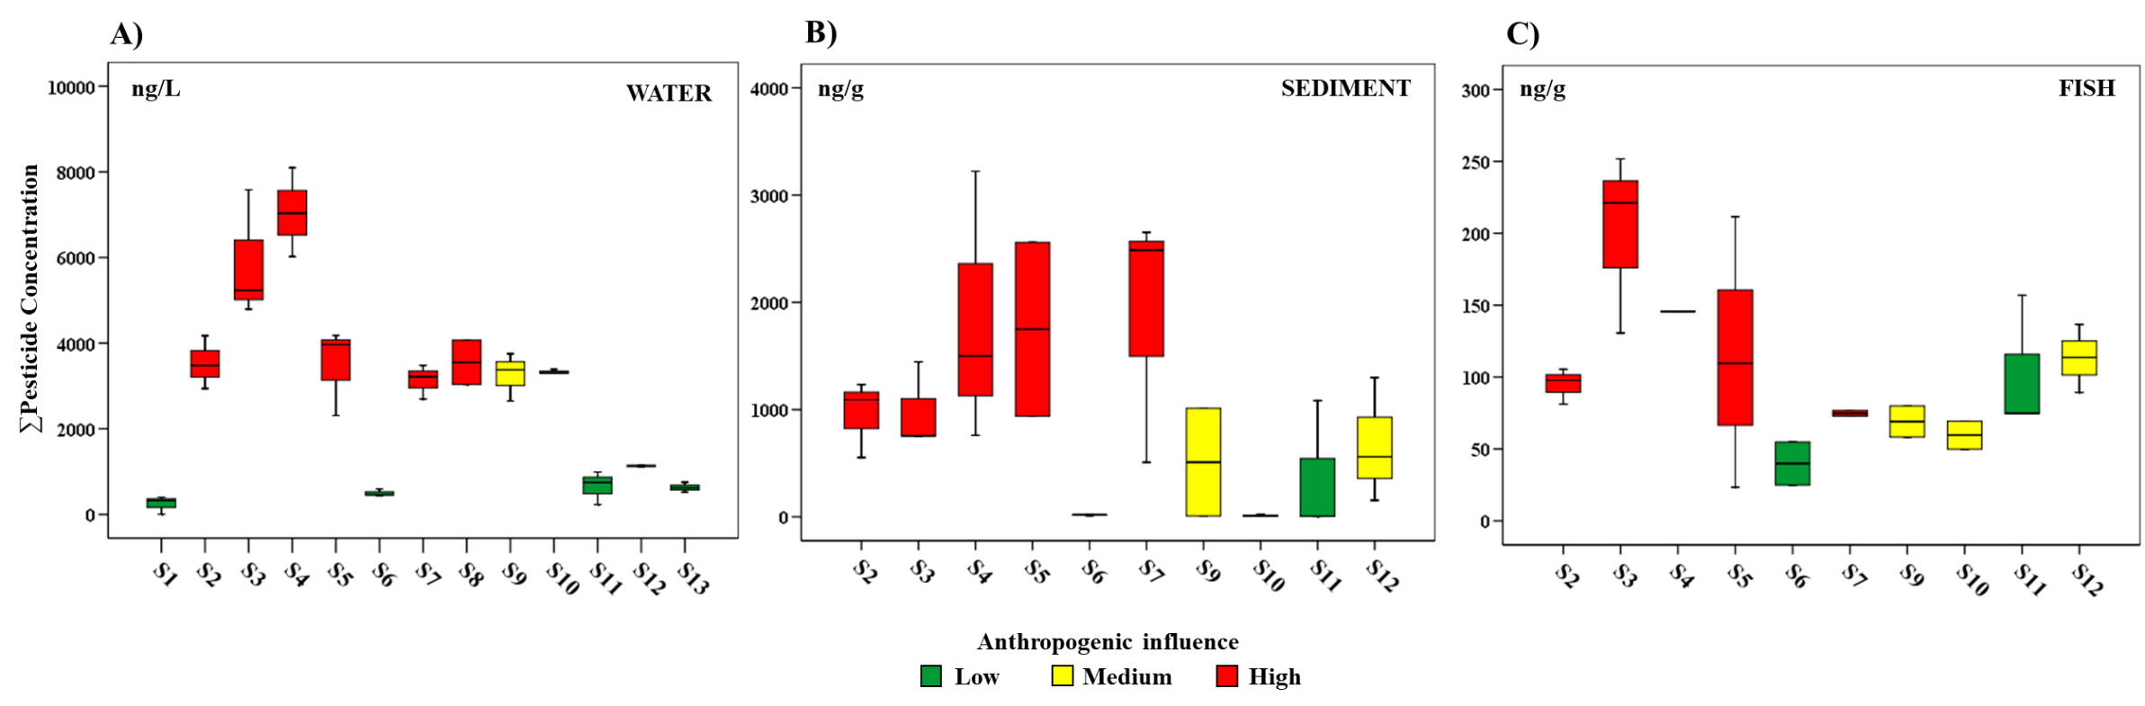

**Figure S4.** Distribution of ∑Pesticides in water (A; ng/L), sediment (B; ng/g d.w.) and fish (C; ng/g d.w.) in the study area. Anthropogenic influence: low (green), medium (yellow) and high (red). Upper edge of the box, line within the box and lower edge of the box, represent the 75th, 50th, and 25th percentiles. Vertical lines extend from the minimum to the maximum value.

**Table S19.** Concentration of pesticides in water, sediment and fish from Tagus River watershed (median (mean ± SD) min-max). No sediment and fish samples were collected at S1, S8 and S13.

**Table S20.** Estimated mass flow rate (kg/y) of pesticides in Tagus River watershed (median (mean ± SD) min-max).

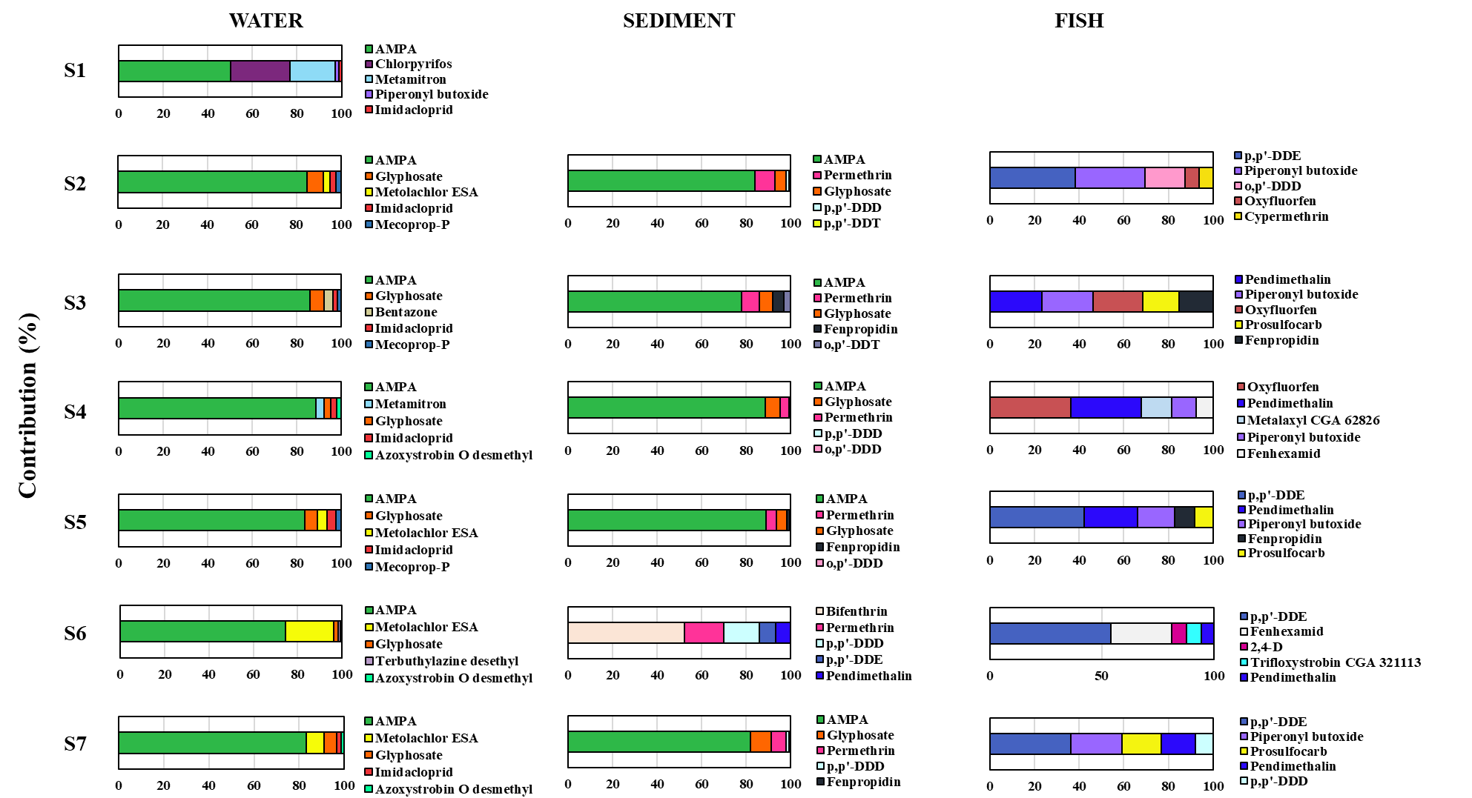**Figure S5.** Contribution (%) of some pesticides in water, sediment and fish from each sampling site. Only the first 5 pesticides with higher contribution and Df > 30% in each matrix are shown. No sediment and fish samples were collected at S1, S8 and S13.

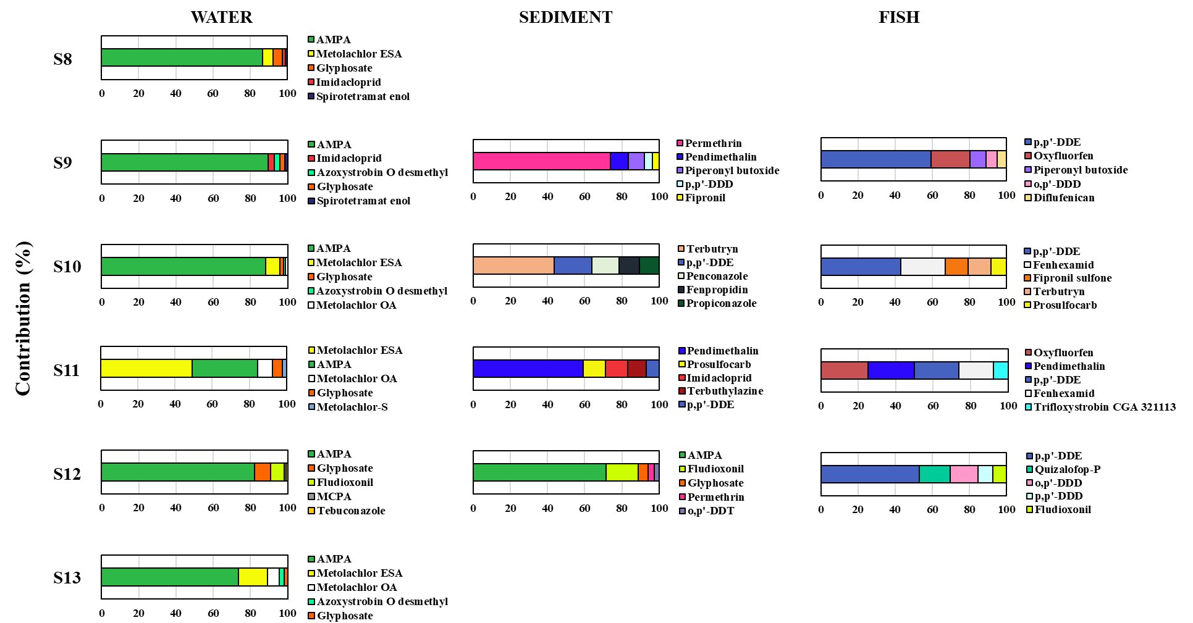**Figure S5 (cont).** Contribution (%) of some pesticides in water, sediment and fish from each sampling site. Only the first 5 pesticides with higher contribution and Df > 30% in each matrix are shown. No sediment and fish samples were collected at S1, S8 and S13.

**Table S21.** Variables of the principal components analysis (PCA) related to the content of pesticides in the aquatic system and pesticide distribution. Detail of the influence of each variable in each component.



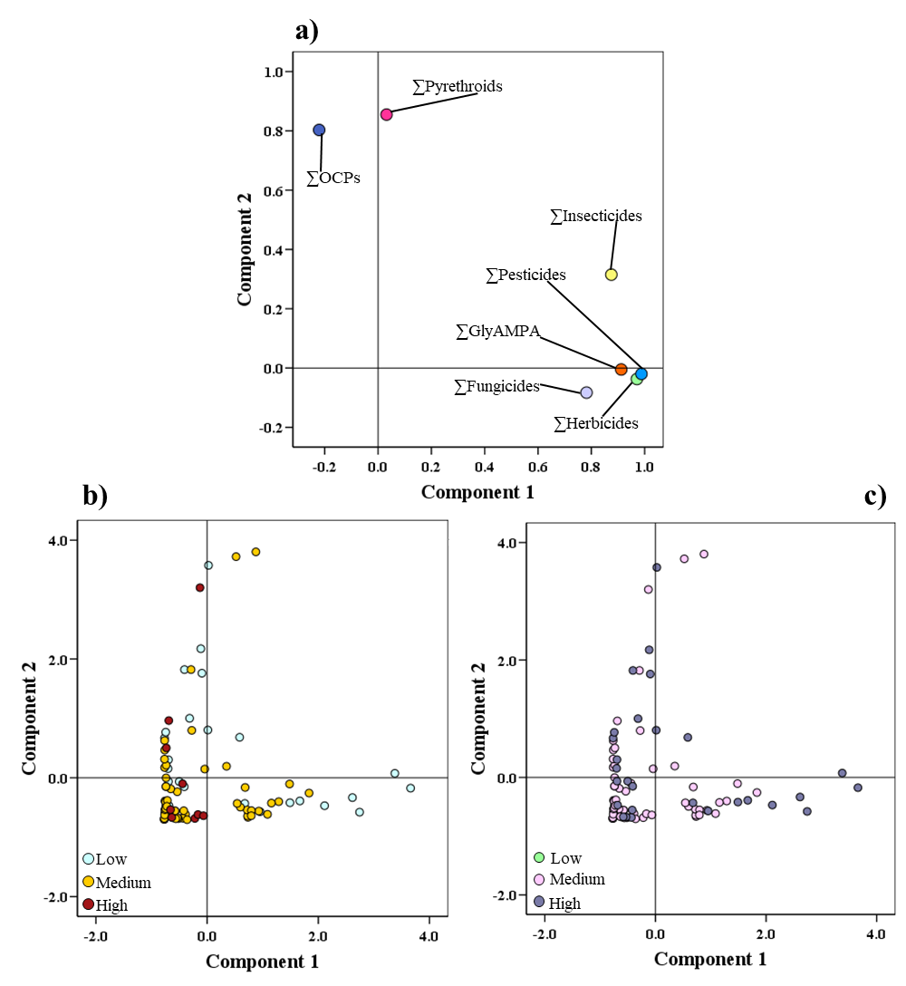

**Figure S6.** Diagrams of dispersion related to the two components resulting from a principal components analysis (PCA) derived from the content and distribution of pesticides in the aquatic ecosystem (Component 1 and 2). Loading plots (a) contribution of each variable to each component. Score plots markers set by livestock (b) and WWTP influence (c), of all samples on each component.

**Table S22.** Matrix of significant differences between content of pesticides and their distribution in the aquatic system.

**Table S24.** Compliance with reference values in water. AA-EQS: Annual Average Environmental Quality Standard, MAC-EQS: Maximum Allowable Concentration Environmental Quality Standard. (Green: value detected in water < reference value; Red: value detected in water > reference value; Blue: no reference value. ‘X’: Not detected).



**Table S24 (cont).** Compliance with reference values in water. AA-EQS: Annual Average Environmental Quality Standard, MAC-EQS: Maximum Allowable Concentration Environmental Quality Standard. (Green: value detected in water < reference value; Red: value detected in water > reference value; Blue: no reference value. ‘X’: Not detected).



**Table S24 (cont).** Compliance with reference values in water. AA-EQS: Annual Average Environmental Quality Standard, MAC-EQS: Maximum Allowable Concentration Environmental Quality Standard. (Green: value detected in water < reference value; Red: value detected in water > reference value; Blue: no reference value. ‘X’: Not detected).



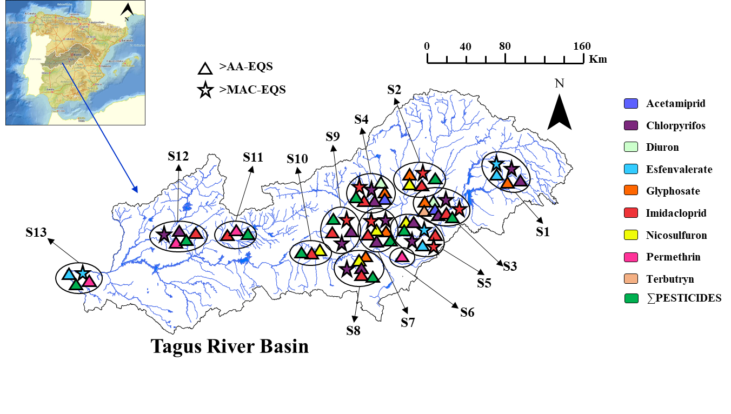

**Figure S7.** Exceedances of reference values in water. AA-EQS: Annual Average Environmental Quality Standard, MAC-EQS: Maximum Allowable Concentration Environmental Quality Standard (European Commission 2013, 2022).

**Table S29.** List of the top three pesticides of concern for aquatic and benthic organisms and fish-eating predators.



**Abbreviations and Acronyms**

**AA-EQS** Annual average environmental quality standard

**AF** Assessment factor

**BAF** Bioaccumulation factor

**BP** Biocide product

**CE** Collision energy

**CXP** Collision cell exit potential

**Df** Detection frequency

**DP** Declustering potential

**d.w.** Dried weight

**EC50** Median effective concentration

**EQS** Environmental quality standards

**ESI** Electrospray ionization

**Kd** Sediment-water partition coefficients

**Koc** Organic carbon-water partition coefficients

**GC** Gas chromatography

**HHP** Highly hazardous pesticides

**HPLC** High Performance Liquid Chromatography

**HRGC-MS/MS** High Resolution Gas Chromatography–tandem Mass Spectrometry

**LC50** Median lethal concentrations

**LOD** Limit of detection

**LOQ** Limits of quantification

**MAC-EQS** Maximum allowable concentration environmental quality standard

**MEC** Measured environmental concentration

**NI** Negative ionization

**NOEC** No-observed effect concentration

**PAN** Pesticide Action Network

**PCA** Principal component analysis

**PC** Principal component

**PNEC P**redicted no effect concentration

**PPBT** Potential particle bound transport

**PPP** Plant protection product

**PI** Positive ionization

**QuEChERS** Quick, Easy, Cheap, Effective, Rugged and Safe

**RQ** Risk quotients

**SD** Standard deviation

**SPE** Solid-phase extraction

**SRM** Selected reaction monitoring

**STU** Sum of toxic units

**TU** Toxic units

**UHPLC-MS/MS** Ultra-High Performance Liquid Chromatography–tandem Mass Spectrometry

**VMP** Veterinary medicinal product

**WFD** Water Framework Directive

**WWTP** Wastewater treatment plant

**References**

Backhaus, T., Faust, M., 2012. Predictive environmental risk assessment of chemical mixtures: a conceptual framework. Environ. Sci. Technol. 46, 2564-2573. <https://doi.org/10.1021/es2034125>.

Casillas, A., de la Torre, A., Navarro, I., Sanz, P., Martínez, M.A., 2022. Environmental risk assessment of neonicotinoids in surface water. Sci. Total Environ. 809, 151161 <https://doi.org/10.1016/j.scitotenv.2021.151161>.

Castaño-Ortiz, J.M., Gil-Solsona, R., Ospina-Álvarez, N., Alcaraz-Hernández, J.D., Farré, M., León, V.M., Barceló, D., Santos, L.H.M.L.M., Rodrígez-Mozaz, S., 2024. Fate of pharmaceuticals in the Ebro River Delta region: The combined evaluation of water, sediment, plastic litter, and biomonitoring. Sci. Total. Environ. 906, 167467. <https://doi.org/10.1016/j.scitotenv.2023.167467>

CIMAVET, 2025. Medicamentos veterinarios. Agencia Española de Medicamentos y Productos Sanitarios. <https://cimavet.aemps.es/cimavet/publico/home.html> (Last access September 2025).

ECHA, 2025. European Chemicals Agency. Information on biocides. <https://echa.europa.eu/es/information-on-chemicals/biocidal-products>. (Last access September 2025).

European Commission, 2003. Technical Guidance Document on Risk Assessment. Part II. <https://echa.europa.eu/documents/10162/987906/tgdpart2_2ed_en.pdf/138b7b71-a069-428e-9036-62f4300b752f>

European Commission, 2013. Directive 2008/105/EC of the European Parliament and of the Council of 16 December 2008 on environmental quality standards in the field of water policy. <https://eur-lex.europa.eu/eli/dir/2008/105/oj> (Last access September 2025).

European Commission, 2022. Proposal for a Directive of the European Parliament and of the Council Amending Directive 2000/60/EC Establishing a Framework for Community Action in the field of Water Policy, Directive 2006/118/EC on the Protection of Groundwater Against Pollution and Deterioration and Directive 2008/105/EC on Environmental Quality Standards in the Field of Water Policy, pp. 1–81. <https://eur-lex.europa.eu/resource.html?uri=cellar:d0c11ba6-55f8-11ed-92ed-01aa75ed71a1.0001.02/DOC_2&format=PDF>. (Last access September 2025).

Goss D. and Wauchope R.D., 1990. The SCR/ARS/CES Pesticides Properties Database: II using it with Soils Data in a Screening Procedure. Weigmann, D.L. (Ed)., Pesticides in the Next Decade: The Challenge Ahead, Virginia Water Resources Research Center, Blacksburg, VA, USA, 471-493.

Gustafson D.I., 1989. Groundwater ubiquity score: a simple method for assessing pesticide leachability. Environmental Toxicology and Chemistry 8, 339-357. <https://doi:10.1002/ETC.5620080411>.

MAPA, 2025. Ministerio de Agricultura, Pesca y Alimentación, Registro de Productos Fitosanitarios. [https://servicio.mapa.gob.es/regfiweb#](https://servicio.mapa.gob.es/regfiweb) (Last access September 2025).

Mendez, M.J., Aimar, S.B., Aparicio, V.C., Ramirez Haberkon, N.B., Buschiazzo, D.E., De Gerónimo, E., Costa, J.L., 2017. Glyphosate and Aminomethylphosphonic acid (AMPA) contents in the respirable dust emitted by an agricultural soil of the central semiarid region of Argentina. Aeolian Res., 29, 23-29. <http://dx.doi.org/10.1016/j.aeolia.2017.09.004>.

MISAN, 2025. Ministerio de Sanidad. Biocide registration. <https://www.sanidad.gob.es/ciudadanos/productos.do?metodo=realizarDetalle> (Last access September 2025).

MITER, 2021. Ministerio para la Transición Ecológica y el Reto Demográfico. Dirección General del agua. Guía para l Evaluación del Estado de las Aguas superficiales y subterráneas. <https://www.miteco.gob.es/content/dam/miteco/es/agua/temas/estado-y-calidad-de-las-aguas/guia-para-evaluacion-del-estado-aguas-superficiales-y-subterraneas_tcm30-514230.pdf>. (Last access September 2025).

Navarro, I., de la Torre, A., Sanz, P., Martínez, M.A., 2020. Perfluoroalkyl acids (PFAAs): Distribution, trends and aquatic ecological risk assessment in surface water from Tagus River basin (Spain). Environ. Pollut. 256, 113511. <https://doi.org/10.1016/j.envpol.2019.113511>

Navarro, I., de la Torre, A., Sanz, P., Abrantes, N., Campos, I., Alaoui, A., Christ, F., Alcon, F., Contreras, J., Glavan, M., Pasković, I., Pasković, M.P., Nørgaard, T., Mandrioli, D., Sgargi, D., Hofman, J., Aparicio, V., Baldi, I., Bureau, M., Vested, A., Harkes, P., Huerta-Lwanga, E., Mol, H., Geissen, V., Silva, V., Martínez, M.A., 2024. Assessing pesticide residues occurrence and risks in water systems: A Pan-European and Argentina perspective. Water Res. 254, 121419. <https://doi.org/10.1016/j.watres.2024.121419>

PAN, 2024. Pesticide Action Network International (PAN) International List of Highly Hazardous Pesticides. December 2024. <https://pan-international.org/wp-content/uploads/PAN_HHP_List.pdf> (Last access September 2025).

PANPDB, 2025. PAN Pesticide Database. Pesticide Action Network Pesticide Database. <http://www.pesticideinfo.org/>. (Last access September 2025).

PPDB, 2025. Pesticide Properties DataBase (PPDB). University of Hertfordshire <https://sitem.herts.ac.uk/aeru/ppdb/en/atoz.htm> (Last access September 2025).

Rocha, M.J., Rocha, E., 2023. Chemical monitoring and risk assessment of 56 pesticides in the Ave River and adjoining Atlantic coastline (Iberian Peninsula, Portugal). Mar. Pollut. Bull. 190, 114844. <https://doi.org/10.1016/j.marpolbul.2023.114844>

Royano, S., de la Torre, A., Navarro, I., Martínez, M.A., 2023. Pharmaceutically active compounds (PhACs) in surface water: occurrence, trends and risk assessment in the Tagus River Basin (Spain). Sci. Total Environ. 905, 167422 <https://doi.org/10.1016/j.scitotenv.2023.167422>

SANTE, 2021a. Guidance Document on Pesticide analytical methods for risk assessment and post-approval control and monitoring purposes, SANTE/2020/12830, Rev. 1.

SANTE, 2021b. Analytical quality control and method validation procedures for pesticide residues analysis in food and feed, SANTE 11312/2021.

Weisner, O., Frische, T., Liebmann, L., Reemtsma, T., Roß-Nickoll, M., Schäfer, R.B., Schäffer, A., Scholz-Starke, B., Vormeier, P., Knillmann, S., Liess, M., 2021. Risk from pesticide mixtures – The gap between risk assessment and reality. Sci. Total Environ. 796, 149017. <https://doi.org/10.1016/j.scitotenv.2021.149017>