Suciu et al. 2025 – Supplementary Materials
Table SM1. Characteristics of the plots and the water bodies taken into consideration for the surface water fate assessment of the PT CSS and PPPs physicochemical characteristics requested by the models.
Characteristics of the plots
 |  | Field 1 |  | Fields 2/3
Crop |  | grape |  | grape
Crop height (m) |  | 1.8 |  | -
Field size (ha) |  | 3.5 |  | 5.5 (4.2 + 1.3)
Topography |  | Flat (0-2%) |  | Flat (0-2%)
Distance between the field and the water body (m) |  | 30 |  | 150
Soil pH |  | 6.54 |  | 7.3
Bulk density (g cm ⁻³) |  | 1.10 |  | 1.15
Topsoil organic matter (%) |  | 1.16 ± 0.02 |  | 1.82 ± 0.004
Soil texture |  | Sandy loam |  | Sandy loam
Sand (%) |  | 58.03 |  | 72.82
Silt (%) |  | 27.56 |  | 14.59
Clay (%) |  | 14.41 |  | 12.58
Average soil depth (cm) |  | 81-120 |  | 81-120
Water bodies characteristics
 |  | Tributary |  | Cértima River
Flow rate of the river (m³/s) |  | 0.44 |  | 0.70
Temperature of river water (°C) |  | 20.2 |  | 19.2
Depth of the river (m) |  | 0.3 |  | 0.25
Width of the river (m) |  | 2.5 |  | 5.5
Length of the river (km) |  | 3.5 |  | 5.9
PPPs physicochemical characteristics
Parameters | Dimethomorph |  | Metalaxyl-M |  | Tebuconazole
Name IUPAC | (EZ)-4-[3-(4-chlorophenyl)-3-(3.4-dimethoxyphenyl) acryloyl]morpholine  (PPDB, 2024) |  | methyl N-(methoxyacetyl)-N-(2.6-xylyl)-D-alaninate  (PPDB, 2024) |  | (RS)-1-p-chlorophenyl-4,4-dimethyl-3-(1H-1.2.4-triazol-1-ylmethyl) pentan-3-ol
Molar mass (g mol⁻¹) | 386.86  (PPDB, 2024) |  | 279.33  (PPDB, 2024) |  | 307.83  (PPDB, 2024)
Saturated vapour pressure (Pa) | 9.7E-7  (PPDB, 2024) |  | 0.0033  (PPDB, 2024) |  | 1.3E-6  (PPDB, 2024)
Solubility in water (mg L⁻¹) | 49.2  (EC, 2017) |  | 26000  (PPDB, 2024) |  | 36  (PPDB, 2024)
K_{oc} (L Kg⁻¹) | 419.4  (EC, 2017) |  | 40  (EFSA, 2015) |  | 769  (EFSA, 2014)
Freundlich sorption exponent (-) | 0.86  (PPDB, 2024) |  | 0.955  (PPDB, 2024) |  | 0.84  (PPDB, 2024)
Half-life soil (d) | 36.27  (EC, 2017) |  | 6.5  (PPDB, 2024) |  | 31  (EFSA, 2014)
Half-life surface water (d) | 1000  (EC, 2017) |  | 47.1  (EFSA, 2015) |  | 365  (EFSA, 2014)
Half-life sediment* (d) | 9.6  (EC, 2017) |  | 1000  (EFSA, 2015) |  | 1000  (EFSA, 2014)
Global degradation rate in sediment* (d⁻¹) | 0.052083333  (EC, 2017) |  | 0.0005  (EFSA, 2015) |  | 0.0005  (EFSA, 2014)
Global degradation rate in water* (d⁻¹) | 0.0005  (EC, 2017) |  | 0.010616  (EFSA, 2015) |  | 0.001369863  (EFSA, 2014)
Henry's law constant* (Pa*m³/mol) | 0.000025  (PPDB, 2024) |  | 0.000035  (PPDB, 2024) |  | 0.00001  (PPDB, 2024)
Water-organic carbon partition coefficient* (log 10) | 2.62  (EC, 2017) |  | 1.60  (EFSA, 2015) |  | 2.88  (EFSA, 2014)
Note: *Characteristics required by the "Atmosphere" and "River" models in MERLIN-Expo.
Table SM2. Characteristics of the plots and the water bodies taken into consideration for the surface water fate assessment of the NL CSS and PPPs physicochemical characteristics requested by the models.
Characteristics of the plots
 |  | Field 1 |  | Field 2 | Field 3
Crop |  | Potato |  | Potato | Potato
Field size (ha) |  | 8 |  | 7.5 | 2.4
Distance between the field and the water body (m) |  | 5 |  | 5 | 5
Soil pH |  | 7.5 |  | 7.8 | 7.3
Topsoil Organic matter (%) |  | 2.0 |  | 2.0 | 2.45
Soil Texture |  | Clay |  | Clay | Zavel/light clay
Bulk density  (g cm ⁻³) |  | 1.58 |  | 1.58 | 1.55
Sand (%) |  | 22 |  | 26 | 25
Silt (%) |  | 30 |  | 36 | 35
Clay (%) |  | 48 |  | 38 | 33
Water bodies characteristics
Field Code | Associated water body | Width of water body (m) | Depth of water body (m) | Flow rate (m/d) | Distance from top of bank to water (m) | Length of water body  (m)
Field 1 | Ditch | 1 | 0.3 | 0.001 | 1 | 320
Field 2 | Ditch | 1 | 0.3 | 0.001 | 1 | 280
Field 3 | Stream | 4 | 0.5 | 0.001 | 1 | 310
PPPs physicochemical characteristics
Parameters | Acetamiprid |  | Mandipropamid
Name IUPAC | (E)-N1-[(6-chloro-3-pyridyl)methyl]-N2-cyano-N1-methylacetamidine  (PPDB, 2023) |  | (RS)-2-(4-chlorophenyl)-N-[3-methoxy-4-(prop-2-ynyloxy)phenethyl]-2-(prop-2-ynyloxy)acetamide (PPDB, 2023)
Molar mass (g mol⁻¹) | 222.67 (PPDB, 2024) |  | 411.9 (PPDB, 2024)
Saturated vapour pressure at 20°C (Pa) | 1 X 10⁻⁶  (EC, 2015) |  | 0  (EFSA, 2012)
Molar enthalpy of vaporisation  (kJ mol⁻¹) | 95(EC, 2015) |  | 95(EFSA, 2012)
Solubility in water at 20°C (mg L⁻¹) | 2950 (PPDB, 2024) |  | 4.2 (PPDB, 2024)
Molar enthalpy of dissolution (kJ mol⁻¹) | 27(EC, 2015) |  | 27(EFSA, 2012)
Reference diffusion coefficient in water (m2 d-1) | 4.3 x 10⁻⁵(EC, 2015) |  | 4.3 x 10⁻⁵(EFSA, 2012)
Reference diffusion coefficient in air (m2 d-1) | 0.43(EC, 2015) |  | 0.43(EFSA, 2012)
K_{OC} (L Kg⁻¹) | 106.5 (EFSA, 2016) |  | 847* (EFSA, 2012)
Freundlich sorption exponent 1/n (-) | 0.86 (EFSA, 2016) |  | 0.85(EFSA, 2012)
Half-life soil (d) | 1.6 (EC, 2015) |  | 43.9 (EFSA, 2012))
Half-life surface water (d) | 27 (EC, 2015) |  | 1000 (EFSA, 2012)
Half-life sediment (d) | 1000 (EC, 2015) |  | 12.2 (EFSA, 2012)
Henry's law constant at 25°C(Pa*m³/mol) | 5.30 X 10⁻⁰⁸ (PPDB,  2024) |  | 9.2 X 10⁻⁰⁵ (PPDB, 2023)
Note: *It refers to K_{FOC}

Table SM3. Characteristics of the plots and the water bodies taken into consideration for the surface water fate assessment of the DK CSS.
Characteristics of the plots
 |  | Field 1 |  | Field 2
Crop |  | Spring barley |  | Winter wheat
Crop height (m) |  | 0.55 |  | 0.9
Field size (ha) |  | 10.5 |  | 9.9
Topography |  | flat |  | flat
Distance between the field and the water body (m) |  | 3 |  | 3
pH* |  | 5.83 |  | 5.78
Topsoil organic carbon (%) |  | 1.66 |  | 4.90
Organic matter (%) |  | 2.86 |  | 8.44
Topsoil Texture |  | silty loam |  | silt
Sand (%) |  | 44.1 |  | 17.6
Silt (%) |  | 51.8 |  | 81.1
Clay (%) |  | 4.1 |  | 1.3
Average soil depth (cm) |  | < 50 cm |  | < 50 cm
Hydrological Soil Group |  | B |  | B
Bulk density  (g cm⁻³) |  | 1.34 |  | 1.06
Water bodies characteristics
 |  | Field 1 |  | Field 2
Flow rate of the river (m³/s) |  | 0.06 |  | 0.50
Temperature of river water (°C) |  | 12.1 |  | 11.7
Depth of the surface water body (m) |  | 0.16 |  | 0.52
Width of the river (m) |  | 1.44 |  | 4
Length of the river (km) |  | 0.3 |  | 0.4
Associated water body |  | stream |  | stream
Distance from top of bank to water (m) |  | 3 |  | 3
PPPs physicochemical characteristics
Parameters | Diflufenican |  | Prosulfocarb
Name IUPAC | 2',4'-difluoro-2-(α,α,α-trifluoro-m-tolyloxy)nicotinanilide  (PPDB, 2024) |  | S-benzyl dipropyl(thiocarbamate)  (PPDB, 2024)
Molar mass (g mol⁻¹) | 394.3 (PPDB, 2024) |  | 251.4 (PPDB, 2024)
Saturated vapour pressure at 20°C (Pa) | 4.25 X 10⁻⁵ (PPDB, 2024) |  | 7.9X10⁻⁴ (PPDB, 2024)
Solubility in water (mg L⁻¹) | 0.05 (PPDB, 2024) |  | 13.2 (PPDB, 2024)
Molar enthalpy of vaporization (Kj mol⁻¹) | 95 (EC, 2018) |  | 95 (EFSA, 2007)
Molar enthalpy of dissolution (Kj mol⁻¹) | 27 (EC, 2018) |  | 27 (EFSA, 2007)
Koc (mL g⁻¹) | 2724 (EC, 2018) |  | 1367 (EFSA, 2007)
Reference diffusion coefficient in water (m² d⁻¹) | 4.3 x 10-5 (EC, 2018) |  | 4.3 x 10-5 (EFSA, 2007)
Reference diffusion coefficient in air (m² d⁻¹) | 0.43 (EC, 2018) |  | 0.43 (EFSA, 2007)
Freundlich sorption exponent 1/n (-) | 0.87 (EC, 2018) |  | 1.0 (EFSA, 2007)
Half-life soil (d) | 645 (EC, 2018) |  | 40.3 (EFSA, 2007)
Half-life surface water (d) | 392 (EC, 2018) |  | 331 (EFSA, 2007)
Half-life sediment (d) | 392 (EC, 2018) |  | 331 (EFSA, 2007)
Henry's law constant (Pa*m³/mol) | 1.18 X 10⁻⁰² (PPDB, 2024) |  | 0.0152 (PPDB, 2024)
Half-life on crop canopy(d) | 10 (EC, 2018) |  | 10 (EFSA, 2007)
Note: *in KCl

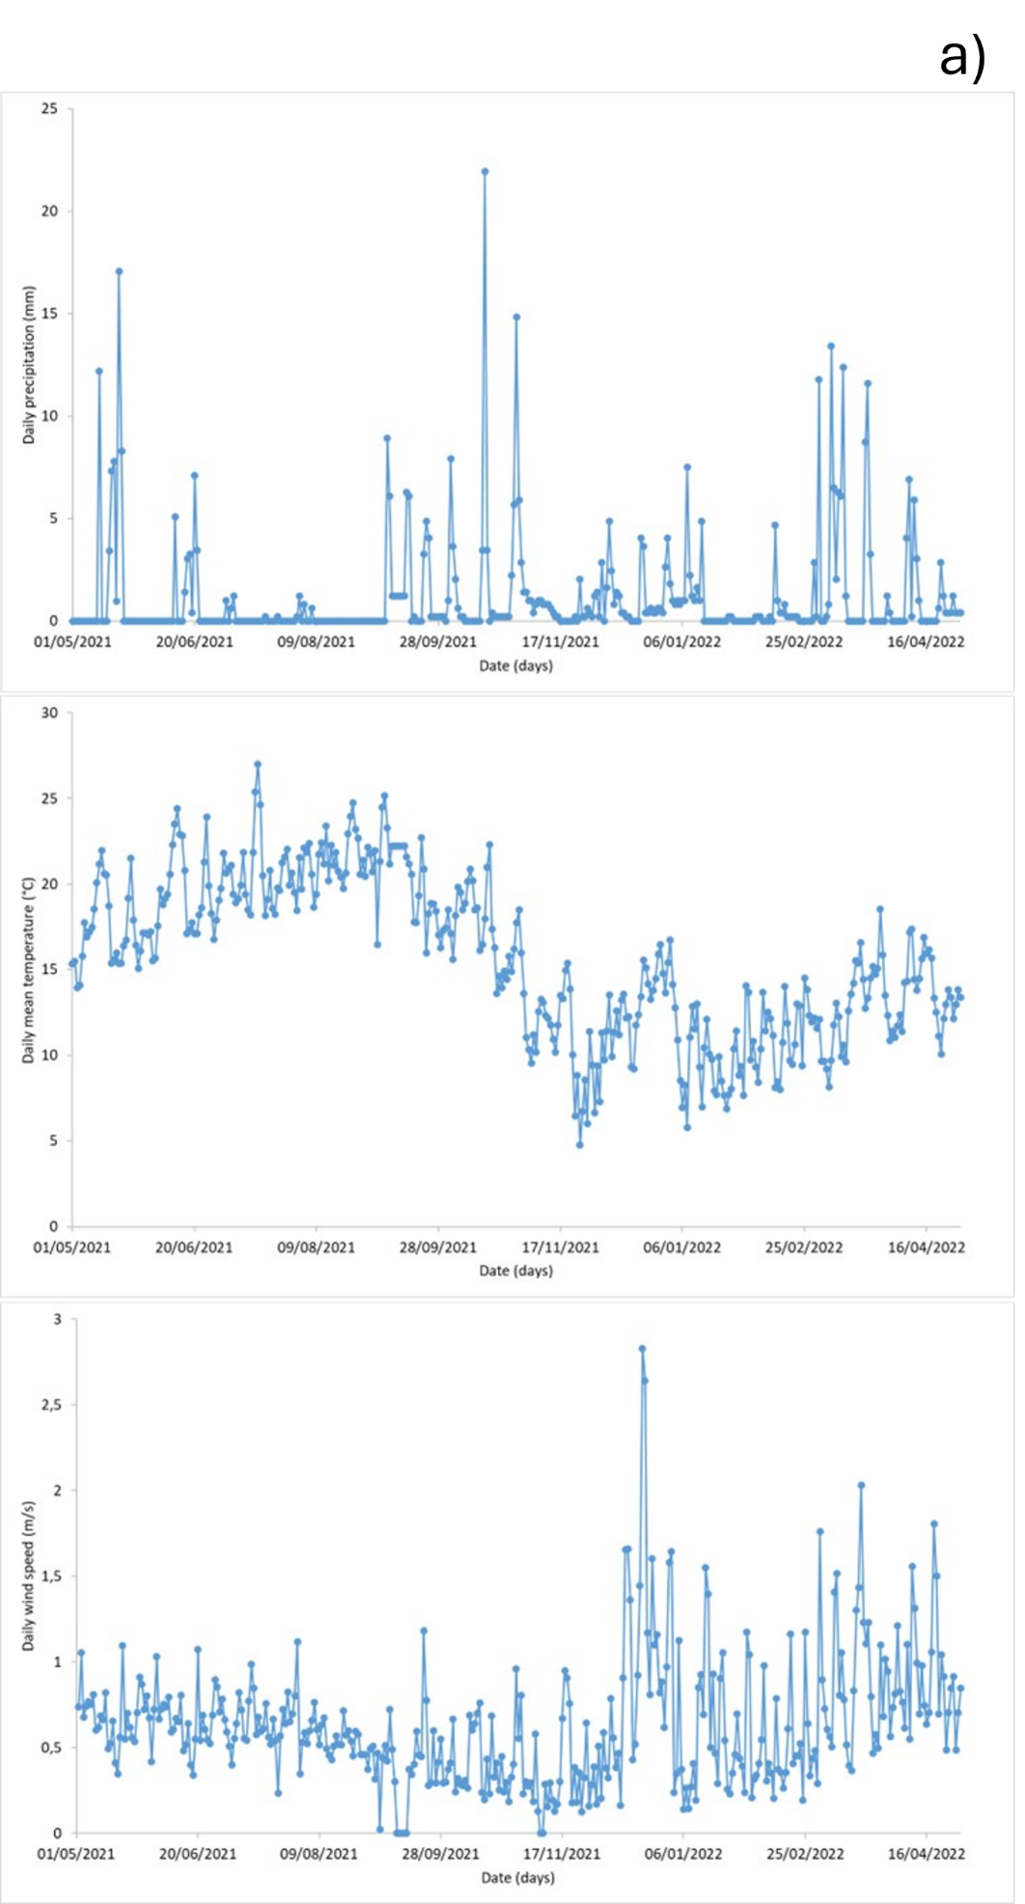
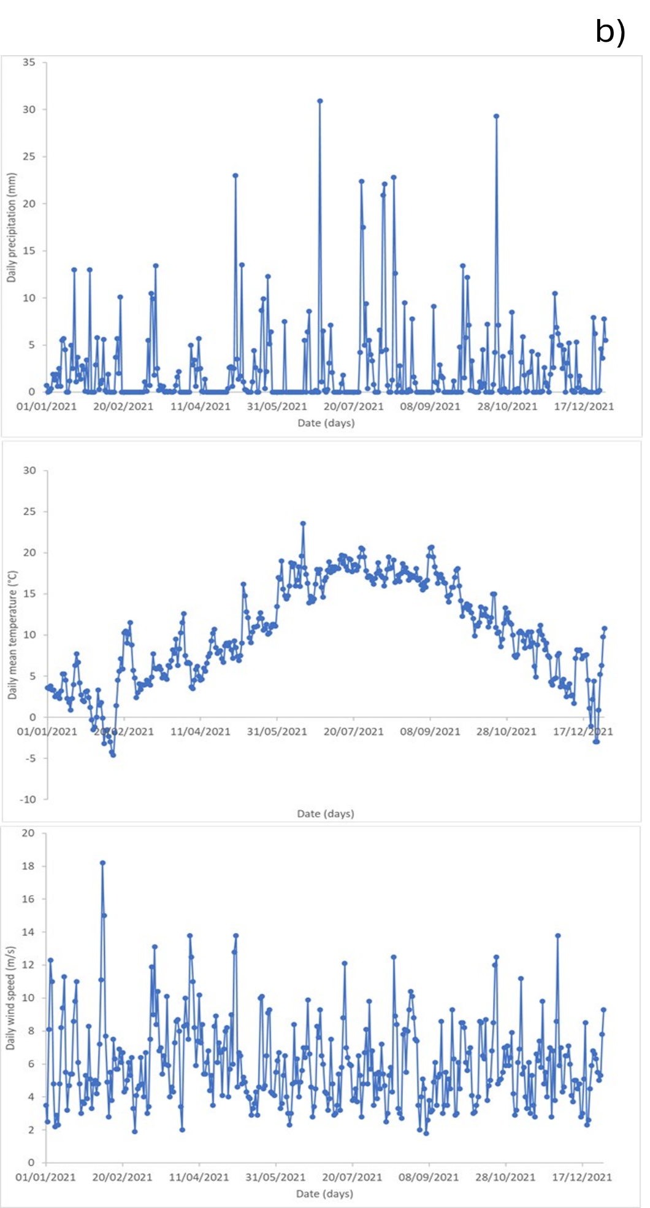

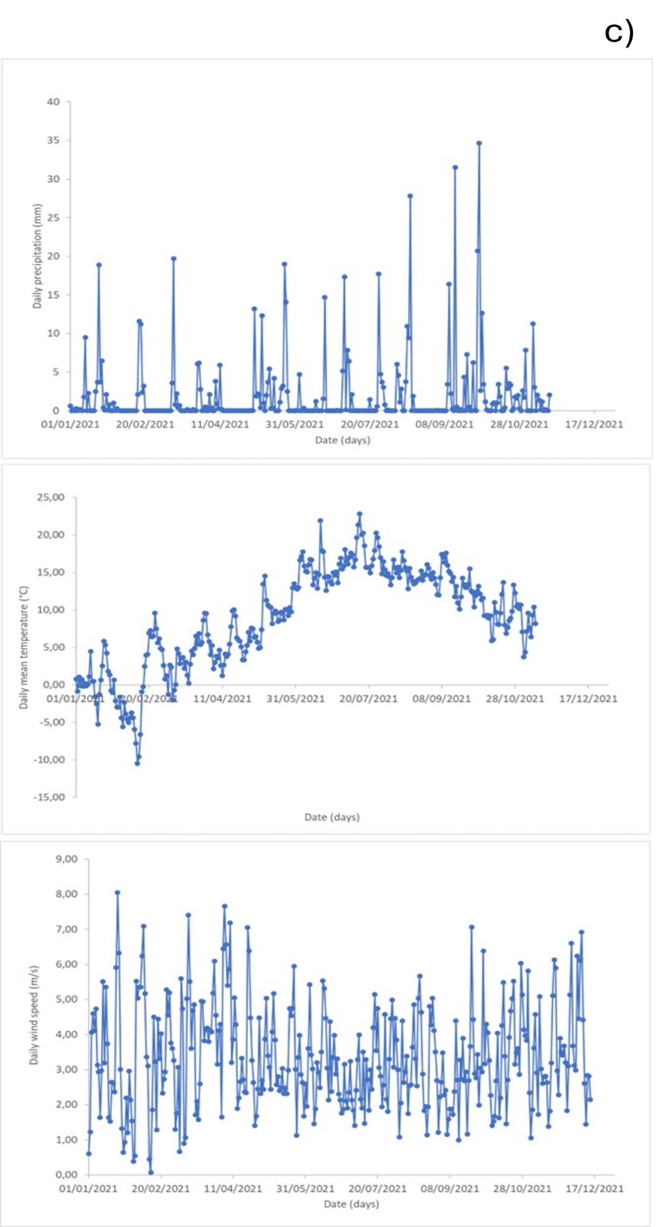
Figure SM1. Atmospheric temperature (°C), rainfall (mm) and wind speed (m/s) collected by the closest available weather stations to the case study fields in Portugal (a), the Netherlands (b) and Denmark (c).

Table SM4. Monitored PPPs concentrations in the soil of the plots taken into consideration in the three countries.
PT
Sampling time | Field | Concentrations (µg kg ⁻¹)
Sampling time | Field | Dimethomorph | Metalaxyl-M |  | Tebuconazole
20/07/2021 | Field 1 | 204.4 (day 25 after application; 50 simulated value) | 6.4 (day 109 after application; 0.0 simulated value at day 100) |  | 86.6 (day 71 after application; 30 simulated value)
20/07/2021 | Field 2 | 64.3 (day 61 after application; 60 simulated value) | 136.8 (day 103 after application; 0.0 simulated value at day 100) |  | 15.2 (day 74 after application; 20 simulated value)
20/07/2021 | Field 3 | 14.5 (day 61 after application; 70 simulated value) | 82.5 (day 103 after application; 0.0 simulated value at day 100) |  | 7.7 (day 74 after application; 20 simulated value)
18/08/2021 | Field 1 | 128.8 (day 55 after application; 30 simulated value) | 3.6 (day 140 after application; 0.0 simulated value at day 100) |  | 94.4 (day 100 after application; 20 simulated value)
18/08/2021 | Field 2 | 116.7 (day 91; 40 simulated value) | 110.8 (day 134 after application; 0.0 simulated value at day 100) |  | 47.9 (day 103 after application; 10 simulated value at day 100)
18/08/2021 | Field 3 | 21.3 (day 91; 40 simulated value) | 77.1 (day 134 after application; 0.0 simulated value at day 100) |  | 14.1(day 103 after application; 10 simulated value at day 100)
14/10/2021 | Field 1 | 67.9* | no data available |  | 54.2*
14/10/2021 | Field 2 | 48.8* | 10.3* |  | 16.9*
14/10/2021 | Field 3 | 12.7* | 6.6* |  | 10.0*
NL
Sampling time | Field | Concentrations (µg kg ⁻¹)
Sampling time | Field | Acetamiprid |  | Mandipropamid
30/06/2021 | Field 1 | <LOD* |  | 13.4 (day 4 after application; 207 simulated value)
30/06/2021 | Field 2 | <LOD * |  | 20.7 (day 4 after application; 207 simulated value)
21/06/2021 | Field 3 | <LOD (day 5 after application; 14 simulated value) |  | 16.3 ( day 13 after application, 403 simulated value)
DK
Sampling time | Field | Concentrations (µg kg ⁻¹)
Sampling time | Field | Diflufenican |  | Prosulfocarb
24/06/2021 | Field 1 | 3.2 (day 45 after application, 75 simulated value) |  | <LOD (not applied in field 1)
08/06/2021 | Field 2 | 29* |  | 3.1*
Note: the limit of detection (LODs) in soil was of 1.3 µg kg⁻¹ for all PPPs considered; * no simulation data available.

Table SM5. TERacute and TERchronic calculation for earthworms in the Portuguese, Dutch and Danish CSS.
PT CSS
 | TERacute results
Time (days) | Dimethomorph TERacute (-) |  |  | metalaxyl-M TERacute (-) |  |  | Tebuconazole TERacute (-)
Time (days) | Field 1 | Field 2 | Field 3 | Field 1 | Field 2 | Field 3 | Field 1 | Field 2 | Field 3
0 | 1E+03 | 5E+02 | 5E+02 | 2E+03 | 2E+03 | 2E+03 | 4E+03 | 3E+03 | 3E+03
1 | 1E+03 | 5E+02 | 5E+02 | 2E+03 | 2E+03 | 2E+03 | 4E+03 | 3E+03 | 3E+03
2 | 1E+03 | 5E+02 | 5E+02 | 2E+03 | 2E+03 | 2E+03 | 4E+03 | 3E+03 | 3E+03
3 | 1E+03 | 5E+02 | 5E+02 | 3E+03 | 3E+03 | 2E+03 | 4E+03 | 3E+03 | 3E+03
4 | 1E+03 | 5E+02 | 5E+02 | 3E+03 | 3E+03 | 3E+03 | 4E+03 | 3E+03 | 3E+03
5 | 2E+03 | 5E+02 | 5E+02 | 3E+03 | 3E+03 | 3E+03 | 5E+03 | 3E+03 | 3E+03
6 | 2E+03 | 5E+02 | 5E+02 | 4E+03 | 4E+03 | 3E+03 | 5E+03 | 3E+03 | 3E+03
7 | 2E+03 | 6E+02 | 5E+02 | 4E+03 | 4E+03 | 4E+03 | 5E+03 | 4E+03 | 3E+03
8 | 2E+03 | 6E+02 | 5E+02 | 5E+03 | 4E+03 | 4E+03 | 5E+03 | 4E+03 | 3E+03
9 | 2E+03 | 6E+02 | 6E+02 | 5E+03 | 5E+03 | 5E+03 | 5E+03 | 4E+03 | 4E+03
10 | 2E+03 | 6E+02 | 6E+02 | 6E+03 | 5E+03 | 5E+03 | 5E+03 | 4E+03 | 4E+03
11 | 2E+03 | 6E+02 | 6E+02 | 6E+03 | 6E+03 | 6E+03 | 5E+03 | 4E+03 | 4E+03
12 | 2E+03 | 6E+02 | 6E+02 | 7E+03 | 7E+03 | 6E+03 | 5E+03 | 4E+03 | 4E+03
13 | 2E+03 | 6E+02 | 6E+02 | 8E+03 | 7E+03 | 7E+03 | 5E+03 | 4E+03 | 4E+03
14 | 2E+03 | 6E+02 | 6E+02 | 9E+03 | 8E+03 | 8E+03 | 6E+03 | 4E+03 | 4E+03
15 | 2E+03 | 7E+02 | 6E+02 | 1E+04 | 9E+03 | 9E+03 | 2E+03 | 4E+03 | 4E+03
16 | 2E+03 | 7E+02 | 6E+02 | 1E+04 | 1E+04 | 1E+04 | 2E+03 | 4E+03 | 4E+03
17 | 2E+03 | 7E+02 | 6E+02 | 1E+04 | 1E+04 | 1E+04 | 2E+03 | 4E+03 | 4E+03
18 | 2E+03 | 7E+02 | 7E+02 | 1E+04 | 1E+04 | 1E+04 | 3E+03 | 5E+03 | 4E+03
19 | 2E+03 | 7E+02 | 7E+02 | 2E+04 | 1E+04 | 1E+04 | 3E+03 | 5E+03 | 4E+03
20 | 2E+03 | 7E+02 | 7E+02 | 2E+04 | 2E+04 | 2E+04 | 3E+03 | 5E+03 | 5E+03
21 | 2E+03 | 7E+02 | 7E+02 | 2E+04 | 2E+04 | 2E+04 | 3E+03 | 5E+03 | 5E+03
22 | 2E+03 | 7E+02 | 7E+02 | 2E+04 | 2E+04 | 2E+04 | 3E+03 | 5E+03 | 5E+03
23 | 2E+03 | 8E+02 | 7E+02 | 2E+04 | 2E+04 | 2E+04 | 3E+03 | 5E+03 | 5E+03
24 | 2E+03 | 8E+02 | 7E+02 | 3E+04 | 2E+04 | 2E+04 | 3E+03 | 5E+03 | 5E+03
25 | 2E+03 | 8E+02 | 8E+02 | 3E+04 | 3E+04 | 3E+04 | 3E+03 | 5E+03 | 5E+03
26 | 2E+03 | 8E+02 | 8E+02 | 3E+04 | 3E+04 | 3E+04 | 3E+03 | 5E+03 | 5E+03
27 | 2E+03 | 8E+02 | 8E+02 | 4E+04 | 3E+04 | 3E+04 | 3E+03 | 6E+03 | 5E+03
28 | 2E+03 | 8E+02 | 8E+02 | 4E+04 | 4E+04 | 4E+04 | 3E+03 | 6E+03 | 5E+03
29 | 2E+03 | 9E+02 | 8E+02 | 4E+04 | 4E+04 | 4E+04 | 3E+03 | 6E+03 | 6E+03
30 | 2E+03 | 9E+02 | 8E+02 | 5E+04 | 5E+04 | 4E+04 | 3E+03 | 6E+03 | 6E+03
31 | 3E+03 | 9E+02 | 8E+02 | 6E+04 | 5E+04 | 5E+04 | 3E+03 | 6E+03 | 6E+03
32 | 3E+03 | 9E+02 | 9E+02 | 6E+04 | 6E+04 | 6E+04 | 3E+03 | 6E+03 | 6E+03
33 | 3E+03 | 9E+02 | 9E+02 | 7E+04 | 6E+04 | 6E+04 | 4E+03 | 6E+03 | 6E+03
34 | 3E+03 | 9E+02 | 9E+02 | 8E+04 | 7E+04 | 7E+04 | 4E+03 | 6E+03 | 6E+03
35 | 3E+03 | 1E+03 | 9E+02 | 8E+04 | 8E+04 | 8E+04 | 4E+03 | 7E+03 | 6E+03
36 | 3E+03 | 1E+03 | 9E+02 | 9E+04 | 8E+04 | 8E+04 | 4E+03 | 7E+03 | 6E+03
37 | 3E+03 | 1E+03 | 9E+02 | 1E+05 | 9E+04 | 9E+04 | 4E+03 | 7E+03 | 7E+03
38 | 3E+03 | 1E+03 | 1E+03 | 1E+05 | 1E+05 | 1E+05 | 4E+03 | 7E+03 | 7E+03
39 | 3E+03 | 1E+03 | 1E+03 | 1E+05 | 1E+05 | 1E+05 | 4E+03 | 7E+03 | 7E+03
40 | 3E+03 | 1E+03 | 1E+03 | 1E+05 | 1E+05 | 1E+05 | 4E+03 | 7E+03 | 7E+03
41 | 3E+03 | 1E+03 | 1E+03 | 2E+05 | 1E+05 | 1E+05 | 4E+03 | 8E+03 | 7E+03
42 | 3E+03 | 1E+03 | 1E+03 | 2E+05 | 2E+05 | 2E+05 | 4E+03 | 8E+03 | 7E+03
43 | 3E+03 | 1E+03 | 1E+03 | 2E+05 | 2E+05 | 2E+05 | 4E+03 | 8E+03 | 8E+03
44 | 3E+03 | 1E+03 | 1E+03 | 2E+05 | 2E+05 | 2E+05 | 5E+03 | 8E+03 | 8E+03
45 | 3E+03 | 1E+03 | 1E+03 | 3E+05 | 2E+05 | 2E+05 | 5E+03 | 8E+03 | 8E+03
46 | 3E+03 | 1E+03 | 1E+03 | 3E+05 | 3E+05 | 3E+05 | 5E+03 | 8E+03 | 8E+03
47 | 3E+03 | 1E+03 | 1E+03 | 3E+05 | 3E+05 | 3E+05 | 5E+03 | 9E+03 | 8E+03
48 | 3E+03 | 1E+03 | 1E+03 | 4E+05 | 3E+05 | 3E+05 | 5E+03 | 9E+03 | 8E+03
49 | 4E+03 | 1E+03 | 1E+03 | 4E+05 | 4E+05 | 4E+05 | 5E+03 | 9E+03 | 9E+03
50 | 4E+03 | 1E+03 | 1E+03 | 4E+05 | 4E+05 | 4E+05 | 5E+03 | 9E+03 | 9E+03
51 | 4E+03 | 1E+03 | 1E+03 | 4E+05 | 4E+05 | 4E+05 | 5E+03 | 1E+04 | 9E+03
52 | 4E+03 | 1E+03 | 1E+03 | 4E+05 | 4E+05 | 4E+05 | 5E+03 | 1E+04 | 9E+03
53 | 4E+03 | 1E+03 | 1E+03 | 8E+05 | 4E+05 | 4E+05 | 6E+03 | 1E+04 | 9E+03
54 | 4E+03 | 1E+03 | 1E+03 | 8E+05 | 8E+05 | 8E+05 | 6E+03 | 1E+04 | 1E+04
55 | 4E+03 | 1E+03 | 1E+03 | 8E+05 | 8E+05 | 8E+05 | 6E+03 | 1E+04 | 1E+04
56 | 4E+03 | 1E+03 | 1E+03 | 8E+05 | 8E+05 | 8E+05 | 6E+03 | 1E+04 | 1E+04
57 | 4E+03 | 1E+03 | 1E+03 | 8E+05 | 8E+05 | 8E+05 | 6E+03 | 1E+04 | 1E+04
58 | 4E+03 | 1E+03 | 1E+03 | 8E+05 | 8E+05 | 8E+05 | 6E+03 | 1E+04 | 1E+04
59 | 4E+03 | 2E+03 | 1E+03 | 8E+05 | 8E+05 | 8E+05 | 6E+03 | 1E+04 | 1E+04
60 | 4E+03 | 2E+03 | 1E+03 | 8E+05 | 8E+05 | 8E+05 | 6E+03 | 1E+04 | 1E+04
61 | 4E+03 | 2E+03 | 1E+03 | 8E+05 | 8E+05 | 8E+05 | 7E+03 | 1E+04 | 1E+04
62 | 5E+03 | 2E+03 | 2E+03 | 8E+05 | 8E+05 | 8E+05 | 7E+03 | 1E+04 | 1E+04
63 | 5E+03 | 2E+03 | 2E+03 | 8E+05 | 8E+05 | 8E+05 | 7E+03 | 1E+04 | 1E+04
64 | 5E+03 | 2E+03 | 2E+03 | nd | nd | 8E+05 | 7E+03 | 1E+04 | 1E+04
65 | 5E+03 | 2E+03 | 2E+03 | nd | nd | nd | 7E+03 | 1E+04 | 1E+04
66 | 5E+03 | 2E+03 | 2E+03 | nd | nd | nd | 7E+03 | 1E+04 | 1E+04
67 | 5E+03 | 2E+03 | 2E+03 | nd | nd | nd | 8E+03 | 1E+04 | 1E+04
68 | 5E+03 | 2E+03 | 2E+03 | nd | nd | nd | 8E+03 | 1E+04 | 1E+04
69 | 5E+03 | 2E+03 | 2E+03 | nd | nd | nd | 8E+03 | 1E+04 | 1E+04
70 | 5E+03 | 2E+03 | 2E+03 | nd | nd | nd | 8E+03 | 1E+04 | 1E+04
71 | 5E+03 | 2E+03 | 2E+03 | nd | nd | nd | 8E+03 | 1E+04 | 1E+04
72 | 5E+03 | 2E+03 | 2E+03 | nd | nd | nd | 8E+03 | 2E+04 | 1E+04
73 | 6E+03 | 2E+03 | 2E+03 | nd | nd | nd | 9E+03 | 2E+04 | 1E+04
74 | 6E+03 | 2E+03 | 2E+03 | nd | nd | nd | 9E+03 | 2E+04 | 2E+04
75 | 6E+03 | 2E+03 | 2E+03 | nd | nd | nd | 9E+03 | 2E+04 | 2E+04
76 | 6E+03 | 2E+03 | 2E+03 | nd | nd | nd | 9E+03 | 2E+04 | 2E+04
77 | 6E+03 | 2E+03 | 2E+03 | nd | nd | nd | 9E+03 | 2E+04 | 2E+04
78 | 6E+03 | 2E+03 | 2E+03 | nd | nd | nd | 1E+04 | 2E+04 | 2E+04
79 | 6E+03 | 2E+03 | 2E+03 | nd | nd | nd | 1E+04 | 2E+04 | 2E+04
80 | 6E+03 | 2E+03 | 2E+03 | nd | nd | nd | 1E+04 | 2E+04 | 2E+04
81 | 6E+03 | 2E+03 | 2E+03 | nd | nd | nd | 1E+04 | 2E+04 | 2E+04
82 | 7E+03 | 2E+03 | 2E+03 | nd | nd | nd | 1E+04 | 2E+04 | 2E+04
83 | 7E+03 | 2E+03 | 2E+03 | nd | nd | nd | 1E+04 | 2E+04 | 2E+04
84 | 7E+03 | 2E+03 | 2E+03 | nd | nd | nd | 1E+04 | 2E+04 | 2E+04
85 | 7E+03 | 2E+03 | 2E+03 | nd | nd | nd | 1E+04 | 2E+04 | 2E+04
86 | 7E+03 | 3E+03 | 2E+03 | nd | nd | nd | 1E+04 | 2E+04 | 2E+04
87 | 7E+03 | 3E+03 | 2E+03 | nd | nd | nd | 1E+04 | 2E+04 | 2E+04
88 | 7E+03 | 3E+03 | 3E+03 | nd | nd | nd | 1E+04 | 2E+04 | 2E+04
89 | 8E+03 | 3E+03 | 3E+03 | nd | nd | nd | 1E+04 | 2E+04 | 2E+04
90 | 8E+03 | 3E+03 | 3E+03 | nd | nd | nd | 1E+04 | 2E+04 | 2E+04
91 | 8E+03 | 3E+03 | 3E+03 | nd | nd | nd | 1E+04 | 2E+04 | 2E+04
92 | 8E+03 | 3E+03 | 3E+03 | nd | nd | nd | 1E+04 | 2E+04 | 2E+04
93 | 8E+03 | 3E+03 | 3E+03 | nd | nd | nd | 1E+04 | 2E+04 | 2E+04
94 | 8E+03 | 3E+03 | 3E+03 | nd | nd | nd | 1E+04 | 2E+04 | 2E+04
95 | 8E+03 | 3E+03 | 3E+03 | nd | nd | nd | 1E+04 | 3E+04 | 2E+04
96 | 9E+03 | 3E+03 | 3E+03 | nd | nd | nd | 1E+04 | 3E+04 | 2E+04
97 | 9E+03 | 3E+03 | 3E+03 | nd | nd | nd | 1E+04 | 3E+04 | 3E+04
98 | 9E+03 | 3E+03 | 3E+03 | nd | nd | nd | 2E+04 | 3E+04 | 3E+04
99 | 9E+03 | 3E+03 | 3E+03 | nd | nd | nd | 2E+04 | 3E+04 | 3E+04
100 | 9E+03 | 3E+03 | 3E+03 | nd | nd | nd | 2E+04 | 3E+04 | 3E+04
 | TERchronic results
Time (days) | Dimethomorph TERchronic (-) |  |  | metalaxyl-M TERchronic (-) |  |  | Tebuconazole TERchronic (-)
Time (days) | Field 1 | Field 2 | Field 3 | Field 1 | Field 2 | Field 3 | Field 1 | Field 2 | Field 3
0 | 2E+02 | 6E+01 | 6E+01 | 9E+01 | 8E+01 | 8E+01 | 3E+01 | 2E+01 | 2E+01
1 | 2E+02 | 6E+01 | 6E+01 | 1E+02 | 9E+01 | 9E+01 | 3E+01 | 2E+01 | 2E+01
2 | 2E+02 | 6E+01 | 6E+01 | 1E+02 | 1E+02 | 1E+02 | 3E+01 | 2E+01 | 2E+01
3 | 2E+02 | 6E+01 | 6E+01 | 1E+02 | 1E+02 | 1E+02 | 3E+01 | 2E+01 | 2E+01
4 | 2E+02 | 6E+01 | 6E+01 | 1E+02 | 1E+02 | 1E+02 | 3E+01 | 2E+01 | 2E+01
5 | 2E+02 | 6E+01 | 6E+01 | 1E+02 | 1E+02 | 1E+02 | 3E+01 | 2E+01 | 2E+01
6 | 2E+02 | 7E+01 | 6E+01 | 2E+02 | 2E+02 | 1E+02 | 3E+01 | 3E+01 | 2E+01
7 | 2E+02 | 7E+01 | 6E+01 | 2E+02 | 2E+02 | 2E+02 | 3E+01 | 3E+01 | 2E+01
8 | 2E+02 | 7E+01 | 7E+01 | 2E+02 | 2E+02 | 2E+02 | 4E+01 | 3E+01 | 3E+01
9 | 2E+02 | 7E+01 | 7E+01 | 2E+02 | 2E+02 | 2E+02 | 4E+01 | 3E+01 | 3E+01
10 | 2E+02 | 7E+01 | 7E+01 | 2E+02 | 2E+02 | 2E+02 | 4E+01 | 3E+01 | 3E+01
11 | 2E+02 | 7E+01 | 7E+01 | 3E+02 | 3E+02 | 2E+02 | 4E+01 | 3E+01 | 3E+01
12 | 2E+02 | 7E+01 | 7E+01 | 3E+02 | 3E+02 | 3E+02 | 4E+01 | 3E+01 | 3E+01
13 | 2E+02 | 8E+01 | 7E+01 | 3E+02 | 3E+02 | 3E+02 | 4E+01 | 3E+01 | 3E+01
14 | 2E+02 | 8E+01 | 7E+01 | 4E+02 | 4E+02 | 3E+02 | 4E+01 | 3E+01 | 3E+01
15 | 2E+02 | 8E+01 | 7E+01 | 4E+02 | 4E+02 | 4E+02 | 2E+01 | 3E+01 | 3E+01
16 | 2E+02 | 8E+01 | 8E+01 | 5E+02 | 4E+02 | 4E+02 | 2E+01 | 3E+01 | 3E+01
17 | 2E+02 | 8E+01 | 8E+01 | 5E+02 | 5E+02 | 5E+02 | 2E+01 | 3E+01 | 3E+01
18 | 2E+02 | 8E+01 | 8E+01 | 6E+02 | 5E+02 | 5E+02 | 2E+01 | 3E+01 | 3E+01
19 | 2E+02 | 8E+01 | 8E+01 | 6E+02 | 6E+02 | 6E+02 | 2E+01 | 3E+01 | 3E+01
20 | 2E+02 | 9E+01 | 8E+01 | 7E+02 | 7E+02 | 6E+02 | 2E+01 | 3E+01 | 3E+01
21 | 2E+02 | 9E+01 | 8E+01 | 8E+02 | 8E+02 | 7E+02 | 2E+01 | 4E+01 | 3E+01
22 | 3E+02 | 9E+01 | 9E+01 | 9E+02 | 8E+02 | 8E+02 | 2E+01 | 4E+01 | 3E+01
23 | 3E+02 | 9E+01 | 9E+01 | 1E+03 | 9E+02 | 9E+02 | 2E+01 | 4E+01 | 4E+01
24 | 3E+02 | 9E+01 | 9E+01 | 1E+03 | 1E+03 | 1E+03 | 2E+01 | 4E+01 | 4E+01
25 | 3E+02 | 9E+01 | 9E+01 | 1E+03 | 1E+03 | 1E+03 | 2E+01 | 4E+01 | 4E+01
26 | 3E+02 | 1E+02 | 9E+01 | 1E+03 | 1E+03 | 1E+03 | 2E+01 | 4E+01 | 4E+01
27 | 3E+02 | 1E+02 | 9E+01 | 2E+03 | 1E+03 | 1E+03 | 2E+01 | 4E+01 | 4E+01
28 | 3E+02 | 1E+02 | 1E+02 | 2E+03 | 2E+03 | 2E+03 | 2E+01 | 4E+01 | 4E+01
29 | 3E+02 | 1E+02 | 1E+02 | 2E+03 | 2E+03 | 2E+03 | 2E+01 | 4E+01 | 4E+01
30 | 3E+02 | 1E+02 | 1E+02 | 2E+03 | 2E+03 | 2E+03 | 2E+01 | 4E+01 | 4E+01
31 | 3E+02 | 1E+02 | 1E+02 | 2E+03 | 2E+03 | 2E+03 | 2E+01 | 4E+01 | 4E+01
32 | 3E+02 | 1E+02 | 1E+02 | 3E+03 | 2E+03 | 2E+03 | 3E+01 | 5E+01 | 4E+01
33 | 3E+02 | 1E+02 | 1E+02 | 3E+03 | 3E+03 | 3E+03 | 3E+01 | 5E+01 | 4E+01
34 | 3E+02 | 1E+02 | 1E+02 | 3E+03 | 3E+03 | 3E+03 | 3E+01 | 5E+01 | 4E+01
35 | 3E+02 | 1E+02 | 1E+02 | 4E+03 | 3E+03 | 3E+03 | 3E+01 | 5E+01 | 5E+01
36 | 3E+02 | 1E+02 | 1E+02 | 4E+03 | 4E+03 | 4E+03 | 3E+01 | 5E+01 | 5E+01
37 | 3E+02 | 1E+02 | 1E+02 | 4E+03 | 4E+03 | 4E+03 | 3E+01 | 5E+01 | 5E+01
38 | 3E+02 | 1E+02 | 1E+02 | 5E+03 | 4E+03 | 4E+03 | 3E+01 | 5E+01 | 5E+01
39 | 4E+02 | 1E+02 | 1E+02 | 6E+03 | 5E+03 | 5E+03 | 3E+01 | 5E+01 | 5E+01
40 | 4E+02 | 1E+02 | 1E+02 | 6E+03 | 6E+03 | 5E+03 | 3E+01 | 5E+01 | 5E+01
41 | 4E+02 | 1E+02 | 1E+02 | 7E+03 | 6E+03 | 6E+03 | 3E+01 | 5E+01 | 5E+01
42 | 4E+02 | 1E+02 | 1E+02 | 7E+03 | 7E+03 | 7E+03 | 3E+01 | 6E+01 | 5E+01
43 | 4E+02 | 1E+02 | 1E+02 | 9E+03 | 7E+03 | 7E+03 | 3E+01 | 6E+01 | 5E+01
44 | 4E+02 | 1E+02 | 1E+02 | 9E+03 | 9E+03 | 9E+03 | 3E+01 | 6E+01 | 6E+01
45 | 4E+02 | 1E+02 | 1E+02 | 1E+04 | 9E+03 | 9E+03 | 3E+01 | 6E+01 | 6E+01
46 | 4E+02 | 1E+02 | 1E+02 | 1E+04 | 1E+04 | 1E+04 | 3E+01 | 6E+01 | 6E+01
47 | 4E+02 | 1E+02 | 1E+02 | 1E+04 | 1E+04 | 1E+04 | 4E+01 | 6E+01 | 6E+01
48 | 4E+02 | 1E+02 | 1E+02 | 2E+04 | 1E+04 | 1E+04 | 4E+01 | 6E+01 | 6E+01
49 | 4E+02 | 1E+02 | 1E+02 | 2E+04 | 2E+04 | 2E+04 | 4E+01 | 7E+01 | 6E+01
50 | 4E+02 | 2E+02 | 1E+02 | 2E+04 | 2E+04 | 2E+04 | 4E+01 | 7E+01 | 6E+01
51 | 4E+02 | 2E+02 | 1E+02 | 2E+04 | 2E+04 | 2E+04 | 4E+01 | 7E+01 | 7E+01
52 | 5E+02 | 2E+02 | 2E+02 | 2E+04 | 2E+04 | 2E+04 | 4E+01 | 7E+01 | 7E+01
53 | 5E+02 | 2E+02 | 2E+02 | 4E+04 | 2E+04 | 2E+04 | 4E+01 | 7E+01 | 7E+01
54 | 5E+02 | 2E+02 | 2E+02 | 4E+04 | 4E+04 | 4E+04 | 4E+01 | 7E+01 | 7E+01
55 | 5E+02 | 2E+02 | 2E+02 | 4E+04 | 4E+04 | 4E+04 | 4E+01 | 8E+01 | 7E+01
56 | 5E+02 | 2E+02 | 2E+02 | 4E+04 | 4E+04 | 4E+04 | 4E+01 | 8E+01 | 7E+01
57 | 5E+02 | 2E+02 | 2E+02 | 4E+04 | 4E+04 | 4E+04 | 4E+01 | 8E+01 | 8E+01
58 | 5E+02 | 2E+02 | 2E+02 | 4E+04 | 4E+04 | 4E+04 | 4E+01 | 8E+01 | 8E+01
59 | 5E+02 | 2E+02 | 2E+02 | 4E+04 | 4E+04 | 4E+04 | 5E+01 | 8E+01 | 8E+01
60 | 5E+02 | 2E+02 | 2E+02 | 4E+04 | 4E+04 | 4E+04 | 5E+01 | 8E+01 | 8E+01
61 | 5E+02 | 2E+02 | 2E+02 | 4E+04 | 4E+04 | 4E+04 | 5E+01 | 9E+01 | 8E+01
62 | 5E+02 | 2E+02 | 2E+02 | 4E+04 | 4E+04 | 4E+04 | 5E+01 | 9E+01 | 8E+01
63 | 6E+02 | 2E+02 | 2E+02 | 4E+04 | 4E+04 | 4E+04 | 5E+01 | 9E+01 | 9E+01
64 | 6E+02 | 2E+02 | 2E+02 | nd | nd | 4E+04 | 5E+01 | 9E+01 | 9E+01
65 | 6E+02 | 2E+02 | 2E+02 | nd | nd | nd | 5E+01 | 9E+01 | 9E+01
66 | 6E+02 | 2E+02 | 2E+02 | nd | nd | nd | 5E+01 | 1E+02 | 9E+01
67 | 6E+02 | 2E+02 | 2E+02 | nd | nd | nd | 5E+01 | 1E+02 | 9E+01
68 | 6E+02 | 2E+02 | 2E+02 | nd | nd | nd | 6E+01 | 1E+02 | 1E+02
69 | 6E+02 | 2E+02 | 2E+02 | nd | nd | nd | 6E+01 | 1E+02 | 1E+02
70 | 6E+02 | 2E+02 | 2E+02 | nd | nd | nd | 6E+01 | 1E+02 | 1E+02
71 | 6E+02 | 2E+02 | 2E+02 | nd | nd | nd | 6E+01 | 1E+02 | 1E+02
72 | 7E+02 | 2E+02 | 2E+02 | nd | nd | nd | 6E+01 | 1E+02 | 1E+02
73 | 7E+02 | 2E+02 | 2E+02 | nd | nd | nd | 6E+01 | 1E+02 | 1E+02
74 | 7E+02 | 2E+02 | 2E+02 | nd | nd | nd | 6E+01 | 1E+02 | 1E+02
75 | 7E+02 | 2E+02 | 2E+02 | nd | nd | nd | 7E+01 | 1E+02 | 1E+02
76 | 7E+02 | 3E+02 | 2E+02 | nd | nd | nd | 7E+01 | 1E+02 | 1E+02
77 | 7E+02 | 3E+02 | 2E+02 | nd | nd | nd | 7E+01 | 1E+02 | 1E+02
78 | 7E+02 | 3E+02 | 2E+02 | nd | nd | nd | 7E+01 | 1E+02 | 1E+02
79 | 8E+02 | 3E+02 | 3E+02 | nd | nd | nd | 7E+01 | 1E+02 | 1E+02
80 | 8E+02 | 3E+02 | 3E+02 | nd | nd | nd | 7E+01 | 1E+02 | 1E+02
81 | 8E+02 | 3E+02 | 3E+02 | nd | nd | nd | 8E+01 | 1E+02 | 1E+02
82 | 8E+02 | 3E+02 | 3E+02 | nd | nd | nd | 8E+01 | 1E+02 | 1E+02
83 | 8E+02 | 3E+02 | 3E+02 | nd | nd | nd | 8E+01 | 1E+02 | 1E+02
84 | 8E+02 | 3E+02 | 3E+02 | nd | nd | nd | 8E+01 | 1E+02 | 1E+02
85 | 8E+02 | 3E+02 | 3E+02 | nd | nd | nd | 8E+01 | 1E+02 | 1E+02
86 | 9E+02 | 3E+02 | 3E+02 | nd | nd | nd | 8E+01 | 2E+02 | 1E+02
87 | 9E+02 | 3E+02 | 3E+02 | nd | nd | nd | 9E+01 | 2E+02 | 1E+02
88 | 9E+02 | 3E+02 | 3E+02 | nd | nd | nd | 9E+01 | 2E+02 | 1E+02
89 | 9E+02 | 3E+02 | 3E+02 | nd | nd | nd | 9E+01 | 2E+02 | 2E+02
90 | 9E+02 | 3E+02 | 3E+02 | nd | nd | nd | 9E+01 | 2E+02 | 2E+02
91 | 1E+03 | 3E+02 | 3E+02 | nd | nd | nd | 9E+01 | 2E+02 | 2E+02
92 | 1E+03 | 3E+02 | 3E+02 | nd | nd | nd | 1E+02 | 2E+02 | 2E+02
93 | 1E+03 | 3E+02 | 3E+02 | nd | nd | nd | 1E+02 | 2E+02 | 2E+02
94 | 1E+03 | 4E+02 | 3E+02 | nd | nd | nd | 1E+02 | 2E+02 | 2E+02
95 | 1E+03 | 4E+02 | 3E+02 | nd | nd | nd | 1E+02 | 2E+02 | 2E+02
96 | 1E+03 | 4E+02 | 4E+02 | nd | nd | nd | 1E+02 | 2E+02 | 2E+02
97 | 1E+03 | 4E+02 | 4E+02 | nd | nd | nd | 1E+02 | 2E+02 | 2E+02
98 | 1E+03 | 4E+02 | 4E+02 | nd | nd | nd | 1E+02 | 2E+02 | 2E+02
99 | 1E+03 | 4E+02 | 4E+02 | nd | nd | nd | 1E+02 | 2E+02 | 2E+02
100 | 1E+03 | 4E+02 | 4E+02 | nd | nd | nd | 1E+02 | 2E+02 | 2E+02
NL CSS
 |  | TERacute results
Time (days) |  | Acetamiprid TERacute (-) |  |  |  | Mandipropamid TERacute (-)
 |  | Field 1&2 |  | Field 3 |  | Field 1&2 |  | Field 3
0 |  | 692.31 |  | 333.33 |  | 2325.58 |  | 2283.11
1 |  | 818.18 |  | 375.00 |  | 2347.42 |  | 2304.15
2 |  | 900.00 |  | 428.57 |  | 2369.67 |  | 2325.58
3 |  | 1000.00 |  | 473.68 |  | 2392.34 |  | 2347.42
4 |  | 1125.00 |  | 562.50 |  | 2415.46 |  | 2369.67
5 |  | 1285.71 |  | 642.86 |  | 2439.02 |  | 2392.34
6 |  | 1500.00 |  | 692.31 |  | 2463.05 |  | 2415.46
7 |  | 360.00 |  | 818.18 |  | 1587.30 |  | 2439.02
8 |  | 409.09 |  | 900.00 |  | 1602.56 |  | 1182.03
9 |  | 450.00 |  | 1000.00 |  | 1618.12 |  | 1196.17
10 |  | 529.41 |  | 1125.00 |  | 1633.99 |  | 1207.73
11 |  | 600.00 |  | 1285.71 |  | 1650.17 |  | 1216.55
12 |  | 692.31 |  | 1500.00 |  | 1666.67 |  | 1228.50
13 |  | 750.00 |  | 1800.00 |  | 1677.85 |  | 1240.69
14 |  | 900.00 |  | 1800.00 |  | 1222.49 |  | 1253.13
15 |  | 1000.00 |  | 2250.00 |  | 1234.57 |  | 1265.82
16 |  | 1125.00 |  | 2250.00 |  | 1246.88 |  | 694.44
17 |  | 1285.71 |  | 163.64 |  | 1259.45 |  | 701.26
18 |  | 1500.00 |  | 187.50 |  | 1272.26 |  | 707.21
19 |  | 1800.00 |  | 214.29 |  | 1285.35 |  | 714.29
20 |  | 1800.00 |  | 243.24 |  | 1295.34 |  | 721.50
21 |  | 2250.00 |  | 272.73 |  | 1308.90 |  | 727.80
22 |  | 2250.00 |  | 310.34 |  | 1322.75 |  | 735.29
23 |  | 3000.00 |  | 360.00 |  | 1333.33 |  | 741.84
24 |  | 3000.00 |  | 409.09 |  | 1347.71 |  | 608.27
25 |  | 3000.00 |  | 450.00 |  | 1358.70 |  | 614.25
26 |  | 4500.00 |  | 529.41 |  | 1373.63 |  | 620.35
27 |  | 4500.00 |  | 600.00 |  | 1385.04 |  | 625.78
28 |  | 4500.00 |  | 692.31 |  | 1400.56 |  | 632.11
29 |  | nd |  | 750.00 |  | 1412.43 |  | 637.76
30 |  | nd |  | 900.00 |  | 1424.50 |  | 644.33
31 |  | nd |  | 1000.00 |  | 1440.92 |  | 650.20
32 |  | nd |  | 1125.00 |  | 1453.49 |  | 657.03
33 |  | nd |  | 1285.71 |  | 1466.28 |  | 663.13
34 |  | nd |  | 473.68 |  | 1483.68 |  | 669.34
35 |  | nd |  | 529.41 |  | 1497.01 |  | 675.68
36 |  | nd |  | 600.00 |  | 1510.57 |  | 682.13
37 |  | nd |  | 692.31 |  | 1524.39 |  | 688.71
38 |  | nd |  | 818.18 |  | 1538.46 |  | 695.41
39 |  | nd |  | 900.00 |  | 1552.80 |  | 702.25
40 |  | nd |  | 1000.00 |  | 1572.33 |  | 709.22
41 |  | nd |  | 1125.00 |  | 1587.30 |  | 716.33
42 |  | nd |  | 1285.71 |  | 1602.56 |  | 722.54
43 |  | nd |  | 1500.00 |  | 1618.12 |  | 729.93
44 |  | nd |  | 1800.00 |  | 1633.99 |  | 736.38
45 |  | nd |  | 1800.00 |  | 1644.74 |  | 744.05
46 |  | nd |  | 2250.00 |  | 1661.13 |  | 750.75
47 |  | nd |  | 2250.00 |  | 1677.85 |  | 758.73
48 |  | nd |  | 3000.00 |  | 1694.92 |  | 765.70
49 |  | nd |  | 3000.00 |  | 1712.33 |  | 772.80
50 |  | nd |  | 4500.00 |  | 1730.10 |  | 780.03
 |  | TERchronic results
Time (days) |  | Acetamiprid TERchronic (-) |  |  |  | Mandipropamid TERchronic (-)
 |  | Field 1&2 |  | Field 3 |  | Field 1&2 |  | Field 3
0 |  | 96.92 |  | 46.67 |  | 74.42 |  | 73.06
1 |  | 114.55 |  | 52.50 |  | 75.12 |  | 73.73
2 |  | 126.00 |  | 60.00 |  | 75.83 |  | 74.42
3 |  | 140.00 |  | 66.32 |  | 76.56 |  | 75.12
4 |  | 157.50 |  | 78.75 |  | 77.29 |  | 75.83
5 |  | 180.00 |  | 90.00 |  | 78.05 |  | 76.56
6 |  | 210.00 |  | 96.92 |  | 78.82 |  | 77.29
7 |  | 50.40 |  | 114.55 |  | 50.79 |  | 78.05
8 |  | 57.27 |  | 126.00 |  | 51.28 |  | 37.83
9 |  | 63.00 |  | 140.00 |  | 51.78 |  | 38.28
10 |  | 74.12 |  | 157.50 |  | 52.29 |  | 38.65
11 |  | 84.00 |  | 180.00 |  | 52.81 |  | 38.93
12 |  | 96.92 |  | 210.00 |  | 53.33 |  | 39.31
13 |  | 105.00 |  | 252.00 |  | 53.69 |  | 39.70
14 |  | 126.00 |  | 252.00 |  | 39.12 |  | 40.10
15 |  | 140.00 |  | 315.00 |  | 39.51 |  | 40.51
16 |  | 157.50 |  | 315.00 |  | 39.90 |  | 22.22
17 |  | 180.00 |  | 22.91 |  | 40.30 |  | 22.44
18 |  | 210.00 |  | 26.25 |  | 40.71 |  | 22.63
19 |  | 252.00 |  | 30.00 |  | 41.13 |  | 22.86
20 |  | 252.00 |  | 34.05 |  | 41.45 |  | 23.09
21 |  | 315.00 |  | 38.18 |  | 41.88 |  | 23.29
22 |  | 315.00 |  | 43.45 |  | 42.33 |  | 23.53
23 |  | 420.00 |  | 50.40 |  | 42.67 |  | 23.74
24 |  | 420.00 |  | 57.27 |  | 43.13 |  | 19.46
25 |  | 420.00 |  | 63.00 |  | 43.48 |  | 19.66
26 |  | 630.00 |  | 74.12 |  | 43.96 |  | 19.85
27 |  | 630.00 |  | 84.00 |  | 44.32 |  | 20.03
28 |  | 630.00 |  | 96.92 |  | 44.82 |  | 20.23
29 |  | nd |  | 105.00 |  | 45.20 |  | 20.41
30 |  | nd |  | 126.00 |  | 45.58 |  | 20.62
31 |  | nd |  | 140.00 |  | 46.11 |  | 20.81
32 |  | nd |  | 157.50 |  | 46.51 |  | 21.02
33 |  | nd |  | 180.00 |  | 46.92 |  | 21.22
34 |  | nd |  | 66.32 |  | 47.48 |  | 21.42
35 |  | nd |  | 74.12 |  | 47.90 |  | 21.62
36 |  | nd |  | 84.00 |  | 48.34 |  | 21.83
37 |  | nd |  | 96.92 |  | 48.78 |  | 22.04
38 |  | nd |  | 114.55 |  | 49.23 |  | 22.25
39 |  | nd |  | 126.00 |  | 49.69 |  | 22.47
40 |  | nd |  | 140.00 |  | 50.31 |  | 22.70
41 |  | nd |  | 157.50 |  | 50.79 |  | 22.92
42 |  | nd |  | 180.00 |  | 51.28 |  | 23.12
43 |  | nd |  | 210.00 |  | 51.78 |  | 23.36
44 |  | nd |  | 252.00 |  | 52.29 |  | 23.56
45 |  | nd |  | 252.00 |  | 52.63 |  | 23.81
46 |  | nd |  | 315.00 |  | 53.16 |  | 24.02
47 |  | nd |  | 315.00 |  | 53.69 |  | 24.28
48 |  | nd |  | 420.00 |  | 54.24 |  | 24.50
49 |  | nd |  | 420.00 |  | 54.79 |  | 24.73
50 |  | nd |  | 630.00 |  | 55.36 |  | 24.96

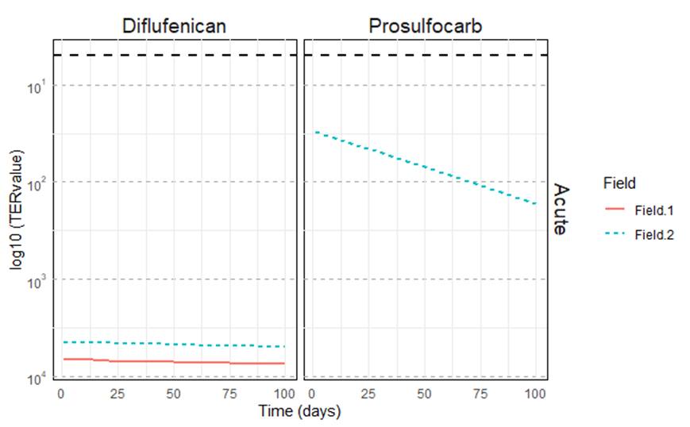
Figure SM2. Earthworms TERacute for different fields in Denmark. In the x axis the simulated days; in the y axis the log10 (TER). Each panel is a different pesticide. The black dotted line indicates TER=5 (above this value there is risk). Each line is a different field (legend on the right).

Table SM6. Monitored concentrations of the seven PPPs in selected locations for PT, NL and DK water bodies.
PT
Sampling time | Concentrations in Water (ng L⁻¹)
Sampling time | Dimethomorph | Metalaxyl-M* |  | Tebuconazole
15/06/2021 | 28.3** | 278.5** |  | 4.6 (day 21 after application, 0.1 simulated value)
24/06/2021 | 19.6 (one day before application) | 166.6** |  | 3.9 (day 29 after application, 0.06 simulated value in day 28)
01/07/2021 | 13.0 (day 6 after application, 1.8 simulated value in day 7) | 98.1** |  | 1.8**
16/07/2021 | 8.1 (day 21 after application, 0.04 simulated value) | 64.3** |  | 1.73**
14/10/2021 | 0.7** | 12.9** |  | 1.1**
NL
Sampling time | Field | Acetamiprid |  | Mandipropamid
Sampling time | Field | Water  (ng L⁻¹) | Sediment  (µg kg ⁻¹) | Water  (ng L⁻¹) | Sediment  (µg kg ⁻¹)
07/04/2021 | Field 1 | <LOD** | <LOD** | 0.9** | <LOD**
08/04/2021 | Field 3 | 0.4** | <LOD** | 0.2** | <LOD**
30/06/2021 | Field 1 | -** | <LOD** | -** | <LOD**
21/06/2021 | Field 3 | <LOD** | <LOD** | 6.8** | <LOD**
26/08/2021 | Field 1 | 35.5 (day 47 after application, 142 simulated value in day 28) | <LOD (day 47 after application, 1.9 simulated value in day 28) | 366.5(day 47 after application, 964 simulated value in day 28) | <LOD (day 47 after application, 33.2 simulated value in day 28)
25/08/2021 | Field 3 | 30.1 (day 36 after application, 95  simulated value in day 28) | <LOD (day 36 after application, 1.2  simulated value in day 28) | 47.5(day 54 after application, 1121 simulated value in day 28) | <LOD (day 54 after application, 38.7 simulated value in day 28)
10/10/2021 | Field 1 | <LOD** | <LOD** | 1.2** | <LOD**
09/10/2021 | Field 3 | 0.3** | <LOD** | 2.0** | <LOD**
DK
Sampling time | Field | Diflufenican |  | Prosulfocarb
Sampling time | Field | Water  (ng L⁻¹) | Sediment  (µg kg ⁻¹) | Water  (ng L⁻¹) | Sediment  (µg kg ⁻¹)
11/05/2021 | field 1 | <LOD (application day, 0.1 simulated value) | <LOD (application day, 0.002 simulated value) | 2.0** | <LOD**
11/05/2021 | field 2 | <LOD** | <LOD** | 1.6** | <LOD**
Note: LODs water: 0.2 ng L⁻¹ Acetamiprid, 1.1 ng L⁻¹ Mandipropamid, 0.7 ng L⁻¹ Diflufenican, 0.5 ng L-1 Prosulfocarb; LODs sediment: 0.12 µg kg⁻¹ Acetamiprid and 0.371 µg kg⁻¹ Mandipropamid; * no comparison possible as the first monitoring was made 45 days after the application and the simulation stopped after 28 days when the simulated concentration was below 10 ng L⁻¹; ** no simulation data available

Table SM7. Ecotoxicological thresholds of the selected PPPs in the water bodies of the Portuguese, Dutch and Danish case study sites and.
PPP | Toxicity for fish (Oncorhynchus mykiss) |  | Toxicity for aquatic invertebrates (Daphnia magna)
PPP | Acute 96 hour LC₅₀ (µg L⁻¹) | Chronic 21 day NOEC (µg L⁻¹) | Acute 48 hour EC₅₀ (µg L⁻¹) | Chronic 21 day NOEC (µg L⁻¹)
PT CSS
Dimethomorph | 6100  (PPDB, 2024) | 56  (PPDB, 2024) | > 20100  (PPDB, 2024) | 220  (PPDB, 2024)
Metalaxyl-M | > 100000  (PPDB, 2024) | 9100 (Pimephales promelas)  (PPDB, 2024) | > 100000  (PPDB, 2024) | 1200  (PPDB, 2024)
Tebuconazole | 4400  (PPDB, 2024) | 10  (PPDB, 2024) | 2790  (PPDB, 2024) | 10  (PPDB, 2024)
NL CSS
Acetamiprid | > 100000  (PPDB, 2024) | 19200  (PPDB, 2024) | 49800  (PPDB, 2024) | 5000  (PPDB, 2024)
Mandipropamid | > 2900  (PPDB, 2024) | 500  (PPDB, 2024) | 7100  (PPDB, 2024) | 870  (PPDB, 2024)
DK CSS
Diflufenican | > 99 (Cyprinus carpio)  (PPDB, 2024) | 15 (35 days)  (PPDB, 2024) | > 240  (PPDB, 2024) | 52  (PPDB, 2024)
Prosulfocarb | 840  (PPDB, 2024) | 310  (PPDB, 2024) | 510  (PPDB, 2024) | 45  (PPDB, 2024)
Note: *day after application; “-” no monitoring data available.

References
EC (2015). Renewal Assessment Report. Acetamiprid. Volume 3. B.8 (PPP)-Acetamiprid
EC (2018). Renewal Assessment Report. Diflufenican. Volume 3. B.8 (PPP)-Diflufenican 500SC
EC (2017). Draft Assessment Report and Proposed decision of the Netherlands prepared in the context of the possible approval of dimethomorph under Regulation (EC)1107/2009. B.8 Environmental fate and behaviour and environmental exposure assessment. VOLUME 3 – Annex B (BAS 550 02 F)
EFSA (2007). Conclusion regarding the peer review of the pesticide risk assessment of the active substance Prosulfocarb. EFSA Scientific Report 2007; 111, 1-81. doi: 10.2903/j.efsa.2007.111r
EFSA. (2012). Conclusion on the peer review of the pesticide risk assessment of the active substance Mandipropamid. EFSA Journal 2012;10(11):2935, 76 pp. doi:10.2903/j.efsa.2012.2935
EFSA (2014). Conclusion on the peer review of the pesticide risk assessment of the active substance tebuconazole. EFSA Journal 2014;12(1):3485
EFSA (2015). Conclusion on the peer review of the pesticide risk assessment of the active substance Metalaxyl-M. EFSA Journal 2015;13(3):3999, 105 pp. doi:10.2903/j.efsa.2015.3999
PPDB (2024): https://sitem.herts.ac.uk/aeru/ppdb/en/atoz.htm; last access June 16, 2025.

