Evaluation of the photocatalytic performance of construction materials for urban air depollution

S. Suárez¹ · M. D. Hernandez‑Alonso² · C. Martínez¹· B. Sanchez¹

1 Photocatalytic Treatment of Pollutants in Air, Renewable
Energy Division, CIEMAT, Avda. Computense 40, Building
42, 28040 Madrid, Spain

2 Repsol Technology Lab, C/Agustín de Betancourt s/n,
28935 Madrid, Spain

Abstract
Two commercial photocatalytic cementitious materials based on TiO₂ were studied. The photodegradation of trichloroethylene and nitric oxide as model volatile organochloride and inorganic compound at laboratory scale were evaluated. TiO₂ P25 was selected as benchmark photocatalyst. Materials were characterised by N₂ adsorption-desorption, TGA, SEM-EDX, XRD and the hydrophobic-hydrophilic nature of the surface was determined through contact angle measurements. Preliminary photoactivity tests covering a glass plate with the photocatalytic materials were performed. Moreover, real asphalt plates of around one-centimetre thickness covered with the photoactive cementitious materials were also evaluated. A notable improvement of the photocatalytic activity from the first to the second photocatalytic run was observed. Thus, sample conditioning with airflow and UV-A irradiation, allows the elimination of adsorbed species on TiO₂ active sites, i.e. carbonates, ensuring the stability under operating conditions. The cementitious samples showed complete photo-oxidation of the organochloride compound while presented less photoefficiency for nitric oxide oxidation. The results obtained with the materials deposited on glass and asphalt showed the crucial role of the sample loading and the nature of the substrate in the nitric oxide photo-oxidation. TiO₂ P25 leads to a total nitric oxide conversion but with high amount of nitrogen dioxide formation. The selected photoactive asphalt exhibited a 32 % nitric oxide conversion, lower than pure TiO₂-P25, but avoids the nitrogen dioxide release. The selected photocatalytic asphalt tested under the ISO 22197-1:2007 standard shows 29 % and 22% NO and NOx removal respectively, under more demanding operating conditions.

Keywords
Cementitious materials; photocatalysis; TiO₂; nitrogen oxides; air pollution control; photocatalytic asphalts.
Introduction

The use of photocatalytic cement and architectonic elements as passive decontamination units is getting a great deal of attention in the last years (Boonen et al. 2015; Maggos et al. 2008; Yu et al. 2017). Thus, building construction materials such as roofing membranes, external building surfaces (Baudys et al. 2015) as well as green city elements based on photocatalytic concrete (Hassan et al. 2010; Hüsken et al. 2009; Sikkema et al. 2015; Yang et al. 2019), cements (Aïssa et al. 2011; Bogutyn et al. 2015; Folli et al. 2012; Macphee and Folli 2016; Pérez-Nicolás et al. 2015) or asphalts (Toro et al. 2016) are being developed in order to obtain friendly and sustainable environmental solutions (Ângelo et al. 2013; Serpone 2018).

The environmental impact of nitrogen oxides is well known. The NOx contribute to the acid rain, and the so call photochemical smog, being the responsibility of human health problems (Butler and Williams 1993; Wayne 1993). The acid rain is based on the reaction between NO_{x} with the water present on the atmosphere to produce nitric acid, producing the deposition of acid in the biosphere. The interaction of ozone generated at the ground level with sunlight, NOx and VOCs lead to the photochemical smog phenomenon. The primary anthropogenic NOx source in the cities comes from the local traffic, mainly by the exponential increase of the diesel engines (Hüsken et al. 2009). Thus, the development of construction materials for pollution control able to reduce the concentration of these nitrogen oxides as passive elements is an exciting option for the pollution control at big cities. The NO_{x} and VOCs coexist in the troposphere, and then the development of materials able to decrease the concentration of these molecules simultaneously is focused on the interest of the scientific community and industry. Thus, municipalities and companies are promoting the development of add-value cementitious materials to be applied in urban scenarios, covering the traditional asphalts with photoactive cements.

Titanium dioxide is the most common semiconductor used for commercial purposes. Self-cleaning surfaces, cements, paints, amongst others, are being developed by the industry, taking advanced of the photocatalytic properties of the titanium oxide. The main advantages of this semiconductor have been described in several articles and mainly deals with the low price, high intrinsic photoactivity, chemical stability and low toxicity (Boyjoo et al. 2017).
Moreover, it is compatible with most of the construction materials and can be activated by the UV fraction (around 3-5%) of the sun irradiation. The generally accepted mechanism for the elimination of nitrogen oxides via photocatalytic oxidation in oxygen vibrant atmospheres goes through the photoexcitation of the semiconductor, generally TiO₂, by UV light irradiation and the formation of electrons and holes (Eq.1) (Fujishima et al. 2000; Lim et al. 2000):

The holes may react with hydroxyl surface groups (OH⁻) coming from the dissociation of water molecules leading to OH● radicals.
TiO₂h⁺ + e⁻ Eq. 1
h⁺ + OH⁻OH● Eq. 2
e⁻ + O₂ O₂^{●-} Eq. 3
O₂⁻+H⁺HO₂● Eq. 4
NO+ (OH●, HO₂●, etc) NO₂ Eq. 5
NO₂ + (OH●, HO₂●, etc) NO_{3(ads)} Eq. 6
NO_{3(ads)}+ H₂O HNO₃ Eq. 7

On the other side, electrons may react with molecular oxygen to produce O₂^{●-} superoxide anions species (Eq. 3), that can further react with H⁺ to produce HO₂● or other oxidising species such as HO₂⁻, H₂O₂ or even OH● radicals (Eq. 4). Then the nitric oxide molecule is oxidised by the powerful oxidising radicals to produce NO₃ species adsorbed on the surface (Eq. 5, Eq. 6) that in the presence of water is transformed into nitric acid (Eq. 7).

The objective of the present study was to determine the most suitable cementitious based material for the production of photocatalytic asphalts at real scale, efficient for the degradation of both volatile organic compounds and nitrogen oxides. Two commercial photoactive types of cement were selected and characterised by XRD, SEM-EDX, thermogravimetry, N₂ adsorption-desorption, analysing the modification of the hydrophobic-hydrophilic character with time. Both the TiO₂-based materials, powder samples themselves and the asphalt test tubes covered by a cementitious layer were tested at laboratory scale under UV-A irradiation and the operating conditions described at ISO 22197-1:2007. The materials were tested during several photocatalytic cycles, for more than 1,500 min, under different concentration of pollutant and catalysts amount. The effect of an initial conditioning step and the nature of the substrate were further analysed.

Experimental Section

Sample preparation
Two commercial cementitious based materials supplied by Global Engineering named as CEM-Ti-A and CEM-Ti-B were studied (Table 1). The benchmark TiO₂ P25 was also studied for comparison purposes. COMSA-EMTE provides asphalt plates with the two types of cementitious materials (2.7 cm width x 8.0 cm length and 4 kg m⁻²). Cementitious materials or TiO₂ P25 powers were immobilised on inert borosilicate glass slides (19 cm²). In order to prepare these samples, the desired TiO₂ amount was attempted to keep to 7.0 g (TiO₂) m⁻². The minimum amount of water needed to homogeneously disperse the material on the glass surface was used. Samples were heated at 100ºC in order to dry the material. Finally, samples were curing for 24 hours. Moreover, to carry out the experiments according to the operating conditions reported in ISO 22197-1:2007 samples with standard dimensions of 4.9 cm x 9.9 cm x 1 cm (width x length x thickness) were supplied by the company.

Table 1. Compositions and physicochemical properties of commercial cementitious based materials
Name | Composition  wt.% |  |  |  |  |  |  |  |  | TiO₂  _{crystal size}  nm
 |  | Al₂O₃ | SiO₂ | SO₄ | CaO | TiO₂ | Fe₂O₃ | KOH | MgOH
CEM-Ti-A |  | 3.3 | 24.8 | 4.5 | 42.6 | 9.8 | 2.2 | 0.1 | 1.5 | 35
CEM-Ti-B |  | 2.9 | 17.2 | 4.1 | 56.0 | 7.0 | 1.4 | 1.0 | 1.0 | 23
CEM-Ti-B/asphalt |  | 0.9 | 11.9 | 5.9 | 61.3 | 6.0 | 1.5 | 0.3 | 1.1 | -

Characterization techniques
A scanning electron microscopy (SEM) study of the cementitious materials and asphalt plate was carried out in a Zeiss DSM 960 coupled with an EDX Link eXL dispersive energy analyser; the samples were initially coated with a conductive layer of golden for analysis.
X-ray diffraction (XRD) analysis was performed using an X’Pert Pro PANalytical X-ray diffractometer. Bragg’s angles (2θ) between 20° and 80° were recorded at a rate of 0.02° per step and a count time of 50 s per step. Diffraction lines were assigned to the corresponding crystalline phases by comparison with powder diffraction ﬁles (PDF) from the international centre for diffraction data (ICDD) (joint committee on power diffraction standards (JCPDS)).
Thermogravimetric analysis (TGA) was done in a controlled atmosphere in a Mettler Toledo TGA/SDTA851e thermobalance from 25 °C to 900 °C with a heating ramp of 10 °C min⁻ ¹ and air ﬂow of 75 Nm L min⁻¹.
The speciﬁc sample surface area (BET area) was calculated by nitrogen adsorption at − 196 °C with a Micromeritics TriStar 3000 Gas Adsorption Analyser by outgassing the samples overnight at 250 °C to a pressure of < 1.33 × 10⁻² Pa to ensure a clean, dry surface, free from any loosely bound adsorbed species.
Contact Angle was measured with a Kruss Instrument, Easy Drop model, laying drops of 0.1 μL of water on the surface. The contact angle was estimated using the Laplace Young method. Ten receptions were performed for each sample. Initial contact angle mean values with standard deviations were calculated.

Photocatalytic activity measurements
In order to determine the photocatalytic activity of the cementitious materials, a certain amount of sample was deposited on a borosilicate glass slide, as explained above. The samples were tested for the photocatalytic degradation of trichloroethylene (C₂HCl₃) as a model volatile organic compound and for the photooxidation of nitric oxide (NO) in a one single pass fixed-bed continuous flow reactor, at a laboratory scale.
The photocatalytic activity experiments were carried out in an automatic device, which allows automatic changes of reaction parameters, such as total flow and concentration of pollutant. Moreover, this system allows recording temperature, pressure and UV-A irradiation. Photocatalytic tests were conducted in a plate-type reactor with a glass window. The photocatalyst illumination was provided by two UV-A fluorescent lamps (4.4 mW·cm⁻²). C₂HCl₃/N₂ (100 ppm) or NO/N₂ (50 ppm) gas cylinders (Air Liquid) and pure air free of water and CO₂ were used. A FTIR Thermo-Nicolet 5700 spectrometer, equipped with a temperature controller multiple reflection gas cell (optical path 2 m) maintained a 110ºC, allows the measurement of the gas composition with reaction time . The variation of C₂HCl₃ and CO₂ concentration with reaction time was evaluated as previously reported (Suárez et al. 2008). A scheme of the experimental system used is described elsewhere (Jansson et al. 2017). The analysis of the NO, NO₂ and N₂O signal was performed by following the evolution of the representative vibrational bands of the desired molecules at the following wavenumbers: NO (1953-1878 cm⁻¹), NO₂ (1662-1550 cm⁻¹) and N₂O (2272-2144 cm⁻¹). The actual concentration of nitrogen oxides was evaluated against calibration mixtures provided by Air Liquide.
Moreover, the sample with the best photocatalytic performance was further studied under the conditions described in the ISO 22197-1:2007. The experimental device is similar to the previous one, but it was designed for larger gas flows. In this case, NO concentration was supplied by a 100 ppm NO/N₂ gas cylinder. The photocatalytic reactor and the dimensions of the test tube were the ones described in the standard. Samples were pretreated under UV-A and air flow during 12 h. The NO and NOx concentration was measured by a chemiluminiscence NOx analyser (Signal Ambitech 447 NOx analyser). The photocatalytic activity was analysed at total gas flow 3,000 mL min⁻¹, 1,000 ppb NO concentration 50 % relative humidity and 10 W m⁻² UV-A irradiation. The photocatalytic activity was evaluated during 300 min reaction time.

Result and Discussion

Photocatalysts characterization
Different techniques characterised the two types of commercial cementitious powder samples in order to determine the possible influence of the physico-chemical properties in the photocatalytic efficiency. According to EDX analysis, calcium and silicon were detected as main components, with aluminium, magnesium, sulphur and iron present as minority elements (Figure 1a). In Table 1, the composition of the cementitious materials expressed as oxide is shown. The data reveal that the composition depends on the nature of the sample with an amount of CaO varying from 42% to 56 wt.% and SiO₂ with loadings of 24.8 wt.% and 17.2 wt.% for CEM-A and CEM-B respectively. Low concentrations of KOH and NaOH were detected with values lower than 1wt.%. As it can be observed TiO₂ was detected in both samples and represent a 10 or 7 wt% of the total composition for CEM-Ti-A and CEM-Ti-B respectively.

These materials were also analysed by SEM microscopy. Both samples presented similar micrographs with analogous particle morphology. In Figure 1 is shown an example of the general aspect of the CEM-Ti-B. The two samples present irregular agglomerates covered with small spheres particles ascribed to calcite and clays. Moreover, rods of different sizes mainly based on silica were detected (Figure 1 a right). According to the EDX analysis TiO₂ was well dispersed on the surface and at this magnification was not possible to distinguish the particle size. The general aspect of the photo-asphalt test tubes is depicted in Figure 1b, where white particles associated with calcium oxide and silica were detected. Moreover, holes around 20-40 µm were observed for CEM-Ti-B (Figure 1b right). A good dispersion of the TiO₂ phase through the asphalt matrix was detected for all exanimated samples.

a)

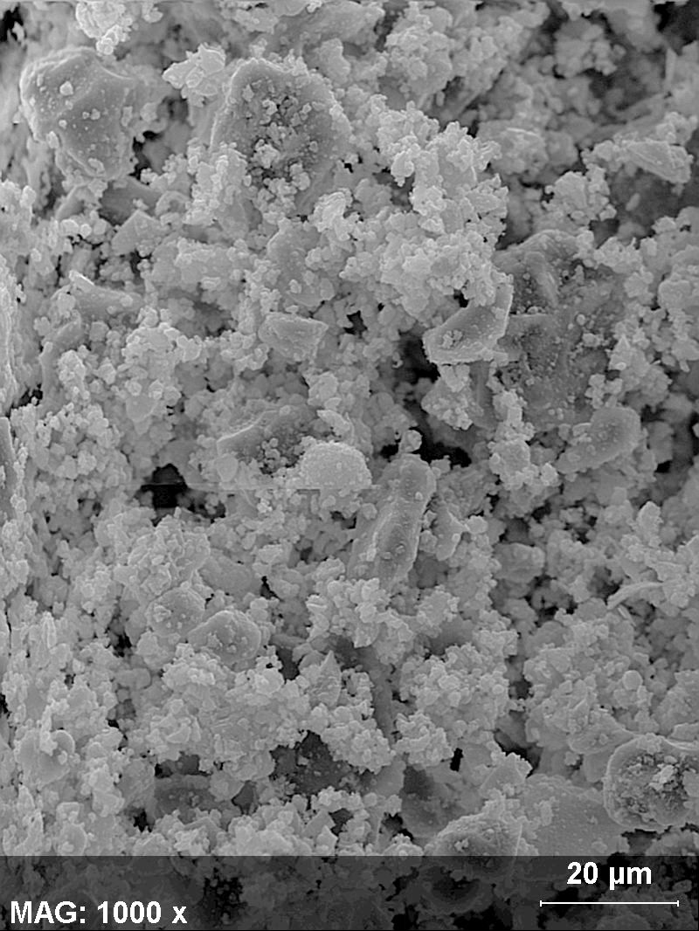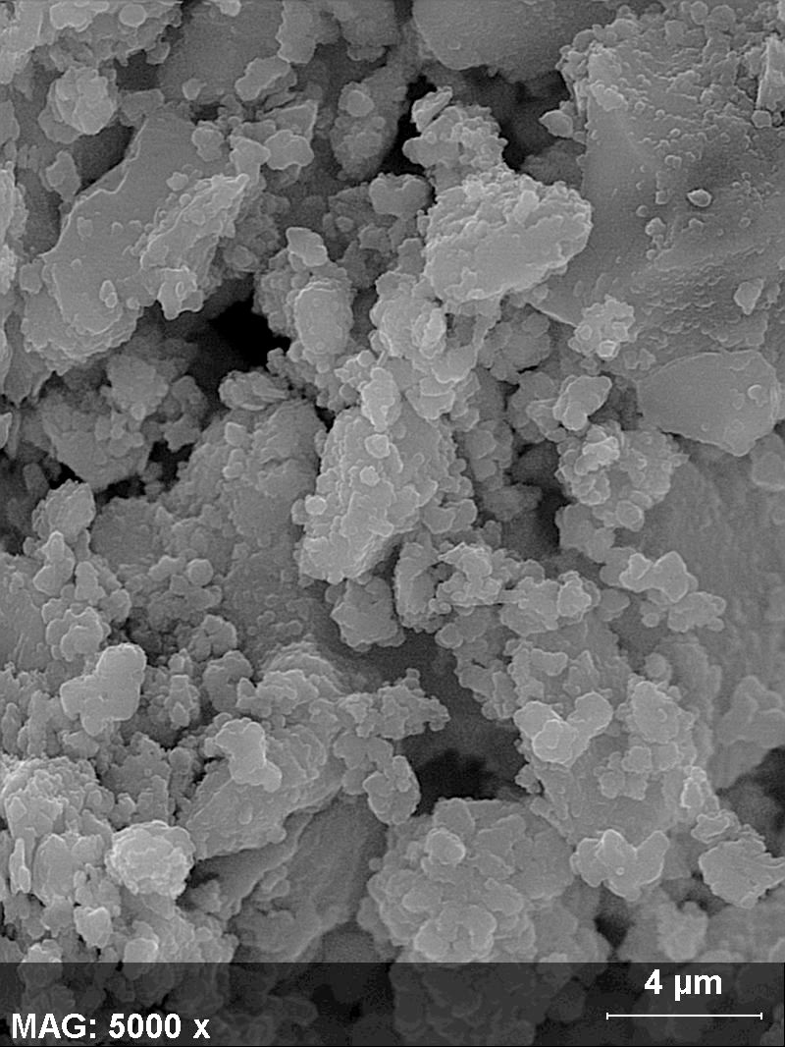

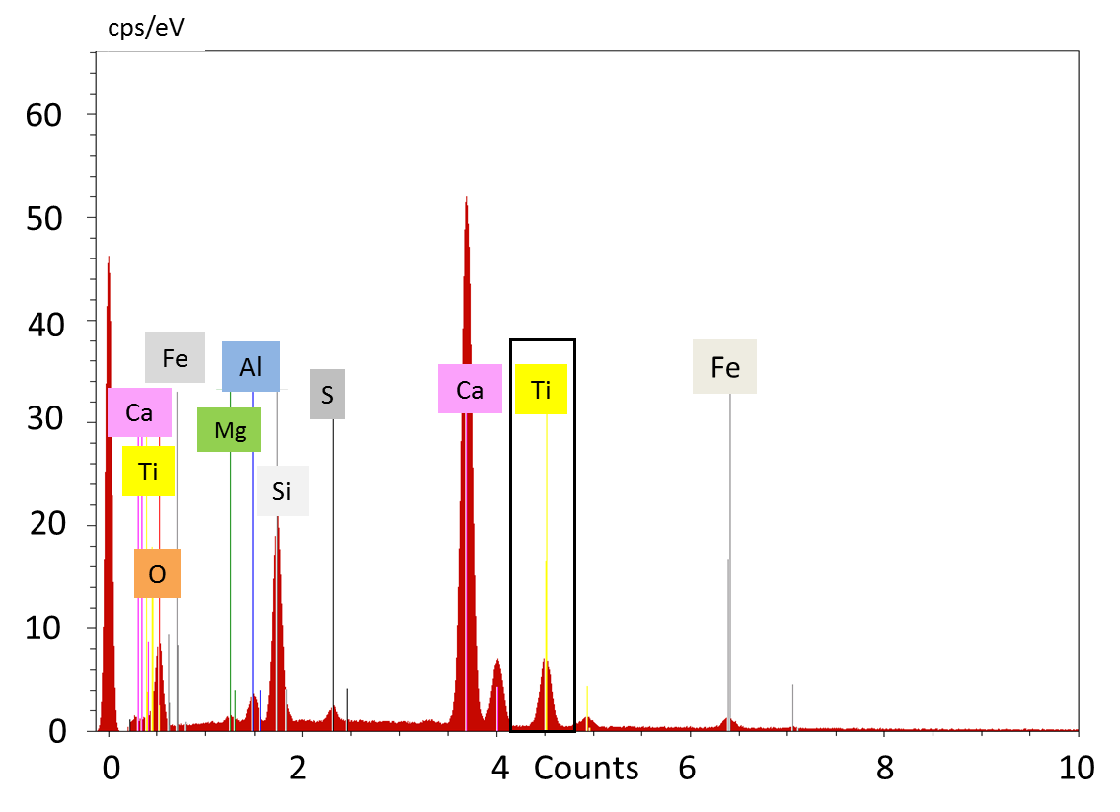

b)

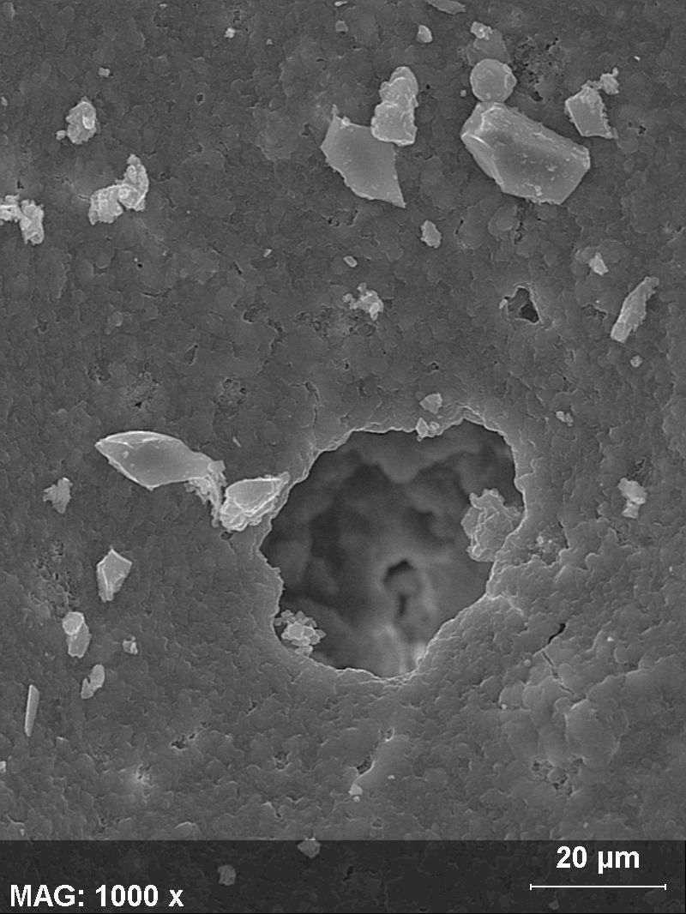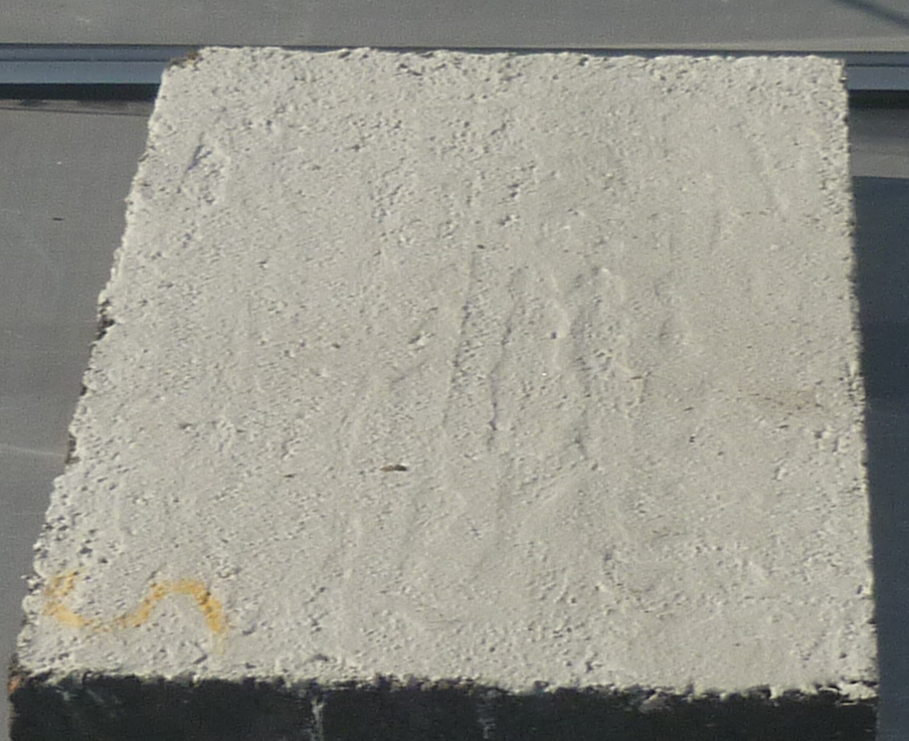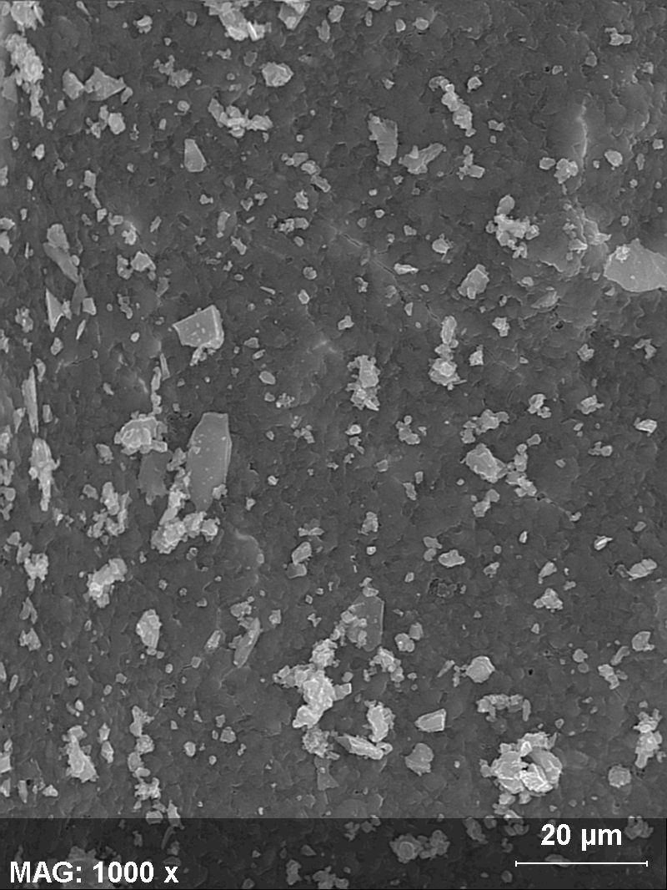

Figure 1. SEM micrographs and EDX analysis of a) CEM-Ti-B and b) CEM-Ti-B/asphalt.

In Figure 2 the X-ray diffractograms for the different cementitious materials are shown. Both samples CEM-Ti-A and CEM-Ti-B present the diffraction peaks corresponded to Ca₅₄MgAl₂Si₁₆O₉₀ (00-044-0603) phase of the cement. This phase is constituted mainly by calcium and silicon compounds in agreement with the EDX analysis (Figure 1). Moreover, SiO₂ in the quartz crystal phase (00-003-0427) and TiO₂-anatase phase (021-1272) was identified in the materials analysed. For the sake of clarity, TiO₂-P25 was included as a reference in Figure 2. The diffraction lines for (101) (200) planes can be observed in both samples, corresponded to TiO₂-anatase crystal phase. The mean TiO₂ crystal size calculated by the Sherrer´s equation showed a slight lower value for CEM-Ti-B (23 nm) compared to CEM-Ti-A (35 nm).
Figure 2. XRD difractograms for cementitious-TiO₂ based materials and TiO₂-P25. (●) TiO₂ –anatase, (*) TiO₂ –rutile, () Ca₅₄MgAl₂Si₁₆O₉₀, (□) SiO₂.

Cementitious material was characterised by N₂ adsorption-desorption and thermogravimetric analysis. The results are represented in Figure 3a and 3b, respectively. Both samples present a shallow BET area below 5 m² g⁻¹. The isotherm was classified as a Type II, with a slight hysteresis cycle H3. This type II isotherms are characteristic of a non-porous or macroporous adsorbent, characterised by a sharp increase a P/P⁰ values, indicating the existence of meso or macropores not filled at the range of partial pressure measured by this technique. The type H3 is typical of plate shape aggregates with slit shaped pores. Despite the low surface area of both cementitious materials, CEM-Ti-B showed a slighter higher porosity and surface area than CEM-Ti-A material. As it can be observed in Figure 3b, the cementitious materials were stable against the temperature changes. The sample weight loss up to 1,000ºC was below 10 % in both cases, as expecting considering the high temperature required for cement production. Despite this, three weight losses can be observed (Alarcon-Ruiz et al. 2005; Grattan-Bellew 1996; Nonnet et al. 1999; Zhou and Glasser 2001). The first weight loss, located at 100 ºC, is the result of the elimination of physisorbed water and dehydration reactions of several hydrates such as carboaluminates. The second significant weight loss, observed between 450–500 ºC, corresponds to the dehydroxylation of portlandite (Ca(OH)₂). The third weight loss appears at 750 ºC and corresponds to the decarbonisation of calcium carbonate coming from the clinker, the based material employed to prepare the cement.
b)
a)
Figure 3. a) N₂ adsorption–desorption isotherms for photoactive cements and b) thermogravimetric analysis.

The hydrophobic-hydrophilic character of the asphalt plate covered with the photocatalytic cementitious layer was measured for the two samples. An equilibrium contact angle should be reached for non-adsorbent surfaces. Nevertheless, due to the heterogeneous composition of the photocatalytic cementitious materials, a variation of the initial value with time was observed. Initial contact angle mean values of 91 ± 10 and 81 ± 11 for CEM-Ti-A/asphalt and CEM-Ti-B/asphalt respectively were obtained. The high contact angle of the former could be related to the higher silica content, according to EDX analysis. Moreover, an example of the evolution of the contact angle with time is represented in Figure 4 for CEM-Ti-B. To determine the wettability of the cementitious material, the experiments were performed in the absence of UV-A. Contact angle values near 90 º are characteristic of hydrophobic surfaces (Θ > 90). Meanwhile, glass window shows values around 40º ± 5, (Θ <90) representative of hydrophilic surfaces. Nevertheless, after 17 s the contact angle decreases to ca. 25º (Fig. 4). All the cementitious asphalts studied, showed similar behaviour. The mineral admixtures, sand types or chemical agents modify the initial contact angel and wetting behaviour of cements (Klein 2012). The physico-chemical properties of the cementitious materials were not apparently changed by the incorporation of low TiO₂ amounts.

Figure 4. Evolution of contact angle with time for CEM-Ti-B/asphalt test tube.

Photocatalytic activity results
In order to determine the inherent photocatalytic activity of cementitious materials, a borosilicate glass flat slide was covered with a homogeneous and opaque layer of the material. In a first stage, the photodegradation of C₂HCl₃ as a model VOC molecule during two consecutive cycles (100 mL min⁻¹ total flow and 30 ppm trichloroethylene) was analysed for CEM-Ti-A (Figure 5 left, sample loading 200 g m⁻²). After stabilization of the C₂HCl₃ concentration in the absence of light (time below 0 min), reaching the steady-state conditions, the sample was irradiated with UV-A light. A progressive decrease of the C₂HCl₃ concentration along to the corresponding formation of CO₂ was observed. During the first cycle, slow decay of the C₂HCl₃ concentration for CEM-Ti-A material was observed. Only a 20 % conversion was achieved after 500 min of irradiation. Then, the reaction rate increased, obtaining a change on the slope of the curve. When the same sample was submitted to the same process for a second cycle, the scenario was completed different. Efficiency near 90% after 500 min reaction time was obtained. Exponential decay for C₂HCl₃ content along to a progressive increase of the CO₂ concentration reaching a plateau at 400 min reaction time was observed.
Nevertheless, the behaviour for CEM-Ti-B sample was utterly different. In Figure 5 right, the curves obtained for CEM-Ti-A (2nd cycle) and CEM-Ti-B (1st cycle) are compared. Both materials showed an exponential decay of the C₂HCl₃ signal, more pronounced for CEM-Ti-B. The asymptotic character of the curse can be appreciated. In both cases, the total conversion of C₂HCl₃ after 600 min reaction time was achieved. The data revealed that an initial activation cycle for CEM-Ti-B was not required. Concerning the CO₂ curves, different shapes were obtained directly related to the type of cement used. Thus, the curve softly increases for CEM-Ti-A meanwhile present a peak centre at 50 min for CEM-Ti-B. Thus, the apparently inactive CEM-Ti-A material, showed total degradation of C₂HCl₃ when is submitted to a second photocatalytic cycle. This observation indicates that a previous activation treatment under UV-A irradiation and in continuous air flow is essential for the correct evaluation of the photocatalytic activity of the samples. Studying real commercial materials is a challenge, since information related to their preparation and composition is usually not provided by the suppliers. Despite this difficulty, the results obtained in this work are extremely relevant, since the photocatalytic properties of materials designed for real scale application are reported. The characterization results obtained report no significant differences in TiO₂ amounts, crystal phases, particles morphology or BET area. But the photocatalytic activity results indicate that the CEM-Ti-A should be pre-treated in order to promote the photoeficiency. During the activation step, the elimination of adsorbed species on titania active sites, i.e. carbonates according to the TGA analysis, impurities remaining from the cement composition or the preparation step, was performed. Before the photocatalytic test a pre-treatment step under UV-A irradiation and air flow for 12 h, was conducted for all samples.

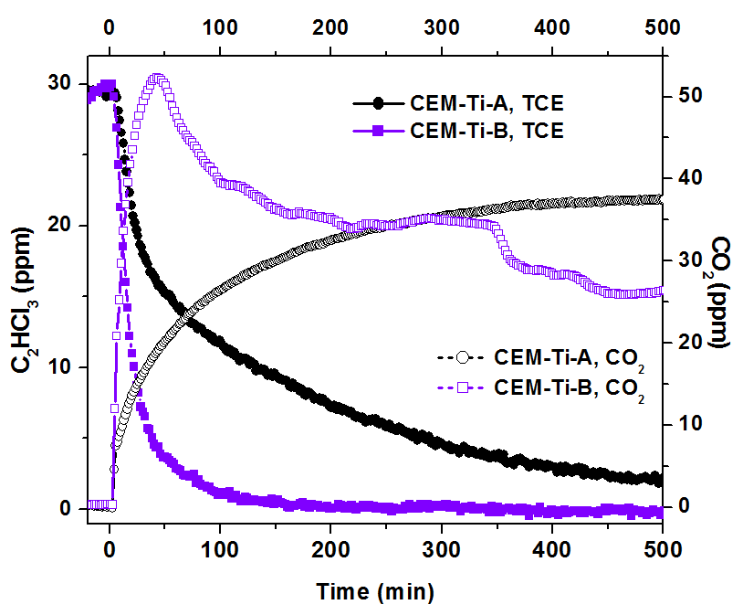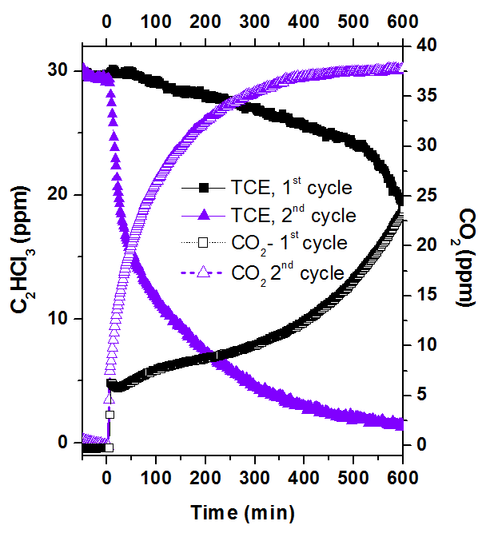
Figure 5. Photocatalytic activity results for CEM-Ti-A, for two consecutive reaction cycles (left). Comparison between CEM-Ti-A after pre-treatment and CEM-Ti-B without pre-treatment (right). Operating conditions: Total flow: 100 mL min⁻¹, [TCE] = 30 ppm.

In a second stage, the photooxidation reaction of nitric oxide was studied. The evolution of the NO and NO₂ profiles for the benchmark TiO₂- P25 and CEM-Ti-B are shown in Figure 6 a and b respectively at a total gas flow of 100 mL min⁻¹ and 5 ppm of nitric oxide. Due to the CEM-Ti-B stability under reaction conditions, was selected for this study. As in the previous case, after stabilisation of the NO signal at dark conditions, the sample was irradiated under UV-A light. TiO₂–P25 showed total degradation of NO at the conditions selected for this experiment. Moreover, a considerable amount of NO₂ was detected in the reactor outlet. After turn off the UV-A light at 900 min, the initial NO values were obtained, and the NO₂ curve rapidly reached values closed to zero. In order to compare the results with the ones obtained for TiO₂ P25, a CEM-Ti-B sample containing ca. 100 g m⁻² was prepared. This sample showed a nitric oxide conversion around 20 %. As in the case of TiO₂ P25 nitrogen dioxide was detected under UV-A irradiation. Nevertheless, this sample was evaluated for more than 30 h, and constant values of both NO and NO₂ signal were obtained. These results indicate that nitrate species adsorbed on the surface may decompose to produce NO₂ or that the NO reacts with oxidising species according to Eq. 5 to produce NO₂. These experiments were performed in the absence of water vapour in the stream and this fact could be related to the NO₂ amounts detected. In any of the cases under study, N₂O was not detected as a reaction product. Samples with less cement amount (25 g m⁻²) were also tested. A 10 % NO conversion (result not shown) was obtained, indicating the importance of the sample amount on the photocatalytic activity. Moreover, CEM-Ti-B sample was tested for three consecutive reaction cycles. The results revealed that the NO conversion was maintained indicating that no deactivation process is taking place due to the accumulation of nitrate on the surface at the studied operating conditions.
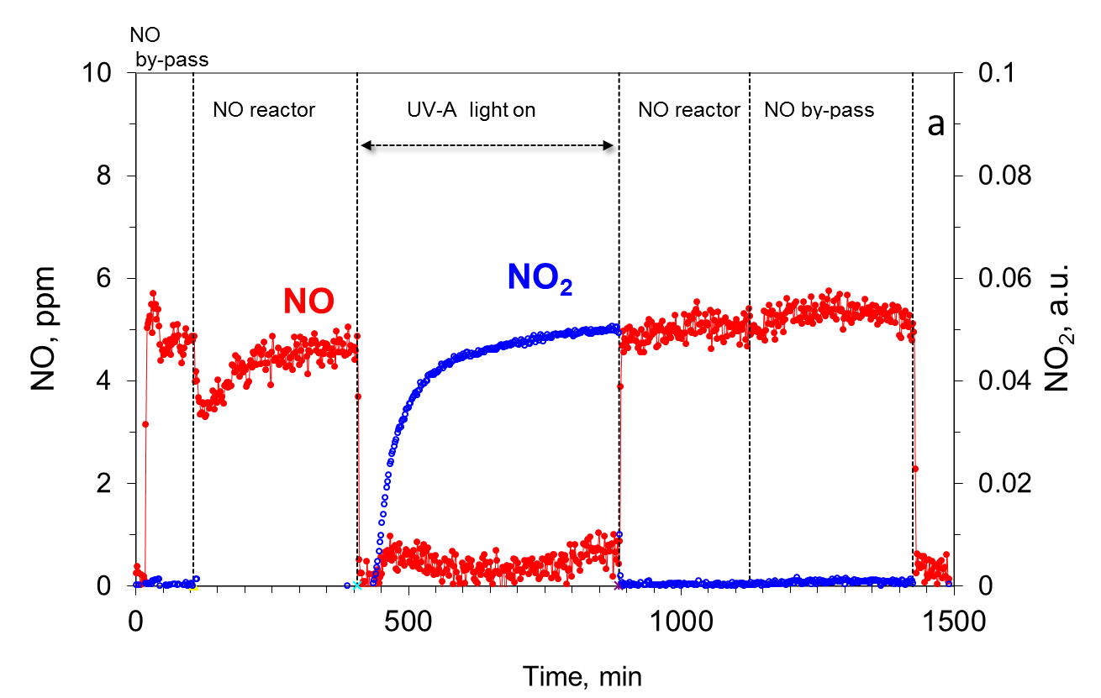
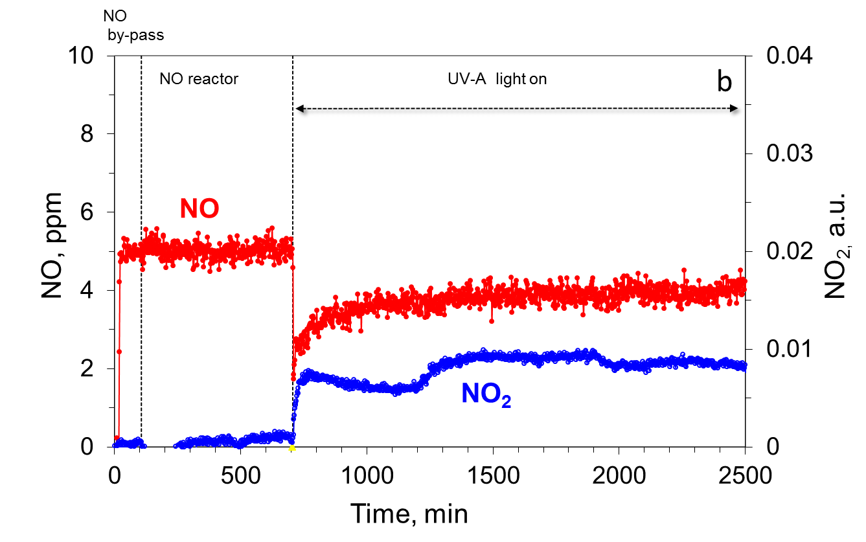
Figure 6. Photocatalytic activity results for the degradation of NO for: a) TiO₂-P25 and b) CEM-Ti-B immobilized on glass. [TiO₂] = 7.0 g m⁻². Total flow: 100 mL min⁻¹; [NO] = 5 ppm.

The photoactive asphalt plates prepared with CEM-Ti-A and CEM-Ti-B were analysed at similar reaction conditions. Unfortunately, CEM-Ti-A/asphalt did not show a significant reduction of the NO concentration under UV-A irradiation. The results obtained for CEM-Ti-B/asphalt are depicted in Figure 7. The evolution of the NO and NO₂ signals with time are represented. In this case, a significant decrease of the NO amount under UV-A irradiation was observed. A NO conversion around 32% after near 10 h reaction time was achieved. Moreover, the NO₂ signal was closed to cero during ca. 600 min reaction time. These results evidenced the importance of the conformation of material, the effect of the nature of the substrate and the material loading in the photocatalytic performance. These parameters play a significant role in the formation and undesirable release of NO₂ to the gas phase.
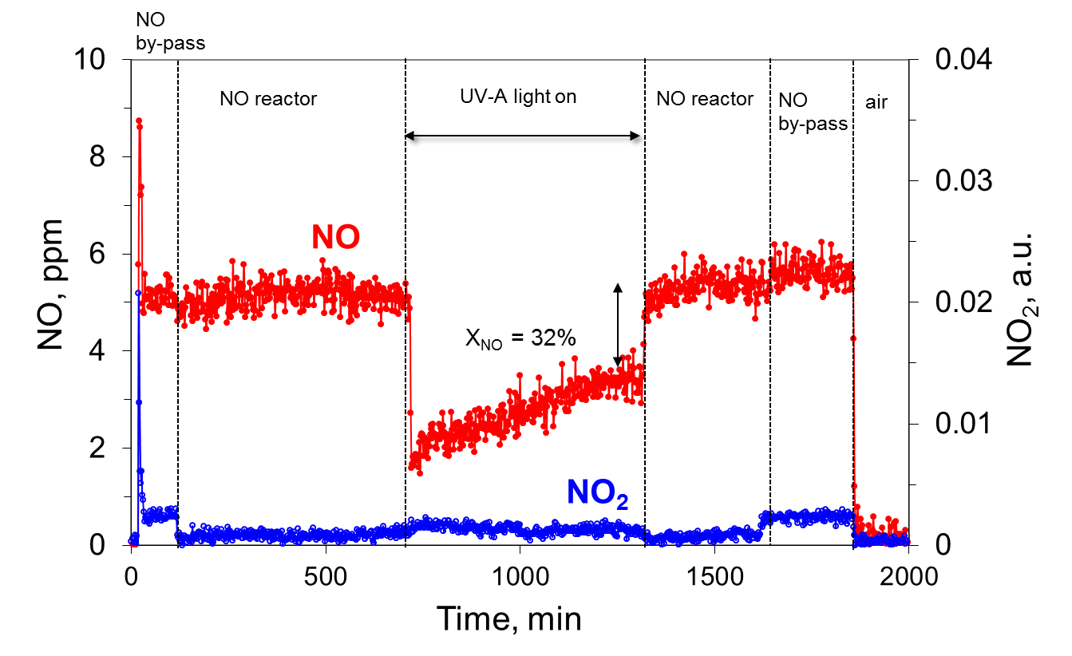
Figure 7. Photocatalytic elimination of NO for asphalt test tube prepared with CEM-Ti-B/asphalt. Total flow 100 mL min⁻¹, [NO] = 5 ppm.

Finally, the photocatalytic performance of CEM-Ti-B/asphalt was tested under stricter conditions reported in the ISO 22197-1:2007 (3,000 mL min⁻¹, 1,000 ppb NO, 50 % R.H., 10 W m⁻². Figure 8 reports the evolution of the NO and NO₂ signals with the reaction time for a typical experiment carried out under this standard. After stabilization of the NO and NO₂ at dark conditions, the sample was irradiated with UV-A during 300 min. Total NO and NOx conversion of 29% and 22 % were attained with CEM-Ti-B/asphalt. A substrate with a macroporous structure and roughness as shown in the SEM micrographs would promote the diffusion of the reactants to the titania active sites and the photocatalytic activity. It will be favoured in this way both the photooxidation process and the accumulation of nitrate species on the photocatalytic surface.

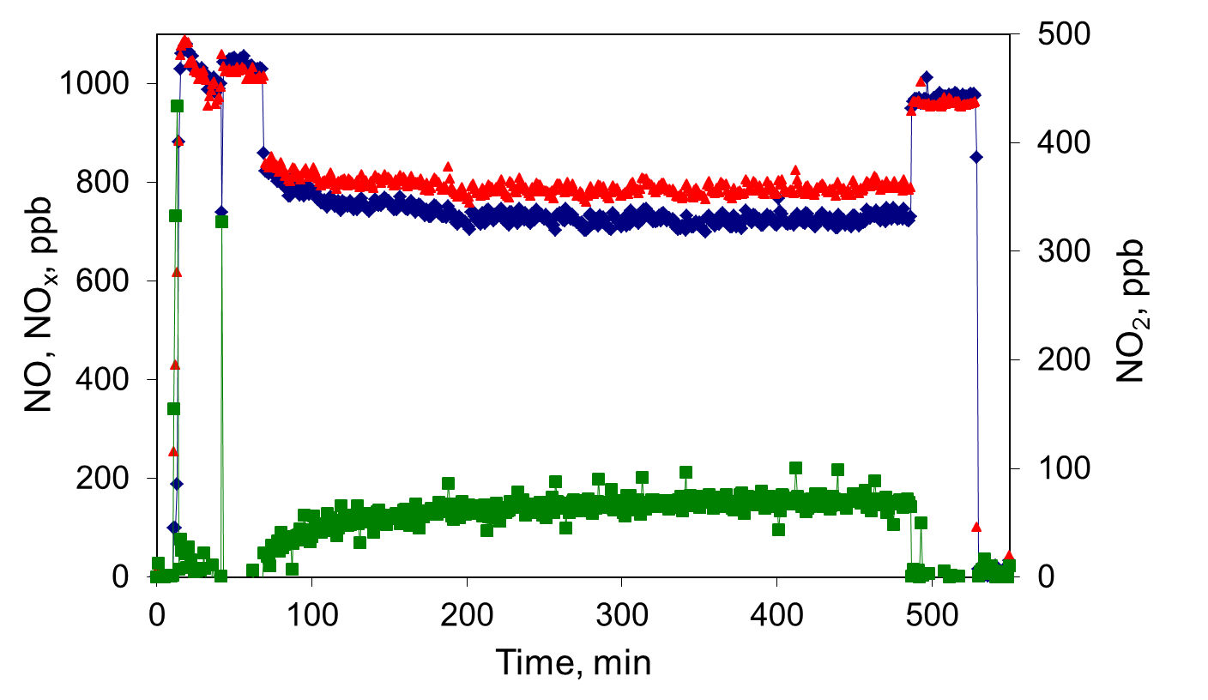
Figure 8. Photocatalytic elimination of NOx for asphalt test tube CEM-Ti-B/asphalt according to ISO 22197-1:2007 (♦) NO, () NOx eliminated and () NO₂ produced. Operating conditions: Total flow F = 3000 mL min⁻¹, [NO] = 1,000 ppb, R.H. = 50 %, I = 10 W m⁻² (UV-A).

The analysis of the mechanical properties changes and the durability of the cementitious photoactive materials is essential for applications at outdoor conditions. Mechanical properties such as compression strength, abrasion resistance, slip resistance, water adsorption and resistance to freeze-thaw with de-icing salt, among others, were studied. According to the UNE-EN 1338:2004/AC: 2006 standard, the mechanical properties of the asphalt after application of the photocatalytic layer were not modified. The effect of rolling due to the vehicle traffic or the weather conditions will be reported in a future work.

Conclusions

Photocatalytic cementitious based materials for the oxidation of trichloroethylene and nitric oxide in gas phase have been evaluated at laboratory scale. The obtained results revealed the dependence of the reaction rate with the nature of the cement components, the photoactive material loading and the effect of certain kinds of additives employed in the preparation procedure. For the correct evaluation of the photocatalytic activity a previous activation treatment under UV-A irradiation in continuous air flow, at least for twelve hours is required. During the activation step, the elimination of adsorbed species on titania active sites or impurities resulting from the composition of cement is promoted. Moreover, the effect of the nature of the substrate is clearly observed. Thus, cementitious materials tested on glass substrates presented considerable formation of NO₂ on the reactor outlet, especially when benchmark TiO₂-P25 is analysed. Nevertheless, the release of nitrogen dioxide to the gas phase on cementitious asphalt based samples is supressed. The porous structure, the roughness and the cement loading of shaped samples, play a key role in the photocatalytic performance.

Acknowledgement

The authors are grateful to the Spanish Ministry of Economy and Competiveness and the Centre for Industrial Technological Development (CDTI Ref. IDI-20180347) Spain, for the financial support. Authors are also grateful to the Universidad Politécnica de Barcelona and COMSA-EMTE (Spain) for sample supply.

References

Aïssa AH, Puzenat E, Plassais A, Herrmann J-M, Haehnel C, Guillard C (2011) Characterization and photocatalytic performance in air of cementitious materials containing TiO₂. Case study of formaldehyde removal Appl Catal B 107:1-8 doi:https://doi.org/10.1016/j.apcatb.2011.06.012
Alarcon-Ruiz L, Platret G, Massieu E, Ehrlacher A (2005) The use of thermal analysis in assessing the effect of temperature on a cement paste Cem Concr Res 35:609-613 doi:https://doi.org/10.1016/j.cemconres.2004.06.015
Ângelo J, Andrade L, Madeira LM, Mendes A (2013) An overview of photocatalysis phenomena applied to NOx abatement J Environ Manage 129:522-539 doi:https://doi.org/10.1016/j.jenvman.2013.08.006.
Baudys M, Krýsa J, Zlámal M, Mills A (2015) Weathering tests of photocatalytic facade paints containing ZnO and TiO₂ Chem Eng J 261:83-87 doi:https://doi.org/10.1016/j.cej.2014.03.112.
Bogutyn S, Arboleda C, Bordelon A, Tikalsky P (2015) Rejuvenation techniques for mortar containing photocatalytic TiO₂ material Constr Build Mater 96:96-101 doi:10.1016/j.conbuildmat.2015.07.192
Boonen E et al. (2015) Construction of a photocatalytic de-polluting field site in the Leopold II tunnel in Brussels J Environ Manage 155:136-144 doi:10.1016/j.jenvman.2015.03.001
Boyjoo Y, Sun H, Liu J, Pareek VK, Wang S (2017) A review on photocatalysis for air treatment: From catalyst development to reactor design Chem Eng J 310:537-559 doi:https://doi.org/10.1016/j.cej.2016.06.090.
Butler AR, Williams DLH (1993) The physiological role of nitric oxide Chem Soc Rev 22:233-241 doi:10.1039/CS9932200233.
Folli A, Pade C, Hansen TB, De Marco T, Macphee DE (2012) TiO₂ photocatalysis in cementitious systems: Insights into self-cleaning and depollution chemistry Cem Concr Res 42:539-548 doi:10.1016/j.cemconres.2011.12.001.
Fujishima A, Rao TN, Tryk DA (2000) Titanium dioxide photocatalysis J Photoch Photobio C 1:1-21 doi:https://doi.org/10.1016/S1389-5567(00)00002-2
Grattan-Bellew PE (1996) Microstructural investigation of deteriorated Portland cement concretes Constr Build Mater 10:3-16 doi:10.1016/0950-0618(95)00066-6.
Hassan MM, Dylla H, Mohammad LN, Rupnow T (2010) Evaluation of the durability of titanium dioxide photocatalyst coating for concrete pavement Constr Build Mater 24:1456-1461 doi:10.1016/j.conbuildmat.2010.01.009.
Hüsken G, Hunger M, Brouwers HJH (2009) Experimental study of photocatalytic concrete products for air purification Build Environ 44:2463-2474 doi:10.1016/j.buildenv.2009.04.010.
ISO 22197-1:2007 Fine ceramics (advanced ceramics, advanced technical ceramics) — Test method for air-purification performance of semiconducting photocatalytic materials — Part 1: Removal of nitric oxide.
Jansson I, Suárez, S, García-García FJ, Sánchez B, (2017) ZSM-5/TiO₂ Hybrid Photocatalysts: Influence of the Preparation Method and Synergistic Effect Topic Catal doi: 10.1007/s11244-017-0805-1.
Klein NS, Bachmann J, Aguado A, Toralles-Carbonari B (2012) Evaluation of the wettability of mortar component granular materials through contact angle measurements Cem Concr Res 42 1611–1620.
Lim TH, Jeong SM, Kim SD, Gyenis J (2000) Photocatalytic decomposition of NO by TiO₂ particles J Photoch Photobio A 134:209-217 doi:https://doi.org/10.1016/S1010-6030(00)00265-3.
Macphee DE, Folli A (2016) Photocatalytic concretes — The interface between photocatalysis and cement chemistry Cem Concr Res 85:48-54 doi:10.1016/j.cemconres.2016.03.007.
Maggos T, Plassais A, Bartzis J, Vasilakos C, Moussiopoulos N, Bonafous L (2008) Photocatalytic degradation of NOx in a pilot street canyon configuration using TiO₂ -mortar panels Environ Monit Assess 136:35-44 doi:10.1007/s10661-007-9722-2.
Nonnet E, Lequeux N, Boch P (1999) Elastic properties of high alumina cement castables from room temperature to 1600°C J Eur Ceram Soc 19:1575-1583 doi:10.1016/S0955-2219(98)00255-6.
Pérez-Nicolás M, Balbuena J, Cruz-Yusta M, Sánchez L, Navarro-Blasco I, Fernández JM, Alvarez JI (2015) Photocatalytic NOx abatement by calcium aluminate cements modified with TiO₂: Improved NO₂ conversion Cem Concr Res 70:67-76 doi:10.1016/j.cemconres.2015.01.011.
Serpone N (2018) Heterogeneous Photocatalysis and Prospects of TiO₂-Based Photocatalytic DeNOxing the Atmospheric Environment Catalysts 8:553 doi:10.3390/catal8110553.
Sikkema JK, Ong SK, Alleman JE (2015) Photocatalytic concrete pavements: Laboratory investigation of NO oxidation rate under varied environmental conditions Constr Build Mater 100:305-314 doi:https://doi.org/10.1016/j.conbuildmat.2015.10.005.
Suárez S, Coronado J, Portela R, Martín J, Yates M, Avila P, Sánchez B (2008) On the Preparation of TiO^sub 2^-Sepiolite Hybrid Materials for the Photocatalytic Degradation of TCE: Influence of TiO^sub 2^ Distribution in the Mineralization Environ Sci Technol 42:5892 doi:10.1021/es703257w.
Toro C, Jobson BT, Haselbach L, Shen S, Chung SH (2016) Photoactive roadways: Determination of CO, NO and VOC uptake coefficients and photolabile side product yields on TiO₂ treated asphalt and concrete Atmos Environ 139:37-45 doi:https://doi.org/10.1016/j.atmosenv.2016.05.007.
Wayne RP (1993) Chemistry of atmospheres : an introduction to the chemistry of the atmospheres of Earth, the Planets, and their Satellites. 2nd ed. edn. Oxford : Clarendon Press, Oxford.
Yang L, Hakki A, Zheng L, Jones MR, Wang F, Macphee DE (2019) Photocatalytic concrete for NOx abatement: Supported TiO₂ efficiencies and impacts Cem Concr Res 116:57-64 doi:https://doi.org/10.1016/j.cemconres.2018.11.002.
Yu JC-C, Nguyen V-H, Lasek J, Wu JCS (2017) Titania nanosheet photocatalysts with dominantly exposed (001) reactive facets for photocatalytic NOx abatement Appl Catal B 219:391-400 doi:10.1016/j.apcatb.2017.07.077.
Zhou Q, Glasser FP (2001) Thermal stability and decomposition mechanisms of ettringite at <120°C Cem Concr Res 31:1333-1339 doi:10.1016/S0008-8846(01)00558-0.

