A 15-year atmospheric record of intentionally produced persistent organic pollutants in Spain: Spatial gradients, thermodynamic fractionation, and temporal trends.
Adrián de la Torre¹, Juan Muñoz-Arnanz², Irene Navarro¹, Pere Colomer-Vidal², Covadonga Alonso¹, José L. Roscales², Ángeles Jiménez³, Ana García³, Begoña Jiménez²*, María Ángeles Martínez¹*
¹Unit of POPs and Emerging Pollutants in Environment, Department of Environment, CIEMAT, Av. Complutense, 40, 28040 Madrid, Spain.
²Department of Instrumental Analysis and Environmental Chemistry, Institute of Organic Chemistry, IQOG-CSIC, Calle Juan de la Cierva, 3, 28006, Madrid, Spain.
³Subdirectorate General for Pollution Prevention, Ministry for the Ecological Transition and the Demographic Challenge (MITECO).
*These authors share last authorship

Table of Contents
Text 1: Materials and Methods …………………………………………………………………………........ | 2
Text 2: Statistical Analysis and Data Processing ….……………………………………………..……... | 2
Figure S1. Geographical distribution of the 23 sampling locations …………………………...….............. | 4
Figure S2. Atmospheric POP levels along the urbanization gradient in Spain ………….…...………….. | 5
Figure S3. Spatial distribution and temporal trends of median HCB and PeCB concentrations ………. | 6
Figure S4. Raincloud plots of HCB and PeCB atmospheric concentrations across the SMN ……….… | 7
Figure S5. Representative Clausius-Clapeyron plots for selected compounds and monitoring stations | 8
Figure S6. Representative long-term temporal trends (2009 - 2023) for selected POPs and monitoring stations ………………………………….………………………………………........ | 9
Figure S7. Raincloud plots of endosulfan atmospheric concentrations across the SMN ……………..... | 10
Figure S8. Spatial distribution and temporal trends of median endosulfan concentrations …………..... | 11
Figure S9. Spatial distribution and temporal trends of median DDX concentrations ……...................... | 12
Figure S10. Spatial distribution and temporal trends of median HCH concentrations ..…..…………..... | 13
Figure S11. Raincloud plots of iPCBs atmospheric concentrations across the SMN …………..……..... | 14
Figure S12. Spatial distribution and temporal trends of median iPCBs concentrations ………………... | 14
Figure S13. Atmospheric median concentrations obtained for iPCBs at representative monitoring stations …………………………………………………………………………………………..... | 15
Figure S14. Raincloud plots of ∑PBDEwo209 and ∑PBDEs atmospheric concentrations across the SMN ………………………………………………….……………………………....................... | 16
Figure S15. Spatial distribution and temporal trends of median ∑PBDEwo209 and ∑PBDEs concentrations ……………………………………………………………………………………. | 17
Figure S16. Atmospheric median concentrations obtained for PBDEs at representative monitoring stations ……………………………………………………………………………………………. | 18
Figure S17. Spearman rank correlation matrix of POP atmospheric concentrations in each location… | 19
References …………..………………………………………………………………………………………..... | 30

Text 1: Materials and Methods

Chemical analysis.
Since the inception of the Spanish Monitoring Network (SMN) in 2009, sample analysis has been distributed equally between two specialized laboratories: the Unit of Persistent Organic Pollutants and emerging contaminants in the environment at CIEMAT and the Department of Instrumental Analysis and Environmental Chemistry at IQOG-CSIC (Table S1). Throughout the 15-year monitoring period, both institutions have updated their analytical capabilities to incorporate advancements in purification and instrumental determination. To ensure multi-decadal data consistency, rigorous inter-laboratory calibration exercises and validation studies were conducted prior to the implementation of any technological transition, as previously documented (De la Torre et al., 2016; Muñoz-Arnanz et al., 2016; Roscales et al., 2018).
Quality assurance and quality control (QA/QC)
To maintain the highest data quality and inter-laboratory comparability, both laboratories adhered to identical performance criteria. Analyte identification and quantification were strictly governed by:
- Retention time: Agreement within ± 3 seconds compared to the calibration standard.
- Isotopic ratios: Measured ion ratios within ± 5% of the theoretical values.
- Sensitivity: A signal-to-noise (S/N) ratio >10:1 for the lowest calibration level.
Surrogate recoveries were consistently maintained between 50% and 120%, in accordance with US EPA Methods 1668C (iPCBs), 1614A (PBDEs), and 8081B/8270D (OCPs). Field blanks were processed, extracted, and analyzed using the same procedure as real samples for each campaign. Blank levels remained consistently below 5% of the typical sample mass, and concentrations were blank-corrected accordingly. Instrumental blanks were analyzed to ensure the absence of carry-over effects.

Text 2: Statistical Analysis and Data Processing
Data visualization and statistical analyses were performed using R software (version 4.5.2). Graphical representations were generated using the ggplot2, ggpubr, ggdist, and tidyquant packages. Non-parametric tests and post-hoc analyses were conducted using FSA and rcompanion, while correlation matrices, power analyses, and Theil-Sen regressions were implemented with corrplot, pwr, and mblm, respectively. Due to the inherent heteroscedasticity and non-normal distribution of atmospheric concentrations, non-parametric methods were prioritized, although a dual frequentist approach was used for trend analysis based on residual distribution. Statistical significance was set at p < 0.05. However, throughout the manuscript and within the correlation matrices, distinct levels of statistical significance are explicitly denoted using asterisks (p < 0.05*, p < 0.01**, and p < 0.001***). Values below the LOQ were substituted by LOQ/√2, and extreme outliers (>3× interquartile range) were excluded following independent detection for each analyte and site.
Descriptive analysis and comparative analysis.
Atmospheric concentrations were visualized using Raincloud plots, integrating raw data plots, boxplots (representing median and interquartile range), and kernel density estimations (half-eye plots). For visualization purposes, concentrations were log-transformed (log₁₀) to accommodate the wide range of magnitudes across compounds and locations. Differences between location types, individual sites, and chemical families were assessed using the Kruskal-Wallis H-test, followed by Dunn’s post-hoc test with Bonferroni correction. Significant differences are presented using compact letter display (CLD), where groups sharing the same letter are not significantly different (p ≥ 0.05).
Correlation and Source Identification
Inter-compound relationships and potential source commonalities were explored using Spearman’s rank correlation coefficients (r_{s}). To ensure statistical robustness, correlations were only calculated for locations with a minimum of five valid samples. Furthermore, compounds with standard deviation < 0.0001 within a specific subset were excluded from the analysis to avoid mathematical artifacts. Correlation matrices were organized using Hierarchical Clustering (H-clust) based on Ward’s method, grouping analytes by mathematical similarity to facilitate the identification of co-varying pollutants with similar emission sources or atmospheric behavior.
Temperature dependence (Clausius-Clapeyron)
The temperature dependence of atmospheric partial pressures (P, Pa) was investigated to evaluate the influence of local soil-air exchange versus long-range transport. To overcome the inherent limitations of categorical seasonal assessments, which can be confounded by short-term meteorological variability (e.g., anomalously warm autumn days blurring categorical boundaries), a strictly continuous thermodynamic approach was prioritized. Atmospheric partial pressures were derived from the measured air concentrations (C_{gas}; pg/m³) using the ideal gas law, expressed in terms of molar concentration:
$P= \left(\frac{C_{gas} ×{ 10}^{-12}}{M}\right)×R×T$ (Eq. S1)
where M is the molecular weight of the specific congener (g/mol), R is the universal gas constant, and T is the average ambient temperature (K) during the sampling period.
Subsequently, the temperature dependence of these partial pressures was modeled using the Clausius-Clapeyron equation:
$Ln P=-\frac{∆Hvap}{R}\left(\frac{1}{T}\right)+b$ (Eq. S2)

By relating the gas-phase partial pressure to the absolute temperature (1/T), this approach provides insights into temperature-driven processes, such as secondary volatilization from local environmental reservoirs or the influence of regional advection. In this equation, T is the ambient temperature (K), R is the ideal gas constant (8.314 x 10-3, kJ/mol K), and ∆H (kJ/mol) represents the apparent enthalpy of vaporization (or desorption). Linear regressions of Ln P vs. 1/T were performed for each analyte at each sampling site. It should be noted that the CC approach carries an inherent mechanistic ambiguity, as positive slopes (higher partial pressures at lower ambient temperatures) can arise from both local winter primary emissions (e.g., combustion or domestic heating) and the advection of cold, contaminated air masses via LRAT. To resolve this ambiguity, CC slope interpretations in this study were cross-examined with spatial urban-remote concentration gradients.
Detection and quantification of temporal trends
For the detection and quantification of temporal trends, a systematic multi-step workflow was implemented following the Global Monitoring Plan (UNEP, 2025) recommendations:
- Pre-processing: Primary data were log10 transformed to stabilize variance and approximate a first-order kinetic change. Annual medians were then calculated to reduce the influence of short-term fluctuations and normality was verified using the Shapiro-Wilk test (n < 50).
- Trend Identification: Significant trends were identified using Pearson correlation (for normally distributed residuals) or the non-parametric Mann-Kendall test.
- Quantification: Trends were modeled using predictive models: Simple Linear Regression (SLR) for parametric data or the Theil-Sen estimator for non-parametric series.
- Environmental rates and power analysis: For each significant trend, the Annual Percentage Change (APC, %) and environmental half-lives (t_{1/2}) were calculated from the regression slopes. To minimize Type II errors, a statistical power analysis was performed following Arctic Monitoring and Assessment Programme (AMAP, 2014) and the OSPAR (2023) protocols. While a target power of 0.80 was prioritized, trends with a power between 0.50 and 0.80 were also considered informative and are explicitly discussed in the results.
Figure S1. Geographical distribution of the 23 sampling locations integrated into the Spanish Monitoring Programme on POPs (SMP-POPs). Sites are distributed across the Iberian Peninsula, the Balearic Islands (Mahón), and the Canary Islands (Izaña and Santa Cruz de Tenerife).
Figure S2. Atmospheric POP levels along the urbanization gradient in Spain. Boxplots represent the distribution of air concentrations (pg/m³) for the POP families across different location types. The central line indicates the median, the box represents the interquartile range (IQR), and whiskers extend to 1.5 times IQR. Data are shown on a logarithmic scale for better visualization of the wide concentration ranges. Different letters above the boxes indicate statistically significant differences (p < 0.05) between categories according to the Kruskal-Wallis test followed by a post-hoc Dunn’s test with Bonferroni correction.

Figure S3. Spatial distribution of median HCB (A) and PeCB (B) concentrations (bars; pg/m³). Statistically significant temporal trends are displayed next to the bars, showing the Annual Percentage Change (APC, %) and its associated statistical power, indicated by superscripts: a for power ≥ 0.8 and b for power between 0.5 and 0.8.
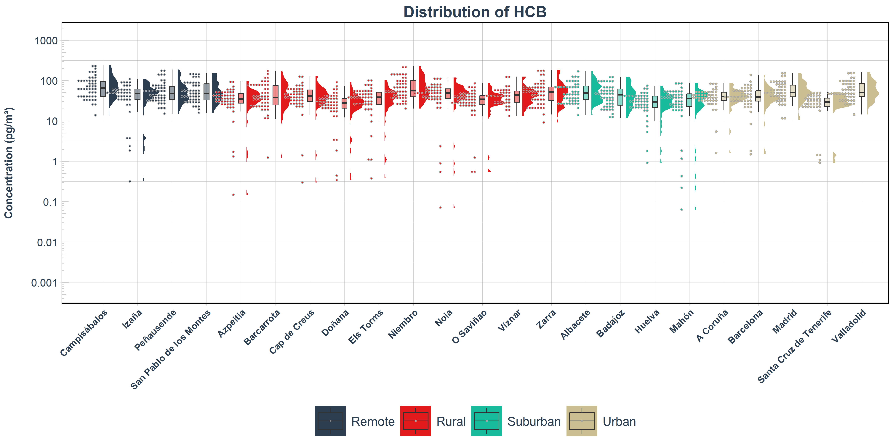

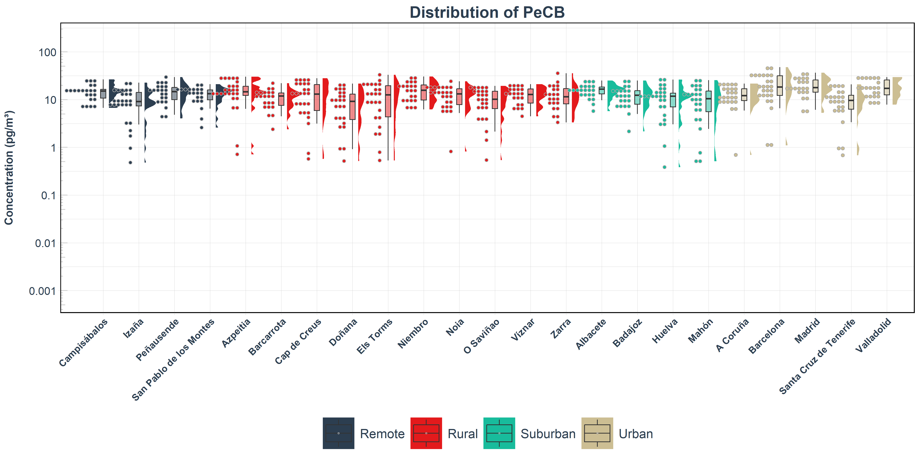
Figure S4. Atmospheric concentrations (pg/m³) of HCB and PeCB across the SMP-POPs (2009–2023). Raincloud plots illustrate the data distribution, displaying jittered observations (left), boxplots representing the median and interquartile range (center), and kernel density shapes (right). The y-axis is shown on log10 scale and sampling sites on the x-axis are grouped by environment type (remote, rural, suburban, and urban) and ordered alphabetically within each group.

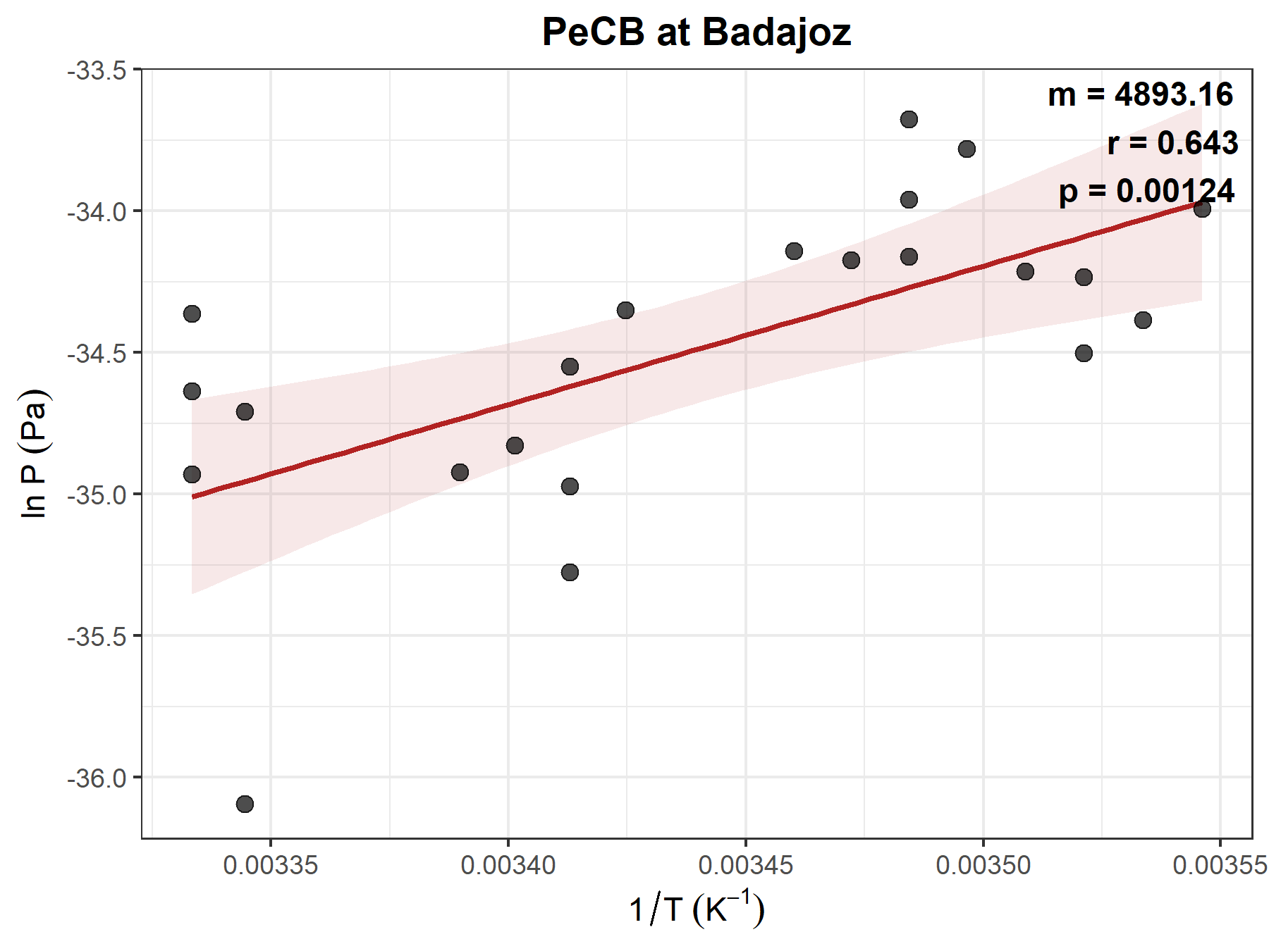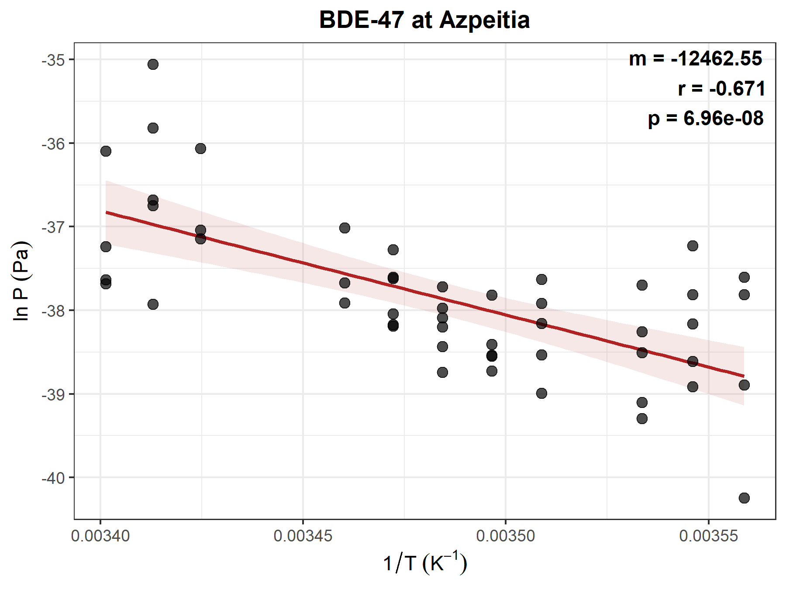
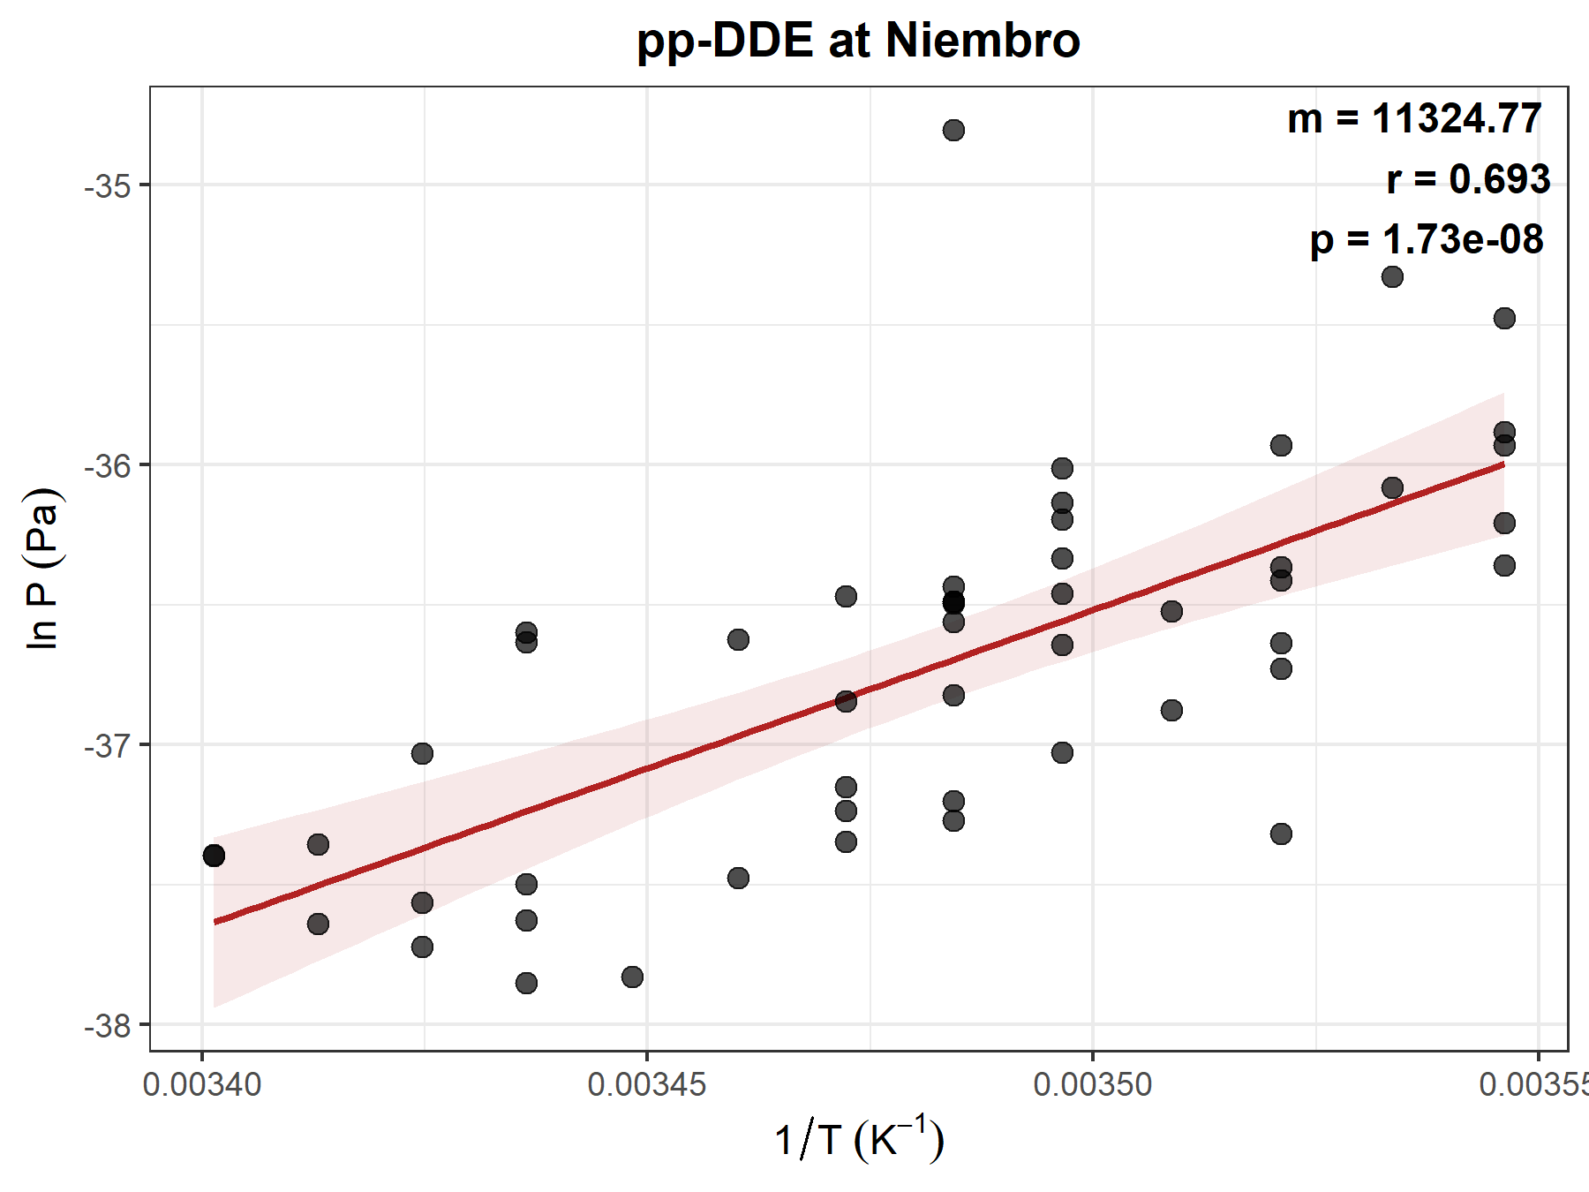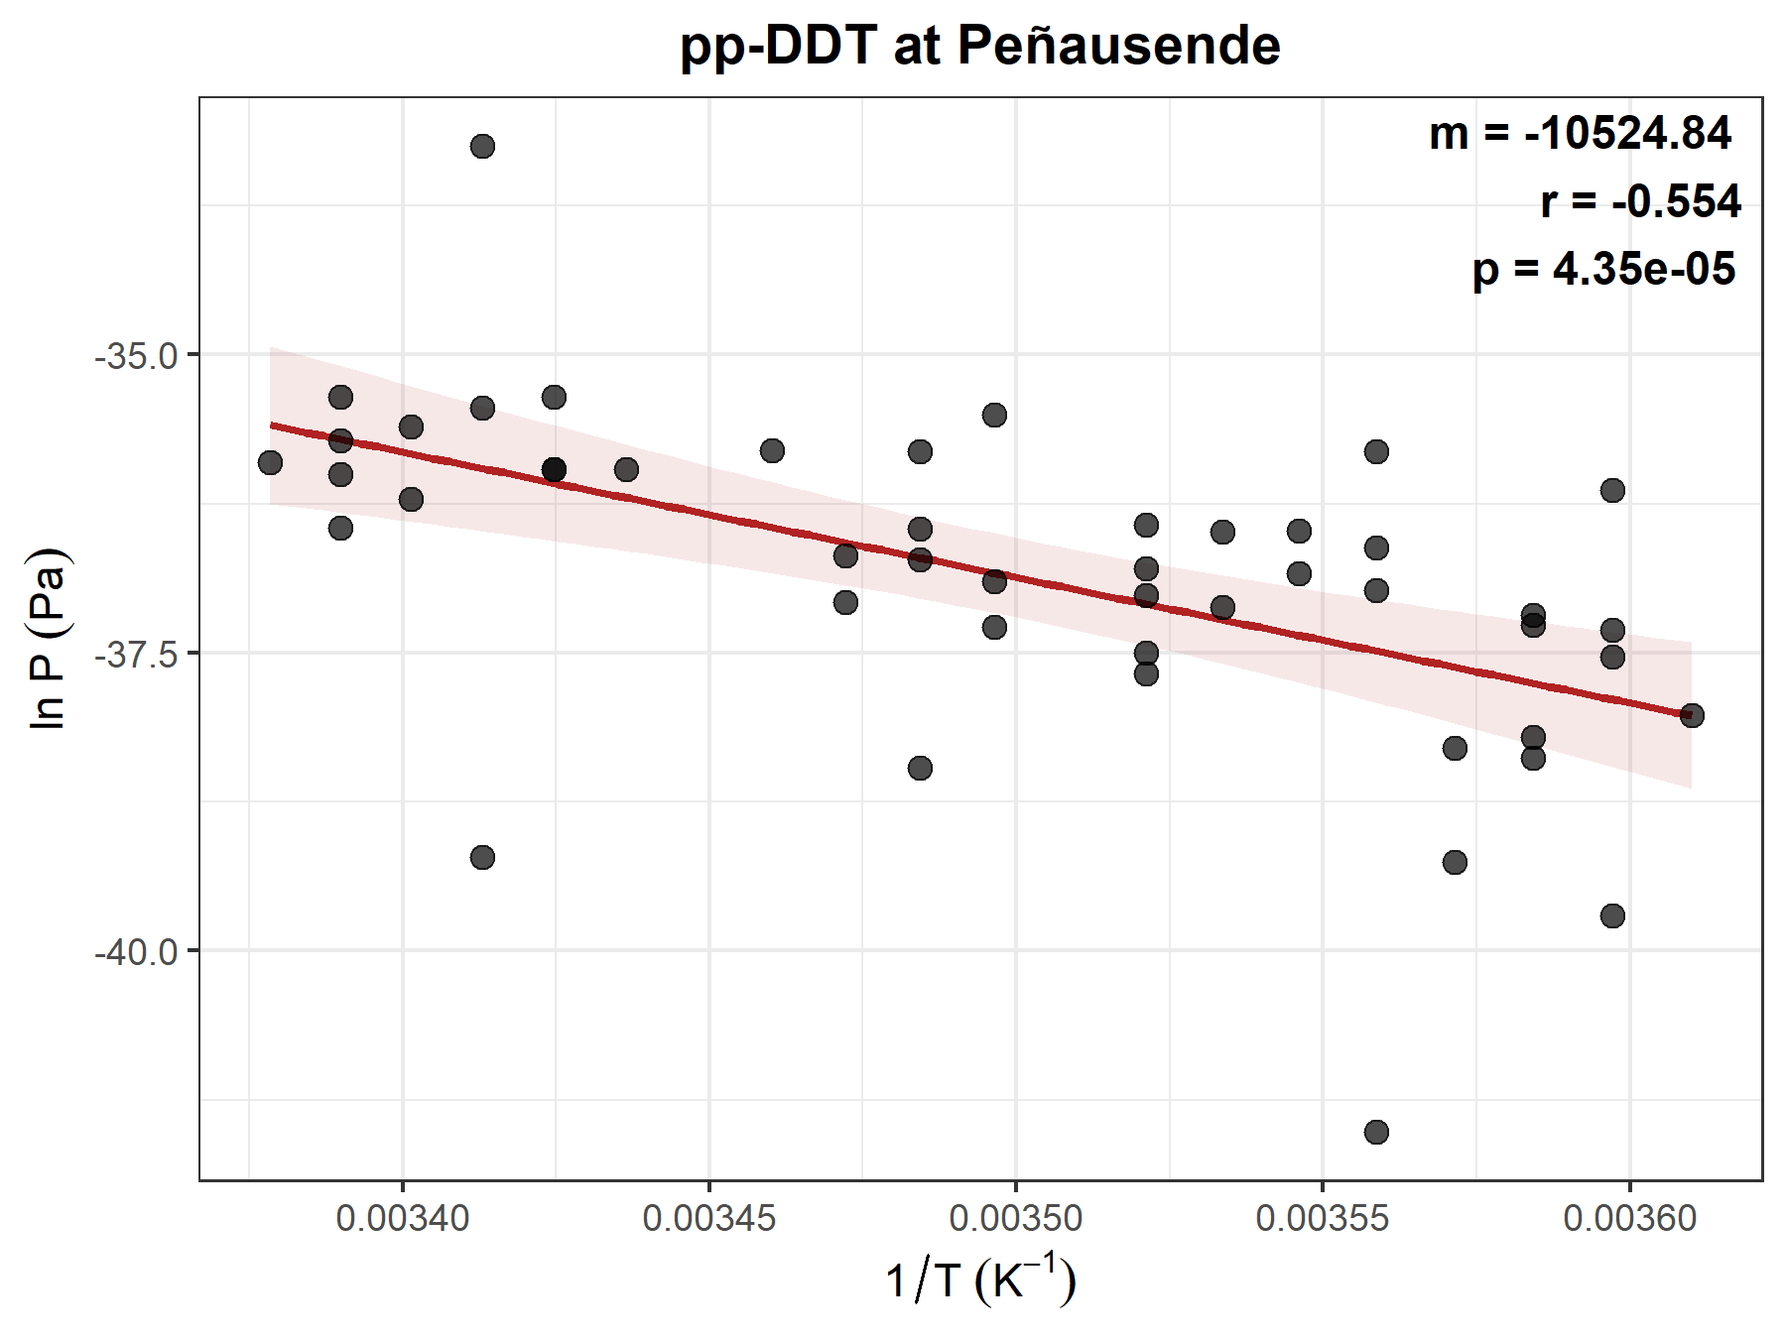
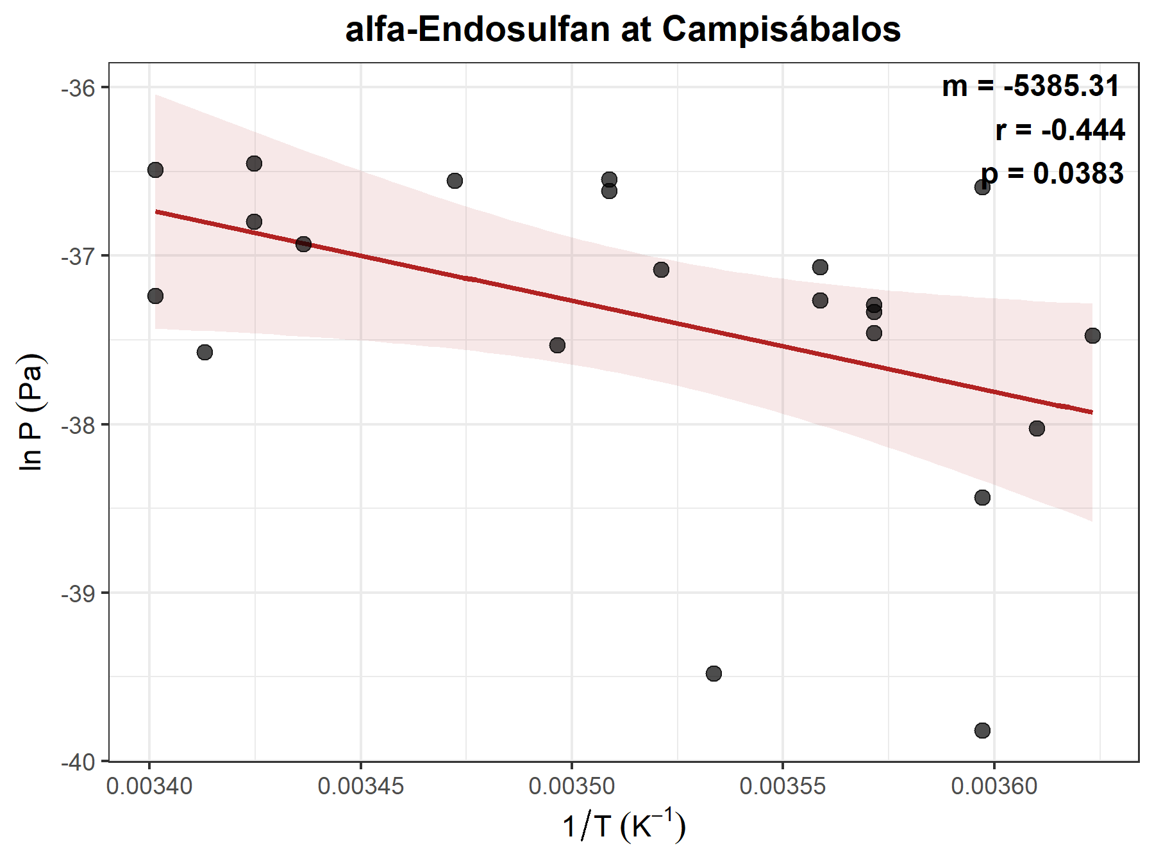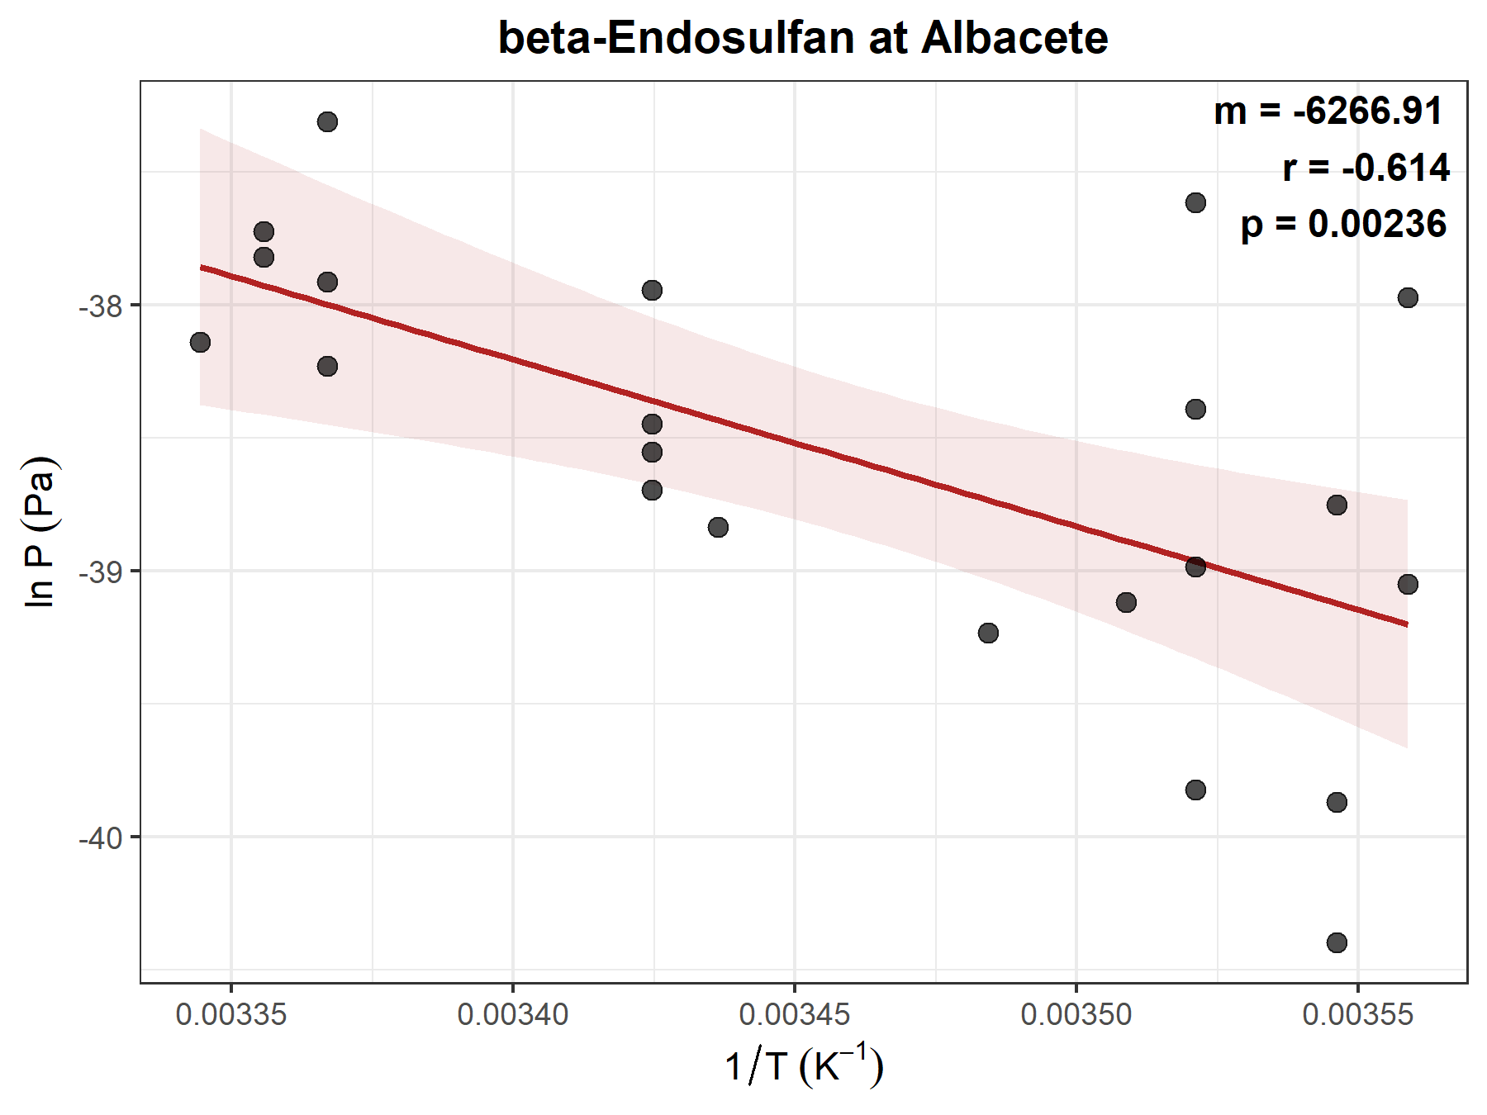
Figure S5. Representative Clausius-Clapeyron plots for selected compounds and monitoring stations illustrating significant temperature-driven volatilization (p < 0.05). The graph shows the relationship between the natural logarithm of partial pressure (ln P, Pa), and the inverse of absolute temperature (1/T, K⁻¹). The red line represents the linear regression fits, with shaded areas indicating the 95% confidence interval.
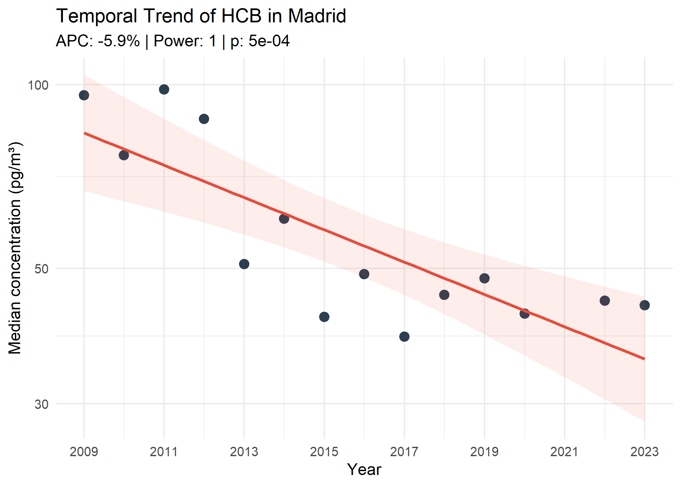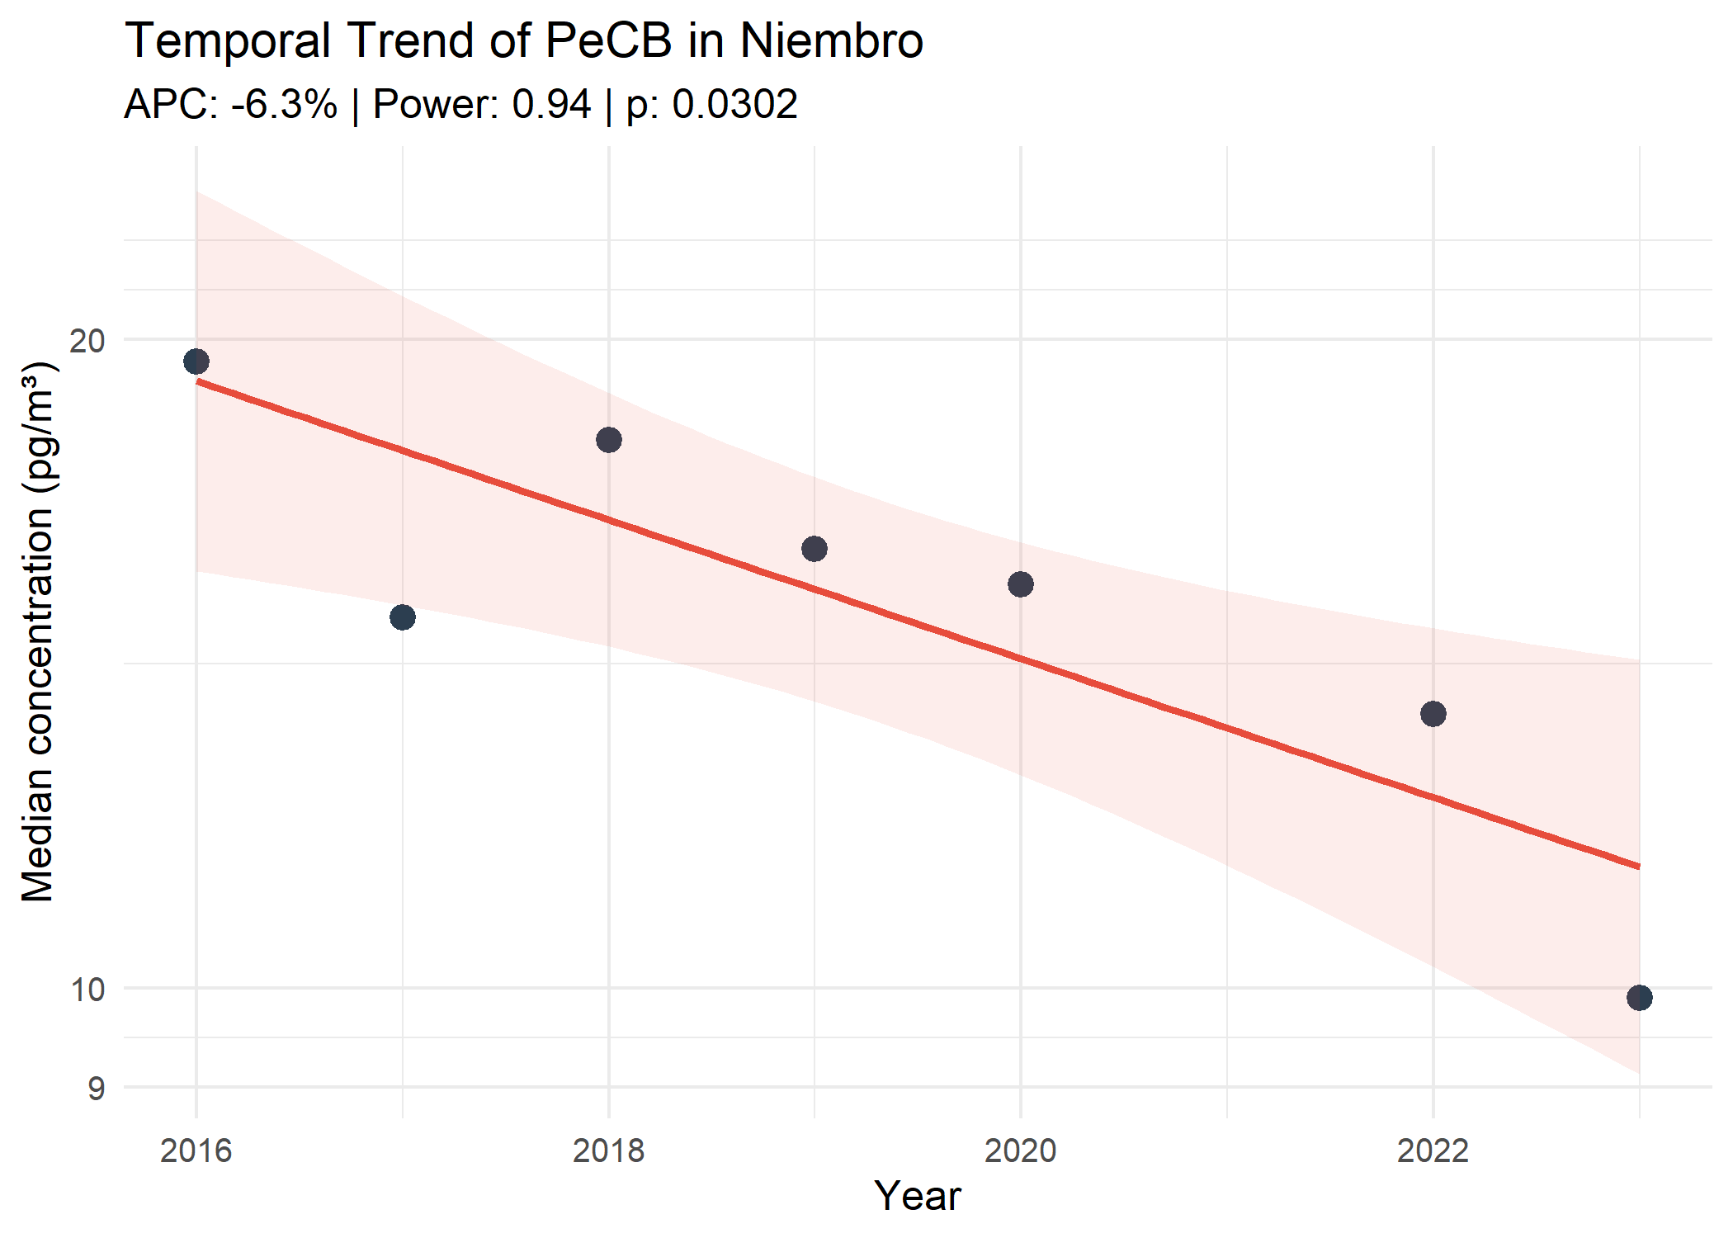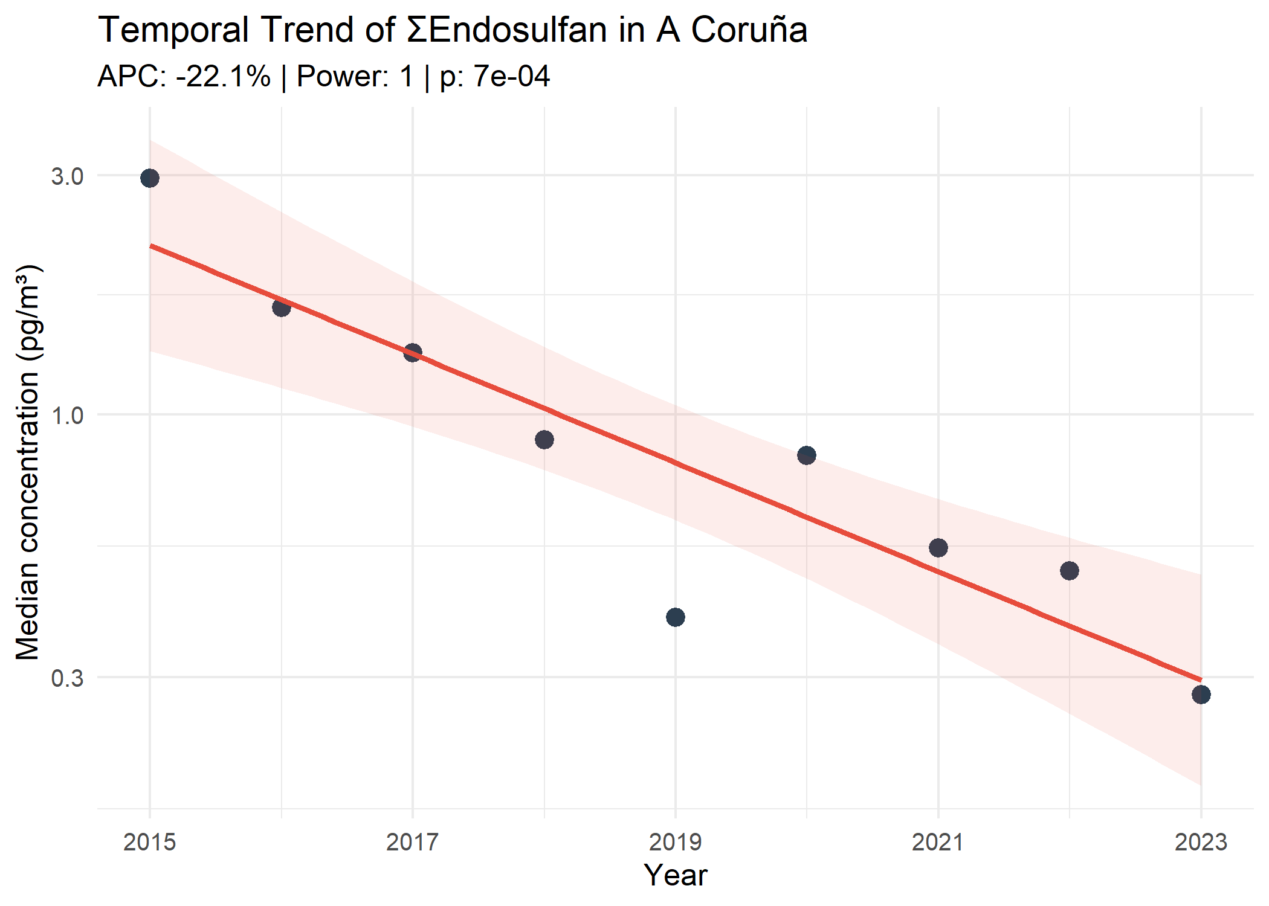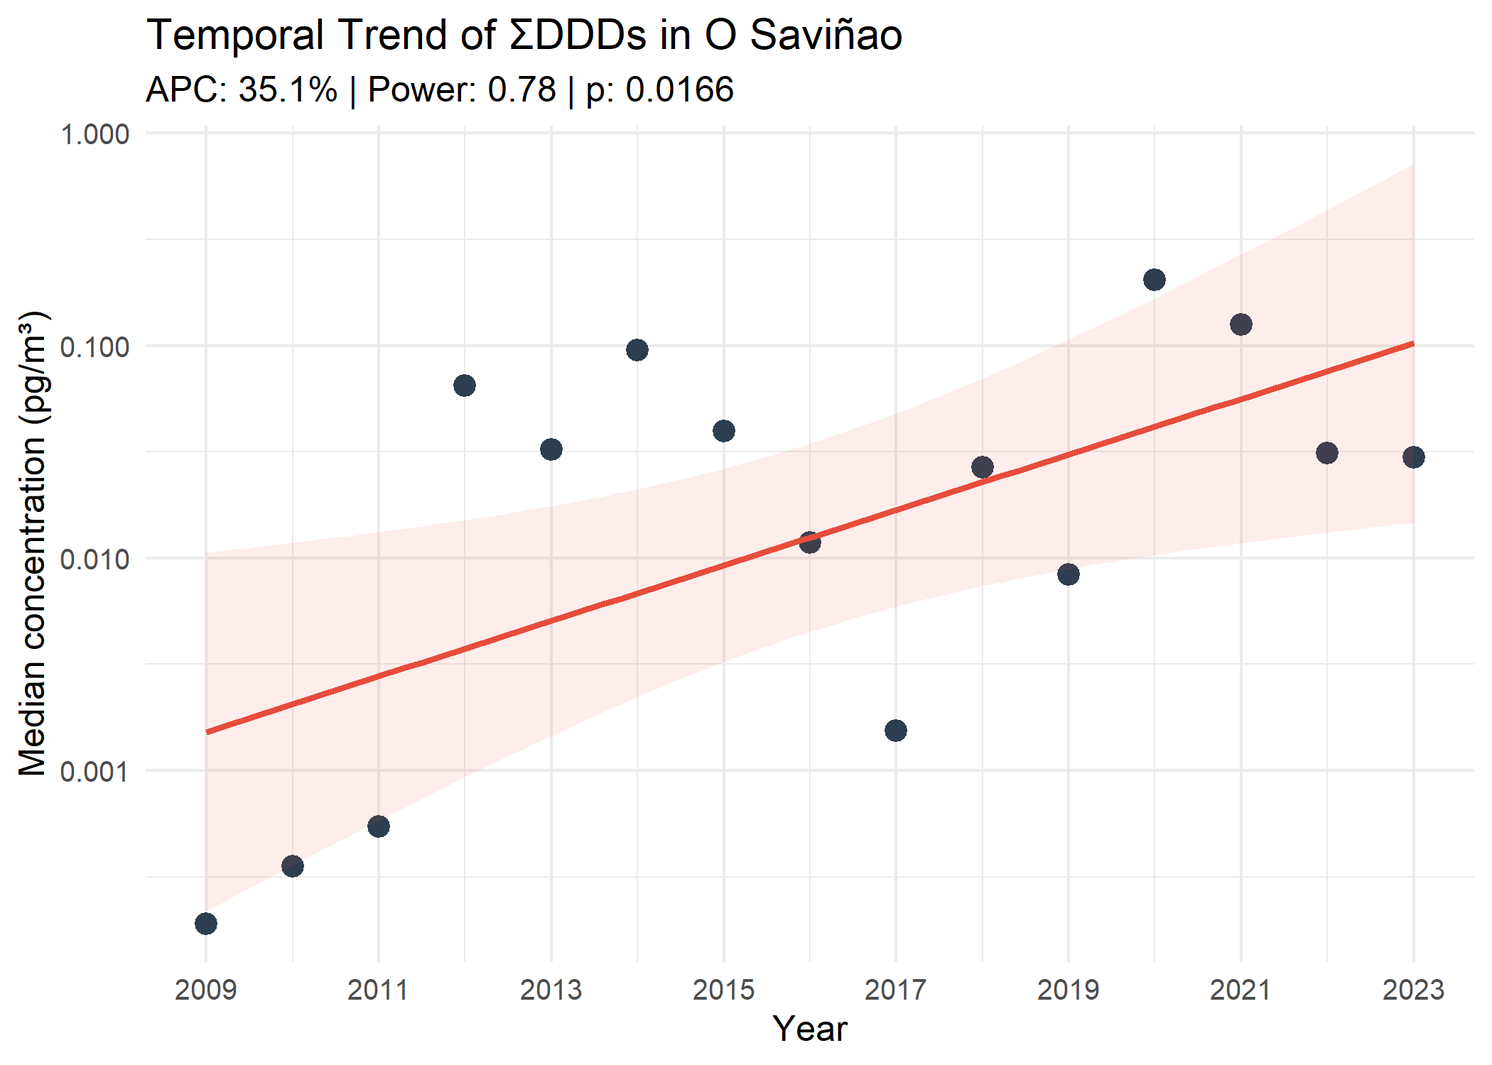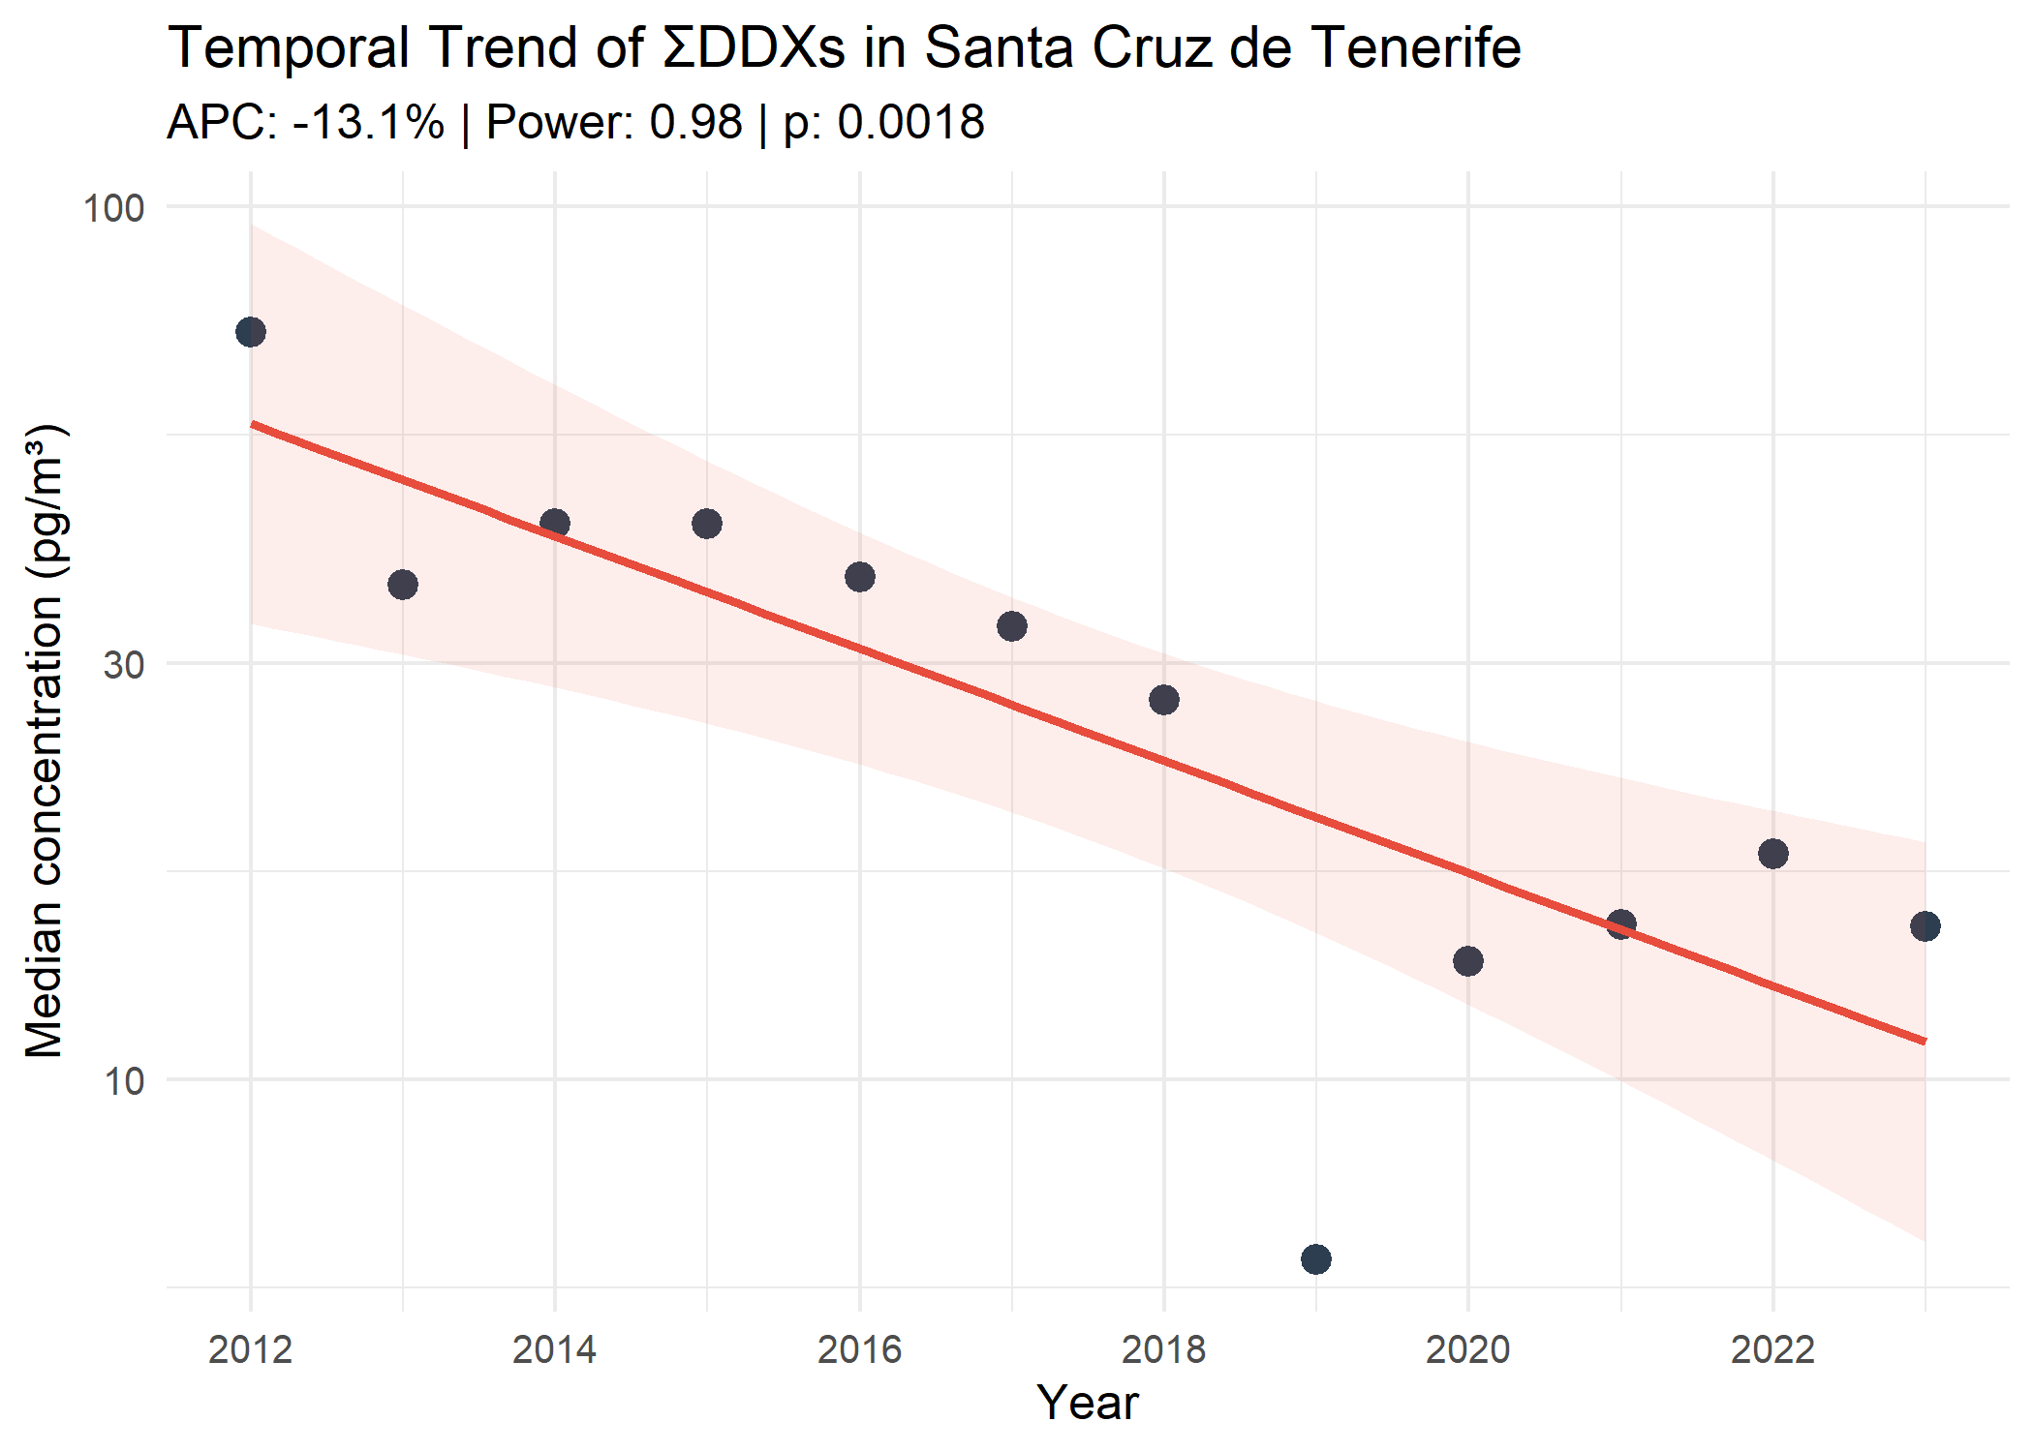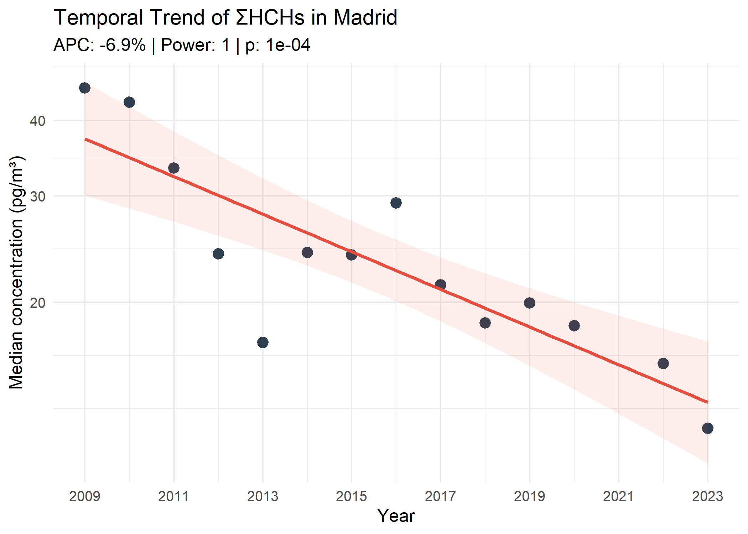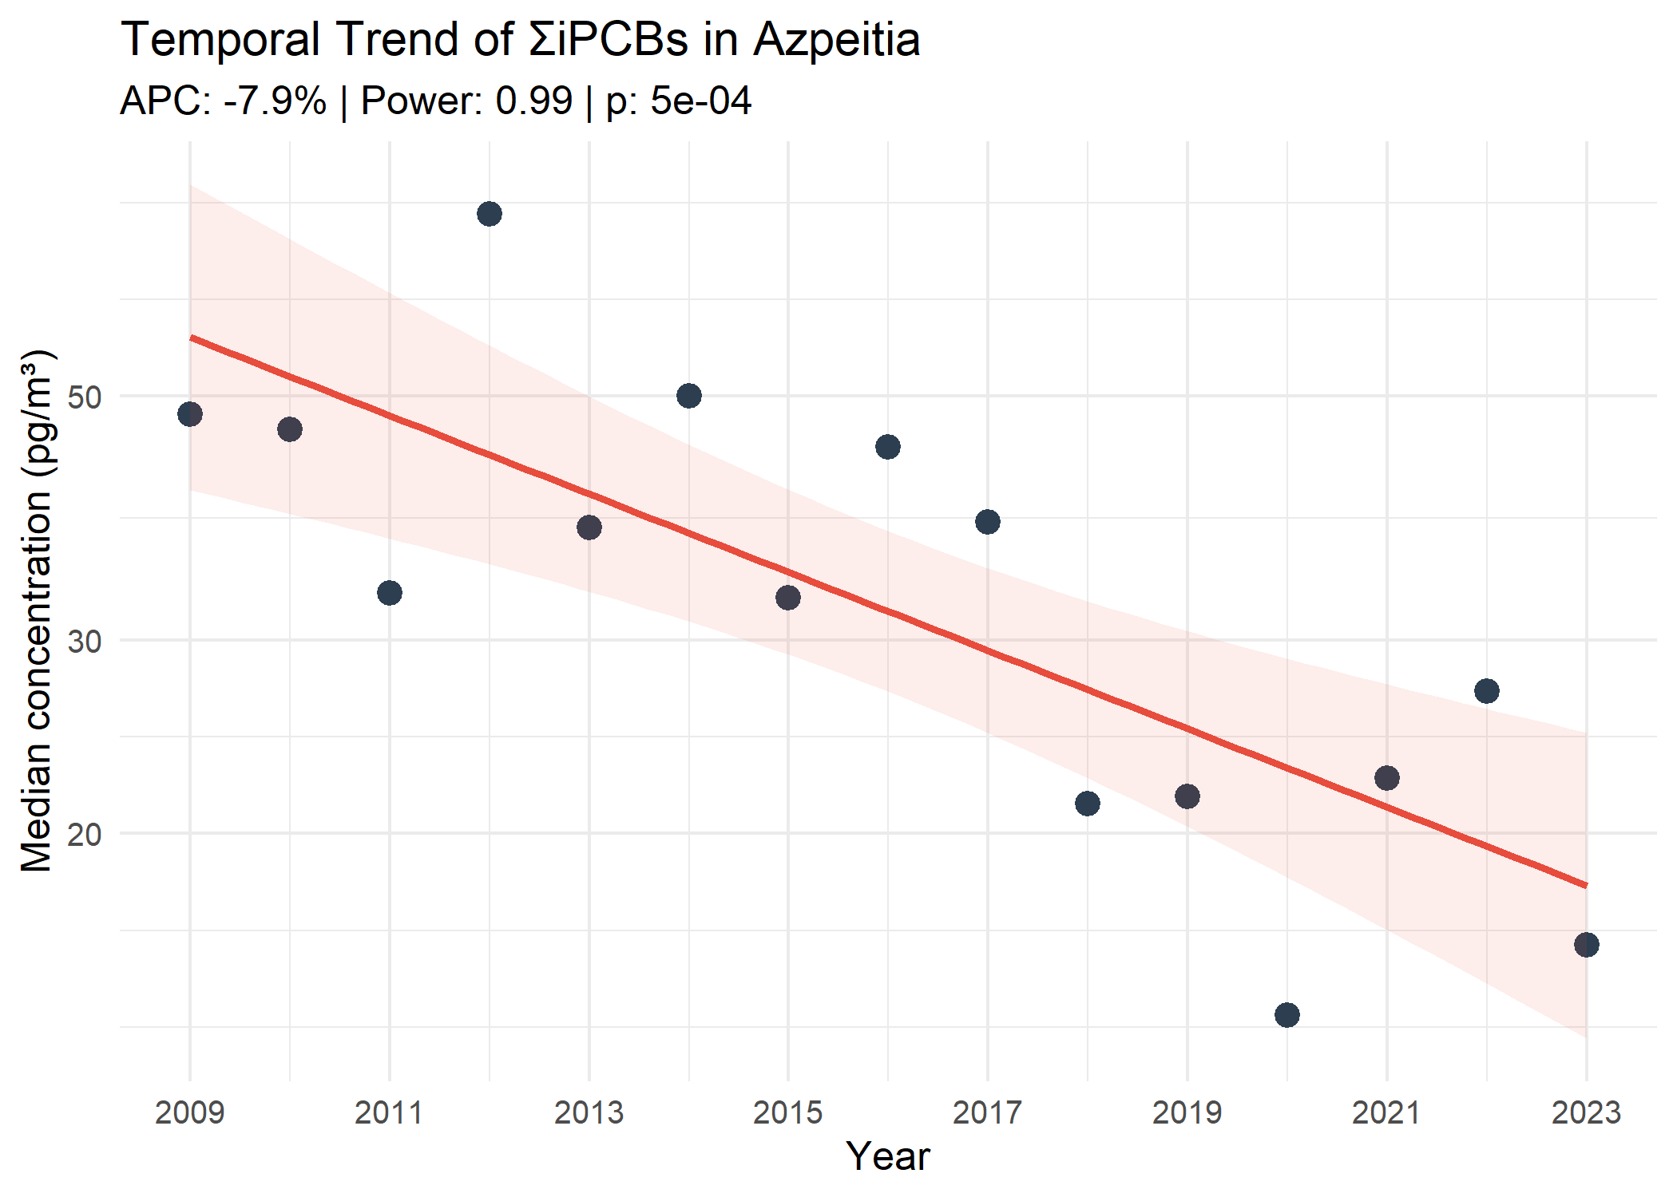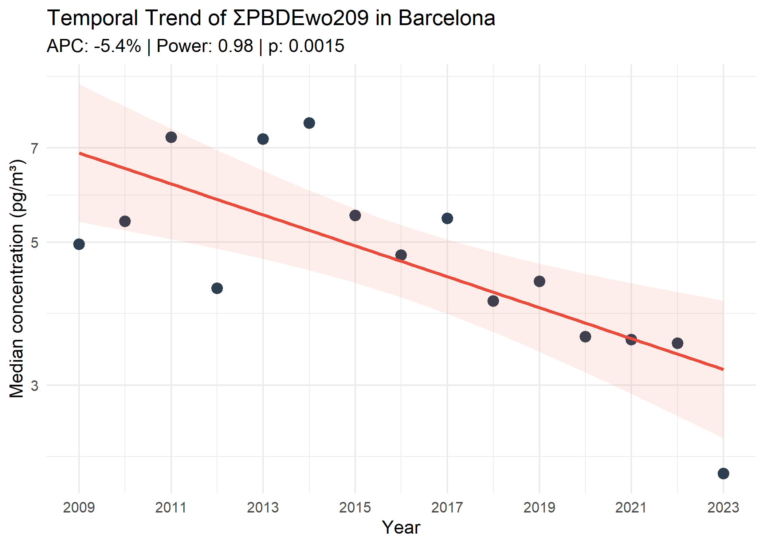
Figure S6. Representative long-term temporal trends (2009 to 2023) for selected POPs and monitoring stations. The plots include the primary regression trends (red lines), Annual Percentage Change (APC), statistical power, and significance level (p). Shaded areas represent the 95% confidence interval.

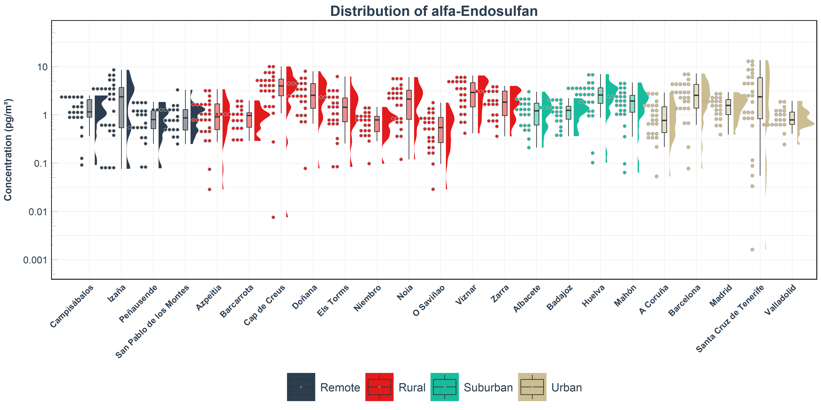

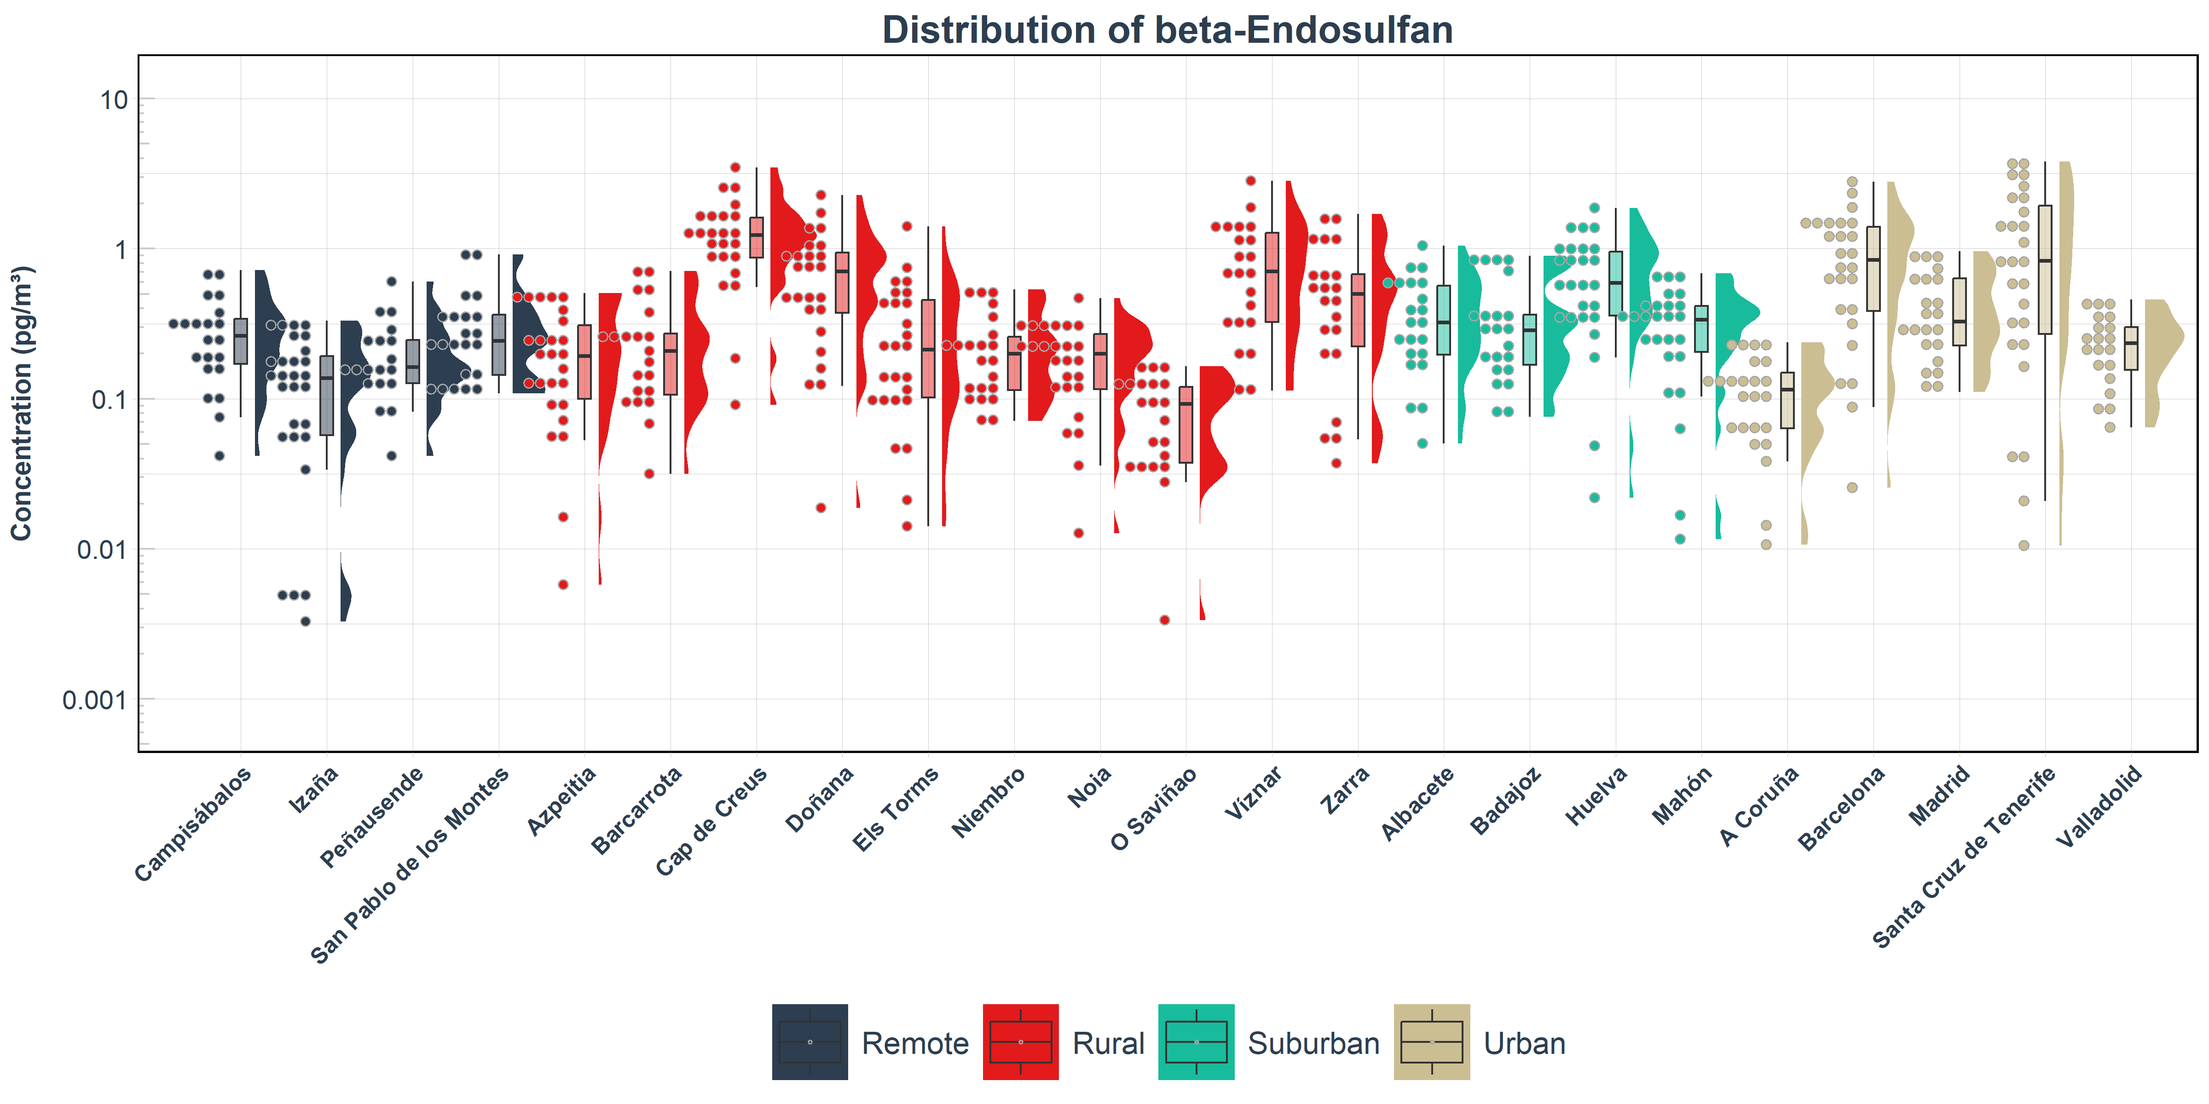
Figure S7. Atmospheric concentrations (pg/m³) of α- and β-endosulfan across the SMP-POPs (2009–2023). Raincloud plots illustrate the data distribution, displaying jittered observations (left), boxplots representing the median and interquartile range (center), and kernel density shapes (right). The y-axis is shown on log10 scale and sampling sites on the x-axis are grouped by environment type (remote, rural, suburban, and urban) and ordered alphabetically within each group.

Figure S8. Spatial distribution of median endosulfan concentrations (pg/m³). Panel A represents α- and β-endosulfan concentrations using blue and red bar segments, respectively. Panel B indicates the total concentration (∑endosulfan) with numerical values above the bars. Statistically significant temporal trends are displayed next to the bars, showing the Annual Percentage Change (APC, %) and its associated statistical power, indicated by superscripts: a for power ≥ 0.8 and b for power between 0.5 and 0.8
Figure S9. Spatial distribution of median DDX concentrations (pg/m³). Panel A represents ∑DDE, ∑DDD and ∑DDT concentrations using blue, red, and green bar segments, respectively. Panel B indicates the total concentration (∑DDXs) with numerical values above the bars. Statistically significant temporal trends are displayed next to the bars, showing the Annual Percentage Change (APC, %) and its associated statistical power, indicated by superscripts: a for power ≥ 0.8 and b for power between 0.5 and 0.8.
Figure S10. Spatial distribution of median HCH concentrations (pg/m³). Panel A represents α-, β- and γ-HCH concentrations using blue, red, and green bar segments, respectively. Panel B indicates the total concentration (∑HCHs) with numerical values above the bars. Statistically significant temporal trends are displayed next to the bars, showing the Annual Percentage Change (APC, %) and its associated statistical power, indicated by superscripts: a for power ≥ 0.8 and b for power between 0.5 and 0.8.
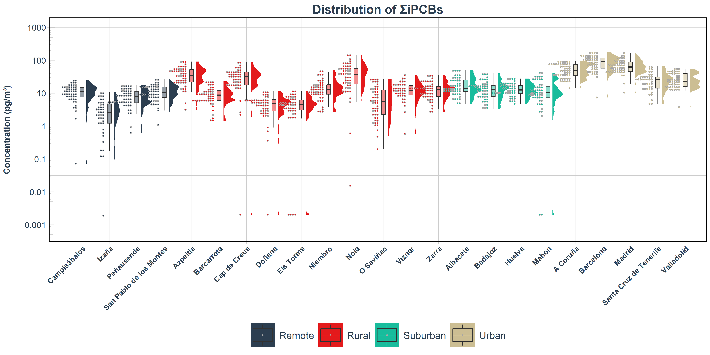
Figure S11. Atmospheric concentrations (pg/m³) of iPCBs across the SMP-POPs (2009–2023). Raincloud plots illustrate the data distribution, displaying jittered observations (left), boxplots representing the median and interquartile range (center), and kernel density shapes (right). The y-axis is shown on log10 scale and sampling sites on the x-axis are grouped by environment type (remote, rural, suburban, and urban) and ordered alphabetically within each group.

Figure S12. Spatial distribution of median total iPCBs (∑iPCBs) concentrations (pg/m³). Statistically significant temporal trends are displayed next to the bars, showing the Annual Percentage Change (APC, %) and its associated statistical power, indicated by superscripts: a for power ≥ 0.8 and b for power between 0.5 and 0.8.

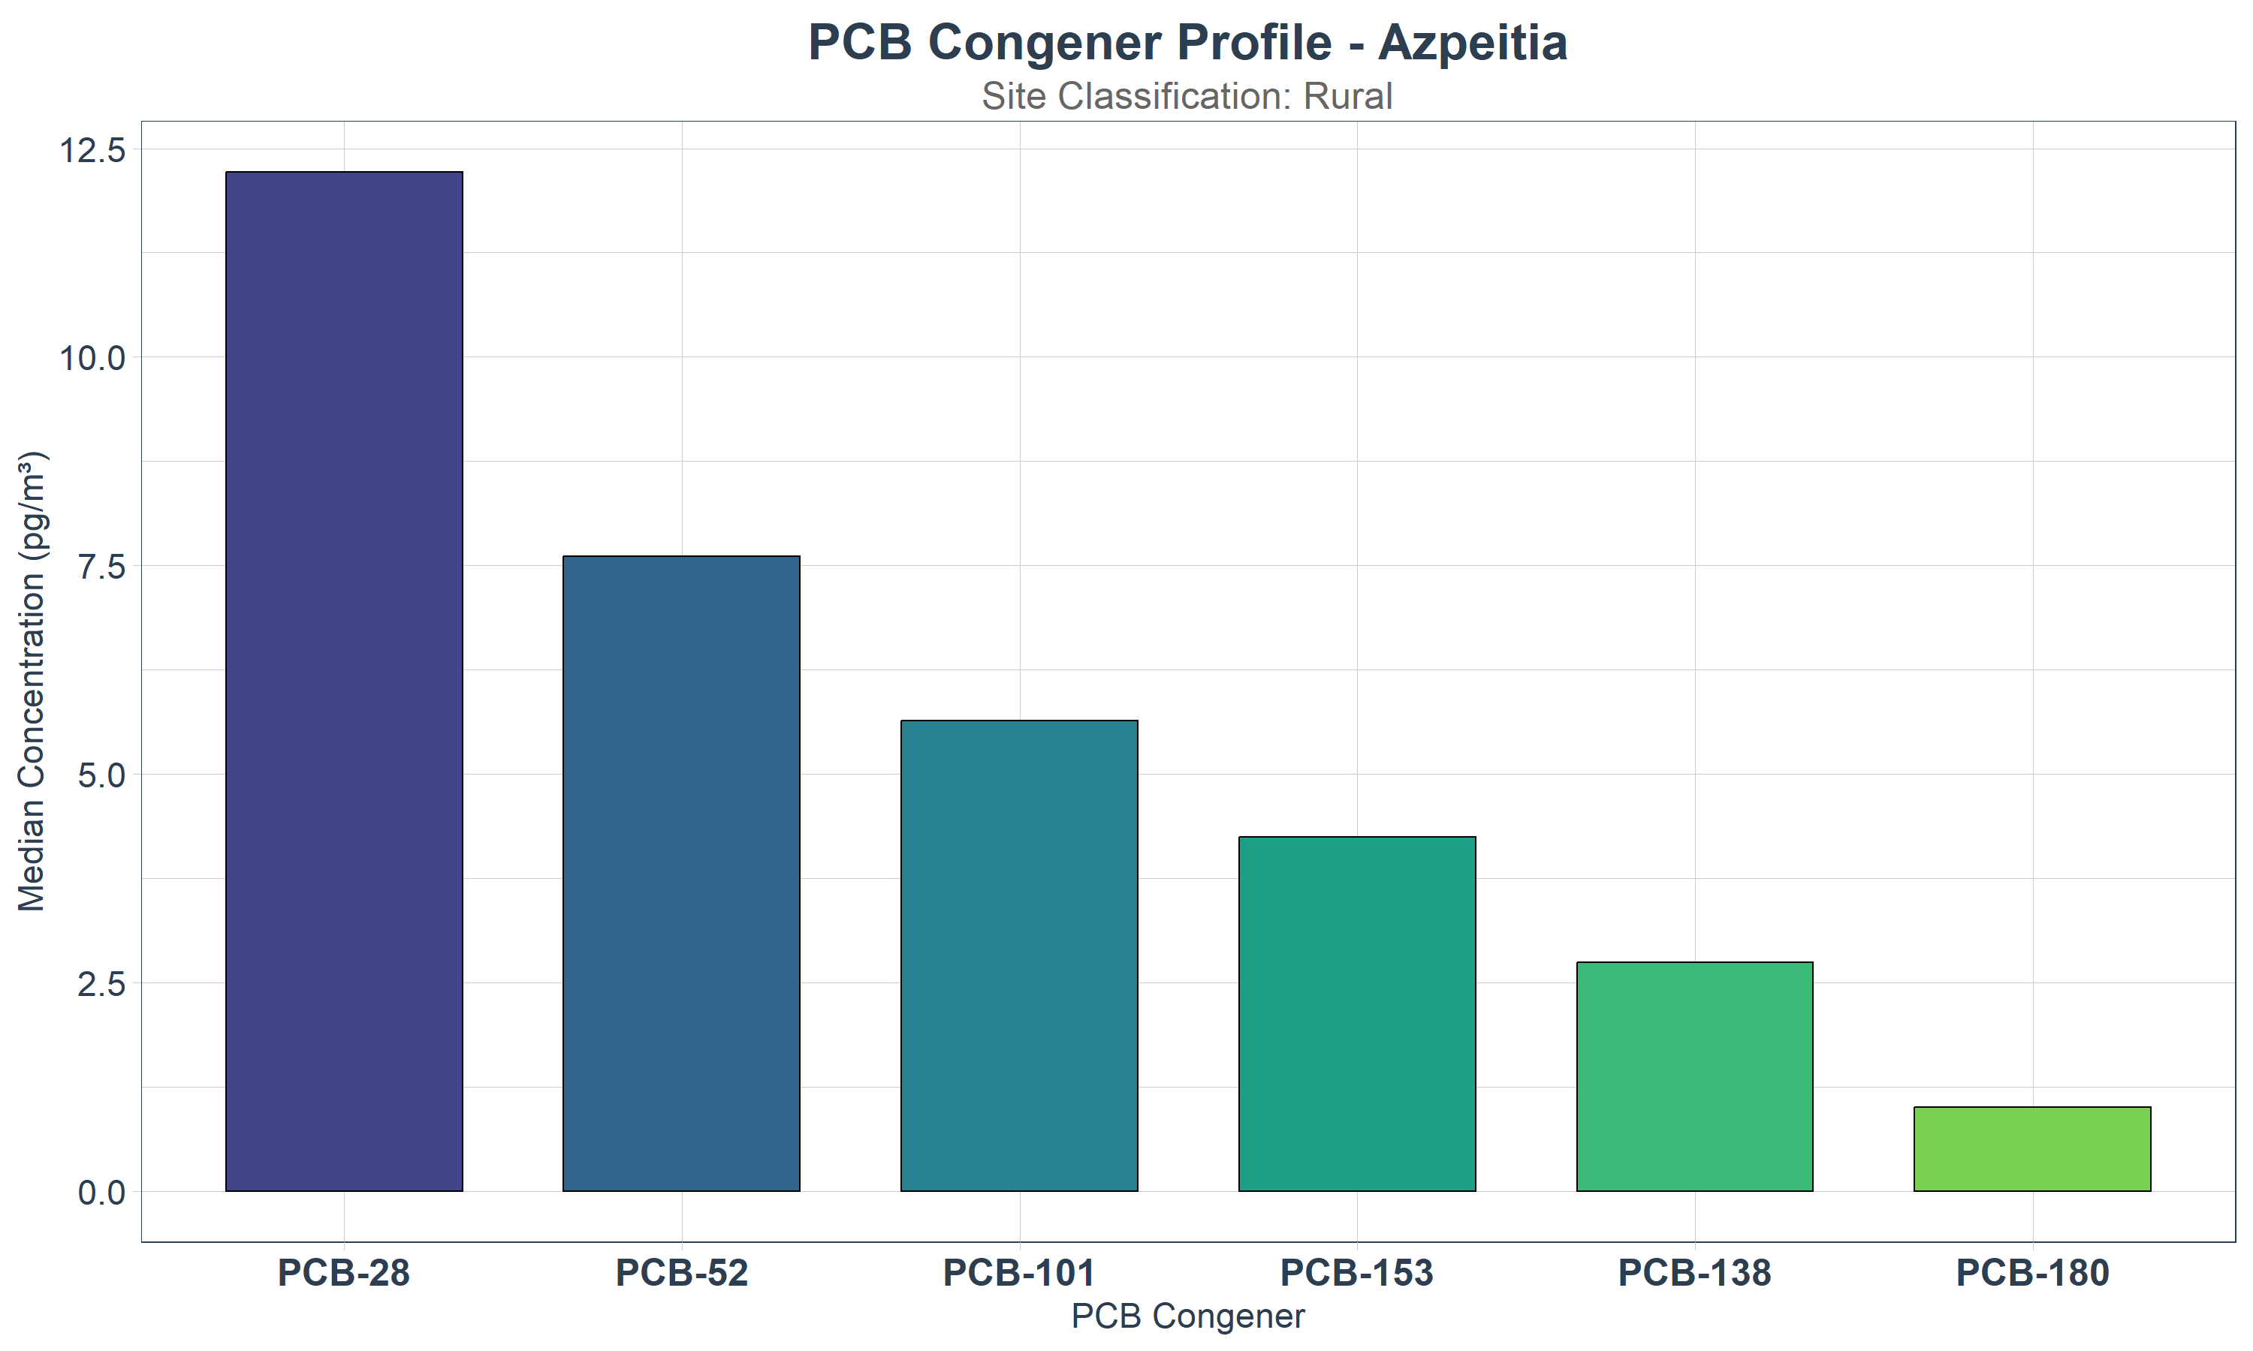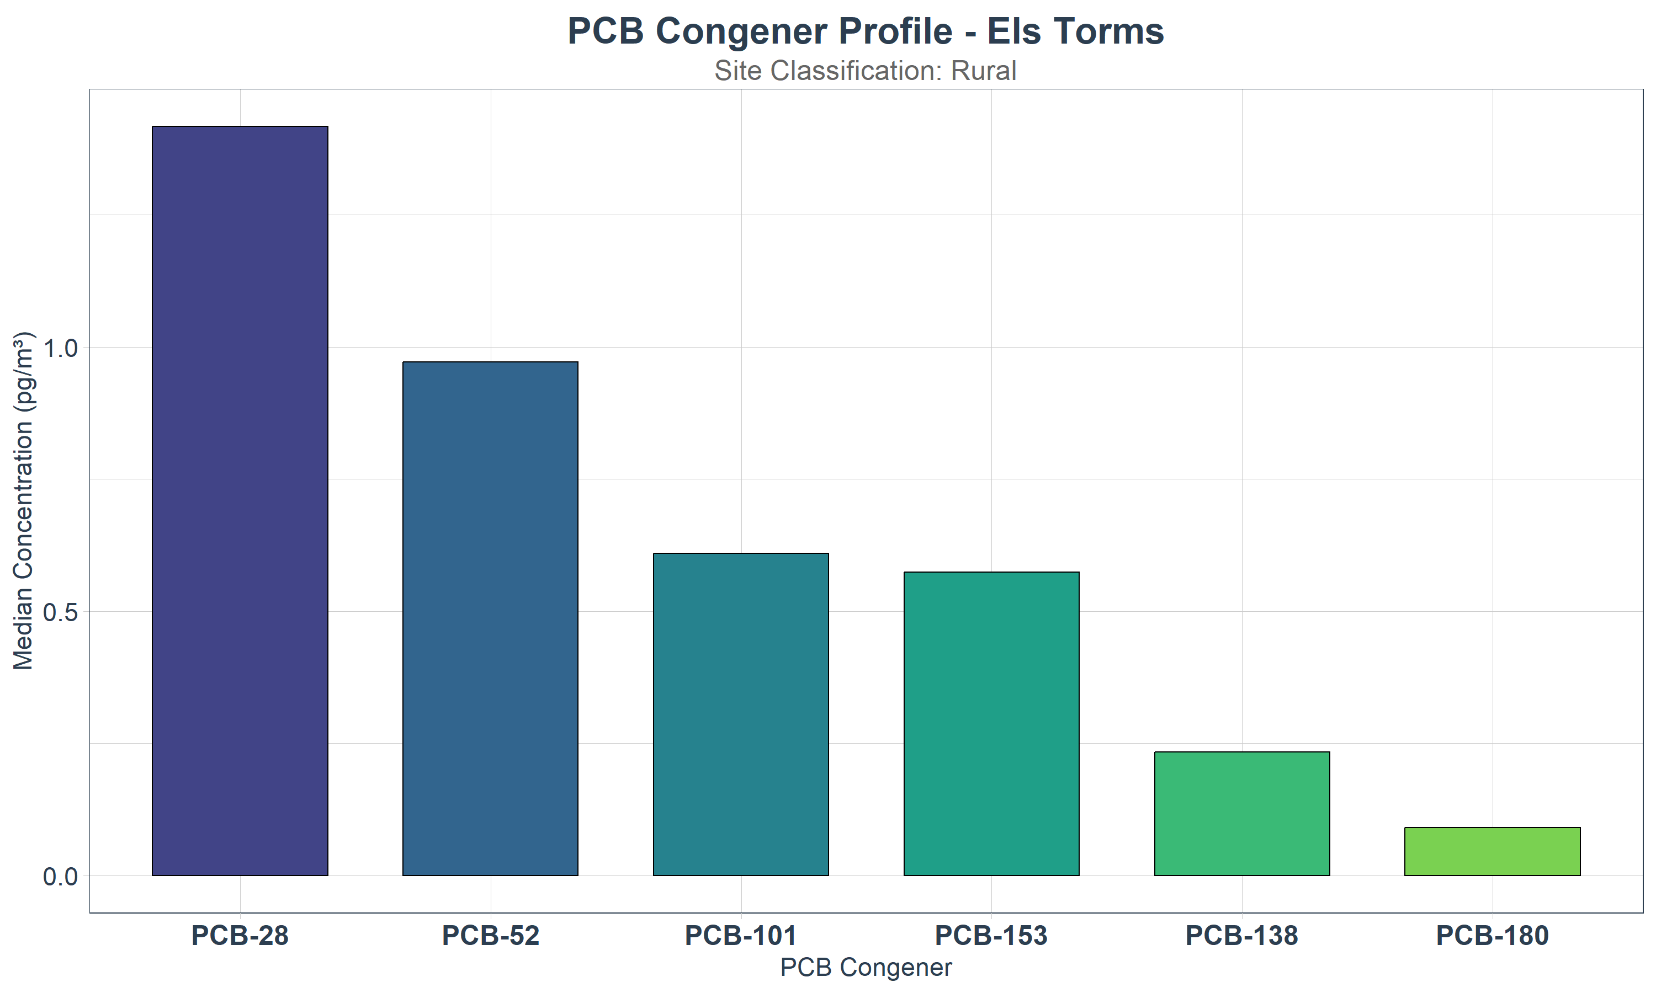
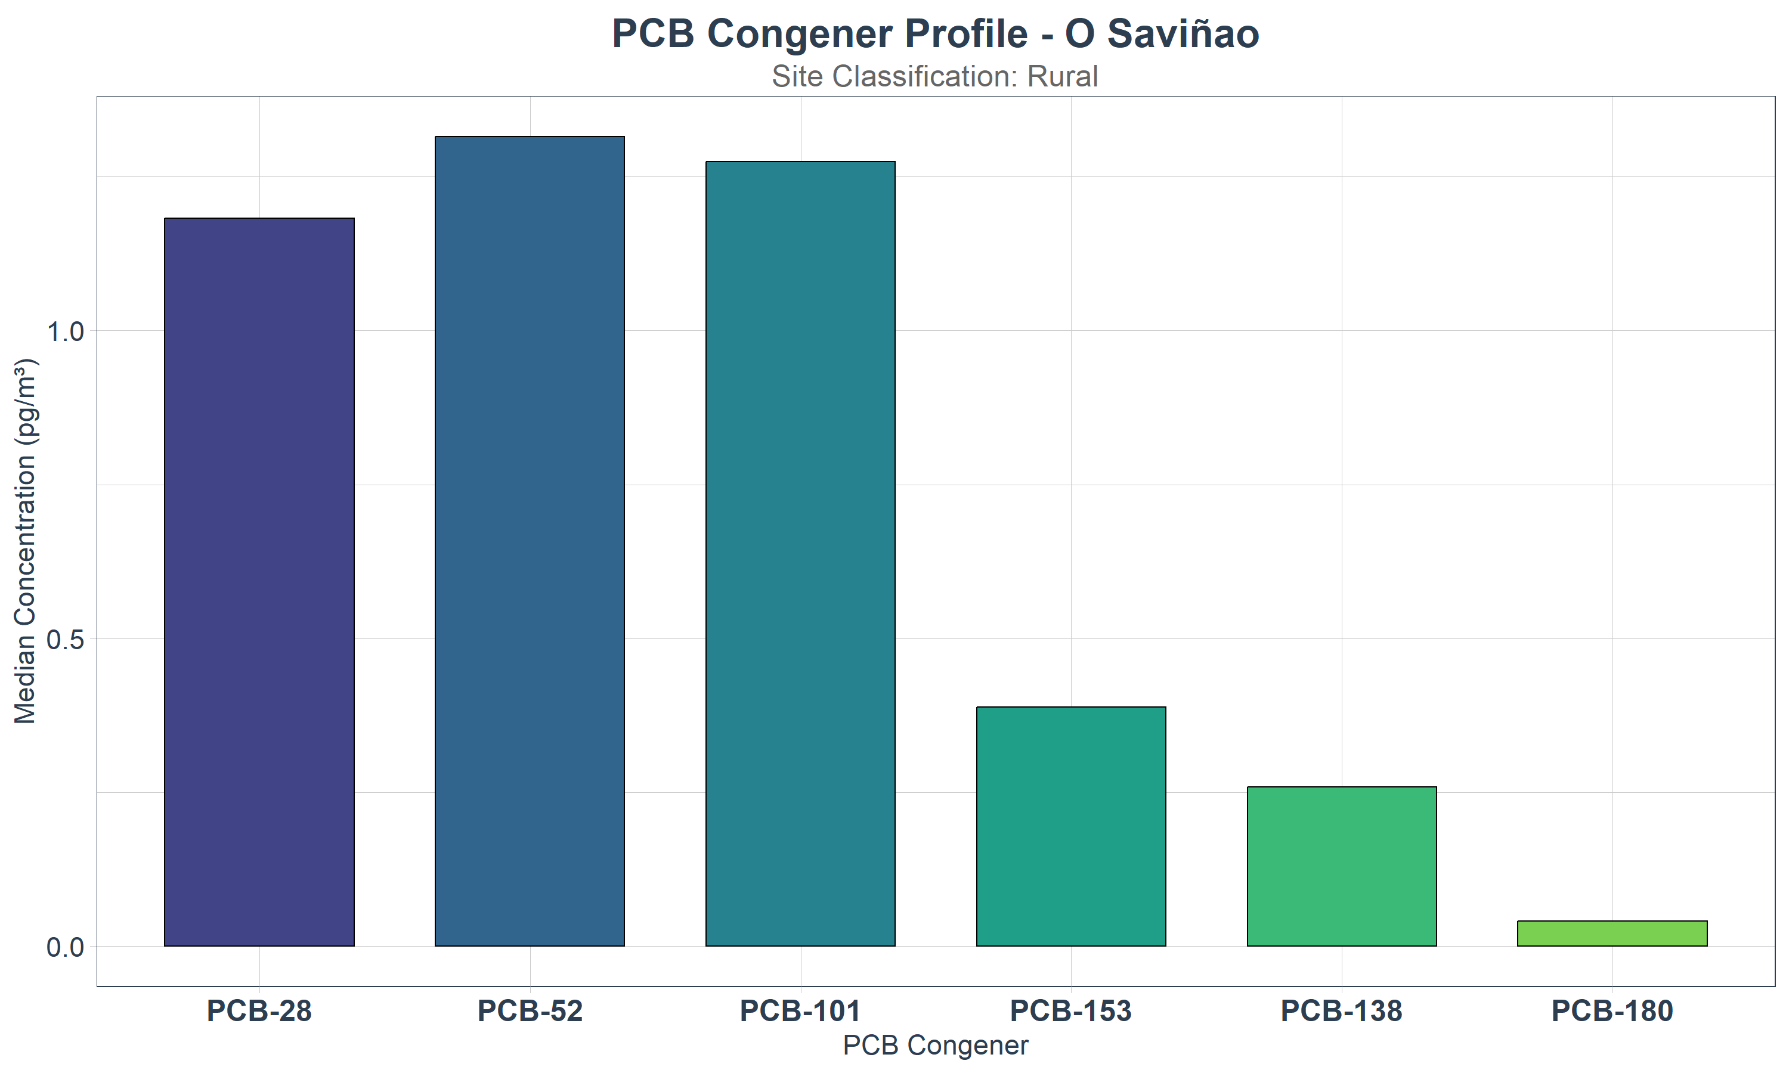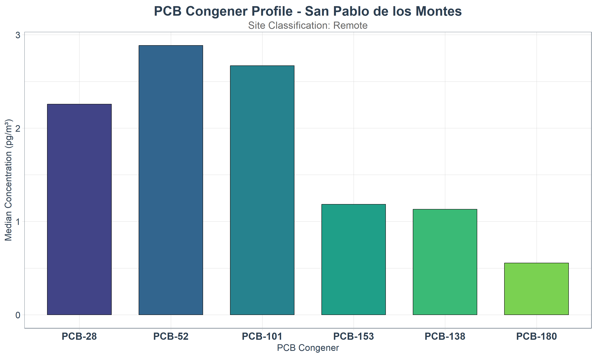
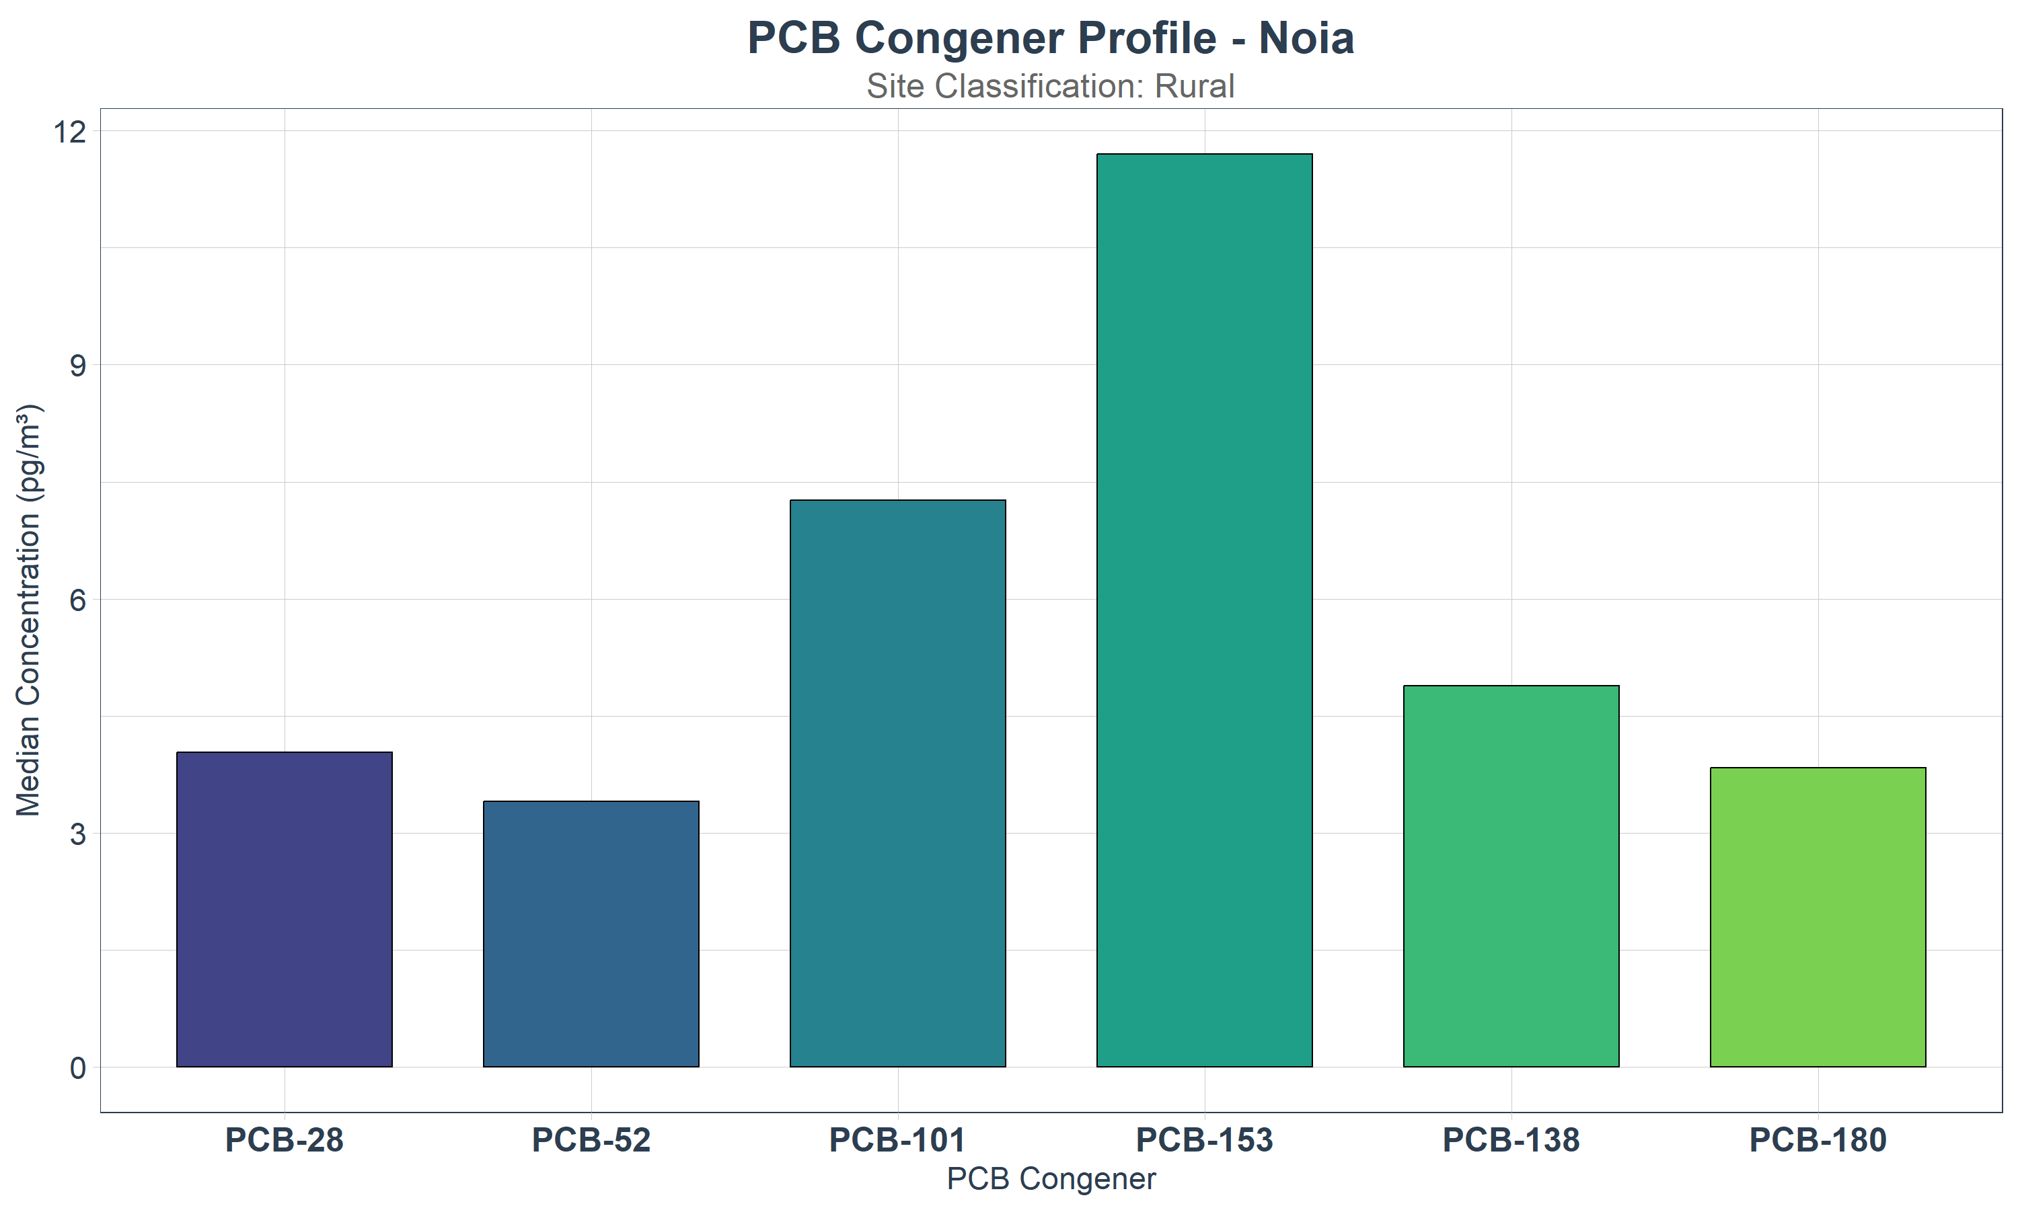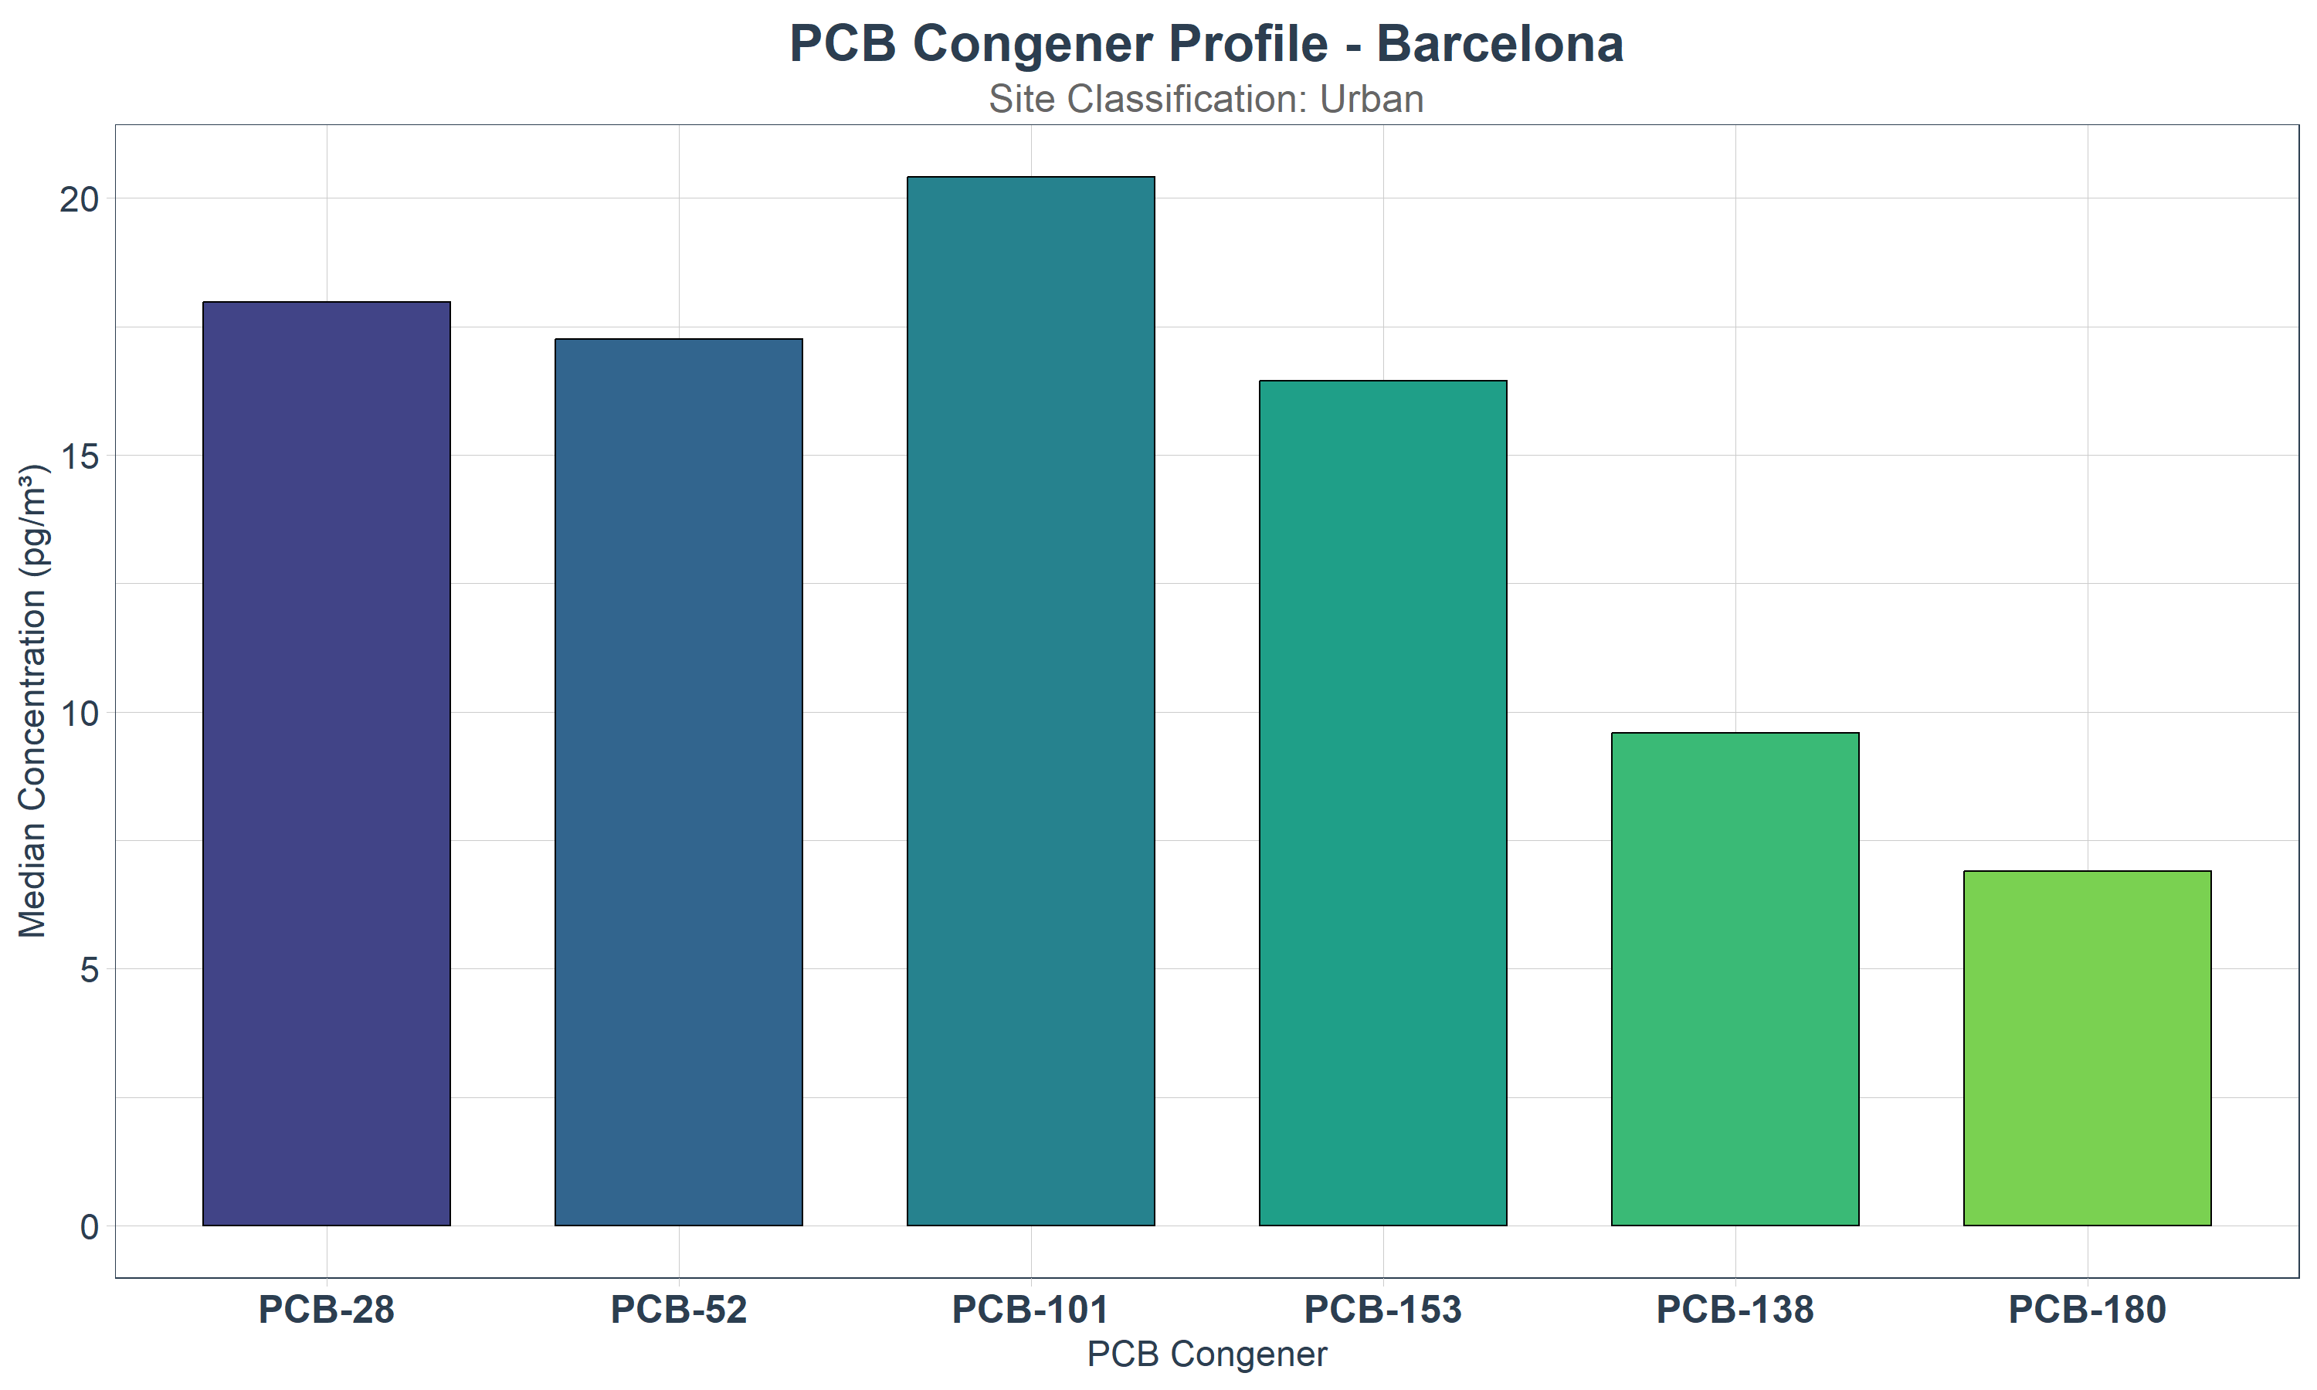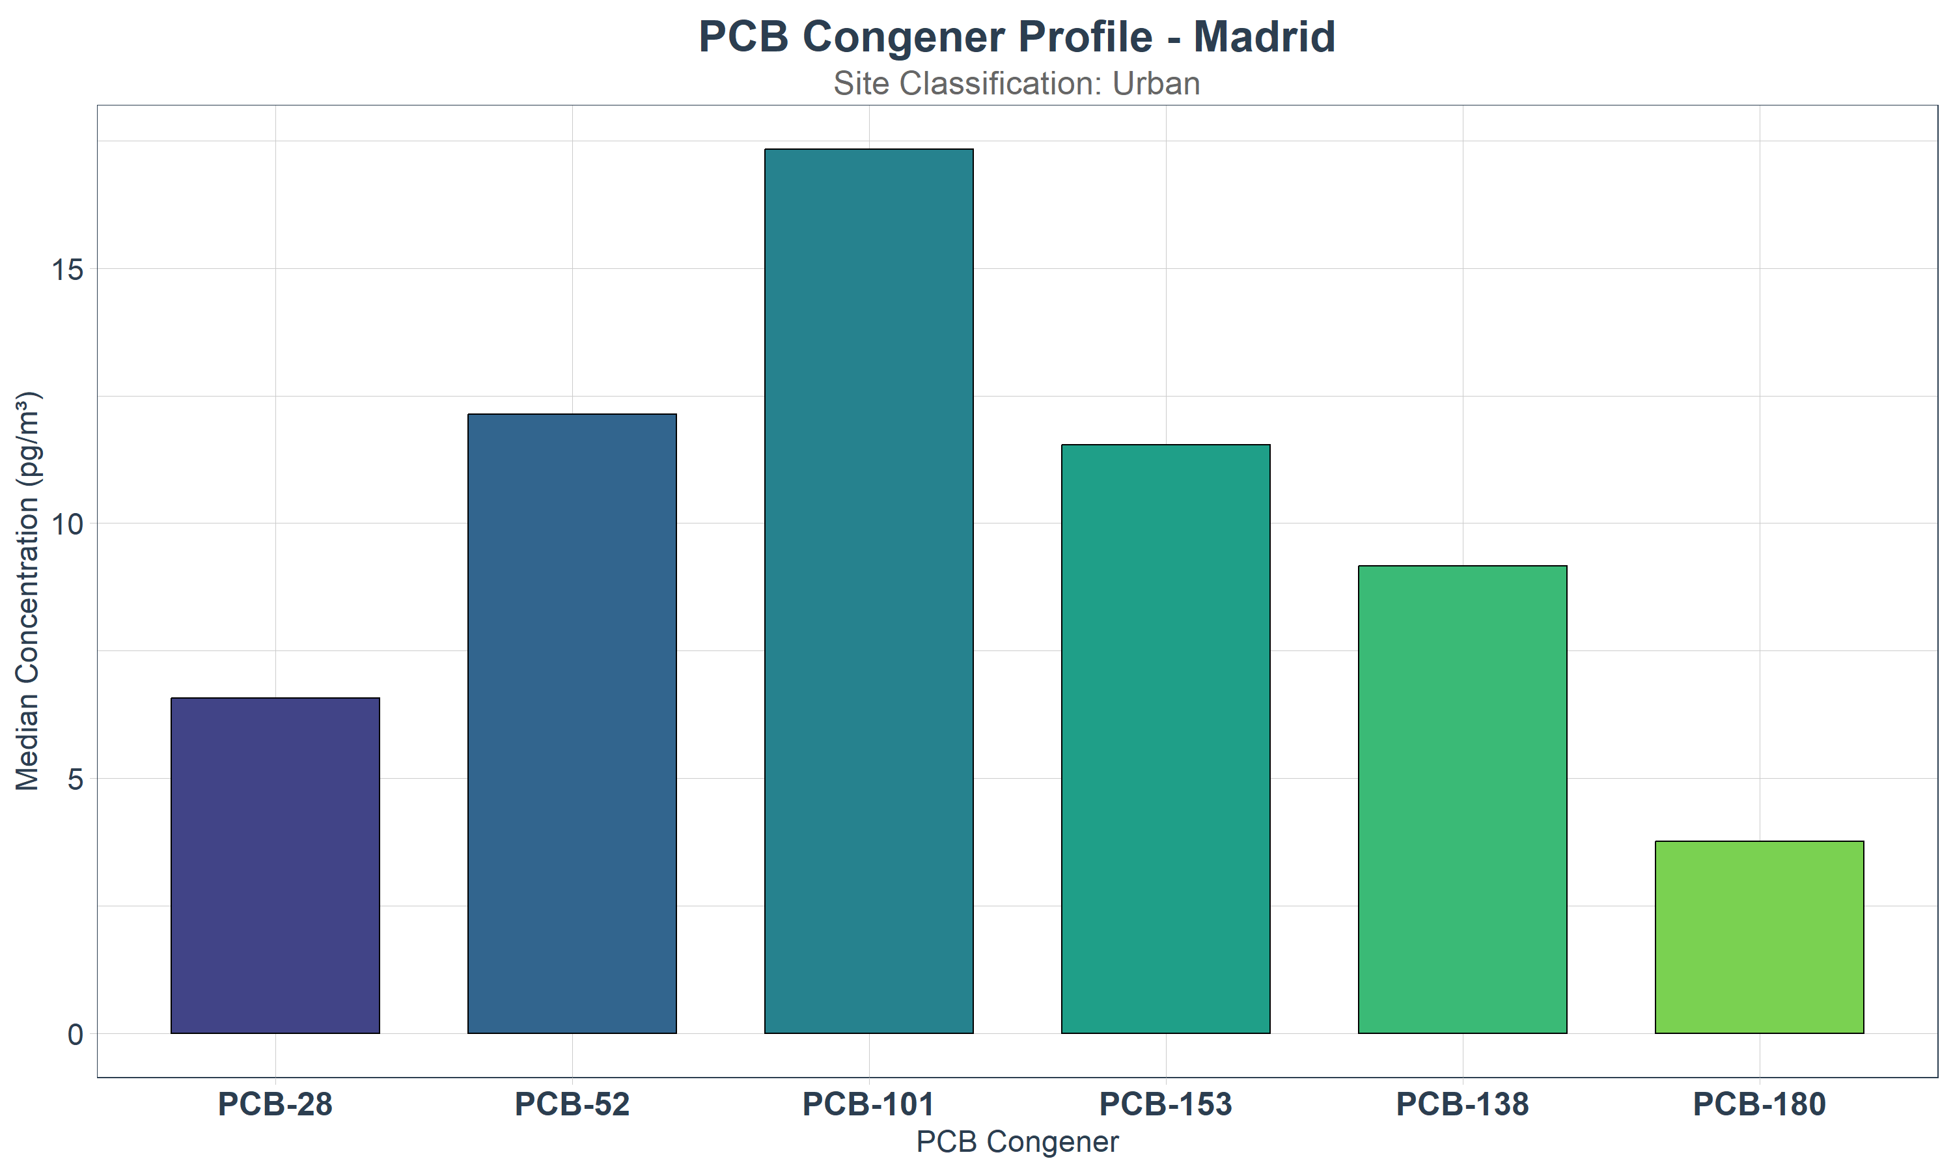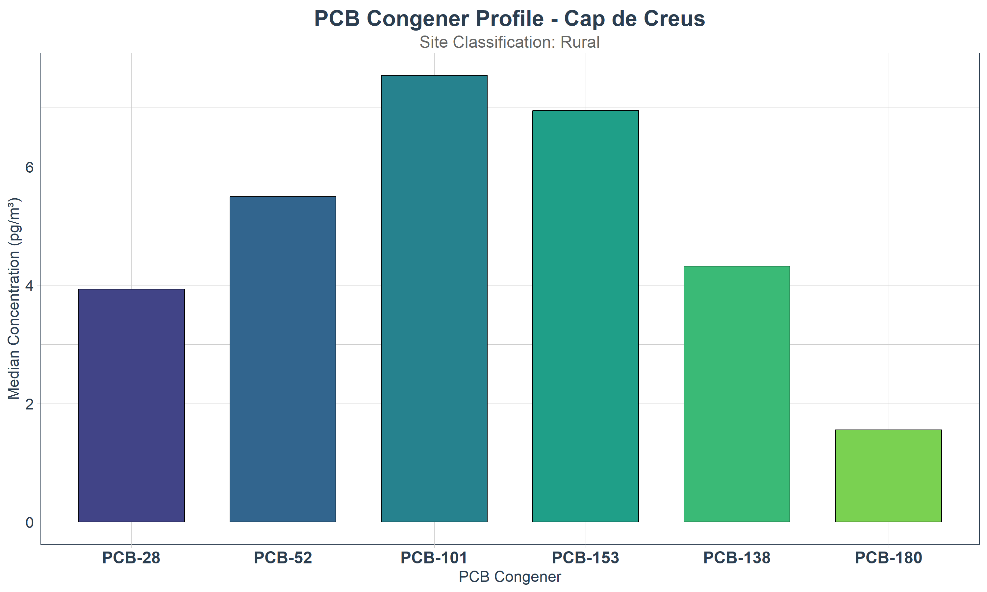
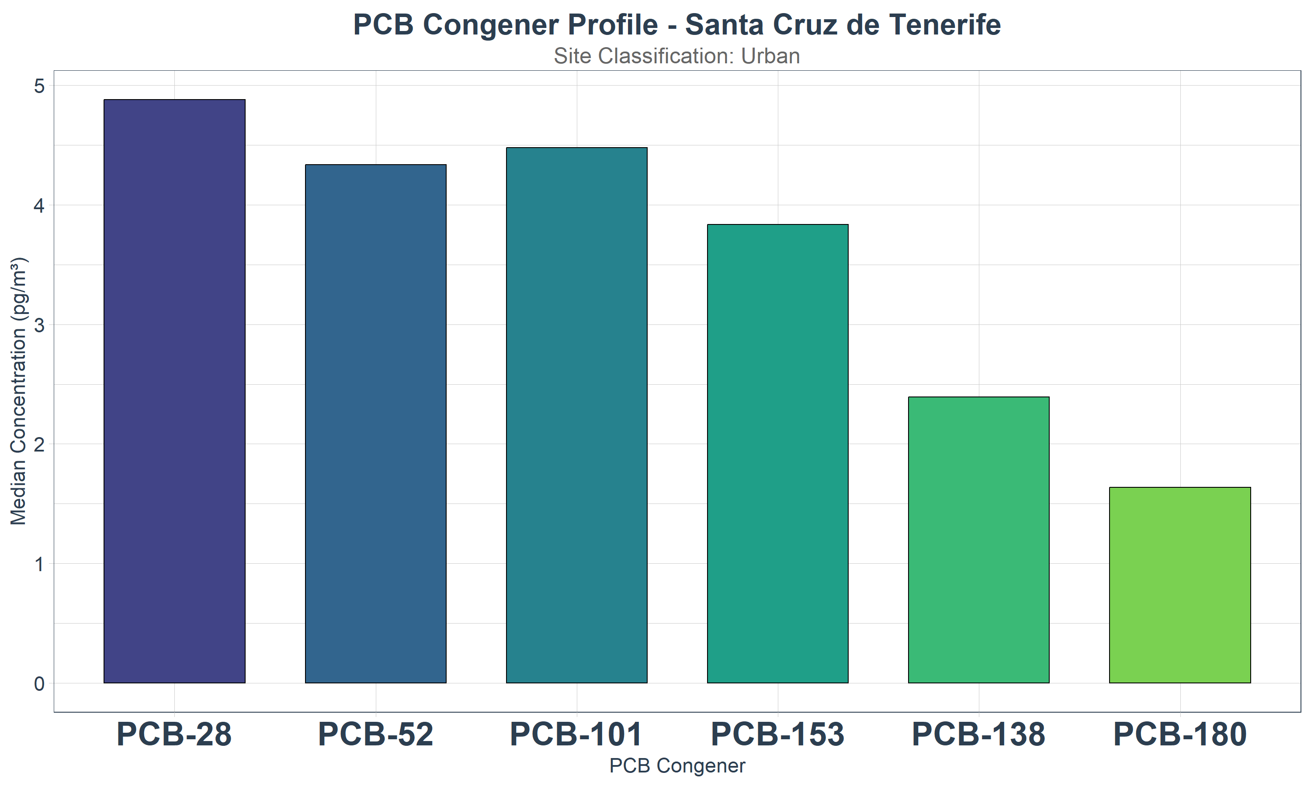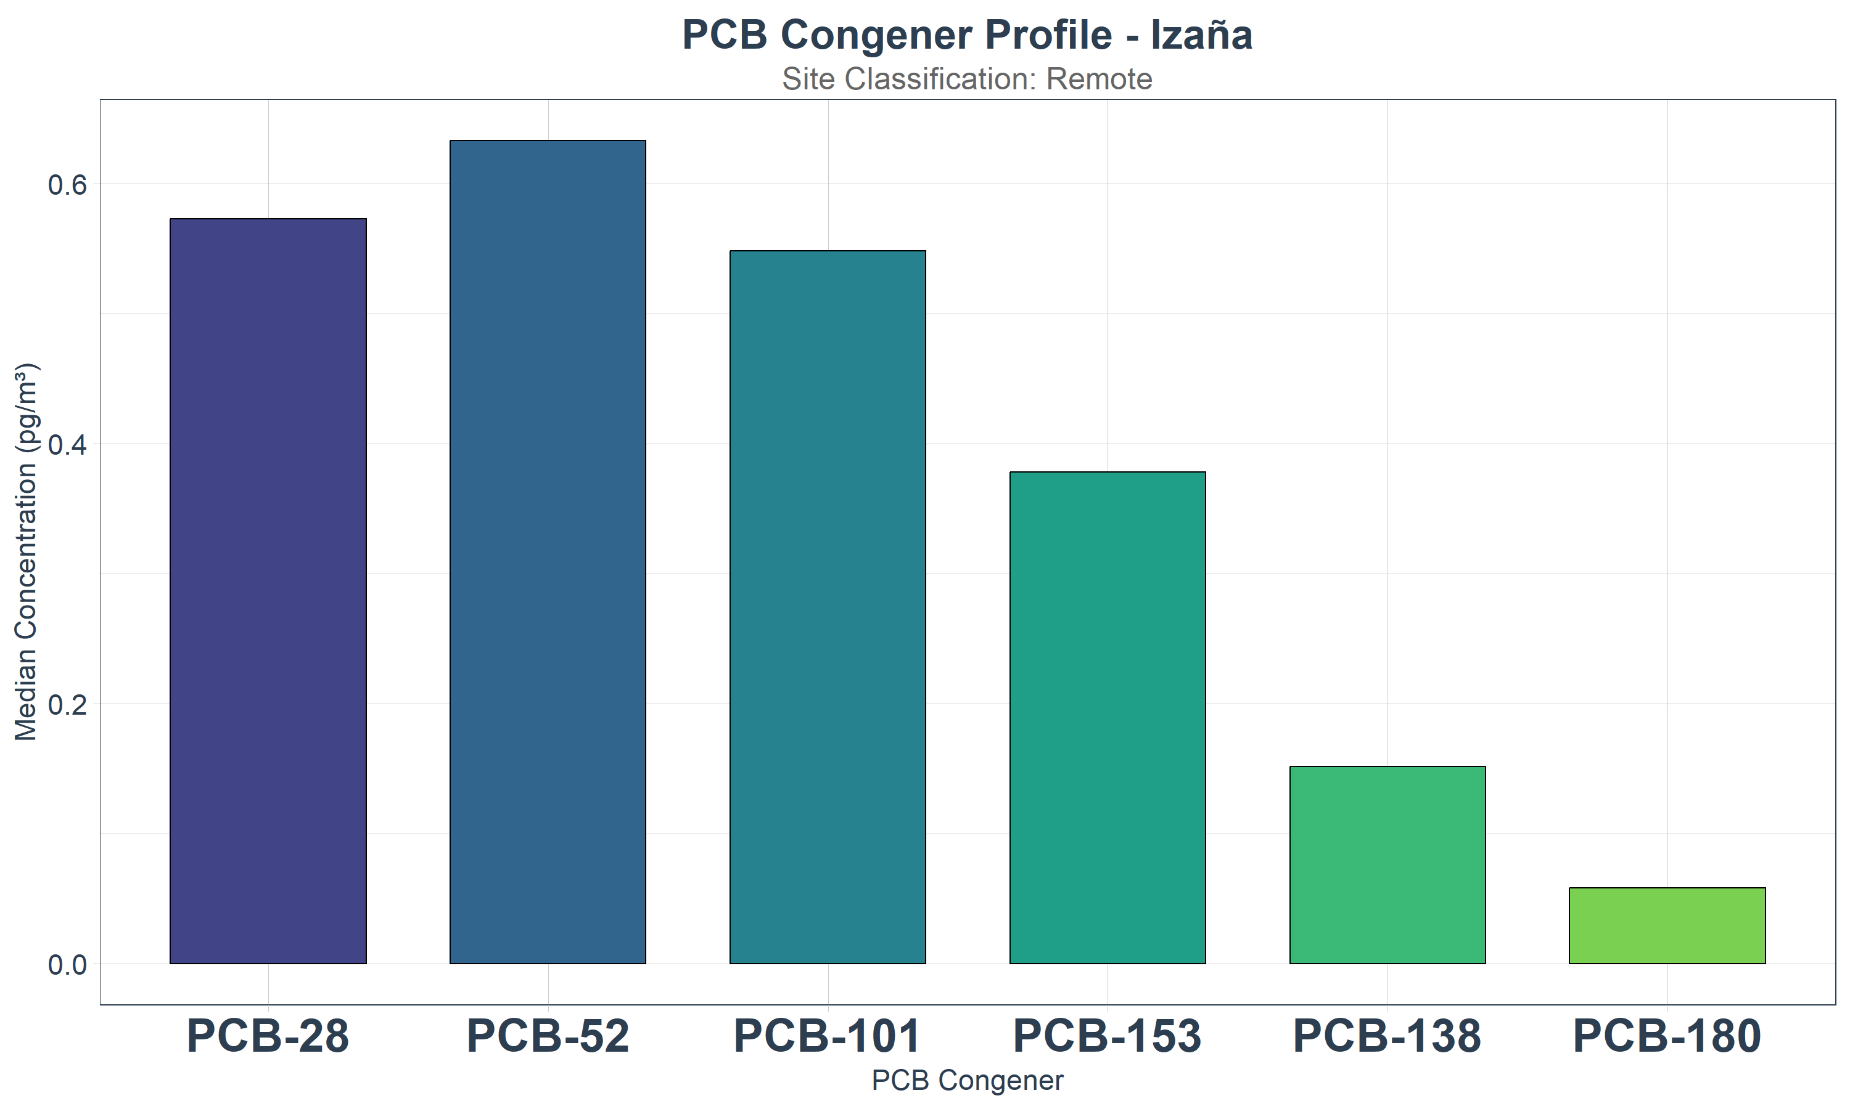
Figure S13. Atmospheric median concentrations (pg/m³) obtained for PCB-28, 52 and 153 at representative monitoring stations
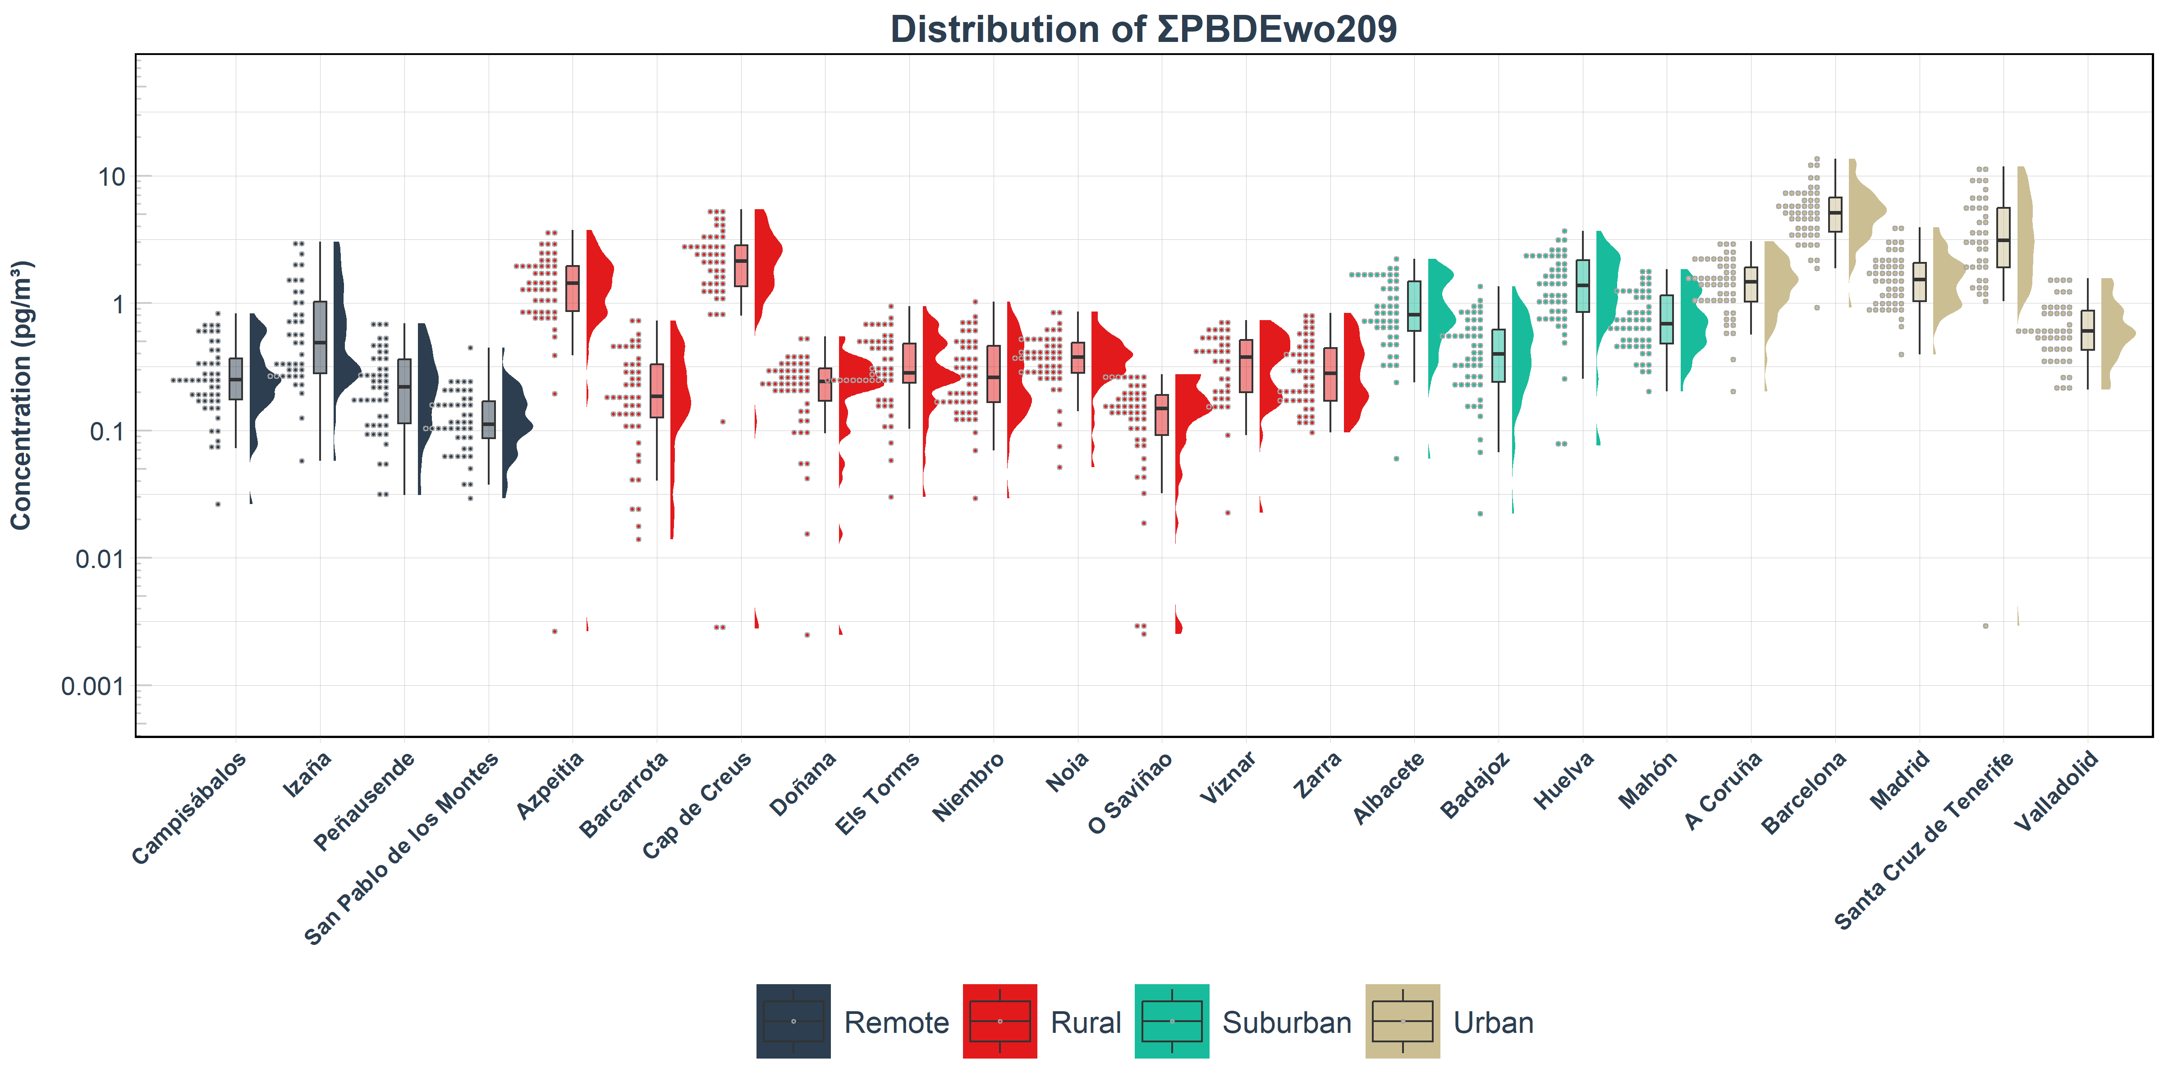

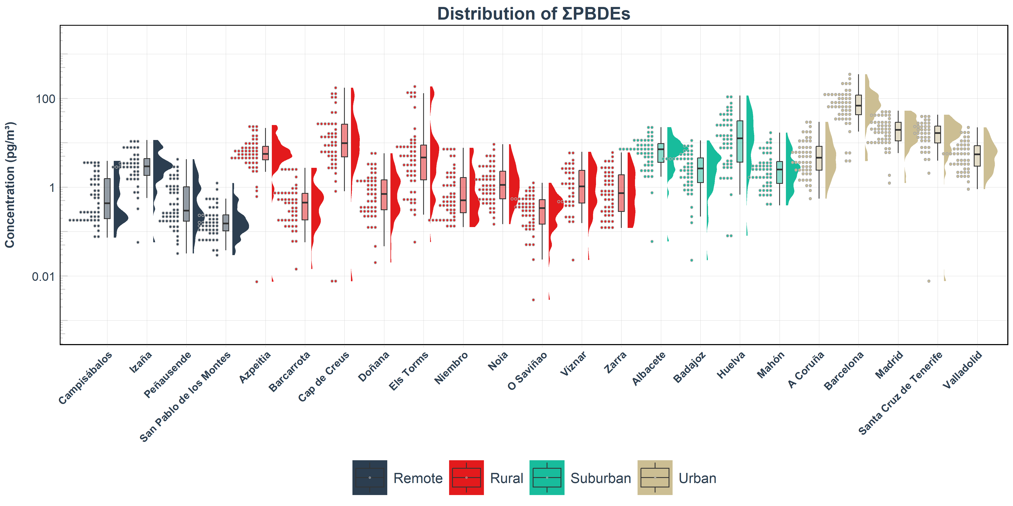
Figure S14. Atmospheric concentrations (pg/m³) for the sum of PBDEs without BDE-209 (∑PBDEwo209) and sum of PBDEs (∑PBDEs) across the SMP-POPs (2009–2023). Raincloud plots illustrate the data distribution, displaying jittered observations (left), boxplots representing the median and interquartile range (center), and kernel density shapes (right). The y-axis is shown on log10 scale and sampling sites on the x-axis are grouped by environment type (remote, rural, suburban, and urban) and ordered alphabetically within each group.

Figure S15. Spatial distribution of median concentrations (pg/m³) for (A) sum of PBDEs without BDE-209 (∑PBDEwo209) and (B) sum of PBDEs (∑PBDEs). Statistically significant temporal trends are displayed next to the bars, showing the Annual Percentage Change (APC, %) and its associated statistical power, indicated by superscripts: a for power ≥ 0.8 and b for power between 0.5 and 0.8.

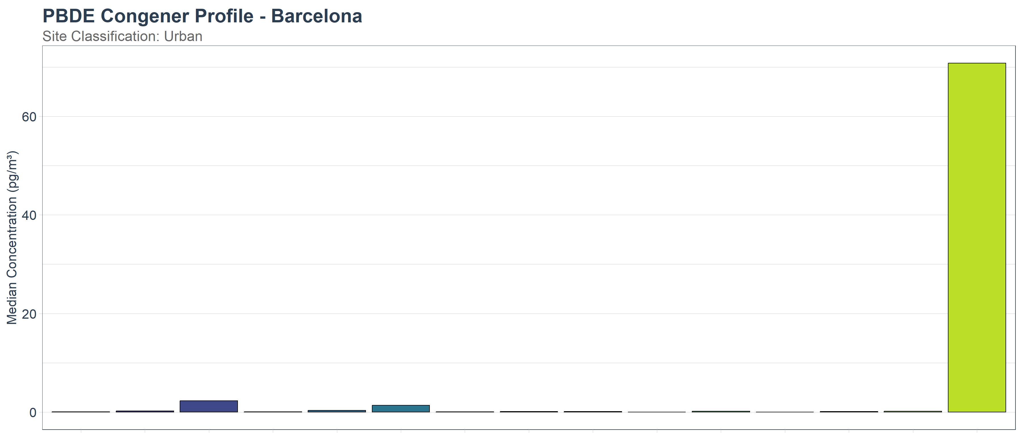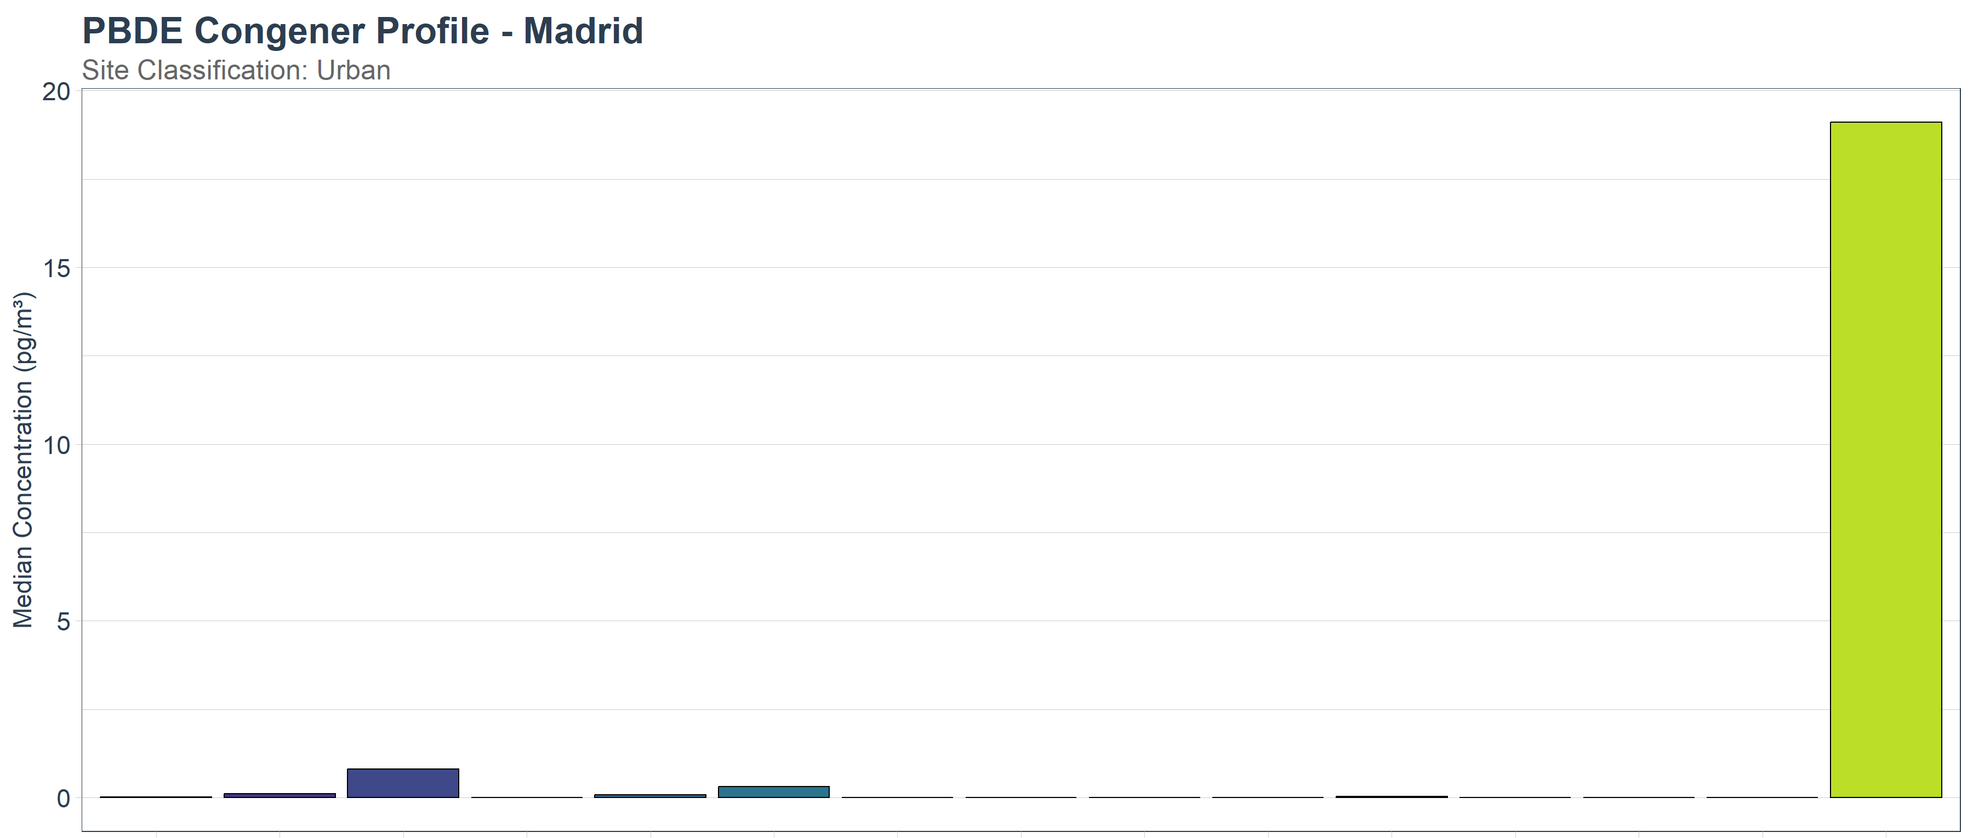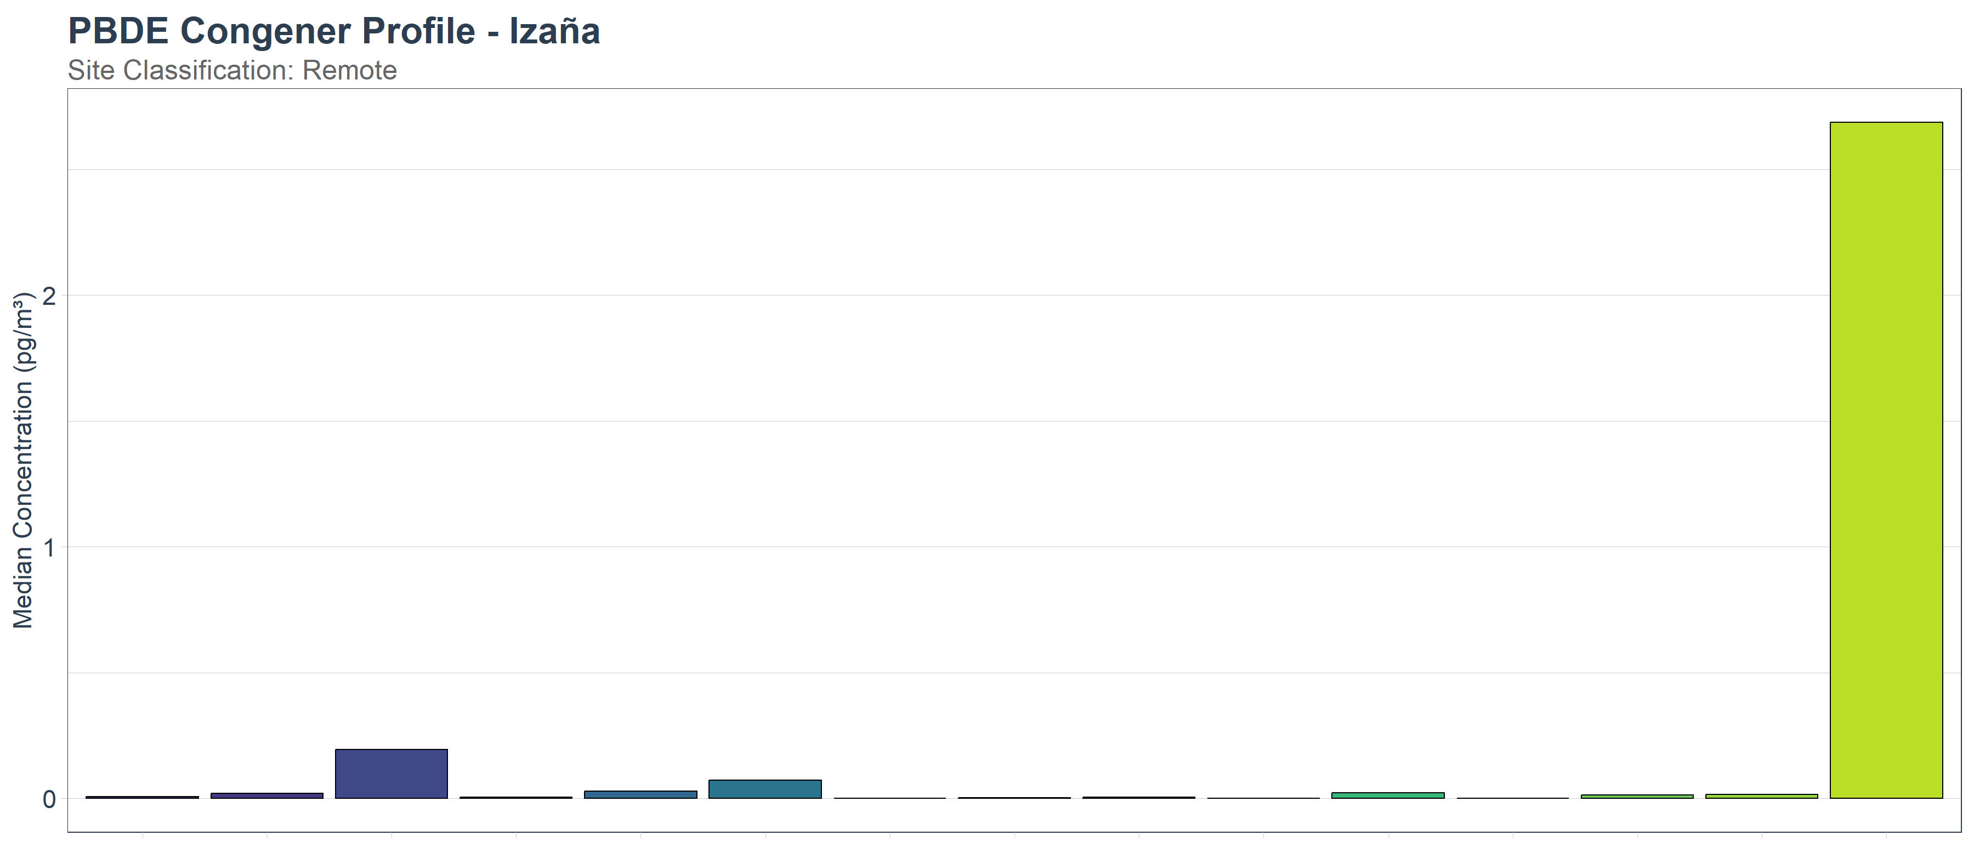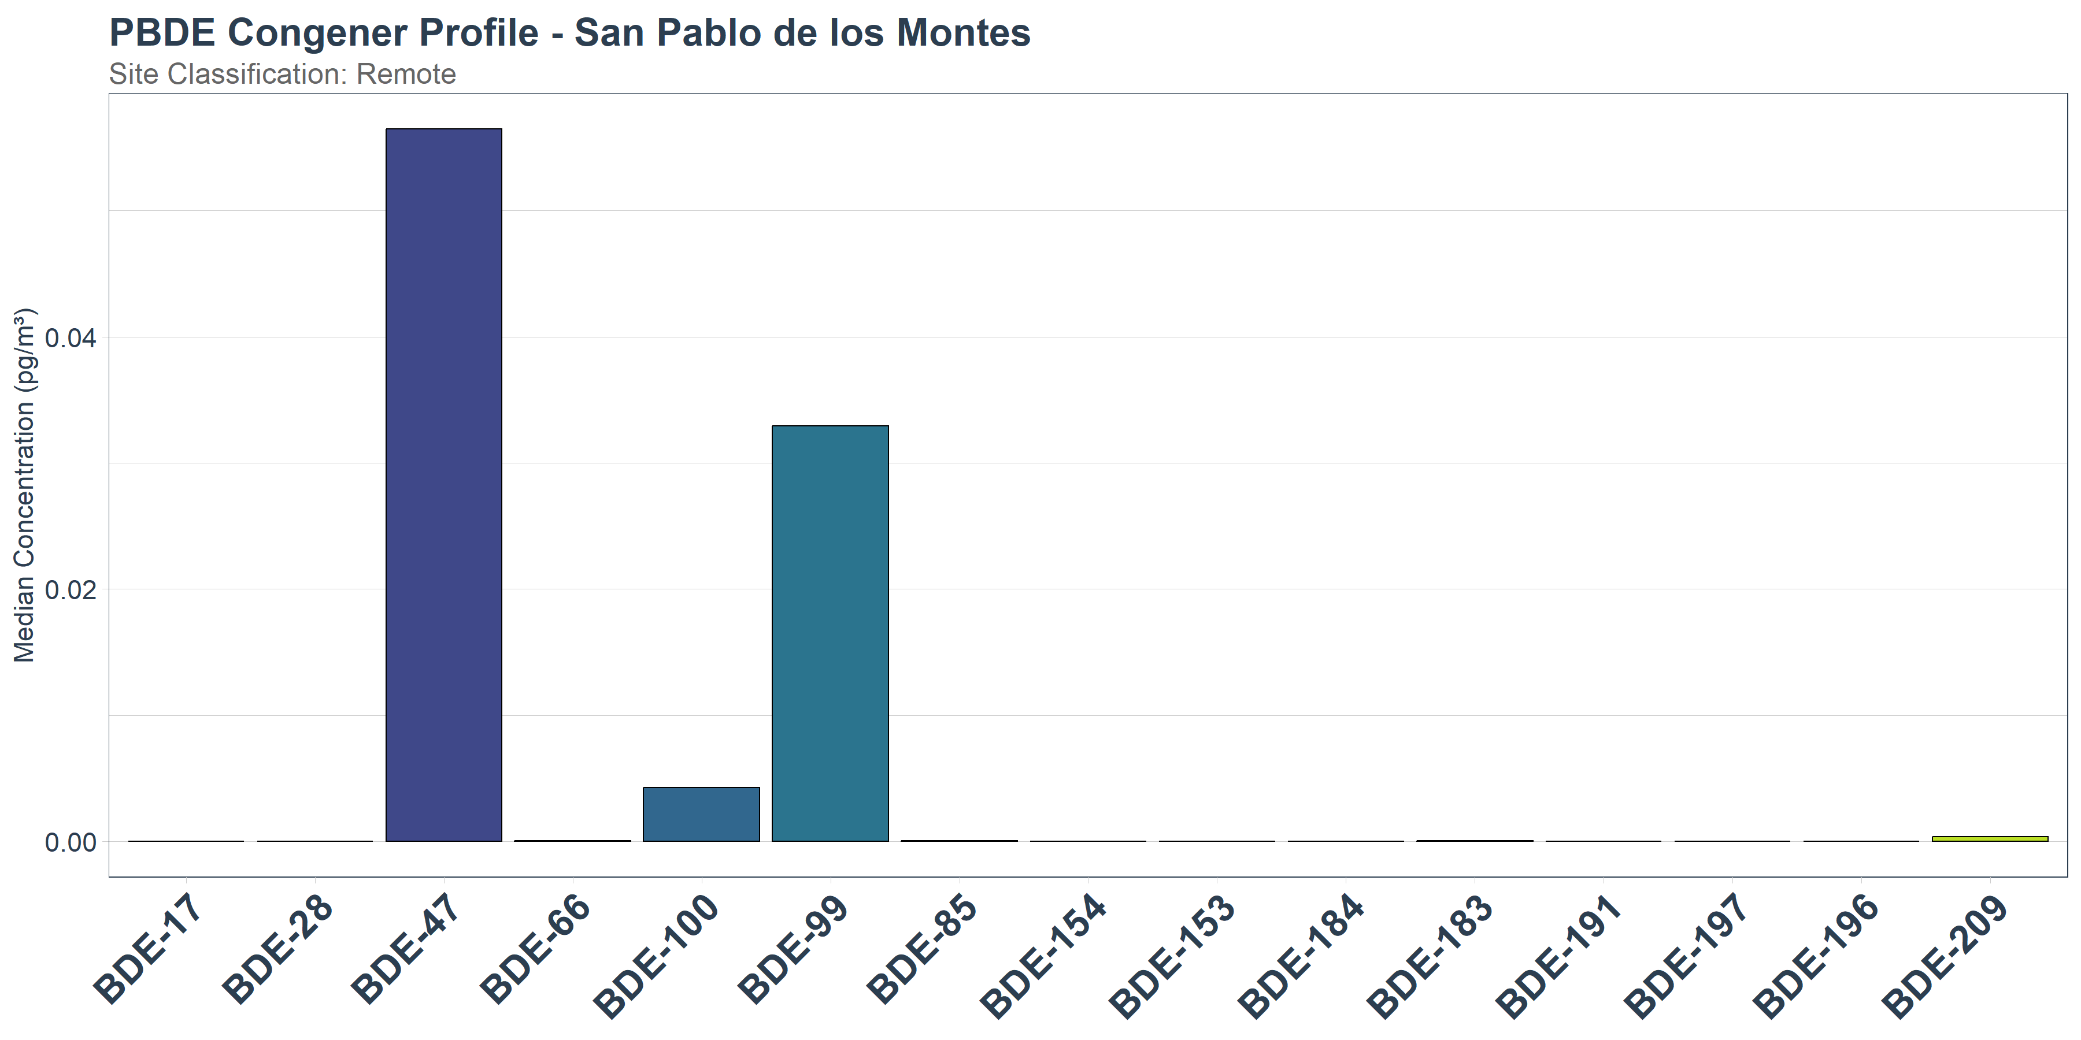
Figure S16. Atmospheric median concentrations (pg/m³) obtained for PBDEs at representative monitoring stations.
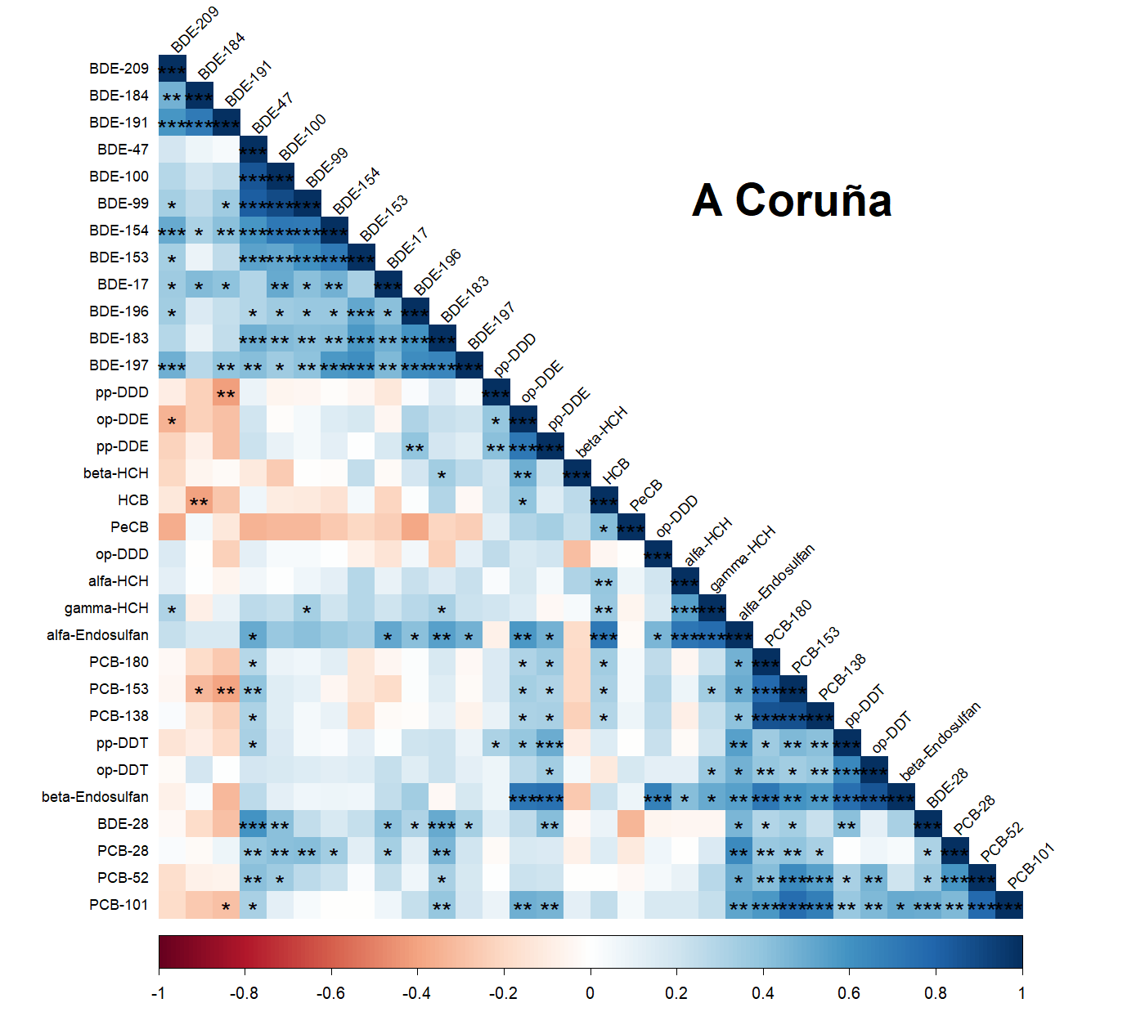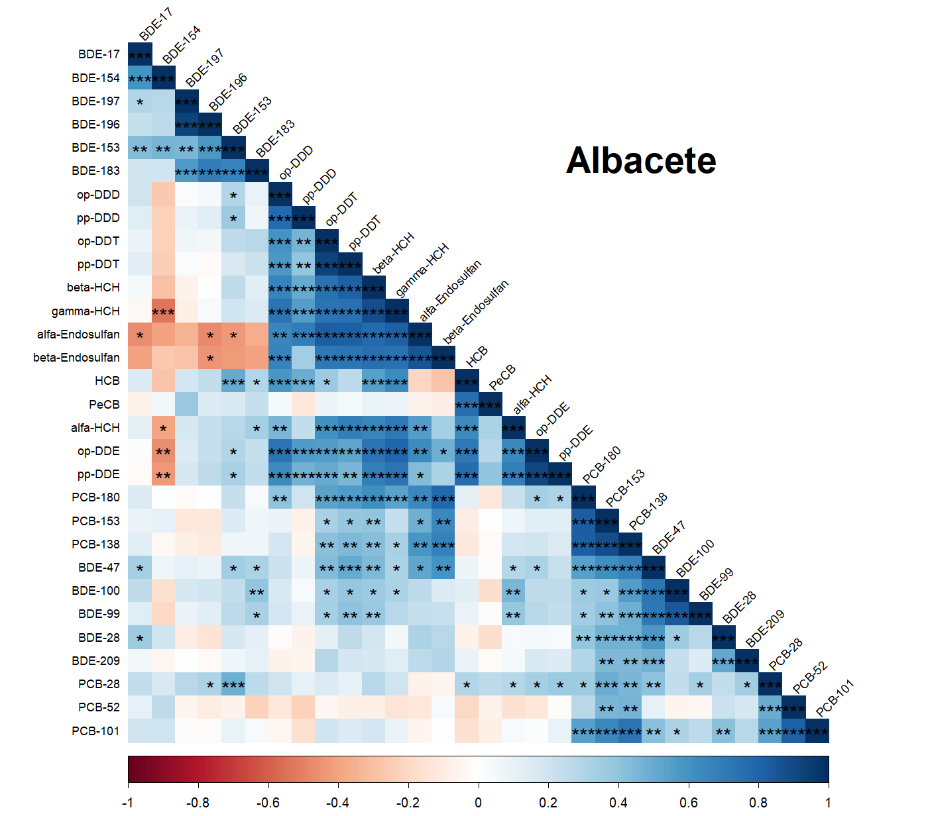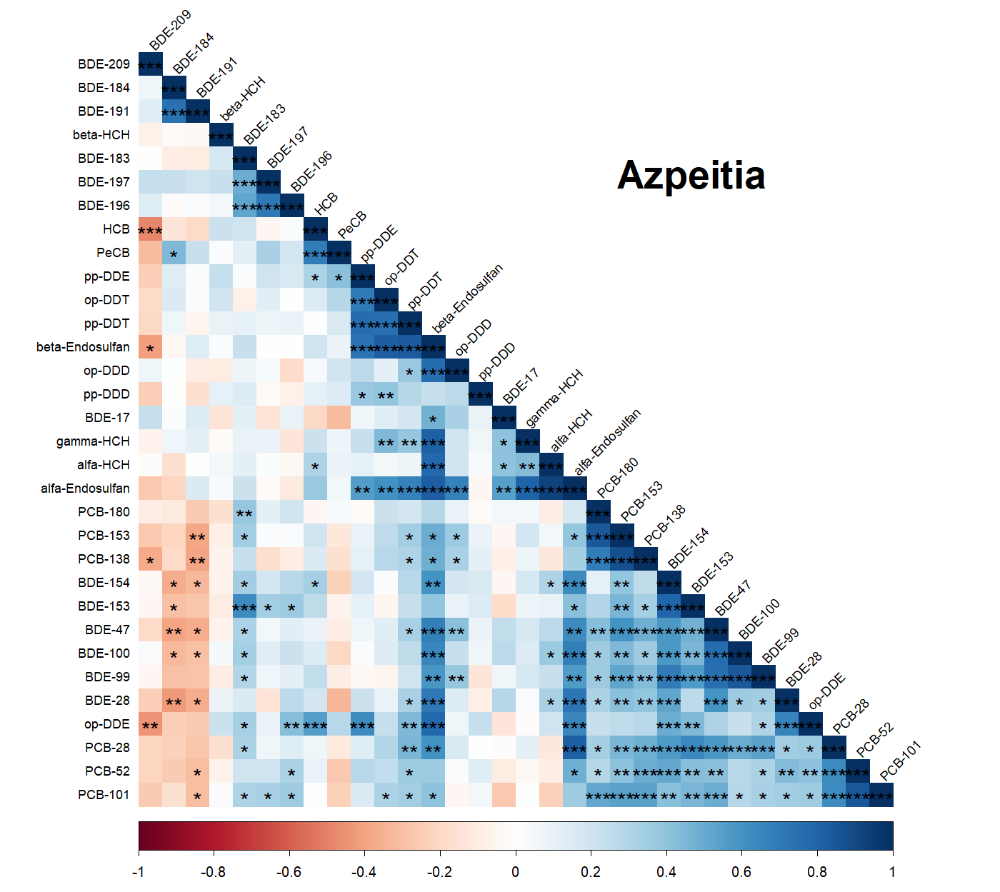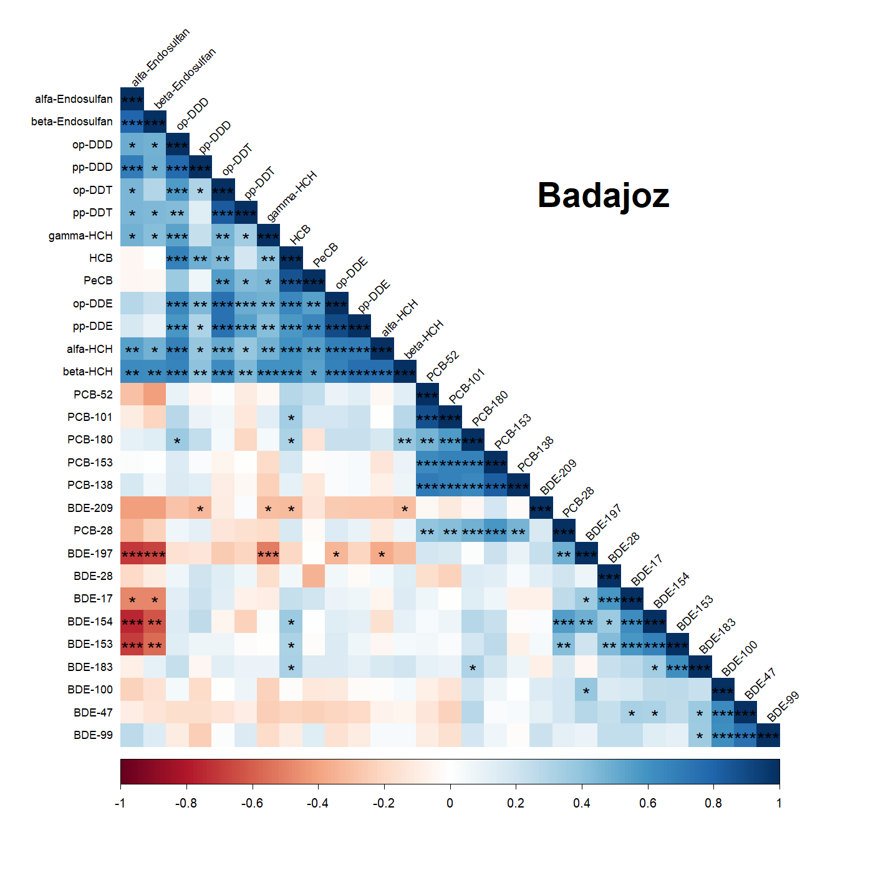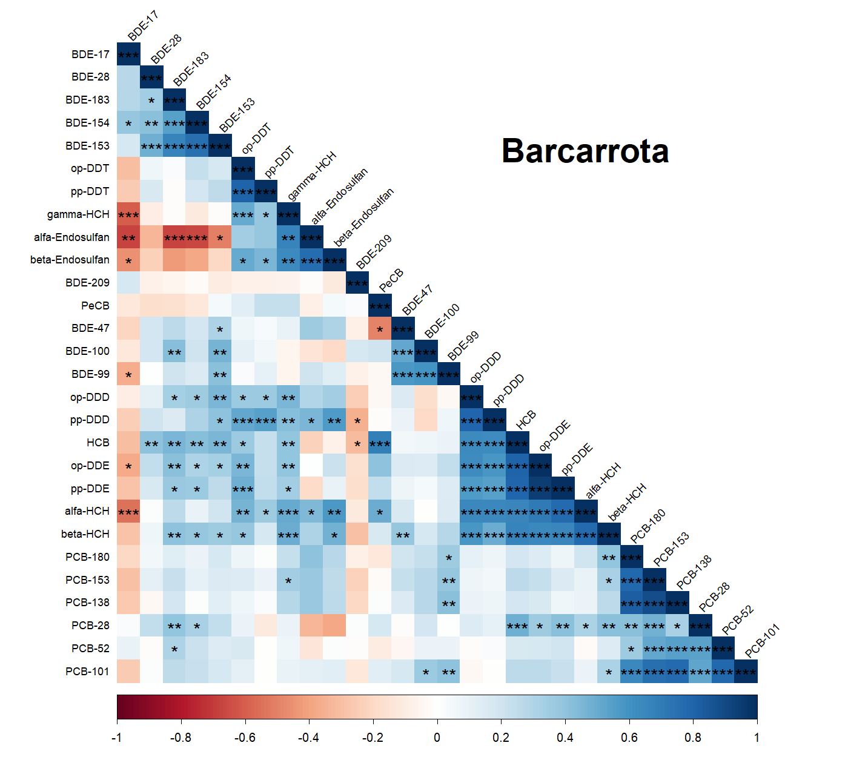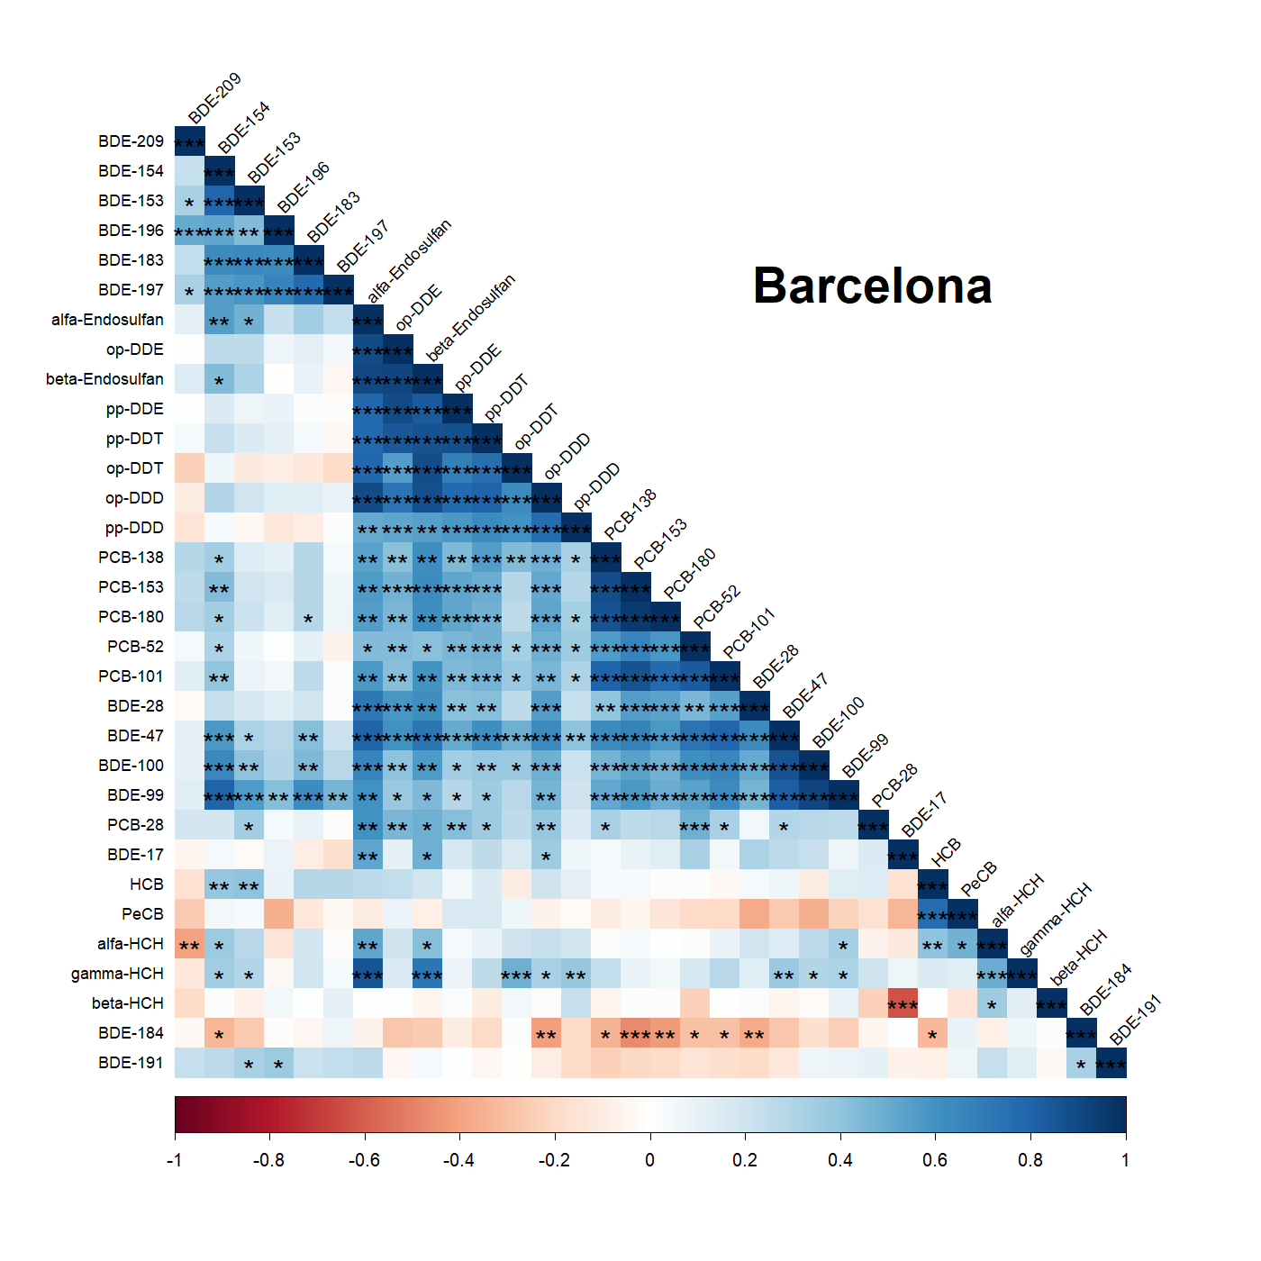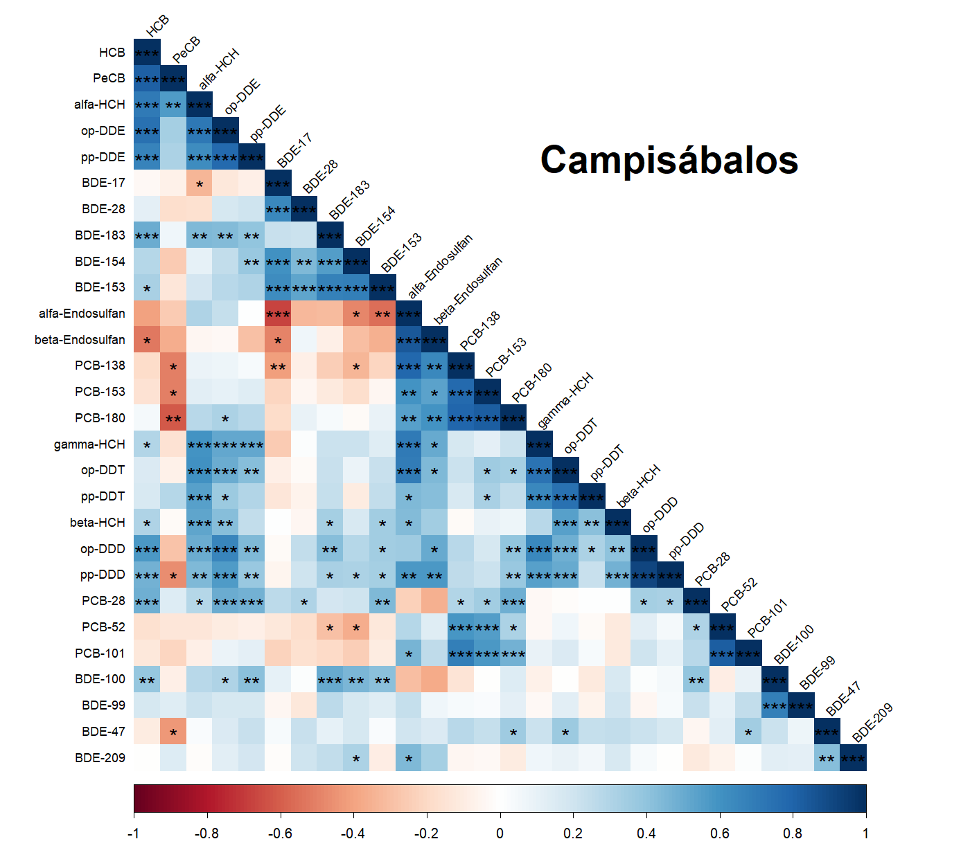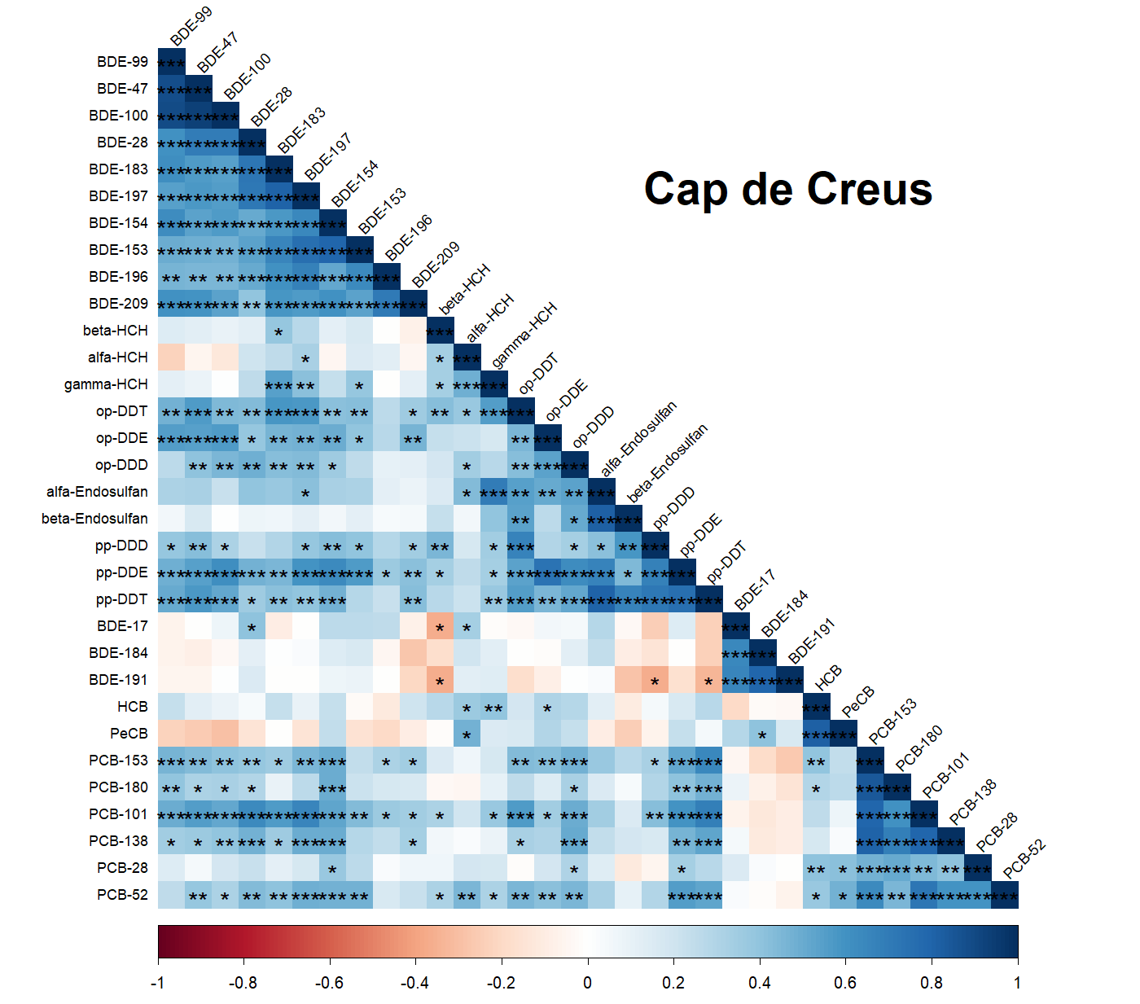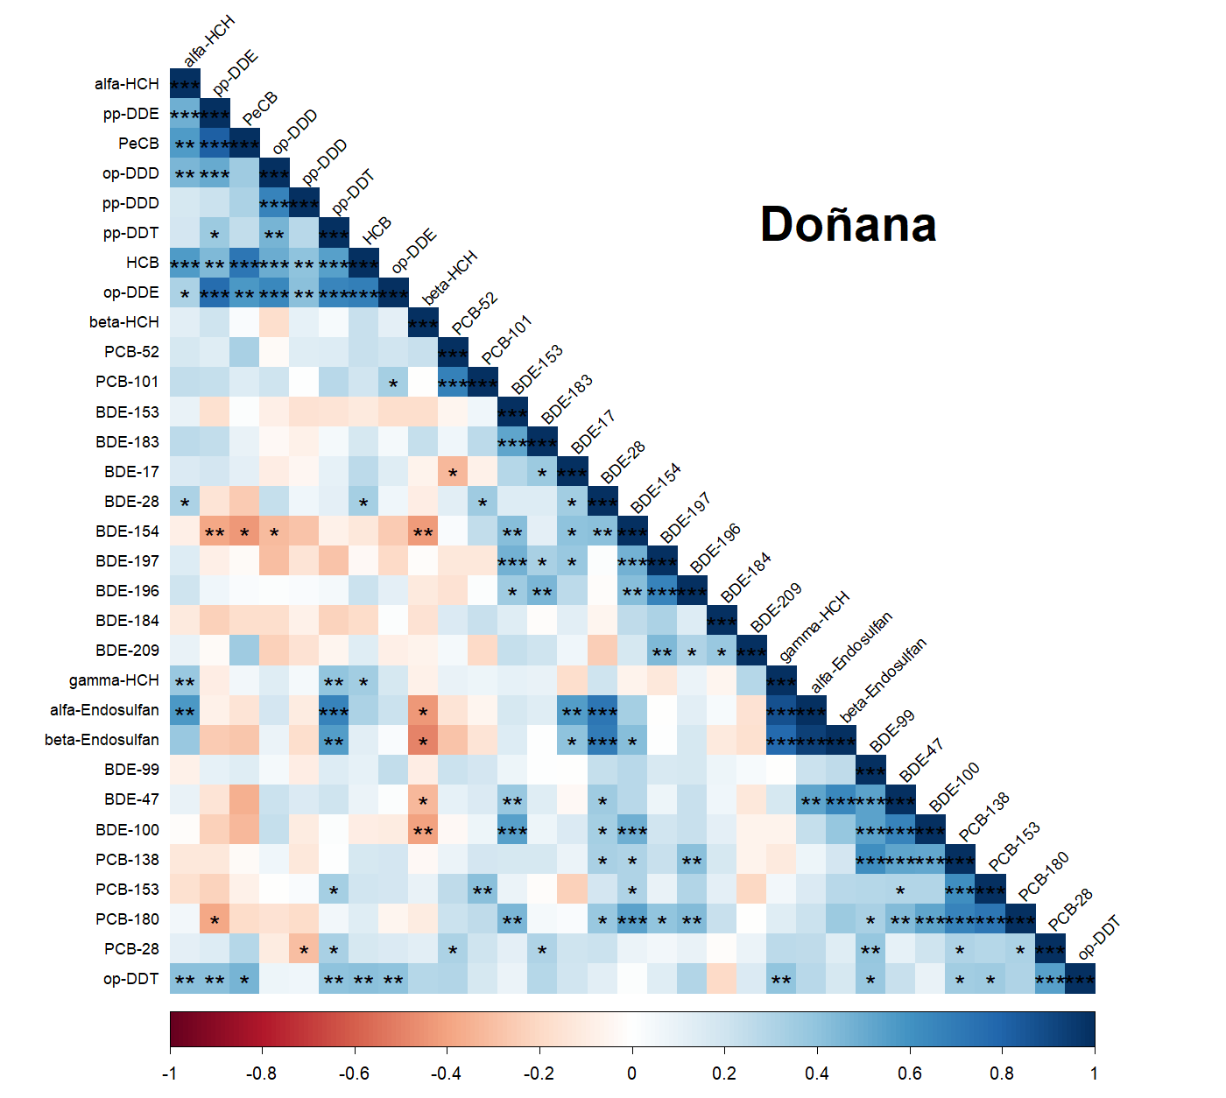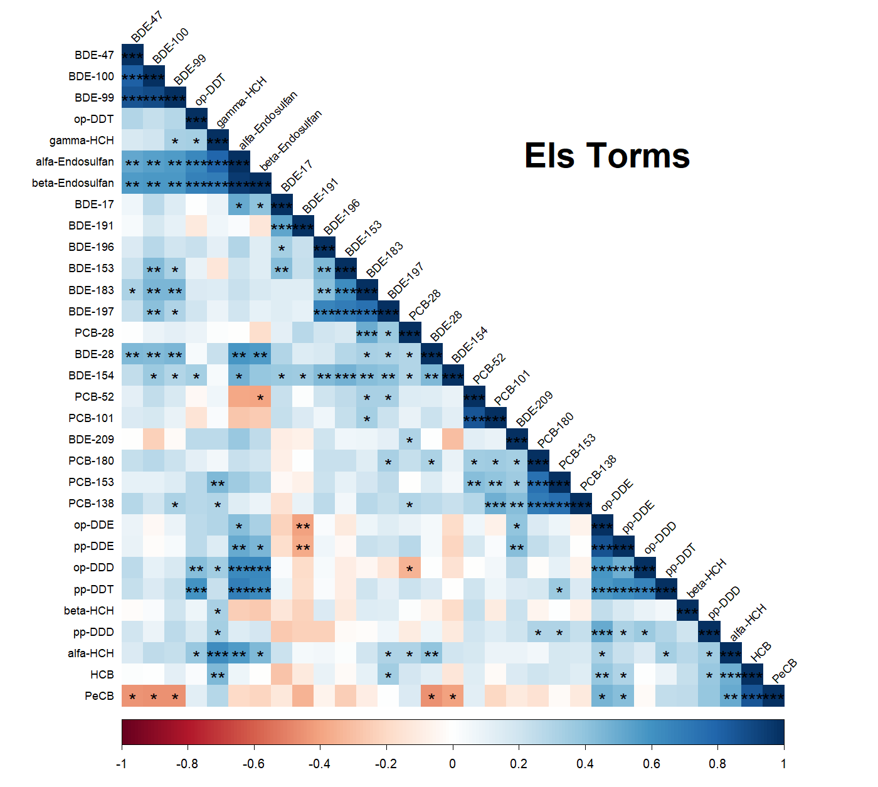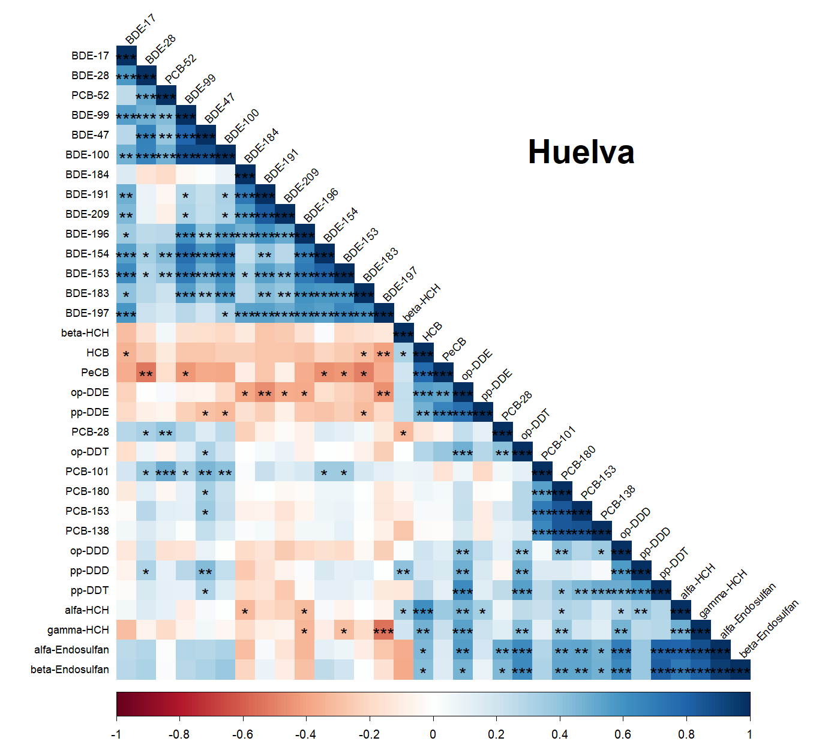
Figure 17. Spearman rank correlation matrix of POP atmospheric concentrations in each location. The color scale represents the Spearman correlation coefficient (rs), ranging from -1 (dark red, negative correlation) to +1 (dark blue, positive correlation). Asterisks (*) denote statistically significant correlations (p < 0.05). Analytes are ordered using hierarchical clustering (H-clust), revealing distinct co-varying groups such as PBDEs (top-left), DDXs/DDTs (center), and PCBs/HCHs (bottom-right). White cells within the lower triangle indicate non-significant or weak correlations.

References
AMAP. (2014). Trends in Stockholm Convention Persistent Organic Pollutants (POPS) in Arctic Air, Human Media and Biota. AMAP Technical Report to the Stockholm Convention. AMAP Technical Report No. 7 (2014), Arctic Monitoring and Assessment Programme (AMAP), Oslo, Norway. Arctic Monitoring and Assessment Programme.
De la Torre, A., Sanz, P., Navarro, I., & Martínez, M. Á. (2016). Time trends of persistent organic pollutants in Spanish air. Environmental Pollution, 217, 26–32. https://doi.org/10.1016/j.envpol.2016.01.040
Muñoz-Arnanz, J., Roscales, J. L., Ros, M., Vicente, A., & Jiménez, B. (2016). Towards the implementation of the Stockholm Convention in Spain: Five-year monitoring (2008–2013) of POPs in air based on passive sampling. Environmental Pollution, 1–7. https://doi.org/10.1016/j.envpol.2016.01.052
OSPAR. (2023). CEMP Assessment Manual: Coordinated Environmental Monitoring Programme. OSPAR Commission, London. Available at: www.ospar.org.
Roscales, J. L., Muñoz-Arnanz, J., Ros, M., Vicente, A., Barrios, L., & Jiménez, B. (2018). Assessment of POPs in air from Spain using passive sampling from 2008 to 2015. Part I: Spatial and temporal observations of PBDEs. Science of the Total Environment, 634, 1657–1668. https://doi.org/10.1016/j.scitotenv.2018.03.043
UNEP. (2025). Guidance on the Global Monitoring Plan for Persistent Organic Pollutants. UINEP/POPS/COP.12/INF/43. Geneva, 28 April - 9 May 2025.

