Supplementary material
Integrated assessment of tire and rubber wear-derived compounds in wastewater treatment systems and receiving environments
Melanie Alejandra Rojas¹, Irene Navarro^{1*}, Silvia Royano, Juan Escobar-Arnanz, Adrián de la Torre², María Ángeles Martínez²
ªUnit of POPs and Emerging Pollutants in Environment, Department of Environment, CIEMAT, Madrid, Spain.
*Corresponding author: Irene Navarro
Address: Av Complutense nº 40, Madrid (28040), Spain.
e-mail: i.navarro@ciemat.es
Telephone: +34 913 466 019
¹These authors share first authorship.
²These authors share last authorship.

TABLE OF CONTENTS | PAGE
Table S1. Physicochemical properties for TRDCs analyzed in the water cycle……………….. | EXCEL
Figure S1. Monthly average rainfall (mm) in the Tagus River during 2022………………….. | S1
Table S2. MS/MS conditions used in the TRDC determination……………………………… | S2
Table S3. Validation of analytical methodology for water samples.……………………..…... | S3
Table S4. Validation of analytical methodology for sludge samples………………………….. | S4
Table S5. Characteristics of the surface water sampling sites………………………….…….. | S4
Table S6. WWTP characteristics……………………………………………………………... | S5
Table S7. Descriptive statistics in wastewater..……………..................................................... | S6
Table S8. Matrix of significant differences between compounds in wastewater.…………….. | S7
Table S9. Correlation matrix of the TRDCs detected in wastewater…………………………. | S7
Figure S2. Seasonal concentrations of TRDCs in both the influent and effluent of each WWTP………………………………………………………………………………………... | S8
Table S10. Mass flow rate and removal efficiency in water and sludge lines for both WWTPs. | S9
Table S11. Descriptive statistics in sewage sludge……………………………………………. | S10
Table S12. Matrix of significant differences between compounds in sewage sludge…………. | S11
Table S13. Correlation matrix of the TRDCs detected in sewage sludge…………………….. | S11
Figure S3. Seasonal concentrations of TRDCs in sewage sludge in WWTP1 and WWTP2…. | S12
Table S14. Wastewater–sludge partition coefficients of the analyzed compounds…………… | S13
Table S15. Descriptive statistics in surface water…………………………………………….. | S14
Table S16. Matrix of significant differences between compounds in surface water…………. | S15
Table S17. Correlation matrix of the TRDCs detected in surface water………………………. | S15
Figure S4. TRDC concentration throughout the different seasons of the year in surface water.. | S16
Table S18. Spatial distribution (ng/L) of TRDCs in the Tagus River basin…………………… | S16
Table S19. Comparison of TRDC concentrations in the water cycle……..………………….. | EXCEL
Table S20. Mass flow rates of TRDCs in Tagus River basin. ….……………………………. | S17
Figure S5. Diagrams of dispersion related to the two components resulting from a principal components analysis (PCA) derived from the distribution of TRDCs in surface water ……..… | S18
Table S21. Ecological risk assessment of individual TRDCs and mixtures in the aquatic environment…………………………………………………………………………………... | S19
Table S22. Acute risk calculation of TRDCs to aquatic organisms………………………….. | S19
Table S23. Risk of each individual compound to terrestrial organisms……………………….. | S20
Table S24. List of the top three TRDCs of concern for aquatic organisms…………………… | S21
Table S25. List of the top three TRDCs of concern for terrestrial organisms……………..….. | S21
References……………………………………………………………………………………. | S22

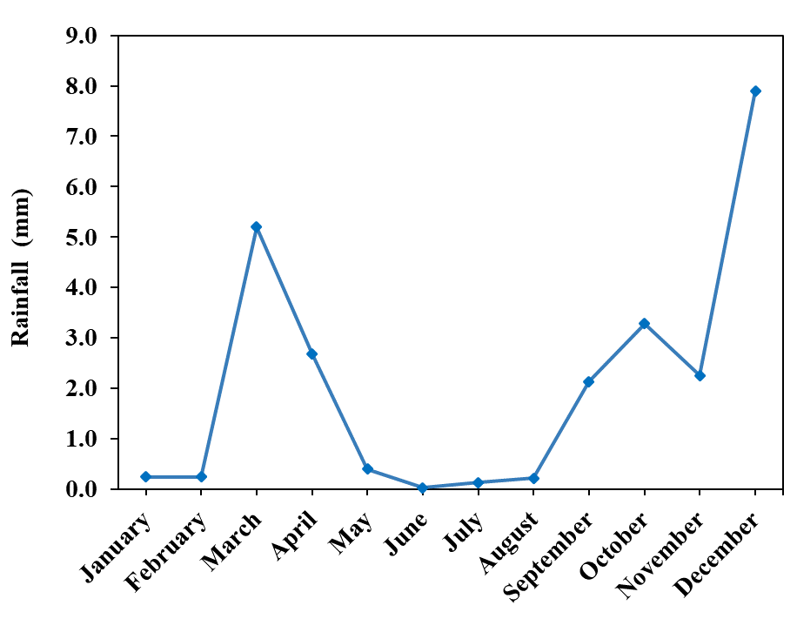
Figure S1. Monthly average rainfall (mm) in the Tagus River during 2022 (SAIH Tajo, 2025; Escobar-Arnanz et al., 2026).

Table S2. MS/MS conditions used in the TRDC determination: quantifying and qualifying transitions, declustering potential (DP), collision energy (CE), collision cell exit potential (CXP).
TRDCs | SRM 1 Quantifying transition (m/z) | DP/CE/CXP  (V) | SRM 2 Qualifying transition (m/z) | DP/CE/CXP  (V)
PI Mode
6PPD | 269 184.1 | 47/60/8 | 269 107.2 | 64/63.3/10
6PPD-Q | 299 215 | 81/27/22 | 299 241 | 81/33/22
IPPD | 227 184 | 51/24/14 | 227 107.1 | 51/51/10
IPPD-Q | 257 187 | 60/35/13 | 257 215 | 60/24/22
DPPD | 259.9 183.1 | 101/43/14 | 259.9 167.1 | 101/51/12
DTPD | 287 180 | 63/39/13 | 287 181.1 | 63/21/13
DPG | 212 119 | 76/29/10 | 212 77 | 76/51/8
DTG | 239.6 108.1 | 62/29/10 | 239.6 106.1 | 62/39/7
CPU | 219.1 94.1 | 76/29/8 | 219.1 77.1 | 76/55/10
DCU | 225.1 55.1 | 81/49/6 | 225.1 100.1 | 81/23/8
DCMA | 233 151 | 66/31/12 | 233 55.1 | 66/45/6
DCA | 196.1 114.1 | 61/25/10 | 196.1 55.1 | 61/43/6
DBZA | 197.9 91 | 50/25/9 | 197.9 65.2 | 50/59/4
TBA | 185.9 130.2 | 46/26/9 | 185.9 57.2 | 46/32/4
DMBA | 101.9 85.2 | 31/12/6 | 101.9 43.2 | 31/18/6
BTH | 136 109.1 | 58/34/9 | 136 65.1 | 58/46/8
2-ABTH | 151 109 | 81/35/10 | 151 124 | 81/29/10
2-OH-BTH | 152 124 | 56/27/12 | 152 92 | 56/25/8
2-MeS-BTH | 181.9 167 | 71/31/12 | 181.9 109 | 71/47/10
BTR | 119.9 65 | 36/29/6 | 119.9 92.3 | 36/23/8
Me-BTR | 133.9 77 | 56/33/8 | 133.9 79 | 56/25/8
4-HDPA | 186.1 109.1 | 47/31/11 | 186.1 80.1 | 47/60/8
HMMM | 391.2 177.1 | 55/37/13 | 391.2 207.1 | 55/26/15
CBS | 265 166 | 71/33/14 | 265 183 | 71/23/16
6PPD-Q-d5 | 304 220.1 | 91/23/16 | 304 246.1 | 91/39/18
IPPD-Q-d5 | 262 220.1 | 76/25/16 | 262 192.1 | 76/37/16
DPG-d10 | 222.1 124.1 | 81/31/10 | 222.1 82.1 | 81/57/8
DPA-d10 | 180 98.1 | 91/41/8 | 180 97.2 | 91/29/8
BTH-d4 | 139.8 113.1 | 59/35/9 | 139.8 112.1 | 59/34/11
BTR-d4 | 123.8 69.1 | 76/31/6 | 123.8 96.1 | 76/25/8
Me-BTR-d6 | 139.9 81.1 | 57/37/7 | 139.9 112.1 | 57/24/11
NI Mode
MBTH | 165.9 134 | -70/-29/-7 | 165.9 58 | -70/-55/-5

Table S3. Validation of analytical methodology for water samples. Limits of detection (LODs), limits of quantification (LOQs) and validation results at low, medium and high concentration levels for water samples.
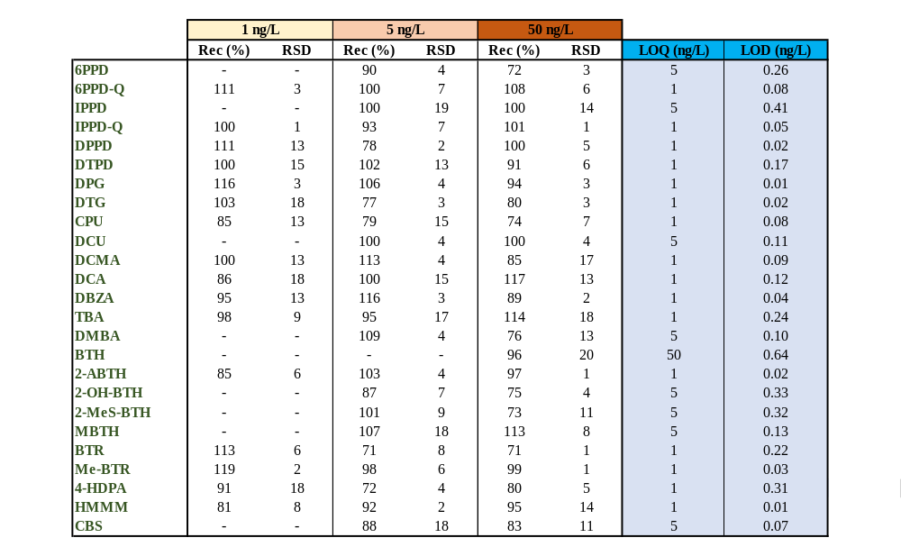

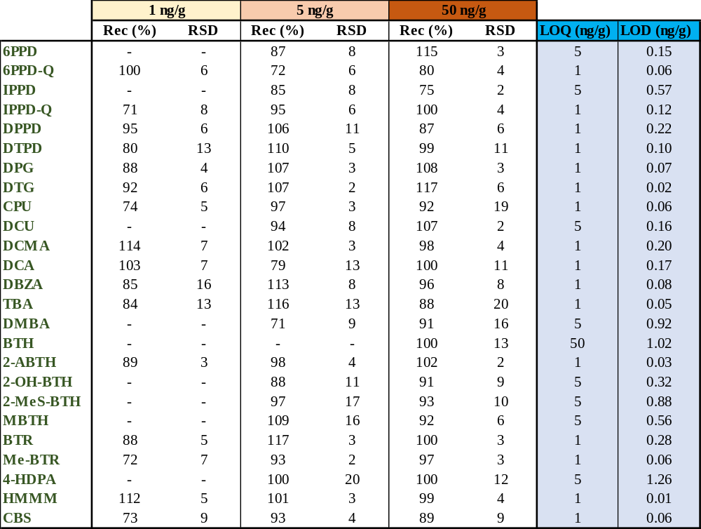
Table S4. Validation of analytical methodology for sludge samples. Limits of detection (LODs), limits of quantification (LOQs) and validation results at low, medium and high concentration levels for sludge samples.

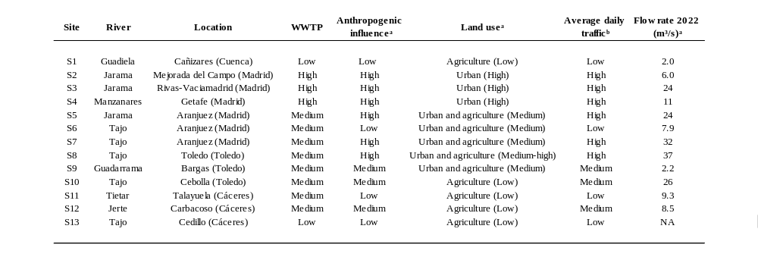
Table S5. Characteristics of the surface water sampling sites (location; WWTP, anthropogenic land use and traffic influence, and mean daily flow rate; ªRoyano et al., 2023; ^{b}Escobar-Arnanz et al., 2026). NA: not available.
Table S6. WWTP characteristics (Royano et al., 2024).
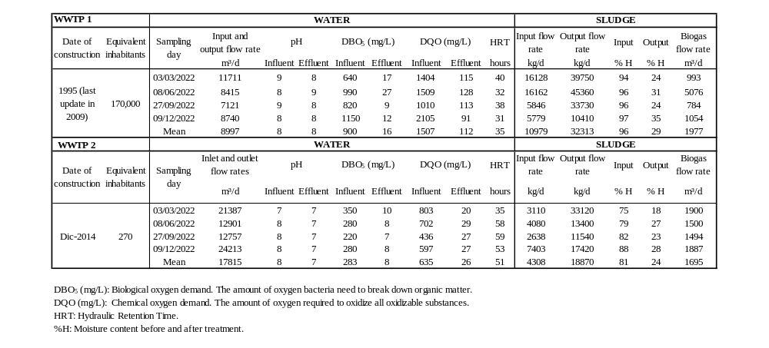
Table S7. Descriptive statistics (median (mean ± SD), min-max of positives and detection frequency (Df, %)) in wastewater.
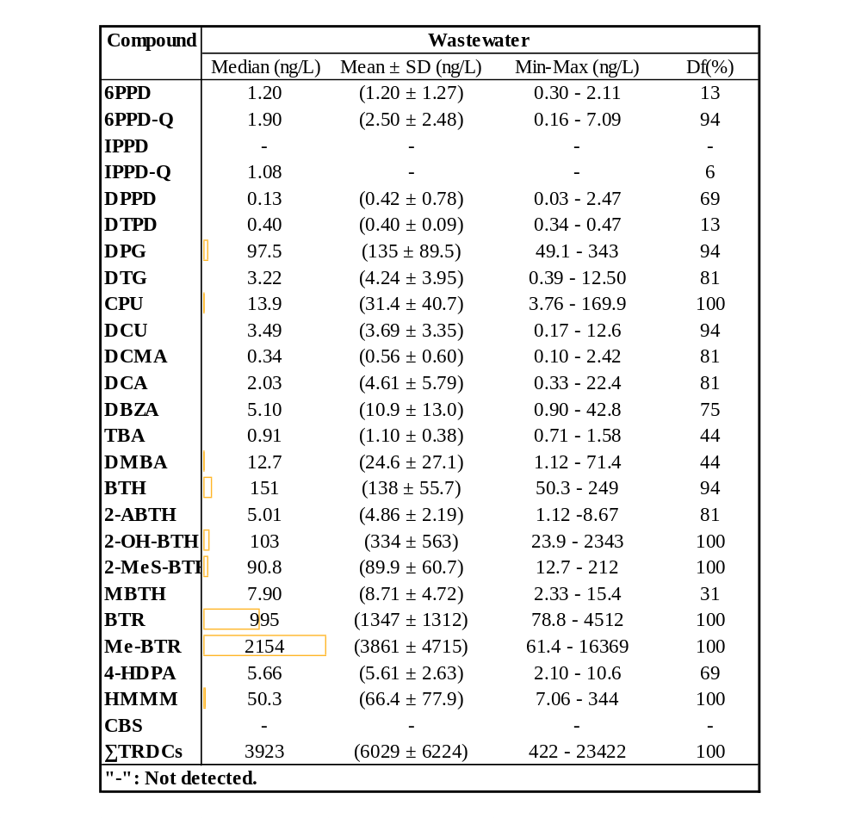

Table S8. Matrix of significant differences (p < 0.05, Kruskal-Wallis test) between compounds in wastewater.
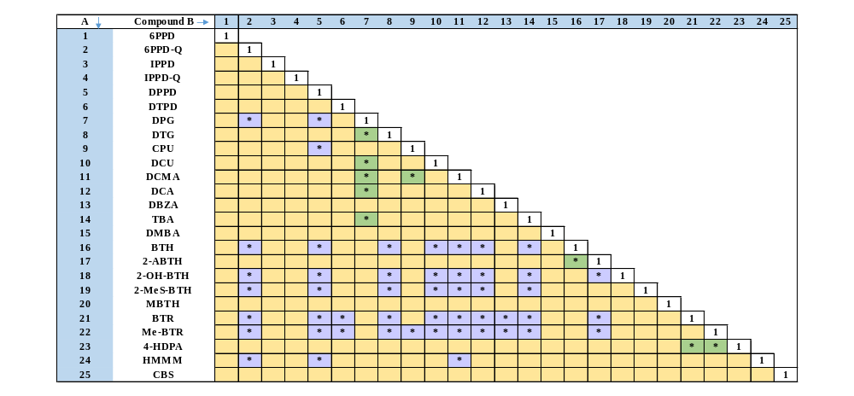
* Significant differences (p < 0.05, Kruskal-Wallis). Purple coloured cell: [A]>[B]; Green coloured cell: [A]<[B]; Yellow coloured cell: no significant difference.

Table S9. Correlation matrix (p < 0.01 and p < 0.05, Spearman’s rank correlation test) of the TRDCs detected in wastewater.
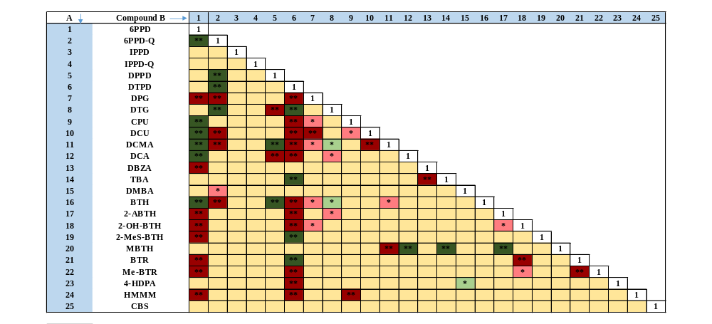
** Significant correlation (p < 0.01, Spearman's rank correlation test); * Significant correlation (p < 0.05, Spearman's rank correlation test); red coloured cell for positive correlation coefficients; green coloured cell for negative correlation coefficients; light yellow coloured cell for no correlation.

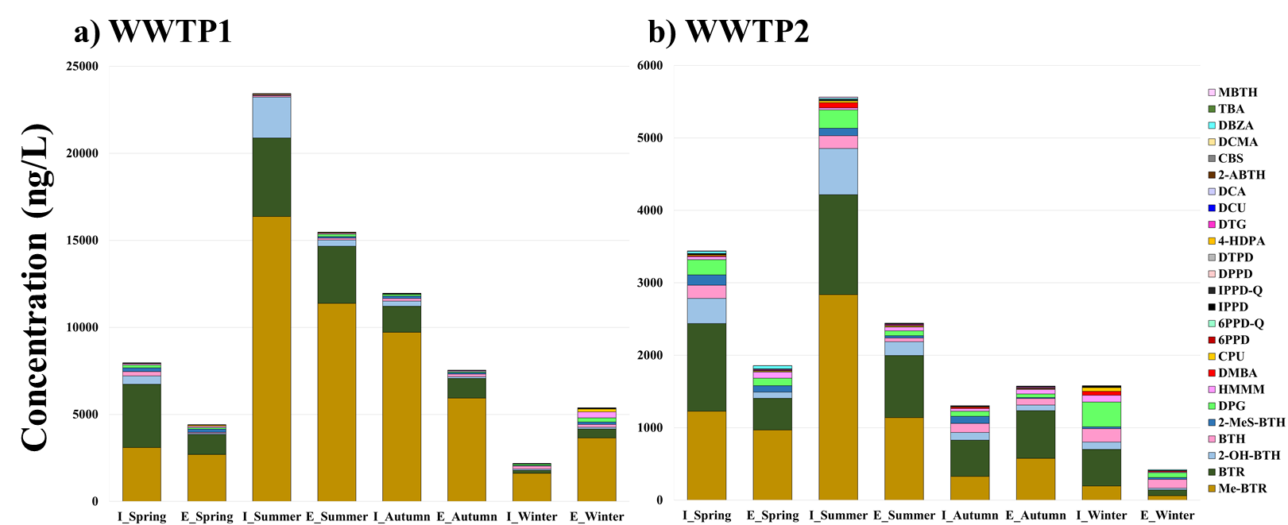
Figure S2. Seasonal concentrations of TRDCs in both the influent and effluent of each WWTP (a, WWTP1; b, WWTP2; I=Influent; E=Effluent).

Table S10. Mass flow rate (g/d) and removal efficiency (RE, %) in water and sludge lines for both WWTPs.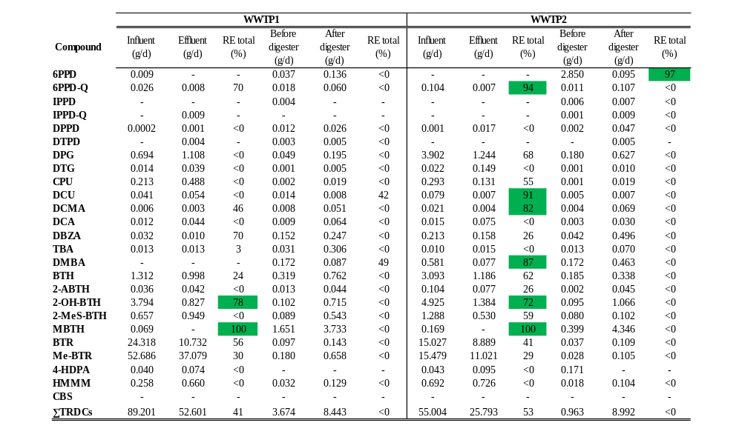

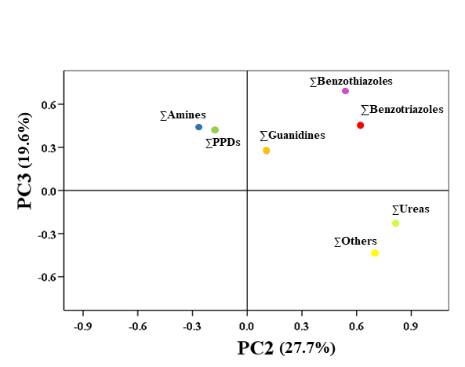
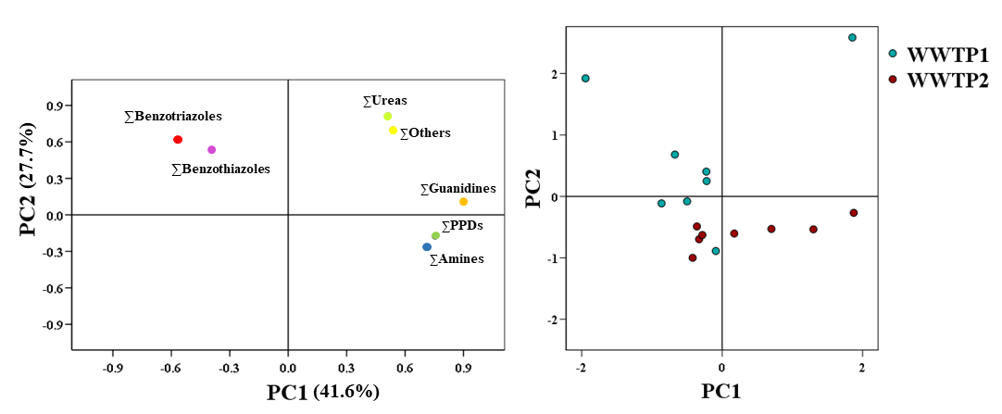
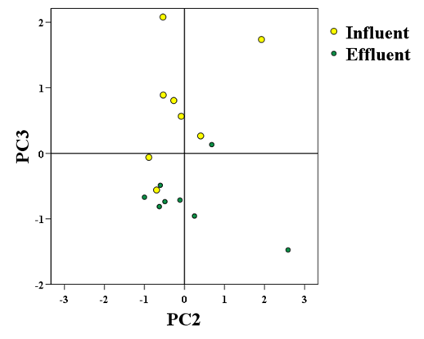
a)
b)
Table S11. Descriptive statistics (median (mean ± SD), min-max of positives and detection frequency (Df, %)) in sewage sludge.
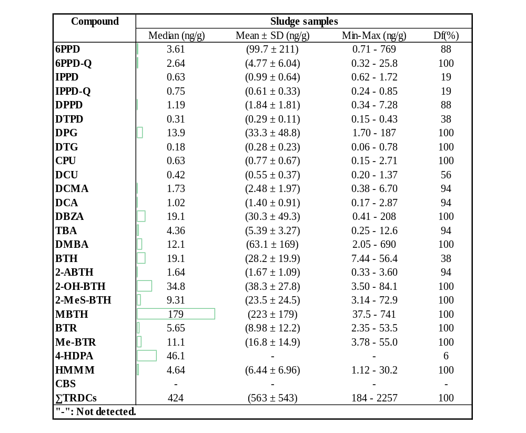

Table S12. Matrix of significant differences (p < 0.05, Kruskal-Wallis test) between compounds in sewage sludge.
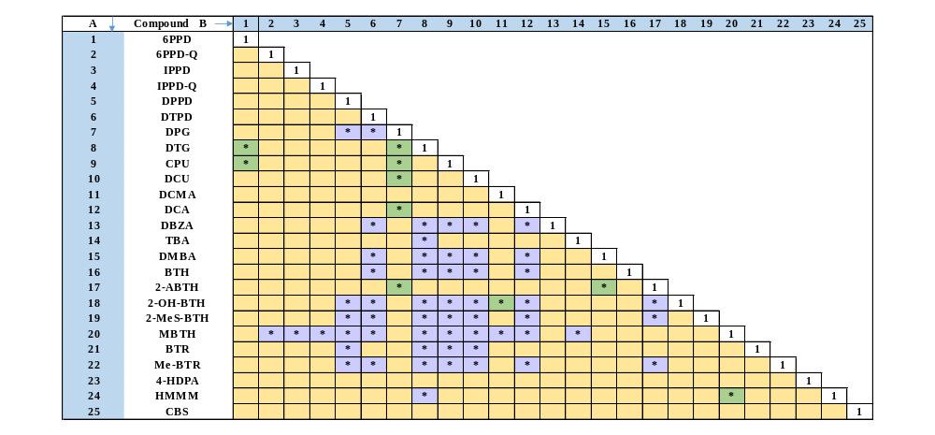
* Significant differences (p > 0.005, Kruskal-Wallis). Purple coloured cell: [A]>[B]; Green coloured cell: [A]<[B]; Yellow coloured cell: no significant difference.

Table S13. Correlation matrix (p < 0.01 and p < 0.05, Spearman’s rank correlation test) of the TRDCs detected in sewage sludge.
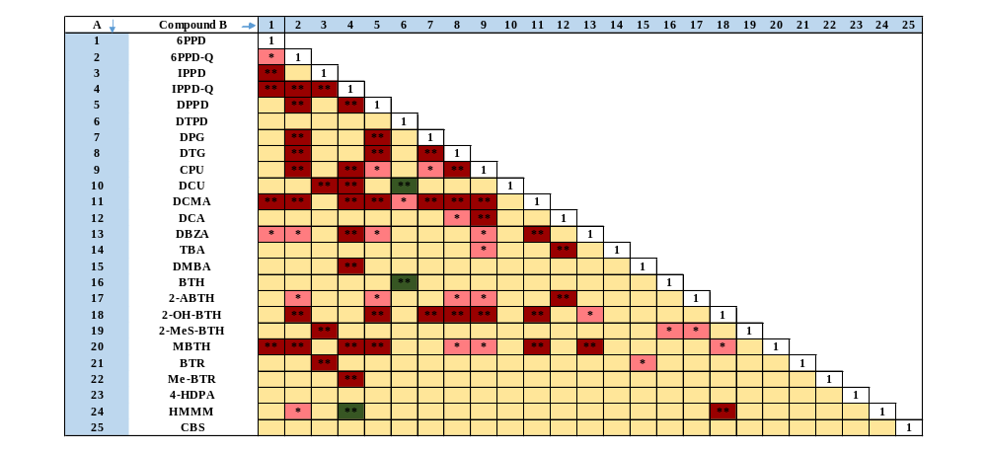
** Significant correlation (p < 0.01, Spearman's rank correlation test); * Significant correlation (p < 0.05, Spearman's rank correlation test); red coloured cell for positive correlation coefficients; green coloured cell for negative correlation coefficients; light yellow coloured cell for no correlation.

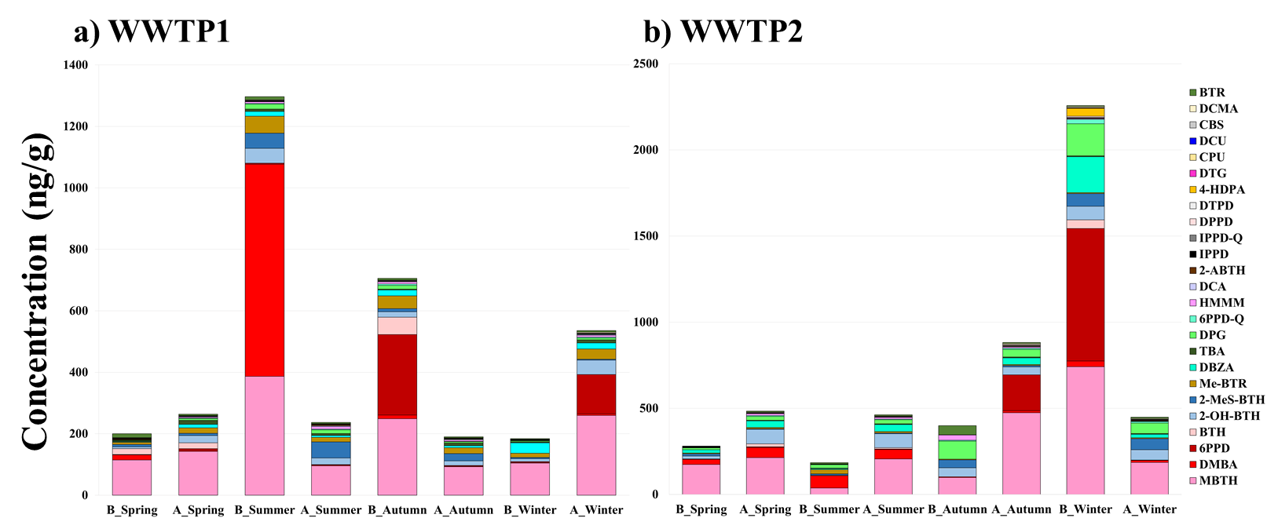
Figure S3. Seasonal concentrations (ng/g) of TRDCs in sewage sludge in WWTP1 (left;a) and WWTP2 (right;b), comparing stages before (B) and after (A) the digester across the four seasons.

Table S14. Wastewater–sludge partition coefficients (Kd, L/kg) of the analyzed compounds, expressed as median, mean, and minimum–maximum range, calculated from measured concentrations in wastewater and sludge. “–” indicates insufficient data for calculation.
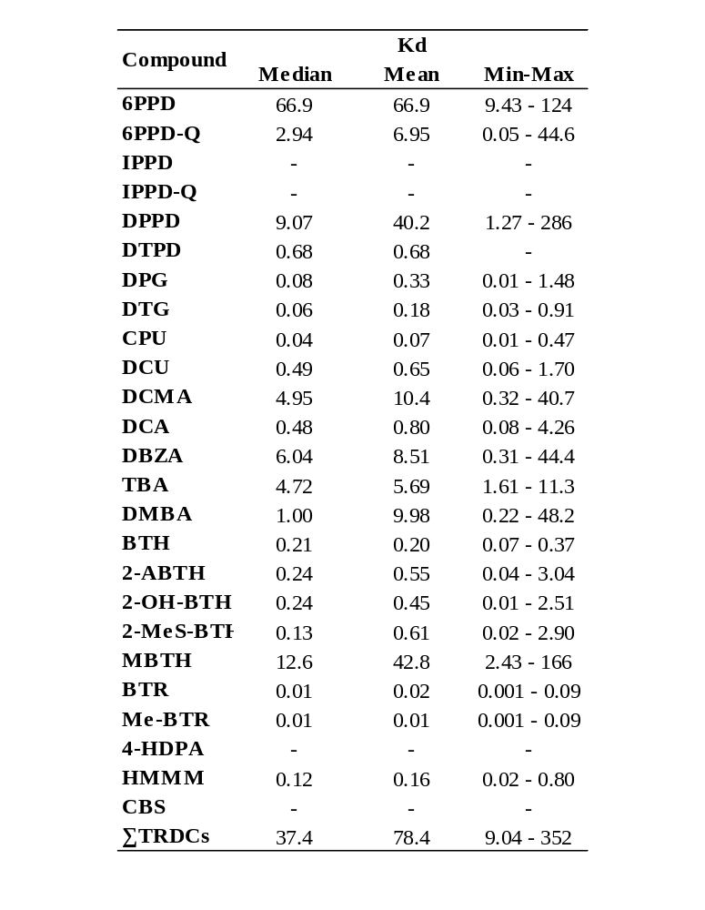

Table S15. Descriptive statistics (median (mean ± SD), min-max of positives and detection frequency (Df, %)) in surface water.
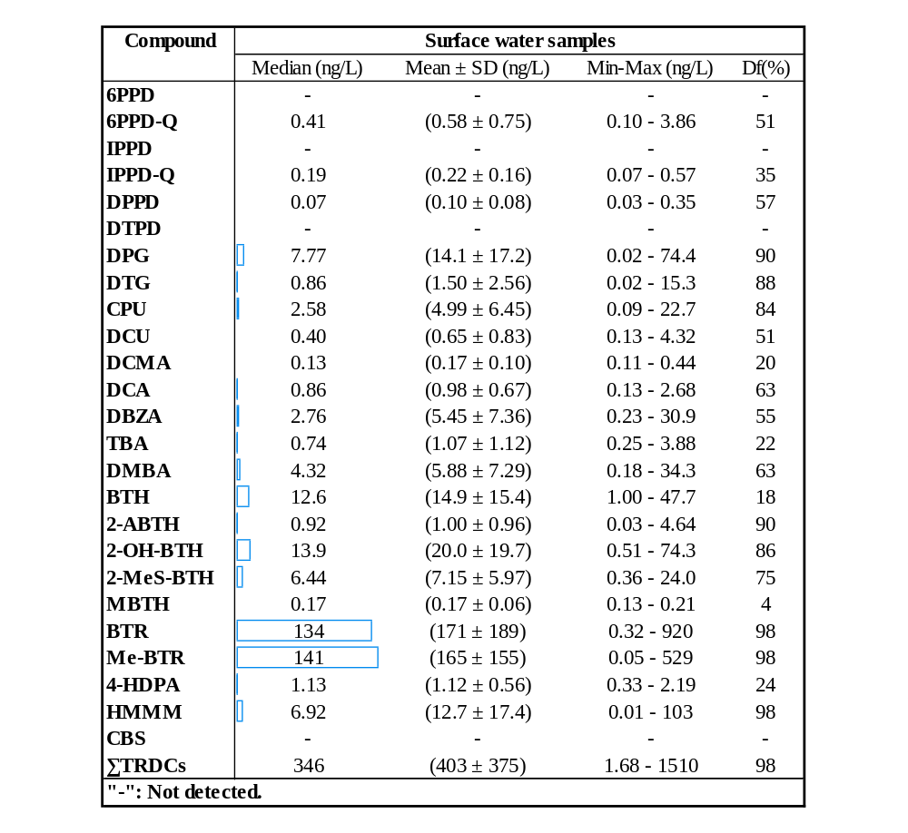

Table S16. Matrix of significant differences (p < 0.05, Kruskal-Wallis test) between compounds in surface water.
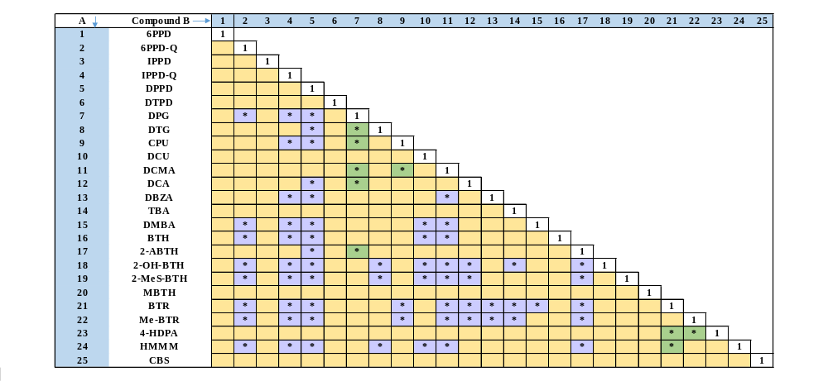
* Significant differences (p < 0.05, Kruskal-Wallis). Purple coloured cell: [A]>[B]; Green coloured cell: [A]<[B]; Yellow coloured cell: no significant difference.

Table S17. Correlation matrix (p < 0.01 and p < 0.05, Spearman’s rank correlation test) of the TRDCs detected in surface water.
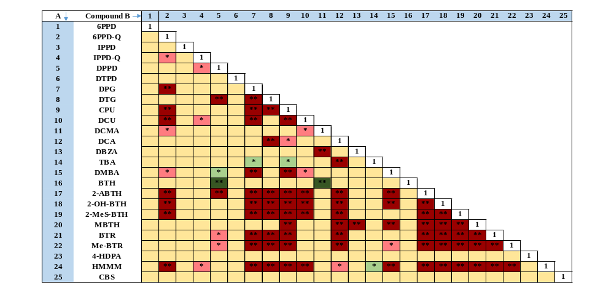
** Significant correlation (p < 0.01, Spearman's rank correlation test); * Significant correlation (p < 0.05, Spearman's rank correlation Test); red coloured cell for positive correlation coefficients; green coloured cell for negative correlation coefficients; light yellow coloured cell for no correlation.
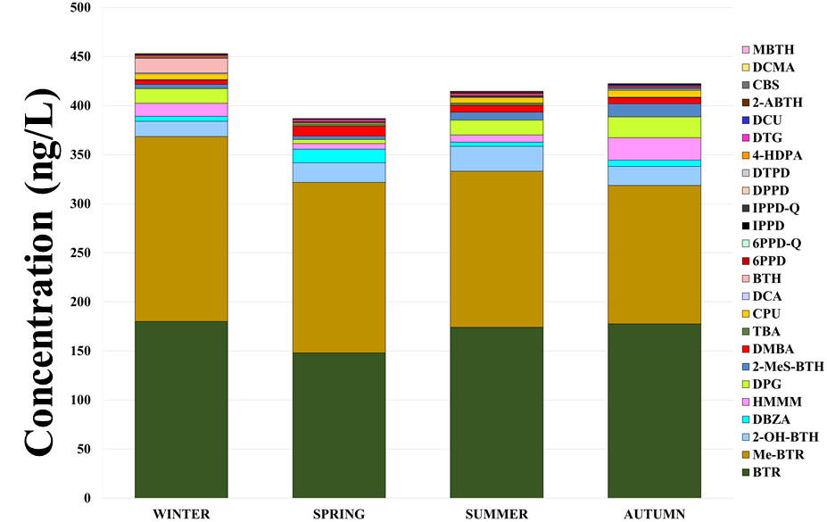
Figure S4. TRDC concentration (ng/L) throughout the different seasons of the year in surface water.

Table S18. Spatial distribution (ng/L) of TRDCs in the Tagus River basin. Low (green), medium (yellow) and high (red) anthropogenic influence.
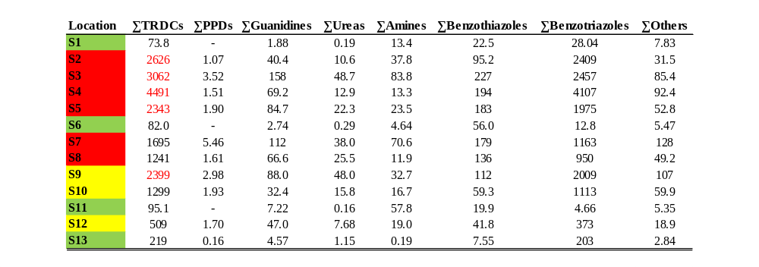

Table S20. Mass flow rates (kg/y) of TRDCs (ΣPPDs, ΣGuanidines, ΣUreas, ΣAmines, ΣBenzothiazoles, ΣBenzotriazoles, ΣOthers and ΣTRDCs) in Tagus River basin. Values are expressed as median annual mass flow, (mean ± standard deviation), and minimum – maximum range. “-“ indicates not detected.
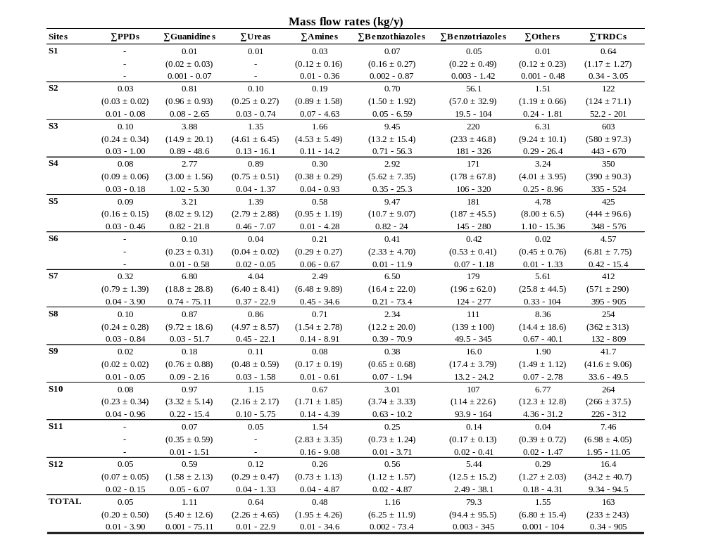

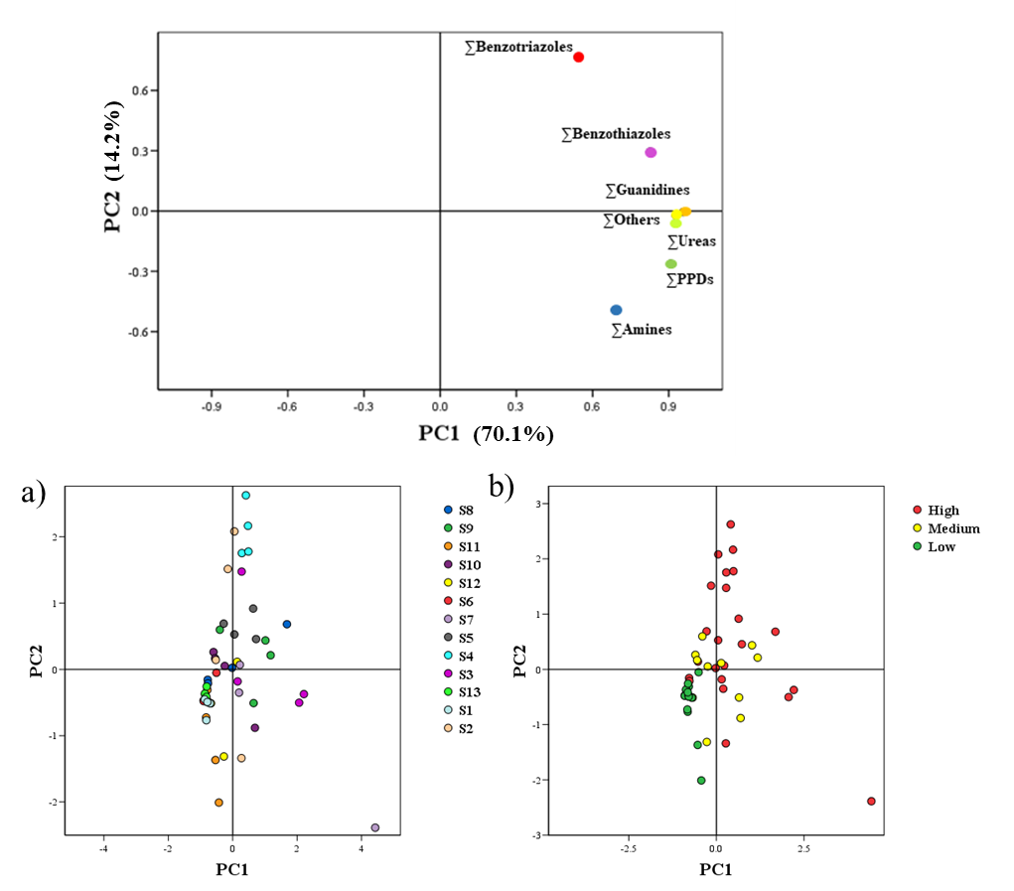
Figure S5. Diagrams of dispersion related to the two components resulting from a principal components analysis (PCA) derived from the distribution of TRDCs in surface water: PC1 and PC2. Score plots (right), markers set by sampling sites (a) and anthropogenic/traffic density influence (b), of all samples on each component.
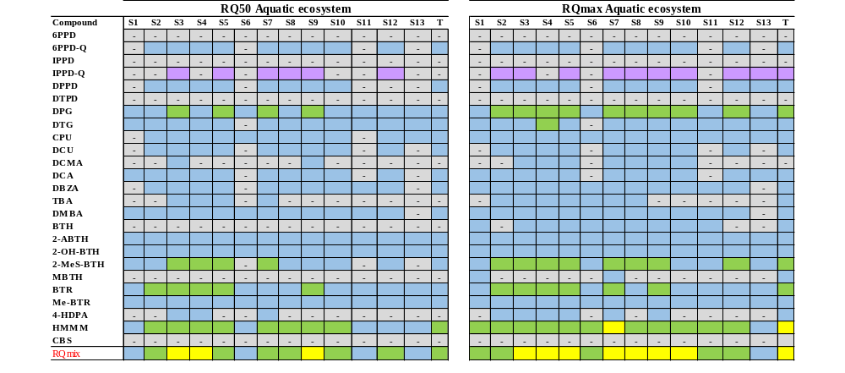
Table S21. Ecological risk assessment (RQ50 and RQmax ratios) of individual TRDCs and mixtures in the aquatic environment. RQ code: Blue: RQ < 0.01, negligible risk; Green: 0.01 < RQ < 0.1, low risk; Yellow: 0.1 < RQ < 1, medium risk; Red: RQ > 1, high risk. Purple: Lack of toxicological data. “-“: not detected.

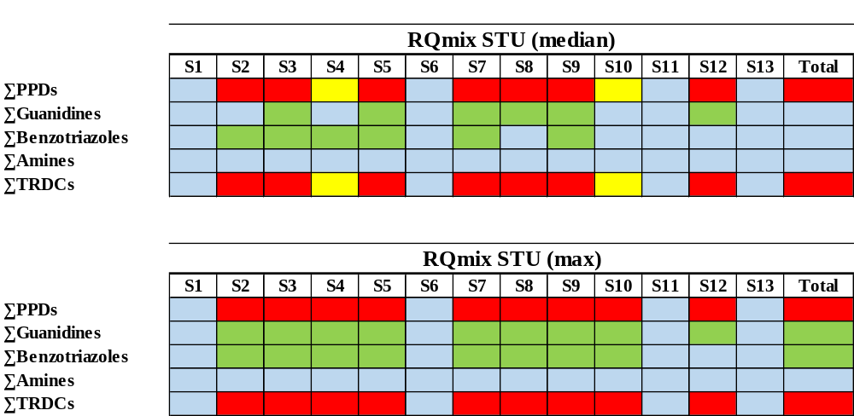
Table S22. Acute risk calculation (RQSTU) of TRDCs to aquatic organisms. RQ code: Blue: RQ < 0.01, negligible risk; Green: 0.01 < RQ < 0.1, low risk; Yellow: 0.1 < RQ < 1, medium risk; Red: RQ > 1, high risk.

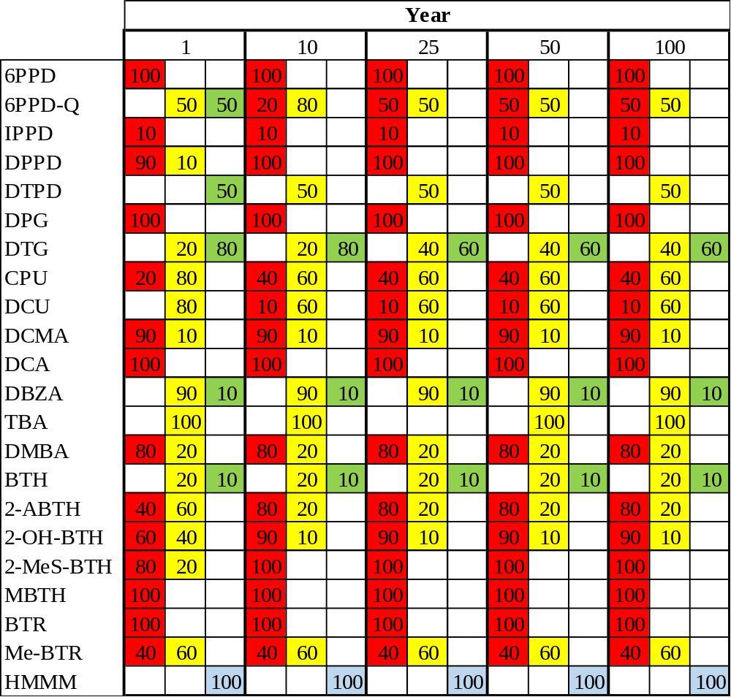
Table S23. Risk of each individual compound to terrestrial organisms (RQ_{soil}) based on its occurrence frequency (%) for a time of 1 to 100 years.

RQ code: Blue: RQ < 0.01, negligible risk; Green: 0.01 < RQ < 0.1; low risk; Yellow: 0.1 < RQ < 1; medium risk; Red: RQ > 1; high risk. Considering the different sludges, the percentages (occurrence frequency; %) indicate the frequency of cases where RQ is negligible, low, medium or high according to the corresponding color code.

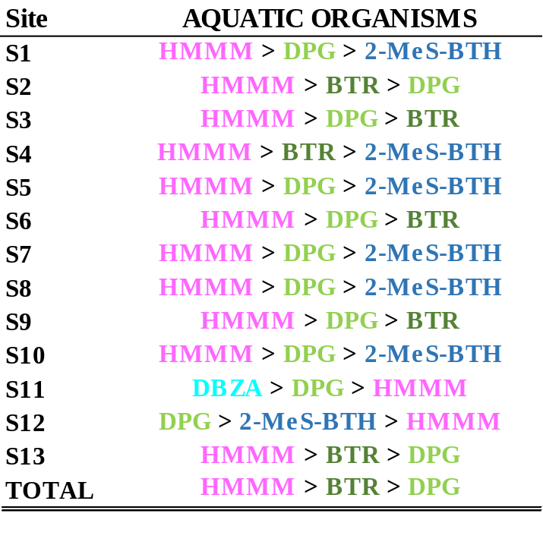
Table S24. List of the top three TRDCs of concern for aquatic organisms.

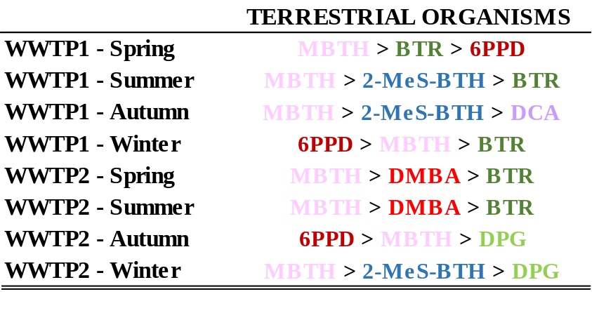
Table S25. List of the top three TRDCs of concern for terrestrial organisms.

References
Alhelou, R., Seiwert, B., Reemtsma, T. (2019). Hexamethoxymethylmelamine – A precursor of persistent and mobile contaminants in municipal wastewater and the water cycle. Water Res. 165, 114973. https://doi.org/10.1016/j.watres.2019.114973
Been, F., Kruve, A., et al. (2021). Risk-based prioritization of suspects detected in riverine water using complementary chromatographic techniques. Water Res. 204, 117612. https://doi.org/10.1016/j.watres.2021.117612
Cao, G., Wang, W., et al. (2023). Occurrence and Fate of Substituted p-Phenylenediamine-Derived Quinones in Hong Kong Wastewater Treatment Plants. Environ. Sci. Technol. 57, 15635-15643. https://doi.org/10.1021/acs.est.3c03758
Chen, X., He, T., et al. (2023). Analysis, environmental occurrence, fate and potential toxicity of tire wear compounds 6PPD and 6PPD-quinone. J. Hazard. Mat. 452, 131245. https://doi.org/10.1016/j.jhazmat.2023.131245
ECHA, 2008. European Chemicals Agency. Guidance on Information Requirements and Chemical Safety Assessment. Chapter R.10: Characterisation of Dose [concentration]-Response for Environment.
ECHA, 2016a. European Chemicals Agency. Guidance on Information Requirements and Chemical Safety Assessment. Chapter R.16: Environmental Exposure Assessment. Version 3.0.
ECHA, 2016b. European Chemicals Agency. Guidance on Information Requirements and Chemical Safety Assessment. Part E: Risk Characterisation. Version 3.0.
Escobar-Arnanz, J., Royano, S., et al. (2026). New insights into the occurrence of vehicle related compounds in one of Europe’s longest rivers. Environ. Res. 288, 123158. https://doi.org/10.1016/j.envres.2025.123158
Herrero, P., Borrull, F., et al. (2013). Efficient tandem solid-phase extraction and liquid chromatography-triple quadrupole mass spectrometry method to determine polar benzotriazole, benzothiazole and benzenesulfonamide contaminants in environmental water samples. J. Chromatogr. A, 1309, 22-32. https://doi.org/10.1016/j.chroma.2013.08.018
Hua, X., & Wang, D. (2023). Tire-rubber related pollutant 6-PPD quinone: A review of its transformation, environmental distribution, bioavailability, and toxicity. J. Hazard. Mat. 459, 132265. https://doi.org/10.1016/j.jhazmat.2023.132265
Hug, C., Ulrich, N., et al. (2013). Identification of novel micropollutants in wastewater by a combination of suspect and nontarget screening. Environ. Pollut. 184, 25-32. https://doi.org/10.1016/j.envpol.2013.07.048
Johannessen, C., & Parnis, J. M. (2021). Environmental modelling of hexamethoxymethylmelamine, its transformation products, and precursor compounds: An emerging family of contaminants from tire wear. Chemosphere, 280, 130914. https://doi.org/10.1016/j.chemosphere.2021.130914
Liao, C., Kim, U., et al. (2018). A Review of Environmental Occurrence, Fate, Exposure, and Toxicity of Benzothiazoles. Environ. Sci. Technol. 52, 5007-5026. https://doi.org/10.1021/acs.est.7b05493
Maurer, L., Carmona, E., et al. (2023). Contamination Pattern and Risk Assessment of Polar Compounds in Snow Melt: An Integrative Proxy of Road Runoffs. Environ. Sci. Technol. 57, 4143-4152. https://doi.org/10.1021/acs.est.2c05784
Peng, Y., Fang, W., et al. (2018). Screening hundreds of emerging organic pollutants (EOPs) in surface water from the Yangtze River Delta (YRD): Occurrence, distribution, ecological risk. Environ. Pollut. 241, 484-493. https://doi.org/10.1016/j.envpol.2018.05.061
Rauert, C., Kaserzon, S. L., et al. (2020). The first environmental assessment of hexa(methoxymethyl)melamine and co-occurring cyclic amines in Australian waterways. Sci. Total Environ. 743, 140834. https://doi.org/10.1016/j.scitotenv.2020.140834
Royano, S., De la Torre, A., et al. (2023). Pharmaceutically active compounds (PhACs) in surface water: Occurrence, trends and risk assessment in the Tagus River Basin (Spain). Sci. Total Environ. 905, 167422. https://doi.org/10.1016/j.scitotenv.2023.167422
Seitz, W., & Winzenbacher, R. (2017). A survey on trace organic chemicals in a German water protection area and the proposal of relevant indicators for anthropogenic influences. Environ. Monit. Assess. 189, 244. https://doi.org/10.1007/s10661-017-5953-z
Seiwert, B., Nihemaiti, M., et al. (2022). Abiotic oxidative transformation of 6-PPD and 6-PPD quinone from tires and occurrence of their products in snow from urban roads and in municipal wastewater. Water Res. 212, 118122. https://doi.org/10.1016/j.watres.2022.118122
Sistema Automático de Información Hidrológica (SAIH Tajo), 2025. Ministerio para la Transición Ecológica y el Reto Demográfico. Confederación Hidrográfica del Tajo. Pluviometría. https://saihtajo.chtajo.es/pluviometria (accessed May 2026).
Struk-Sokołowska, J., Kotowska, U., et al. (2022). Analysis of 1H-benzotriazole removal efficiency from wastewater in individual process phases of a sequencing batch reactor SBR. Water Resour. Ind. 28, 100182. https://doi.org/10.1016/j.wri.2022.100182
Van Leerdam, J. A., Hogenboom, A. C., et al. (2009). Determination of polar 1H-benzotriazoles and benzothiazoles in water by solid-phase extraction and liquid chromatography LTQ FT Orbitrap mass spectrometry. Int. Journal Mass Spectrom. 282, 99-107. https://doi.org/10.1016/j.ijms.2009.02.018
Wan, X., Liang, G., et al. (2024). Potential human health risk of the emerging environmental contaminant 6-PPD quinone. Sci. Total Environ. 949, 175057. https://doi.org/10.1016/j.scitotenv.2024.175057
Wang, L., Zhang, J., et al. (2016). Widespread Occurrence of Benzotriazoles and Benzothiazoles in Tap Water: Influencing Factors and Contribution to Human Exposure. Environ. Sci. Technol. 50, 2709-2717. https://doi.org/10.1021/acs.est.5b06093
Wluka, A., Coenen, L., et al. (2017). Screening of organic pollutants in urban wastewater treatment plants and corresponding receiving waters. Water Sci. Technol. 76, 832-846. https://doi.org/10.2166/wst.2017.265
Xie, L., Yuan, L., et al. (2024). Compound Class-Specific Temporal Trends (2021–2023) of Tire Wear Compounds in Suspended Solids from Toronto Wastewater Treatment Plants. ACS ES&T Water, 4(12), 5708-5719. https://doi.org/10.1021/acsestwater.4c00705
Xu, T., Guo, J., et al. (2024). Occurrence and risk assessment of p-phenylenediamines and their quinones in aquatic environment: From city wastewater to deep sea. Sci. Total Environ. 954, 176123. https://doi.org/10.1016/j.scitotenv.2024.176123
Zhang, H., Huang, Z., et al. (2023). Occurrence and risks of 23 tire additives and their transformation products in an urban water system. Environ. Int. 171, 107715. https://doi.org/10.1016/j.envint.2022.107715

