Dislocation loop generation differences between thin films and bulk in EFDA pure iron under self-ion irradiation at 20 MeV.
M. Roldán ^{(1) *}, P. Fernández ⁽¹⁾, F. J. Sánchez ⁽¹⁾ C. Ortiz ^{(1),} A. Gómez-Herrero⁽²⁾ and D. Jiménez-Rey ⁽¹⁾.
¹ CIEMAT. National Fusion Laboratory. Technology Division. Avda. Complutense, 40. 28040. Madrid, Spain
² National Center for Electronic Microscopy. Av. Complutense s/n.28040 Madrid, Spain.

Abstract
In the present research, irradiation experiments in thin films have been performed to evaluate the formation of dislocation loops in pure Fe when high energy self ions (20 MeV Fe⁺⁴) get through the material. With this procedure, the accumulated damage zone, which is the peak where the ions stop, would be prevented, and the effect of free surfaces can be studied. The experimental conditions were an ion fluence of 4.25 and 8.5x10¹⁵ ions.cm⁻² and an irradiation temperature of 350 and 450 ºC, respectively. Understanding dislocation loop formation and interaction mechanisms are the main objectives of this research, given that this interaction is suspicious of being responsible for the embrittlement of structural steels in fusion reactors. On the other hand, we carried out the same irradiations on bulk (conventional electropolished TEM discs) to compare the defect creation in the first 150 nm in depth with dislocations found in the whole thickness of the thin films (approximately 100 nm).

Introduction
Nowadays, one of the most critical challenges in the development of fusion energy is to predict and mitigate the effects of significant levels of transmuted gas atoms (He and H) along with high displacement damage produced by high energy neutrons that affect the mechanical properties of the structural materials and gives rise to phenomena like swelling. Many issues related to the irradiation defects are still unknown. Understanding the macroscopic effects of loops due to irradiation on the structural materials requires further research at different levels: experimental observations by TEM in basic and straightforward metals such as model alloys will be helpful as a validation tool for modeling.
Computational modeling of radiation damage in fusion materials may help predict the damage effects and how could mitigate it and contribute to the design of DEMO [1] (DEMOnstration fusion power plant) in the medium term. Modeling would help to understand the damage underlying physical mechanisms and predict its evolution along the reactor lifetime. The new models and computational codes must be validated with experiments to achieve a robust computational approach. There are three ways of analyzing irradiation defects with a TEM which are in-situ TEM on thin films [2-8], ex-situ irradiated thin films [9], and ex-situ irradiated bulk, also called post-mortem experiments [10-13].

Experimental procedure

Material
The material used for this research is a very pure iron provided by EFDA (now EUROfusion) and manufactured by ARMINES (École Nationale Supérieure Des Mines, France) [14]. Its composition and microstructural characteristics are the following. First, the average grain size was 183 μm, but grains between 4 and 650 μm also were found. Second, the initial dislocation density provided by the manufacturer was 1.8x10⁸ cm⁻² (non-homogenously distributed). However, it was calculated a higher dislocation density after the conventional sample preparation route, 1.44x10¹⁰cm⁻². Further details about dislocation microstructure can be found in [15]. Finally, no secondary phases within the matrix were observed.
 | C | S | O | N | P | Cr
[wt ppm] | 4.3 | 1.3 | 4 | 3.6 | 0.03 | 0.03
Table 1: Chemical composition of pure EFDA Fe manufactured by ARMINES.

Before irradiation, 3 mm discs were prepared following the conventional route for metal specimens for TEM observations. First, the pure iron foil is thinned up to 100 μm so the 3 mm discs can be punched out. Finally, the discs are electropolished with the Tenupol-5 (Struers) device, using a mixture of sulfuric acid and methanol (4:1) at RT and 9 V.
However, the inner characteristics of this electrolytic process generate a specimen with a gradual increase in thickness with a large electron transparent area (Figure 1 a). However, it sometimes makes small smooth holes that allow us to analyze the sample far from the main thin area (Figure 1 b).
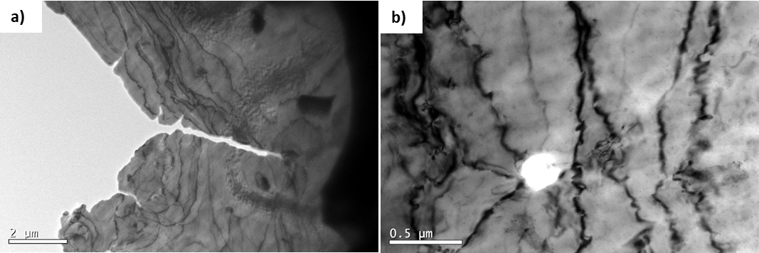
Figure 1 Pure EFDA Fe TEM micrograph showing the main hole and the transparent area after the electropolishing with a large and homogeneous thin area (a) and a small smooth hole with an excellent electropolished volume irradiated (b).

Irradiation
Irradiations were performed in a Tandem accelerator of 5 MV of terminal voltage with a Cockroft-Walton multiplier, placed at CMAM (Universidad Autónoma de Madrid, Spain). More details about the ion accelerator can be found in [16]. In every experiment, two specimens were irradiated simultaneously: one electropolished for thin-film studies and the other just superficially polished for bulk experiments. In addition, the beam quality and size were checked by the ionoluminescence signal [17] of some pieces of fused silica attached to the holder. Also, as the temperature is a critical parameter, it was controlled using a K-type thermocouple attached very close to the specimens to control the holder temperature (to double-check the temperature set-point in the controller). Figure 2 shows all of the features mentioned above conforming the set-up.
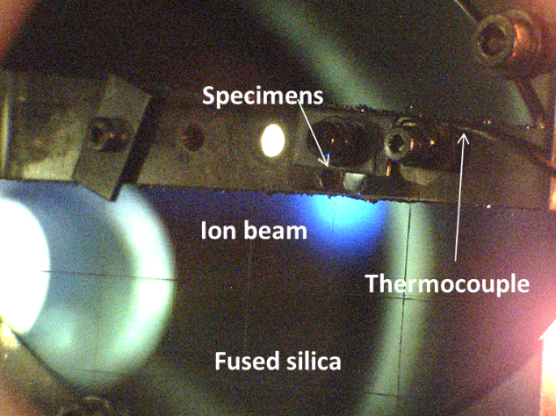
Figure 2 Sample holder shows the irradiated discs, with part of the beam hitting the fused silica (blue light). The image was taken with a considerable integration time to enhance contrast.
After checking the quality of the electropolished specimens, the irradiation took place as follows: Using self- ions at 20 MeV, Fe⁺⁴ at two different fluences, 4.25x10¹⁵ ion/cm² and 8.53x10¹⁵ ion/cm², henceforth low dose (LD) and high dose (HD) and two different irradiation temperatures 300 and 450 ºC. The corresponding damage at the Bragg peak was 5 and 10 dpa for the bulk specimens, as shown in Figure 3 a (calculated by SRIM, using the method proposed in [18]). However, focusing on the first 200 nm, the dpa level dropped drastically to 0.05 and 0.17 dpa approximately, corresponding to the damage produced in the thin films, Figure 3 b.

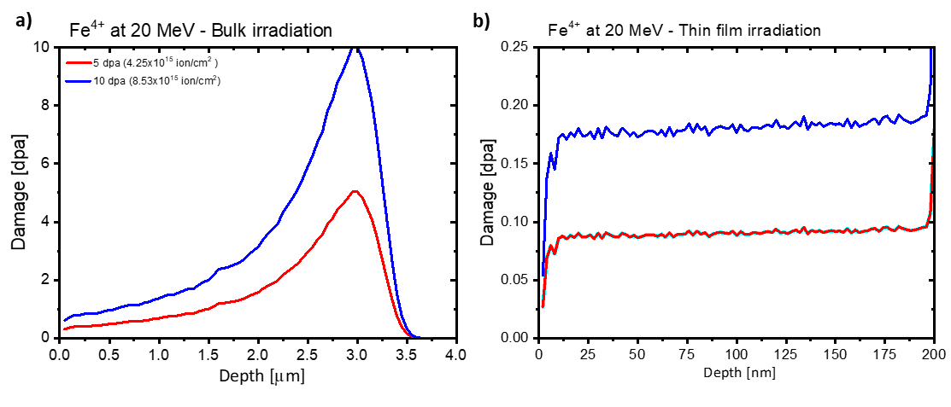
Figure 3 Damage profile for the fluences used in the experiments: LD, 4,25x10¹⁵ ion/cm^{2,} and HD, 8.53x10¹⁵ ion/cm^{2,} which correspond at the damage level at the peak of 5 and 10 dpa respectively a), and the damage expected only in the first 200 nm for the same fluences, b).

Sample characterization
Focus ion beam (FIB) lamellae were fabricated from the irradiated bulk specimens employing the lift-out technique, and their surface was cleaned with low Ar kV, using PIPS II (Gatan) device [19]. The lamellae contained all the irradiation depth, but only the first 100 nm were studied since that depth corresponds to the thin film thickness. On the other hand, irradiated thin films were studied directly by transmission electron microscopy (TEM); only a plasma cleaning procedure was applied every time the samples got in the microscope to remove any organic residue.
The defect characterization was performed with a JEOL 2100HT transmission electron microscope with a high tilt holder (± 45 º) at Centro Nacional de Microscopía at Madrid (CNME).
As mentioned before, the main objective is to carry out a complete characterization by TEM of the defects produced by the irradiation of very energetic iron ions when passing through thin films. These results will be compared with those obtained by analyzing the defects found in the first 200 nm of irradiated bulk material. Due to the characteristics of the TEM itself and the time cost involved, it is essential to design an optimal methodology to carry out these studies.
First, an initial check of the four samples was carried out to validate the thin areas and detect a possible oxide formation or some other type of surface degradation. Then, in the same way, it was evaluated qualitatively if any of the samples had excessive dislocations that could have interfered in the evolution of the irradiation defects.
Once the samples have been checked, validating their condition for TEM analysis, a study of the size of the dislocation loops was carried out. This consideration is essential when one wants to determine the Burger vector, b, of these defects. This parameter represents the magnitude and direction of lattice distortion induced by these defects. It can be determined by TEM because the dislocation is invisible in the microscope when b and the diffraction vector g are mutually perpendicular, i.e., when b lies in the diffraction planes of a crystal. More rigorously, the invisibility criterion is derived from the dynamic image theory of dislocation image contrast [20]. Tilting the sample in the TEM satisfying several different diffraction conditions (i.e., different g-vectors) implies that the loops lying in the same area change their shape. This observation is produced because of a geometrical effect. Upon rotation, the projection of the disk contained in a given habit plane onto the plane perpendicular to the electron beam changes, and when the g.b=0 condition is fulfilled, it makes them invisible. By taking images of each condition and performing a subsequent analysis, it is possible to determine the value of the Burgers vector. It is important to emphasize that the value of the extinction vector, s, has always been positive.
This method is widely applied in the investigations of dislocations and dislocation loops. Prokhotsdeva et al. [11] have developed a statistical method that facilitates its calculation. However, it is a laborious but necessary method if the loop is smaller than 10 nm in size. On the other hand, if the loop sizes are significant, it is possible to identify their Burgers vector if one knows in advance the expected Burgers vector and their geometrical projection in the plane perpendicular to the electron beam (microscope viewing plane). The shape will depend on the zone axis under which one is working, as shown in Figure 4. More information on this method is published in [21]. This methodology is valid if most of the loops are large, especially if one wants to determine the swelling produced by them.

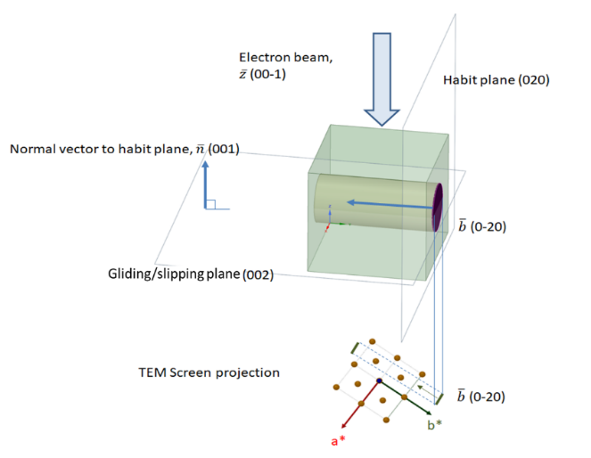
Figure 4 Relationship between the electron beam and the TEM view plane, b, and the loop habit plane. The projection of b depends on the zone axis and the foil orientation.

An example of this series of images with large-sized loops is presented in Figure 5, as they are like those found in all samples. Depending on the diffraction conditions, some loops change from visible to invisible. In Figure 5 a), the central area of the image represents that the crystal is under zone-axis condition (high diffraction contrast), in particular under [00-1]. In addition, different g vectors are observed since the two-beam diffraction condition is satisfied in every direction. Bent crystal foils of pseudo-constant thickness as this one show long and curved bend contours. Lines with the same intensity contrast represent equal inclination of the lattice planes to the electron beam. The broadest bands are usually superpositions of low index reflections with the regions of diffraction contrast overlap. Figure 5 b, c, and d show the same area with different g vectors and hence the loops visible are only the ones whose Burger vector is not parallel with the g vector, meaning b.g≠0.

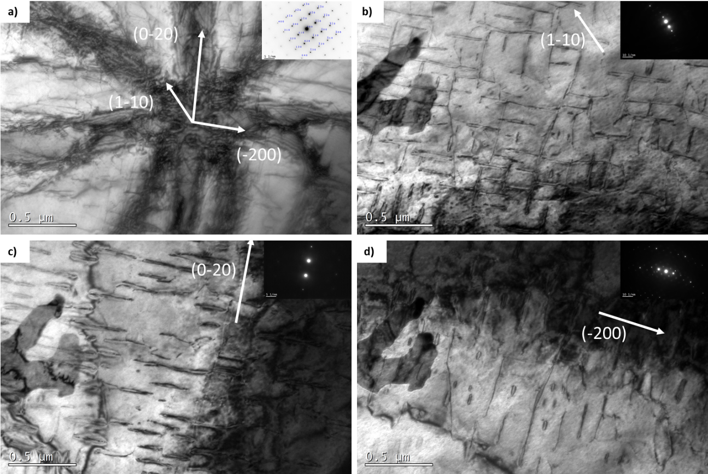
Figure 5 TEM micrographs of pure iron irradiated with 20 MeV at 300ºC and high dose showing a) bend contours under [00-1] zone axis, and dislocation loops under b) (1-10), c) (0-20), and d) (-200) diffraction vectors.

After observing that the loops are large and that most of them have their habit plane in {100#, to calculate their average size and population in a relatively easy way, it was determined that the best diffraction vector g, of a low index such as {112# near the main zone axes [110] and [111]. With this diffraction vector, all three families of the {100 planes and 3 of 4 families of the ½ {111# type can be observed. This procedure underestimates the relative population of loops since only 75% of the (111) are being considered. However, very few of the other three types are observed in each condition, so the results are accurate.
Once the size distribution has been determined, assuming that the loops are pure edge type prismatic, disk-shaped, we determine the family to which each loop belongs. Firstly by discriminating between the two types of habit planes (200) or ½(111) and then assigning the correct direction. It is necessary to obtain images with different diffraction conditions, considering that the g vector does not belong to both zone axis. They must be linearly independent.
Since nature studies and complete designation of b are to be performed, at least 3 zone axes have to be chosen. By calculating the tilt between them, a portion of the Kikuchi map can be constructed. An equation that calculates the effective angle between two planes using the values of the double-axis holder tilting can be found in [22]. In this way, it is possible to assign the correct signs to the different diffraction vectors using the ± g pair plus the axis of b method so as not to exceed a crystal twist angle called unsafe [23]. Figure 6 shows a portion of the Kikuchi map between three zone axes. The rotation of each axis of the double-tilt holder has been included, and CBED (convergent-beam electron diffraction) images where the Kikuchi paths and the corresponding diffraction vectors can be seen.
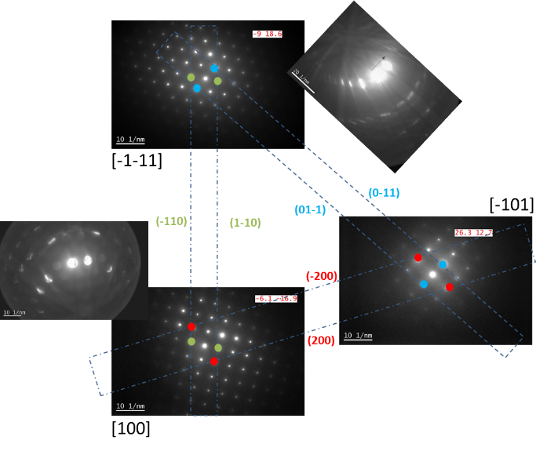
Figure 6 Kikuchi map between 3 zone-axis, including the values of the diffraction vectors.

Once the portion of the Kikuchi map was known, to determine the habit plane of the observed loops, different images were taken in which the diffraction conditions were two-beam, with a positive extinction parameter (s>0). Suppose the loops are larger than 5 nm. In that case, it is possible to make a morphological comparison by constructing a BCC structure with lattice parameter 2.86 Å, which would be oriented as a function of the zone axis under which the observations were made. Knowing that the b-vectors of the loops would be <100> or ½<111> as well as their habit planes, it is possible to identify in most cases to which family they belong. In addition, sometimes to which one in particular (assuming the equivalents as a type) by a morphological comparison, without the need to perform more complex analyses such as the one proposed in [11] for small size loops, of the embryo type, where a morphological comparison is unfeasible.
Traditionally, methods quantify their density as a function of the volume corresponding to each micrograph analyzed to characterize materials that present dislocations. However, if it is desired to estimate the effect of dislocations on possible hardening or degradation of mechanical properties, it has been estimated that an evaluation of the ratio of the volume that the loops have modified is more relevant as well as clarifying because the ratio corresponds with the swelling produced by dislocation loops.
Finally, the value of swelling that the thin-foil has undergone by irradiation will be calculated. For this, it is necessary to distinguish the nature of the loops since an interstitial loop will add atoms to the defined control volume, and a vacancy loop will eliminate them. The chosen method to reveal their nature is the well-known inside/outside contrast [24]. On the other hand, the loops will be defined as disks with a height corresponding to the value of the b modulus, being positive for interstitial loop and negative for vacancy ones. The depth of every micrograph was determined using a CBED pattern and the distance between the parallel Kossel-Möllenstedt fringes [25].
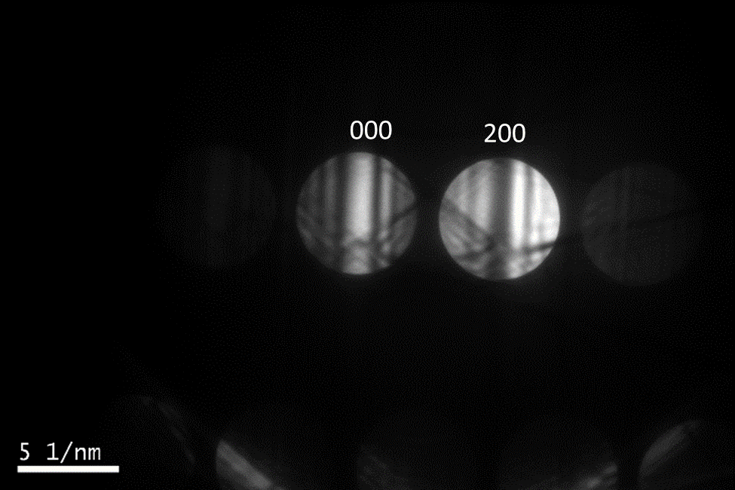
Figure 7 CBED pattern to calculate the thickness of the sample at a certain point.

Results

Simulation
PKA spectrum of bulk experiment and thin-film using MARLOWE [26, 27] was calculated to evaluate if both experiments are comparable regarding energy deposition. As observed in Figure 8, both curves are practically the same but slightly different at low probability. This result means that the most significant probability of PKA is for energies lower than 10 eV, which is very low and makes both experiments comparable in terms of energy deposition.
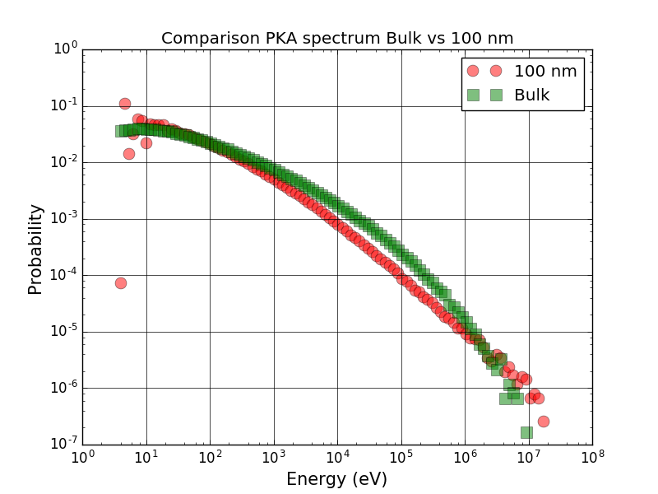
Figure 8 Pka spectrum comparing thin films (100 nm) and bulk by means of MARLOWE code.

Bulk specimens
The entire irradiation depth is contained within the lamela extracted from the specimens for bulk studies, as shown in Figure 9. However, only the first 100-150 nm were considered in this research, so it can be compared with the thin film specimens, whose thickness was smaller than 100 nm.
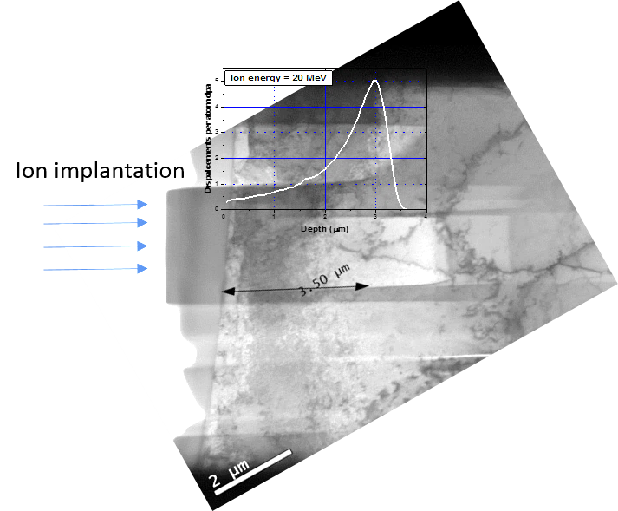
Figure 9 TEM micrograph of a lamella of Fe irradiated a 300 ºC and high dose, showing the irradiated peak wholly contained in the sample.
In all four cases, the defects observed were similar. Tiny black dots (supposedly loop-embryos) but no loops were found, even at high magnifications, Figure 10
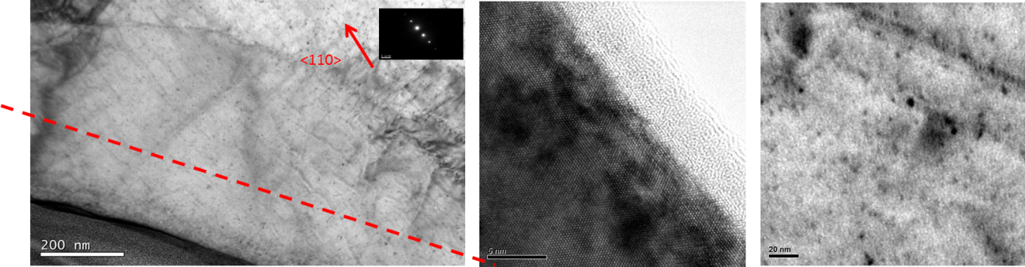
Figure 10 Representative microstructures of the irradiated bulk samples at the same conditions as the thin films.

However, some cavities were detected at the peak, as observed in Figure 11, along with other defects as small dislocation loops. But, in summary, no apparent defect generation in the first 100- 150 nm of the bulk samples.
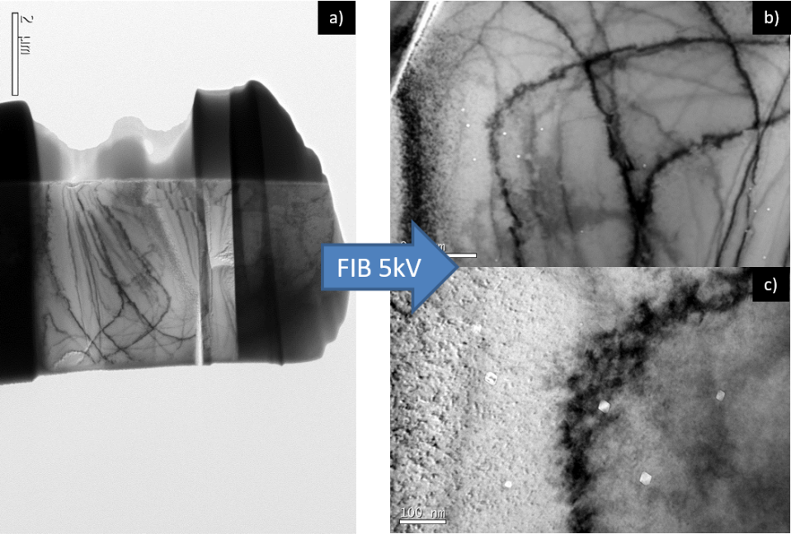
Figure 11 a) Lamella overview irradiated at 300 ºC up to 4.27x10¹⁵ cm⁻², b-c) Cavities observed in the same sample.

It was previously shown that the energy deposition in terms of PKA probability comparing both thin films and bulk specimens was practically the same. So, the next step is to analyze the possible defects generated in the first 150 nm of the bulk specimens. However, as observed in other lamellae extracted from irradiated samples, the Ga ion may produce artifacts. So, it was decided to electropolish an irradiated disc covering the irradiated surface with a protective commercial lacker (Lacomit) to place the electropolished hole precisely at the irradiated surface.
In Figure 12, a scheme of the process is depicted, and it was performed as follows. In the first place, a 3 mm disc is irradiated with Fe ions at 20 MeV producing a shallow layer of 3 micros of damage. Then, as the depth of interest is close to the very surface of the disc, a very thin, homogenous layer of the lacker was spread over the surface, protecting it from the electropolishing process. As a result, the hole was created successfully at the surface, as observed in the mentioned figure. The irradiation damage calculated from the SRIM simulation on the left close to the surface corresponds practically with the damage obtained in thin films.

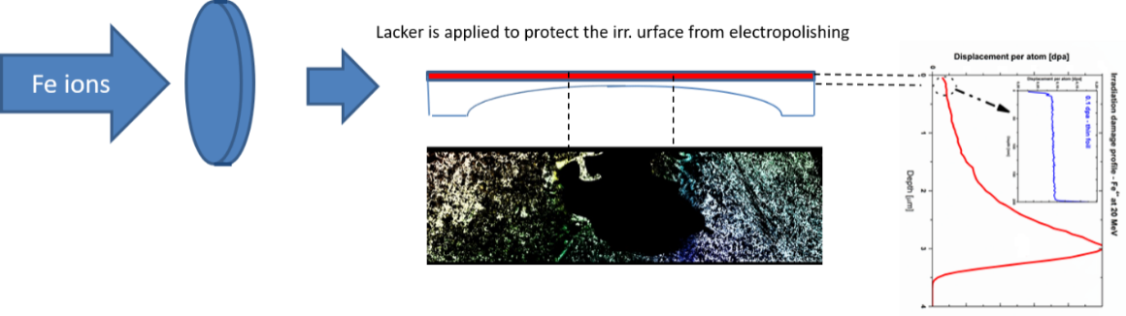
Figure 12 Scheme of electropolished irradiated specimen protected with a lacker.

An in-depth TEM study was conducted afterward on the four irradiated discs specimens previously analyzed in the form of thin films (300 ºC and 450 ºC irradiated at high and low doses, Figure 13 a) and b). In all the cases, the hole was placed at or very close to the very surface, so, generally speaking, the comparison is possible. Regarding defects, none of them showed loops (even less large loops like the ones found on irradiated thin films). Only in the case of 450 ºC and high dose Figure 13 b, small black dots (maybe embryo-like loops) were observed (highlighted with red ovals). In summary, the size and type of defects are mostly similar between the FIBed and electropolished samples. There are no large loops, and their distribution turns out very heterogeneous.

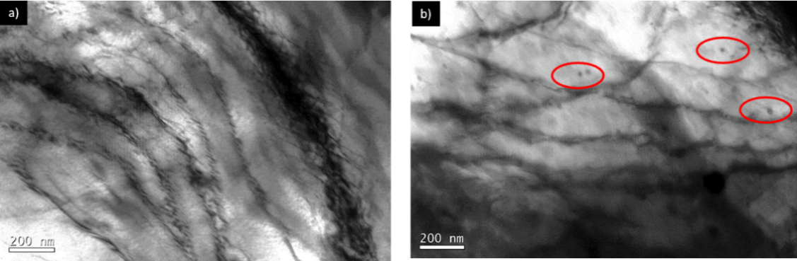
Figure 13 TEM micrograph of electropolished discs protecting the irradiated surface with lacker of a) 300 ºC and low dose and b) 450 ºC and high dose. Highlighted with red ovals some defects detected

Thin-film specimens

Loop size distribution
A minimum count of 300 loops was established due to the loop size to have relatively good statistics. As a limit, those whose diameter was more significant than or equal to 10 nm were counted; since the analysis area is large, such small loops are not resolved correctly and could be misleading. Figure 14 shows the histograms obtained from the measurements as a function of the relative frequency, and Figure 15 shows the mean size and its standard deviation.

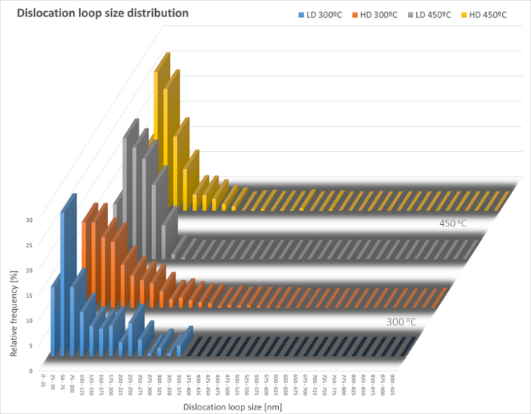
Figure 14 Distribution of dislocation loop sizes under g vector (112) for a Fe thin foil irradiated with 20 MeV at a) 300 ºC, 4.25x10¹⁵ ions/cm², b) 300 ºC, 8.5x10¹⁵ ions/cm², c) 450 ºC, 4.25x10¹⁵ ions/cm2 and d) 450 ºC, 8.5x10¹⁵ ions/cm².

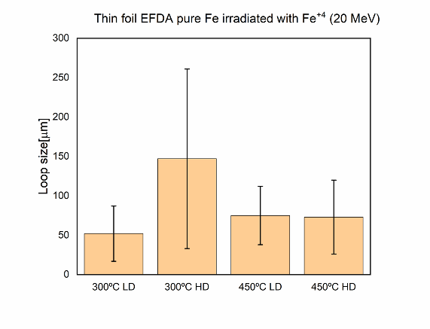
Figure 15 Loop mean size and standard deviation for all the irradiation conditions.

Both representations analyzed together perfectly describe the loop size distribution and their heterogeneity as a function of the experimental conditions. It is observed that increasing the dose while maintaining the temperature at 300 ºC generates growth of loops, as shown in Figure 16, which contains the largest loop detected of the four experimental conditions, 1 μm. In other words, growth is enhanced as opposed to the generation of new defects. On the other hand, such a dose increase at high temperature also produces this effect, but much milder. Thus, it seems that the formation of medium-sized loops (around 50 - 100 nm) prevails over growth for the actual experimental condition. In addition, this micrograph represents a phenomenon that must be considered when studying thin foils with a slight bend. The loops with a much more intense contrast satisfy that b.g=1, for g (200). However, another weaker reflection is excited, g(3-12) revealing the loop arrangement highlighted in the blue oval. This quasi-mixed diffraction condition shows that there may be a greater interconnection between loops than would appear if only g(200) had been excited. On the other hand, within the red circles, loops {11# are shown, which, despite appearing small, are about 20 to 30 nm in size.

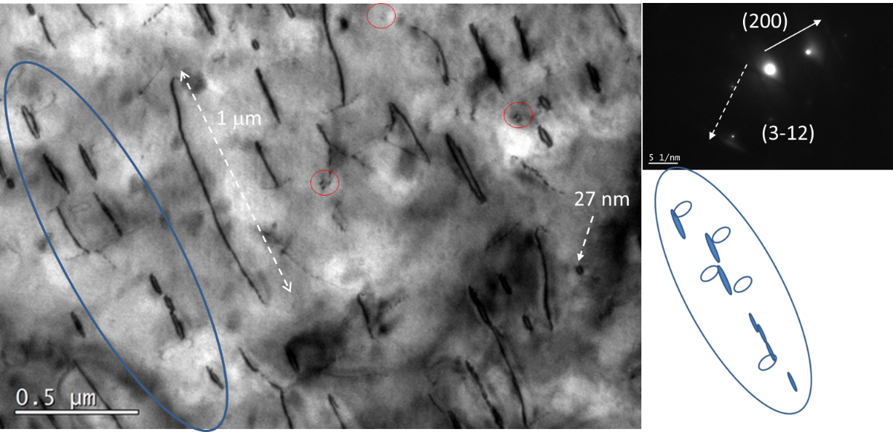
Figure 16 TEM micrograph from Fe sample irradiated at HD and 300 ºC with Fe⁺⁴ at 20 MeV.

In all the samples, some zones are more or less irregular in thickness. It is possible that it slightly alters the measurements since if the crystal has a slight bending, the dynamic diffraction condition (slightly away from the zone of higher contrast) no longer met in a few nm. Thus, the volume of material analyzed is relatively smaller than samples whose thickness is kept more constant. Figure 17 shows representative micrographs of the loops found under the conditions discussed above (g <112>, under {111#, with s>0). The images that best describe the global set of defects found are selected.
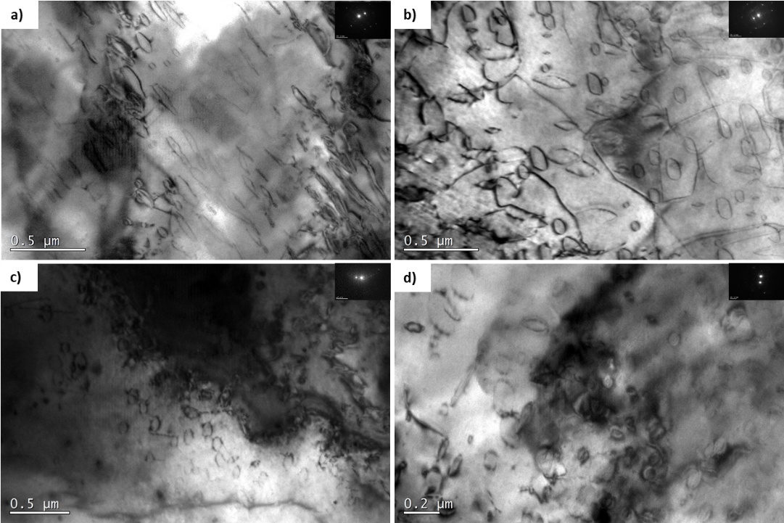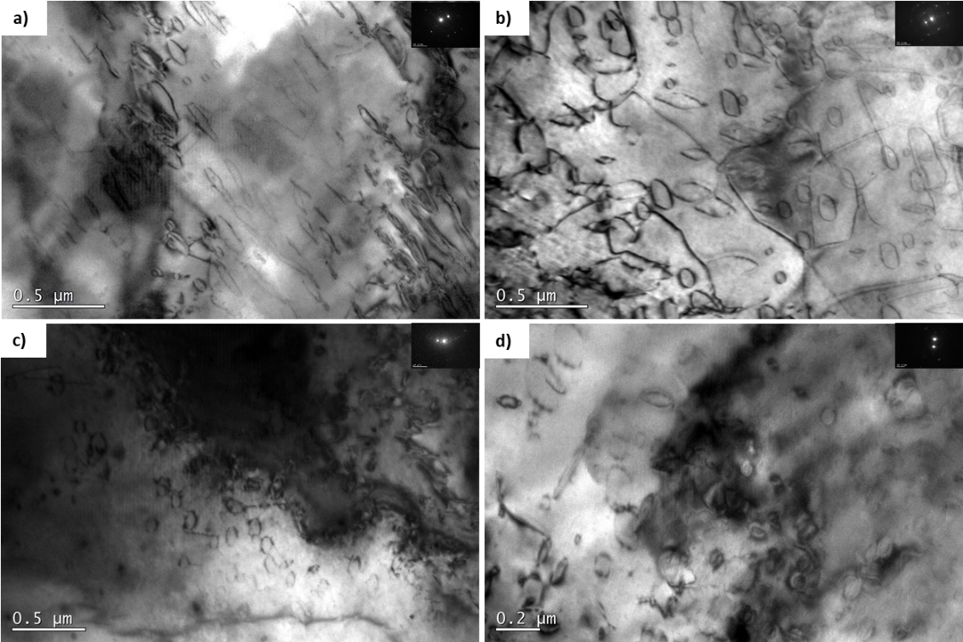
Figure 17 Representative TEM microstructures of Distribution of dislocation loops observed under g vector <112> near {111# zone axis, irradiated with 20 MeV at a) 300 ºC, 4.25x10¹⁵ ions/cm2, b) 300 ºC, 8.5x10¹⁵ ions/cm2, c) 450 ºC, 4.25x10¹⁵ ions/cm² and d) 450 ºC, 8.5x10¹⁵ ions/cm².

Loop habit plane
In the following, the observed microstructure of each experimental condition will be described after analyzing together the different zones of each sample. In this way, the random choice of any zone, which may be uncharacteristic of the whole sample, is minimized. Studies were carried out in different transparent zones of the irradiated disk, under three different zone axes, trying to find areas as homogeneous as possible in thickness and linear dislocations. However, in some zones, there were dislocations, which possibly affected the evolution of the loops.
On the right side of each micrograph, one can see how the unit cell is oriented and the projections of the different types of visible loops lying on their respective habit plane. The atomic representations are built respecting the angle formed between the zone axis and a plane [002] perpendicular to the electron beam (which symbolizes the phosphoric screen. Thus, it is possible to see how the morphology of the loops in the micrographs matches entirely with the schemes, except for the smallest loops with no oval shape.
300 ºC Low dose (4.25x10¹⁵ ion/cm²)
Considering only loops of size equal to or larger than 10 nm, the pure iron EFDA sample irradiated at 300°C with Fe ions at 20 MeV up to a dose of 4.25x10¹⁵ ions/cm² shows that 92 % of the detected and characterized loop population belonged to the family of loops with Burger vector of family <200> whose habit planes were of family {200#. Specifically, after analyzing different zones of the sample, under 3 different zone axes, almost 60% were ±a₀[002](002), 27% ±a₀[020](020), and the rest, approximately 8% ±a₀[200](200). In Figure 18 (a), the overall result of the observations is very clearly reflected. Under dynamic two-beam conditions (s>0) under the zone axis [1-11] and with a diffraction vector g [132], all loops of the <200> family should be visible since they all satisfy that b.g ≠ 0 and b.g> |1|. However, the vast majority are ±a0[002](002). If only the observations in Figure 18 (b) had been taken into account, under axis [-110] and g [002], one could reach the same conclusion, but erroneously, since with these conditions, the loops ±a0[020](020) and ±a0[200](200) are invisible.
On the other hand, 8 % of the total number of observed and uniquely identified defects had a b <111> family in {111# habit planes. However, there are no loops with a predominant Burgers vector, unlike the <200> loops that exhibit it very clearly.
Although sizes from the minimum of 10 nm to almost 200 nm were detected, the average value was 94.48 ± 81.77 nm, and the maximum size detected was 348 nm. The largest, in general terms, is the most frequent loops ±a0[002](002). Small clusters, heterogeneously distributed in the matrix, such as those highlighted with a red circle in Figure 18 b, were observed in all the analyzed areas. Although it was impossible to assign them a habit plane with this method in most cases, they seem to present a contrast that could resemble possible <111>. On the other hand, a phenomenon that did recur in different samples for containing linear dislocations was the accumulation of these small-sized loops around them, as shown in the graphical representation in Figure 18 b, where the red lines represent the dislocations and the black dots, possible uncharacterized loops (embryos). Everything seems to indicate that they were trapped during their movement, since in the areas where there are no linear dislocations, the population density. Larger loops were also observed, although this was not the most common.
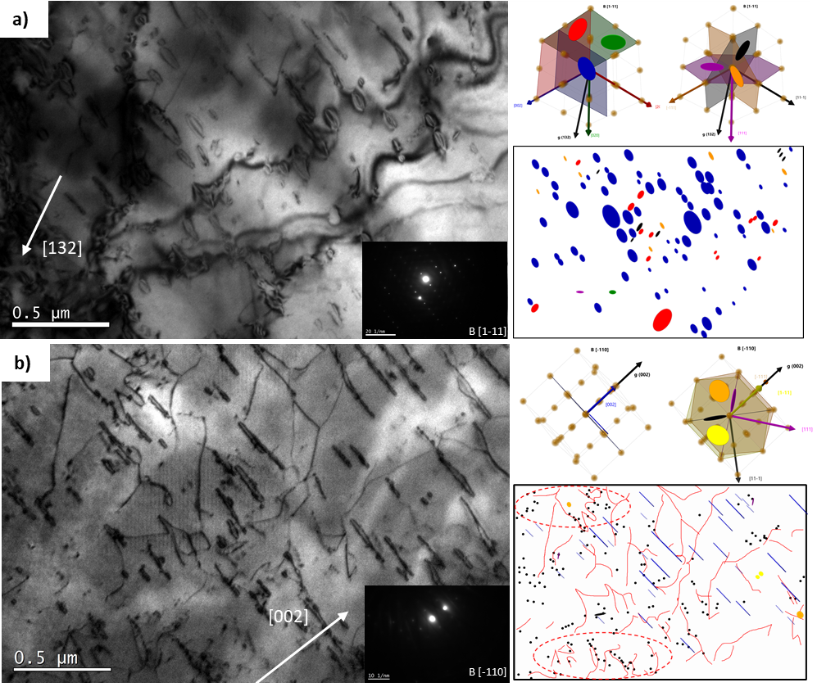
Figure 18 TEM micrographs of EFDA pure iron thin-foil irradiated with 20 MeV at 300˚C up to 4.25x10¹⁵ ion/cm² near [1-11] ans [-110] zone axis with two beam diffraction contrast condition along a) [132] and b) [002].

300 ºC high dose (8.5x10¹⁵ ion/cm²)
The pure iron EFDA sample irradiated at 300°C with Fe ions at 20 MeV up to a dose of 8.5x1015 ions/cm2 shows a population of dislocation loops similar to the sample irradiated at a low dose and the same temperature. About 80 % of all the loops analyzed in this sample present a Burgers vector of the <200> family with {200# habit plane. Although there is a reduction in the population of loops with b of this family, it is determined that, after increasing the dose, loops with the largest size of the four conditions studied are identified, and the largest of all of 907 nm. The size is 106.7 ± 102.4 nm, reflecting the high range of sizes present in this sample.
Regarding the loops with Burgers vector <111>, it is observed that they have increased both in size and population, almost 20 % of the total. Although in relative terms, it is still low, compared to the presence and size of the <200>, it is a relevant population. This observation coincides with the qualitative appreciation of this method decrease in embryo-type loops or those not identifiable by size. Of the 4 families of loops <111> (without discriminating by direction), the ± ½ a₀[1-11](1-11) and ± ½ a₀[-111](-111) are the most frequent with almost 7 % of the total number of loops identified.
In the sample irradiated under these experimental conditions, it is not determined that there is one Burgers vector/preferential habit plane, but rather two. The largest population corresponds to ±a₀[020](020) with slightly more than 37 %, but is closely followed with 32 % by ±a₀[200](200), the smallest population with almost 11 % by ±a₀[002](002). It is striking that the majority population in the case of irradiation at 300˚C and LD is under these conditions the least detected, dropping from almost 60 % to 11 %. This is probably not due to an effect of the increased dose per-se, but in addition to increased radiation damage, this sample must have microstructural features that intervene in the evolution of defects so clearly. Possibly the orientation of the grain to the beam and those of its free surfaces.
Figure 19 shows three micrographs obtained under different diffraction conditions under three different zone axes: a) [0-12], g [-1-2-1], b) [-11-3], g [-1-2-1] and c) [111], g [-211]. In all of them loops <200> fulfill that b.g ≠ 0 and b.g> |1| and it is observed that the population of ±a0[002](002) loops is the smallest of all, appreciating qualitatively how the density of ±a0[200](200) and ±a0[020](020) loops are similar.
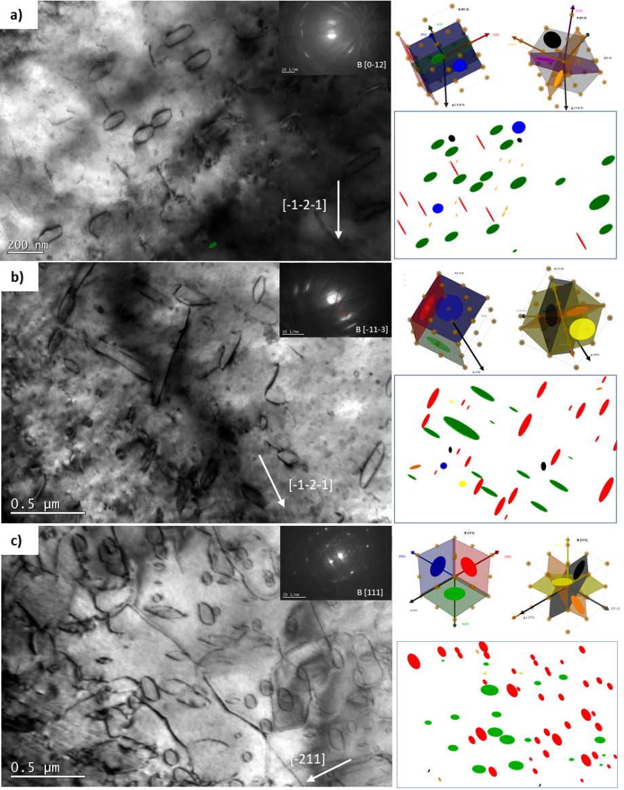
Figure 19 TEM micrographs of pure EFDA iron irradiated with Fe ions at 20MeV at 300 ˚C up to 8.5x10¹⁵ ion/cm² under a) [0-12] with g [-1-2-1] , b) [-11-3] with g [-1-2-1] and c) [111] with g [-211], showing the results for every area.

450 ºC low dose (4.25x10¹⁵ ion/cm²)
In the pure iron EFDA sample irradiated at 450°C with Fe ions at 20 MeV up to a dose of 4.25x10¹⁵ ions/cm², 85 % of all identified loops are of the <200> family with {200# habit plane.
The average size is 69.2 ± 37.01 nm, the smallest and most homogeneous of the four samples studied. The two samples irradiated at LD have the smallest population of loops without distinguishing between them, being the volumetric dislocation density very similar, although it is somewhat lower.
Regarding the loops with Burgers vector <111>, the predominant family with 55.5 % of the population concerning the total of <111> detected are the ± ½ a₀[11-1](11-1).
Figure 20shows three micrographs obtained under different diffraction conditions under two different zone axes. Figure 20 a) under [10-1] with g [0-20] shows ±a₀[020](020) loops in green completely perpendicular to the diffraction vector. Furthermore, with these diffraction conditions all loops <111> should be visible, because with g {200# they all fulfill b.g> |1|, however only 4 loops b <111> are identified which could be ± ½ a₀[-111](-111) or ± ½ a₀[11-1](11-1). Figure 20 b) and c) are taken under the same zone axis [-1-1-1] with different diffraction vectors, g [01-1] and g [-211], respectively. The respective microstructures describe very clearly an observation that was present in the whole sample. In no area of the crystal studied were ±a0[200](200), ±a0[020](020), and ±a0[002](002) loops with similar population density detected. A similar number of loops with b ±a0[020](020) and ±a0[002](002) together (b) or ±a0[200](200) were dominant (c), which was the least frequent microstructural distribution.
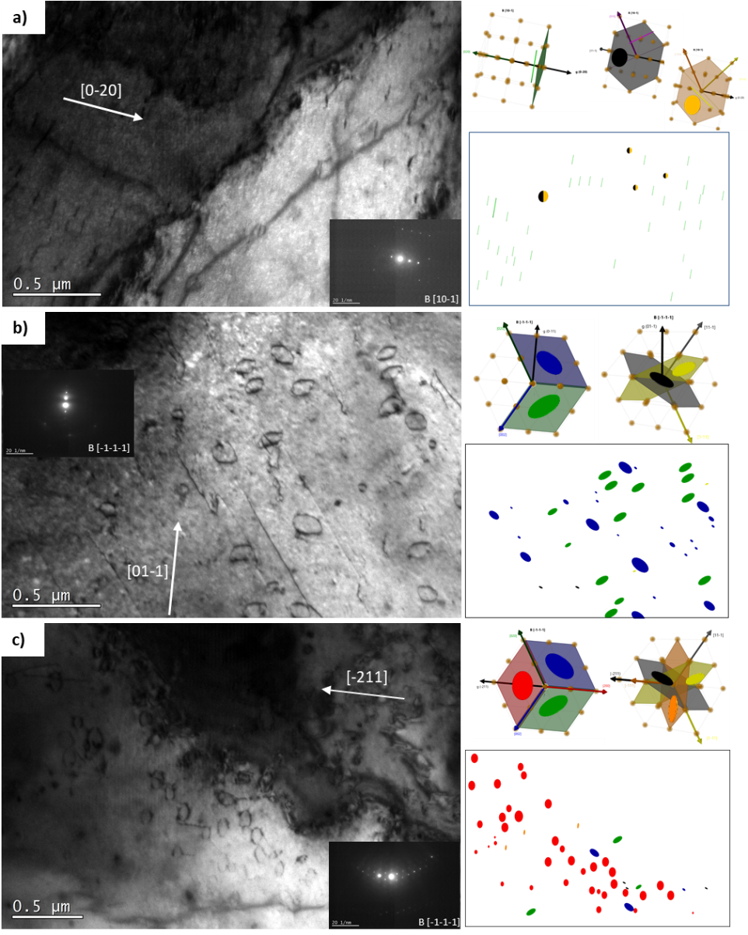
Figure 20 TEM micrographs of pure EFDA iron irradiated with Fe ions at 20MeV at 300 ˚C up to 8.5x10¹⁵ ion/cm² under a) [10-1] with g [0-20] , b) [-1-1-1] with g [01-1] and c) [-1-1-1] with g [-211], showing the results for every area.
450 ºC high dose (8.5x10¹⁵ ion/cm²)
The sample irradiated up to a dose of 8.5x10¹⁵ ions/cm² at 450°C contained 92 % of loops with Burgers vector of the <200> family with {200# habit planes. As for the distribution of loops according to b, it is the sample with the most homogeneous distribution. 38 %of the loops are ±a₀[200](200), 27.5 % ±a₀[020](020) and 26 % ±a₀[002](002). The average loop size is 74.3 ± 63.21 nm, with the maximum loop size being 577 nm.
Figure 21 shows three micrographs obtained under different diffraction conditions under three different zone axes: a) [111], g [1-10], b) [131], g [-101] and c) [-1-11], g [112]. Figures a and b show 2/3 type <200> and 2/4 type <111> loops so that it can be seen that there is no family of type <200> loops that predominate over the others. However, probably due to the randomness of the processes or to the effect of some variables such as sample thickness, surface orientation, etc., in global terms, it seems that the ±a₀[200](200) loops are the most frequent. In addition, in these figures, the existence of the so-called open loops can be observed, i.e., loops anchored to the surface whose extra interstitial plane is cut. This sample is the one that shows more defects of this type, and although there is no convincing explanation, everything seems to indicate that the high temperature and the smaller thickness of the sample enhance the formation of these open loops.
Figure 21 c), finally, represents an overall picture of the coexistence of the three families of loops <200> together with some <111> of small size. Thus, for example, a loop highlighted in a red dotted oval whose habit plane appears to be (1-11), but the angle ratio (angle between B and b, is related to the projection between the diagonals of the oval) does not coincide with a projection of a loop with b ± ½ a0[1-11].
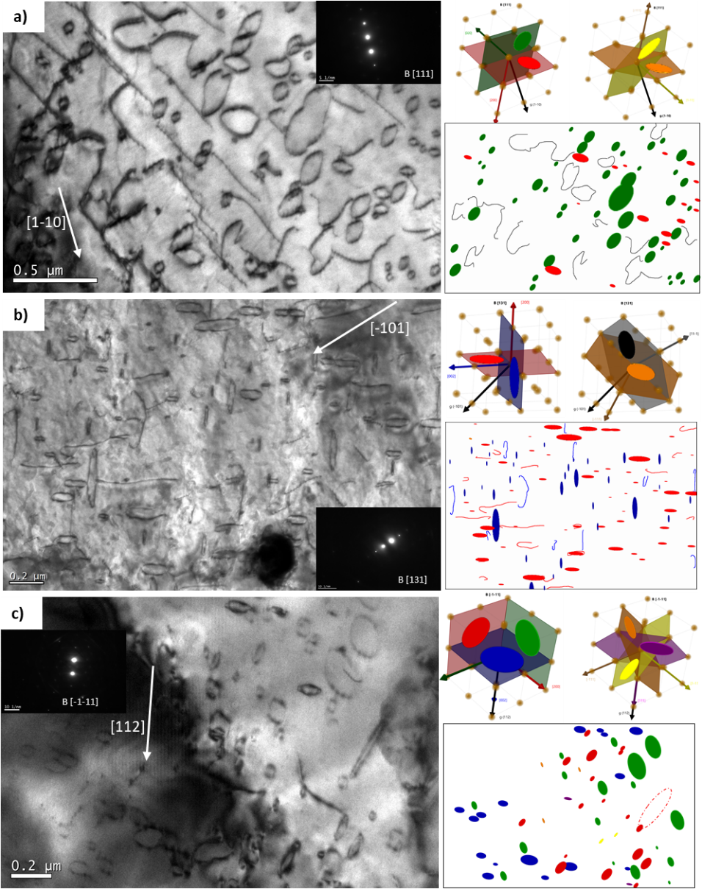
Figure 21 TEM micrographs of pure EFDA iron irradiated with Fe ions at 20MeV at 300 ˚C up to 8.5x10¹⁵ ion/cm² under a) [111] with g [1-10] , b) [131] with g [-101] and c) [-1-11] with g [112] showing the results for every area.

Comparison of the results
Comparing the four samples, it is evident that the population of loops located in the {100# planes results in the great majority of the loops observed, although an increase of the <111> type is observed for the sample irradiated at high dose and low temperature, Figure 22. Usually, with a diffraction vector that allows the {200# loops to be visible, such as the [112] type direction, all three types should have been observed, but this is not the case, or if it occurs, the population of one of them is almost irrelevant compared to the number of defects of the other two (Figure 21 a).

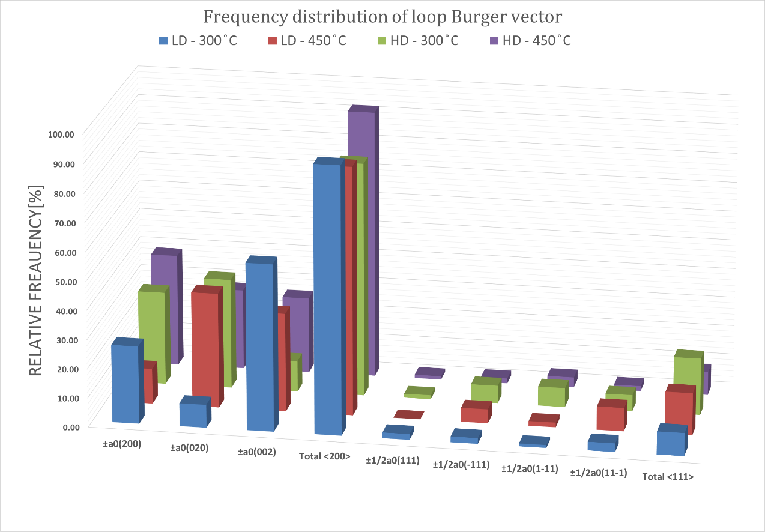
Figure 22 Distribution of habit planes of the dislocation loops observed in all the specimens.

Swelling
A study of the volume variation due to the generation of dislocation loops and voids was performed. As described in the experimental development section, to perform these calculations accurately, it is necessary to determine the particular Burger vector (no, just the habit plane) and subsequently apply the inside-outside method to determine the nature of each loop individually. During the process of establishing the crystal map through the Kikuchi paths using 3 zone axes, sometimes, the contrast of the area varied significantly. Moreover, because of the ferromagnetism of the disk concerning the polar lens, the image was not good or, there could even be a high drift, or in the worst case, the sample jumped, losing the references of the successive turns of the double sample holder. Despite these reasons, about 100 loops were analyzed, especially with diffraction vectors of type {122# so that the {100# loops were visible, and relative averages for the calculation of the total of type {111#.
Figure 23 shows some examples of areas analyzed using the I-O method for all the conditions studied. Besides representing the contrast change so evident in large loops, it is essential to know how to interpret the contrast limit s>0 of the micrograph and not to analyze loops that are already being excited with other diffraction conditions and may show a different contrast change. On the other hand, it is necessary to establish the maximum sample rotation, where the I-O contrast change remains constant, which is called "safe zone," since, beyond that angle, the direction of the change is reversed and can lead, again, to misinterpretations.
Figure 23 (a - b) belongs to the sample irradiated at 300ºC up to a dose of 4.25x1015 ion/cm2. The diffraction vector is in (a) (1-2-1) and in (b) (-121), which results in b.ga<0 and b.gb>0. Therefore, to meet this criterion, the observed loops located in the habit plane (010) must have an "inside" type contrast at a, and vice versa. It is observed that the contrast of the most prominent loops is, on the contrary: "outside" in Figure 23 a and "inside" in b. Therefore, the plane is (0-20). It has been determined that if the size of the loop decreases when changing from outside to inside contrast, it is of interstitial type, which is confirmed. A similar example is observed in the loops inside the blue oval, one with vector (00-2) and interstitial (decreases from outside, a, to inside, b). Similar analyses are performed on other loops and nearby zones under the same zone axis [-1-11]. In total, 90% of the analyzed loops are interstitials, 5% are vacancies (4% at 300°C and 1% at about 450%), and the rest could not be confirmed with certainty.
The results of the other samples are similar. The vast majority of the analyzed loops are of interstitial type, indicating an increase in volume due to the incorporation of the atomic planes due to the loops generated by ion irradiation.
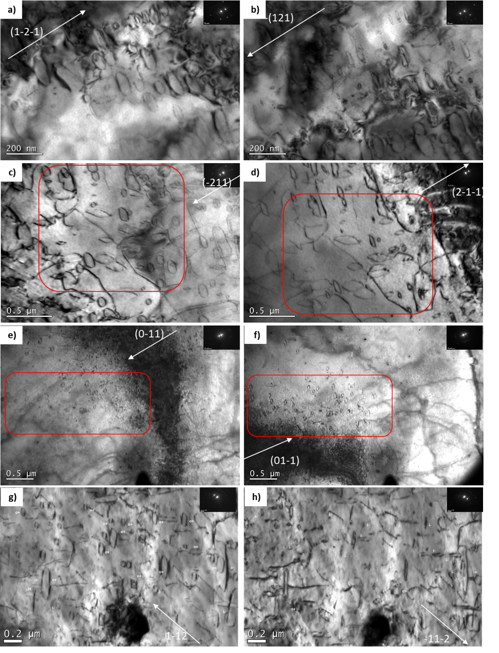

Figure 23 Inside-outside method to study the nature of the visible loops in a) low dose and 300ºC, b) low dose 450ºC, c) high dose 300ºC, and d) high dose and 450ºC.

Approximating the micrograph area that maintains the correct diffraction conditions, i.e., the loops being analyzed must be revealed by a single diffraction condition, or at least not show a significant change in their contrast or size. Next, the loop-induced swelling and dislocation density were calculated, approximating each loop to a cylinder of height, b, and assuming all as interstitials.

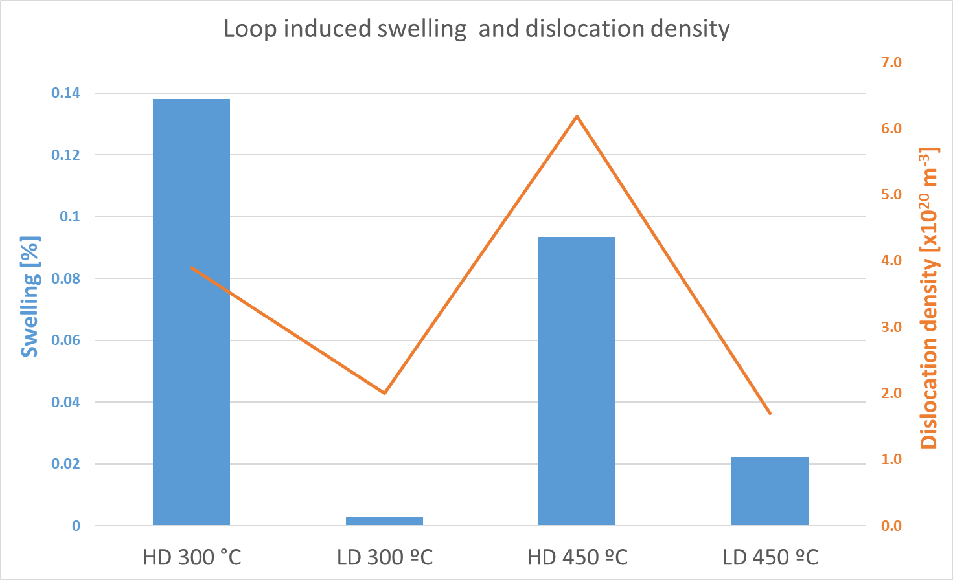
Figure 24 Dislocation induced swelling and density.

It is important to emphasize that although all samples have a relatively heterogeneous population of defects, the samples with the lowest swelling, which correspond to those that have received a lower dose, have large defect-free areas so that the population density decreases in absolute terms.
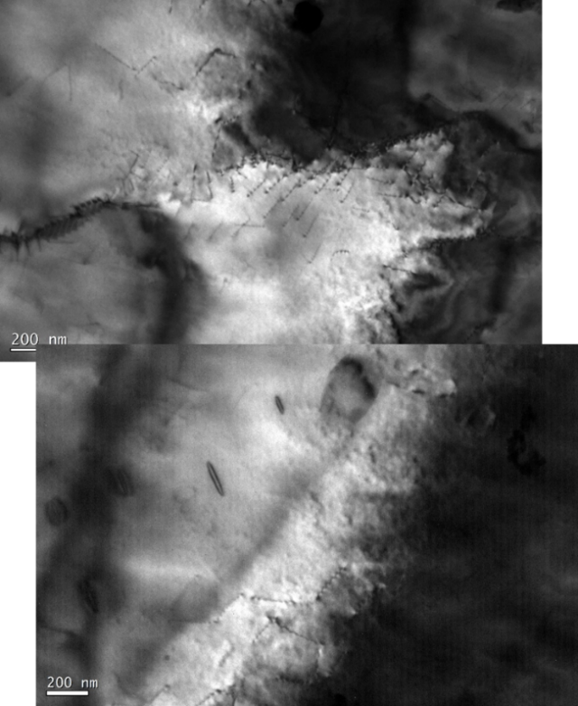
Figure 25 TEM micrograph of the sample irradiated at a low dose and 450ºC showing large area with a very few dislocation loops and lineal dislocations

Additional observation

Effect of film thickness
Inherently to thin-film irradiation experiments, is expected a sample thickness increasing effect. Depending on the quality of the electropolishing, the slope will be much or less pronounced to affect the dislocation formation and evolution. For example, in Figure 26, a large transparent area is observed with a high population of large a₀<200> loops. However, close to the hole where the sample thickness is shallow, almost no loops are observed even to the left of the dark zone, representing the area dynamically excited, where also the contrast condition should be excited. Then, as thickness increases, the population of loops increases when the thickness is too large, making the loops observation harder. On the other hand, the loops accommodation changes a bit, being wider as thickness increases. As a result of this observation, the perfect thickness to perform irradiated thin film studies is around 100 nm because the thinnest samples diminish the diffraction contrast, making it very difficult to get, for example, clear two-beam condition.
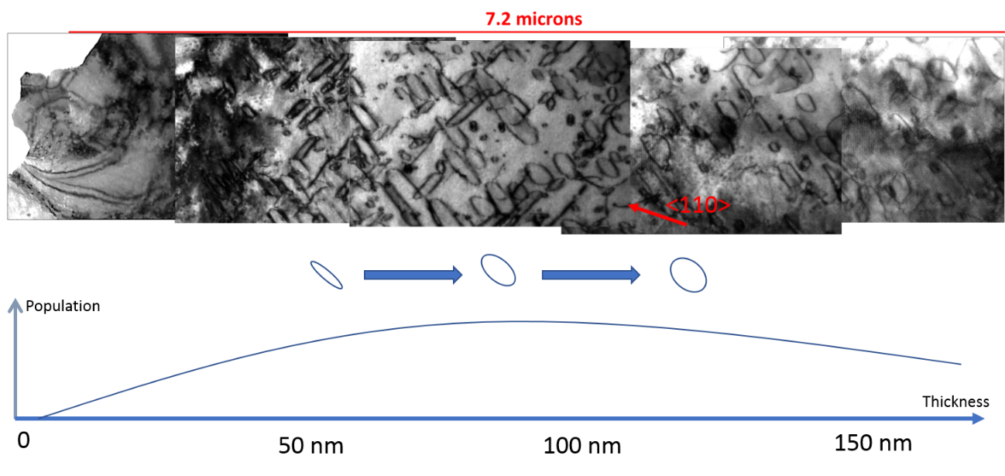
Figure 26 TEM micrograph of irradiated thin film showing the thickness dependence of loops in terms of population and visibility.

Open loops
Sometimes large open dislocation loops were discovered, as shown in the following micrograph. Figure 27, along with a sketch where easy one can have an idea of the implication of these observations. With no regard to the temperature and dose studied, in all the specimens were found open loops.
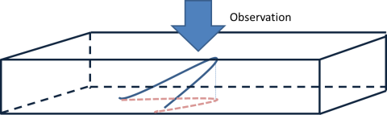
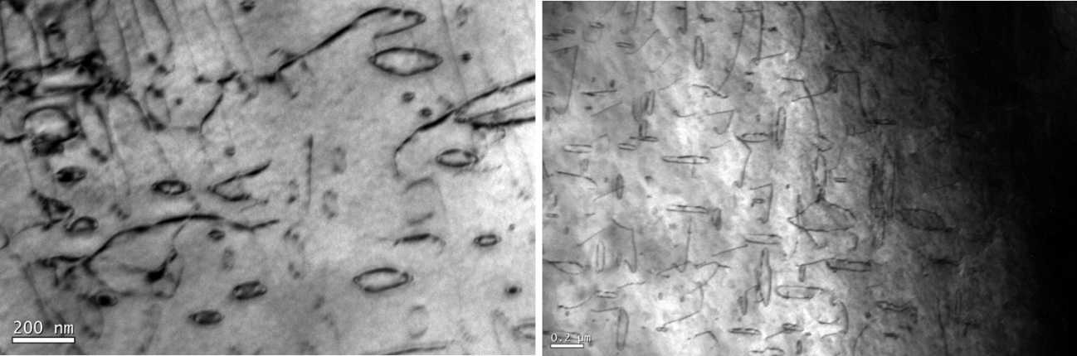
Figure 27 Scheme and micrographs showing open loops distributed within the matrix

Discussion
This research has been carried out to advance the development of computer-solved physical models that simulate the evolution of the defects generated by irradiation and their interaction with all the other factors involved, such as alloying elements and other dislocations present precipitates, among others. Nowadays, the available models are not multiscale, but different methods and codes depend on the desired result, accuracy, and available computing power [28]. From the point of view of defect evolution, the most common are O-KMCs that allow parallel work using state-of-the-art graphics cards. It is expected that, in the short term, the gap between these models, which study the dynamics of dislocations on a larger scale, will be eliminated and eventually be able to be coupled to more common codes of structural calculations using finite elements. However, regardless of the physics that is simulated, it is always necessary to validate both the physics implemented in these codes and the efficiency at the time the code operates. For this, it is necessary to have experimental results obtained from experiments developed to support the modeling invstigations, not only to obtain experimental results. It is necessary to consider all the parameters that can influence the development of the experiment to determine which are quantifiable and controllable (furnace temperature, sample preparation, irradiation area, beam energy, and current) and maintain these systematics at all times. Since, from a scientific point of view, working with some uncertainty in the results is valid. However, computational scientists require greater accuracy.
In this case, these experiments have been performed to obtain more information about the effect on defects generated by irradiation in thin films, having two free surfaces that act as defect sinks and are a source of vacancies, and affect the evolution of dislocation loops [29-31], an increase in dose, the irradiation temperature and, especially, avoiding the injection of SIA into the material by irradiating with very energetic ions that have a very low probability of collision with lattice atoms (Figure 8). In this way, the damage profile is more similar to that of neutrons.
The structural materials that will be part of the future nuclear fusion reactor will have to withstand an extremely aggressive environment for as long as possible. Developing steel that maintains its structural integrity against this environment, characterized by high temperature, cyclic loading, and 14 MeV neutron radiation, is a considerable challenge for the scientific community [1, 32]. Two routes have been established which, although independent, are necessary to reach the final goal. On the one hand, the experimental route, which, based on the vast knowledge of the effects of radiation on materials used, mainly in fission reactors, has managed to materialize steels with good properties against radiation in terms of structural stability, corrosion, and radiation resistance [33, 34], but which to date lacks a scenario similar to that of the future fusion reactor in which to study the effect of neutron damage. On the other hand, the development of computational models that simulate the effects of radiation allows the development of experiments with other damage techniques, such as ion beams [16] or fast neutrons that emulate neutron damage.
However, to predict the evolution of materials and thus their microstructure, a profound understanding of the physics of irradiation damage is necessary. In addition, computational scientists must rely on results from experiments designed for this purpose, allowing them to validate the physics implemented in these models. Moreover, it is with this objective in mind that this research has been carried out.
From the point of view of the study of the evolution of irradiation defects in materials, being able to observe how they are generated, how they interact with each other, growing or disappearing through in-situ TEM studies [6, 7, 35] allows us to have a dynamic interpretation of the defect fate. On the other hand, the results obtained from the more conventional studies called post-mortem (studied when irradiation ends) only represent the photo finish of the microstructural evolution. However, there is a fundamental difference between the two; the sample volume subjected to the radiation is radically different: a few nanometers (less than 100 nm) for thin foils and a semi-infinite material in bulk in terms of thickness.
Regarding the energy of the ions, in order to avoid the effect of the injection of self-interstitial atoms into the material in thin foils, as well as to move the braking peak away from the surface in bulk samples, 20 MeV Fe ions were used. Comparing the damage generated in the thin foils and the first 100 nm of the FIB lamellae extracted from the bulk specimens, it was observed that both microstructural developments were utterly different, so the whole study was focused on understanding and explaining the reasons for such a high generation of dislocation loops even when the probability of kinetic energy transfer by the incident ion to the atoms forming the sample is very low. In probabilistic terms, this means that the vast majority of irradiated ions transfer very little energy to the lattice, i.e., the film should be transparent. However, the results indicate the opposite.

Defect generation during irradiation
It is clear that when a vacancy is formed, an interstitial is also formed, but the evolution of these into more complex defects or their recombination depends on many factors. Beyond the initial production of defects, the production bias has significant consequences on the evolution of defects in the irradiated microstructure. One possibility being studied is that, during a cascade, clustered interstitials may move towards relatively close defect sinks due to their high mobility, such as I₂, C15, or developed loops of the ½a₀<111> family in alpha iron [36-39]. This would lead to an imbalance between V and I, causing excess vacancies to form vacancies [40] or, in some cases, vacancy loops [41, 42]. However, in ferritic matrices, they are not usually observed. Similarly, if interstitials form immobile type clusters (or require high energy to move), loops of interstitial dislocations would be generated, which would also act as sinks for other interstitials or mobile clusters of interstitials. This observation has been used as an explanation [43] for the formation of large interstitial loops in irradiated iron [44].
It is well known that the nature of the defect conditions its fate within the environment formed by the crystal and its component defects. In the case of these irradiations in thin foil, it has been presented in the results section that of all the loops analyzed 5% of the total turn out to be vacancies of which 4% have been detected in the samples at 300ºC, not seeing a clear difference in terms of dose. The identification was quite errant and heterogeneous between the two conditions, i.e. it was not possible to identify the microstructural feature present in that area that would make the formation of a vacancy loop the most energetically favorable structure. On the other hand, a similar number of loops, around another 5%, have not been univocally identified, also mostly belonging to the 300ºC samples. These results are consistent with the evidence that voids were not detected in all samples. It is possible that some regions had higher concentrations of voids or were closer to one of the two free surfaces acting as a source of these defects. Having detected these loops instead of voids, knowing that energetically the latter is more favorable in Fe BCC [45], may indicate some factor that modifies this bias, which could be the confinement between two relatively close free surfaces. However, it is not very easy to establish a precise correlation in this material, in the same way that occurs with vacancy loops in other metallic materials such as Zn, Mg, and W [42, 46, 47]. Nevertheless, the results observed in this investigation are in agreement with the literature.
It was presented in Figure 3 (SRIM curve, calculated by the Stoller method) that the damage generated in terms of atomic displacement is relatively low ~10-2 dpa. A low dose generates a low defect density (either loop embryos or already formed loops). This implies that those defects nucleated during irradiation may exist in the material, rather than recombining with defects of opposite nature or interacting with other microstructural features that act as sinks. However, as the dose increases, and thus the atomic damage generated, the probability of interaction between them increases, generating microstructural evolution [48, 49]. If point defects are the same nature and the energy state is favorable, they will form vacancy and/or interstitial clusters, even if their Burger vector is different [50, 51]. However, it should be pointed out that these hypotheses are based on computational calculations, as they are experimentally challenging to observe and validate. This evolution strongly depends on the host material and thus on its crystal structure. In the case of BCC iron, either voids, vacancy clusters, or dislocation loops (both V and I) can form.

Effect of temperature and dose on loop size.
Loops can move in two different ways; glide or climb [52] with gliding being the one that occurs in the glide plane and climbing mode being the one that allows prismatic loops to move in their habit plane. For that movement to occur, vacancies must be absorbed or emitted, allowing that extra partial plane (in the case of interstitial loops) to move. In terms of mobility, both can move within the crystal lattice, although the energy required to move is much lower for <111> (glissile) than <100> (sessile) in irradiated BCC iron. However, recent papers supported by computational codes have observed that <100> loops may have mobility mechanisms, more complex than gliding and climbing, such as 1D diffusion changing their habit plane [53], so considering them immobile (sessile) is not entirely correct. On the other hand, it has been shown that C15 clusters [48, 54, 55] act as embryos of loops since they can evolve to loops with b<100> or b<111>, or even to more complex forms with the so-called mixed loops [55]. This evolution depends, once again, on the boundary conditions, such as irradiation temperature, dose, dose rate, and in the present case, volume of material available to relax [41, 56]. If the dose continues to increase, the interaction between defects is enhanced, since the population has been increasing in proportion, until the rate of generation of new defects slows down, increasing the growth phase, until reaching a saturation value that depends on the dose rate and temperature, as long as this is around 0.3 - 0.4 Tm (melting temperature) [57]. This phenomenon becomes even more critical in volumes of material where one of the dimensions is of the order of magnitude of the defects [30], as in this case, the depth, where the sheet is at most 100 nm thick, which is approximately equivalent to about 350 atoms. As the loop grows, its effect as a defect sink also increases, which, from an energetic point of view, implies that its movement through the crystal is more complex, so that as the irradiation elapses, it becomes an element with which other loops can interact if encountered [58]. This hypothesis reinforces the idea that the growth of dislocation loops will be dominated by the movement and subsequent trapping of minor interstitial-type defects, rather than by the reaction of small loops generating a large one, which occurs during cascading overlap [59, 60].
The future of a defect produced by irradiation depends largely on the initial stages of the generation of what will be, the embryos of that defect. During the cascade of atomic displacements, a huge number of point defects are generated, of which only a few will survive, i.e., they will not recombine with a defect of the opposite nature (vacancy with interstitial), allowing them to form larger defects [61, 62]. Similarly, a high rate of defect cluster generation (In or Vn) decreases the level of recombination, since the population available for recombination has decreased. This phenomenon is enhanced when the defect clusters are mobile (glissiles), being able to move away from the volume of material affected by the cascade, therefore, the higher the clustering rate, the lower the recombination, which means higher strain damage. The material cannot inhibit the formation of such defects with the consequent occurrence of irradiation damage. Specifically, in the case of steels, it has been shown that those with BBC structure withstand irradiation better than those with FCC [63-68], evidently, for crystals with the same atomic structure, the resistance to radiation depends on the microstructural characteristics as well as on the composition, i.e., on the binding energy (which is the energy that must be transferred to a nucleus to remove it from its equilibrium position [54, 60, 69].
They are well established, therefore, that in the process of damage structure evolution in materials subjected to irradiation, so-called bias effects, i.e. dislocation bias and production bias, play an essential role [70].
Generally speaking, irrespective of fluence or irradiation temperature, it was shown that the vast majority of the loops were of the <100> type, with the <111> loops being much smaller in size. To analyze the effect of dose and temperature as factors promoting the growth or nucleation of loops (which is similar to saying that they enhance the development of pre-loop embryos to small loops), all loops counted regardless of their habit plane were taken into account. Figure 28 compares the 4 experiments by setting the temperature and increasing the dose (a, 300 ºC and b, 450 ºC) or vice versa (c, low dose, and d, high dose). It is observed that, at low temperatures, an increase in the dose causes growth of the loops in general and a significant decrease in the population of loops smaller than 100 nm (the orange graph is shifted to the right and downward concerning the blue one). This effect is also evident at high temperatures, although a decrease in the population of loops smaller than 100 nm is not as high as at low temperatures (b). If the dose value is fixed and the effect of temperature is evaluated, the effect produced promotes the generation of medium and low size loops, detecting larger loops at higher doses.
It is important to note that this evidence does not discriminate between loops but analyzes them as a whole to get a global picture. A study in which the evolution of loops {100# and {111# are studied separately will probably shed more light since it is likely that the small mobile loops play a fundamental role in the nucleation and growth of the loops. This has been demonstrated in several papers where they propose possible reactions between different types of loops [71-73], opening the possibility that two loops <111> interact one another, forming a <100>.
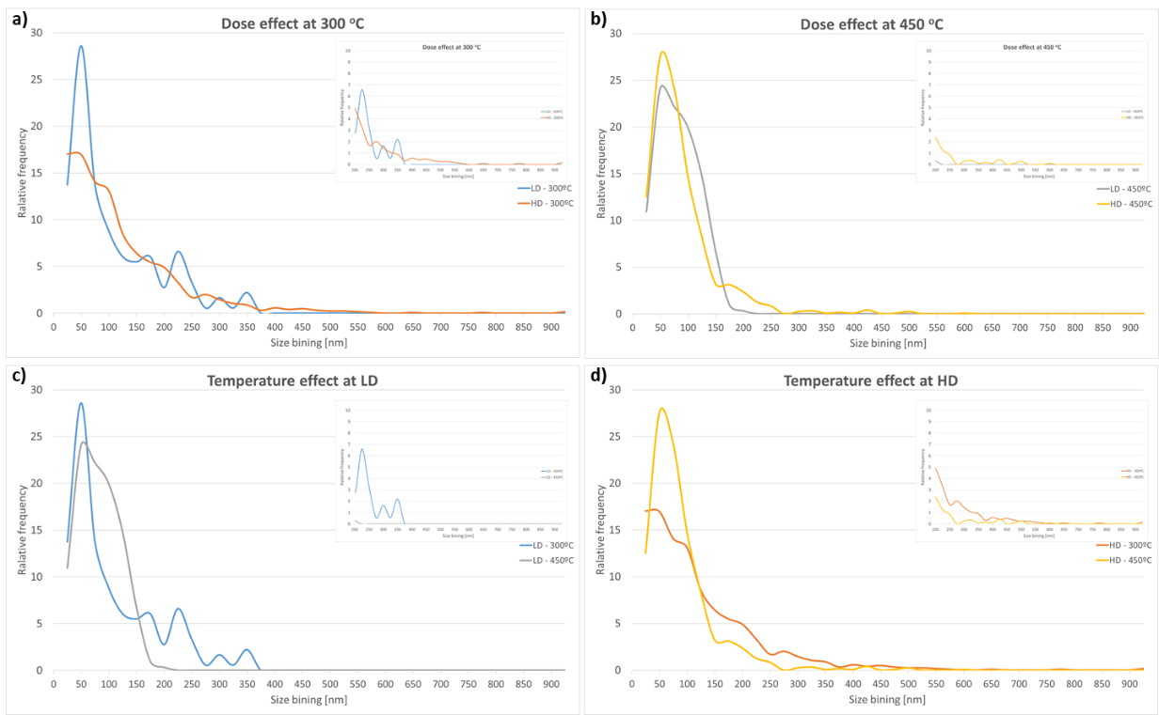
Figure 28 Effect of increasing irradiation dose at constant temperature (a) 300°C and b) 450°C), of increasing irradiation temperature for the same effective dose c) low dose, and d) high dose).

Burger vector and habit planes
Once we have a global picture of the effect of dose and temperature on the size distribution of the loops, as well as on their distribution density (remembering that this is an average of several micrographs in different areas of the sample, since it is not a completely homogeneous distribution as shown in Figure 17), it was experimentally observed that most of the loops of size greater than 5 nm are of the <100> family.
In the literature, many works have been carried out to get to know in-depth the relationship between chemical composition, the microstructure of the material and irradiation characteristics (such as temperature, fluence, dose or radiant species). In the case of pure iron BCC, in [9, 35, 44, 74] in-situ irradiations were performed with Fe ions between 100 and 150 KeV and temperatures between 300 and 500ºC, in the order of 1 to 2 dpa concluding that at temperatures below 300ºC the <111> loops are in the majority. As the temperature increases, the population of <100> loops increases until they are the only ones detected. In [10] a thin foil was irradiated with 500 keV up to 0.5 dpa at RT, observing that the presence of defects is much higher in the thin foil than in the bulk material, and that most of the defects are of the <100> type. The difference in the observations lies in the ion energy as well as in the effect of interstitials that have been injected into the sample, intervening in the evolution of the defects. For this reason, it is possible that even at temperatures of 300 ºC, the majority of the loops are <111>, whereas, in this investigation, the majority are <100>. It is true, however, that at lower irradiation temperatures, most of the mobile loops <111> are detected.
In [75], a foil was irradiated with 1 MeV of Kr at 435ºC together with He, achieving damage between 15 and 25 dpa. The observations showed complex reaction mechanisms and the expected reaction <111> loops forming <100>. However, in the initial stages of irradiation with doses around 1 dpa, the size of the loops is notably smaller than those detected in this work; the damage is substantially more significant than that predicted by SRIM with Fe ions at 20 MeV.
Although the comparison is not entirely accurate, experiments with neutrons passing through the sample without depositing interstitials reflect that at low temperatures and doses, most loops are <111> (70 °C and 4.7x10²⁰ n/cm² - 0.72 dpa [76], 60 °C and 2. 5x10²⁰ n/cm² [77]), while for higher temperatures and doses, most of the observed loops are <100> ([78]observed at temperatures between 275 to 450 °C, from 0.87 to 1.13x10²¹ n/cm2, [79] at 300°C, 1.5x10²¹ n/cm² - 0.2dpa, [80] at 400 °C, up to a dose of 25.8 dpa, do not give the fluence in n/cm²).
Open loops and free surfaces
On the other hand, the effect of free surfaces and the observed crystal surface orientation must be considered. For example, the glissile dislocation loops ½[111] can be lost on the surface by sliding if the surface is oriented close to the (111) plane. In contrast, in a thin film (110), two variants of ½<111> loops have a Burger vector lying in the plane of the film, and cannot be lost by sliding, and for that reason, a higher amount of ½<111> was observed [8].
The proportion of dislocation loops with b=a0<100> and b=½a0<111> depends, among other things, on the irradiation temperature: in general, ½<111> loops are preferentially created at low temperatures, while <100> loops at high temperatures. In this case, it is impossible to confirm the predominant mechanism that generates such large <100> loops and such a low <111> density, but it is probably the coalescence of these forming 100, acting in turn as sinks for more defects. Furthermore, in some cases, when the loops are small, such as those referred to as embryos in this work, smaller than 5 nm, they are not fully identified although they are estimated to be of the <111> type [81]. Similar observations on the effect of crystal surface orientation were obtained in [11].

Nature of loops (vacancy or interstitial).
Interstitials, as well as vacancies, can form the dislocation loops generated by irradiation. Those of interstitial type, as is evident, produce a higher distortion in the crystal structure, generating larger elastic fields of strain so that the interaction with other defects is more significant, acting as defect sinks. This observation indicates that the loops prefer interstitial defects to vacancies, modifying the final resulting microstructure of the crystal. The bias induced by a dislocation depends on the magnitude of its Burgers vector, so in principle, <111> type loops will have a higher capture efficiency than <100> loops, although new work has obtained results, which highlight that this phenomenon is not so straightforward [82]. The experimental procedure section described in detail that empirical determination of the nature of dislocation loops is a complex task [83, 84].
Although loops of the two types can form with both b <111> and <100> , those formed of vacancies are not usually detected since vacancies have a higher migration energy than interstitials within a crystal [85]. Moreover, they tend to cluster together forming voids, and the consequent swelling effect [86, 87]. On the other hand, to a lesser extent, in all samples a sink effect has been observed in grain brodes as shown in Figure 29. The mechanism at work is explained in [88] and allows predicting a recombination of defects in the vicinity of the defects. However, it does not go into detail about the possible effect of crystal misorientation, and therefore, the relationship between the energy of the grain boundary and its potential as a defect sink.
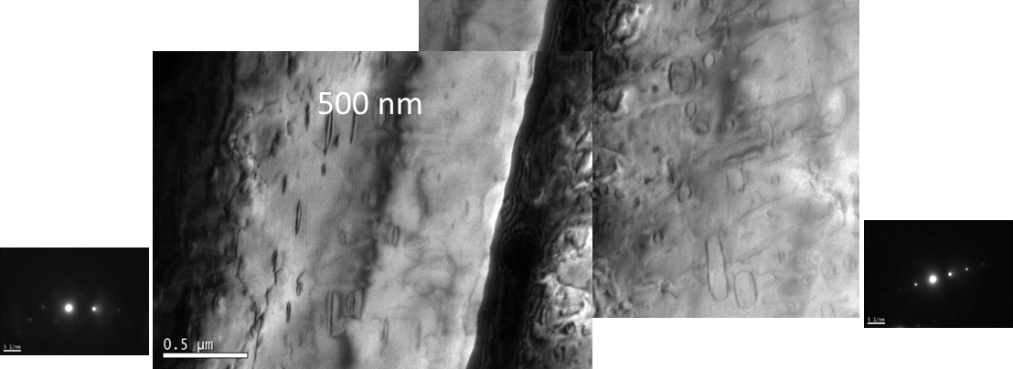
Figure 29 Irradiation sink effect at a grain boundary.

Fresnel contrast revealed vacancy-type structures <5 nm in diameter randomly distributed throughout the lamellae for all alloys; however, it could not be verified that they were not simply oxides on the sample surface, so they were not analyzed.
Available studies show that most of the dislocation loops created under irradiation in pure Fe are interstitial type, as shown by TEM on samples irradiated with different species [78, 89, 90].

Conclusions
- As an ultimate goal, designing an experiment with ion irradiation to be comparable with neutrons turns out as a source of valuable knowledge regarding the development of nuclear fusion reactors. Performing irradiation with no interstitials injected and low dpa value (and dpa rate) may be closer to neutron irradiation than self-ion in bulk.
- In situ TEM irradiations help gain insight into the dynamic evolution of irradiation defects as parameters such as dose, temperature, or strain vary. However, there is a noticeable difference in defect formation when comparing experiments on thin films with bulk.
- Apparent differences were found between thin foil irradiation and first nm in bulk specimens in terms of dislocation loops. There is an evident effect of the reduced volume available for the defects to recombine in thin films specimens. In addition, according to the literature, the experimental conditions critically affect the fate of the microstructure. Microstructural observations produced by low keV self-ion irradiation placing the stopping range within the film seem to be hardly comparable to the results obtained in this research. Injected interstitials bias the production of defects, end hence their evolution.
- Understanding the complex diffusion mechanism <100> loops is a critical step in further exploring the mechanical properties of Fe and Fe-based alloys associated with the formation of <100> dislocation loops by deformation or radiation.
- The most loops identified in all four experimental conditions are b <200> type, between 80 to 92% in total. Concerning literature, dislocations at 300ºC should be <111>, and as the irradiation temperature increases, <200> loop population too. However, in this research, the observations indicate otherwise.
- The highest average loop size value was found in HD 300ºC, and the largest loop, 907 nm, that corresponds to 9 times the sample thickness. In addition, this experimental condition produces the biggest loop swelling, 0.14 %.
- Free surfaces orientation must be taken into consideration in order to determine the importance of this parameter in terms of defect annihilation or image forces.

References
[1] J. Knaster, An assessment of the available alternatives for fusion relevant neutron sources, Nuclear Fusion 58(9) (2018) 095001.
[2] J.C. Haley, S.A. Briggs, P.D. Edmondson, K. Sridharan, S.G. Roberts, S. Lozano-Perez, K.G. Field, Dislocation loop evolution during in-situ ion irradiation of model FeCrAl alloys, Acta Materialia 136 (2017) 390-401.
[3] D. Kaoumi, J. Adamson, M. Kirk, Microstructure Evolution of Two Model Ferritic/Martensitic Steels Under In-situ Ion Irradiation at Low Doses (0-2dpa), Journal of Nuclear Materials (0) (2013).
[4] D. Kaoumi, J. Adamson, Self-ordered defect structures in two model F/M steels under in situ ion irradiation, Journal of Nuclear Materials 448(1–3) (2014) 233-238.
[5] Z. Yang, N. Sakaguchi, S. Watanabe, M. Kawai, Dislocation loop formation and growth under in situ laser and/or electron irradiation, Sci Rep 1 (2011) 190.
[6] R.C. Birtcher, M.A. Kirk, K. Furuya, G.R. Lumpkin, M.O. Ruault, In situ Transmission Electron Microscopy Investigation of Radiation Effects, Journal of Materials Research 20(7) (2005) 1654-1683.
[7] A. Kirk Marquis, M. Baldo Peter, C.Y. Liu Amelia, A. Ryan Edward, C. Birtcher Robert, Z. Yao, S. Xu, L. Jenkins Michael, M. Hernandez-Mayoral, D. Kaoumi, T. Motta Arthur, In situ transmission electron microscopy and ion irradiation of ferritic materials, Microscopy Research and Technique 72(3) (2009) 182-186.
[8] M.L. Jenkins, Z. Yao, M. Hernández-Mayoral, M.A. Kirk, Dynamic observations of heavy-ion damage in Fe and Fe–Cr alloys, Journal of Nuclear Materials 389(2) (2009) 197-202.
[9] Z. Yao, M.L. Jenkins, M. Hernández-Mayoral, M.A. Kirk, The temperature dependence of heavy-ion damage in iron: A microstructural transition at elevated temperatures, Philosophical Magazine 90(35-36) (2010) 4623-4634.
[10] A. Prokhodtseva, B. Décamps, R. Schäublin, Comparison between bulk and thin foil ion irradiation of ultra high purity Fe, Journal of Nuclear Materials 442(1–3, Supplement 1) (2013) S786-S789.
[11] A. Prokhodtseva, B. Décamps, A. Ramar, R. Schäublin, Impact of He and Cr on defect accumulation in ion-irradiated ultrahigh-purity Fe(Cr) alloys, Acta Materialia 61(18) (2013) 6958-6971.
[12] M. Roldán, P. Fernández, J. Rams, D. Jiménez-Rey, E. Materna-Morris, M. Klimenkov, Comparative study of helium effects on EU-ODS EUROFER and EUROFER97 by nanoindentation and TEM, Journal of Nuclear Materials 460(0) (2015) 226-234.
[13] J. Chen, F. Duval, P. Jung, R. Schäublin, N. Gao, M.F. Barthe, Dislocation loops in ultra-high purity Fe(Cr) alloys after 7.2 MeV proton irradiation, Journal of Nuclear Materials 503 (2018) 81-90.
[14] J. Le Coze, Procurement of pure Fe metal and Fe-based alloys with controlled chemical alloying element contents and microstructure, Final report on model alloy preparation, 2007.
[15] M. Roldán, P. Fernández, R. Vila, A. Gómez-Herrero, F.J. Sánchez, The effect of triple ion beam irradiation on cavity formation on pure EFDA iron, Journal of Nuclear Materials 479 (2016) 100-111.
[16] M. Roldan, P. Galán, F.J. Sánchez, I. García-Cortés, D. Jiménez-Rey, P. Fernámdez, Ion Beam Experiments to Emulate Nuclear Fusion Environment on Structural Materials at CMAM, InTech2018.
[17] R. Saavedra, D. Jiménez-Rey, P. Martin, R. Vila, Ionoluminescence of fused silica under swift ion irradiation, Nuclear Instruments and Methods in Physics Research Section B: Beam Interactions with Materials and Atoms 382 (2016) 96-100.
[18] R.E. Stoller, M.B. Toloczko, G.S. Was, A.G. Certain, S. Dwaraknath, F.A. Garner, On the use of SRIM for computing radiation damage exposure, Nuclear Instruments and Methods in Physics Research Section B: Beam Interactions with Materials and Atoms 310 (2013) 75-80.
[19] N.I. Kato, Reducing focused ion beam damage to transmission electron microscopy samples, Journal of Electron Microscopy 53(5) (2004) 451-458.
[20] A. Howie, M.J. Whelan, Diffraction contrast of electron microscope images of crystal lattice defects. III. Results and experimental confirmation of the dynamical theory of dislocation image contrast, Proceedings of the Royal Society of London. Series A. Mathematical and Physical Sciences 267(1329) (1962) 206-230.
[21] B. Yao, D.J. Edwards, R.J. Kurtz, TEM characterization of dislocation loops in irradiated bcc Fe-based steels, Journal of Nuclear Materials 434(1) (2013) 402-410.
[22] L. Qing, An equation to determine the practical tilt angle of a double-tilt specimen holder and its application to transmission electron microscopy, Micron and Microscopica Acta 20(3) (1989) 261-264.
[23] D.M. Maher, B.L. Eyre, Neutron irradiation damage in molybdenum, Philosophical Magazine 23(182) (1971) 409-438.
[24] B.L. Eyre, R.C. Perrin, D.M. Maher, Electron microscope image contrast from small dislocation loops. I. Theoretical predictions for edge dislocation loops in a BCC crystal, Journal of Physics F: Metal Physics 7(8) (1977) 1359.
[25] D.B. Williams, C. Barry Carter, Transmission Electron Microscopy: A textbook for materials, 2009, p. 779.
[26] M.T. Robinson, I.M. Torrens, Computer simulation of atomic-displacement cascades in solids in the binary-collision approximation, Physical Review B 9(12) (1974) 5008-5024.
[27] M.T. Robinson, Slowing-down time of energetic atoms in solids, Physical Review B 40(16) (1989) 10717-10726.
[28] K. Nordlund, S.J. Zinkle, A.E. Sand, F. Granberg, R.S. Averback, R.E. Stoller, T. Suzudo, L. Malerba, F. Banhart, W.J. Weber, F. Willaime, S.L. Dudarev, D. Simeone, Primary radiation damage: A review of current understanding and models, Journal of Nuclear Materials 512 (2018) 450-479.
[29] J. Fikar, R. Gröger, Interactions of prismatic dislocation loops with free surfaces in thin foils of body-centered cubic iron, Acta Materialia 99 (2015) 392-401.
[30] R.E. Stoller, The effect of free surfaces on cascade damage production in iron, Journal of Nuclear Materials 307–311, Part 2 (2002) 935-940.
[31] A.V. Korchuganov, K.P. Zolnikov, D.S. Kryzhevich, S.G. Psakhie, Primary Ion-Irradiation Damage of BCC-Iron Surfaces, Russ Phys J 60(1) (2017) 170-174.
[32] J. Knaster, A. Moeslang, T. Muroga, Materials research for fusion, Nature Physics (2016) 424-434.
[33] L. Tan, L.L. Snead, Y. Katoh, Development of new generation reduced activation ferritic-martensitic steels for advanced fusion reactors, Journal of Nuclear Materials 478 (2016) 42-49.
[34] P. Fernández, J. Hoffmann, M. Rieth, M. Roldán, A. Gómez-Herrero, TEM characterization on new 9% Cr advanced steels thermomechanical treated after tempering, Journal of Nuclear Materials 500 (2018) 1-10.
[35] M.L. Jenkins, Z. Yao, M. Kirk, M. Hernández-Mayoral, Direct in-situ electron microscope observations of the dynamics of irradiation damage effects in Fe and FeCr alloys, 2009.
[36] C.H.M. Broeders, A.Y. Konobeyev, Defect production efficiency in metals under neutron irradiation, Journal of Nuclear Materials 328(2-3) (2004) 197-214.
[37] C. Domain, C.S. Becquart, Ab initio calculations of defects in Fe and dilute Fe-Cu alloys, Physical Review B 65(2) (2001) 024103.
[38] C.-C. Fu, F. Willaime, P. Ordejón, Stability and Mobility of Mono- and Di-Interstitials in $\ensuremath{\alpha}$-Fe, Physical Review Letters 92(17) (2004) 175503.
[39] C.-C. Fu, J.D. Torre, F. Willaime, J.-L. Bocquet, A. Barbu, Multiscale modelling of defect kinetics in irradiated iron, Nat Mater 4(1) (2005) 68-74.
[40] P.T. Heald, The preferential trapping of interstitials at dislocations, The Philosophical Magazine: A Journal of Theoretical Experimental and Applied Physics 31(3) (1975) 551-558.
[41] M.J. Aliaga, R. Schäublin, J.F. Löffler, M.J. Caturla, Surface-induced vacancy loops and damage dispersion in irradiated Fe thin films, Acta Materialia 101 (2015) 22-30.
[42] R. Hales, R.E. Smallman, P.S. Dobson, The Formation and Growth of Vacancy Loops in Magnesium, Proceedings of the Royal Society of London. Series A, Mathematical and Physical Sciences 307(1488) (1968) 71-81.
[43] D.A. Terentyev, T.P.C. Klaver, P. Olsson, M.C. Marinica, F. Willaime, C. Domain, L. Malerba, Self-Trapped Interstitial-Type Defects in Iron, Physical Review Letters 100(14) (2008) 145503.
[44] M. Hernández-Mayoral, Z. Yao, M.L. Jenkins, M.A. Kirk, Heavy-ion irradiations of Fe and Fe–Cr model alloys Part 2: Damage evolution in thin-foils at higher doses, Philosophical Magazine 88(21) (2008) 2881-2897.
[45] M.R. Gilbert, S.L. Dudarev, P.M. Derlet, D.G. Pettifor, Structure and metastability of mesoscopic vacancy and interstitial loop defects in iron and tungsten, Journal of Physics: Condensed Matter 20(34) (2008) 345214.
[46] C. Dai, F. Long, P. Saidi, Laurent, Z. Yao, Mark, Primary damage production in the presence of extended defects and growth of vacancy-type dislocation loops in hcp zirconium, Physical Review Materials 3(4) (2019).
[47] J. Fikar, R. Schäublin, D.R. Mason, D. Nguyen-Manh, Nano-sized prismatic vacancy dislocation loops and vacancy clusters in tungsten, Nuclear Materials and Energy 16 (2018) 60-65.
[48] J. Byggmästar, F. Granberg, Dynamical stability of radiation-induced C15 clusters in iron, Journal of Nuclear Materials 528 (2020) 151893.
[49] F. Granberg, J. Byggmästar, K. Nordlund, Defect accumulation and evolution during prolonged irradiation of Fe and FeCr alloys, Journal of Nuclear Materials 528 (2020) 151843.
[50] K. Arakawa, T. Amino, H. Mori, Direct observation of the coalescence process between nanoscale dislocation loops with different Burgers vectors, Acta Materialia 59(1) (2011) 141-145.
[51] P. Grammatikopoulos, D.J. Bacon, Y.N. Osetsky, Simulation of the interaction between an edge dislocation and ⟨111⟩ interstitial dislocation loops in α-iron, Radiation Effects and Defects in Solids 174(3-4) (2019) 329-338.
[52] D. Hull, D.J. Bacon, Introduction to dislocations, 5. ed ed., Elsevier/Butterworth-Heinemann, Amsterdam, 2011.
[53] N. Gao, Z.W. Yao, G.H. Lu, H.Q. Deng, F. Gao, Mechanisms for <100> interstitial dislocation loops to diffuse in BCC iron, Nature Communications 12(1) (2021) 225.
[54] R. Alexander, L. Proville, C.S. Becquart, A.M. Goryeava, J. Dérès, C. Lapointe, M.-C. Marinica, Interatomic potentials for irradiation-induced defects in iron, Journal of Nuclear Materials 535 (2020) 152141.
[55] J. Byggmästar, F. Granberg, A.E. Sand, A. Pirttikoski, R. Alexander, M.C. Marinica, K. Nordlund, Collision cascades overlapping with self-interstitial defect clusters in Fe and W, Journal of Physics: Condensed Matter 31(24) (2019) 245402.
[56] R.E. Stoller, The role of cascade energy and temperature in primary defect formation in iron, Journal of Nuclear Materials 276(1) (2000) 22-32.
[57] S.J. Zinkle, Microstructures and Mechanical Properties of Irradiated Metals and Alloys, in: V. Ghetta, D. Gorse, D. Mazière, V. Pontikis (Eds.) Materials Issues for Generation IV Systems, Springer Netherlands, Dordrecht, 2008, pp. 227-244.
[58] Y. Li, M. Boleininger, C. Robertson, L. Dupuy, S.L. Dudarev, Diffusion and interaction of prismatic dislocation loops simulated by stochastic discrete dislocation dynamics, Physical Review Materials 3(7) (2019) 073805.
[59] M.L. Jenkins, M.A. Kirk, W.J. Phythian, Experimental studies of cascade phenomena in metals, Journal of Nuclear Materials 205 (1993) 16-30.
[60] A. Souidi, M. Hou, C.S. Becquart, C. Domain, Atomic displacement cascade distributions in iron, Journal of Nuclear Materials 295(2–3) (2001) 179-188.
[61] M.A. Kirk, I.M. Robert, J.S. Vetrano, M.L. Jenkins, L.L. Funk, The collapse of defect cascades to dislocation loops during self-ion irradiations of iron, nickel, and copper at 30, 300, and 600 K, ASTM, United States, 1987.
[62] Q.-u.-a. Sahi, Y.-S. Kim, Primary radiation damage characterization of α-iron under irradiation temperature for various PKA energies, Materials Research Express 5(4) (2018) 046518.
[63] J.L. Straalsund, R.W. Powell, B.A. Chin, An overview of neutron irradiation effects in LMFBR materials, Journal of Nuclear Materials 108–109(0) (1982) 299-305.
[64] A.D. Brailsford, L.K. Mansur, effect of self-ion injection in simulation studies of void swelling, Journal of Nuclear Materials 71(1) (1977) 110-116.
[65] C. Cawthorne, E.J. Fulton, Voids in Irradiated Stainless Steel, Nature 216(5115) (1967) 575-576.
[66] F.A. Garner, 3.02 - Radiation-Induced Damage in Austenitic Structural Steels Used in Nuclear Reactors☆, in: R.J.M. Konings, R.E. Stoller (Eds.), Comprehensive Nuclear Materials (Second Edition), Elsevier, Oxford, 2020, pp. 57-168.
[67] N. Hashimoto, R. Kasada, B. Raj, M. Vijayalakshmi, 3.05 - Radiation Effects in Ferritic Steels and Advanced Ferritic-Martensitic Steels☆, in: R.J.M. Konings, R.E. Stoller (Eds.), Comprehensive Nuclear Materials (Second Edition), Elsevier, Oxford, 2020, pp. 226-254.
[68] S.I. Golubov, B.N. Singh, H. Trinkaus, Defect accumulation in fcc and bcc metals and alloys under cascade damage conditions – Towards a generalisation of the production bias model, Journal of Nuclear Materials 276(1–3) (2000) 78-89.
[69] C.S. Becquart, C. Domain, A. Legris, J.C. Van Duysen, Influence of the interatomic potentials on molecular dynamics simulations of displacement cascades, Journal of Nuclear Materials 280(1) (2000) 73-85.
[70] E. Kuramoto, K. Ohsawa, J. Imai, K. Obata, T. Tsutsumi, Bias Mechanism and Its Effects for Fundamental Process of Irradiation Damage, MATERIALS TRANSACTIONS 45(1) (2004) 34-39.
[71] T.D. Swinburne, K. Arakawa, H. Mori, H. Yasuda, M. Isshiki, K. Mimura, M. Uchikoshi, S.L. Dudarev, Fast, vacancy-free climb of prismatic dislocation loops in bcc metals, Sci Rep 6 (2016) 30596.
[72] K. Arakawa, T. Amino, H. Yasuda, H. Mori, <110> Dislocation Junction Formation via the Coalescence between Nanoscale 1/2 <111> Prismatic Dislocation Loops in Iron, ISIJ International 57(11) (2017) 2065-2069.
[73] H. Xu, R.E. Stoller, Y.N. Osetsky, D. Terentyev, Solving the Puzzle of $⟨100⟩$ Interstitial Loop Formation in bcc Iron, Physical Review Letters 110(26) (2013) 265503.
[74] Z. Yao, M. Hernández-Mayoral, M.L. Jenkins, M.A. Kirk, Heavy-ion irradiations of Fe and Fe–Cr model alloys Part 1: Damage evolution in thin-foils at lower doses, Philosophical Magazine 88(21) (2008) 2851-2880.
[75] Y.-R. Lin, W.-Y. Chen, M. Li, J. Henry, S.J. Zinkle, Dynamic observation of dual-beam irradiated Fe and Fe-10Cr alloys at 435 °C, Acta Materialia 209 (2021) 116793.
[76] S.J. Zinkle, B.N. Singh, microstructure of neutron-irradiated iron before and after tensile deformation, Journal of Nuclear Materials 351(1) (2006) 269-284.
[77] B.L. Eyre, A.F. Bartlett, An electron microscope study of neutron irradiation damage in alpha-iron, The Philosophical Magazine: A Journal of Theoretical Experimental and Applied Physics 12(116) (1965) 261-272.
[78] L.L. Horton, J. Bentley, K. Farrell, A TEM study of neutron-irradiated iron, Journal of Nuclear Materials 108-109(C) (1982) 222-233.
[79] M. Matijasevic, W. Van Renterghem, A. Almazouzi, Characterization of irradiated single crystals of Fe and Fe–15Cr, Acta Materialia 57(5) (2009) 1577-1585.
[80] Y.V. Konobeev, A.M. Dvoriashin, S.I. Porollo, F.A. Garner, Swelling and microstructure of pure Fe and Fe–Cr alloys after neutron irradiation to ∼26dpa at 400°C, Journal of Nuclear Materials 355(1) (2006) 124-130.
[81] M. Hernández-Mayoral, D. Gómez-Briceño, Transmission electron microscopy study on neutron irradiated pure iron and RPV model alloys, Journal of Nuclear Materials 399(2) (2010) 146-153.
[82] Z. Chang, D. Terentyev, N. Sandberg, K. Samuelsson, P. Olsson, Anomalous bias factors of dislocations in bcc iron, Journal of Nuclear Materials 461 (2015) 221-229.
[83] M.H. Loretto, Electron Beam Analysis of Materials, Springer Netherlands, Dordrecht, 1984.
[84] M. Kirk, X. Yi, M. Jenkins, Characterization of irradiation defect structures and densities by transmission electron microscopy, Journal of Materials Research 30(09) (2015) 1195-1201.
[85] R.A. Johnson, Interstitials and Vacancies in $\ensuremath{\alpha}$ Iron, Physical Review 134(5A) (1964) A1329-A1336.
[86] M.P. Surh, J.B. Sturgeon, W.G. Wolfer, Void nucleation, growth, and coalescence in irradiated metals, Journal of Nuclear Materials 378(1) (2008) 86-97.
[87] G.A. Cottrell, Void migration, coalescence and swelling in fusion materials, Fusion Engineering and Design 66–68(0) (2003) 253-257.
[88] X. Li, W. Liu, Y. Xu, C.S. Liu, B.C. Pan, Y. Liang, Q.F. Fang, J.-L. Chen, G.N. Luo, G.-H. Lu, Z. Wang, Energetic and kinetic dataset on interaction of the vacancy and self-interstitial atom with the grain boundary in α-iron, Data in Brief 7 (2016) 798-813.
[89] R. I;, M. Jenkins, Low-dose neutron-irradiation damage in alfa iron, Journal of nuclear materials 108 (1982) 12.
[90] J. Marian, B.D. Wirth, R. Schäublin, J.M. Perlado, T. Dı́az de la Rubia, 〈100〉-Loop characterization in α-Fe: comparison between experiments and modeling, Journal of Nuclear Materials 307 (2002) 871-875.

