Supplementary Material

Organochlorine pesticides air monitoring near a historical lindane production site in Spain

Authors
I. Navarro ª, *, A. de la Torre ª, P. Sanz ª, M.A. Arjol ^{b}, J. Fernández ^{c}, M.A.Martínez ª

ª Group of Persistent Organic Pollutants, Department of Environment, CIEMAT, Av. Complutense 40, 28040 Madrid, Spain
^{b} Sociedad Aragonesa de Gestión Agroambiental SARGA, Av. Ranillas 5 Edificio A, 50018 Zaragoza, Spain
^{c} Department of Rural Development and Sustainability, Government of Aragón, Pza. San Pedro Nolasco, 50071 Zaragoza, Spain

*Corresponding author: Tel: +34 91 346 61 43. Fax: +34 91 346 62 69. E-mail address: i.navarro@ciemat.es. (I. Navarro).

Table of content
Figures
Figure S1. Current status of Sardas landfill and INQUINOSA Factory……......…. | S3
Figure S2. Mean HCH concentration (ng/m³) obtained during the different sampling campaigns……………...……………………………………………………… | S4
Figure S3. Relationship between logarithm of the partial pressure (Ln P_{a}) for HCH isomers in air and the temperature (1/T)…………………………….………... | S5
Figure S4. Relationship between logarithm of the partial pressure (Ln P_{a}) for PeCB and HCB in air and the temperature (1/T).…………………………….…….…...... | S6
Tables
Table S1. Details of sampling deployment and meteorological data monitored during the sampling campaigns………………………………………………………...… | S7
Table S2. Descriptive statistics (mean ± SD; (median); min-max) of α-, β-, γ-, δ-, ε-HCH, PeCB and HCB air concentration in each sampling point….………….. | S8
Table S3. Spearman Rho correlation matrix for HCH concentrations and meteorological data obtained at each sampling point……………………….….……………. | S9
Table S4. Comparison of concentrations (pg/m³) of HCH in air at different locations….. | S11
Table S5. Comparison of concentrations (pg/m³) of PeCB in air at different locations…. | S13
Table S6. Comparison of concentrations (pg/m³) of HCB in air at different locations….. | S13
Table S7. Spearman Rho correlation matrix corresponding to HCHs, PeCB, HCB and meteorological data…………………………………………………………… | S14
Table S8. Clausius-Clapeiron regression, Ln P_{a} = m (1/T) + b$\text{, }$obtained for HCH isomers, PeCB and HCB in the different sampling points ………………….. | S16
References………………………………………………………………………………… | S17

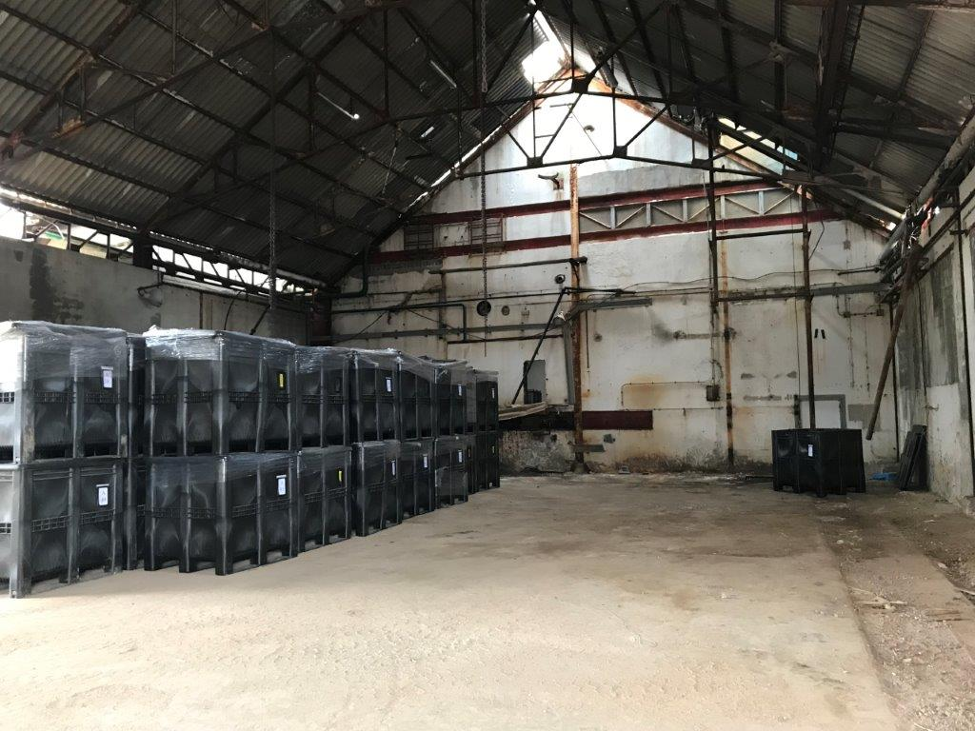
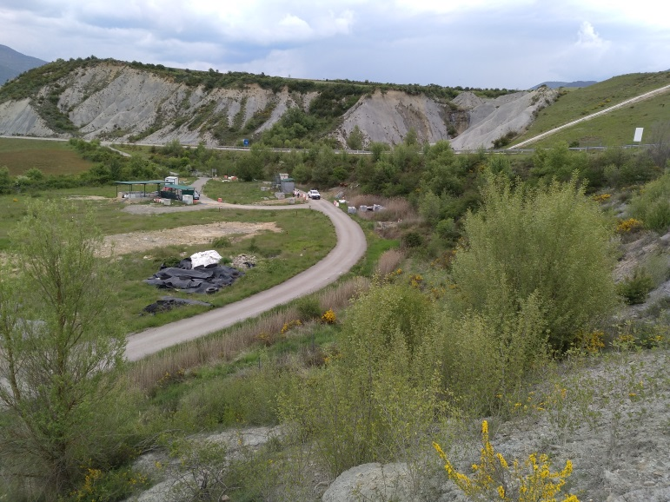
- SARDAS DUMPSITE
B) INQUINOSA FACTORY

Figure S1. Current status of A) Sardas dumpsite and B) INQUINOSA Factory.

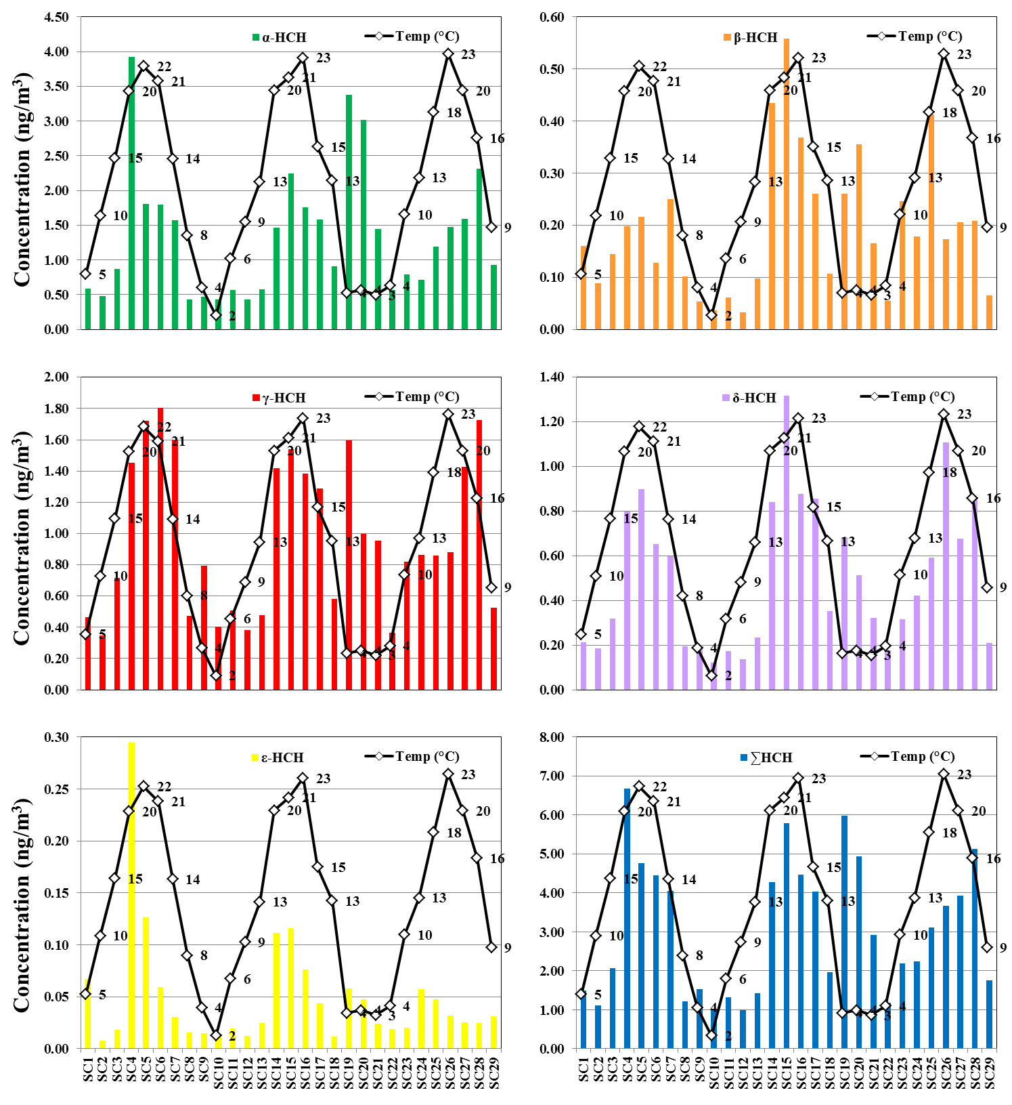
Figure S2. Mean HCH concentration (ng/m³) obtained during the different sampling campaigns. The solid line represents the mean temperature in the area at each sampling campaign.

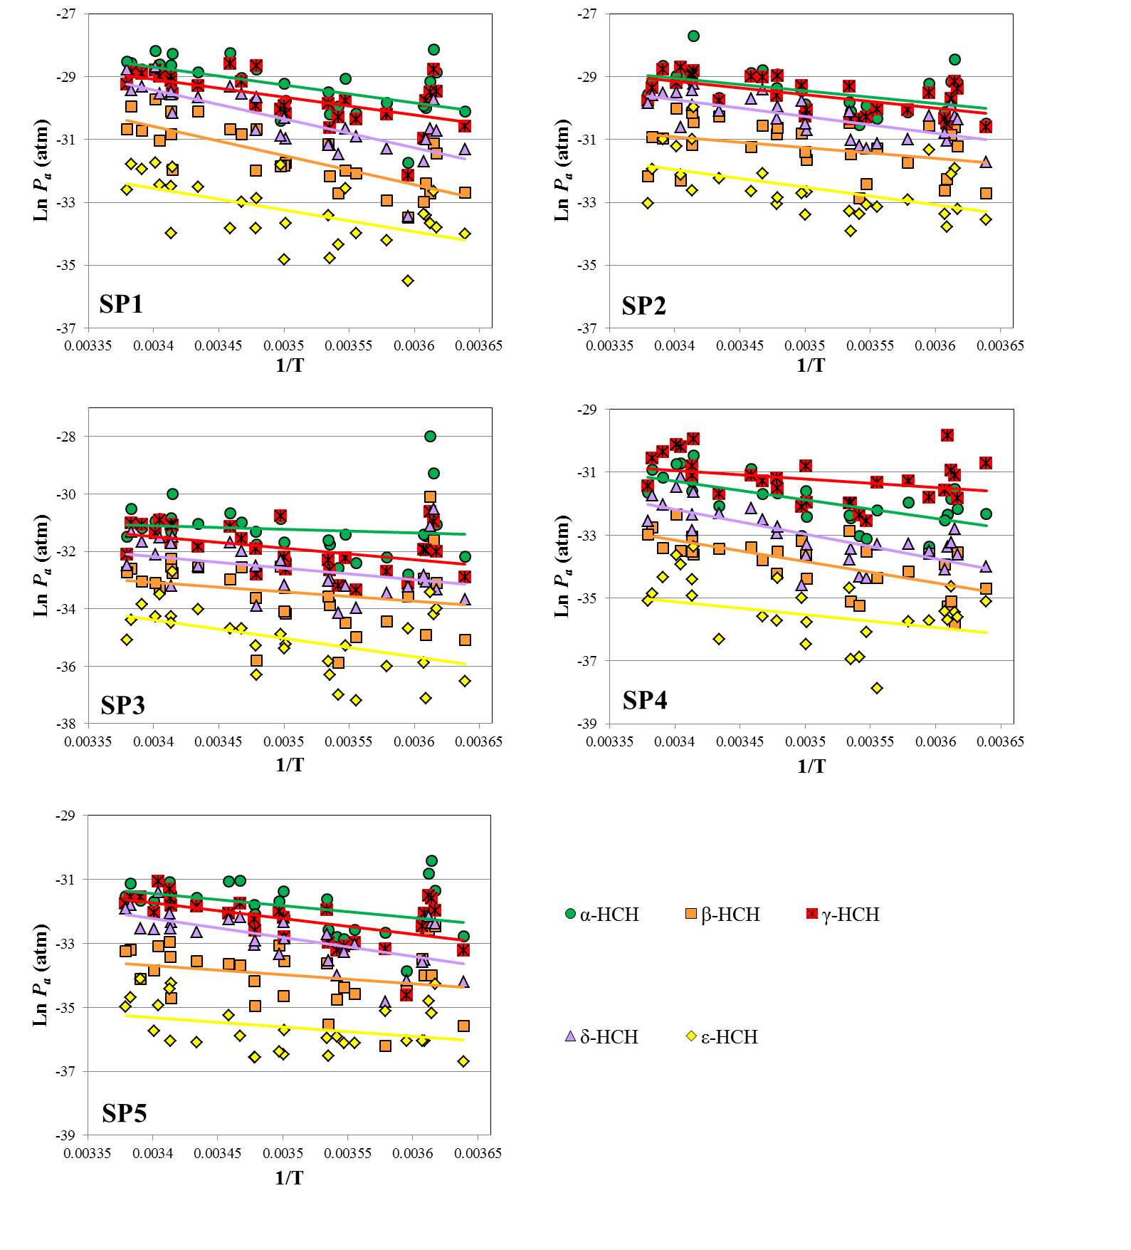
Figure S3. Relationship between logarithm of the partial pressure (Ln P_{a}) for HCH isomers in air and the temperature (1/T).

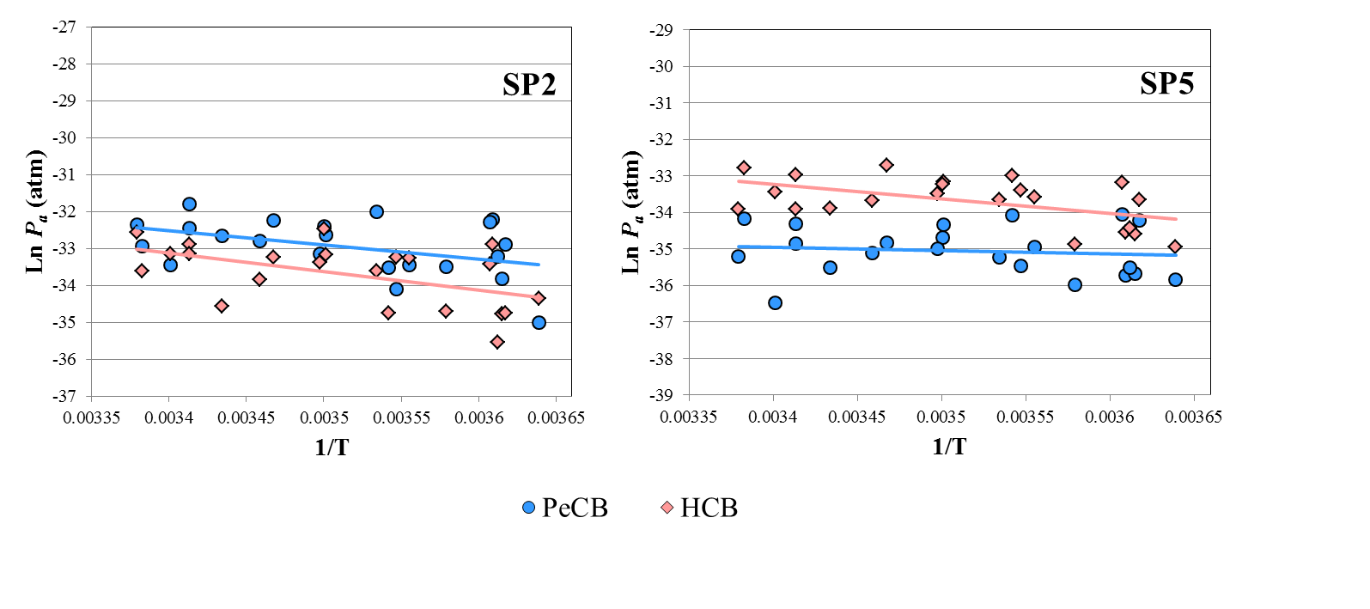
Figure S4. Relationship between logarithm of the partial pressure (Ln P_{a}) for PeCB and HCB in air and the temperature (1/T).

Table S1. Details of sampling deployment and meteorological data monitored during the sampling campaigns
Sampling  Campaigns | Date  (start) | Date  (finish) | Sampling  days | Temperature  (°C) | Relative  Humidity (%) | Solar irradiance  (W m ⁻²)
SC1 | 24/02/2016 | 30/03/2016 | 35 | 5.2 | 76.0 | 138.3
SC2 | 30/03/2016 | 05/05/2016 | 36 | 9.9 | 66.2 | 186.7
SC3 | 05/05/2016 | 08/06/2016 | 34 | 14.5 | 63.9 | 211.5
SC4 | 08/06/2016 | 13/07/2016 | 35 | 19.9 | 56.1 | 236.2
SC5 | 13/07/2016 | 16/08/2016 | 34 | 21.9 | 44.9 | 235.0
SC6 | 16/08/2016 | 22/09/2016 | 37 | 20.7 | 50.5 | 182.9
SC7 | 22/09/2016 | 19/10/2016 | 27 | 14.4 | 63.4 | 144.0
SC8 | 19/10/2016 | 28/11/2016 | 40 | 8.3 | 79.8 | 92.4
SC9 | 28/11/2016 | 28/12/2016 | 30 | 4.1 | 78.0 | 83.0
SC10 | 28/12/2016 | 01/02/2017 | 35 | 1.8 | 68.6 | 94.1
SC11 | 01/02/2017 | 09/03/2017 | 36 | 6.4 | 71.5 | 123.4
SC12 | 09/03/2017 | 11/04/2017 | 33 | 9.3 | 61.8 | 202.0
SC13 | 11/04/2017 | 17/05/2017 | 36 | 12.6 | 57.5 | 247.0
SC14 | 17/05/2017 | 21/06/2017 | 35 | 20.0 | 55.2 | 280.4
SC15 | 21/06/2017 | 26/07/2017 | 35 | 21.0 | 56.6 | 265.6
SC16 | 26/07/2017 | 29/08/2017 | 34 | 22.6 | 48.1 | 243.6
SC17 | 29/08/2017 | 03/10/2017 | 35 | 15.4 | 62.0 | 187.8
SC18 | 03/10/2017 | 07/11/2017 | 35 | 12.7 | 63.4 | 142.0
SC19 | 07/11/2017 | 13/12/2017 | 36 | 3.6 | 67.4 | 90.9
SC20 | 13/12/2017 | 17/01/2018 | 35 | 3.8 | 82.7 | 65.1
SC21 | 17/01/2018 | 20/02/2018 | 34 | 3.5 | 75.3 | 96.4
SC22 | 20/02/2018 | 26/03/2018 | 34 | 4.2 | 69.7 | 127.5
SC23 | 26/03/2018 | 26/04/2018 | 31 | 10.0 | 68.6 | 172.6
SC24 | 26/04/2018 | 30/05/2018 | 34 | 12.9 | 69.0 | 220.9
SC25 | 30/05/2018 | 04/07/2018 | 35 | 18.2 | 67.1 | 250.1
SC26 | 04/07/2018 | 08/08/2018 | 35 | 22.9 | 51.7 | 275.6
SC27 | 08/08/2018 | 12/09/2018 | 35 | 20.0 | 59.6 | 222.9
SC28 | 12/09/2018 | 17/10/2018 | 35 | 16.1 | 66.4 | 163.1
SC29 | 17/10/2018 | 21/11/2018 | 35 | 8.9 | 77.9 | 87.9

Table S2. Descriptive statistics (mean ± SD; (median); min-max) of α-, β-, γ-, δ-, ε-HCH, PeCB and HCB air concentration in each sampling point.
 | α-HCHª  ng/m³ | β-HCHª  ng/m³ | γ-HCHª  ng/m³ | δ-HCHª  ng/m³ | ε-HCHª  ng/m³ | ΣHCH^{b}  ng/m³ | α-/γ-HCHª | PeCB^{c}  pg/m³ | HCB^{c}  pg/m³ | ΣCB^{d}  pg/m³
SP1 | 3.1 ± 2.06 | 0.39 ± 0.38 | 2.04 ± 1.27 | 1.19 ± 1.05 | 0.07 ± 0.06 | 6.79 ± 4.4 | 1.56 ± 0.57
 | (2.96) | (0.2) | (1.81) | (0.63) | (0.04) | (5.48) | (1.45)
 | 0.21 - 7.77 | 0.04 - 1.5 | 0.14 - 4.66 | 0.04 - 4.22 | 0.005 - 0.2 | 0.43 - 16.64 | 0.69 - 3.53
SP2 | 2.51 ± 2.06 | 0.43 ± 0.28 | 2.03 ± 1.07 | 1.06 ± 0.61 | 0.15 ± 0.22 | 6.18 ± 3.75 | 1.2 ± 0.46 | 76 ± 47 | 38 ± 25 | 114 ± 64
 | (2.19) | (0.35) | (1.92) | (0.94) | (0.08) | (6.12) | (1.13) | (68) | (39) | (91)
 | 0.65 - 11.15 | 0.07 - 1.11 | 0.65 - 4.15 | 0.21 - 2.45 | 0.02 - 1.17 | 1.72 - 19.18 | 0.62 - 3.02 | 8.1 - 187 | 4.7 - 98 | 24 - 250
SP3 | 0.7 ± 1.63 | 0.09 ± 0.2 | 0.23 ± 0.17 | 0.13 ± 0.15 | 0.01 ± 0.02 | 1.17 ± 2.03 | 2.35 ± 2.34
 | (0.3) | (0.05) | (0.17) | (0.07) | (0.01) | (0.61) | (1.77)
 | 0.07 - 8.83 | 0.003 - 1.09 | 0.04 - 0.65 | 0.02 - 0.72 | 0.001 - 0.08 | 0.16 - 10.99 | 0.88 - 13.67
SP4 | 0.23 ± 0.17 | 0.03 ± 0.02 | 0.44 ± 0.34 | 0.08 ± 0.08 | 0.01 ± 0.01 | 0.79 ± 0.54 | 0.57 ± 0.22
 | (0.19) | (0.03) | (0.33) | (0.05) | (0.01) | (0.65) | (0.59)
 | 0.04 - 0.7 | 0.004 - 0.11 | 0.09 - 1.43 | 0.01 - 0.35 | 0.001 - 0.04 | 0.19 - 2.19 | 0.08 - 1.23
SP5 | 0.24 ± 0.17 | 0.03 ± 0.02 | 0.15 ± 0.09 | 0.09 ± 0.06 | 0.01 ± 0.01 | 0.52 ± 0.3 | 1.6 ± 0.54 | 9.1 ± 5.8 | 35 ± 19 | 44 ± 24
 | (0.22) | (0.02) | (0.15) | (0.08) | (0.003) | (0.51) | (1.49) | (7.4) | (32) | (39)
 | 0.02 - 0.79 | 0.002 - 0.1 | 0.01 - 0.39 | 0.01 - 0.28 | 0.001 - 0.02 | 0.07 - 1.18 | 0.61 - 3.23 | 1.7 - 21 | 8.6 - 76 | 12 - 87
TOTAL | 1.35 ± 1.91 | 0.19 ± 0.29 | 0.98 ± 1.15 | 0.51 ± 0.74 | 0.05 ± 0.12 | 3.09 ± 3.90 | 1.46 ± 1.25 | 43 ± 48 | 36 ± 22 | 79 ± 60
 | (0.44) | (0.06) | (0.4) | (0.16) | (0.01) | (1.12) | (1.3) | (20) | (34) | (65)
 | 0.02 - 11.15 | 0.002 - 1.5 | 0.01 - 4.66 | 0.01 - 4.22 | 0.001 - 1.17 | 0.07 - 19.18 | 0.08 - 13.67 | 1.7 - 187 | 4.7 - 98 | 12 - 250
ª Sampling campaigns (n=29) conducted from February 2016 to November 2018;^{b} Sum of α-, β-, γ-, δ- and ε-HCH; ^{c} Sampling campaigns (n=21) conducted from October 2016 to November 2018; ^{d} Sum of PeCB and HCB.

Table S3. Spearman Rho correlation matrix for HCH concentrations and meteorological data obtained at each sampling point.
SP1 | α-HCH | β-HCH | γ-HCH | δ-HCH | ε-HCH | ∑HCH | SCª | H^{b} | SR^{c} | T^{d} | α-/γ-HCH
α-HCH | 1.000
β-HCH | 0.746** | 1.000
γ-HCH | 0.889** | 0.836** | 1.000
δ-HCH | 0.844** | 0.864** | 0.888** | 1.000
ε-HCH | 0.543** | 0.593** | 0.571** | 0.575** | 1.000
∑HCH | 0.959** | 0.838** | 0.963** | 0.924** | 0.579** | 1.000
SCª | 0.308 | 0.320 | 0.275 | 0.292 | 0.178 | 0.306 | 1.000
H^{b} | -0.566** | -0.628** | -0.491** | -0.616** | -0.413* | -0.568** | 0.148 | 1.000
SR^{c} | 0.346 | 0.604** | 0.276 | 0.489** | 0.421* | 0.378* | 0.009 | -0.812** | 1.000
T^{d} | 0.561** | 0.740** | .0559** | 0.768** | 0.530** | 0.633** | 0.045 | -0.843** | 0.840** | 1.000
α-/γ-HCH | 0.264 | -0.090 | -0.143 | -0.042 | -0.045 | 0.050 | 0.260 | -0.014 | -0.005 | -0.113 | 1.000
SP2 | α-HCH | β-HCH | γ-HCH | δ-HCH | ε-HCH | ∑HCH | SCª | H^{b} | SR^{c} | T^{d} | α-/γ-HCH
α-HCH | 1.000
β-HCH | 0.634** | 1.000
γ-HCH | 0.899** | 0.612** | 1.000
δ-HCH | 0.818** | 0.748** | 0.775** | 1.000
ε-HCH | 0.802** | 0.668** | 0.767** | 0.767** | 1.000
∑HCH | 0.967** | 0.711** | 0.943** | 0.867** | 0.856** | 1.000
SCª | 0.015 | -0.011 | -0.019 | 0.155 | -0.075 | -0.014 | 1.000
H^{b} | -0.458* | -0.148 | -0.507** | -0.508** | -0.439* | -0.501** | 0.148 | 1.000
SR^{c} | 0.291 | 0.371* | 0.383* | 0.568** | 0.435* | 0.385* | 0.009 | -0.812** | 1.000
T^{d} | 0.475** | 0.313 | 0.577** | 0.645** | 0.505** | 0.541** | 0.045 | -0.843** | 0.840** | 1.000
α-/γ-HCH | 0.320 | 0.174 | -0.083 | 0.176 | 0.208 | 0.175 | -0.038 | 0.083 | -0.166 | -0.136 | 1.000
SP3 | α-HCH | β-HCH | γ-HCH | δ-HCH | ε-HCH | ∑HCH | SCª | H^{b} | SR^{c} | T^{d} | α-/γ-HCH
α-HCH | 1.000
β-HCH | 0.785** | 1.000
γ-HCH | 0.946** | 0.813** | 1.000
δ-HCH | 0.874** | 0.731** | 0.897** | 1.000
ε-HCH | 0.757** | 0.737** | 0.759** | 0.717** | 1.000
∑HCH | 0.983** | 0.818** | 0.975** | 0.912** | 0.800** | 1.000
SCª | 0.313 | 0.450* | 0.273 | 0.095 | 0.143 | 0.267 | 1.000
H^{b} | -0.224 | -0.189 | -0.309 | -0.362 | -0.356 | -0.297 | 0.148 | 1.000
SR^{c} | 0.172 | 0.305 | 0.247 | 0.264 | 0.327 | 0.218 | 0.009 | -0.812** | 1.000
T^{d} | 0.319 | 0.309 | 0.394* | 0.430* | 0.392* | 0.389* | 0.045 | -0.843** | 0.840** | 1.000
α-/γ-HCH | -0.001 | -0.101 | -0.234 | -0.125 | -0.133 | -0.082 | 0.038 | 0.414* | -0.455* | -0.468* | 1.000
SP4 | α-HCH | β-HCH | γ-HCH | δ-HCH | ε-HCH | ∑HCH | SCª | H^{b} | SR^{c} | T^{d} | α-/γ-HCH
α-HCH | 1.000
β-HCH | 0.317 | 1.000
γ-HCH | 0.775** | 0.015 | 1.000
δ-HCH | 0.859** | 0.363 | 0.635** | 1.000
ε-HCH | 0.475** | 0.413** | 0.485** | 0.443* | 1.000
∑HCH | 0.876** | 0.184 | 0.968** | 0.744** | 0.516** | 1.000
SCª | -0.058 | 0.381* | -0.254 | -0.167 | -0.105 | -0.148 | 1.000
H^{b} | -0.631** | -0.410** | -0.337 | -0.641** | -0.428* | -0.461* | 0.148 | 1.000
SR^{c} | 0.356 | 0.556** | 0.048 | 0.500** | 0.282 | 0.186 | 0.009 | -0.812** | 1.000
T^{d} | 0.623** | 0.674** | 0.295 | 0.711** | 0.372* | 0.451* | 0.045 | -0.843** | 0.840** | 1.000
α-/γ-HCH | 0.374* | 0.391* | -0.173 | 0.433* | -0.033 | 0.035 | 0.320 | -0.404** | 0.388** | 0.430* | 1.000
SP5 | α-HCH | β-HCH | γ-HCH | δ-HCH | ε-HCH | ∑HCH | SCª | H^{b} | SR^{c} | T^{d} | α-/γ-HCH
α-HCH | 1.000
β-HCH | 0.613** | 1.000
γ-HCH | 0.861** | 0.688** | 1.000
δ-HCH | 0.902** | 0.611** | 0.848** | 1.000
ε-HCH | 0.523** | 0.453* | 0.600** | 0.598** | 1.000
∑HCH | 0.970** | 0.682** | 0.932** | 0.941** | 0.613** | 1.000
SCª | 0.352 | 0.522** | 0.241 | 0.288 | 0.037 | 0.322 | 1.000
H^{b} | -0.335 | -0.130 | -0.434* | -0.520** | -0.360 | -0.415* | 0.148 | 1.000
SR^{c} | 0.187 | 0.263 | 0.305 | 0.330 | 0.215 | 0.249 | 0.009 | -0.812** | 1.000
T^{d} | 0.347 | 0.258 | 0.475** | 0.557** | 0.273 | 0.419* | 0.045 | -0.843** | 0.840** | 1.000
α-/γ-HCH | 0.194 | -0.233 | -0.249 | 0.043 | -0.050 | 0.038 | -0.057 | 0.217 | -0.278 | -0.361 | 1.000
ªSC: sampling campaign; ^{b}H: relative humidity; ^{c}SR: solar radiation; ^{d}T: temperature. * (p < 0.05); ** (p < 0.01).

Table S4. Comparison of concentrations (pg/m³) of HCH in air at different locations.

Country | Year | Location Type | Mean (min-max) | Isomer | Sampling System | Reference
Spain | 2016-2018 | Sardas | 3089 ± 3899  (73-19178) | Σα-,β-,γ-,δ, ε-HCH | PAS | The present study
Spain | 2014-2016 | Bailín | 195000 ± 658000  (243-6561083) | Σα-,β-,γ-,δ, ε-HCH | PAS | De la Torre et al. 2018
China | 2014 | HCH Factory  (1952-1983) | 52300 (at site)  (14300-133000)  5090 (around site)  (1300 -13800) | Σα-,β-,γ-,δ-HCH | PAS | Fang et al. 2017
Kuwait | 2013-2014 | Urban  Indutrial  Remote | 67 (5-383)  13 (0.2-125)  8 (N.D.-25) | Σα-,β-,γ-,δ-HCH | AAS | Gevao et al. 2018
South Asia | 2013-2014 | Urban | 33-207 | Σα-,γ-HCH | PAS | Pozo et al. 2017a
Japan | 2009-2014 | Remote | 15 (59-43) | Σα-,β-,γ-,δ-HCH | AAS | Takazawa et al. 2016
Spain | 2008-2013 | Urban | 37 ( 5-154) | Σα-,β-,γ-HCH | PAS | De la Torre et al. 2016
Spain | 2008-2013 | Rural | 22 (0.1-100) | Σα-,β-,γ-HCH | PAS | De la Torre et al. 2016
Pakistan | 2012 | Industrial  Residential  Background  Pesticide burial ground | 1500  6600  9300  97400 | Σα-,β-,γ-HCH | PAS | Alamdar et al. 2014
Greenland (Denmark) | 2008-2010 | Remote | 9 (0.1-23)  1.2 (0.06-12) | α-HCH  γ-HCH | AAS | Bossi et al. 2016
Italy | 2008-2009 | Urban  Rural | 9 ± 3  6.5 ± 3 | Σα-, γ-HCH | PAS | Estellano et al. 2017
India | 2006-2007 | Urban | 5400 (890-17000) | Σα-,β-,γ-,δ-HCH | AAS | Chakraborty et al. 2010
Europe | 2006 | Background | 64 ± 59 | Σα-,β-,γ-HCH | PAS | Halse et al. 2011
China | 2005 | Global | 620 (44-3500) | Σα-,β-,γ-HCH | PAS | Liu et al. 2016
India | 2005 | Agricultural | 530 (194-999) | α-HCH | PAS | Pozo et al. 2009
India | 2005 | Agricultural | 2175 (922-3994) | γ-HCH | PAS | Pozo et al. 2009
Turkey | 2005 | Rural | 27 (18-38) | α-HCH | PAS | Pozo et al. 2009
Turkey | 2005 | Rural | 25 (9-58) | γ-HCH | PAS | Pozo et al. 2009
South Africa | 2005 | Remote | 80 (9-117) | α-HCH | PAS | Pozo et al. 2009
South Africa | 2005 | Remote | 48 (10-68) | γ-HCH | PAS | Pozo et al. 2009
Mexico | 2005 | Agricultural | 24 | α-HCH | PAS | Pozo et al.2009
Mexico | 2005 | Agricultural | 25 | γ-HCH | PAS | Pozo et al.2009
EEUU | 2005 | Agricultural | 40 (16-102) | α-HCH | PAS | Pozo et al. 2009
EEUU | 2005 | Agricultural | 21 (17-23) | γ-HCH | PAS | Pozo et al. 2009
Canada | 1992-2012 | Remote | 3.1-52  0.6-17  3.7-69 | α-HCH  γ-HCH  Σα-,γ-HCH | AAS | Shunthirasingham et al., 2016
Canada | 1995-2006 | Rural/Urban | 6.5-36  3.2-49  9.7-75 | α-HCH  γ-HCH  Σα-,γ-HCH | AAS | Shunthirasingham et al., 2016
North America | 1996-2010 | Urban | 6.6-98  0.9-9.7  4.0-53  12-148 | α-HCH  β-HCH  γ-HCH  Σα-,β-,γ-HCH | AAS | Venier and Hites, 2014
North America | 1992-2010 | Rural | 3.7-218  0.4-14  1.0-169  5-370 | α-HCH  β-HCH  γ-HCH  Σα-,β-,γ-HCH | AAS | Venier and Hites, 2014
North America | 1991-2010 | Remote | 10-303  0.4-2.3  1.8-42  13-345 | α-HCH  β-HCH  γ-HCH  Σα-,β-,γ-HCH | AAS | Venier and Hites, 2014
EEUU | 1978 | Landfill  (Chemical Factory)  (1942-1953) | 2000-100000  3000000  400000  3500000 | α-HCH  β-HCH  δ-HCH  Σα-,β-, δ -HCH | --- | NYSDOH, 1981
Mean ± S.D. (min- max).PAS: Passive Air Samplers. AAS: Active Air Sampler.

Table S5. Comparison of concentrations (pg/m³) of PeCB in air at different locations.
Country | Year | Location Type | Mean (min-max) | Sampling System | Reference
Spain | 2016-2018 | Sardas | 43 ± 48  (1.7-187) | PAS | The present study
South America | 2014-2015 | Background/Agricultural/Urban | <4-146 | PAS | Rauert et al. 2018
Kuwait | 2013-2014 | Industrial  Urban  Remote | 7.4 (N.D.-26.3) | AAS | Gevao et al. 2018
Kuwait | 2013-2014 | Industrial  Urban  Remote | 24.6 (2.2-108)  8.7 (N.D.-51.1) | AAS | Gevao et al. 2018
Antarctica | 2010-2011 | Background | N.D.-6.1 | PAS | Pozo et al. 2017b
Czech Republic | 2003-2005 | Background | 0.5-441 | AAS | Dvorska et al. 2008
Sweden | 2003 | - | 33 | - | Bailey et al. 2009
Mean ± S.D. (min- max).PAS: Passive Air Samplers. AAS: Active Air Sampler.

Table S6. Comparison of concentrations (pg/m³) of HCB in air at different locations.
Country | Year | Location Type | Mean (min-max) | Sampling System | Reference
Spain | 2016-2018 | Sardas | 36 ± 22  (4.7-98) | PAS | The present study
South America | 2014-2015 | Background/Agricultural/Urban | 8.8-108 | PAS | Raouert et al. 2018
Brazil | 2010-2015 | Urban | N.D.-126 | PAS | Tominaga et al. 2016
Kuwait | 2013-2014 | Industrial  Urban  Remote | 37.1 (N.D. -173.4)  108.4 (8.7-539)  39.8 (N.D.-259.4) | AAS | Gevao et al. 2018
Africa | 2012-2013 | Remote | 11.35 (6.95-19.30) | AAS | Nøst et al. 2018
Tibet | 2013 | Remote/Rural | 3.6-54.3 | PAS | Wang et al. 2017
Spain | 2008-2013 | Urban  Remote | 51 (12-152) | PAS | De la Torre et al. 2016
Spain | 2008-2013 | Urban  Remote | 61 (0.03-244) | PAS | De la Torre et al. 2016
Greenland | 2008-2013 | Background | 80.3 (1.01-160.1) | AAS | Bossi et al. 2016
Antarctica | 2010-2011 | Background | 0.8-47 | PAS | Pozo et al. 2017b
Mean ± S.D. (min- max).PAS: Passive Air Samplers. AAS: Active Air Sampler.

Table S7. Spearman Rho correlation matrix corresponding to HCHs, PeCB, HCB and meteorological data.
SP2 | PeCB | HCB | ∑CB | α-HCH | β-HCH | γ-HCH | δ-HCH | ε-HCH | ∑HCH | SCª | H^{b} | SR^{c} | T^{d}
PeCB | 1.000
HCB | 0.527* | 1.000
∑CB | 0.936** | 0.754** | 1.000
α-HCH | 0.109 | -0.112 | 0.095 | 1.000
β-HCH | 0.239 | -0.057 | 0.198 | 0.634** | 1.000
γ-HCH | 0.250 | -0.020 | 0.211 | 0.899** | 0.612** | 1.000
δ-HCH | 0.404 | 0.111 | 0.064 | 0.818** | 0.748** | 0.775** | 1.000
ε-HCH | -0.027 | -0.110 | -0.024 | 0.802** | 0.668** | 0.767** | 0.767** | 1.000
∑HCH | 0.171 | -0.060 | 0.155 | 0.967** | 0.711** | 0.943** | 0.867** | 0.856** | 1.000
SCª | 0.141 | -0.012 | 0.169 | 0.015 | -0.011 | -0.019 | 0.155 | -0.075 | -0.014 | 1.000
H^{b} | -0.255 | -0.351 | -0.369 | -0.458* | -0.148 | -0.507** | -0.508** | -0.439* | -0.501** | -0.072 | 1.000
SR^{c} | 0.357 | 0.366 | 0.434* | 0.291 | 0.371* | 0.383* | 0.568** | 0.435* | 0.385* | 0.151 | -0.863** | 1.000
T^{d} | 0.363 | 0.493* | 0.527* | 0.475** | 0.313 | 0.577** | 0.645** | 0.505** | 0.541** | 0.310 | -0.796** | 0.859** | 1.000
SP5 | PeCB | HCB | ∑CB | α-HCH | β-HCH | γ-HCH | δ-HCH | ε-HCH | ∑HCH | SCª | H^{b} | SR^{c} | T^{d}
PeCB | 1.000
HCB | 0.744** | 1.000
∑CB | 0.840** | 0.980** | 1.000
α-HCH | 0.138 | 0.043 | 0.085 | 1.000
β-HCH | 0.383 | 0.186 | 0.266 | 0.613** | 1.000
γ-HCH | 0.460 | -0.003 | 0.028 | 0.861** | 0.688** | 1.000
δ-HCH | 0.181 | 0.203 | 0.237 | 0.902** | 0.611** | 0.848** | 1.000
ε-HCH | 0.159 | 0.063 | 0.123 | 0.523** | 0.453* | 0.600** | 0.598** | 1.000
∑HCH | 0.163 | 0.094 | 0.138 | 0.970** | 0.682** | 0.932** | 0.941** | 0.613** | 1.000
SCª | 0.064 | -0.027 | -0.014 | 0.352 | 0.522** | 0.241 | 0.288 | 0.037 | 0.322 | 1.000
H^{b} | -0.270 | -0.425* | -0.406 | -0.335 | -0.130 | -0.434* | -0.520** | -0.360 | -0.415* | -0.072 | 1.000
SR^{c} | 0.254 | 0.421 | 0.382 | 0.187 | 0.263 | 0.305 | 0.330 | 0.215 | 0.249 | 0.151 | -0.863** | 1.000
T^{d} | 0.142 | 0.417 | 0.355 | 0.347 | 0.258 | 0.475** | 0.557** | 0.273 | 0.419* | 0.310 | -0.796** | 0.859** | 1.000
ªSC: sampling campaign; ^{b}H: relative humidity; ^{c}SR: solar radiation; ^{d}T: temperature. * (p < 0.05); ** (p < 0.01).

Table S8. Clausius-Clapeiron regression, Ln P_{a} = m (1/T) + b$\text{, }$obtained for HCH isomer, PeCB and HCB in the different sampling point.
 | α-HCH | β-HCH | γ-HCH | δ-HCH | ε-HCH | PeCB | HCB
SP1 | Ln P_{a} = -5656 (1/T) -9.5 | Ln P_{a} = -9203 (1/T) +0.7 | Ln P_{a} = -5687 (1/T) -9.8 | Ln P_{a} = -9194 (1/T) +1.8 | Ln P_{a} = -6879 (1/T) -9.2 | - | -
 | R²= 0.321 | R²= 0.580 | R²= 0.350 | R²= 0.556 | R²= 0.327 | - | -
 | (p=0.001) | (p=0.000) | (p=0.001) | (p=0.000) | (p=0.001) | - | -
SP2 | Ln P_{a} = -4093 (1/T) -15.1 | Ln P_{a} = -3446 (1/T) -19.2 | Ln P_{a} = -4291 (1/T) -14.6 | Ln P_{a} = -5296 (1/T) -11.7 | Ln P_{a} = -5672 (1/T) -12.7 | Ln Pa = -3857 (1/T) -19.4 | Ln Pa = -5077 (1/T) -15.9
 | R²= 0.247 | R²= 0.123 | R²= 0.369 | R²= 0.441 | R²= 0.254 | R2= 0.185 | R2= 0.265
 | (p=0.005) | (p=0.076) | (p=0.001) | (p=0.000) | (p=0.004) | (p=0.083) | (p=0.008)
SP3 | Ln Pa = -1238 (1/T) -26.9 | Ln Pa = -3241 (1/T) -22.1 | Ln Pa = -4034 (1/T) -17.8 | Ln Pa = -4096 (1/T) -18.2 | Ln Pa = -6390 (1/T) +12.7 | - | -
 | R²= 0.011 | R²= 0.047 | R²= 0.179 | R²= 0.134 | R²= 0.212 | - | -
 | (p=0.072) | (p=0.068) | (p=0.026) | (p=0.016) | (p=0.028) | - | -
SP4 | Ln Pa = -5926 (1/T) -11.1 | Ln Pa = -6764 (1/T) -10.2 | Ln Pa = -2770 (1/T) -21.5 | Ln Pa = -7880 (1/T) -5.4 | Ln Pa = -4078 (1/T) -21.3 | - | -
 | R²= 0.427 | R²= 0.447 | R²= 0.104 | R²= 0.528 | R²= 0.056 | - | -
 | (p=0.000) | (p=0.000) | (p=0.101) | (p=0.000) | (p=0.032) | - | -
SP5 | Ln Pa = -3825 (1/T) -18.4 | Ln Pa = -2805 (1/T) -24.2 | Ln Pa = -4881 (1/T) -15.1 | Ln Pa = -5912 (1/T) -12.1 | Ln Pa = -2909 (1/T) -25.4 | Ln Pa = -991 (1/T) -31.6 | Ln Pa = -3999 (1/T) -19.6
 | R²= 0.173 | R²= 0.068 | R²= 0.283 | R²= 0.379 | R²= 0.096 | R²= 0.016 | R²= 0.273
 | (p=0.058) | (p=0.176) | (p=0.003) | (p=0.001) | (p=0.101) | (p=0.377) | (p =0.038)

References
Alamdar, A., Syed, J.H., Malik, R.N., Katsoyiannis, A., Liud, J., Li, J., Zhang, G., Jones, K.C., 2014. Organochlorine pesticides in surface soils from obsolete pesticide dumping ground in Hyderabad City, Pakistan: Contamination levels and their potential for air-soil exchange. Sci. Total Environ. 470-471, 733-741. http://dx.doi.org/10.1016/j.scitotenv.2013.09.053.
Bailey, R.E., van Wijk, D., Thomas, P.C., 2009. Sources and prevalence of pentachlorobenzene in the environment. Chemosphere 75, 555-564. http\\:doi:10.1016/j.chemosphere.2009.01.038.
Bossi, R., Vorkamp, K., Skov, H., 2016. Concentrations of organochlorine pesticides, polybrominated diphenyl ethers and perfluorinated compounds in the atmosphere of North Greenland. Environmental Pollution 217, 4-10. http://dx.doi.org/10.1016/j.envpol.2015.12.026.
Chakraborty, P., Zhang, G., Jun, L., Xu, Y., Liu, X., Tanabe, S., Jones, K., 2010. Selected organochlorine pesticides in the atmosphere of major Indian cities: levels, regional versus local variations, and sources. Environ. Sci. Technol. 44, 8038-8043. http\\:doi:10.1021/es102029t.
De la Torre, A., Sanz, P., Navarro, I., Martínez, M.A., 2016. Time trends of persistent organic pollutants in Spanish air. Environ. Pollut. 217, 26-32. http://dx.doi.org/10.1016/j.envpol.2016.01.040.
De la Torre, A., Navarro, I., Sanz, P., Arjol, M.A., Fernández, J., Martínez, M.A., 2018. HCH air levels derived from Bailín dumpsite dismantling (Sabiñánigo, Spain). Sci. Total Environ. 626, 1367-1372. https://doi.org/10.1016/j.scitotenv.2018.01.178.
Dvorska, A., Lammel, G., Klanova, J., Holoubek, I., 2008. Kosetice, Czech Republic - ten years of air pollution monitoring and four years of evaluating the origin of persistent organic pollutants. Environ. Pollut. 156, 403-408. http\\:doi:10.1016/j.envpol.2008.01.034.
Estellano, V.H., Pozo, K., Přibylová, P., Klánová, J., Audy, O., Focardi, S., 2017. Assessment of seasonal variations in persistent organic pollutants across the region of Tuscany using passive air samplers. Environ. Pollut. 222, 609-616. https://doi.org/10.1016/j.envpol.2016.08.092.
Fang, Y., Nie, Z., Die, Q., Tian, Y., Liu, F., He, J., Huang, Q., 2017. Organochlorine pesticides in soil, air, and vegetation at and around a contaminated site in southwestern China: concentration, transmission, and risk evaluation. Chemosphere 178, 340-349. http://dx.doi.org/10.1016/j.chemosphere.2017.02.151.
Gevao, B., Porcelli, M., Rajagopalan, S., Krishnan, D., Martinez-Guijarro,K., Alshemmari, H., Bahloul, M., Zafar, J., 2018. Spatial and temporal variations in the atmospheric concentrations of “Stockholm Convention” organochlorine pesticides in Kuwait. Sci. Total Environ. 622-623, 1621-1629. https://doi.org/10.1016/j.scitotenv.2017.10.036.
Halse, A.K., Schlabach, M., Eckhardt, S., Sweetman, A., Jones, K.C., Breivik, K., 2011. Spatial variability of POPs in European background air. Atmos. Chem. Phys. 11, 1549-1564. http\\:doi:10.5194/acp-11-1549-2011.
NYSDOH (New York State Department of Health), 1981. Love Canal: A special report to the Governor and Legislature: April 1981. https://www.health.ny.gov/environmental/investigations/love_canal/lcreport.htm. (accessed 8 March 2019).
Nøst, T.H., Halse, A.K., Schlabach, M., Bäcklund, A., Eckhardt, S., Breivik, K., 2018. Low concentrations of persistent organic pollutants (POPs) in air at Cape Verde. Sci. Total Environ. 612, 129-137. http://dx.doi.org/10.1016/j.scitotenv.2017.08.217.
Liu, L., Ma, W., Jia, H., Zhang, Z., Song, W., Li, Y., 2016. Research on persistent organic pollutants in China on a national scale: 10 years after the enforcement of the Stockholm Convention Environ. Pollut. 217, 70-81. http://dx.doi.org/10.1016/j.envpol.2015.12.056.
Pozo, K., Harner, T., Lee, S.C., Wania, F., Muir, D.C.G., Jones, K.C., 2009. Seasonally resolved concentrations of persistent organic pollutants in the global atmosphere from the first year of the gaps study. Environ. Sci. Technol. 43, 796-803. http\\:doi: 10.1021/es802106a.
Pozo, K., Sarkar, S.K., Estellano, V.H., Mitra, S., Audi, O., Kukucka P., Přibylová, P., Klánová, J., Corsolini, S., 2017a. Passive air sampling of persistent organic pollutants (POPs) and emerging compounds in Kolkata megacity and rural mangrove wetland Sundarban in India: An approach to regional monitoring. Chemosphere 168, 1430-1438. http://dx.doi.org/10.1016/j.chemosphere.2016.09.055.
Pozo, K., Martellini, T., Corsolini, S., Harner, T., Estellano, V., Kukucka, P., Mulder, M.D., Lammel, G., Cincinelli, A., 2017b. Persistent organic pollutants (POPs) in the atmosphere of coastal areas of the Ross Sea, Antarctica: Indications for long-term downward trends. Chemosphere 178, 458-465. http://dx.doi.org/10.1016/j.chemosphere.2017.02.118.
Rauert, C., Harner, T., Schuster, J.K., Eng, A., Fillmann, G., Castillo, L.E., Fentanes, O., Villa, M., Miglioranza, K.S.B., Moreno, I., Pozo, K., Aristizabal, B.H., 2018. Air monitoring of new and legacy POPs in the Group of Latin America and Caribbean (GRULAC) region. Environ. Pollut. 243, 1252-1262. https://doi.org/10.1016/j.envpol.2018.09.048.
Shunthirasingham, C., Gawor, A., Hung, H., Brice, K.A., Su, K., Alexandrou, N., Dryfhout-Clark, H., Backus, S., Sverko, E., Shin, C., Park, R., Noronha, R., 2016. Atmospheric concentrations and loadings of organochlorine pesticides and polychlorinated biphenyls in the Canadian Great Lakes Basin (GLB): Spatial and temporal analysis (1992-2012). Environ. Pollut. 217, 124-133. http://dx.doi.org/10.1016/j.envpol.2016.01.039.
Takazawa, Y., Takasuga, T., Doi, K., Saito, M., Shibata, Y., 2016. Recent decline of DDTs among several organochlorine pesticides in background air in East Asia. Environ. Pollut. 217, 134-142. http://dx.doi.org/10.1016/j.envpol.2016.02.019.
Tominaga, M.Y., Silva, C.R., Melo, J.P., Niwa, N.A., Plascak, D., Souza, C.A., Sato, M.I., 2016. PCDD, PCDF, dl-PCB and organochlorine pesticides monitoring in São Paulo City using passive air sampler as part of the Global Monitoring Plan. Sci. Total Environ. 571, 323-331. http\\:doi: 10.1016/j.scitotenv.2016.07.173.
Venier, M., Hites, R.A., 2014. DDT and HCH, two discontinued organochlorine insecticides in the Great Lakes region: Isomer trends and sources. Environ. Int. 69, 159-165. http://dx.doi.org/10.1016/j.envint.2014.03.028.
Wang, C., Wang, X., Rena, J., Gong, P., Yao, T., 2017. Using a passive air sampler to monitor air–soil exchange of organochlorine pesticides in the pasture of the central Tibetan Plateau. Sci. Total Environ. 580, 958-965. http://dx.doi.org/10.1016/j.scitotenv.2016.12.046.

