ARTICLE TYPE
Simultaneous Photocatalytic Abatement of NO and SO₂: Influence of the TiO₂ Nature and Mechanistic Insights
María D. Hernández-Alonsoª, Silvia Suárez ^{b}, Fernando Fresno^{c}, Juan M. Coronado ^{d*}, Benigno Sánchez^{b*}
^{a.}Repsol Technology Lab, Agustín de Betancourt, s/n. 28935 Móstoles, Madrid, Spain.^{b} FOTOAIR-Ciemat, Unit of Analysis and of Photocatalytic Treatment of Pollutants in Air. Renewable Energies Division CIEMAT. Avenida Complutense 40, Bldg. 42. 28040 Madrid, Spain.^{c} Photoactivated Processes Unit, IMDEA Energy, Avda. Ramón de la Sagra, 3, 28935 Móstoles, Madrid, Spain.^{.d} Instituto de Catálisis y Petroleoquímica, CSIC, Marie Curie, 2, Cantoblanco, 28049 Madrid, Spain.
Abstract: Background TiO₂ is currently being incorporated into several construction materials, such as cement and asphalt, because this photocatalyst can act as a passive system to reduce the concentration of typical urban pollutants like NO_{x} and SO₂ under solar illumination.
Objective: In order to get further insights on the possible influence of the interaction between common pollutants, the present work investigates the mechanism of NO_{x} photo-oxidation in the presence of SO₂ traces over TiO₂ samples of different textural and morphological characteristics.
Methods: The performance on the photo-oxidation of NOx and SO₂ in a dry air stream over different TiO₂ samples, both commercial and lab-prepared by hydrothermal and thermal methods, were evaluated by means of FTIR analyses of the gas phase. These materials were characterized by XRD, N₂ adsorption isotherms and DR UV-vis spectroscopy. Mechanistic studies were performed by in situ DRIFT under UV irradiation.
Results: Photocatalytic tests showed a very efficient removal of the two selected pollutants using most of the TiO₂ samples. In the case of SO₂, elimination of this molecules is due, not only to photocatalytic oxidation, but also in a significant extent to adsorption. Although in shorter periods no by-products are generated, following irradiation for several hours the production of NO₂ progressively increases and reaches 100 % selectivity over some photocatalyst. In situ DRIFTS analyses show the evolution of the surface composition and reveal the formation of the different types of surface nitrates with different symmetry. Under these operating conditions, a limited amount of sulfates are also formed.
Conclusions: The presence of low concentration of SO₂ does not appear to be detrimental for NO removal. NO₂ formation is delayed on the TiO₂ samples with high specific surface area, which also tend to be more active. The spectroscopic results confirm the involvement of surface hydroxyls on the formation of adsorbed nitrate species.

A R T I C L E H I S T O R Y
Received:
Revised:
Accepted:

DOI:
Keywords: Photocatalysis, Air Treatment, NOx, Nitrates, NO₂, SO₂, TiO₂, Hydrothermal Synthesis, DRIFT.

1. INTRODUCTION
Anthropogenic NO_{x} emissions, which include both NO and NO₂, are released to the atmosphere by internal combustion processes, with an important contribution from automobiles emissions []. Consequently, these molecules are among the main pollutants found in urban areas. These emissions are cause of serious concern because of their direct negative impact on human health, with significant influence in aggravating pulmonary conditions such as asthma [,]. In addition, NO_{x} are responsible for the generation of several secondary pollutants, including deleterious tropospheric ozone, which is produced by means of a complex network of
*Address correspondence to these authors JMC at Instituto de Catálisis y Petroleoquímica, CSIC, Marie Curie, 2, Cantoblanco, 28049 Madrid, Spain; Tel: +34915854801; E-mails: jm.coronado@csic.es; BS at FOTOAIR-Ciemat, Avda. Complutense 40, Bldg. 42. 28040 Madrid, Spain E-mails: benigno.sanchez@ciemat.es
photoactivated reactions with volatile organic compounds (VOCs) []. To protect public health, the EU Air Quality Directive (EU, 2008c, Directive 2008/50/EC) introduced an annual limit value for NO₂ exposure of 40 μgm⁻³ (around 20 ppb), which is often exceeded by the accumulated vehicles emissions at heavy traffic hotspots in urban areas. Despite the progressive recovery of air quality due to the technological improvement in emissions control of the automobiles, which has been documented in long term studies of certain cities [], urban pollution in many regions is still a serious health concern. [] For example, in 2016, about 70 % of members states of the European Union reported annual NOx concentration above the legal limit [1]. The situation is even worse in some regions of high density of population, where the proximity of thermal plants for electricity generation intensifies the problem due to the additional release of pollutants such as SO₂ [2]. Examples of this scenario can be found in the metropolitan areas of China and other densely populated regions, where the implementation of more stringent control of thermal plants is expected to lead to a progressive increase of air quality [].
In order to complement the efforts to limit the emissions of these harmful gases at the source, it is also necessary to develop efficient systems to remove the existing concentrations of air pollutants. In this context, heterogeneous photocatalysis with natural solar irradiation has been considered a plausible and low-cost technology that can be easily implemented for NO_{x} abatement in urban areas [,]. Similarly, other pollutants such as SO₂ can be also efficiently removed by photocatalytic oxidation [,]. Accordingly, TiO₂ is being incorporated into the formulation of an increasing number of construction materials (e.g. cements, concrete, asphalt, and paints), which are already in the market [8, ,,,]. The presence of photocatalyst provides these building elements with self-cleaning properties and, at the same time, allows them to act as passive, maintenance-free systems for the abatement of urban pollutants. [,]
The NO_{x} photo-oxidation process can be described in a very simplified way as a two-stage reaction occurring on the surface of the photocatalyst:
NO + 2 OH• → NO₂ + H₂O (1)
NO₂ + OH• → HNO₃ (2)
Therefore, NO₂ is the first oxidation product and the key precursor for further oxidation to surface nitrate ions. In outdoor applications, nitrate species accumulated on the photoactive materials are expected to be washed away from the surface by rain, as a dilute nitric acid solution [5,15, ]. However, the possibility of releasing back to the atmosphere NO₂ or traces of other harmful by-products such as HNO₂, has been also reported to occur under certain circumstances with photocatalytic materials []. Accordingly, overcoming these drawbacks will require a deeper understanding of the mechanism of the NO_{x} removal, as to drive the design of more efficient photocatalytic coatings for applications in buildings and other infrastructures. In a similar way to the case of NO, SO₂ can be first photocatalytically oxidized to SO₃, which eventually reacts with the semiconductor surface to produce adsorbed sulphites and, in larger extent, sulphates. [10, 11]
Within this context, the main objective of the present study is to assess how the physicochemical characteristics of TiO₂-based photocatalysts affect the efficiency of the NOx photo-oxidation in the presence of traces of SO₂. Despite the simultaneous occurrence of these two atmospheric pollutants, their concurrent photocatalytic degradation has not been extensively investigated [,,]. Some studies have reported positive effects due to the promotion of either thermal [] or photocatalytic oxidation [20] of SO₂ to sulphate by NO over TiO₂, and the enhancement of NO adsorption [10]. However, detrimental effects of co-feeding these pollutants on the photocatalytic efficiency have been also reported. In this way, the overall reduction of photoactivity observed when treating NO and SO₂ blends [20] has been related to the deactivation of the photocatalyst by sulphate deposition [10]. In this line, the present study is aimed to gain further insight into the possible interactions of these two molecules during photocatalytic abatement. With this purpose, different TiO₂ photocatalysts with anatase structure have been synthesized by both hydrothermal and thermal treatments, in order to modulate their morphological and textural properties, as previously reported. [] The photocatalytic activity of these materials for the removal of NO in the presence of traces of SO₂ has been evaluated and their performance compared with the efficiency of several commercial photocatalysts, including the benchmark P25. Besides, to gain more detailed information about the mechanism at molecular level of the removal of these two widespread air pollutants, an in situ DRIFTS study was performed. In these tests, a three-window reaction chamber that allows IR analyses and simultaneous UV-A irradiation in flow conditions was used. Although similar investigations were previously undertaken with model TiO₂ with well-defined facets, the present study approaches the behaviour of the nanostructured TiO₂ that is used in real world applications. [23] Besides, the photocatalytic removal of NO₂, which is a relevant toxic by-product of NO oxidation, which is released after extensive irradiation of the photocatalysts, was also investigated in order to unravel the possible routes for its degradation.
2. MATERIALS AND METHODS
Titanium isopropoxide (97 %) and isopropanol (HPLC, 99.9 %) for synthesis were purchased from Aldrich. Three commercial TiO₂ samples from Evonik P25, BDH and HOMBIKAT TiO₂ UV 100 were used for comparison. All the chemical substances were used without any further treatment.
3. EXPERIMENTAL
3.1. Photocatalysts Preparation
For the synthesis of nanostructured TiO_{2,} 1 ml of titanium isopropoxide (Aldrich) was added drop by drop into a vigorously stirred isopropanol–water solution in a dry nitrogen hood, according to the procedure described in detail elsewhere [24]. After the addition, the mixture was aged for 1 h at room temperature and the recovered amorphous titania was then transformed into crystalline TiO₂ particles following either thermal or hydrothermal processes. Depending on the specific temperature and duration of the crystallization procedure, different samples were obtained, as it is summarized in Table 1. Using this method, the aggregate or secondary particle size was around 100 nm, while the crystal or primary particle size ranged between 6 and 15 nm, depending on the conditions of the thermal treatment.
3.2. Materials Characterization
BET surface area and average pore diameter values (Table 1) were estimated from N₂ adsorption isotherms, measured at 77 K in a Micromeritics 2100 automatic apparatus taking p/p₀ values between 0.05 and 0.35. Powder XRD patterns were recorded on a Seifert XRD 3000P diffractometer using Ni-filtered CuKα radiation in the Bragg-Brentano configuration. Average crystal sizes of the anatase phase were calculated by applying the Scherrer´s equation to the (101) reflection at 2θ = 25.3°. Diffuse reflectance (DR-UV-vis) spectra of the materials were recorded in the 200-900 nm wavelength range using a double beam UV-vis spectrophotometer PerkinElmer Lambda 650 UV/Vis equipped with an integrating sphere and a sample holder specific for powder samples. TEM images were obtained with a JEOL 2000 FX II microscope.
3.3. Photocatalytic Activity Measurements
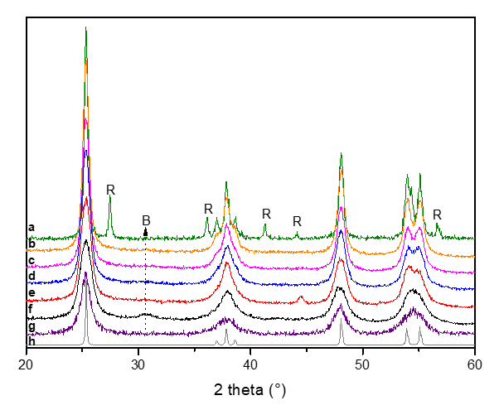
The photocatalytic oxidation of NO_{x} was studied in a continuous plug-flow flat photoreactor described in detail elsewhere [17,]. This reactor is constructed in stainless steel except for the top window, which is made of borosilicate glass with low iron content. The photocatalyst samples were coated, after dispersion in 2-propanol, on a microscope slide that was placed under the glass window. Although the irradiated area was kept constant (19 cm²), the weight of catalyst varied from 16 to 22 mg depending on the sample apparent density. Irradiation was provided by two UVA fluorescent lamps (TL-8W/05, Philips), which present a maximum emission at 365 nm and a measured irradiance of 4.4 mW/cm². Flow rate, pressure, temperature, turning on/off the UV lamp and relative humidity were controlled by using electronic mass flow controllers, specific sensors and automated valves (Process Integral Development Eng&Tech S.L.). NO and SO₂ were fed to the reactor at concentrations of 5 and approximately 0.1 ppm_{v}, respectively, using a certified low concentration cylinder of these gases in N₂ (Air Liquide), with dry air as make-up to get a total gas flow of 100 ml/min (residence time = 1.98 s). Selected tests were also performed by mixing NO₂ in N₂ (Air Liquide) at a concentration of 5 ppm_{v}, keeping the operation conditions unchanged. The gas phase composition was continuously monitored using a FTIR Thermo-Nicolet 5700 spectrometer provided with a temperature controlled multiple-reflection gas cell (optical path 2 m) maintained at 110 ºC.
Intensity (a.u.)
3.4. In situ Photocatalytic studies by DRIFTS
In situ DRIFTS experiments of NO_{x} photocatalytic oxidation were carried out in a Thermo Nicolet 5700 spectrometer equipped with a liquid N₂-cooled MCT detector and a Harrick three-window environmental high-temperature cell. Two of the catalytic chamber windows, made out of BaF₂, were used for IR transmission, and the third quartz window allows the UV irradiation of the photocatalyst during the reaction, using two UVA Philips TL-8W/05 fluorescent lamps. The spectra were registered continuously after accumulation of 64 scans at a resolution of 4 cm⁻¹, which allows acquiring one spectrum every 2 minutes. A continuous gas flow rate of 30 ml/min was applied, of the same blend of NO and SO₂ in air used in the photocatalytic tests. High purity dry gases were used for blending, resulting in a residual water content lower than 5 ppm_{v}.
4. RESULTS
4.1. Characterization of the Photocatalysts
Fig. 1 displays the X-ray diffraction patterns of the different TiO₂ samples, both commercial and synthesized. All of them show the characteristic peaks of the anatase phase (ICDD PDF # 00-021-1272). As it is well-known, TiO₂ P25 is constituted by an anatase-rutile mixture [], while a small contribution at ca. 44° 2θ due to the sample holder is present in TiO₂-9. Additionally, the sample TiO₂-6 shows a weak diffraction peak at ca. 30.5°, which can be ascribed to the presence of a small amount of the brookite phase of TiO₂. A broadening of the diffraction peaks is observed as the temperature of the hydrothermal treatment decreases, revealing a parallel diminution in crystal size. Application of the Scherrer´s equation to the most intense reflection at 25.3° 2θ, corresponding to (101) planes, confirms the decrease in average crystal size with decreasing crystallization temperature, as indicated by the size values collected in Table 1. Thus, a fine control of the anatase crystal diameter is attained by varying the synthesis conditions, allowing the exploration of the effect of this parameter on the photocatalytic behavior for NO_{x}-SO₂ abatement.

Fig. (1). X-ray diffractograms of the tested TiO₂ samples: (a) TiO₂-P25 (b) TiO₂-15 (c) TiO₂-13 (d) TiO₂-11 (e) TiO₂-9 (f) TiO₂-6 (g) TiO₂-HBK (h) TiO₂-BDH. The main reflections of rutile are marked as R, while the most intense peak of brookite is labelled as B. Unmarked features corresponds to anatase, which is the main phase for all the samples.
Surface areas, also collected in Table 1, vary in good agreement with crystal size, so that the relation between the two parameters is inverse as can be expected in the present case where the aggregate size is kept constant among samples [24]. A geometrical calculation of the surface area assuming spherical particles with the diameter estimated by the Scherrer´s equation results in a trend similar to that obtained with the BET data, although with generally higher values, revealing that there is actually certain agglomeration of crystals. Previous TEM studies of TiO₂ samples prepared by analogous procedures, have shown that they consist of nanoparticles with fairly narrow size distribution. [24] Similarly, the TEM images of TiO₂-P6 sample (see Fig S1) show that it consists of aggregates of rounded nanoparticles of homogeneous size.
Bandgap energy for some representative samples was estimated from the DR-UV-vis spectra. The obtained values are very close for all the anatase samples, ranging from 3.15 to 3.22 eV. In contrast, this parameter is significantly lower for TiO₂-P25, as expected due to the presence of rutile. [26]

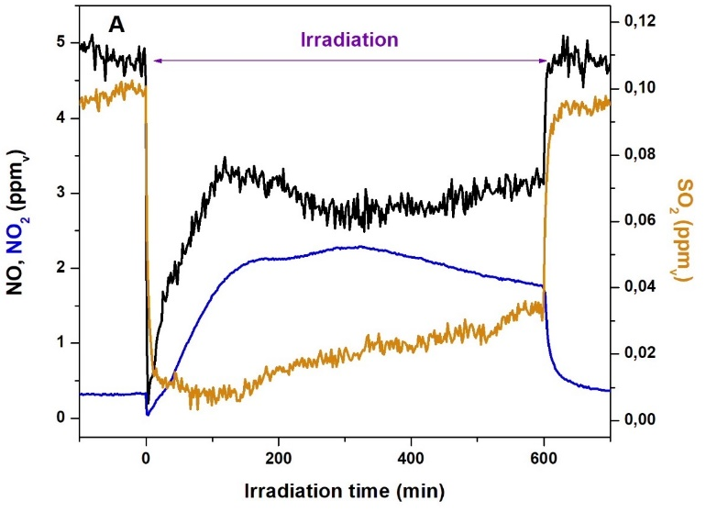
Table 1. Main characteristics of the photocatalysts
Photocatalyst | Preparation conditions | Crystal Phase | Crystal size (nm) | S_{BET} (m²/g) | E_{g} (eV)
TiO₂ – 15 | Thermal: 450ºC, 12 h | Anatase | 15 | 59 | -
TiO₂ – 13 | Thermal: 450ºC, 3 h | Anatase | 13 | 80 | -
TiO₂ – 11 | Thermal: 400ºC, 3 h | Anatase | 11 | 107 | 3.15
TiO₂ – 9 | Hydrothermal: 200ºC, 8 h | Anatase | 9 | 150 | -
TiO₂ – 6 | Hydrothermal: 150ºC, 8 h | Anatase | 6 | 184 | 3.18
Commercial photocatalyst |  | Crystal Phase | Crystal size (nm) | S_{BET} (m²/g)
TiO₂-BDH |  | Anatase | 63 | 10 | 3.16
TiO₂-P25 |  | Anatase/Rutile | 21/26* | 47 | 3.00
TiO₂-HBK |  | Anatase | 8 | 330 | 3.22
* anatase and rutile crystals, respectively

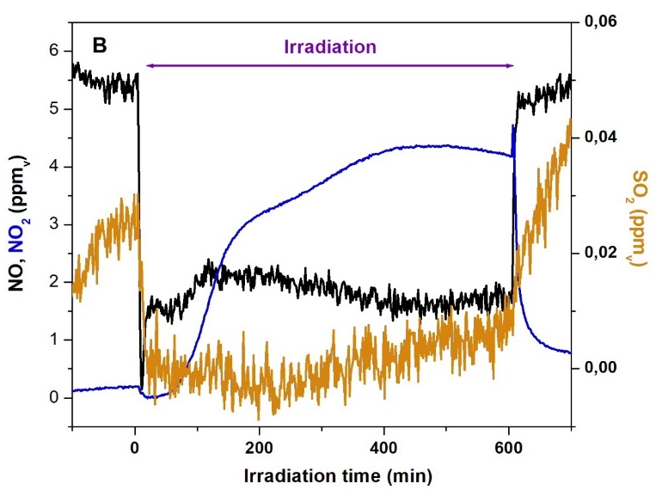
4.2. Photocatalytic activity for the removal of NO and SO₂ mixtures
The present selection of TiO₂ samples, which were characterized in the previous section, provides a wide range of variation of textural and morphological properties as to determine the influence of these parameters on the photocatalytic removal of NO and SO₂.
Similarly to previous studies [18], in order to accelerate the saturation of the surface and to increase the sensitivity of the analyses, the concentration of NO and SO₂ pollutants used in these photocatalytic tests is remarkably higher than those found in highly polluted urban environments [6,9]. Such harsh operation conditions, caused by these high concentrations and the absence of water vapor, can challenge the treatment capacity of these photocatalysts, but they allow to underline differences between TiO₂ samples. Figure 2 displays NO and SO₂ conversion profiles over time for 10 hours of continuous operation, for commercial TiO₂-P25 and synthesized TiO₂-13 photocatalysts, as illustrative examples. In addition, the formation of NO₂ from NO photo-oxidation in the gas-phase stream is also plotted. No indication of the formation of HNO₂, which is considered a possible intermediate of the photocatalytic removal of NO_{x}, was found, nor were any additional oxidation products of SO₂ observed. In both cases, an initial period with high conversion is observed, reaching a peak value of 95 % and 97 % of NO removal for TiO₂-P25 and TiO₂-13, respectively, and without any NO₂ release. For longer irradiation times, NO conversion tends to decrease and subsequently it stabilizes around 34 % for the commercial photocatalyst, while it reaches 69 % for lab-made TiO₂-13. Under these conditions, NO₂ selectivity is about 78 % for TiO₂-P25 and slightly exceeds 100 % for TiO₂-13, suggesting that some previously adsorbed NO₂ molecules may be released after prolonged irradiation. On the other hand, removal of SO₂ is initially about 92 % for TiO₂-P25, but it progressively decreases down to 67 % after 10 hours. Likewise, SO₂ removal efficiency slightly diminishes with irradiation time for TiO₂-13, although conversion is still 94% after 10 hours of irradiation. However, it is important noticing that, except for TiO₂-P25, for all selected photocatalysts SO₂ adsorption is not complete after 4 hours of equilibration in the dark and, accordingly, the observed removal yield is the combination of photocatalytic abatement and adsorption. This is consistent with previous reports, which have found that NO adsorption on TiO₂ is not as high as for SO₂, although it can be promoted by the presence of the latter molecule. [11,21]
Fig. (2). Photocatalytic removal of NO (black) and SO₂ (orange) over TiO₂-P25 (A) and TiO₂-13 (B) showing the variation with irradiation time of NO₂ production (blue).
The main activity results for all the photocatalysts under evaluation are collected in Table 2. As it can be appreciated, there are marked differences between samples but, in most cases, long-term removal efficiencies for both SO₂ and NO are higher than 50%, except for the low surface area commercial TiO₂-BDH, and for TiO₂-P25 in the case of NO elimination. Regarding SO₂ abatement, it is worth noticing that the contribution to adsorption in the dark is more important than for NO (see Table 2), as it has been mentioned above. This is particularly relevant for TiO₂- BDH, which does not increase its SO₂ removal capacity upon irradiation, while TiO₂-P25 is the most effective sample for the photocatalytic oxidation of this pollutant under the selected conditions.
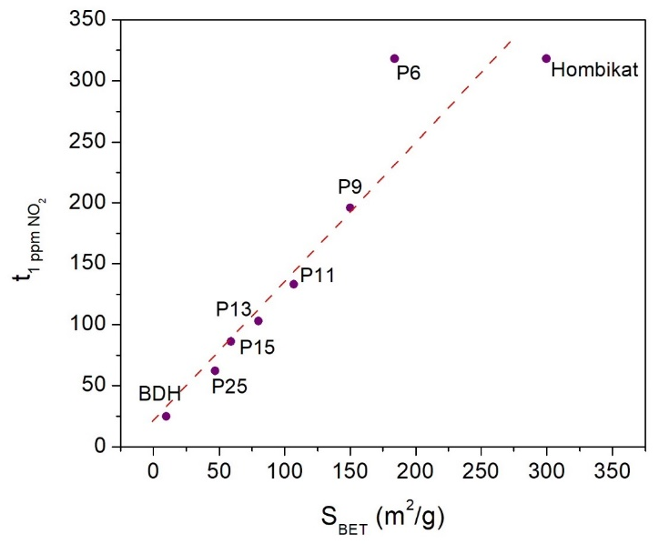
On the other hand, a rough correlation between specific surface area and photocatalytic activity is apparent, although the highest NO conversion corresponds to TiO₂-11, which presents a moderate surface area. Hydrothermally prepared TiO₂ nanoparticles show conversion of NO above 85 % and, in the case of TiO₂-6, a remarkable NO_{x} storage capacity. These samples have enhanced textural properties, and although their significant defect concentrations that although may be detrimental for photoactivity, they can promote adsorption. In addition, as discussed later, residual organic complexes can also promote photoactivity of hydrothermally prepared materials. Finally, the presence of some brookite domains in TiO₂-6 can also have a positive effect on photoactivity, as it has been previously reported for mixtures with anatase [] In general, lab-prepared samples present better performance than commercial TiO₂ in terms of conversion, probably due to differences on their surface characteristics.

Table 2. Main photocatalytic activity parameters
Photocatalyst | NO conv.* (%) | NO₂ *  Selectivity (%) | NO_{x} stored  (mmols.g⁻¹)# | SO₂ adsorbed⁺ (%) | SO₂ removal§ (%)
TiO₂ – 15 | 52 | 111 | 80.6 | 58 | 77
TiO₂ – 13 | 69 | 109 | 96.9 | 74 | 94
TiO₂ – 11 | 97 | 98 | 159.7 | 86 | 91
TiO₂ – 9 | 86 | 109 | 117.6 | 82 | 100
TiO₂ – 6 | 93 | 67 | 289.3 | 88 | 100
TiO₂-BDH | 18 | 97 | 40.7 | 10 | 39
TiO₂-P25 | 34 | 78 | 59.2 | 0 | 67
TiO₂-HBK | 88 | 64 | 263.2 | 91 | 89
* Measured after 600 minutes of irradiation time #Estimated after 400 minutes of irradiation ⁺After 200 minutes adsorption in the dark. §After 600 min of irradiation, considering both adsorption and photo-oxidation processes
Likewise, the selectivity to NO₂ after 6 hours irradiation is remarkably high and, for some photocatalysts overpass 100%. These anomalous results can be ascribed in some extent to the experimental uncertainty in the determination of the concentration of NO_{x} species, although a slight contribution of partial NO₂ desorption following saturation of the surface is also possible. Regarding the generation of this by-product, another important aspect to consider is the irradiation period required for the onset of NO₂ releasing, which can be associated with the blockage of the photocatalyst surface. Time lapsed until the concentration of NO₂ reaches 1 ppm is plotted as a function of BET surface area in Figure 3 for each TiO₂ sample. As it may be expected, a clear linear correlation (r=0.880) between these parameters is obtained, which suggests that the end-products of NO photocatalytic oxidation are initially adsorbed species such as surface nitrates. Subsequently, when surface sites are fully covered, NO₂ is gradually released to the gas phase. An estimation of the NO_{x} species accumulated on the surface of the different TiO₂ samples after 400 minutes of irradiation is gathered in Table 2. The evolution of the amount of adsorbed species with surface area is analogous to that of the onset time. Similar trend has been previously reported for Ba-modified TiO₂ and it has been related to surface storage of NO_{x} []. Nevertheless, this a complex process that depends not only on available sites but also on intrinsic photoactivity of the TiO₂ samples, which can be influenced by additional factors (e.g. presence of surface and structural defects, exposed facets…). In this way, certain deviation of this general tendency is observed for high surface area photocatalysts, particularly for TiO₂-6, which show higher capacity for NO_{x} storage than expected. This behaviour could be related to secondary reactions with adsorbed organic impurities remaining after synthesis on hydrothermally prepared samples, as observed by DRIFT (see Fig S2). The presence of these organic surface complexes may contribute to promote the overall photoactivity of these TiO₂ samples, by enhancing the NO_{x} and SO_{x} storage capacity. On the other hand, at this low concentration, the additional presence of SO_{x} species does not appear to appreciably affect the accumulation of NO_{x} species on the photocatalysts surface.
Fig. (3). Correlation between the irradiation time required for releasing 1ppm of NO₂ over different photocatalyst as a function of the BET surface area.
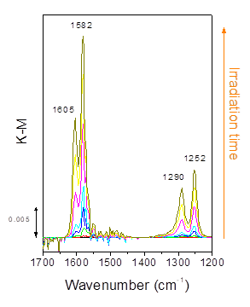
In order to further understand the role of NO₂ in the photocatalytic process, an additional test was performed feeding the photoreactor with 5 ppm of this molecule in a dry air stream and using TiO₂-11 as photocatalyst. The results obtained following more than 8 hours of irradiation are shown in Figure 4. Initially, a maximum NO₂ conversion of about 86 % is achieved after about 20 minutes of irradiation. Then, conversion decreases slightly to 79 %, and subsequently it gradually declines, first slightly and then, after 300 minutes more steeply. In parallel, the concentration of NO, which was initially absent, progressively rises to reach a maximum after about 2 hours of irradiation. This is consistent with the disproportionation of NO₂into surface nitrates and NO, as it has been previously reported. [] Finally, after about 4 hours of irradiation, the NO₂ abatement efficiency swiftly declines and, in parallel, NO emission follows. Consequently, after about 500 min of irradiation, the photocatalyst is fully deactivated. This fact suggests a surface saturation with oxidized complexes such as nitrates species. This is not entirely a photoactivated process because a strong and continuous adsorption of NO₂ starts during equilibration in the dark.
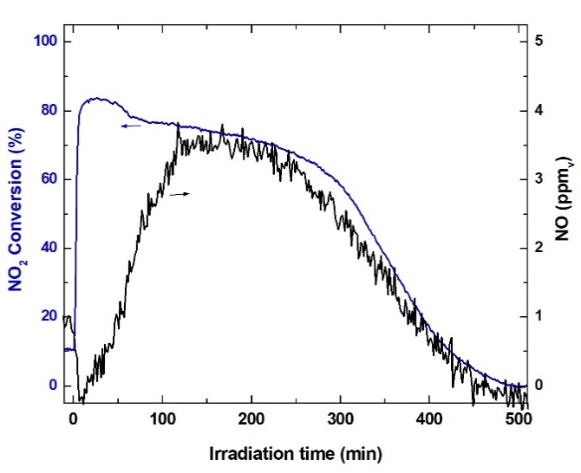

Fig. (4). Photocatalytic conversion of NO₂ (blue line) over TiO₂-11 photocatalyst as a function of irradiation time. Evolution of the concentration of NO (black line) during the reaction is also plotted.
Finally, it is worth mentioning that, despite the key role of water in the performance, selectivity, and regeneration of the photocatalysts, these experiments were conducted under dry conditions to be able to study saturation and deactivation of the samples. In this respect, previous studies confirmed that the depletion of adsorbed water is a key factor on driving photocatalyst deactivation and can explain the specific behaviour observed here. [,] On the other hand, the absence of water facilitates the analyses of the IR spectra used to monitor these processes, avoiding the massive water vapour interferences, which can render these assays unfeasible.
3.3 In situ DRIFTS Study of NO and NO₂ Photooxidation over TiO₂
In order to gain further insight into the mechanism of the NO_{x} photocatalytic removal over TiO₂ in the presence of SO₂ traces, in situ DRIFTS tests were undertaken. This spectroscopic tool is particularly adequate to reveal changes in surface species in the study of photocatalysts. []
Apart from a brief (ca. 20 minutes) flushing in a dry air flow in the DRIFT chamber to remove any weakly absorbed molecules (e.g. physisorbed water), TiO₂ samples were used without any further treatment and, accordingly, they are partly hydrated after being in contact with atmospheric air. Once equilibrated in the dry air stream, the spectrum of the TiO₂ was taken as a background to enhance the spectral features caused by the photocatalytic reaction. Subsequently, the time evolution of the surface composition was evaluated under continuous UVA illumination while flowing the same gas blend used in the photoactivity experiments (5 ppm_{v} NO and 0.1 ppm_{v} SO₂). Laboratory-made TiO₂-11 was selected for this study as one of the most active samples, while commercial photocatalyst TiO₂-P25 was also investigated for the sake of comparison.

Fig. (5). Variation of DRIFT spectra of TiO₂-11 with irradiation time during the photocatalytic conversion of NO and SO₂ in dry air.
Figure 5 shows the evolution of the DRIFT spectra with irradiation time in the 1700-1200 cm⁻¹ range corresponding to the TiO₂-11 photocatalyst. This figure reveals the progressive rising of prominent bands at 1605, 1582, 1290 and 1252 cm⁻¹. These features can be attributed to the symmetric and asymmetric vibrations of surface nitrates, υ(NO₃), of different geometry. According to the literature, the more intense features at 1582 cm⁻¹ and 1252 cm⁻¹ correspond to bidentate nitrates, which constitute the main contribution at short irradiation time, while the bands at 1605 and 1290 cm⁻¹ are ascribed to bridging nitrates [, , ]. Despite some small differences with the assignments previously reported, the parallel evolution of these two pairs of bands strongly suggest that they correspond to the same surface species. In addition, a shoulder around 1550 cm⁻¹ in the tail of the strong contribution at 1582 cm⁻¹ could be associated to monodentate nitrates. Finally, a weak and broad band at about 1483 cm⁻¹, which can be ascribed to water-coordinated nitrate, is observed following prolonged irradiation. Table 3 summarizes the main bands observed following irradiation and their assignment.
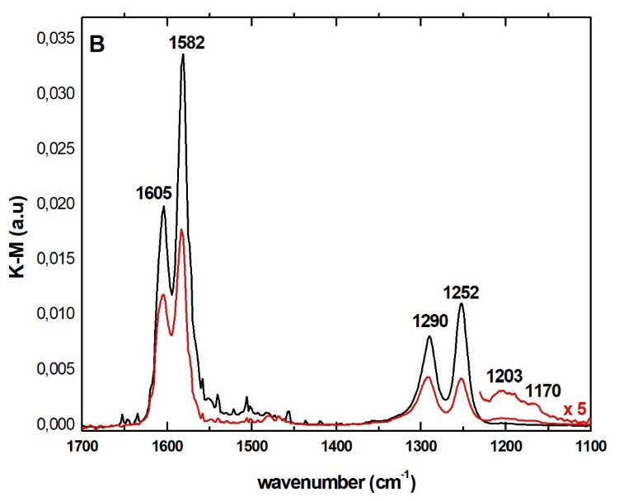
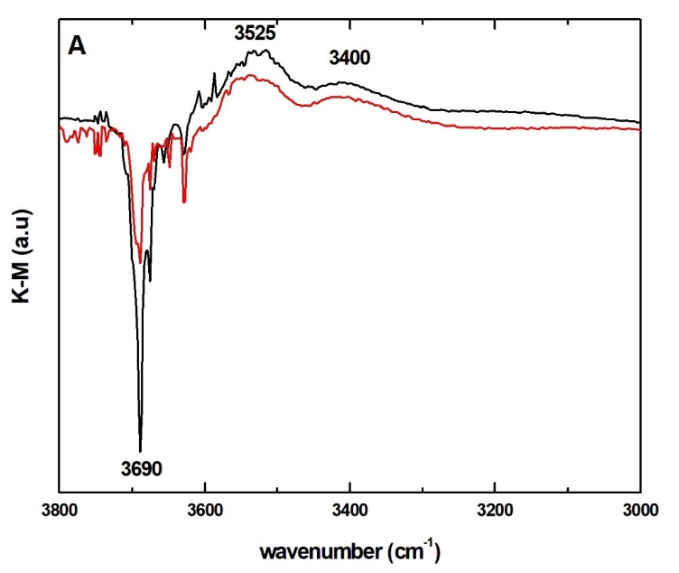
Table 3. Assignment of the main bands observed on TiO₂ following in situ photocatalytic oxidation of NO_{x} and SO₂ blends
υ(cm⁻¹) | Assignment
3630 | Surface OH⁻
3525 | Hydrogen-bonded hydroxyls
3400 | N-OH groups
1605 | Bridging nitrate
1582 | Bidentate nitrate
1550 | Monodentate nitrate
1290 | Bridging nitrate
1252 | Bidentate nitrate
1483 | Solvated nitrate
1205, 1170 | Bidentate sulfate

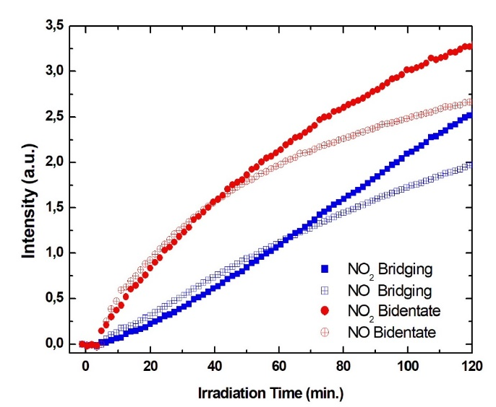
Figure 6 displays the spectra of TiO₂-P25 and TiO₂-11 photocatalysts after 120 minutes of UV-irradiation in a flow of air with NO and SO₂, in the two regions which show the most relevant features generated after irradiation. The profile of the spectra of both TiO₂ samples is rather similar and, although the intensity of the nitrate bands is lower for TiO₂-P25, the geometry of these surface complexes is the same as in TiO₂-11. Differences in intensity are consistent with the lower surface area and photoactivity of the commercial TiO₂, as it was mentioned in the previous section. In the low wavenumber area, some additional bands at 1205 and 1170 cm⁻¹ are observed for TiO₂-P25, as it is shown in the magnified region in Figure 6B. These spectral features can be assigned to bidentate sulfate species [23, , ] formed due to SO₂ photocatalytic oxidation. For a long irradiation time some very weak bands in this range are also observed for TiO₂-11. This reduced contribution of the sulfate bands for TiO₂-11 could be because SO₂ is mainly removed by adsorption in the dark, while contribution of photocatalytic oxidation is small, and therefore the formation of these surface species during in situ DRIFT experiments is expected to be limited. Nevertheless, the effect that preferential adsorption of NOx_{(ads)} species on titania sites can have on preventing the adsorption of sulfate species cannot be ruled out.
At high wavenumbers, in the 3800 to 3000 cm⁻¹ range, both TiO₂ samples show a sharp negative band at 3690 cm⁻¹ and two broad positive contributions centered about 3525 and 3400 cm⁻¹ (see Fig. 6A). The negative feature is associated with surface hydroxyl groups on the anatase, which are removed due to gradual formation of surface nitrates []. The intensity of that band is lower for TiO₂-P25, and despite the overlapping with the features of water vapor traces, this sample appears to show an additional less intense negative band at around 3630 cm⁻¹, which can be associated to a different type of surface hydroxyl present on this sample [,]. On the other hand, the broad positive band at 3525 cm⁻¹ can be ascribed to hydrogen-bonded hydroxyls perturbed by the nitrates, while the feature at 3400 cm⁻¹ is directly associated to N-OH groups [18] of adsorbed nitric acid.

Fig. (6). Comparison of the DRIFT spectra in two selected spectral windows (A) 3800-3000 cm⁻¹ and B) 1700-1100 cm ⁻¹) of TiO₂-11 (black) and TiO₂-P25 (red) after 120 minutes of irradiation in a dry stream containing NO and SO₂.

Fig. (7). Evolution of the integrated intensities for the bands ascribed to bridging (blue squares blue) and bidentate (red circles) nitrates photocatalytically produced on TiO₂-11 for the two different gas compositions: NO₂ (filled symbols) and NO and SO₂ blends (open).

In the case of hydrothermal samples, DRIFT spectra (see Fig S2), in addition to bands of adsorbed nitrates, show additional features, which can be ascribed to the modification of the organic complexes, remaining on surface after the synthesis. Negative bands at 1170-1130 cm⁻¹ are assigned to the C-O vibration of surface alkoxides, which are progressively removed under irradiation. Positive bands at 1718 cm⁻¹ are associated to C=O groups of carboxylic acids, while broad bands centered at about 1540 cm⁻¹ and 1360 cm⁻¹ are very likely due to N-O vibrations of organic nitro groups. These spectral features indicate the formation on these surface species under irradiation and they suggest the participation of these organic species in reactions with NO. These transformations may partly contribute to the good performance of TiO₂-6. In this respect, it has been reported that the interaction of nitric acid with different hydrocarbons can lead to the formation of organic nitro compounds and carboxylic acids. []
The time evolution of the DRIFT spectra of TiO₂-11 in the nitrate region during the photocatalytic oxidation of NO₂ (see Fig S3) is very similar to those obtained during irradiation of the NO and SO₂ blends, although some variations in the intensity can be observed. In particular, a broader and low intensity band centered at about 1500 cm⁻¹, which is more marked after the photocatalytic oxidation of NO₂, can be ascribed to the higher proportion of partially solvated nitrates [28]. For TiO₂-11, a detailed comparison of the variation with irradiation time of the integrated area of the main nitrate bands, corresponding to bridging and bidentate geometries, under either gas composition, NO with SO₂ and NO₂, is plotted in Fig. 7. These curves show that nitrate concentration is appreciably higher under prolonged irradiation when the inlet feed contains NO₂. This is consistent with the quicker decline in the NO₂ conversion with irradiation time. Bidentate nitrates are predominant in all cases and the final proportion of bridging and bidentate surface complexes does not vary significantly with gas composition. The profile of these curves suggests a progressive saturation of the surface, which most likely is modulated by partial decomposition of the nitrates, as it has been found in the case of the intermediates of other photocatalytic reactions. [] On the other hand, these similarities in the spectra despite the changes in gas composition indicate that, at this low concentration level, SO₂ traces do not modify appreciably the route of NO photocatalytic oxidation and the removal reactions of these molecules are basically independent.
5. DISCUSSION
According to the observed evolution of the surface species during irradiation and, taking into account literature results, including recent detailed kinetic modelling [22, 25], the following mechanism for NO_{x} photocatalytic oxidation over TiO₂ can be proposed:
TiO₂ + hυ → TiO₂ (h⁺ + e ) (3)
Ti⁴⁺-OH⁻ + h⁺ → Ti⁴⁺-OH• (4)
NO + Ti⁴⁺-OH• → Ti⁴⁺-HNO₂ (5)
Ti⁴⁺-HNO₂ + Ti⁴⁺-OH• → 2 Ti⁴⁺+ H₂O + NO₂ (6)
Ti⁴⁺-OH⁻ + NO₂→ Ti⁴⁺-HNO₃ (7)
Ti⁴⁺ + O₂ + e- → Ti⁴⁺ -O₂⁻ (8)
Ti⁴⁺-O₂⁻+ NO → Ti⁴⁺-NO₃⁻ (9)
These equations show that both photogenerated electrons and holes can contribute to the fixation of NO_{x} on the TiO₂ surface as it has been previously suggested [29]. In addition, it is important to consider the possible photoreduction of nitrates to yield NO₂ that can take place according to:
Ti⁴⁺-HNO₃ + e⁻ → Ti⁴⁺-OH⁻ + NO₂ (10)
Ti⁴⁺-NO₃⁻ + e⁻ → Ti⁴⁺-O²⁻+ NO₂ (11)
In addition, photoreduction in the presence of NO can also generate NO₂ as follow:
Ti⁴⁺-NO₃⁻ + NO + h⁺ → Ti⁴⁺⁻+ 2 NO₂ (12)
These last processes, as well as that of equation (6), can explain the progressive increment of the concentration of NO₂ in the outlet stream, once the coverage of the TiO₂ surface by nitrates is high. In particular, reaction (12) could be the reason why, despite the similar initial rates of nitrates formation in the presence of either NO₂ or NO and SO₂ blends (see fig 7), a progressive decline of the rate is observed in the last case and, therefore, lower nitrates concentration is detected after extensive irradiation. Similarly, disproportionation of NO₂ can take place according to [29]:
Ti⁴⁺-O²⁻ + Ti⁴⁺ + 3 NO₂→ 2 Ti⁴⁺-NO₃ ⁻+ NO (13)
This reaction can partly justify the progressive decline of photoactivity and the high selectivity towards NO observed after extensive irradiation of NO₂ in dry air. In any case, the complexity of these processes implies that efficient photocatalytic removal of NO_{x} requires frequent regeneration of the photocatalytic surface.
In a similar way, the photocatalytic oxidation of SO₂ can occur according to:
2 Ti⁴⁺-OH• + SO₂ → Ti⁴⁺-SO₄²⁻ + Ti⁴⁺ + 2H⁺ (14)
Previous studies have approached the kinetics of the photocatalytic oxidation of SO₂ [19] and NO and SO₂ blends [22]. In this last case, it has been reported that the presence of NO can promoted the photocatalytic removal of SO₂ due to a series of surface reactions [20,23], which are initiated by the SO₂ adsorption in the dark:
Ti⁴⁺-OH⁻ + SO₂ → Ti⁴⁺-HSO₃⁻ (15)
and follows with
Ti⁴⁺-NO₃⁻ + Ti⁴⁺-HSO₃⁻ → Ti⁴⁺-SO₄²⁻+ Ti⁴⁺+ HNO₂ (16)
However, due to the low concentration of SO₂ used in this study, the presence of these surface sulfates does not appear to affect the NO removal to a significant extent and the possible formation of HNO₂ is well below the detection limits.
CONCLUSIONS
Photocatalytic tests performed with lab made and commercial TiO₂ samples, mainly containing the anatase phase, but with a wide variation of textural properties, reveal very efficient removal of both NO and SO₂ in dry air streams in most of the cases. In the case of SO₂, efficient elimination is caused not only by photocatalytic oxidation but also, to a significant extent, by adsorption. On the other hand, the presence of SO₂ in low concentration does not appear to detrimental for NO removal. In general terms, TiO₂ photocatalysts with higher surface area and smaller crystallite size tend to be more photoactive in these conditions, but for the materials with better textural properties other factors, such as the presence of defects, may also play a significant role reducing the influence of specific surface. In this regards, high surface area TiO₂ prepared in the lab appears shows the best performance for the removal of these pollutants.
Although initially no by-products are generated, following irradiation for several hours formation of NO₂ progressively increases and reaches 100 % selectivity over some photocatalyst. Certain correlation between the surface area of the TiO₂ samples and the onset time for NO₂ releasing is observed, strongly suggesting that reaction products are accumulated on the surface of the photocatalyst. This is further confirmed by the in situ DRIFTS analyses the evolution of the surface composition. These experiments confirm the formation of surface nitrates with different symmetry, together with a limited concentration of sulfates under the selected operating conditions. The evolution of the bands corresponding to these surfaces complexes shows an initial rapid increment, but they progressive tend to level-off, as expected due to the increase of nitrate surface coverage. On the other hand, DRIFTS results reveal the involvement of surface hydroxyls on the formation of nitrate species under this dry conditions.
CONSENT FOR PUBLICATION
Not applicable
AVAILABILTY OF DATA AND MATERIALS
Not applicable
FUNDING
Financial support from the Spanish Ministry of Science and Innovation (MICINN, CMT2011-25093) and project FotoArt from “Comunidad de Madrid” and European Structural Funds to (S2018/NMT-4367) is greatly appreciated.

CONFLICT OF INTEREST
The authors declare no conflict of interest, financial or otherwise.

REFERENCES

[] https://www.eea.europa.eu//publications/air-quality-in-europe-2018
[] Guarnieri, M; .Balmes, J.R, Outdoor air pollution and asthma. The Lancet, 2014, 383 (9928), 1581-1592, doi.org/10.1016/S0140-6736(14)60617-6.
[] https://www.epa.gov/no2-pollution/basic-information-about-no2#Effects
[] Saiz-Lopez,A.; Borge, R.; Notario, A.; Adame, J. A.; de la Paz, D.; Querol, X.; Artíñano, B.; Gómez-Moreno, F. J.; Cuevas, C. A., Unexpected increase in the oxidation capacity of the urban atmosphere of Madrid, Spain. Sci. Reports 2017, 7, 45956. https://doi.org/10.1038/srep45956
[] Bishop, G. A.; Haugen, M. J., The Story of Ever Diminishing Vehicle Tailpipe Emissions as Observed in the Chicago, Illinois Area, Environ. Sci. Technol. 2018, 52, 7587−7593 DOI: 10.1021/acs.est.8b00926
[] Nakashima, Y. Sadanaga, Y., Saito, S., Hoshi, J., Ueno, H., Contributions of vehicular emissions and secondary formation to nitrous acid concentrations in ambient urban air in Tokyo in the winter, Sci.Total Environ. 2017, 592, 178-186, doi.org/10.1016/j.scitotenv.2017.03.122
[] Wang, L.; Li, P.; Yu, S.; Mehmood, K.; Li, Z.; Chang, S.; Liu, W.; Rosenfeld, D.; Flagan, R. C.; Seinfeld. J. H. Predicted impact of thermal power generation emission control measures in the Beijing-Tianjin-Hebei region on air pollution over Beijing, China. Sci. Rep., 2018, 8, 934 DOI:10.1038/s41598-018-19481-0
[] Zouzelka, R.; Rathousky, J., Photocatalytic abatement of NOx pollutants in the air using commercial functional coating with porous morphology. Appl. Catal. B 2017 217 466–476 doi.org/10.1016/j.apcatb.2017.06.009
[] Suárez, S.; Portela, R.; Hernández-Alonso, M. D.; Sánchez. B., Development of a versatile experimental setup for the evaluation of the photocatalytic properties of construction materials under realistic outdoor conditions. Environ. Sci. Pollut. Res. 2014 21:11208–11217 DOI 10.1007/s11356-014-2725-y
[] Wang, H.; You, C., Photocatalytic oxidation of SO₂ on TiO₂ and the catalyst deactivation: A kinetic study, Chem. Eng. J. 2018, 350, 268–277
[] Wang, L.; Zhao, Y.; Zhang, J., Photochemical Removal of SO₂ over TiO₂-Based Nanofibers by a Dry Photocatalytic Oxidation Process, Energy Fuels 2017, 31, 9905−9914 doi.org/10.1021/acs.energyfuels.7b01514
[] Chen, J.; Poon, C.-S, Photocatalytic construction and building materials: From fundamentals to applications, Building and Environment 2009, 44, 1899-1906. doi.org/10.1016/j.cej.2018.05.152
[] Hüsken, G.; Hunger, M.; Brouwers, H.J.H.; Experimental study of photocatalytic concrete products for air purification, Building and Environment, 2009, 44, 2463-2474. doi.org/10.1016/j.buildenv.2009.04.010
[] Yang, L.; Hakki, A.; Wang, F.; Macphee, D. E.; Photocatalyst efficiencies in concrete technology: The effect of photocatalyst placement, Appl. Catal. B 2018, 222, 200-208, https://doi.org/10.1016/j.apcatb.2017.10.013.
[] Chen, M., Chu, J-W., NOx photocatalytic degradation on active concrete road surface — from experiment to real-scale application, J. Clean. Prod. 2011, 19(11), 1266-1272, doi.org/10.1016/j.jclepro.2011.03.001.
[] Fermoso, J.; Sánchez, B.; Suárez, S. “Air purification applications using photocatalysis” in “Nanostructure photocatalysis: From Materials to Applications in Solar Fuels and Environmental Remediation” Chp. 5, 2020, 99-128, Edts. R. Boukherroub, S. B. Ogale and N. Robertson ISBN: 978-0-12-817836-2, Elsevier.
[] Suárez, S.; Hernández‑Alonso, M. D.; Martínez, C.; Sanchez, B., Evaluation of the photocatalytic performance of construction materials for urban air depollution. Euro-Mediterr J. Environ. Integr 2020, 5, 25. https://doi.org/10.1007/s41207-020-00162-21
[] Dalton, J.S.; Janes, P.A.; Jones, N.G.; Nicholson, J.A.; Hallam, K.R.; Allen, G.C., Photocatalytic oxidation of NOx gases using TiO₂: a surface spectroscopic approach, Environmental Pollution 2002, 120, 415-422. doi.org/10.1016/S0269-7491(02)00107-0
[] Bedjanian, Y.; El Zein, A., Interaction of NO₂ with TiO₂ Surface Under UV Irradiation: Products Study, J. Phys. Chem. A 2012, 116, 1758−1764 doi.org/10.1021/jp210078b
[] Liu, H.; Yu, X.; Yang, H. The integrated photocatalytic removal of SO₂ and NO using Cu doped titanium dioxide supported by multi-walled carbon nanotubes, Chem. Eng. J. 2014, 243, 465−472 doi.org/10.1016/j.cej.2014.01.020
[] Wang, H., Liu, H., Chen, Z., Veksha, A., Lisak, G., You, G., Interaction between SO₂ and NO in their adsorption and photocatalytic conversion on TiO₂, Chemosphere, 2020, 249, 126136 doi.org/10.1016/j.chemosphere.2020.126136.
[] Han, Y., Zhang, J., Zhao, Y. Visible-light-induced photocatalytic oxidation of nitric oxide and sulfur dioxide: Discrete kinetics and mechanism, Energy, 2016, 103, 725-734,doi.org/10.1016/j.energy.2015.12.007.
[] Yang, W.; Chen, M.; Xiao, W.; Guoa, Y.; Ding, J.; Zhang, L.; He, H., Molecular Insights into NO-Promoted Sulfate Formation on Model TiO₂ Nanoparticles with Different Exposed Facets. Environ. Sci. Technol. 2018, 52(24), 14110-14118 doi.org/10.1021/acs.est.8b02688
[] Maira, A.J.; Yeung, K.L.; Lee, C.Y.; Yue, P.L.; Chan, C.K., Size Effects in Gas-Phase Photo-oxidation of Trichloroethylene Using Nanometer-Sized TiO₂ Catalysts. J. Catal., 2000, 192 (1), 185-196 doi.org/10.1006/jcat.2000.2838
[] Muñoz, V.; Casado, C.; Suárez, S.; Sánchez, B.; Marugán, J., Photocatalytic NOx removal: Rigorous kinetic modelling and ISO standard reactor simulation, Catal. Today, 2019, 326, 82-93, doi.org/10.1016/j.cattod.2018.09.001.
[] Ohno, T.; Sarukawa, K.; Tokieda, K.; Matsumura, M. Morphology of a TiO₂ Photocatalyst (Degussa, P-25) Consisting of Anatase and Rutile Crystalline Phases J. Catal. 2001, 203, 82–86. doi.org/10.1006/jcat.2001.3316
[] Di Paola, A., Bellardita, M., Palmisano, L., Brookite, the Least Known TiO₂ Photocatalyst, Catalysts 2013, 3, 36-73; doi:10.3390/catal3010036
[] Yamamoto, A.; Mizuno, Y.; Teramura, K.; Hosokawa, S.; Tanaka, T. Surface Ba species effective for photoassisted NOx storage over Ba-modified TiO₂ photocatalysts. Appl. Catal. B. 2016, 180, 283-290 doi.org/10.1016/j.apcatb.2015.06.036.
[] Araña, J.; Garzón-Sousa, D.; González-Díaz, O.; Pulido-Melián, E.; Doña-Rodríguez, J.M. Effect of NO₂ and NO₃-/HNO₃ adsorption on NO photocatalytic conversion. Appl. Catal. B 2019, 244, 660–670. doi.org/10.1016/j.apcatb.2018.12.005.
[] Folli A.; Campbell, S. B.; Anderson, J. A.; Macphee, D. E., Role of TiO₂ surface hydration on NO oxidation photo-activity. J. Photochem. Photobio. A, 2011, 220, 85–93. doi:10.1016/j.jphotochem.2011.03.017[
[] Yang, L-.; Hakki, A.; Wang, F.; Macphee, D. E. Different Roles of Water in Photocatalytic DeNOx Mechanisms on TiO₂: Basis for Engineering Nitrate Selectivity? ACS Appl. Mater. Interfaces, 2017, 9(20) 17034–17041 doi.org/10.1021/acsami.7b01989
[] Maira, A.J.; Coronado, J.M.; Augugliaro, V.; Yeung, K.L.; Conesa, J.C.; Soria, J. Fourier Transform Infrared Study of the Performance of Nanostructured TiO₂ Particles for the Photocatalytic Oxidation of Gaseous Toluene, J. Catal., 2001, 202(2), 413-420, doi.org/10.1006/jcat.2001.3301.
[] Mikhaylov, R. V.; Lisachenko, A. A.; Shelimov, B. N.; Kazansky, V. B.; Martra, G.; Coluccia, S. FTIR and TPD Study of the Room Temperature Interaction of a NO–Oxygen Mixture and of NO₂ with Titanium Dioxide, J. Phys. Chem. C 2013, 117 (20), 10345−10352 doi.org/10.1021/jp311593s
[] Liu, C.; Ma, Q.; He, H.; He, G.; Ma, J.; Liua, Y., Wu Y., Structure–activity relationship of surface hydroxyl groups during NO₂ adsorption and transformation on TiO₂ nanoparticles, Environ. Sci.: Nano, 2017, 4, 2388-2394 DOI: 10.1039/C7EN00920H
[] Gankanda, A.; Grassian, V. H., Nitrate Photochemistry on Laboratory Proxies of Mineral Dust Aerosol: Wavelength Dependence and Action Spectra, J. Phys. Chem. C 2014, 118, 29117−29125 doi.org/10.1021/jp504399a
[] Jiang, B. Q.; Wu, Z. B.; Liu, Y.; Lee, S. C.; Ho, W. K.; DRIFT Study of the SO2 Effect on Low-Temperature SCR Reaction over Fe−Mn/TiO₂ J. Phys. Chem. C, 2010, 114 (11), 4961-4965 doi.org/10.1021/jp907783g
[]Kataoka S., Lee E., Tejedor-Tejedor M. I., Anderson M. A., Photocatalytic degradation of hydrogen sulfide and in situ FT-IR analysis of reaction products on surface of TiO₂, Appl. Catal. B, 2005, 61, 159–163 doi.org/10.1016/j.apcatb.2005.04.018
[]Litke A., Su Y., Tranca I., Weber T., Hensen E. J. M., Hofmann J. P., Role of Adsorbed Water on Charge Carrier Dynamics in Photoexcited TiO₂, J. Phys. Chem. C 2017, 121, 7514−7524 doi.org/10.1021/acs.jpcc.7b00472
[] A. Mahdavi-Shakib, J. M. Arce-Ramos, R. N. Austin, T. J. Schwartz, L. C. Grabow, B. G. Frederick, Frequencies and Thermal Stability of Isolated Surface Hydroxyls on Pyrogenic TiO₂ Nanoparticles. J. Phys. Chem. C, 2019, 123(40), 24533–24548 doi.org/10.1021/acs.jpcc.9b05699
[] Soria, J.; Sanz, J.; Sobrados, I.; Coronado, J. M.; Hernández-Alonso, M. D.; Fresno, F. Water−Hydroxyl Interactions on Small Anatase Nanoparticles Prepared by the Hydrothermal Route, J. Phys. Chem. C 2010, 114, 39, 16534–16540 doi.org/10.1021/jp105131w
[] Ando, A., Fujita, M., Izato, Y., Miyake, A., Autocatalytic reaction mechanism of nitric acid and formic acid mixtures based on thermal and in situ Raman spectroscopic analyses J. Therm. Anal. Calorim. 2020;(in press) https://doi.org/10.1007/s10973-020-10311-y
[] Hernández-Alonso, M.D.; Tejedor-Tejedor, M. I.; Coronado, J. M.; Anderson, M. A. Soria. J.; Operando FTIR study of the photocatalytic oxidation of acetone in air over TiO₂–ZrO₂ thin films, Catal. Today 2009, 143, 364–373372 doi.org/10.1016/j.cattod.2009.02.033

