Identifying Pesticides of High Concern for Ecosystem, Plant, Animal, and Human Health: A Comprehensive Field Study Across Europe and Argentina – by Alaoui et al., STOTEN, 2024

SM5 – Correlation analysis

A – Correlations between concentrations in environmental and animal matrices; the scale on the right side of each graph represents the correlation coefficient, while the numbers within the cells represent the P values; NA means that the samples of the respective matrices do not match, hampering statistical analysis.
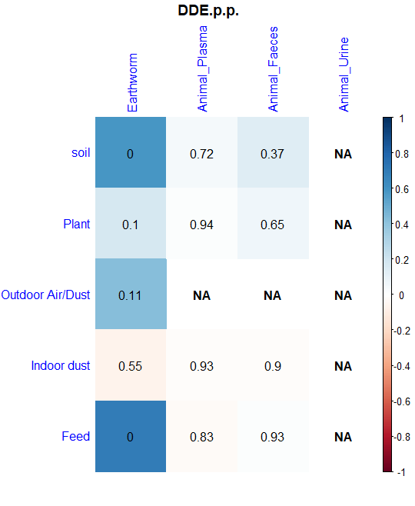 | 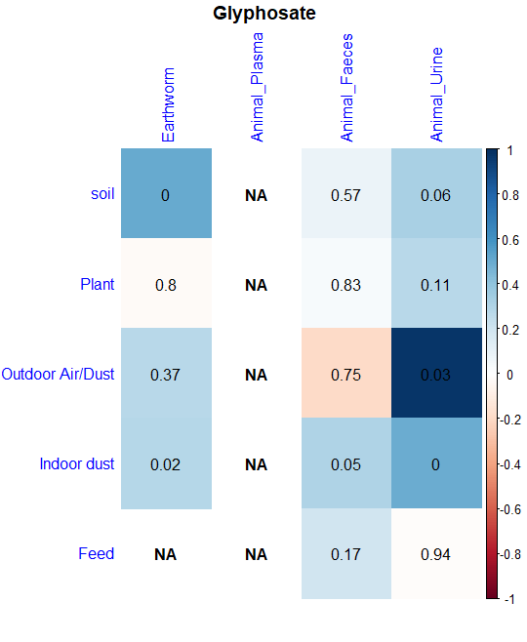
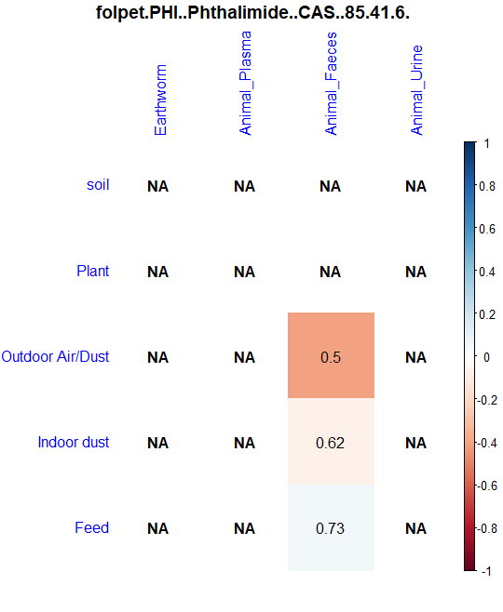 | 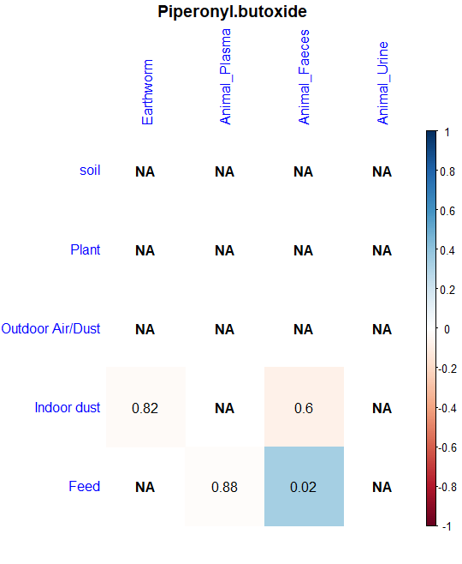
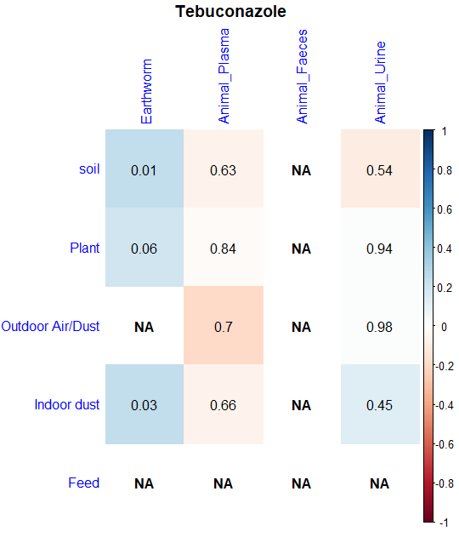 | 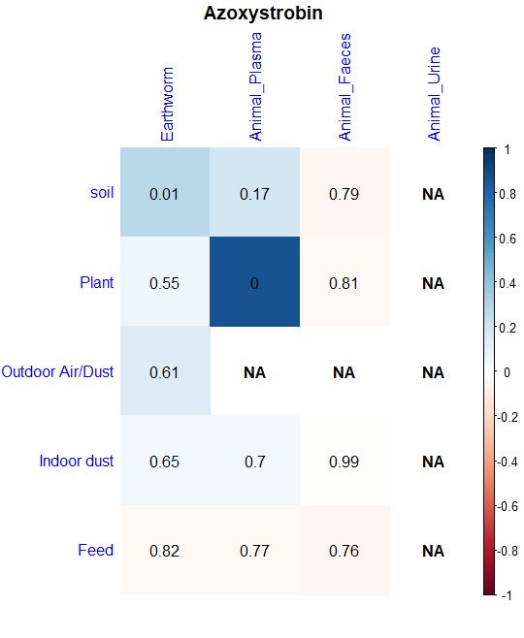
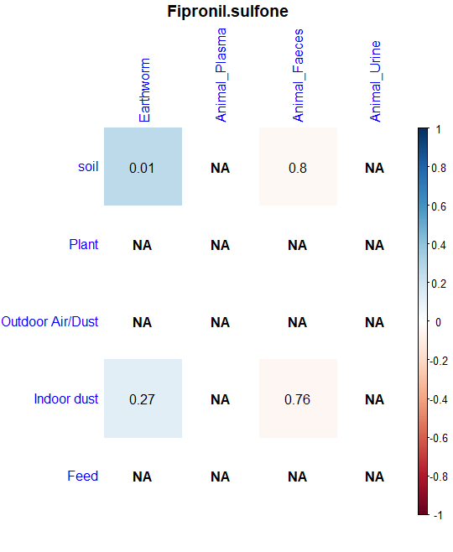 | 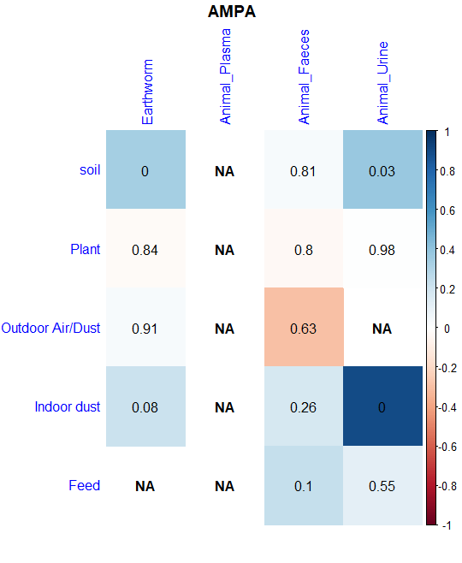
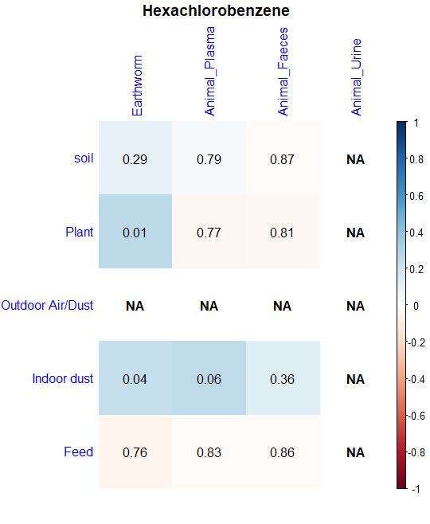 | 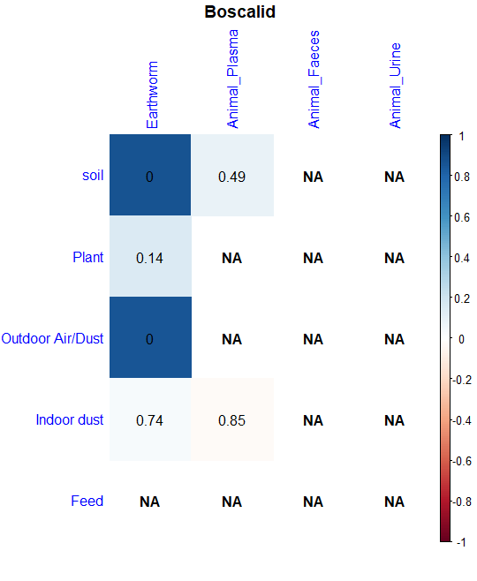

B – Correlations between concentrations in environmental and human matrices; the scale on the right side of each graph represents the correlation coefficient, while the numbers within the cells represent the P values; NA means that the samples of the respective matrices do not match, hampering statistical analysis.
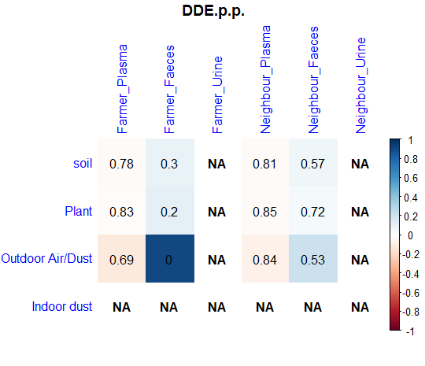 | 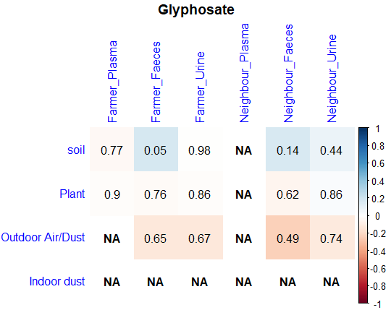
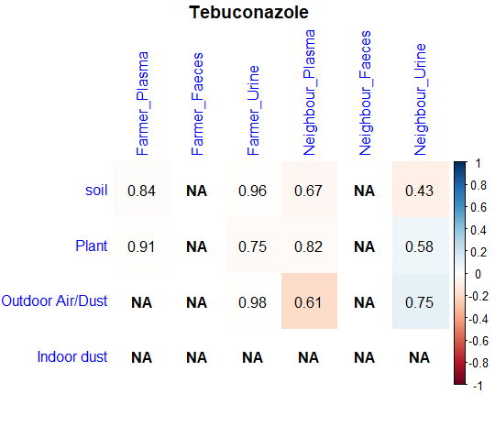 | 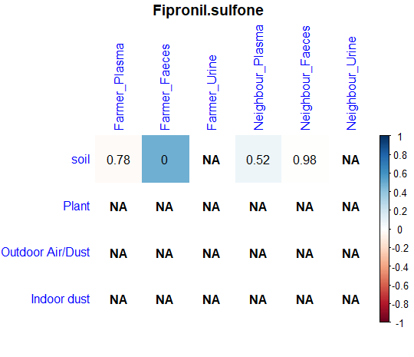
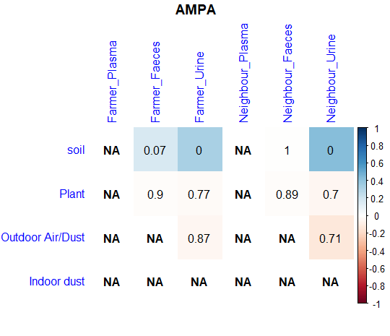 | 