Supplementary material
New insights into the occurrence of vehicle related compounds in one of Europe's longest rivers
Juan Escobar-Arnanz^{a,}*, Silvia Royanoª, Irene Navarroª, Adrián de la Torre^{a,1}, María Ángeles Martínez^{a,1}
*Corresponding author contact information
Email: Juan.Escobar@ciemat.es
ªUnit of POPs and Emerging Pollutants in Environment, Department of Environment, CIEMAT, Avda. Complutense 40, E-28040 Madrid, Spain Madrid, Spain.
¹Adrián de la Torre and María Ángeles Martínez share last authorship.

Supplementary material-1

TABLE OF CONTENTS
 | Page
FIGURES
Figure S1. Location and traffic details around sampling points S1 to S13. Average daily traffic (vehicles/day) of the main roads around each point is depicted. Average daily traffic of the regional roads around S11, S12 and S13 were not available. | 8
Figure S2. General workflow for data processing. | 17
Figure S3. Identification workflow based on Schymanski’s scale followed for suspect analysis. | 18
Figure S4. Chemical structures of VRCs identified in surface waters from the Tagus River basin. | 19
Figure S5. Box and whisker plots of the normalized area (logarithmic scale) of the 46 VRCs compounds detected in surface water samples in (A).annual and (B) seasonal campaigns. | 25
Figure S6. Bar plots depicting the normalized areas per sampling point (S1 to S13) of individual compounds and compounds grouped by their main use in the vehicle industry, for river water samples collected annually in (A) 2020, (B) 2021 and (C) 2022. Sample from S8 was not collected in 2020 annual campaign. | 26
Figure S7. Bar plots depicting the normalized areas per sampling point (S1 to S13) of individual compounds and compounds grouped by their main use in the vehicle industry, for river water samples collected seasonally during 2022 in (A) March, (B) June, (C) September and (D) December. Sample from S7 was not collected in June 2022 campaign. | 27
Figure S8. Number of detected compounds (as sum of detected compounds in all samples) by chemical class and use in all surface water samples. | 28
Figure S9. Contribution (%) to the total number of detected compounds by (A) chemical class and (B) compound use in all surface water samples. | 28
Figure S10. Monthly average rainfall (mm) in the Tagus River during 2022. | 29
Figure S11. Normalized area for DPG in 2022 comparing (A) seasonal samplings and (B) dry and wet periods. Upper edge of the box, line within the box and lower edge of the box represent the 75th, 50th, and 25th percentiles. Vertical lines indicates the extension from the minimum to the maximum value. | 29
Figure S12. XIC chromatograms and MS/MS mass spectrum of 6PPD-Q in river water samples (upper panels). Identification by reference standard (identification level, 1) whose XIC chromatogram and MS/MS mass spectrum are depicted in the bottom panels. | 29
Figure S13. XIC chromatograms and MS/MS mass spectrum of 6PPD TP274 in river water samples. Identification level, 2a. | 30
Figure S14. MS/MS mass spectrum of HMMM detected in river water samples. | 30
Figure S15. XIC chromatograms of five major methoxy-methyl-melamine compounds detected in river water samples: (A) HMMM, (B) d-HMMM, (C) HMPE, (D) TMMM and (E) DMMM. | 31
Figure S16. MS/MS mass spectrum of d-HMMM detected in river water samples. | 31
Figure S17. MS/MS mass spectrum of HMPE detected in river water samples. | 32
Figure S18. MS/MS mass spectrum of TMMM detected in river water samples. | 32
Figure S19. MS/MS mass spectrum of DMMM detected in river water samples. | 32
Figure S20. XIC chromatograms of three minor methoxy-methyl-melamine compounds detected in river water samples: (B) dd-HMMM, (C) dd-PMMM, (D) PMMM. As reference of the elution order the upper panel (A) shows the XIC chromatograms of the major HMMM-related compounds (HMMM, d-HMMM. HMPE, TMMM and DMMM). | 34
Figure S21. MS/MS mass spectra of minor HMMM-related compounds detected in river water samples (A) dd-HMMM, (B) dd-PMMM and (C) PMMM. | 35
Figure S22. Box and whisker plots for HMMM-related compounds detected in the samples depicted as total area (upper panels) and individual area those compounds with DF>20%. Panels in the left side (A, C) show data from annual campaigns, while panels in the right show data of the seasonal samplings. | 36
Figure S23. Median normalized areas of VRCs (DF>20%) in locations S7 and S8. | 36
Figure S24. Annual variation for the sum of (A) normalized areas and (B) number of detected VRCs. Upper edge of the box, line within the box and lower edge of the box represent the 75th, 50th, and 25th percentiles. Vertical lines indicates the extension from the minimum to the maximum value. | 37
Figure S25. Seasonal variation for the sum of (A) normalized areas and (B) number of detected VRCs. Upper edge of the box, line within the box and lower edge of the box represent the 75th, 50th, and 25th percentiles. Vertical lines indicates the extension from the minimum to the maximum value. | 37
Figure S26. PC1 and PC2 from Principal Component Analysis depicting (A) Loading plot and score plots considering (B) chemical class and (C) compound use. | 39
Figure S27. PC1 and PC3 from Principal Component Analysis depicting (A) Loading plot and score plots considering (B) chemical class and (C) compound use. | 39
Figure S28. PC2 and PC3 from Principal Component Analysis depicting (A) Loading plot and score plots considering (B) chemical class and (C) compound use. | 40
TABLES
Table S1. Details of annual and seasonal sampling campaigns along the Tagus River basin (2020-2022). | 4
Table S2. Details of sampling points and classification of their anthropogenic impact according to river flow/inputs, inhabitants and average daily traffic. | 7
Table S3. Details of recovery (ISTD), external and confirmation standards (STD) used in the current study. | 11
Table S4. ISTDs used for normalization via sample specific ISTD-ratio. | 13
Table S5. Chromatographic conditions used in the current study with a SCIEX ExionLC™ AC system. | 13
Table S6. MS conditions in DIA acquisition mode with a SCIEX X500R QTOF system. | 14
Table S7. MS conditions in DDA acquisition mode with a SCIEX X500R QTOF system. | 15
TableS11. 26 VRCs identified in surface water samples from the Tagus River with detection frequencies above 20%. | 23
Table S12. Spearman`s Rho correlation matrix. | 33
Table S13. Component matrix. Extraction method by Principal Component Analysis. | 38
Table S14. Cumulative variance for all components of Principal Component Analysis. | 38
TEXT
Text S1. Classification of anthropogenic impact of sampling points. | 6
Text S2. Quality assurance and quality control. | 13
Text S3. General data treatment workflow and data reduction procedure. | 15
REFERENCES | 41

Table S1. Details of annual and seasonal sampling campaigns along the Tagus River basin (2020-2022).
Site | Year | Sampling campaign | Sampling date
S1 | 2020 | Annual | 28/09/2020
S2 | 2020 | Annual | 01/10/2020
S3 | 2020 | Annual | 05/10/2020
S4 | 2020 | Annual | 05/10/2020
S5 | 2020 | Annual | 06/10/2020
S6 | 2020 | Annual | 06/10/2020
S7 | 2020 | Annual | 02/10/2020
S8 | 2020 | Annual | Not sampled
S9 | 2020 | Annual | 08/10/2020
S10 | 2020 | Annual | 13/10/2020
S11 | 2020 | Annual | 14/10/2020
S12 | 2020 | Annual | 19/10/2020
S13 | 2020 | Annual | 16/10/2020
S1 | 2021 | Annual | 25/10/2021
S2 | 2021 | Annual | 04/10/2021
S3 | 2021 | Annual | 07/10/2021
S4 | 2021 | Annual | 15/10/2021
S5 | 2021 | Annual | 08/10/2021
S6 | 2021 | Annual | 08/10/2021
S7 | 2021 | Annual | 05/10/2021
S8 | 2021 | Annual | 13/10/2021
S9 | 2021 | Annual | 06/10/2021
S10 | 2021 | Annual | 25/10/2021
S11 | 2021 | Annual | 25/10/2021
S12 | 2021 | Annual | 26/10/2021
S13 | 2021 | Annual | 05/10/2021
S1 | 2022 | Annual | 19/12/2022
S2 | 2022 | Annual | 24/10/2022
S3 | 2022 | Annual | 25/11/2022
S4 | 2022 | Annual | 25/11/2022
S5 | 2022 | Annual | 14/11/2022
S6 | 2022 | Annual | 14/11/2022
S7 | 2022 | Annual | 25/10/2022
S8 | 2022 | Annual | 01/12/2022
S9 | 2022 | Annual | 28/11/2022
S10 | 2022 | Annual | 05/10/2022
S11 | 2022 | Annual | 06/10/2022
S12 | 2022 | Annual | 06/10/2022
S13 | 2022 | Annual | 16/11/2022
S1 | 2022 | Seasonal | 10/03/2022
S2 | 2022 | Seasonal | 31/03/2022
S3 | 2022 | Seasonal | 02/03/2022
S4 | 2022 | Seasonal | 02/03/2022
S5 | 2022 | Seasonal | 07/03/2022
S6 | 2022 | Seasonal | 07/03/2022
S7 | 2022 | Seasonal | 28/03/2022
S8 | 2022 | Seasonal | 07/03/2022
S9 | 2022 | Seasonal | 09/03/2022
S10 | 2022 | Seasonal | 08/03/2022
S11 | 2022 | Seasonal | 15/03/2022
S12 | 2022 | Seasonal | 16/03/2022
S13 | 2022 | Seasonal | 02/03/2022
S1 | 2022 | Seasonal | 09/06/2022
S2 | 2022 | Seasonal | 13/06/2022
S3 | 2022 | Seasonal | 14/06/2022
S4 | 2022 | Seasonal | 15/06/2022
S5 | 2022 | Seasonal | 06/06/2022
Table S1 (cont.). Details of annual and seasonal sampling campaigns along the Tagus River basin (2020-2022).
Site | Year | Sampling campaign | Sampling date
S6 | 2022 | Seasonal | 06/06/2022
S7 | 2022 | Seasonal | Not sampled
S8 | 2022 | Seasonal | 06/06/2022
S9 | 2022 | Seasonal | 08/06/2022
S10 | 2022 | Seasonal | 07/06/2022
S11 | 2022 | Seasonal | 27/06/2022
S12 | 2022 | Seasonal | 23/06/2022
S13 | 2022 | Seasonal | 01/06/2022
S1 | 2022 | Seasonal | 07/09/2022
S2 | 2022 | Seasonal | 12/09/2022
S3 | 2022 | Seasonal | 21/09/2022
S4 | 2022 | Seasonal | 12/09/2022
S5 | 2022 | Seasonal | 31/08/2022
S6 | 2022 | Seasonal | 31/08/2022
S7 | 2022 | Seasonal | 13/09/2022
S8 | 2022 | Seasonal | 31/08/2022
S9 | 2022 | Seasonal | 15/09/2022
S10 | 2022 | Seasonal | 19/09/2022
S11 | 2022 | Seasonal | 27/09/2022
S12 | 2022 | Seasonal | 28/09/2022
S13 | 2022 | Seasonal | 22/09/2022
S1 | 2022 | Seasonal | 19/12/2022
S2 | 2022 | Seasonal | 27/12/2022
S3 | 2022 | Seasonal | 25/11/2022
S4 | 2022 | Seasonal | 27/12/2022
S5 | 2022 | Seasonal | 01/12/2022
S6 | 2022 | Seasonal | 01/12/2022
S7 | 2022 | Seasonal | 12/12/2022
S8 | 2022 | Seasonal | 01/12/2022
S9 | 2022 | Seasonal | 20/12/2022
S10 | 2022 | Seasonal | 20/12/2022
S11 | 2022 | Seasonal | 12/12/2022
S12 | 2022 | Seasonal | 13/12/2022
S13 | 2022 | Seasonal | 21/12/2022

Text S1. Classification of anthropogenic impact of sampling points.
Anthropogenic impact (low, medium or high) on each sampling point was evaluated according to number of inhabitants (Instituto Nacional de Estadística (INE), 2025), average daily traffic (ADT) (Dirección General de Carreteras. Comunidad de Madrid, 2022; Dirección General de Carreteras. Consejería de Fomento. Castilla-La Mancha, 2022; Ministerio de Transporte, 2021) and specific river flow or inputs at each point (Royano et al., 2023). Average daily traffic corresponds to the number of vehicles per day passing through a specific section of the road and was compiled for the main roads around each point.
The sampling points with high anthropogenic impact S2, S3 and S4 correspond to urban sites as they are located in the city of Madrid (3.3 million inhabitants) and are surrounded by roads with high traffic density (>15,000 vh/day). S5 was also classified as a high impacted site as it is located downstream of the previous points and receives the direct discharge from the Madrid metropolitan area. It is also close to a large municipality (Aranjuez city; 59,762 inhabitants) with an ADT of more than 20,000 vh/day through surrounding urban arterial roads. S6 and S7 are located in the Tagus River also close to Aranjuez area, but have rather different characteristics. S6 is upstream the city and was classified as low anthropogenic impact. S7 is located downstream Aranjuez and close to a highway with 40,000 vh/day. However, it was classified as medium anthropogenic impact as in this point there is an important dilution effect and increase of the flow of the water body due to the junction of the Jarama River and the Tagus River from less polluted areas (S6).
Other points with a medium anthropogenic impact are S8, S9, S10 and S12, which are located in areas of medium population influence with lower density and anthropogenic activity than the Community of Madrid. In S8 the flow of the Tagus River is significant, while S9 has the opposite situation, as it is located on a tributary with a very low flow.
S1, S11 and S13 are located in remote areas with low levels of population and low traffic densities, so were classified as low anthropogenic impacted sites.
Table S2. Details of sampling points and classification of their anthropogenic impact according to river flow/inputs, inhabitants and average daily traffic.
Site | UTMX | UTMY | River | Municipality (province) | River flow/inputsª | Inhabitants^{b} | Average daily traffic^{c, d, e} | Anthropogenic impact
S1 | 562,378 | 4,487,590 | Guadiela | Cañizares (Cuenca) | Low | Low | Low | Low
S2 | 456,764 | 4,471,760 | Jarama | Mejorada del Campo (Madrid) | Low | High | High | High
S3 | 453,833 | 4,461,168 | Jarama | Rivas-Vaciamadrid (Madrid) | Medium | High | High | High
S4 | 449,199 | 4,461,632 | Manzanares | Getafe (Madrid) | Medium | High | High | High
S5 | 448,137 | 4,437,335 | Jarama | Aranjuez (Madrid) | Medium | High | High | High
S6 | 452,121 | 4,432,818 | Tajo | Aranjuez (Madrid) | Low | Low | Low | Low
S7 | 443,484 | 4,432,071 | Tajo | Aranjuez (Madrid) | High | High | High | Medium
S8 | 413,267 | 4,413,772 | Tajo | Toledo (Toledo) | High | High | High | Medium
S9 | 411,552 | 4,427,537 | Guadarrama | Bargas (Toledo) | Low | Medium | Medium | Medium
S10 | 364,743 | 4,420,877 | Tajo | Cebolla (Toledo) | High | Medium | Medium | Medium
S11 | 276,945 | 4,433,529 | Tietar | Talayuela (Cáceres) | Medium | Low | Low | Low
S12 | 226,285 | 4,437,778 | Jerte | Carbacoso (Cáceres) | Medium | Medium | Medium | Medium
S13 | 111,595 | 4,400,310 | Tajo | Cedillo (Cáceres) | - | Low | Low | Low
ªRoyano, S., de la Torre, A., Navarro, I., Martínez, M.Á., 2023. Pharmaceutically active compounds (PhACs) in surface water: Occurrence, trends and risk assessment in the Tagus River Basin (Spain). Sci. Total Environ. 905, 167422. https://doi.org/10.1016/j.scitotenv.2023.167422
^{b}Instituto Nacional de Estadística (INE), 2025. Cifras oficiales de población de los municipios españoles en aplicación de la Ley de Bases del Régimen Local (Art. 17). Población por municipio y sexo. https://www.ine.es/jaxiT3/Tabla.htm?t=2852 (accessed 03/06/2025).
^{c}Dirección General de Carreteras. Comunidad de Madrid. Tráfico IMD 2022. https://www.comunidad.madrid/servicios/transporte/estudio-intensidad-media-diaria-vehiculos-imd (accessed 04/06/2025).
^{d}Dirección General de Carreteras. Consejería de Fomento. Castilla-La Mancha. Aforo Tráfico. IMD 2022. Castilla-La Mancha, 2022. https://www.castillalamancha.es/sites/default/files/documentos/pdf/20230419/dossier_imd_2022.pdf (accessed 04/06/2025).

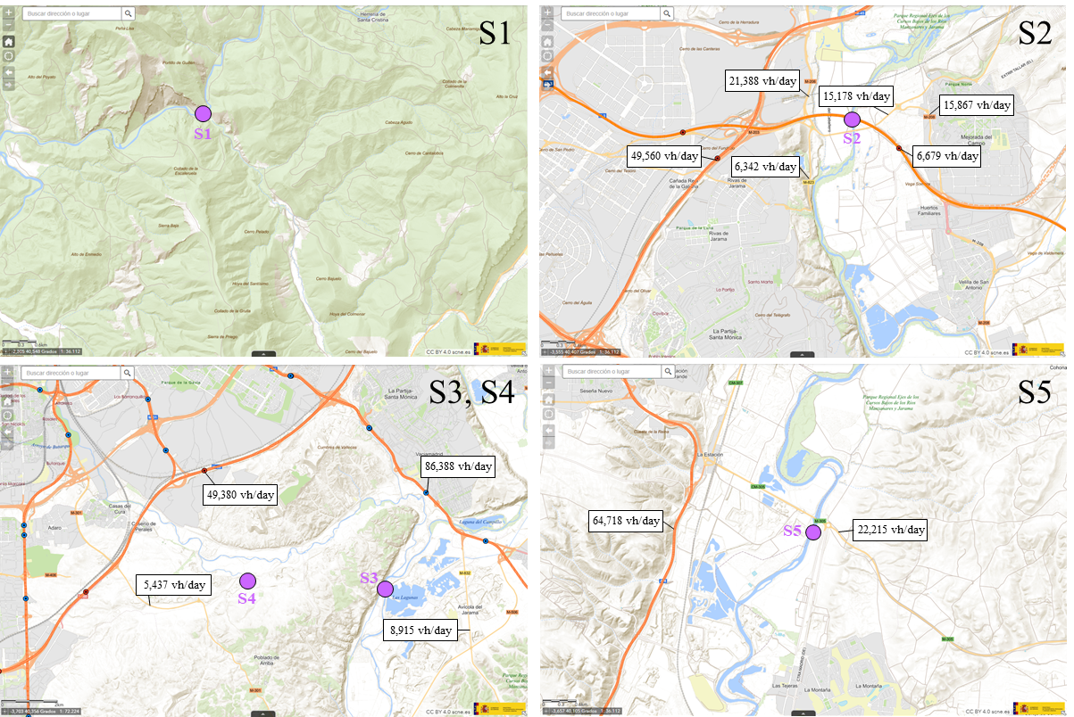
Figure S1. Location and traffic details around sampling points S1 to S13. Average daily traffic (vehicles/day) of the main roads around each point is depicted. Average daily traffic of the regional roads around S11, S12 and S13 were not available.
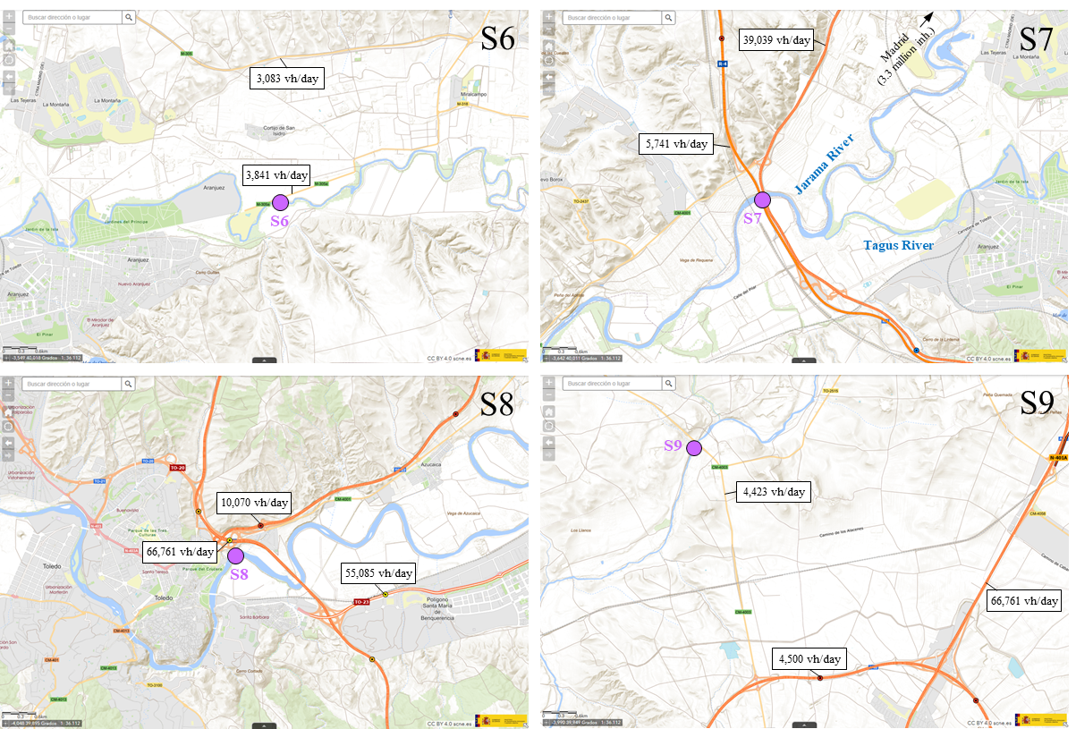
Figure S1 (cont.). Location and traffic details around sampling points S1 to S13. Average daily traffic (vehicles/day) of the main roads around each point is depicted. Average daily traffic of the regional roads around S11, S12 and S13 were not available.
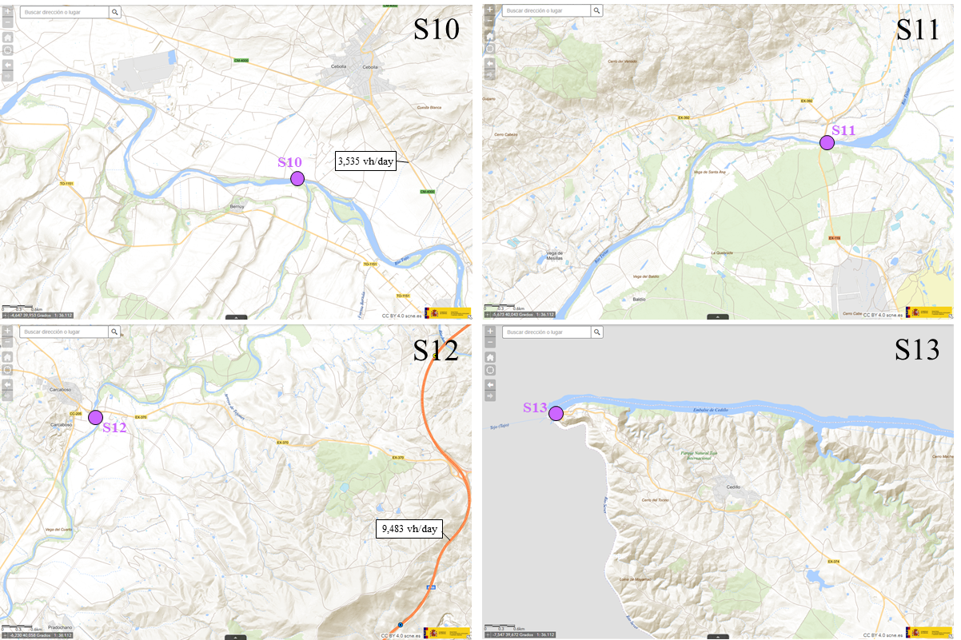
Figure S1 (cont.). Location and traffic details around sampling points S1 to S13. Average daily traffic (vehicles/day) of the main roads around each point is depicted. Average daily traffic of the regional roads around S11, S12 and S13 were not available.
Table S3. Details of recovery (ISTD), external and confirmation standards (STD) used in the current study.
Compound | CAS | Formula | Laboratory
Recovery standards (ISTD) (n=10)
Azoxystrobin-d4 | 1346606-39-0 | C₂₂H₁₃D₄N₃O₅ | A2S
Boscalid-d4 | 2468796-76-9 | C₁₈H₈D₄Cl₂N₂O | A2S
Dimethoate-d6 | 1219794-81-6 | C₅H₆D₆NO₃PS₂ | A2S
Diuron-d6 | 1007536-67-5 | C₉H₄D₆Cl₂N₂O | A2S
Epoxiconazole-d4 | 133855-98-8ª | C₁₇H₉D₄ClFN₃O | A2S
Metolachlor-d6 | 1219803-97-0 | C₁₅H₁₆D₆ClNO₂ | A2S
Terbuthylazine-d5 | 222986-60-9 | C₉H₁₁D₅ClN₅ | A2S
Thiacloprid-d4 | 1793071-39-2 | C₁₀H₅D₄ClN₄S | LabStandard
Atenolol-d7 | 1202864-50-3 | C₁₅H₁₅D₇N₂O₃ | LabStandard
Venlafaxine-d6 | 1062606-12-5 | C₁₇H₂₂D₆ClNO₂ | LoGiCal
External standards (n=23)
Azithromycin | 83905-01-5 | C₃₈H₇₂N₂O₁₂ | LabStandard
Clarithromycin | 81103-11-9 | C₃₈H₆₉NO₁₃ | Dr Ehrentsorfer
Erythromycin | 114-07-8 | C₃₇H₆₇NO₁₃ | Dr Ehrentsorfer
Anhydroerythromycin | 23893-13-2 | C₃₇H₆₅NO₁₂ | Pharma Analytical Standards Solutions
Sulfamethoxazole | 723-46-6 | C₁₀H₁₁N₃O₃S | Dr Ehrenstorfer
Trimethoprim | 738-70-5 | C₁₄H₁₈N₄O₃ | Dr Ehrenstorfer
Atenolol | 29122-68-7 | C₁₄H₂₂N₂O₃ | LabStandard
Irbesartan | 138402-11-6 | C₂₅H₂₈N₆O | Dr Ehrenstorfer
Metoprolol | 56392-17-7 | C₁₅H₂₅NO₃ | LabStandard
Valsartan | 137862-53-4 | C₂₄H₂₉N₅O₃ | Dr Ehrenstorfer
O-desmethylvenlafaxine | 93413-62-8 | C₁₆H₂₅NO₂ | Dr Ehrenstorfer
Venlafaxine | 99300-78-4 | C₁₇H₂₇NO₂ | LabStandard
Carbamazepine | 298-46-4 | C₁₅H₁₂N₂O | Dr Ehrenstorfer
Acetaminophen | 103-90-2 | C₈H₉NO₂ | LabStandard
Ibuprofen | 15687-27-1 | C₁₃H₁₈O₂ | LabStandard
Ketoprofen | 22071-15-4 | C₁₆H₁₄O₃ | LabStandard
Naproxen | 22204-53-1 | C₁₄H₁₄O₃ | Dr Ehrenstorfer
Atorvastatin | 134523-03-8 | C₃₃H₃₅N₂FO₅ | LabStandard
Gemfibrozil | 25812-30-0 | C₁₅H₂₂O₃ | LabStandard
Clotrimazole | 23593-75-1 | C₂₂H₁₇ClN₂ | Dr Ehrenstorfer
Fluconazole | 86386-73-4 | C₁₃H₁₂F₂N₆O | Dr Ehrenstorfer
Miconazole | 22916-47-8 | C₁₈H₁₄Cl₄N₂O | LabStandard
Table S3 (cont.). Details of recovery (ISTD), external and confirmation standards (STD) used in the current study.
Compound | CAS | Formula | Supplier
Thiabendazole | 148-79-8 | C₁₀H₇N₃S | Dr Ehrenstorfer
Confirmation standards (n=25)
N-(1,3-dimethylbutyl)-N′-phenyl-p-phenylenediamine (6PPD) | 793-24-8 | C₁₈H₂₄N₂ | A2S
N-(1,3-dimethylbutyl)-N′-phenyl-p-phenylenediamine quinone (6PPD-Q) | 2754428-18-5 | C₁₈H₂₂N₂O₂ | A2S
N-isopropyl-N′-phenyl-1,4-phenylenediamine (IPPD) | 101-72-4 | C₁₅H₁₈N₂ | A2S
N-isopropyl-N′-phenyl-1,4-phenylenediamine quinone (IPPD-Q) | 68054-73-9 | C₁₅H₁₆N₂O₂ | A2S
N,N′-diphenyl-p-phenylenediamine (DPPD) | 74-31-7 | C₁₈H₁₆N₂ | A2S
N,N′-di(o-tolyl)-p-phenylenediamine (DTPD) | 620-91-7 | C₂₀H₂₀N₂ | TRC Canada
4-Hydroxydiphenylamine (4-HDPA) | 122-37-2 | C₁₂H₁₁NO | A2S
1,3-Diphenylguanidine (DPG) | 102-06-7 | C₁₃H₁₃N₃ | A2S
1,3-Di-o-tolylguanidine (DTG) | 97-39-2 | C₁₅H₁₇N₃ | A2S
1,3-Dicyclohexylurea (DCU) | 2387-23-7 | C₁₃H₂₄N₂O | A2S
1-Cyclohexyl-3-phenylurea (CPU) | 886-59-9 | C₁₃H₁₈N₂O | A2S
Tributylamine (TBA) | 102-82-9 | C₁₂H₂₇N | A2S
Dibenzylamine (DBA) | 103-49-1 | C₁₄H₁₅N | A2S
1,3-Dimethylbutylamine (DMBA) | 108-09-8 | C₆H₁₅N | A2S
Dicyclohexylamine (M-DCA) | 7560-83-0 | C₁₃H₂₅N | A2S
N-Cyclohexyl-1,3-benzothiazol-2-amine (DCMA) | 28291-75-0 | C₁₃H₁₆N₂S | A2S
N-cyclohexylbenzothiazole-2-sulfenamide (CBS) | 95-33-0 | C₁₃H₁₆N₂S₂ | A2S
Hexa(methoxymethyl)melamine (HMMM) | 3089-11-0 | C₁₅H₃₀N₆O₆ | A2S
Benzothiazole (BT) | 95-16-9 | C₇H₅NS | A2S
2-Hydroxybenzothiazole (2-OH-BT) | 934-34-9 | C₇H₅NOS | A2S
2-Aminobenzothiazole (2-ABT) | 136-95-8 | C₇H₆N₂S | A2S
2-Mercaptobenzothiazole (MBTZ) | 149-30-4 | C₇H₅NS₂ | A2S
2-(Methylthio)bezothiazole (MTBT) | 615-22-5 | C₈H₇NS₂ | A2S
Benzotriazole (BTR) | 95-14-7 | C₆H₅N₃ | A2S
5-Methyl-1H-benzotriazole (Me-BTR) | 136-85-6 | C₇H₇N₃ | A2S
ªData corresponding to unlabelled compound.

Table S4. ISTDs used for normalization via sample specific ISTD-ratio.
Compound | m/z | tR (min)
Atenolol-d7 | 274.2143; 145.0649; 191.0923 | 2.46
Dimethoate-d6 | 236.0446; 131.0203 | 5.20
Thiacloprid-d4 | 257.0560; 126.0109 | 6.39
Venlafaxine-d6 | 284.2491; 266.2392; 215.1429; 64.1027 | 6.89
Diuron-d6 | 239.0620; 159.9718 | 9.41
Terbuthylazine-d5 | 235.1481; 179.0865 | 10.60
Azoxystrobin-d4 | 408.1492; 376.1243; 348.1293 | 10.61
Boscalid-d4 | 347.0650; 311.0881 | 10.69
Epoxiconazole-d4 | 334.1055; 121.0450 | 11.57
Metolachlor-d6 | 290.1788; 258.1520; 182.181 | 11.62
In bold: Precursor, [M+H]⁺.
Text S2. Quality assurance and quality control.
Deuterated compounds were used as internal standards (ISTDs; n=10) for signal normalization and quality control purposes. A mixture of external reference standards available in the laboratory (n=23) was also used to control and monitor instrument performance during instrumental analysis. Reference standards (n=25) were used for confirmation of the identity of tentatively identified VRC compounds by suspect approach. Detailed information on all the standards is included in Table S3.
Field and instrumental blanks were analysed in every batch of samples to ensure proper method development. Field blanks, treated in the same manner as samples, were used to exclude unreliable signals during data processing where only peak areas above 10 times the average field blank samples were considered (Krauss et al., 2019; Oetjen and Tackett, 2023; Tarábek et al., 2024). Also, blanks of plastic materials used during sample treatment (e.g., bottles, pipettes, septum vials, SPE cartridges) were checked to assess possible cross-contamination.

Table S5. Chromatographic conditions used in the current study with a SCIEX ExionLC™ AC system.
Instrument | SCIEX ExionLC™ AC system
Columns
Guard column | Securityguard column C18 (2.1 x 4,6 mm) (Phenomenex, CA, USA)
Analytical column | Luna® Omega 1.6 μm C18 100 Å (100 × 2.1 mm i.d) (Phenomenex, CA, USA)
General parameters
Total run time | 22 min
Injection volume | 5 µL
Oven temperature | 40 ºC
Chromatopraphy
Mobile phase A | Milli-Q water (2 mM ammonium formate; 0.1% formic acid)
Mobile phase B | Methanol (2 mM ammonium formate; 0.1% formic acid)
Flow | 0.35 mL/min
Gradient
 | Time (min) | Flow (mL/min) | MP A (%) | MP B (%)
 | 0 | 0.35 | 95 | 5
 | 1 | 0.35 | 80 | 20
 | 15 | 0.35 | 5 | 95
 | 17 | 0.35 | 5 | 95
 | 17.1 | 0.35 | 0 | 100
 | 19 | 0.35 | 0 | 100
 | 19.1 | 0.35 | 95 | 5
 | 22 | 0.35 | 95 | 5

Table S6. MS conditions in DIA acquisition mode with a SCIEX X500R QTOF system.
Instrument | SCIEX X500R QTOF
Ion source
Model | SCIEX Turbo V™ ion source
Ionization mode | ESI+
Acquisition mode | DIA (SWATH in SCIEX software)
General parameters
Total run time | 22 min
Total scan time | 0.851 s
Cycles | 1,551
Source and Gas Parameters
Temperature | 550 ºC
Ion source gas 1 | 60 psi
Ion source gas 2 | 60 psi
Curtain gas | 35 psi
CAD gas | 9
Spray voltage | 5,500 V
TOF MS
Mass range | 100 – 1,100 Da
DP | 60 V
DP Spread | 0 V
CE | 10 V
CE spread | 0 V
Accumulation time | 0.03 s
TOF MS/MS
Mass range | 40 – 1,100 Da
Accumulation time | 0.03 s
DDA windows
 | Start mass (Da) | Stop mass (Da) | DP (V) | DP spread (V) | CE (V) | CE spread (V)
1 | 100 | 120 | 60 | 30 | 35 | 15
2 | 119 | 140 | 60 | 30 | 35 | 15
3 | 139 | 160 | 60 | 30 | 35 | 15
4 | 159 | 180 | 60 | 30 | 35 | 15
5 | 179 | 200 | 60 | 30 | 35 | 15
6 | 199 | 220 | 60 | 30 | 35 | 15
7 | 219 | 240 | 60 | 30 | 35 | 15
8 | 239 | 260 | 60 | 30 | 35 | 15
9 | 259 | 280 | 60 | 30 | 35 | 15
10 | 279 | 300 | 60 | 30 | 35 | 15
11 | 299 | 320 | 60 | 30 | 35 | 15
12 | 319 | 340 | 60 | 30 | 35 | 15
13 | 339 | 360 | 60 | 30 | 35 | 15
14 | 359 | 380 | 60 | 30 | 35 | 15
15 | 379 | 400 | 60 | 30 | 35 | 15
16 | 399 | 420 | 60 | 30 | 35 | 15
17 | 419 | 440 | 60 | 30 | 35 | 15
18 | 439 | 460 | 60 | 30 | 35 | 15
19 | 459 | 480 | 60 | 30 | 35 | 15
20 | 479 | 500 | 60 | 30 | 35 | 15
21 | 499 | 600 | 60 | 30 | 35 | 15
22 | 599 | 800 | 60 | 30 | 35 | 15
23 | 799 | 1100 | 60 | 30 | 35 | 15
DIA: Data independent acquisition.
ESI+: Positive electrospray ionization.
DP: Declustering potential.
CE: Collision energy.

Table S7. MS conditions in DDA acquisition mode with a SCIEX X500R QTOF system.
Instrument | SCIEX X500R QTOF
Ion source
Model | SCIEX Turbo V™ ion source
Ionization mode | ESI+
Acquisition mode | DDA (IDA in SCIEX software)
General parameters
Total run time | 22 min
Total scan time | 0.628 s
Cycles | 2,102
Source and Gas Parameters
Temperature | 550 ºC
Ion source gas 1 | 60 psi
Ion source gas 2 | 60 psi
Curtain gas | 35 psi
CAD gas | 9
Spray voltage | 5,500 V
TOF MS
Mass range | 100 – 1,100 Da
DP | 60 V
DP Spread | 0 V
CE | 10 V
CE spread | 0 V
Accumulation time | 0.1 s
DDA criteria | Small molecule
 | Maximum candidate ions | 15 ions
 | Intesity threshold | 100 cps
 | Dynamic background substraction | enabled
 | Exclude former candidate ions | for 3 s
 |  | after 2 occurrences
TOF MS/MS
Mass range | 40 – 1,100 Da
DP | 60 V
DP Spread | 0 V
CE | 35 V
CE spread | 15 V
Accumulation time | 0.03 s
DDA: Data dependent acquisition.
ESI+: Positive electrospray ionization.
DP: Declustering potential.
CE: Collision energy.

Text S3. General data treatment workflow and data reduction procedure.
In the first place, two parallel data processing methods for an overall screening were applied in order to optimize data processing, prioritize and reduce the initial suspect list comprised by 153 VRCs. Data obtained by both approaches were combined and later used for identification of contaminants.
On one hand, a first data processing was conducted in order to identify predominant compounds in the analyzed samples. For that purpose, a batch was created including river water samples (n=10) from highly anthropogenic locations, selected due to the greater pollutant load and, hence, the higher number of compounds expected in these extracts. Procedural field blanks were included in the batch to facilitate data simplification. Molecular ion, adducts, and fragment information was included for each suspect in the component list of the method and the 5 candidate most intense peaks were searched for each component. This scenario resulted in more than 2,500 potential features per sample after data processing and the following data reduction and prioritization procedure was applied:
- All peaks with a peak height less than 10,000 cps were excluded.
- Peak shape was prioritized and just those chromatographic peaks with a full width at half maximum (FWHM) value below 0.2 were maintained.
- Features with S/N < 3 and less than 10 times above average peak area of the blanks (±0.3 min, same mass spectra) were excluded.
- Just those suspect features with an accurate mass error below 5 ppm were maintained.
- Duplicates were removed from the peak table.
- Data were manually review and excluded as considered necessary.
- Mass spectra were inspected and those peaks with high quality HRMS data matching reference information were simultaneously added to an in-house mass spectral library.
- Candidate peaks were annotated and preserved for further data analysis.
On the other hand, a second strategy was designed to identify potential interesting features with high detection frequencies. For this purpose, the same initial list of 153 VRC suspects was used and applied to the total number of samples. In this case, the chromatograms were processed to look for the most intense peak of each suspect, which reduced the potential number of detected features to less than 500 per sample. HRMS data were manually inspected and those interesting candidate features detected in 25% of the samples and >10 above blanks were maintained in the suspect list and their retention time (RT) was preserved for the next step of the workflow. As in the previous case, those high quality MS/MS spectra of unambiguously assigned compounds were added to the in-house mass spectral library.
Both procedures complementary yielded a reduced suspect list of 62 candidate features which was used to create a new data processing method. This method simulated a semi-targeted approach as it included RTs of suspect features in order to increase accuracy in peak detection and integration. Features from the peak table were manually review and the identification was assigned according to criteria proposed by Schymanski et al. (2014) (Schymanski et al., 2014), where different identification levels (IL) were proposed:
- Level 1: Confirmation with reference standard by matching of retention time and MS/MS data.
- Level 2a: MS/MS fragmentation pattern match mass spectrum from library database.
- Level 2b: Diagnostic evidence indicating that no other structure is possible.
- Level 3: Tentative identification based on MS/MS fragmentation. Evidence to propose a structure exist but other isomers or related structures are possible.
- Level 4: MS/MS information insufficient to propose a structure, but good mass error (<5ppm) indicates a plausible candidate formula.
- Level 5: No structure or formula can be assigned, but exact mass and retention time are provided.
To reach previous identification levels, in all cases, HRMS data must be review in order to have a 70% match with libraries (when available), a maximum accurate mass error of 5 ppm and an isotopic pattern difference among 5-20%. When mass spectra were not available for automatic software processing, manual inspection was performed by comparison with compiled mass spectra from literature or online databases. In-silico fragmentation using ChemSpider tool within SCIEX OS was also used as an additional evidence for structural confirmation. Fragment RT must match precursor RT and a threshold value of 5 ppm for mass error should be met.
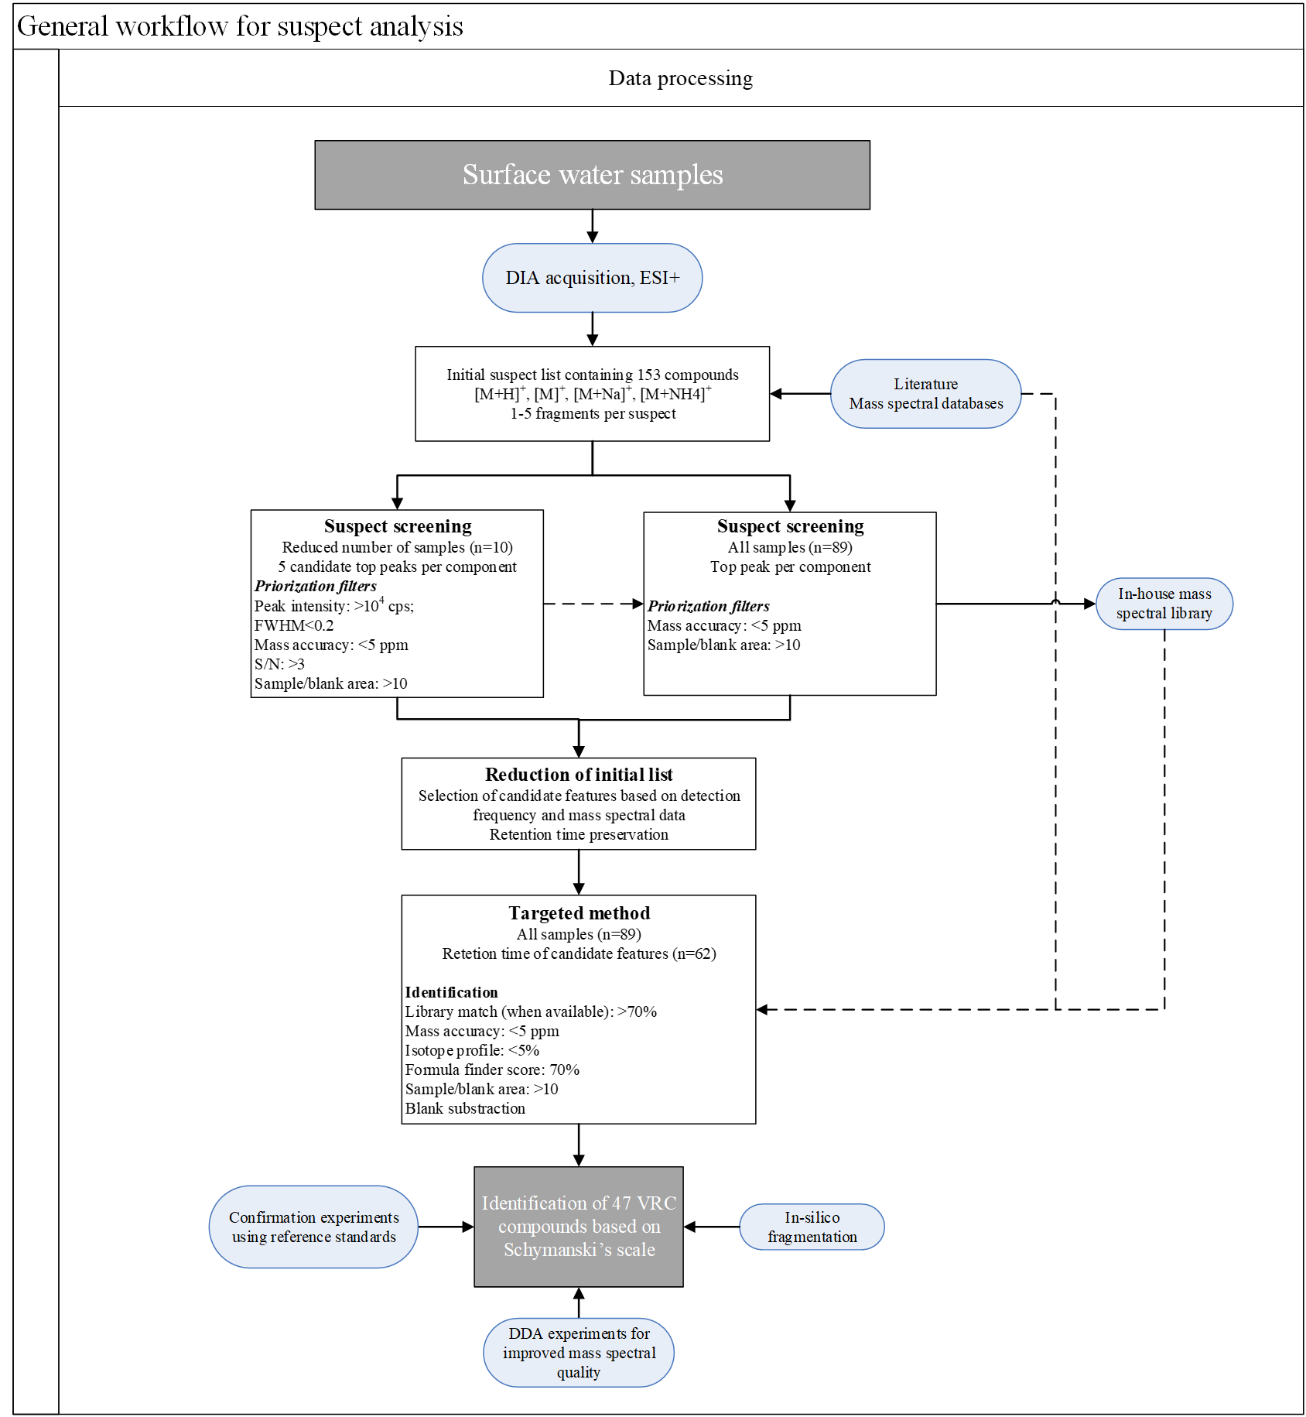
Figure S2. General workflow for data processing.

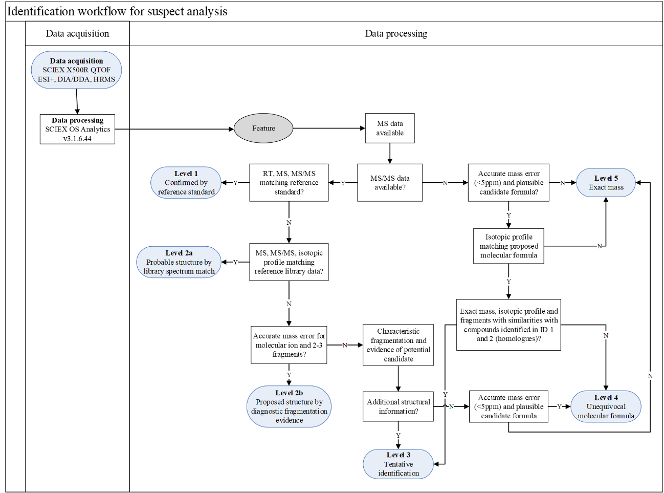
Figure S3. Identification workflow based on Schymanski’s scale followed for suspect analysis.

6PPD-Q | 6PPD TP274 | 4-NDPA | DPG
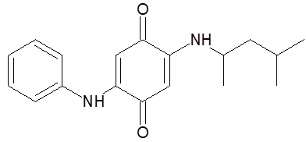 | 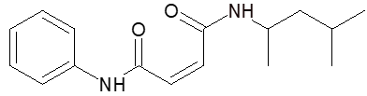 | 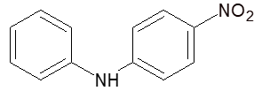 | 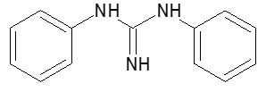
DTG | 123-TPG | DCU | CPU
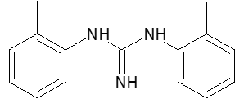 | 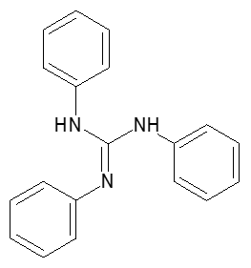 | 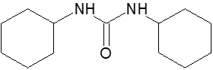 | 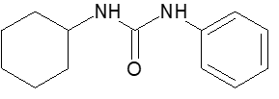
C-DMU | DPU | PU | CHU
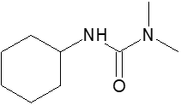 | 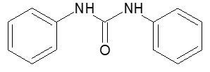 | 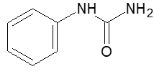 | 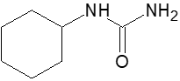
Figure S4. Chemical structures of VRCs identified in surface waters from the Tagus River basin.

N-Hexyl-N'-cyclohexylurea | N-Hexyl-N'-phenylurea | TBA | DBA
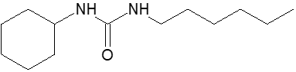 | 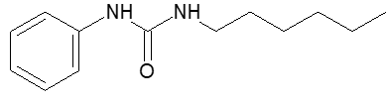 | 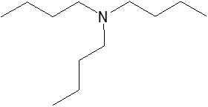 | 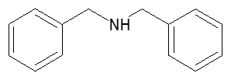
DCA | M-DCA | Acetanilide | N,N’-Dimethylaniline
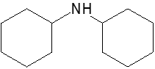 | 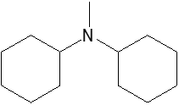 | 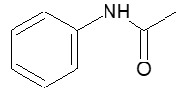 | 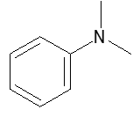
2-DBAE | TIPA | HMMM | d-HMMM
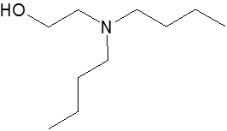 | 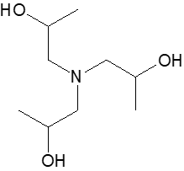 | 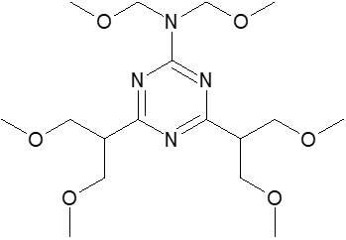 | 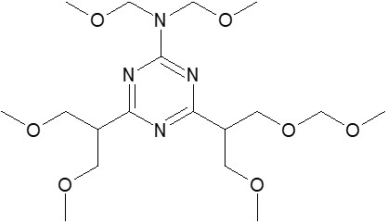
Figure S4 (cont.). Chemical structures of VRCs identified in surface waters from the Tagus River basin.

dd-HMMM | PMMM | dd-PMMM | HMPE
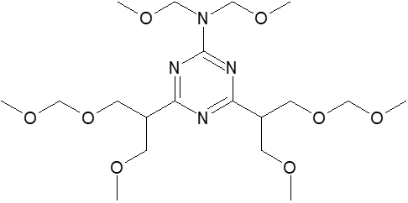 | 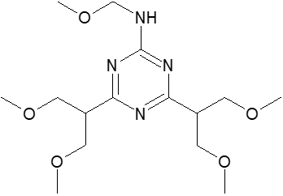 | 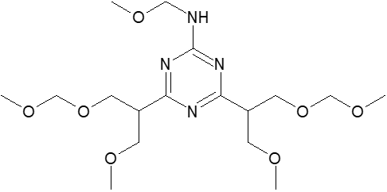 | 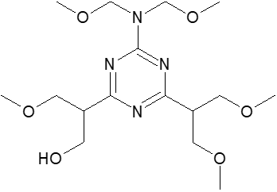
TMMM | DMMM | Tetradecamide | Linoleamide
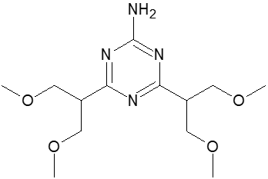 | 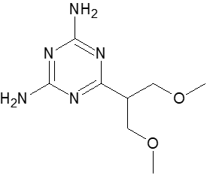 | 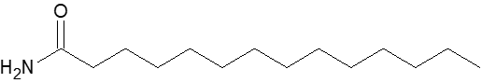
Stereamide | Icosanamide | Lauric diethanolamide | BT
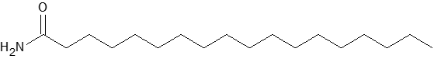 |  | 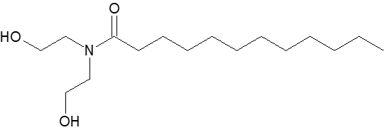 | 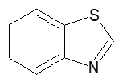
Figure S4 (cont.). Chemical structures of VRCs identified in surface waters from the Tagus River basin.

BTSA | 2-OH-BT | 2-ABT | MTBT
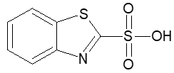 | 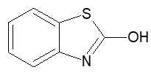 | 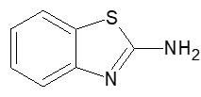 | 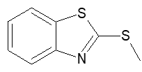
24MOBT | BTR | Me-BTR | 5,6-DiMe-BTR
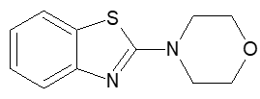 | 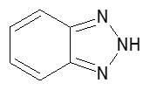 | 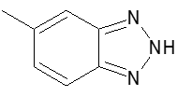 | 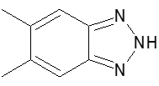
5-Cl-BTR | DB
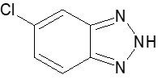 | 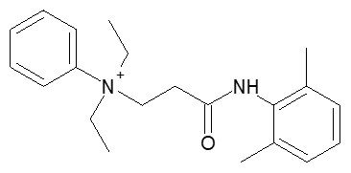
Figure S4 (cont.). Chemical structures of VRCs identified in surface waters from the Tagus River basin.

Table S11. 26 VRCs identified in surface water samples from the Tagus River with detection frequencies above 20%.
Name | Acronym | Molecular formula | Use | Identification level | RT (min) | # samples detected | DF (%)
PPD
6PPD TP274 | 6PPD TP274 | C₁₆H₂₂N₂O₂ | Transformation product | 3 | 11.96 | 53 | 59.6
Guanidine
1,3-diphenyl guanidine | DPG | C₁₃H₁₃N₃ | Vulcanizer | 1 | 4.52 | 57 | 64.0
1,3-di-o-tolilguanidine | DTG | C₁₅H₁₇N₃ | Vulcanizer | 1 | 5.70 | 24 | 27.0
Urea
1,3-Dicyclohexylurea | DCU | C₁₃H₂₄N₂O | Miscellaneous | 1 | 10.57 | 51 | 57.3
1-cyclohexyl-3-phenylurea | CPU | C₁₃H₁₈N₂O | Miscellaneous | 1 | 9.80 | 47 | 52.8
1,3-Diphenylurea | DPU | C₁₃H₁₂N₂O | Vulcanizer | 2a | 8.99 | 36 | 40.4
Phenylurea | PU | C₇H₈N₂O | Transformation product | 3 | 3.70 | 41 | 46.1
Cyclohexylurea | CHU | C₇H₁₄N₂O | Other | 3 | 5.15 | 21 | 23.6
N-Hexyl-N'-phenylurea | N-Hexyl-N'-phenylurea | C₁₃H₂₀N₂O | Other | 4 | 10.46 | 18 | 20.2
Amine
Dibenzylamine | DBA | C₁₄H₁₅N | Vulcanizer | 1 | 5.34 | 28 | 31.5
Dicyclohexylamine | DCA | C₁₂H₂₃N | Vulcanizer | 2a | 5.69 | 64 | 71.9
N-methyldicyclohexylamine | M-DCA | C₁₃H₂₅N | Other | 1 | 5.45 | 26 | 29.2
2-N-dibutylaminoethanol | 2-DBAE | C₁₀H₂₃NO | Stabilizer | 3 | 3.61 | 37 | 41.6
Triisopropanolamine | TIPA | C₉H₂₁NO₃ | Vulcanizer | 2a | 1.10 | 55 | 61.8
Melamine
Hexa(methoxymethyl)melamine | HMMM | C₁₅H₃₀N₆O₆ | Cross-linker | 1 | 8.97 | 81 | 91.0
diformylated-HMMM | d-HMMM | C₁₆H₃₂N₆O₇ | Transformation product | 2a | 9.44 | 68 | 76.4
Hexamethylolmelamine pentamethyl ether | HMPE | C₁₄H₂₈N6O6 | Transformation product | 2a | 7.74 | 71 | 79.8
Tetra(methoxymethyl)melamine | TMMM | C₁₁H₂₂N₆O₄ | Transformation product | 2a | 5.96 | 65 | 73.0
Di(methoxymethyl)melamine | DMMM | C₇H₁₅N₆O₂ | Transformation product | 2a | 2.41 | 19 | 21.3
Benzothiazole
Benzothiazole-2-sulfonic acid | BTSA | C₇H₅NO₃S₂ | Vulcanizer | 2a | 3.78 | 69 | 77.5
Table S11 (cont.). 26 VRCs identified in surface water samples from the Tagus River with detection frequencies above 20%.
Name | Acronym | Molecular formula | Use | Identification level | RT (min) | # samples detected | DF (%)
2-Hydroxybenzothiazole | 2-OHBT | C₇H₅NOS | Transformation product | 1 | 6.85 | 55 | 61.8
2-Aminobenzothiazole | 2-ABT | C₇H₆N₂S | Other | 1 | 3.59 | 25 | 28.1
2-(Methylthio)benzothiazole | MTBT | C₈H₇NS₂ | Transformation product | 1 | 10.44 | 51 | 57.3
Benzotriazole
1H-Benzotriazole | BTR | C₆H₅N₃ | Corrosion inhibitor | 1 | 4.42 | 69 | 77.5
5-Methyl-1H-benzotriazole | Me-BTR | C₇H₇N₃ | Corrosion inhibitor | 1 | 6.17 | 67 | 75.3
Others
Denatonium benzoate | DB | C₂₁H₂₉N₂O | Bittering agent | 2a | 7.66 | 78 | 87.6

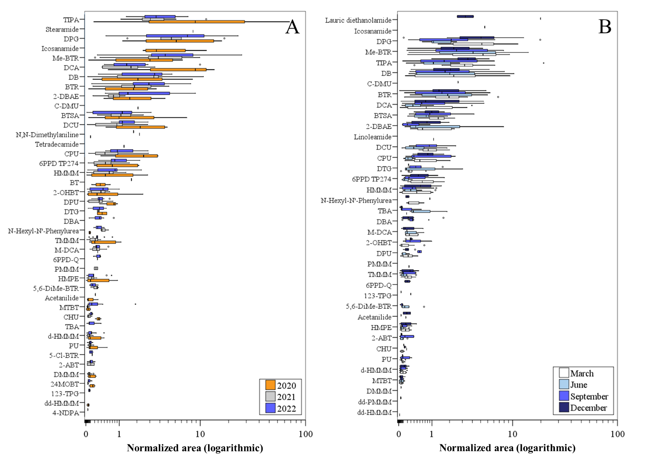
Figure S5. Box and whisker plots of the normalized area (logarithmic scale) of the 46 VRCs compounds detected in surface river samples in (A) annual and (B) seasonal campaigns.
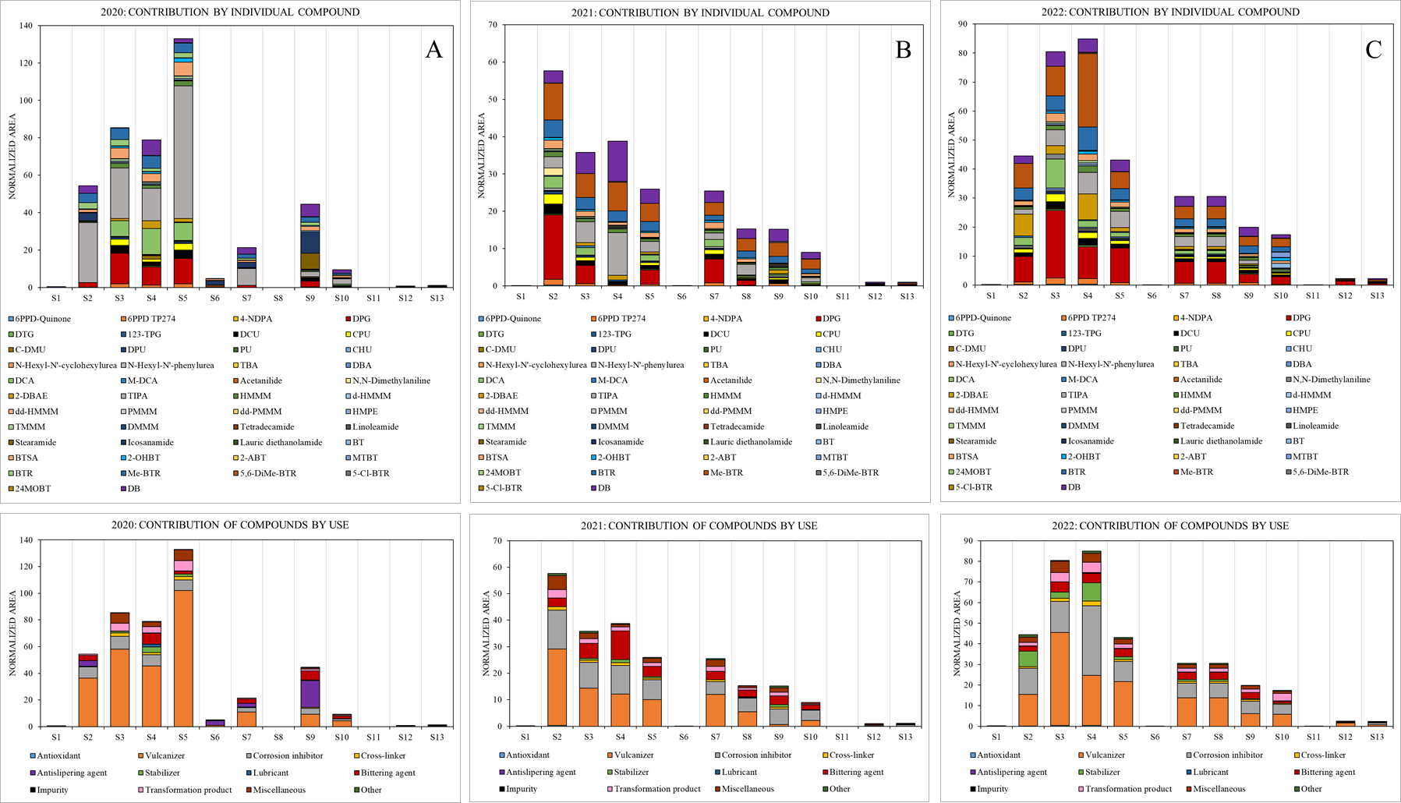
Figure S6. Bar plots depicting the normalized areas per sampling point (S1 to S13) of individual compounds and compounds grouped by their main use in the vehicle industry, for river water samples collected annually in (A) 2020, (B) 2021 and (C) 2022. Sample from S8 was not collected in 2020 annual campaign.

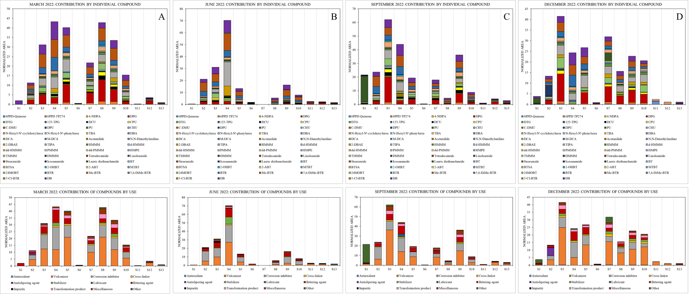
Figure S7. Bar plots depicting the normalized areas per sampling point (S1 to S13) of individual compounds and compounds grouped by their main use in the vehicle industry, for river water samples collected seasonally during 2022 in (A) March, (B) June, (C) September and (D) December. Sample from S7 was not collected in June 2022 campaign.

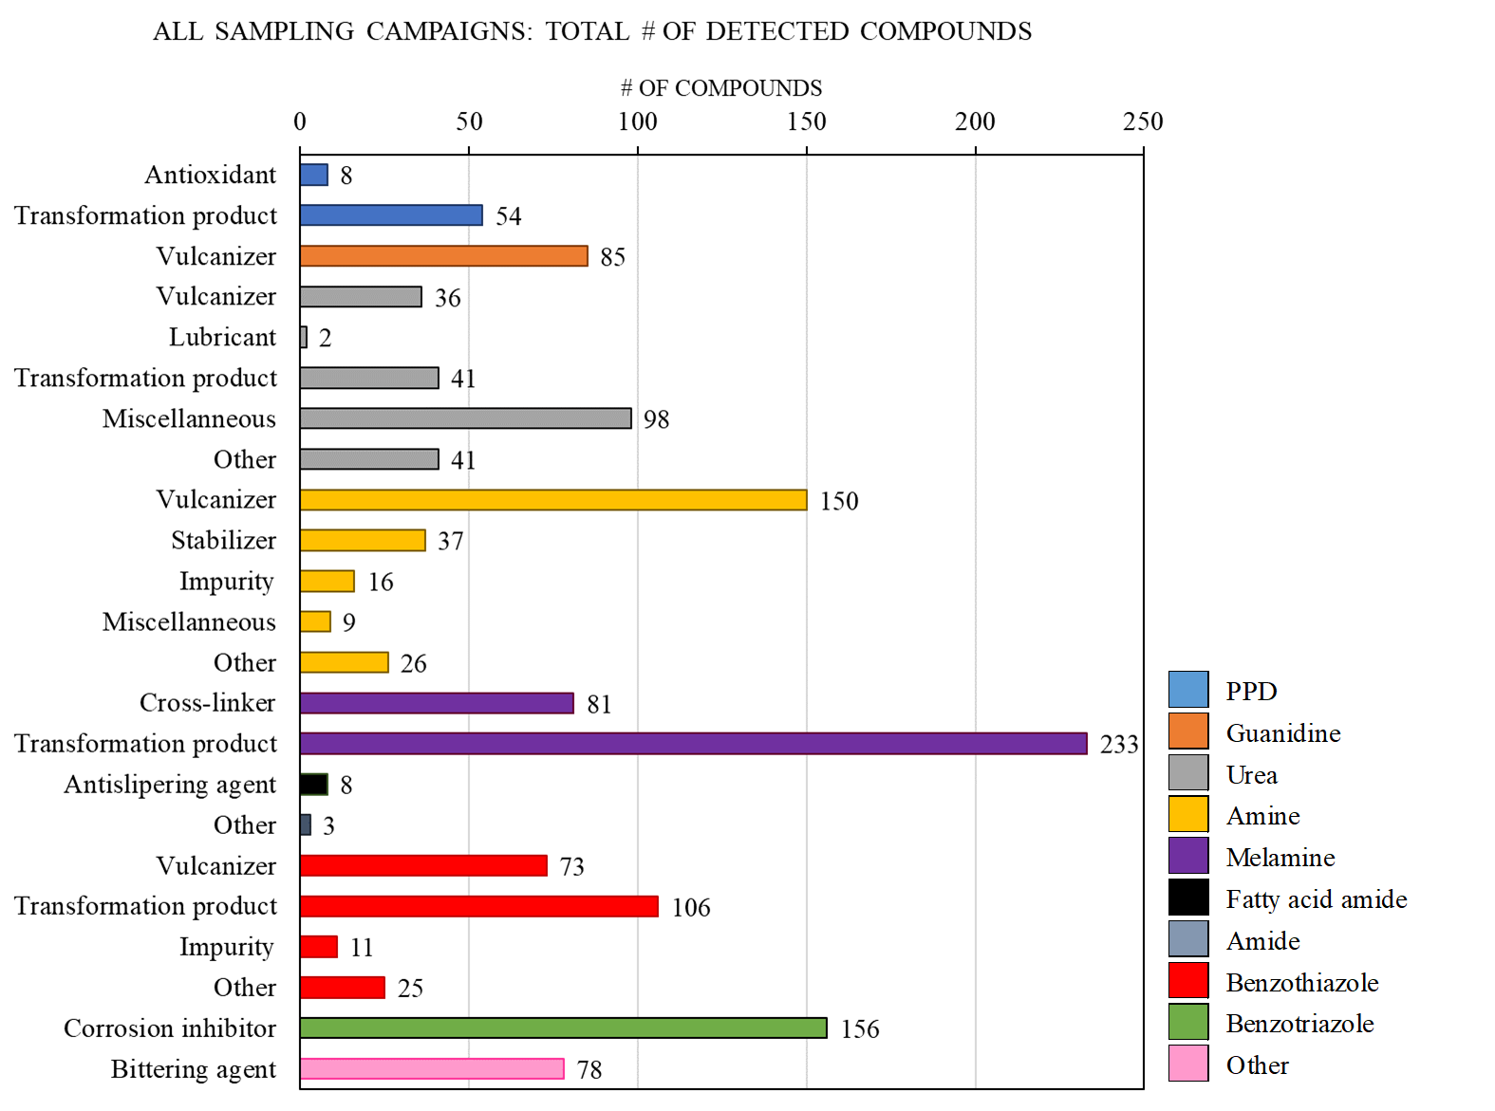
Figure S8. Number of detected compounds (as sum of detected compounds in all samples) by chemical class and use in all surface water samples.
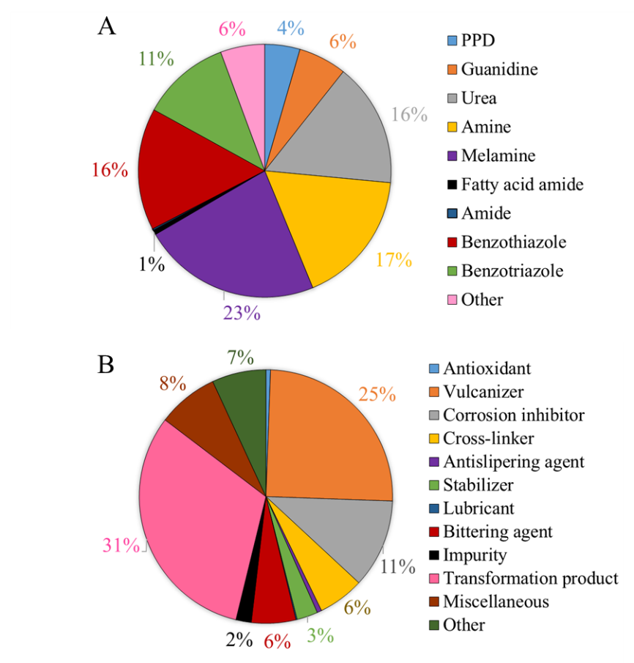
Figure S9. Contribution (%) to the total number of detected compounds by (A) chemical class and (B) compound use in all surface water samples.
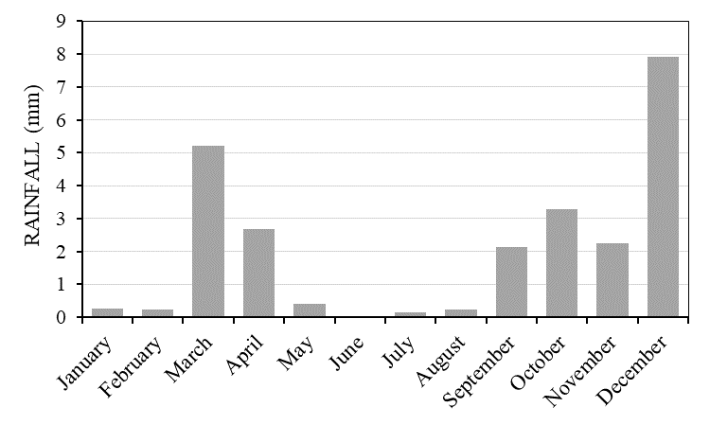
Figure S10. Monthly average rainfall (mm) in the Tagus River during 2022 (Sistema Automático de Información Hidrológica (SAIH Tajo). Ministerio para la Transición Ecológica y el Reto Demográfico. Confederación Hidrográfica del Tajo, 2025).
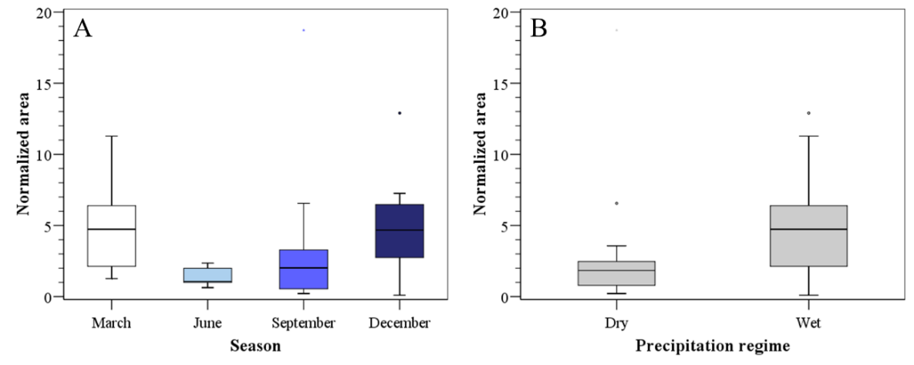
Figure S11. Normalized area for DPG in 2022 comparing (A) seasonal samplings and (B) dry and wet periods. Upper edge of the box, line within the box and lower edge of the box represent the 75th, 50th, and 25th percentiles. Vertical lines indicates the extension from the minimum to the maximum value.
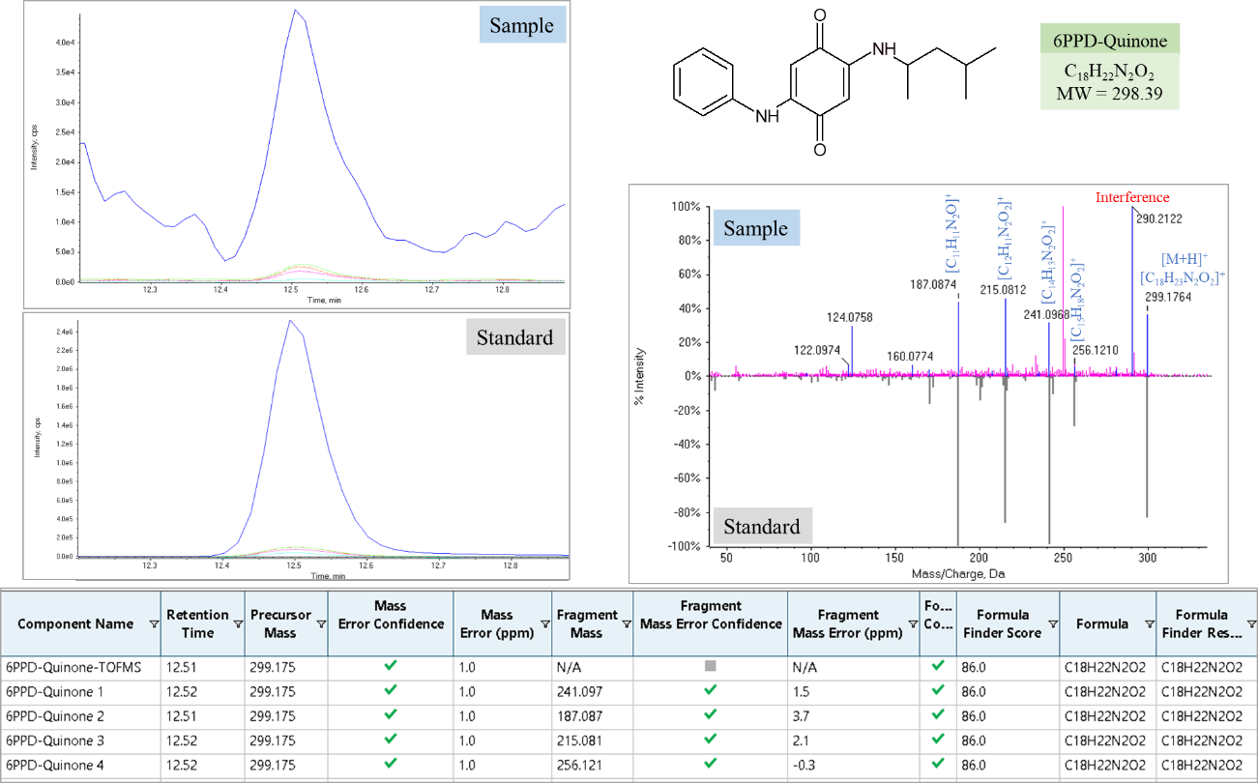
Figure S12. XIC chromatograms and MS/MS mass spectrum of 6PPD-Q in river water samples (upper panels). Identification by reference standard (identification level, 1) whose XIC chromatogram and MS/MS mass spectrum are depicted in the bottom panels.
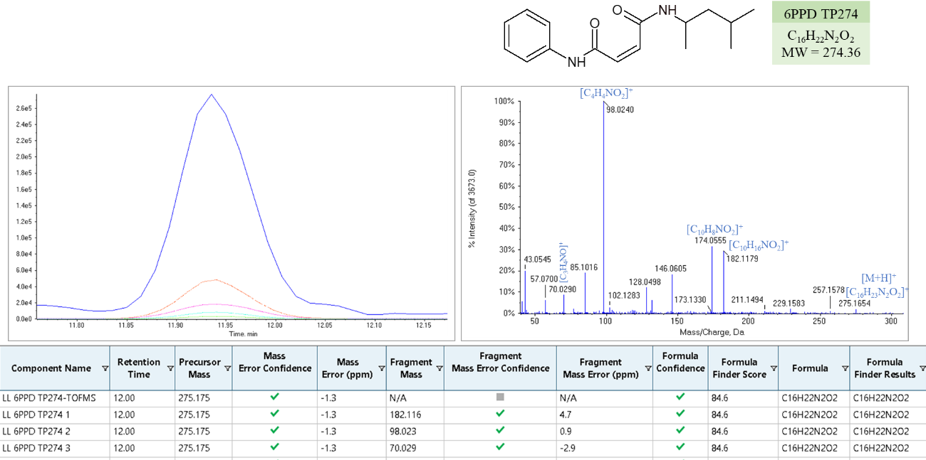
Figure S13. XIC chromatograms and MS/MS mass spectrum of 6PPD TP274 in river water samples. Identification level, 2a.
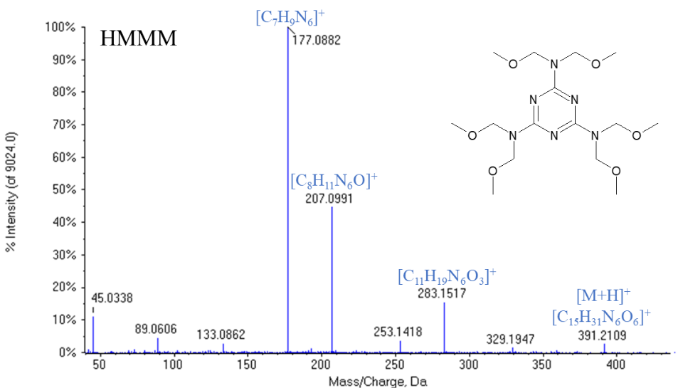
Figure S14. MS/MS mass spectrum of HMMM detected in river water samples.

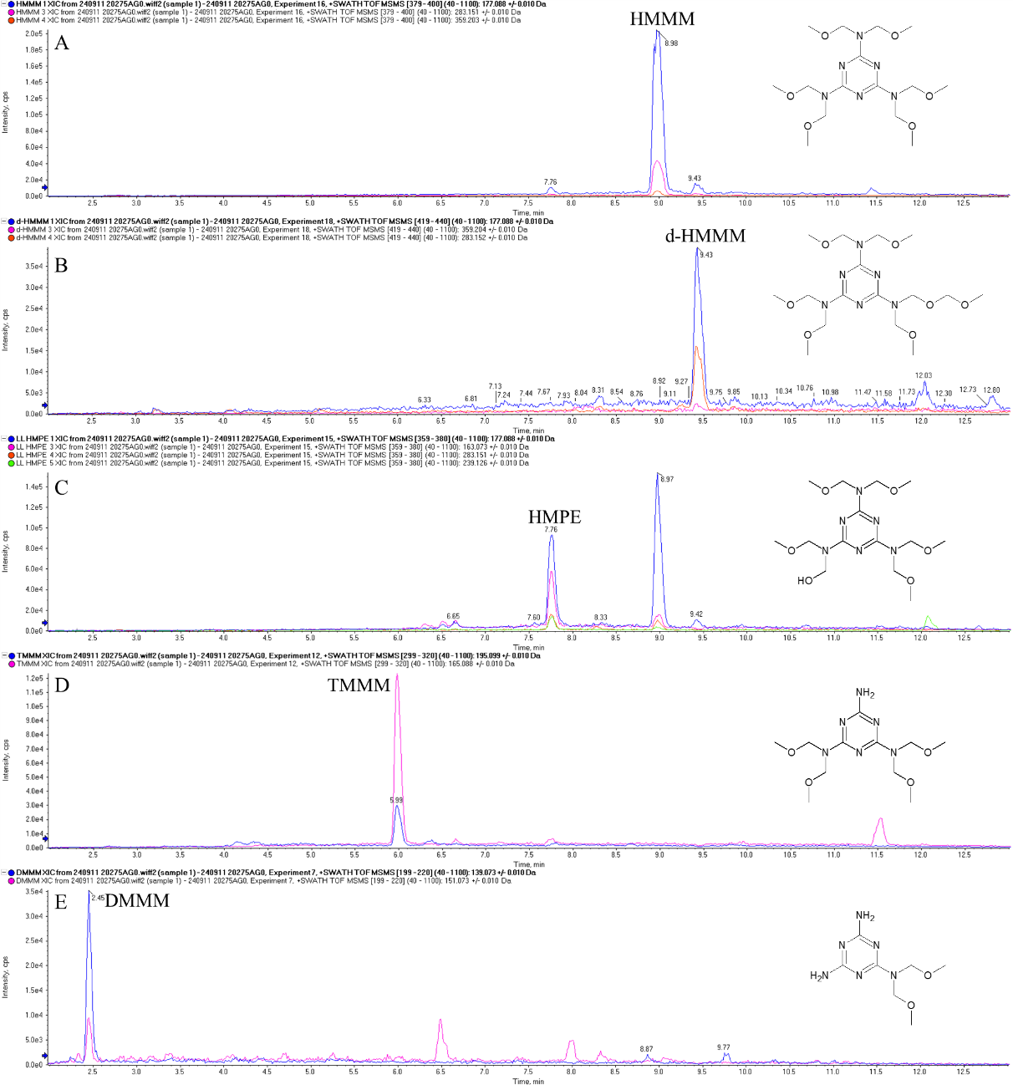
Figure S15. XIC chromatograms of five major methoxy-methyl-melamine compounds detected in river water samples: (A) HMMM, (B) d-HMMM, (C) HMPE, (D) TMMM and (E) DMMM.

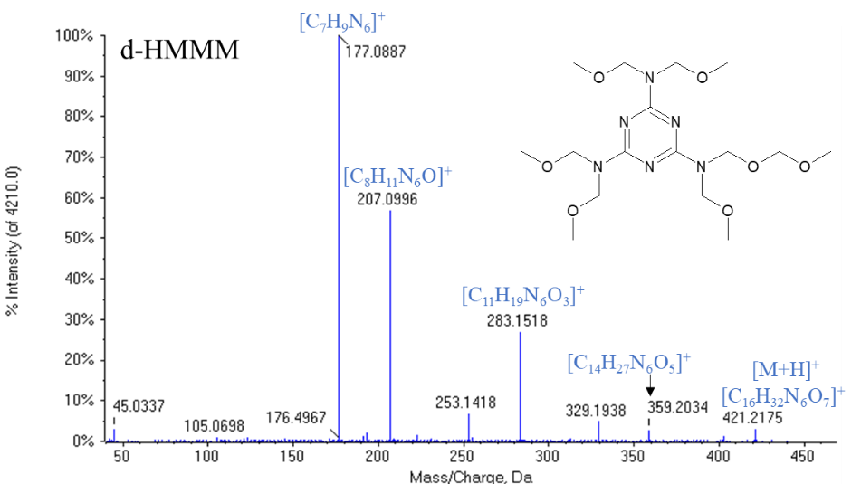
Figure S16. MS/MS mass spectrum of d-HMMM detected in river water samples.
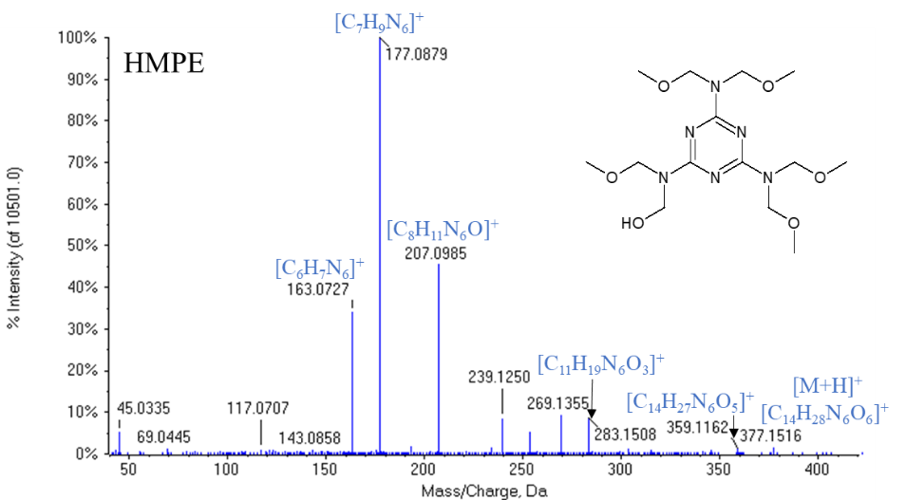
Figure S17. MS/MS mass spectrum of HMPE detected in river water samples.
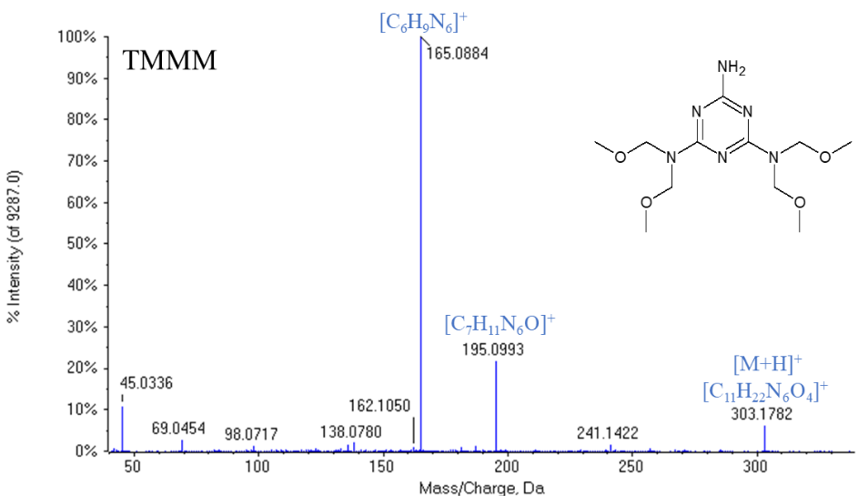
Figure S18. MS/MS mass spectrum of TMMM detected in river water samples.
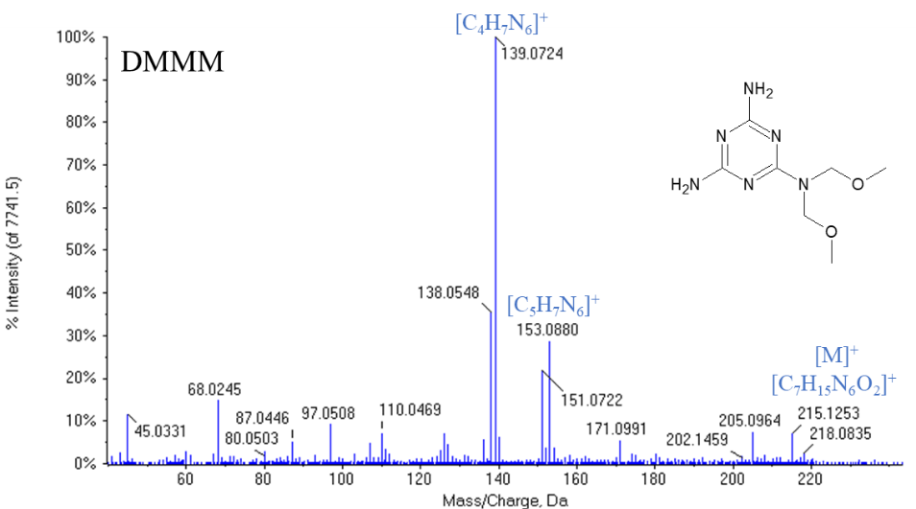
Figure S19. MS/MS mass spectrum of DMMM detected in river water samples.

Table S12. Spearman’s Rho correlation matrix.
Compound | 6PPD TP274 | DPG | DTG | DCU | CPU | DPU | PU | CHU | N-Hexyl-N'-phenylurea | DBA | DCA | M-DCA | 2-DBAE | TIPA | HMMM | d-HMMM | HMPE | TMMM | DMMM | BTSA | 2-OHBT | 2-ABT | MTBT | BTR | Me-BTR | DB
6PPD TP274 | 1
DPG | .895(**) | 1
DTG | .424(*) | .472(*) | 1
DCU | .886(**) | .898(**) | .516(*) | 1
CPU | .951(**) | .926(**) | .757(**) | .952(**) | 1
DPU | .791(**) | .868(**) | .684(**) | .883(**) | .923(**) | 1
PU | .750(**) | .756(**) | .617(**) | .787(**) | .831(**) | .763(**) | 1
CHU | 0.386 | 0.36 | .737(**) | .522(*) | .756(**) | .788(**) | .625(**) | 1
N-Hexyl-N'-phenylurea | .650(**) | .660(**) | 0.048 | .770(**) | .666(**) | .583(*) | .612(**) | 0.414 | 1
DBA | .678(**) | .758(**) | .847(*) | .684(*) | .690(**) | .821(**) | 0.442 | 0.316 | 0.511 | 1
DCA | .682(**) | .814(**) | .547(*) | .805(**) | .791(**) | .829(**) | .652(**) | .572(*) | .505(*) | .563(**) | 1
M-DCA | 0.232 | .474(*) | .651(*) | 0.387 | .453(*) | .611(**) | 0.225 | .634(*) | 0.213 | 0.664 | .447(*) | 1
2-DBAE | .648(**) | .692(**) | .555(*) | .663(**) | .761(**) | .483(*) | .431(*) | 0.465 | 0.31 | .692(**) | .587(**) | 0.205 | 1
TIPA | .570(**) | .544(**) | .802(**) | .668(**) | .780(**) | .734(**) | .601(**) | .840(**) | 0.157 | .554(*) | .695(**) | .477(*) | .532(**) | 1
HMMM | .836(**) | .871(**) | .747(**) | .887(**) | .943(**) | .815(**) | .789(**) | .845(**) | .510(*) | .577(**) | .824(**) | 0.364 | .813(**) | .789(**) | 1
d-HMMM | .801(**) | .841(**) | .713(**) | .872(**) | .917(**) | .776(**) | .768(**) | .876(**) | 0.464 | .693(**) | .783(**) | .415(*) | .733(**) | .753(**) | .988(**) | 1
HMPE | .855(**) | .865(**) | .641(**) | .885(**) | .928(**) | .789(**) | .771(**) | .759(**) | 0.361 | .758(**) | .796(**) | .424(*) | .702(**) | .735(**) | .986(**) | .980(**) | 1
TMMM | .817(**) | .831(**) | .688(**) | .889(**) | .934(**) | .780(**) | .816(**) | .870(**) | .553(*) | .653(**) | .741(**) | .413(*) | .742(**) | .717(**) | .977(**) | .975(**) | .973(**) | 1
DMMM | .581(*) | 0.517 | 0.316 | .770(**) | .719(**) | 0.426 | .732(**) | .895(**) | 0.4 | . | .587(*) | 0.396 | .691(*) | .541(*) | .785(**) | .716(**) | .764(**) | .838(**) | 1
BTSA | .670(**) | .792(**) | .696(**) | .851(**) | .856(**) | .940(**) | .786(**) | .710(**) | .673(**) | .703(**) | .833(**) | .534(**) | .594(**) | .694(**) | .835(**) | .824(**) | .829(**) | .806(**) | .587(*) | 1
2-OHBT | .524(**) | .660(**) | .491(*) | .678(**) | .738(**) | .826(**) | .701(**) | .655(**) | 0.25 | .538(*) | .690(**) | 0.226 | 0.254 | .573(**) | .745(**) | .656(**) | .684(**) | .651(**) | .637(**) | .796(**) | 1
2-ABT | .502(*) | .590(**) |  | .810(**) | .669(**) | 0.533 | .868(**) | 0.218 | .731(*) | 0.409 | .564(**) | 0.283 | 0.512 | 0.473 | .809(**) | .784(**) | .765(**) | .847(**) | 1.000(**) | .778(**) | .570(*) | 1
MTBT | .487(**) | .533(**) | .716(**) | .464(**) | .617(**) | .633(**) | .410(*) | .768(**) | -0.137 | 0.32 | .549(**) | .558(**) | 0.264 | .640(**) | .684(**) | .625(**) | .652(**) | .591(**) | 0.345 | .469(**) | .623(**) | 0.247 | 1
BTR | .338(*) | .562(**) | .617(**) | .608(**) | .592(**) | .596(**) | .601(**) | .494(*) | .471(*) | .667(**) | .585(**) | .650(**) | .434(**) | .571(**) | .785(**) | .737(**) | .731(**) | .722(**) | .539(*) | .694(**) | .555(**) | .745(**) | .577(**) | 1
Me-BTR | .432(**) | .548(**) | .524(**) | .611(**) | .629(**) | .626(**) | .632(**) | .461(*) | .650(**) | .651(**) | .640(**) | .603(**) | .517(**) | .598(**) | .790(**) | .739(**) | .750(**) | .738(**) | .725(**) | .701(**) | .547(**) | .804(**) | .583(**) | .945(**) | 1
DB | .293(*) | .550(**) | .854(**) | .657(**) | .570(**) | .527(**) | .434(**) | .568(**) | 0.459 | .748(**) | .679(**) | .755(**) | .350(*) | .690(**) | .815(**) | .751(**) | .769(**) | .746(**) | .605(**) | .747(**) | .556(**) | .802(**) | .558(**) | .848(**) | .838(**) | 1
** The correlation is significant at the 0.01 level (bilateral).
* The correlation is significant at the 0.05 level (bilateral).
In red: correlation coefficient above 0.9.
In orange: correlation coefficient above 0.8.

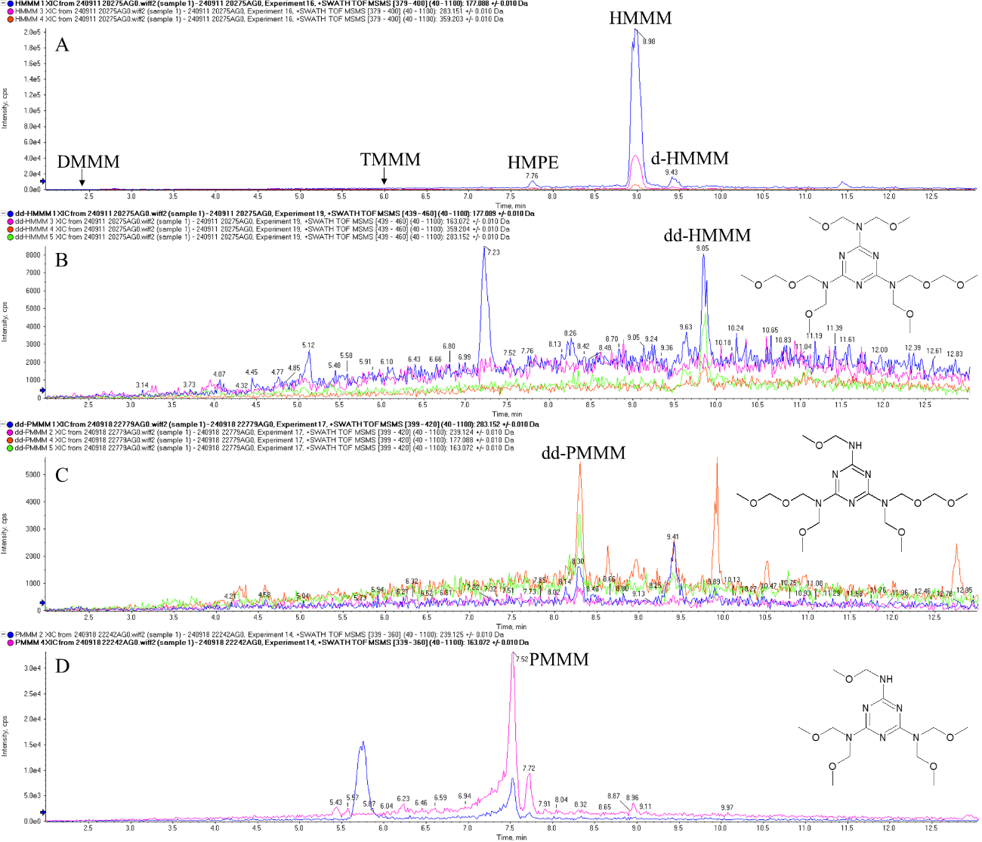
Figure S20. XIC chromatograms of three minor methoxy-methyl-melamine compounds detected in river water samples: (B) dd-HMMM, (C) dd-PMMM, (D) PMMM. As reference of the elution order the upper panel (A) shows the XIC chromatograms of the major HMMM-related compounds (HMMM, d-HMMM. HMPE, TMMM and DMMM).
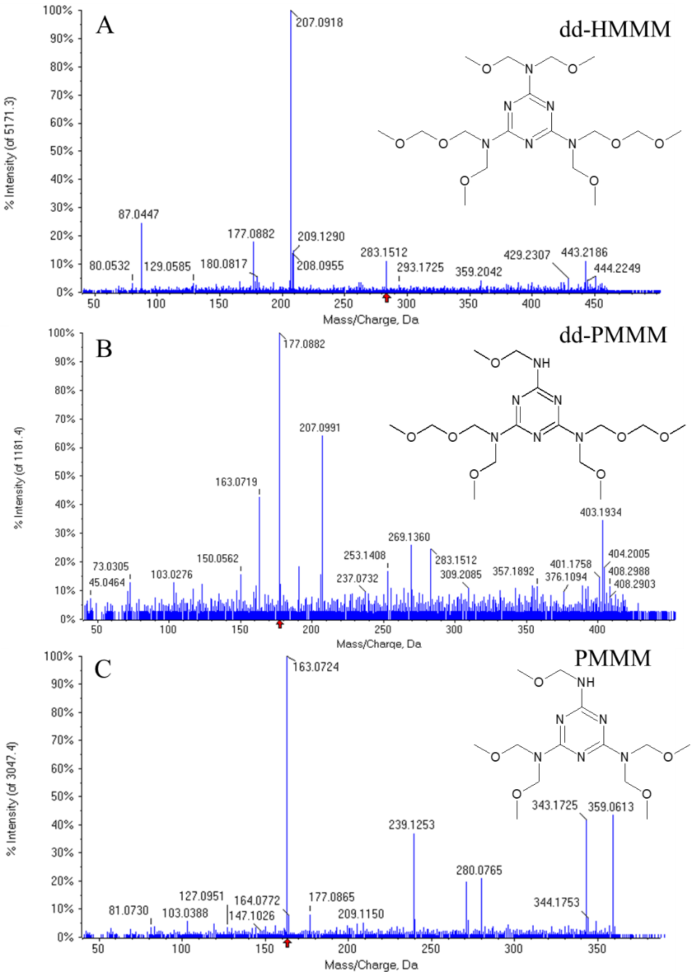
Figure S21. MS/MS mass spectra of minor HMMM-related compounds detected in river water samples (A) dd-HMMM, (B) dd-PMMM and (C) PMMM.
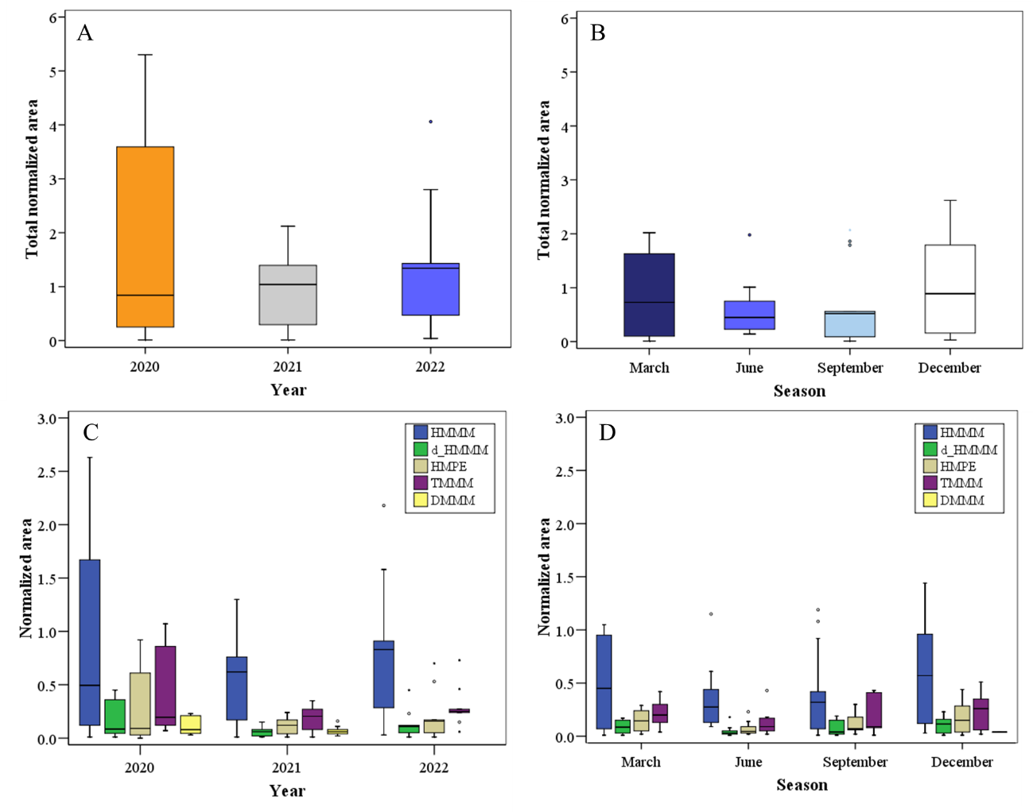Figure S22. Box and whisker plots for HMMM-related compounds detected in the samples depicted as total area (upper panels) and individual area those compounds with DF>20%. Panels in the left side (A, C) show data from annual campaigns, while panels in the right show data of the seasonal samplings.
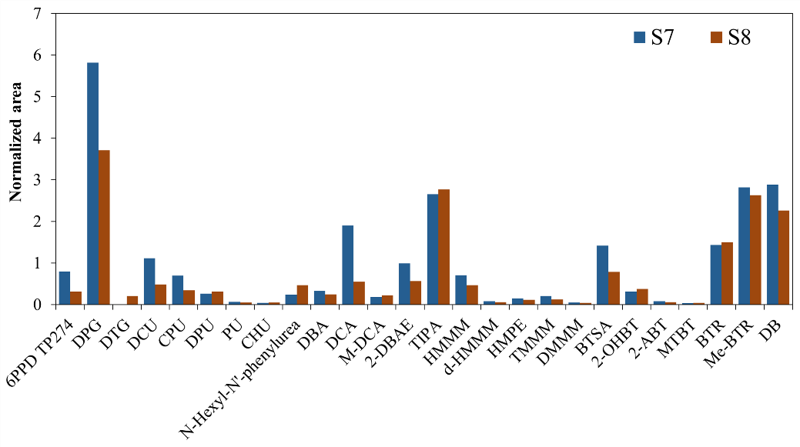
Figure S23. Median normalized areas of VRCs (DF>20%) in locations S7 and S8.

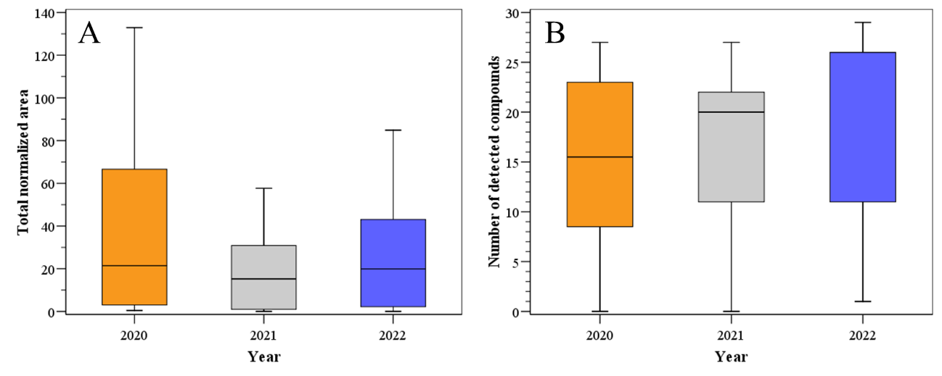
Figure S24. Annual variation for the sum of (A) normalized areas and (B) number of detected VRCs. Upper edge of the box, line within the box and lower edge of the box represent the 75th, 50th, and 25th percentiles. Vertical lines indicates the extension from the minimum to the maximum value.
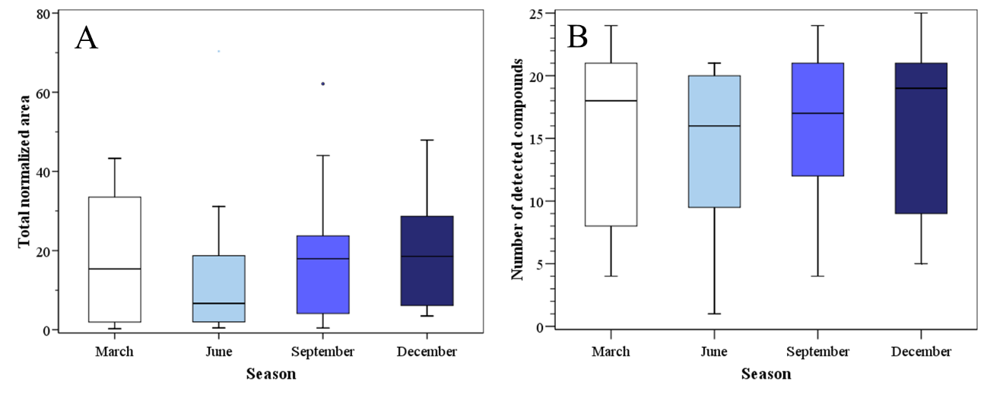
Figure S25. Seasonal variation for the sum of (A) normalized areas and (B) number of detected VRCs. Upper edge of the box, line within the box and lower edge of the box represent the 75th, 50th, and 25th percentiles. Vertical lines indicates the extension from the minimum to the maximum value.

Table S13. Component matrix. Extraction method by Principal Component Analysis.
 | Component
 | 1 | 2 | 3
6PPD TP274 | 0.92 | -0.02 | 0.28
DPG | 0.86 | -0.02 | 0.41
DTG | 0.37 | 0.60 | -0.40
DCU | 0.90 | -0.14 | 0.06
CPU | 0.90 | -0.20 | 0.31
DPU | 0.83 | -0.14 | 0.39
PU | 0.85 | -0.26 | -0.04
CHU | 0.83 | -0.08 | -0.39
N-Hexyl-N'-phenylurea | 0.49 | 0.24 | 0.64
DBA | 0.21 | 0.16 | 0.53
DCA | 0.81 | -0.30 | 0.02
M-DCA | 0.25 | 0.36 | 0.02
2-DBAE | 0.58 | 0.49 | -0.19
TIPA | 0.69 | -0.36 | -0.40
HMMM | 0.97 | 0.02 | -0.06
d-HMMM | 0.94 | 0.02 | -0.10
HMPE | 0.94 | -0.12 | -0.06
TMMM | 0.96 | -0.06 | -0.12
DMMM | 0.59 | -0.50 | -0.41
BTSA | 0.94 | -0.20 | -0.07
2-OHBT | 0.85 | -0.25 | 0.01
2-ABT | 0.38 | 0.50 | 0.19
MTBT | 0.21 | 0.11 | 0.23
BTR | 0.70 | 0.57 | -0.10
Me-BTR | 0.74 | 0.57 | -0.09
DB | 0.57 | 0.53 | -0.37

Table S14. Cumulative variance for all components of Principal Component Analysis.
Component | Total | % variance | % cumulative
1 | 14.37 | 55.28 | 55.28
2 | 2.75 | 10.57 | 65.86
3 | 2.14 | 8.23 | 74.08

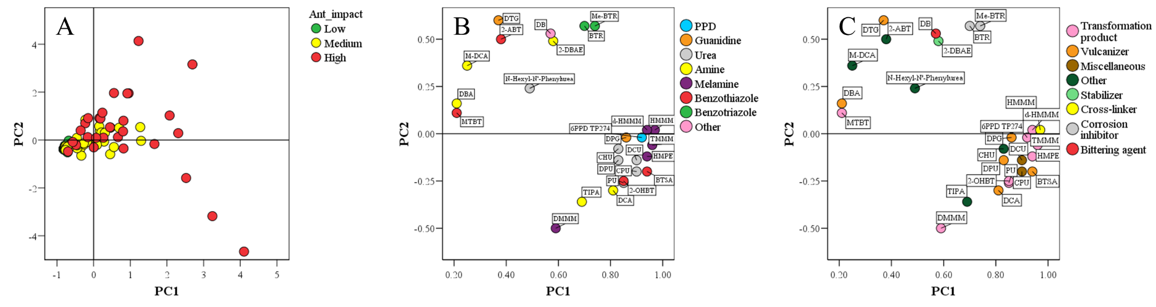
Figure S26. PC1 and PC2 from Principal Component Analysis depicting (A) Loading plot and score plots considering (B) chemical class and (C) compound use.
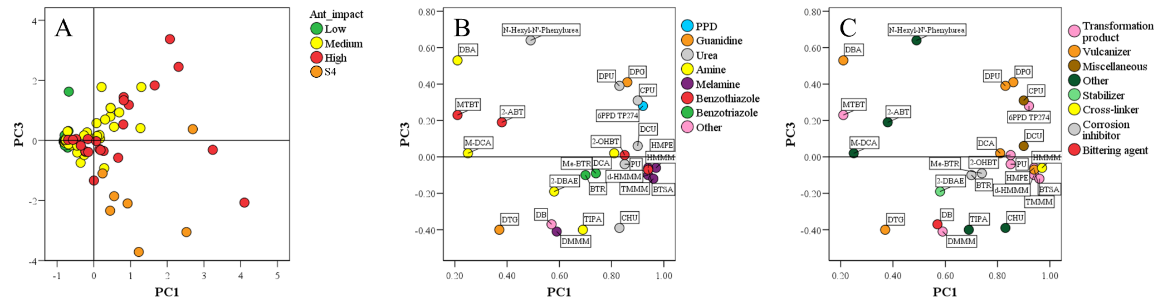
Figure S27. PC1 and PC3 from Principal Component Analysis depicting (A) Loading plot and score plots considering (B) chemical class and (C) compound use.
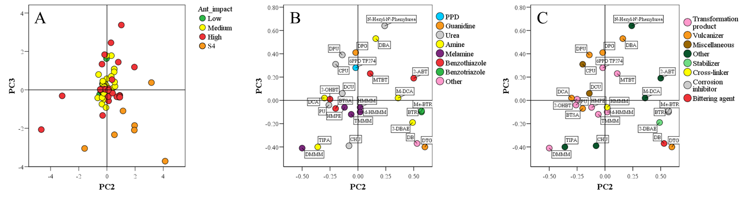
Figure S28. PC2 and PC3 from Principal Component Analysis depicting (A) Loading plot and score plots considering (B) chemical class and (C) compound use.

REFERENCES
Dirección General de Carreteras. Comunidad de Madrid, 2022. Tráfico IMD 2022. https://www.comunidad.madrid/servicios/transporte/estudio-intensidad-media-diaria-vehiculos-imd (accessed 04/06/2025).
Dirección General de Carreteras. Consejería de Fomento. Castilla-La Mancha, 2022. Aforo Tráfico. IMD 2022. Castilla-La Mancha, 2022. https://www.castillalamancha.es/sites/default/files/documentos/pdf/20230419/dossier_imd_2022.pdf (accessed 04/06/2025).
Instituto Nacional de Estadística (INE), 2025. Cifras oficiales de población de los municipios españoles en aplicación de la Ley de Bases del Régimen Local (Art. 17). Población por municipio y sexo. https://www.ine.es/jaxiT3/Tabla.htm?t=2852 (accessed 03/06/2025).
Krauss, M., Hug, C., Bloch, R., Schulze, T., Brack, W., 2019. Prioritising site-specific micropollutants in surface water from LC-HRMS non-target screening data using a rarity score. Environ. Sci. Eur. 31, 45. https://doi.org/10.1186/s12302-019-0231-z.
Ministerio de Transportes y Movilidad Sostenible, 2021. Mapa de Tráfico de la Dirección General de Carreteras (DGC). Año 2021. https://mapas.fomento.gob.es/mapatrafico/2021/ (accessed 04/06/2025).
Oetjen, K., Tackett, B., 2023. Nontarget and Suspect Screening Analysis of Samples Containing 6PPD quinone and Other Tire derived Compounds. TN-1339. Phenomenex.
Royano, S., de la Torre, A., Navarro, I., Martínez, M.Á., 2023. Pharmaceutically active compounds (PhACs) in surface water: Occurrence, trends and risk assessment in the Tagus River Basin (Spain). Science of the Total Environment 905, 167422. https://doi.org/10.1016/j.scitotenv.2023.167422.
Schymanski, E.L., Jeon, J., Gulde, R., Fenner, K., Ruff, M., Singer, H.P., Hollender, J., 2014. Identifying small molecules via high resolution mass spectrometry: Communicating confidence. Environ. Sci. Technol., 48(4), 2097-2098 https://doi.org/10.1021/es5002105.
Sistema Automático de Información Hidrológica (SAIH Tajo), 2025. Ministerio para la Transición Ecológica y el Reto Demográfico. Confederación Hidrográfica del Tajo. Pluviometría. https://saihtajo.chtajo.es/pluviometria (accessed 14/08/2025).
Tarábek, P., Leonova, N., Konovalova, O., Kirchner, M., 2024. Identification of organic contaminants in water and related matrices using untargeted liquid chromatography high-resolution mass spectrometry screening with MS/MS libraries. Chemosphere 366, 143489. https://doi.org/10.1016/j.chemosphere.2024.143489.

