Anomalous secondary electron emission of metallic surfaces exposed to a Glow Discharge plasma
E. Oyarzabal ¹, A.B. Martín-Rojo, J.A. Ferreira, D. Tafalla, F.L. Tabarés

Abstract
Secondary electron emission (SEE) yields, γ, of Li, stainless steel (SS) and W surfaces immersed in a He Direct Current Glow Discharge (dc-GD) Plasma have been calculated from the experimental I–V curves as a function of electron mean energy. The data obtained showed that γ_{Li} > γ_{SS} > γ_{W}. Line emission ratios 728/706 of excited He and Langmuir probe measurements provide a clear evidence of the presence of a suprathermal electron tail responsible for the observed SEE.
The results show that SEE is well correlated with the anomalous extra current component found in the I–V curves. The resulting value of γ_{Li} is significantly higher than its theoretical value suggesting a possible synergetic effect of the ion bombardment in the SEE of lithium. The effect of Li surface oxidation has also been addressed, leading to a substantial decrease of both, sputtering yield and SEE yield of Li with higher oxygen content.

1. Introduction
The secondary electron emission (SEE) by electron or ion impact is a well-known surface effect with practical applications and rather well understood [1]. In fusion plasma research, this effect has been mostly characterized in relation to the development of electrostatic probes and their interpretation [2]. However, the particle and heat loads that plasma-facing materials undergo upon exposure to the plasmas can be very sensitive to their actual value of this parameter [3]. For a SEE yield of unity, a full suppression of the plasma sheath takes place. This will reduce the ion energy to twice the ion temperature, Ti, as compared to the typical value of five times Ti for hydrogen ions in the presence of the sheath. However, this reduction is overcompensated by the sharp increase of heat fluxes due to the electron bombardment. In spite of these considerations, there are very few measurements of the SEE yield during plasma exposure in the literature [4]. Measurements in the Divertor Injection Tokamak Experiment (DITE) with a Retarding Filed Analyzer (RFA) probe indicated an enhancement of both, ion induced and electron induced SEE in graphite. This effect was associated to surface modifications by metal coatings and hydrogenation [5]. However, no enhancement on metal surfaces has been reported to date.
Lithium is presently one of the most appealing elements for the implementation of liquid metal Plasma Facing Components (PFCs) concepts for a fusion reactor [6]. Its strong chemical reactivity, however, makes surface characterization of critical importance when it comes to the comparison of its performance as a first wall material in different plasma devices. One of the consequences of this point is the scattering of results reported about the recycling and performance improvement due to lithiation techniques. In a previous work, the anomalous I–V characteristics of lithium surfaces exposed to He and H GD plasmas was reported, but no conclusion about the origin of this anomaly was reached [7]. In the present work we address the characterization of the suprathermal tail of the Electron Energy Distribution Function (EEDF) and we report for the first time the averaged values for the SEE coefficient of a Li surface exposed to a plasma. W and SS surfaces are also studied for reference. Furthermore, intentionally oxidized Li surfaces were prepared and characterized with respect to sputtering and SEE yields.

2. Experimental set-up
The present experiments are performed in the set-up shown in Fig. 1a. The dc-GD is produced in a SS chamber maintaining a voltage of around 375 V and a current of 300 mA between the anode and the chamber walls (cathode) at a He pressure of 3 mTorr [7]. The secondary electron emission for the studied materials (SS, W and Li) is calculated from the I–V characteristic curves of the targets, as will be explained in more detail in Section 5. In order to do this two types of cell targets have been mounted in a 1 cm diameter SS bar, which can be biased from −80 to Vp (plasma potential) and can be retracted from the discharge chamber to the Li deposition chamber in order to perform the in situ deposition of Li in SS targets. The deposition is achieved by evaporation of lithium from an oven heated to 600 °C. Type A cell targets are used to measure simultaneously the I–V characteristics of two different targets by rotating the cell for each applied bias voltage. This assures that the differences in the results are not due to possible drifts in plasma conditions. The Type B cell target is used to measure the incident electron current reaching Type A targets during the biasing. This cell consist of a grid which is biased from −80 to Vp (so exactly the same ion and electron current is attracted to the grid and to Type A targets) and a collector which is biased to a sufficiently high positive voltage to repel the ion current passing through the grid and to retain the secondary emission electrons that are created in the collector. In this manner, the current collected at the different voltages applied to the grid directly represents the electron current arriving to Type A targets for each studied bias voltage. A photomultiplier/interference filter (filterscope) system looks for emission of neutral Li, at λ = 671 nm, to measure the relative sputtering yield of Li for the different He ion incident energies [7]. This energy is assumed to be the local potential drop, as collisionless sheath conditions are expected at these low pressures. The same set-up is used as well to detect the He 728 and 706 emission lines in order to measure the effective temperature of the plasma [8]. A single Langmuir probe directly inserted into the He plasma is used for the recording of the microscopic parameters, n_{e}, T_{e}, of the main discharge and to check for any possible perturbation of the bar/target biasing on the plasma parameters. The I–V characteristics of the probe did not show any appreciable difference in any case with the biasing of the different targets, so it was concluded that target biasing did not affect the plasma discharge (the maximum current that the target carries is under 2% of the total plasma current).
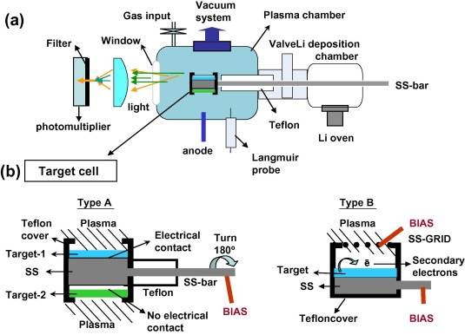
Fig. 1. (a) Experimental set-up and (b) sketch of the two types of target cells used in the present experiments.

3. Anomaly in the I–V characteristics of the studied targets and suprathermal population in the dc-GD
Fig. 2 shows the I–V characteristics for negative biasing with respect to the plasma potential of Li, SS and W. In principle, I–V characteristics at this negative bias with respect to plasma potential should be only given by the current of ions arriving to the target (represented with dashed lines) unless electrons, energetic enough to overcome the voltage barrier of the plasma sheath (the difference between the plasma voltage and the bias voltage), are present. As seen in the figure, an anomalous current for these negative voltages is clearly observed. After ruling out other possibilities, as penning processes involving metastables atoms among others, the existence of suprathermal electrons in our dc-GD remains as the main candidate for this anomalous behavior. Results from He 728/706 line emission measurements [8] have shown effective electron temperatures of about 20–30 eV (depending on plasma conditions). The highest temperatures occur for the lowest pressures and the highest plasma potentials. This clearly points to the existence of a suprathermal electron population, in line with the difference observed with respect to the lower temperatures measured with the Langmuir probe (6–9 eV). The presence of suprathermal populations has been previously reported in dc-GD [9]. They are produced from the secondary electrons created by ion impact of the chamber walls (cathode) and accelerated to the plasma potential in the sheath and not thermalized by electron-neutral collisions. Even though this population is very small with respect to the thermalized population (around 1%), due to their high energies, they can produce a current sufficiently high to generate the secondary electron emission in the targets leading to the observed anomalies.
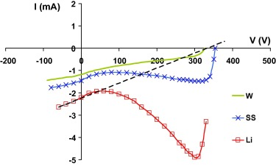
Fig. 2. I–V characteristics from the biasing of the Li, SS and W targets. Dashed line represents the He ion current for the case of Li biasing.

4. SEE yield calculation
The SSE yield for each studied target is calculated from the results of Type A and B cell targets (Fig. 3). The intensity measured by Type B cell target for each bias voltage represents the incident current of electrons bombarding Type A targets (Iei) at each bias, as has been explained earlier. The intensity measured by Type A cell targets for each bias (once the He ion current has been subtracted from the total measured intensity) represents the total electron intensity through Type A targets (Iet) at each bias voltage, which is the sum of the incident intensity (Iei) and the secondary emitted electron intensity (Ies). For each bias voltage the SEE yield is equal to Ies/Iei. Even though 2/3rd’s of Li is sputtered as ions, due to the potential drop in the sheath developed at the surface of the target, the sputtered ions are attracted back to the target during He bombardment. Consequently, the net current that this effect produces in the target is zero, and it does not affect the SEE calculations.
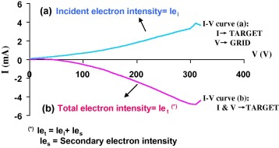
Fig. 3. I–V characteristics from Type A and Type B cell targets used to obtain the SEE yield of the studied materials.
In order to have a SEE yield value related to the energy of the incident electrons, the mean energy of the incident electrons for each value of the bias voltage (Vb) is calculated. From the differentiation of the Iei curve from Type B cell experiments (Fig. 3) and taking into account the deceleration that electrons undergo in the sheath (Vp–Vb at each bias voltage), the Iei energy distribution function at the target can be calculated. The mean energy at each bias voltage is then calculated from this distribution. In this manner we obtain the SEE yield vs. mean incident electron energy curves that will be presented in next section.

5. Results and discussion

5.1. SEE yield of Li, SS and W
Fig. 4 shows the results of the Li, SS and W SEE yields vs. mean incident electron energy. A comparison of the present SEE yield values to the literature [10] data is shown in Table 1. The results for W and SS are not very different from the literature values, if allowance for the energy range of the present experiment is made. Thus, the maximum of the W SEE yield from the literature (1.35) takes place at an electron energy of 650 eV, whereas the maximum mean energy that we achieve in the present experiments is of about 120 eV, so it is not suprising that we obtain a somewhat lower value (0.95). On the other hand, the difference from the literature value for the case of the Li target is clearly visible. The maximum SEE yield calculated from the present experiments is about five times larger than that value. It is worth noting that literature values are typically obtained by electron bombardment under vacuum, while in the present experiments the lithium target is immersed in the plasma. This behavior suggests a synergetic effect of ion bombardment on the SEE of lithium. Nevertheless, this result still requires further studies.
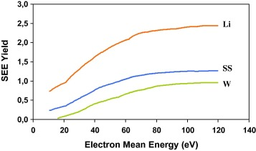
Fig. 4. Results of the Li, SS and W SEE Yields vs. mean electron energy of the suprathermal electrons arriving to the targets at each bias.
Table 1. Comparison between literature and experimental maximum SEE values for the studied targets.
Material | Maximum coefficient literature (experimental) | Incident energy at SEE maximum (eV)
Li | 0.5 (2.44) | 85
SS | 1.3 (1.27) | 400
W | 1.35 (0.95) | 650

5.2. Effect of oxygen addition to Li surfaces
As one of the possible reasons for the anomalous SEE yield of Li surfaces is its oxidation by the residual water and leak, the effect of oxygen addition in the sputtering and the SEE yields of Li surfaces has been intentionally addressed. Oxidation of the lithium targets was obtained by exposure to a 80% Helium −20% Oxygen plasma at a total pressure of 3.7 mTorr. The Li target is negatively biased with respect to the plasma potential and exposed to the bombardment of oxygen and He with an energy of about 300 eV. During this bombardment, the current to the target and the release of Li, as measured by the photomultiplier signal with the neutral lithium interference filter, are recorded and the conditions of the plasma are maintained constant until these two values become stationary. As lithium is a well-known good getter for oxygen, and oxidation leads to a decrease of the sputtering yield [11], surface oxygen saturation for the selected plasma composition is assumed when the Li signal reaches a stable minimum value. In order to study the characteristics at different surface oxygen concentration levels, the oxidized target is sputtered (biasing the target to a −70 eV) in a pure He plasma and the SEE and sputtering yield curves (Fig. 5, Fig. 6) are recorded at different values of the exposure time to the He cleaning plasma. After each fast sweep in He ion energy (achieved by sweeping the bias to the sample), the initial values of Li signal and current are checked again. In the experiments here reported, the possible “cleaning” effect of the He plasma during the sweep was negligible. These sweeps were repeated at different levels of surface recovery, as indicated by the Li signal compared to the non-oxidized value at maximum ion energy. Unfortunately, no direct measurements of the actual oxygen contamination for each run was possible.
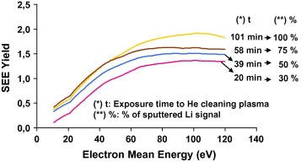
Fig. 5. Li SEE Yields vs. mean electron energy for different oxygen contents. Labels correspond to surface conditions leading to a given% of sputtered Li signal.
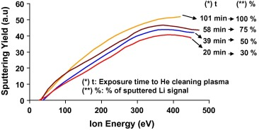
Fig. 6. Same as in Fig 5 for the Li Sputtering Yield. See text.
The present results show that the addition of oxygen to the lithium surface decreases both the SEE and the sputtering yield. This could suggest the presence of a synergetic effect from the ion bombardment on the SEE of lithium.

6. Conclusions
Anomalous I–V characteristics for negative biasing (with respect to plasma potential) of different materials have been observed in He discharges. This effect has been ascribed to the presence of suprathermal electrons, produced by acceleration up to the plasma potential of the secondary electrons originated at the discharge chamber walls.
The SEE yield vs. the mean energy of the suprathermal electrons for each applied voltage (an approximation to the real SEE yield vs. electron incident energy) has been calculated for Li, SS and W surfaces. Lithium SEE yield is clearly higher than its theoretical value and than the value for W and SS. Experiments to address the effect of oxygen addition to the lithium surfaces were carried out in the same set up. A clear decrease of both, sputtering yield and SEE Yield of lithium at increasing oxygen content was observed. The existence of a possible synergetic enhancement by ion bombardment on the SEE of Lithium is suggested.

Acknowledgements
This work was partly supported by Dirección General de Investigación Científica y Técnica (DGICYT) under Project FIS2010-20911. Also, ABMR and EO have been supported by Madrid Community through the Project TECHNOFUSION (S2009/ENE-1679).

References
[1]H. Bruining, Physics and Applications of Secondary Electron Emission, McGraw-Hill Book Co., 1954.
[2]N. Hershkowitz, Phys. Plasmas 12 (2005) 055502.
[3]P.C. Stangeby, Physics of Plasma-Wall Interaction, D.E. Post and R. Behrisch Plenum, New York, 1986. p. 41.
[4]R.A. Pitts, G.F. Matthews, J. Nucl. Mater. 176 and 177 (1990) 877.
[5]M.E. Woodst et al., J. Phys. D: Appl. Phys. 20 (1987) 1136.
[6]Y. Hirooka et al., Nucl. Fusion 50 (2010) 077001.
[7]F. L. Tabarés et al., in: 38th EPS Conference on, Plasma Physics, P5.065, 2011.
[8]S. Kajita et al., Phys. Plasmas 13 (2006) 013301.
[9]H. Sugai et al., Plasma Sources Sci. Technol. 4 (1995) 366.
[10]R. Kollath, Handbuch Phys., vol. 21, Springer-Verlag, Berlin, 1956. p. 232.
[11]J.P. Allain, D.N. Ruzic, Nucl. Fusion 42 (2002) 202.

