Supplementary Material

Assessing pesticide residues occurrence and risks in water systems: A Pan-European and Argentina perspective

Irene Navarro^{a*}, Adrián de la Torreª, Paloma Sanzª, Nelson Abrantes^{b}, Isabel Campos^{c}, Abdallah Alaoui^{d}, Florian Christ^{d}, Francisco Alcon^{e}, Josefina Contreras^{f}, Matjaž Glavan^{g}, Igor Pasković^{h}, Marija Polić Pasković^{h}, Trine Nørgaard^{i}, Daniele Mandrioli^{j} , Daria Sgargi^{j}, Jakub Hofman^{k}, Virginia Aparicio^{l}, Isabelle Baldi^{m}, Mathilde Bureau^{m}, Anne Vested^{n}, Paula Harkesº, Esperanza Huerta-Lwangaº, Hans Mol^{p}, Violette Geissenº, Vera Silvaº, María Ángeles Martínezª

ª Unit of POPs and Emerging Pollutants in Environment, Department of Environment, CIEMAT, Madrid, Spain.
^{b-} CESAM and Department of Biology, University of Aveiro, Portugal.
^{c-} CESAM and Department of Environment and Planning, University of Aveiro, Portugal.
^{d-} Institute of Geography, University of Bern, Bern, Switzerland.
^{e-} Department of Business Economics, Universidad Politécnica de Cartagena, Spain.
^{f-} Department Agricultural Engineering. Universidad Politécnica de Cartagena, Spain.
^{g-} Agronomy Department, Biotechnical Faculty, University of Ljubljana, Ljubljana, Slovenia.
^{h-} Department of Agriculture and Nutrition, Institute of Agriculture and Tourism, Porec, Croatia.
^{i-}Department of Agroecology, Aarhus University, Aarhus, Denmark.
^{j-}Cesare Maltoni Cancer Research Centre, Ramazzini Institute, Bologna, Italy.
^{k-} RECETOX, Faculty of Science, Masaryk University, Brno, the Czech Republic.
^{l-} Instituto Nacional de Tecnología Agropecuaria (INTA), Buenos Aires, Argentina
^{m-} University of Bordeaux, INSERM, BPH, U1219, Bordeaux, France.
^{n-} Department of Public Health - Unit for Environment, Occupation, and Health, Danish Ramazzini Centre, Aarhus University, Denmark.
^{o-} Soil Physics and Land Management Group, Wageningen University & Research, Wageningen, Netherlands.
^{p-} Wageningen Food Safety Research - part of Wageningen University & Research, Wageningen, Netherlands.

*Corresponding author: Irene Navarro
Address: Av Complutense nº 40, Madrid (28040), Spain.
e-mail: i.navarro@ciemat.es
Telephone: +34 913 466 019

Table of contents

S1. Materials and Methods. S1.1. Sample collection…………………………………………… | S4
Table S1. Characteristics of the of the water bodies sampled in each case study site (CSS)…........ | S5
S1. Materials and Methods. S1.2. Chemical analysis…………………………………………… | S7
S1. Materials and Methods. S1.3. Quality assurance..…………………………………………. | S9
Table S2. Validation parameters of pesticides analysed…..…………………………..………….. | S10
S1. Materials and Methods. S1.4. Environmental risk assessment calculations………….......... | S15
Table S3. Physicochemical properties, PPP approval status and aquatic ecotoxicological information of pesticides found in this study..………………...….………………….. | S17
Figure S1. Pesticide residues ((a) number pesticides/sample, %; (b) total concentration; Log 1+X; ng/L) in the water samples related to the type of water body……...………...… | S22
Figure S2. Concentration (ng/L; logarithmic scale) of fungicides, herbicides and insecticides in water………………………………………...…….….………......................…........... | S23
Table S4. Descriptive statistics (mean; (median); max of positives) and detection frequency (DF, %) of the pesticides obtained for the number of pesticides obtained in water in each case study site...……………………………………………………...….……… | S24
Table S5. Matrix of significant differences (p < 0.05, Kruskal-Wallis test) between compounds….……………………………………………………………………...… | S34
Table S6. Correlation matrix (p < 0.01 and p < 0.05, Spearman's rank correlation Test) of the pesticides in water.…………………………………………………….………....…... | S35
Figure S3. Diagrams of dispersion related to the three components resulting from a principal components analysis (PCA) derived from the content of pesticides in water and pesticide distribution (type of land use and CSS)…...……………………..……….... | S36
Table S7. Variables of the principal components analysis (PCA) related to the content of pesticides in water and pesticide distribution (CSS, water body type, land use of the banktop). Detail of the influence of each variable in each component......................... | S37
Figure S4. Total concentration (a; ng/L) and number of pesticides (b) in water related to the distance (m) to agricultural fields……………………………………………………. | S38
Figure S5. Contribution (%) of each pesticide to the total in water from each CSS……..……... | S39
Table S8. Compliance with reference values in water……...………………………….………... | S40
Figure S6. Exceedances of reference values in water.……...………………………….………... | S44
Table S9. Ecological risk assessment (RQ₅₀ and RQ_{max} ratios) of individual pesticides and mixtures in the aquatic environment.………….……………...…...…………….….... | S45
Table S10. Ecological risk assessment (RQ₅₀ and RQ_{max} ratios, %) of pesticides in the aquatic environment from each CSS ……………………….………………………………... | S47
Table S11. Comparison of concentrations (ng/L) in water from European countries and Argentina……………………………………….…………………………….………. | Excel file
LC-MSMS, GC-MSMS, GC-HRGC conditions.………………………………….…………... | Excel File
References….…………………………………………………………………………………… | S48

S1. Materials and Methods

S1.1. Sample collection
A total of 64 grab samples were collected during the pesticide application period of the 2021 growing season from water bodies located in regions with high agricultural activity across 11 case study sites (CSS): Spain (case study site 1, CSS1, n=7), Portugal (CSS2, n=8), France (CSS3, n=6), Switzerland (CSS4, n=5), Italy (CSS5, n=6), Croatia (CSS6, n=3), Slovenia (CSS7, n=6), Czech Republic (CSS8, n=8), the Netherlands (CSS9, n=6), Denmark (CSS10, n=3) and Argentina (CSS11, n=6), (Table S1). Water samples were collected sub-superficially using acetonitrile-water-methanol precleaned polypropylene bottles, frozen at -20 ºC and sent refrigerated (-20 ºC) to CIEMAT labs (Alaoui et al., 2021). Once arrived at the laboratory, samples were stored at -20 °C until analysis.

Table S1. Characteristics of the water bodies sampled in each case study site (CSS).

Table S1 (cont.). Characteristics of the water bodies sampled in each case study site (CSS).

S1.2. Chemical analysis
S1.2.1. Multi-residue analysis of pesticides by LC-MS/MS and GC-MS/MS
Water samples (1 L), filtered and acidified to pH 3 with formic acid, were spiked with surrogate labeled standards (acetamiprid-d3, azoxystrobin-d4, boscalid-d4, dimethoate-d6, diuron-d6, epoxiconazole-d4, imidacloprid-d4, metolachlor-d6, prochloraz-d7, terbuthylazine-d5, thiacloprid-d4, thiamethoxam-d3, cypermethrin-d6 and deltamethrin-d6) and then extracted by solid-phase extraction (SPE). Oasis HLB (500 mg, 6 mL) cartridges were firstly conditioned with 10 mL of methanol followed by 10 mL of ultrapure water adjusted to pH 3 with formic acid. Once the sample passed through the cartridge, this was dried with air during 30 min and then was eluted with 25 mL of methanol. The extract was transferred into a TurboVap vessel and blown down, under a stream of nitrogen, to 5 mL. This extract was divided into two aliquots for the GC and HPLC analyses. For the HPLC analysis, the extract was concentrated to 0.5 mL and 50 µL of 0.1 % formic acid in water and internal labeled standards (clothianidin d3 and diazinon d10) were added. For the GC analysis, 2.5 mL of the extract were transferred to a PP tube, and 4 mL of MilliQ water and 2 mL of isooctane were added, then vortexed 1 min, agitated 5 min, and centrifuged for 6 min at 13000 g. The upper isooctane layer was transferred to another vial to the GC analysis and spiked with internal labeled standards (¹³C₁₂-PCB 15 and ¹³C₁₂-PCB 70, EC-5350-L from Cambridge Isotope Laboratories Inc.). HPLC analyses (for pesticides included see Table S2) were performed on a high performance liquid chromatography system (Varian HPLC 212) connected to a triple quadrupole mass spectrometer (Varian 320 MS-TQ), with an analytical column Polaris 3 C18-A 150 x 2.0 mm and a mobile phase composed of water buffered with 0.1% formic acid (solvent A) and MeOH (solvent B). GC analyses (for pesticides included see Table S2) were conducted in a Varian CP-3800 gas chromatograph connected to a 320 MS-TQ mass spectrometer with a column DB 5MS 30 m × 0.25 mm × 0.25 μm Agilent. For all pesticides, two transitions were monitored. See Excel SM for more details related to instrumental analysis.
S1.2.2. Glyphosate/AMPA
Filtered water samples (100 mL) were spiked with ¹³C₂, ¹⁵N-glyphosate and ¹³C, ¹⁵N-AMPA labeled standards and treated with 25 mL of 0.1 M KH₂PO₄ and ultrasonicated for 30 min. Then, 25 mL of 0.1 M Na₂B₄O₇ were added to the sample to reach a pH=9 and 15 mL of 6.5 mM 9-fluorenylmethoxycarbonyl chloride FMOC-Cl was used for the derivatization. The extract was shaken vigorously and was kept overnight in darkness at room temperature. Next, the reaction was stopped by acidifying the solution to pH 3 by adding 1 mL of formic acid. The derivatized sample was diluted with ultrapure water to approximately 340 mL and passed through Oasis HLB (200 mg, 6 mL). Samples were loaded on cartridges previously conditioned with 5 mL of methanol and 5 ml of 0.1% formic acid in water. The excess of water was removed by drying the cartridge with air for 30 min, and the excess of derivatization by-products was removed by rinsing with 3.5 mL of dichloromethane and drying the cartridge with air for another 30 min. The analytes were eluted with 9 mL of MeOH. The extracts were concentrated under a gentle nitrogen stream and analysed in the HPLC-MS/MS (Varian HPLC 212- Varian 320 MS-TQ) with an analytical column Polaris 3 C18-A 150 x 2.0 mm and a mobile phase composed of water buffered with 2 mM ammonium acetate (solvent A) and MeOH (solvent B). See Excel SM for more details related to instrumental analysis.
S1.2.3. Organochlorinated pesticides by GC-HRMS
Water samples (250 mL) filtered were spiked with 7 ¹³C labeled surrogate standards (¹³C₆-hexachlorobenzene, ¹³C₆-gamma-HCH, ¹³C₁₂-2,4’-DDE, ¹³C₁₂-4,4’-DDE, ¹³C₁₂-2,4’-DDD, ¹³C₁₂-4,4’-DDD, ¹³C₁₂-dieldrin; ES-5465-5X from Cambridge Isotope Laboratories Inc.) and extracted by liquid-liquid extraction with 200 mL of dichloromethane. The extracts were solvent exchanged into hexane and concentrated under a gentle nitrogen stream to 100 µL. Prior to analysis, the extract was spiked with 2 internal ¹³C labeled standards (¹³C₁₂-PCB 15, ¹³C₁₂-PCB 70; EC-5350-L from Cambridge Isotope Laboratories Inc.). Instrumental analyses were carried out by high resolution mass spectrometry (MicroMass Autospec Ultima NT HRMS) coupled to an Agilent 6890 gas chromatograph. See Excel SM for more details related to instrumental analysis.
S1.3. Quality assurance
The analytical methodologies developed were optimized and validated in surface water matrix (n=5; pesticide residue content <LOD) at three concentration levels (Table S2), meeting the criteria established in SANTE/2020/12830 (SANTE, 2021a) and SANTE/11312/2021 (SANTE, 2021b) documents. The limit of quantification (LOQ) was defined as the lowest level tested during the validation, fulfilling good mean recovery (70-120%) and precision (RSDr ≤ 20%) requirements (Table S2). The limit of detection (LOD), defined as the estimated lowest level at which the analyte can be detected and identified, was calculated as the level at which S/N for qualifier ion is at least 3 (Table S2). Procedural blanks (MilliQ water) were extracted with each batch under the same conditions as samples. In addition, instrumental blanks were run before each sample injection to check the possibility of cross-contamination from the analysis system.

Table S2. Validation parameters of pesticides analysed.
Table S2 (cont.). Validation parameters of pesticides analysed.
Table S2 (cont.). Validation parameters of pesticides analysed.
Table S2 (cont.). Validation parameters of pesticides analysed.
Table S2 (cont.). Validation parameters of pesticides analysed.

S1.4. Environmental risk assessment calculations
The environmental risk in the aquatic ecosystem was estimated following the recommendations of the European Chemicals Bureau at Technical Guidance Document on Risk Assessment (European Commission, 2003). Risk quotients (RQ) were used to estimate the potential ecological risk of pesticides in the aquatic ecosystem at general (RQ₅₀) and worst (RQ_{max}) scenarios (Eq.1).
$$\text{RQ}\text{50}\text{ or }\text{RQ}\text{max} \text{=}\frac{\text{MEC}\text{50 }\text{or MEC}\text{max}}{\text{PNEC}}$$
Eq. (1)
where MEC was the measured environmental concentration of pesticides (MEC₅₀, median; MEC_{max}, maximum) and PNEC was the predicted no effect concentration calculated by dividing ecotoxicological data (Table S3) by an assessment factor (AF) (Eq.2) (European Commission, 2003; Li et al., 2023).
$$\text{PNEC=}\frac{\text{NOEC (LC}\text{50}\text{)(EC}\text{50}\text{)}}{\text{AF}}$$
Eq. (2)
PNEC was estimated preferably with the no-observed effect concentration (NOEC). When NOEC data was not available, the most sensitive acute toxicity values (median lethal, LC₅₀, and median effective, EC₅₀, concentrations) were used (Table S3; PPBD, 2023; Lewis et al., 2016); this is the case of o,p’-DDD, p,p’-DDD, o,p’-DDE, p,p’-DDE, dieldrin and tetramethrin.The assessment factor (AF) to derive a PNEC aquatic was determined according to the criteria set by the European Commission (2003): i) AF=1000, when at least one short-term test (LC₅₀ or EC₅₀) from each of three trophic levels of the base set (fish, Daphnia magna and algae) is available; ii) AF=100, when one long-term NOEC (either fish or aquatic invertebrates) data is available; iii) AF=50, when two long-term NOECs from species representing 2 trophic levels are available; iv) AF=10, when there are long-term NOECs from at least three species (normally fish, Daphnia and algae) representing three trophic levels.

Risk quotients for mixtures were also calculated at general (RQ_{mix_50}) and worst (RQ_{mix_max}) scenarios (Eq.3) from MEC and PNEC of each individual pesticide (i) (Price et al., 2012; Spycher et al., 2018).
$$\text{RQ}\text{mix}\text{_}\text{50 }\text{or }\text{RQ}\text{mix}\text{_}\text{max }\text{=}\sum{\frac{\text{MEC}\text{50_i }\text{or }\text{MEC}\text{max_i}}{\text{PNEC}\text{i}}}$$
Eq. (3)
In general, RQ < 0.01 denotes a negligible risk, 0.01 < RQ < 0.1 reveals a low risk, 0.1 < RQ < 1 represents a medium risk and RQ > 1 indicates a high ecological risk to aquatic organisms.

Table S3. Physicochemical properties, EU pesticide approval status and aquatic ecotoxicological information of the pesticides found in this study.

Table S3 (cont.). Physicochemical properties, EU pesticide approval status and aquatic ecotoxicological information of the pesticides found in this study.

Table S3 (cont.). Physicochemical properties, EU pesticide approval status and aquatic ecotoxicological information of the pesticides found in this study.
Table S3 (cont.). Physicochemical properties, EU pesticide approval status and aquatic ecotoxicological information of the pesticides found in this study.
Table S3 (cont.). Physicochemical properties, EU pesticide approval status and aquatic ecotoxicological information of the pesticides found in this study.

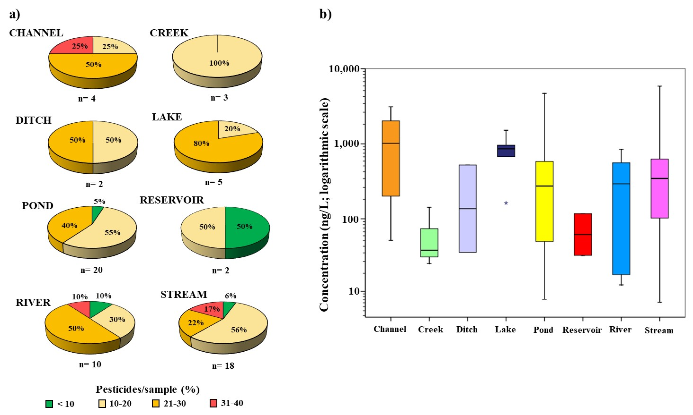
Figure S1. Pesticide residues (a) number pesticides/sample, %; b) concentration; ng/L; logarithmic scale) in the water samples related to the type of water body.

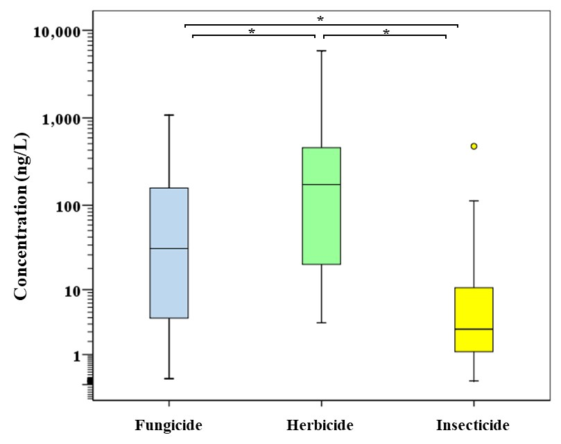

Figure S2. Concentration (ng/L; logarithmic scale) of fungicides, herbicides and insecticides in water. Upper edge of the box, line within the box and lower edge of the box, represents the 75th, 50th, and 25th percentiles. Vertical lines extend from the minimum to the maximum value, excluding outliers (circles). Statistical differences between groups are shown (asterisks).

Table S4. Descriptive statistics (mean; (median); max of positives) and detection frequency (Df, %) of the pesticides obtained in water in each case study site. Only pesticides detected have been listed.
Table S4 (cont). Descriptive statistics (mean; (median); max of positives) and detection frequency (Df, %) of the pesticides obtained in water in each case study site. Only pesticides detected have been listed.
Table S4 (cont). Descriptive statistics (mean; (median); max of positives) and detection frequency (Df, %) of the pesticides obtained in water in each case study site. Only pesticides detected have been listed.
Table S4 (cont). Descriptive statistics (mean; (median); max of positives) and detection frequency (Df, %) of the pesticides obtained in water in each case study site. Only pesticides detected have been listed.
Table S4 (cont). Descriptive statistics (mean; (median); max of positives) and detection frequency (Df, %) of the pesticides obtained in water in each case study site. Only pesticides detected have been listed.
Table S4 (cont). Descriptive statistics (mean; (median); max of positives) and detection frequency (Df, %) of the pesticides obtained in water in each case study site. Only pesticides detected have been listed.
Table S4 (cont). Descriptive statistics (mean; (median); max of positives) and detection frequency (Df, %) of the pesticides obtained in water in each case study site. Only pesticides detected have been listed.
Table S4 (cont). Descriptive statistics (mean; (median); max of positives) and detection frequency (Df, %) of the pesticides obtained in water in each case study site. Only pesticides detected have been listed.
Table S4 (cont). Descriptive statistics (mean; (median); max of positives) and detection frequency (Df, %) of the pesticides obtained in water in each case study site. Only pesticides detected have been listed.
Table S4 (cont). Descriptive statistics (mean; (median); max of positives) and detection frequency (Df, %) of the pesticides obtained in water in each case study site. Only pesticides detected have been listed.

Table S5. Matrix of significant differences (p < 0.05, Kruskal-Wallis test) between compounds. Only pesticides with Df > 10% are shown.
Table S6. Correlation matrix (p < 0.01 and p < 0.05, Spearman's rank correlation Test) of the pesticides in water. Only pesticides with Df > 10% are shown.

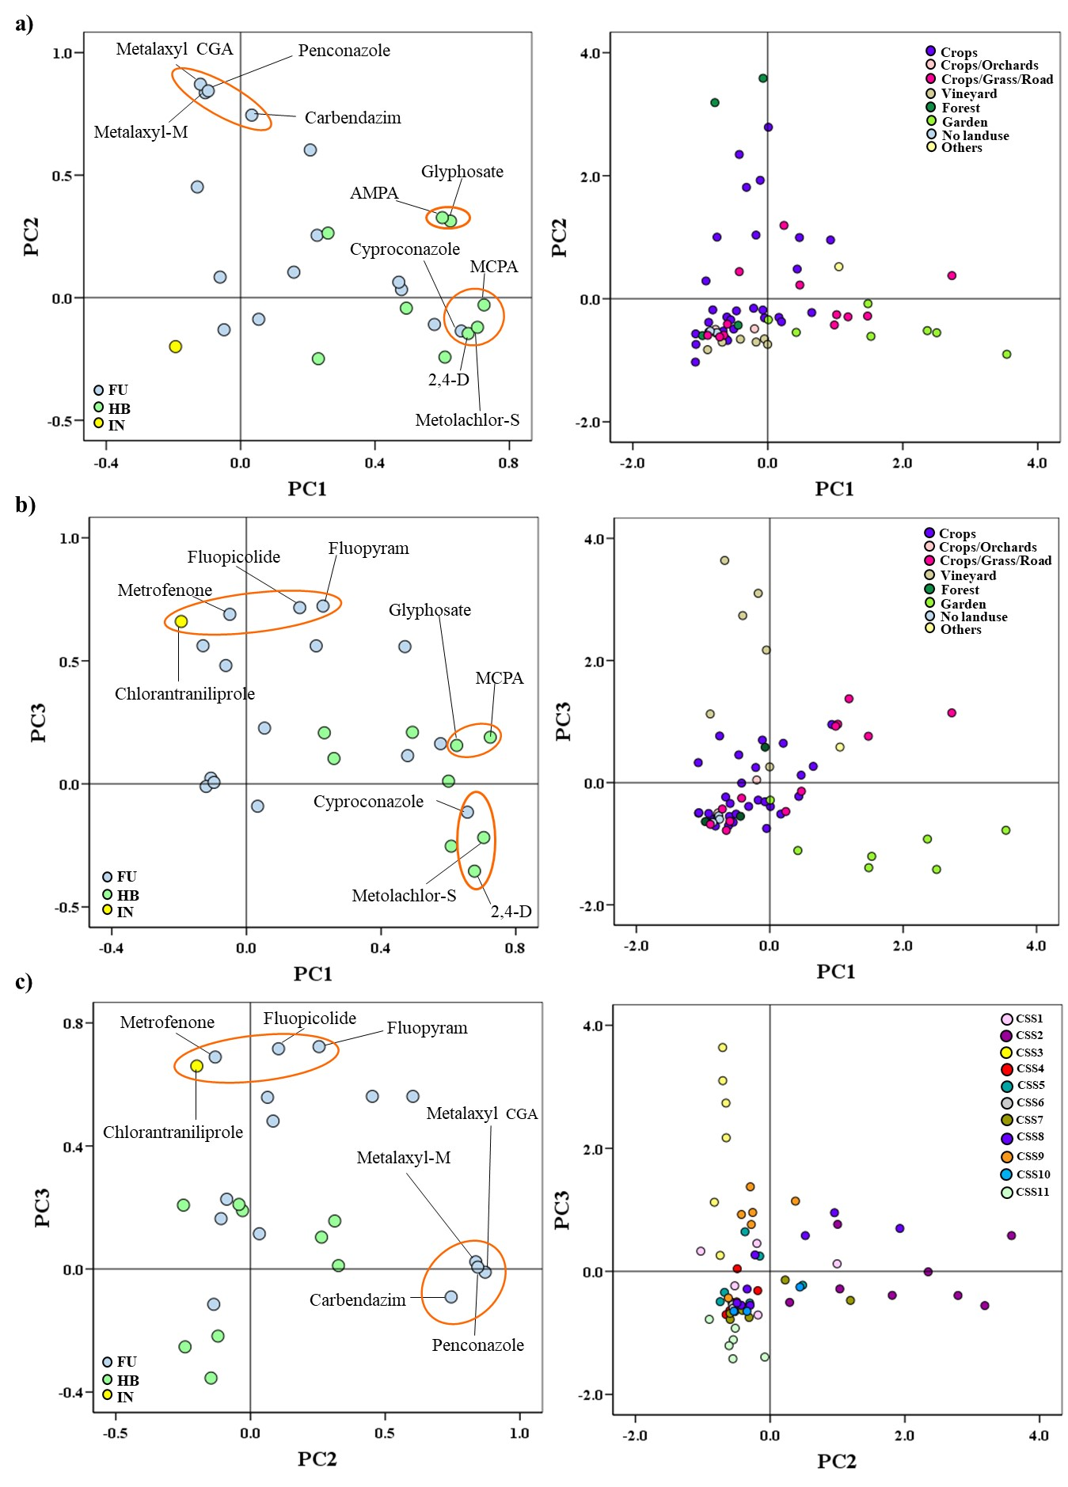
Figure S3. Diagrams of dispersion related to the three components resulting from a principal components analysis (PCA) derived from the content of pesticides in water and pesticide distribution (type of land use and CSS): a) PC1 and PC2, b) PC1 and PC3, and c) PC2 and PC3. Loading plots (left) contribution of each variable to each component; FU: fungicide, HB: herbicide, IN: insecticide. Score plots (right), markers set by land use (a and b) and CSS (c), of all samples on each component.

Table S7. Variables of the principal components analysis (PCA) related to the content of pesticides in water and pesticide distribution (CSS, water body type, land use of the banktop). Detail of the influence of each variable in each component.

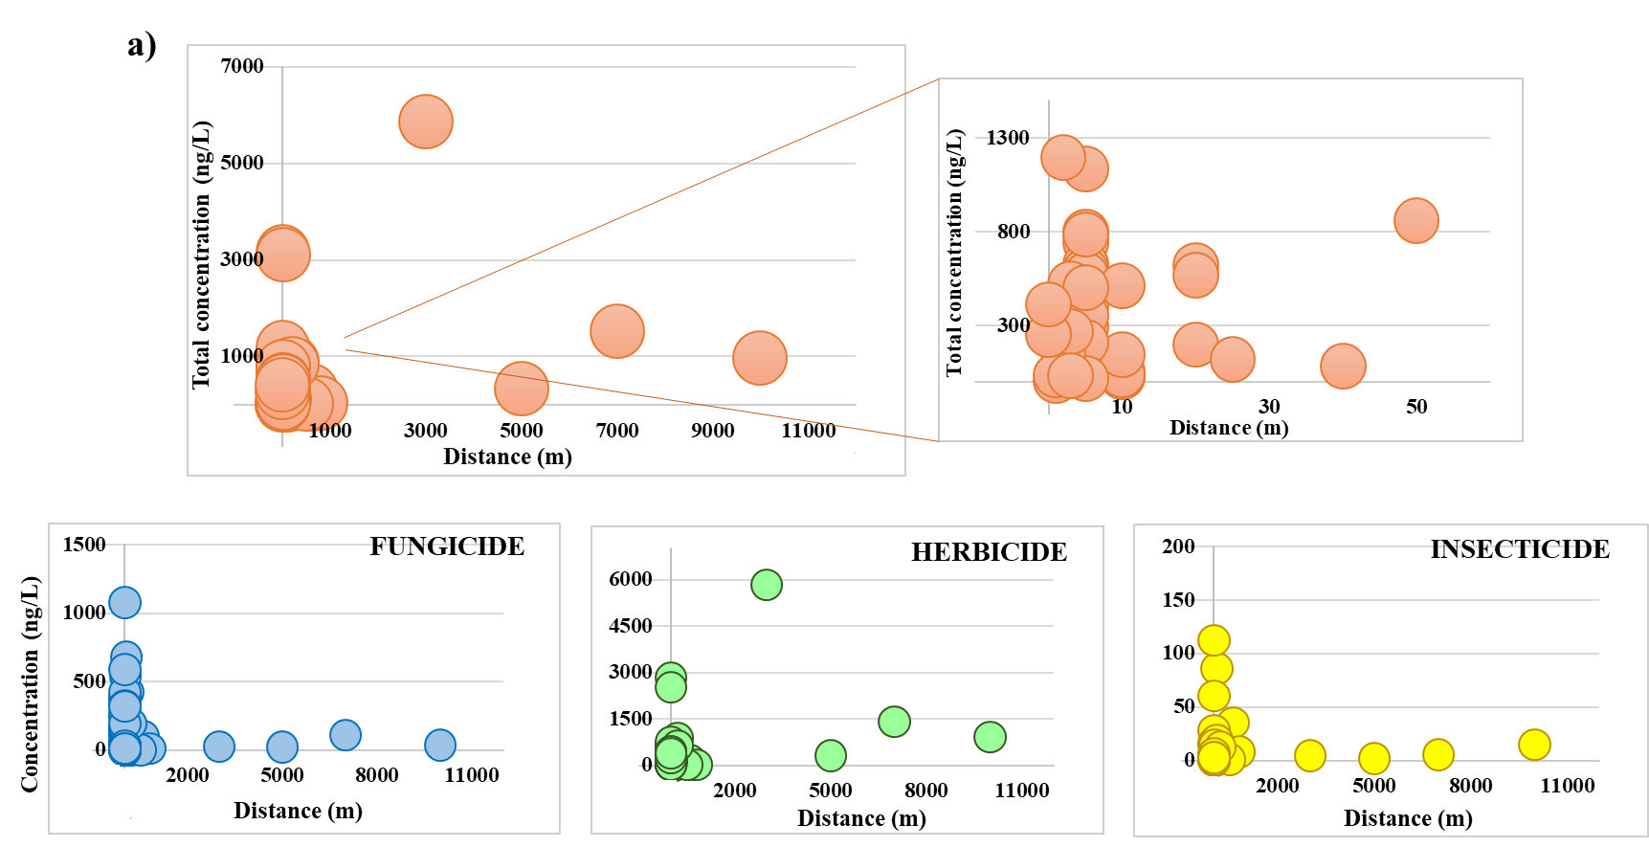
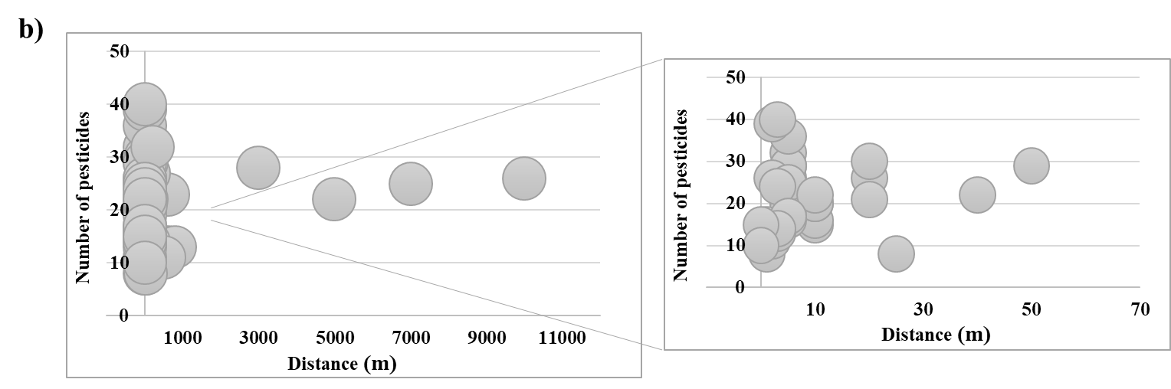

Figure S4. Total concentration (a; ng/L) and number of pesticides (b) in water related to the distance (m) to agricultural fields.

.
Figure S5. Contribution (%) of each pesticide to the total in water from each CSS. Only the first 20 pesticides with higher contribution and Df > 10% in each CSS are shown.
Table S8. Compliance with reference values in water. AA-EQS: Annual Average Environmental Quality Standard, MAC-EQS: Maximum Allowable Concentration Environmental Quality Standard, RAC: Regulatory Acceptable Concentration. (Green: value detected in water < reference value; Red: value detected in water > reference value; Blue: no reference value. 'X': Not detected).
Table S8 (cont). Compliance with reference values in water. AA-EQS: Annual Average Environmental Quality Standard, MAC-EQS: Maximum Allowable Concentration Environmental Quality Standard, RAC: Regulatory Acceptable Concentration. (Green: value detected in water < reference value; Red: value detected in water > reference value; Blue: no reference value. 'X': Not detected).
Table S8 (cont). Compliance with reference values in water. AA-EQS: Annual Average Environmental Quality Standard, MAC-EQS: Maximum Allowable Concentration Environmental Quality Standard, RAC: Regulatory Acceptable Concentration. (Green: value detected in water < reference value; Red: value detected in water > reference value; Blue: no reference value. 'X': Not detected).

Table S8 (cont). Compliance with reference values in water. AA-EQS: Annual Average Environmental Quality Standard, MAC-EQS: Maximum Allowable Concentration Environmental Quality Standard, RAC: Regulatory Acceptable Concentration. (Green: value detected in water < reference value; Red: value detected in water > reference value; Blue: no reference value. X: Not detected).

Figure S6. Exceedances of reference values in water. AA-EQS: Annual Average Environmental Quality Standard, MAC-EQS: Maximum Allowable Concentration Environmental Quality Standard (European Commission 2013, 2022), RAC: Regulatory Acceptable Concentration (UBA, 2020).
Table S9. Ecological risk assessment (RQ₅₀ and RQ_{max} ratios) of individual pesticides and mixtures in the aquatic environment. RQ code: Light Green: RQ < 0.01; negligible risk; Green: 0.01 < RQ < 0.1; low risk; Yellow: 0.1 < RQ < 1; medium risk; Red: RQ > 1; high risk. Blue: Lack of toxicological data. X: not detected.

Table S9 (cont.). Ecological risk assessment (RQ₅₀ and RQ_{max} ratios) of individual pesticides and mixtures in the aquatic environment. RQ code: Light Green: RQ < 0.01; negligible risk; Green: 0.01 < RQ < 0.1; low risk; Yellow: 0.1 < RQ < 1; medium risk; Red: RQ > 1; high risk. Blue: Lack of toxicological data. X: not detected.

Table S10. Ecological risk assessment (RQ₅₀ and RQ_{max} ratios, %) of pesticides in the aquatic environment from each CSS.
References
Alaoui, A., Vested, A., Silva, V., Schlünssen V., et al., 2021. Monitoring plan for assessing ecosystem, plant, animal and human health at case study sites. Deliverable D2.1 (Version 2) Report. https://sprint-h2020.eu/index.php/resources/project-milestones (Last access February 2024).
Belles, A., Alary, C., Rivière, A., Guillon, S., Patault, E., Flipo, N., Franke, C., 2019. Transfer Pathways and fluxes of water-soluble pesticides in various compartments of the agricultural catchment of the Canche River (Northern France). Water 11, 1428. 428; https://doi.org/10.3390/w11071428
Casillas, A., de la Torre, A., Navarro, I., Sanz, P., Martínez, M.A., 2022. Environmental risk assessment of neonicotinoids in surface water. Sci. Total Environ. 809, 151161 https://doi.org/10.1016/j.scitotenv.2021.151161
Ccanccapa, A., Masia, A., Navarro-Ortega, A., Picó Y., Barceló, D.,2016. Pesticides in the Ebro river basin: occurrence and risk assessment. Environ. Pollut. 211, 414-424. http://dx.doi.org/10.1016/j.envpol.2015.12.059
Corcoran, S., Metcalfe, C.D., Sultana, T., Amé, M.V. Menone, M.L., 2020. Pesticides in surface waters in Argentina monitored using polar organic chemical integrative samplers. Bull. Environ. Contam. Toxicol. 104, 21-26. https://doi.org/10.1007/s00128-019-02758-z
Cruzeiro, C., Amaral, S., Rocha, E., Rocha, M.J., 2017. Determination of 54 pesticides in waters of the Iberian Douro River estuary and risk assessment of environmentally relevant mixtures using theoretical approaches and Artemia salina and Daphnia magna bioassays. Ecotoxicol. Environ. Saf. 145, 126-134. http://dx.doi.org/10.1016/j.ecoenv.2017.07.010
European Commission, 2003. Technical Guidance Document on Risk Assessment. Part II. https://echa.europa.eu/documents/10162/987906/tgdpart2_2ed_en.pdf/138b7b71-a069-428e-9036-62f4300b752f
European Commission, 2013. Directive 2008/105/EC of the European Parliament and of the Council of 16 December 2008 on environmental quality standards in the field of water policy. https://eur-lex.europa.eu/eli/dir/2008/105/oj (Last access February 2024).
European Commission, 2022. Proposal for a Directive of the European Parliament and of the Council Amending Directive 2000/60/EC Establishing a Framework for Community Action in the field of Water Policy, Directive 2006/118/EC on the Protection of Groundwater Against Pollution and Deterioration and Directive 2008/105/EC on Environmental Quality Standards in the Field of Water Policy, pp. 1–81. https://eur-lex.europa.eu/resource.html?uri=cellar:d0c11ba6-55f8-11ed-92ed-01aa75ed71a1.0001.02/DOC_2&format=PDF. (Last access February 2024).
Flinger, S., Mendaš, G., Dvoršćak, M., Stipičević, S., Vasilić, Z., Drevenkar, V., 2021. Seasonal distribution of multiclass pesticide residues in the surface waters of northwest Croatia. Arh Hig Rada. Toksikol. 72, 280-288. https://doi:10.2478/aiht-2021-72-3598
Ineris, 2020. Institut national de l’environnement industriel et des risques, 2020. Glyphosate et ses principaux composes. https://substances.ineris.fr/fr/substance/getDocument/3043 (Last access February 2024).
Herrero-Hernández, E., Simón-Egea, A.B., Sánchez-Martín, M.J., Rodríguez-Cruz, M.S., Andrades, M.S., 2020. Monitoring and environmental risk assessment of pesticide residues and some of their degradation products in natural waters of the Spanish vineyard region included in the Denomination of Origin Jumilla. Environ. Pollut. 264, 114666. https://doi.org/10.1016/j.envpol.2020.114666
Karlsson, A.S., Lesch, M., Weihermüller, L., Thiele, B., Disko, U., Hofmann, D., Vereecken, H., Spielvogel, S., 2020. Pesticide contamination of the upper Elbe River and an adjacent floodplain area. J. Soils Sediments 20, 2067-2081. https://doi.org/10.1007/s11368-020-02571-w
Knauer, K., 2016. Pesticides in surface waters: a comparison with regulatory acceptable concentrations (RACs) determined in the authorization process and consideration for regulation. Environ. Sci. Eur. 28, 13. https://doi.org/10.1186/s12302-016-0083-8
Kapsi, M., Tsoutsi, C., Paschalidou, A., Albanis, T., 2019. Environmental monitoring and risk assessment of pesticide residues in surface waters of the Louros River (N.W. Greece). Sci. Total Environ. 650, 2188-2198. https://doi.org/10.1016/j.scitotenv.2018.09.185
Konečná, J., Zajíček, A., Sáňka, M., Halešová, T., Kaplická, M., Nováková, E., 2023. Pesticides in Small Agricultural Catchments in the Czech Republic. J. Ecol. Eng. 24, 99-112. https://doi.org/10.12911/22998993/157471
Koroša, A., Mali, N., 2015. Pharmaceuticals and pesticides in urban groundwater: a case study – Maribor, Slovenia. WIT Transactions on Ecology and The Environment 196. Water Resources Management VIII, 413-422. https://www.witpress.com/Secure/elibrary/papers/WRM15/WRM15035FU1.pdf (Last access February 2024)
Lewis, K.A., Tzilivakis, J., Warner, D.J., Green, A., 2016. An international database for pesticide risk assessments and management. Human and Ecological Risk Assessment: An International Journal 22, 1050–1064. https://doi.org/10.1080/10807039.2015.1133242
Li W., Xin S., Deng W., Wang B., Liu X., Yuan Y., Wang, S., 2023. Occurrence, spatiotemporal distribution patterns,partitioning and risk assessments of multiple pesticide residues in typical estuarine water environments in eastern China. Water Res. 245, 120570. https://doi.org/10.1016/j.watres.2023.120570
Masiol, M., Gianni, B., Prete, M., 2018. Herbicides in river water across the northeastern Italy: occurrence and spatial patterns of glyphosate, aminomethylphosphonic acid, and glufosinate ammonium. Environ. Sci. Pollut. Res. 25, 24368-24378. https://doi.org/10.1007/s11356-018-2511-3
Moschet, C., Wittmer, I., Simovic, J., Junghans, M., Piazzoli, A., Singer, H., Stamm, C., Leu, C., Hollender, J., 2014. How a complete pesticide screening changes the assessment of surface water quality. Environ. Sci. Technol. 48, 5423-5432. https://doi.org/10.1021/es500371t
Munaron; D., Mérigot, B., Derolez, V., Tapie, N., Budzinski, H., Fiandrino, A., 2023. Evaluating pesticide mixture risks in French Mediterranean coastal lagoons waters. Sci. Total Environ. 867, 161303 http://dx.doi.org/10.1016/j.scitotenv.2022.161303
PAN, 2021. Pesticide Action Network International (PAN) International List of Highly Hazardous Pesticides. March 2021. https://pan-international.org/wp-content/uploads/PAN_HHP_List.pdf. (Last access February 2024).
PANPDB, 2023. PAN Pesticide Database. Pesticide Action Network Pesticide Database. http://www.pesticideinfo.org/. (Last access February 2024).
Papadakis, E., Tsaboula, A., Kotopoulou, A., Kintzikoglou, K., Vryzas, Z., Papadopoulou-Mourkidou, E., 2015. Pesticides in the surface waters of Lake Vistonis Basin, Greece: Occurrence and environmental risk assessment. Sci. Total Environ. 536, 793-802. http://dx.doi.org/10.1016/j.scitotenv.2015.07.099
Pérez D.J., Iturburu, F.G., Calderon, G., Oyesqui, L.A.E., De Gerónimo, E., Aparicio, V.C., 2021. Ecological risk assessment of current-use pesticides and biocides in soils, sediments and surface water of a mixed land-use basin of the Pampas region, Argentina. Chemosphere 263, 128061 https://doi.org/10.1016/j.chemosphere.2020.128061
PPDB, 2023. Pesticide Properties DataBase (PPDB). University of Hertfordshire https://sitem.herts.ac.uk/aeru/ppdb/en/atoz.htm. (Last access February 2024).
Price, P., Dhein, E., Hamer, M., Han, X., Heneweer, M., Junghans, M., Kunz, P., Magyar, C., Penning, H., Rodriguez C., 2012. A decision tree for assessing effects from exposures to multiple substances. Environ. Sci. Eur. 24. http://www.enveurope.com/content/24/1/26
Quintana, J., de la Cal, A., Boleda, M.R., 2019. Monitoring the complex occurrence of pesticides in the Llobregat basin, natural and drinking waters in Barcelona metropolitan area (Catalonia, NE Spain) by a validated multi-residue online analytical method. Sci. Total Environ. 692, 952-965 https://doi.org/10.1016/j.scitotenv.2019.07.317
Reemtsma, T., Alder, L., Banasiak, U., 2013. Emerging pesticide metabolites in groundwater and surface water as determined by the application of a multimethod for 150 pesticide metabolites. Water Res. 47, 5535-5545. https://doi.org/10.1016/j.watres.2013.06.031
RIWA-Rijn, 2021. Annual Report 2020 The Rhine. https://www.riwa-rijn.org/wp-content/uploads/2021/10/RIWA-2021-EN-Anual-Report-2020-The-Rhine.pdf (Last access February 2024)
Rocha, M.J., Rocha, E., 2023. Chemical monitoring and risk assessment of 56 pesticides in the Ave River and adjoining Atlantic coastline (Iberian Peninsula, Portugal). Mar. Pollu. Bull. 190, 114844. https://doi.org/10.1016/j.marpolbul.2023.114844
SANTE, 2021a. Guidance Document on Pesticide analytical methods for risk assessment and post-approval control and monitoring purposes, SANTE/2020/12830, Rev. 1.
SANTE, 2021b. Analytical quality control and method validation procedures for pesticide residues analysis in food and feed, SANTE 11312/2021.
Spycher, S., Mangold, S., Doppler, T., Junghans, M., Wittmer, I., Stamm, C., Singer, H., 2018. Pesticide risks in small streams-How to get as close as possible to the stress imposed on aquatic organisms. Environ. Sci. Technol. 52, 4526-4535. https://doi.org/10.1021/acs.est.8b00077
Triassi, M., Nardone, A., Giovinetti, M.C., De Rosa, E., Canzanella, S., Sarnacchiaro, P., Montuori, P., 2019. Ecological risk and estimates of organophosphate pesticides loads into the Central Mediterranean Sea from Volturno River, the river of the “Land of Fires” area, southern Italy. Sci. Total Environ. 678, 741-754. https://doi.org/10.1016/j.scitotenv.2019.04.202
UBA, Federal Environmental Agency of Germany, 2020. http://webetox.uba.de/webETOX/public/basics/literatur/download.do;jsessionid=4E3224EF2A91678E4E2CDF2638ECD522?id=528. (Last access February 2024).
Vera-Candioti, J., Araujo, P.I., Huerga, I.R., Rojas, D.E., Cristos, D.S., Malmantile A.D., 2021. Pesticides detected in surface and groundwater from agroecosystems in the Pampas region of Argentina: occurrence and ecological risk assessment. Environ. Monit. Assess 193, 689. https://doi.org/10.1007/s10661-021-09462-8.
Vormeier, P., Schreiner, V.S., Liebmann, L., Link, M., Schäfer, R.B., Schneeweiss, A., Weisner, O., Liess, M., 2023. Temporal scales of pesticide exposure and risks in German small streams. Sci. Total Environ. 871, 162105. https://doi.org/10.1016/j.scitotenv.2023.162105
Weisner, O., Jens Arle, J., Liebmann, L., Link, M., Schäfer, R.B., Schneeweiss, A., Schreiner, V.C., Vormeier, P., Liess, M., 2022. Three reasons why the Water Framework Directive (WFD) fails to identify pesticide risks. Water Res. 208, 117848. https://doi.org/10.1016/j.watres.2021.117848

