Supplementary material
Pharmaceutical footprint in the river ecosystem: suspect screening approach with high resolution mass spectrometry
Silvia Royano*, Juan Escobar-Arnanz, Irene Navarro, Adrián de la Torre¹, María Ángeles Martínez¹
Unit of Persistent Organic Pollutants and Emerging Pollutants in Environment, Department of Environment, CIEMAT, Avda. Complutense 40, 28040, Madrid, Spain.
¹ These authors share last authorship
* Corresponding author: silvia.royano@ciemat.es

TABLE OF CONTENTS
 | Page
FIGURES
Figure S1. Geographical distribution of surface water, sediment, and fish sampling points (S1-S13) and location of the two WWTPs (blue) investigated. Sampling points were classified in low (green), medium (yellow) and high (red) anthropogenic influence. | 1
Figure S2. Comparison of the obtained PhAC profile in a surface water sample. Normalized areas (top) obtained with X500R QTOF and concentration (ng/L, bottom) obtained with a triple quadrupole mass spectrometer. | 5
Figure S3. Number of PhACs identified in each family. | 6
Figure S4. Normalized area (logarithmic scale) of PhACs (Df% > 50%) in influents. | 7
Figure S5. Normalized area (logarithmic scale) of PhACs (Df% > 50%) in effluents. | 8
Figure S6. Normalized area (logarithmic scale) of PhACs in influents and effluents. Significant differences (p < 0.05, Mann Whitney U test) between the influent and the effluent are represented by the asterisk (* p < 0.05) and the double asterisk (**, p < 0.01)). The triple asterisk (***) represents those PhACs that were only identified in the influent or effluent. | 9
Figure S7. Normalized area (logarithmic scale) of PhACs (Df% > 50%) in surface water. | 10
Figure S8. Normalized area (logarithmic scale) of PhACs (Df% > 50%) in sediments. | 11
Figure S9. Normalized area (logarithmic scale) of PhACs (Df% > 50%) in sewage sludge (before digester). | 12
Figure S10. Normalized area (logarithmic scale) of PhACs (Df% > 50%) in sewage sludge (after digester). | 13
Figure S11. Normalized area (logarithmic scale) of PhACs (Df% > 50%) in sewage sludge (before and after digester). The asterisk (*) represents those PhACs that were only identified before or after the digester. | 14
Figure S12. Normalized area (logarithmic scale) of PhACs (Df% > 50%) in fish. | 15
Figure S13. Total normalized area (left) and number of compounds (right) in each location for surface water (A), sediments (B) and fish (C). (s) indicates statistically significant differences. | 15
Figure S14. Temporal trends according to the number of compounds (left) and total normalized area (right) for surface water (A), sediments (B) and fish (C). | 16
Figure S15. Seasonality variations according to the number of compounds (A) and total normalized area (B) for surface water. | 17
TABLES
Table S1. Characteristics of the area of influence and classification (anthropogenic influence) of the sampling points. | 1
Table S2. Chromatographic conditions. | 3
Table S3. Mass spectrometer parameters for MS/MS spectra acquisition. | 4
Table S4. Weight (%) of each identification criteria in the combined score. | 5
Table S5. Family and subfamily classification, name, CAS number, physicochemical properties and ATC code of identified PhACs. Blue names represent metabolites. | Excel
Table S6. Normalized areas of identified PhACs. | Excel
Table S7. Median normalized areas and detection frequency (%) of identified PhACs. Blue names represent metabolites. | Excel
Table S8. Spearman's Rho correlation matrix for therapeutic families found in aquatic ecosystem. | Excel
Table S9. Detection frequency (%), and normalized areas of identified transformation products (TP) and their parent compounds. Colors represent contribution to each compound for each PhAC groups (parent + TP). | Excel
TEXT
Text S1. Wastewater and sludge treatment processes applied in the WWTPs. | 2
Text S2. Reagents and chemicals. | 2
Text S3. Search algorithm used during data processing. | 5

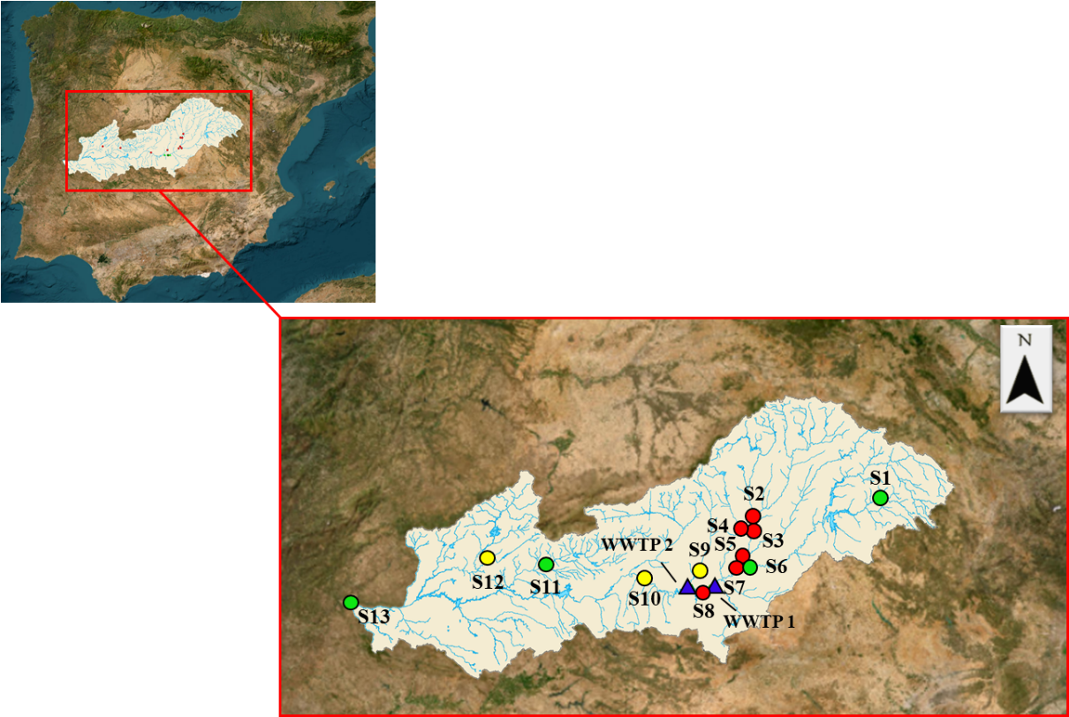
Figure S1. Geographical distribution of surface water, sediment, and fish sampling points (S1-S13) and location of the two WWTPs (blue) investigated. Sampling points were classified in low (green), medium (yellow) and high (red) anthropogenic influence.

Table S1. Characteristics of the area of influence and classification (anthropogenic influence) of the sampling points.
Site | River (province) | Inhabitants | WWTP | Land use | Livestock  farms | Anthropogenic influence
S1 | Guadiela (Cuenca) | Low | Low | Agriculture (Low) | Low | Low
S2 | Jarama (Madrid) | High | High | Urban (High) | Low | High
S3 | Jarama (Madrid) | High | High | Urban (High) | Low | High
S4 | Manzanares (Madrid) | High | High | Urban (High) | Low | High
S5 | Jarama (Madrid) | High | Medium | Urban and agriculture (Medium) | Medium | High
S6 | Tajo (Madrid) | Low | Medium | Urban and agriculture (Medium) | Medium | Low
S7 | Tajo (Madrid) | High | Medium | Urban and agriculture (Medium) | Medium | High
S8 | Tajo (Toledo) | High | Medium | Urban and agriculture (Medium-high) | Medium | High
S9 | Guadarrama (Toledo) | Medium | Medium | Urban and agriculture (Medium) | Medium | Medium
S10 | Tajo (Toledo) | Medium | Medium | Agriculture (Low) | Medium | Medium
S11 | Tietar (Cáceres) | Low | Medium | Agriculture (Low) | Medium | Low
S12 | Jerte (Cáceres) | Medium | Medium | Agriculture (Low) | High | Medium
S13 | Tajo (Cáceres) | Low | Low | Agriculture (Low) | Medium | Low

Text S1. Wastewater and sludge treatment processes applied in the WWTPs.
At both facilities, wastewater entering the treatment plant undergoes a physical separation step, or primary treatment, which removes large solids, sand, and grease (MITECO, 2024). This process uses systems such as grit chambers or coarse screens to remove bulky materials (stones, branches, plastics, etc.) through decantation or filtration. After removing these material and grease, the water flows into a primary clarifier or settling tank, where remaining suspended solids settle to the bottom and are separated. After the removal of all coarse and settable solids, the wastewater undergoes secondary, or biological, treatment during which microorganisms degrade the organic matter and nutrients (nitrogen and phosphorus) dissolved in the water. The wastewater enters a reactor operated under controlled aerobic, anoxic, and anaerobic conditions, allowing microbial communities to grow and metabolize the organic load. The biomass formed during this process constitutes the activated sludge, which is subsequently collected in a secondary settling tank. The deposited material generated during both primary and secondary treatment, composed of organic matter, inorganic matter, and microorganisms, is collected in a single sludge line, where a further processing begins. First, the sludge is stabilized through anaerobic digestion, which breaks down the organic fraction and afterwards,the volume of the stabilized sludge is reduced by removing as much water as possible.

Text S2. Reagents and chemicals.
Native and deuterated standards were acquired from LabStandard (Barcelona, Spain) (acetaminophen, atenolol, atorvastatin, azithromycin, gemfibrozil, ibuprofen, ketoprofen, metoprolol, miconazole, venlafaxine, acetaminophen-d3 and atenolol-d7), LGC Dr. Ehrenstorfer (Augsburg, Germany) (carbamazepine, clarithromycin, clotrimazole, o-desmetilvenlafaxine, erythromycin, fluconazole, irbesartan, naproxen, sulfamethoxazole, thiabendazole, trimethoprim, valsartan, ibuprofen-d3 and sulfamethoxazole-d4), Trc Canada (North York, ON, Canadá) (gemfibrozil-d6) and LGC LoGiCal (Luckenwalde, Germany) (velafaxine-d6).
Methanol (HPLC grade) was purchased from J.T. Baker (USA), acetonitrile (HPLC grade) and formic acid (99-100%) from Scharlab SL (Spain) and ammonium formate (>99%, LC-MS grade) from VWR (Spain).
All previous stock solutions were at concentration of 100 mg/L in acetonitrile or methanol. Two working standard mixtures, native and deuterated compounds separately, were prepared from commercial solutions at a concentration of 1 mg/L in acetonitrile. All standard solutions were stored at -20ºC.

Table S2. Chromatographic conditions.
CHROMATOGRAPHIC CONDITIONS
Column | Luna Omega C18 100Å column (100 mm x 2.1 mm i.d., 1.6 µm particle size) (Phenomenex)
Column temperature | 40 ºC
Injection volume | 5 µL
Mobile phase | A: Milli-Q water (2 mM ammonium formate; 0.1% formic acid)
 | B: Methanol (2 mM ammonium formate; 0.1% formic acid)
Gradient | Min | % A | % B
Gradient | 0 | 95 | 5
Gradient | 1 | 80 | 20
Gradient | 15 | 5 | 95
Gradient | 17 | 5 | 95
Gradient | 17.1 | 0 | 100
Gradient | 19 | 0 | 100
Gradient | 19.1 | 95 | 5
Gradient | 22 | 95 | 5
Flow rate | 0.35 mL/min

Table S3. Mass spectrometer parameters for MS/MS spectra acquisition.
QTOF PARAMETERS
Ionization mode |  | Positive (ESI⁺)
Acquisition mode |  | DIA (SWATH)
ESI temperature |  | 550 ºC
Curtain gas pressure |  | 35 psi
Ion source Gas 1 and 2 |  | 60 psi
Ion Spray Voltage |  | 5,500 V
Collision Gas |  | 9
TOF MS
Mass range |  | 100-1,100 Da
DP |  | 60 V
DP Spread |  | 0 V
CE |  | 10 V
CE Spread |  | 0 V
Accumulation time |  | 0.03 s
TOF MS/MS
Mass range |  | 40-1,100 Da
Accumulation time |  | 0.03 s
DIA windows
 | Mass range (Da) |  | DP (V) | DP Spread (V) | CE (V) | CE Spread (V)
 | 100-120 |  | 60 | 30 | 35 | 15
 | 119-140 |  | 60 | 30 | 35 | 15
 | 139-160 |  | 60 | 30 | 35 | 15
 | 159-180 |  | 60 | 30 | 35 | 15
 | 179-200 |  | 60 | 30 | 35 | 15
 | 199-220 |  | 60 | 30 | 35 | 15
 | 219-240 |  | 60 | 30 | 35 | 15
 | 239-260 |  | 60 | 30 | 35 | 15
 | 259-280 |  | 60 | 30 | 35 | 15
 | 279-300 |  | 60 | 30 | 35 | 15
 | 299-320 |  | 60 | 30 | 35 | 15
 | 319-340 |  | 60 | 30 | 35 | 15
 | 339-360 |  | 60 | 30 | 35 | 15
 | 359-380 |  | 60 | 30 | 35 | 15
 | 379-400 |  | 60 | 30 | 35 | 15
 | 399-420 |  | 60 | 30 | 35 | 15
 | 419-440 |  | 60 | 30 | 35 | 15
 | 439-460 |  | 60 | 30 | 35 | 15
 | 459-480 |  | 60 | 30 | 35 | 15
 | 479-500 |  | 60 | 30 | 35 | 15
 | 499-600 |  | 60 | 30 | 35 | 15
 | 599-800 |  | 60 | 30 | 35 | 15
 | 799-1,100 |  | 60 | 30 | 35 | 15

Text S3. Search algorithm used during data processing.
Before starting data processing, the user must specify in the processing method the name, monoisotopic mass, and molecular formula of each suspected compound. Then, Smart Confirmation Search algorithm identifies the name of the compound indicated in the processing method and searches for it in the library. If it does not find a candidate, it searches for the MS/MS spectrum that best matches the experimental spectrum. Subsequently, the Fit method was used to calculate match percentages, based on the overlap between peaks in the library and experimental spectra (Schulze et al., 2024).

Table S4. Weight (%) of each identification criteria in the combined score.
Criteria | Acceptable value | Weight in the combined score (%)
Accurate mass error | ≤ 5 ppm | 30
Isotopic pattern difference | ≤ 20% | 10
Match with libraries | ≥ 70% | 50
Prediction of the molecular formula | ≥ 50% | 10
Combined score | ≥ 75% | NA
Peak height | ≥ 10.000 cps | NA
Area / Blank area | > 10 | NA
Width at half height | ≤ 0,20 Da | NA
NA: not applicable

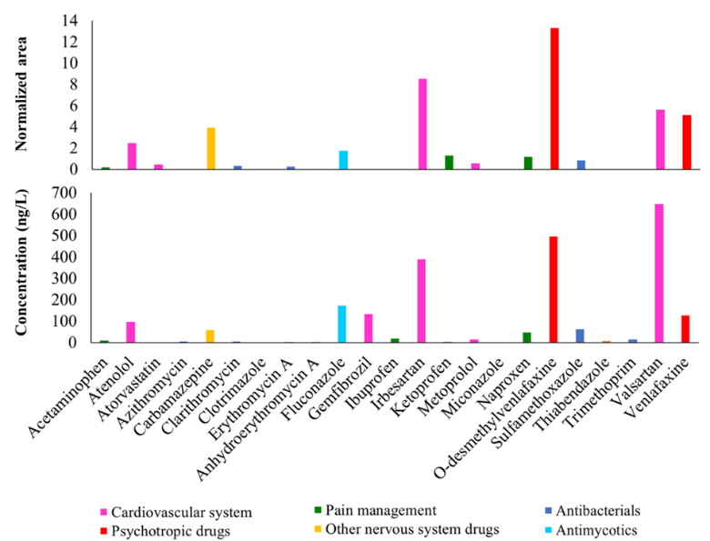
Figure S2. Comparison of the obtained PhAC profile in a surface water sample. Normalized areas (top) obtained with X500R QTOF and concentration (ng/L, bottom) obtained with a triple quadrupole mass spectrometer.
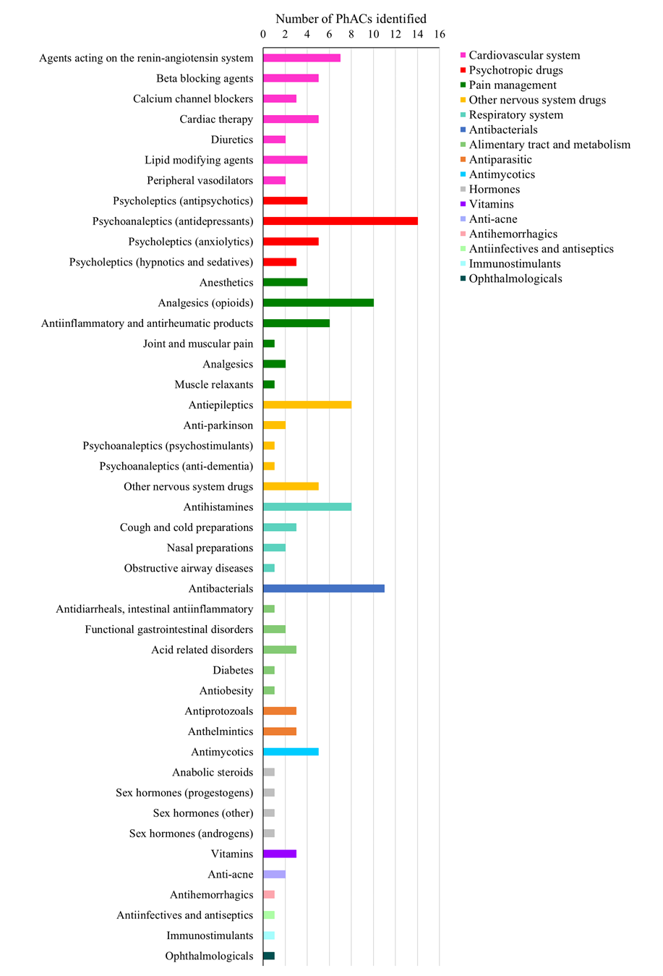
Figure S3. Number of PhACs identified in each family.
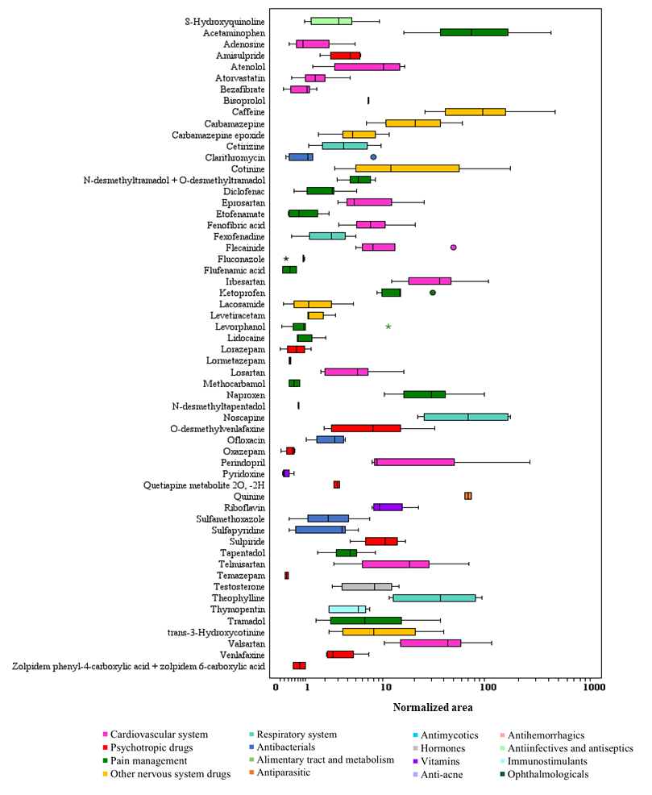
Figure S4. Normalized area (logarithmic scale) of PhACs (Df% > 50%) in influents.
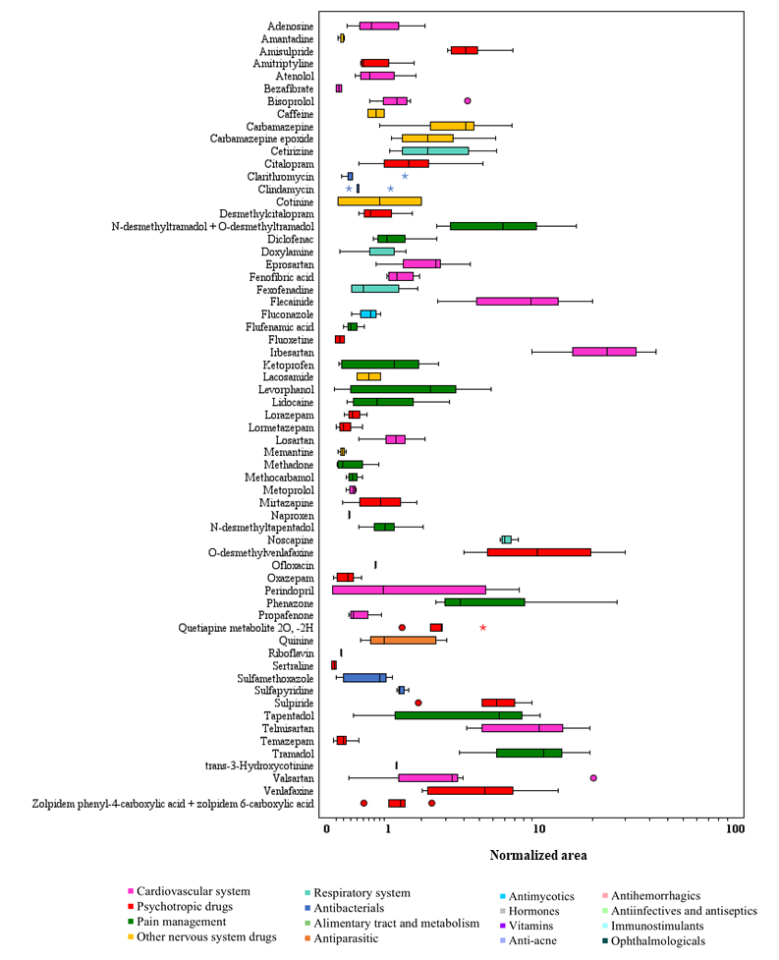
Figure S5. Normalized area (logarithmic scale) of PhACs (Df% > 50%) in effluents.
Figure S6. Normalized area (logarithmic scale) of PhACs in influents and effluents. Significant differences (p < 0.05, Mann Whitney U test) between the influent and the effluent are represented by the asterisk (* p < 0.05) and the double asterisk (**, p < 0.01)). The triple asterisk (***) represents those PhACs that were only identified in the influent or effluent.
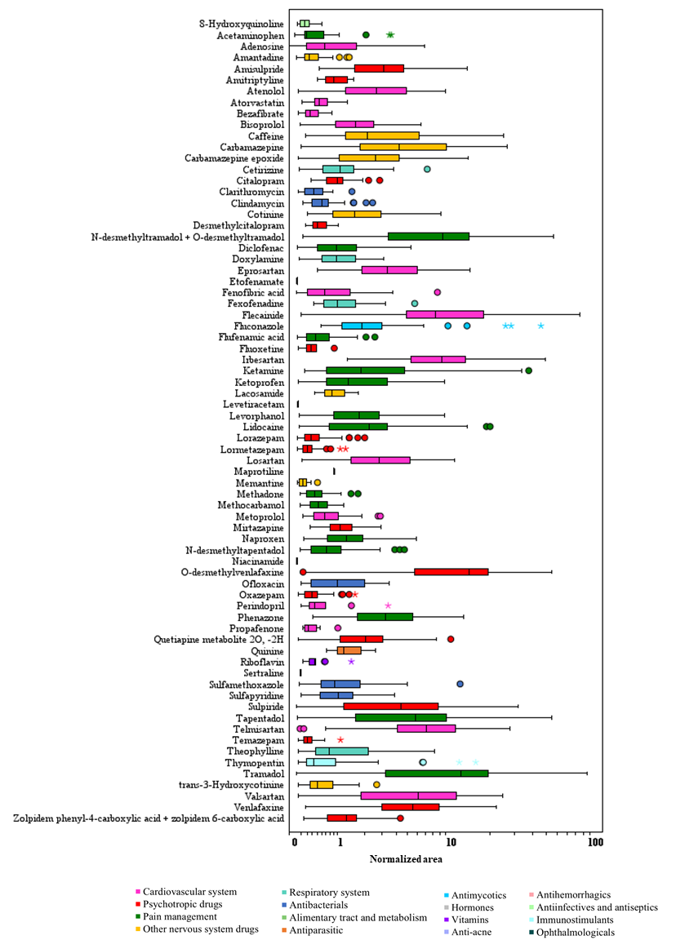
Figure S7. Normalized area (logarithmic scale) of PhACs (Df% > 50%) in surface water.
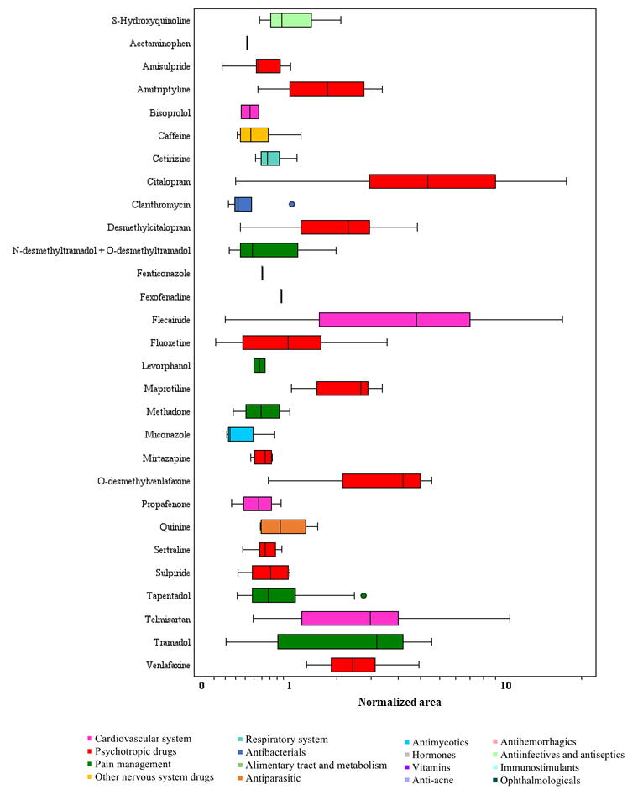
Figure S8. Normalized area (logarithmic scale) of PhACs (Df% > 50%) in sediments.

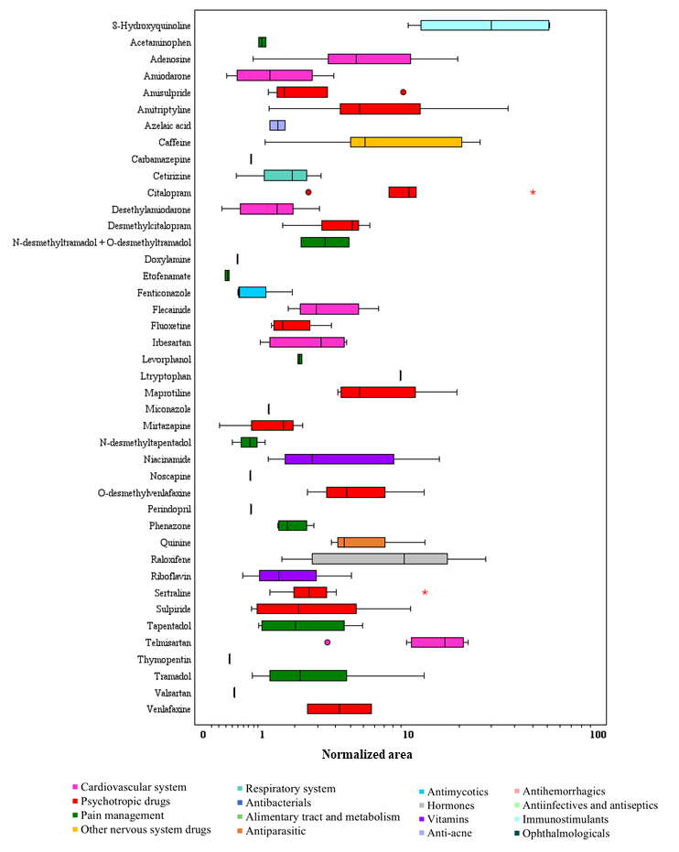
Figure S9. Normalized area (logarithmic scale) of PhACs (Df% > 50%) in sewage sludge (before digester).

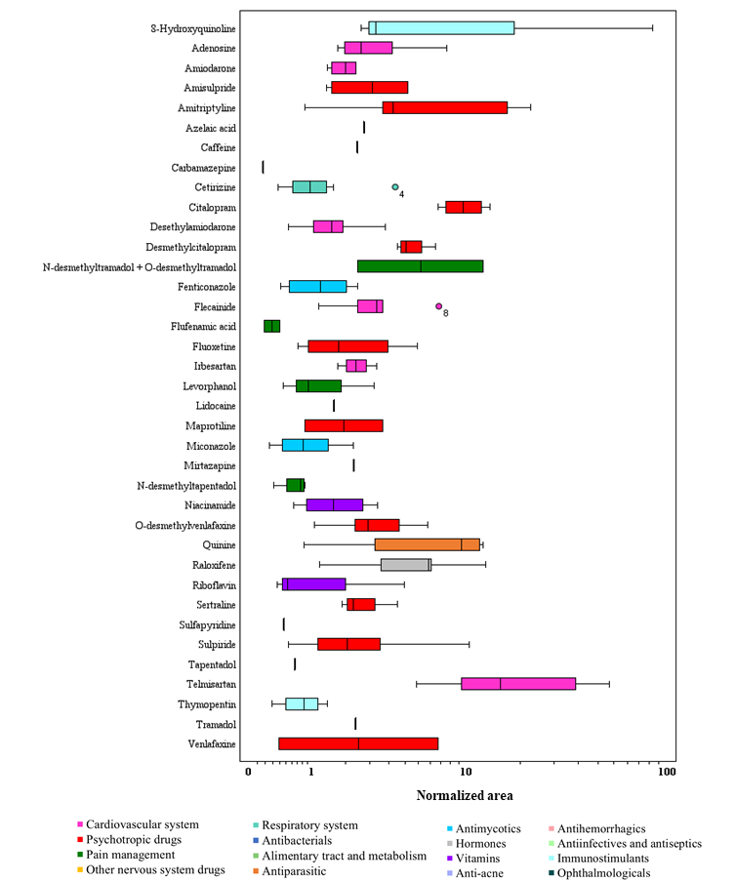
Figure S10. Normalized area (logarithmic scale) of PhACs (Df% > 50%) in sewage sludge (after digester).

Figure S11. Normalized area (logarithmic scale) of PhACs (Df% > 50%) in sewage sludge (before and after digester). The asterisk (*) represents those PhACs that were only identified before or after the digester.
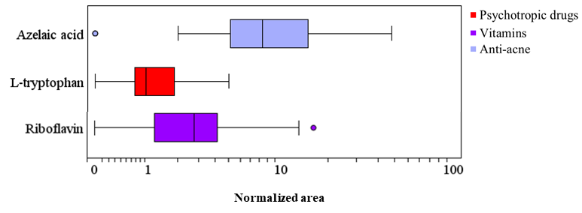
Figure S12. Normalized area (logarithmic scale) of PhACs (Df% > 50%) in fish.

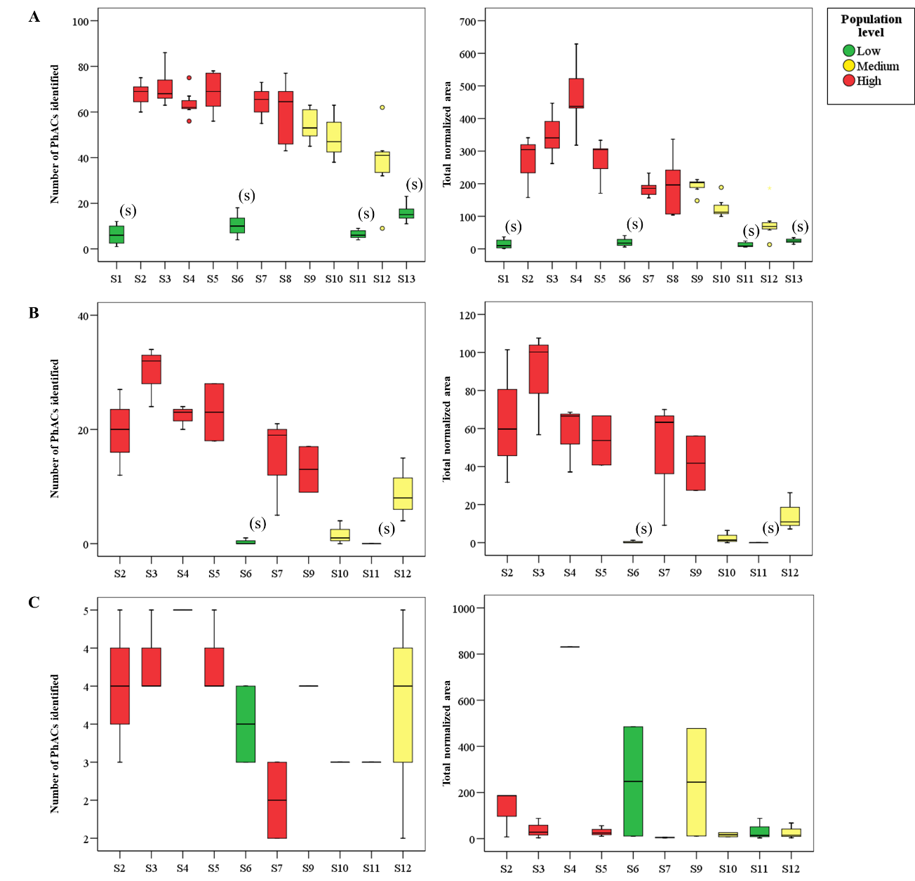
Figure S13. Number of compounds (left) and total normalized area (right) in each location for surface water (A), sediments (B) and fish (C). (s) indicates statistically significant differences.

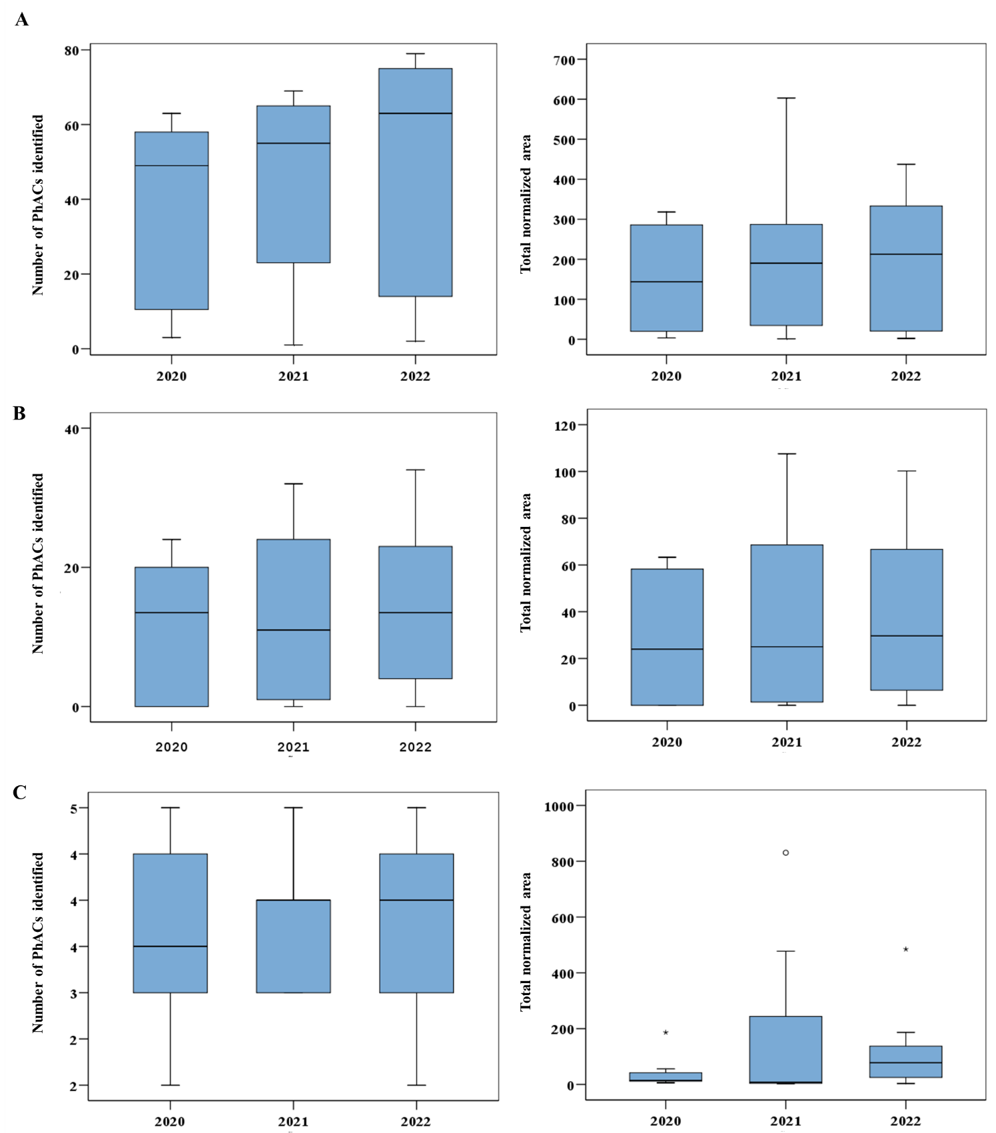
Figure S14. Temporal trends according to the number of compounds (left) and total normalized area (right) for surface water (A), sediments (B) and fish (C).

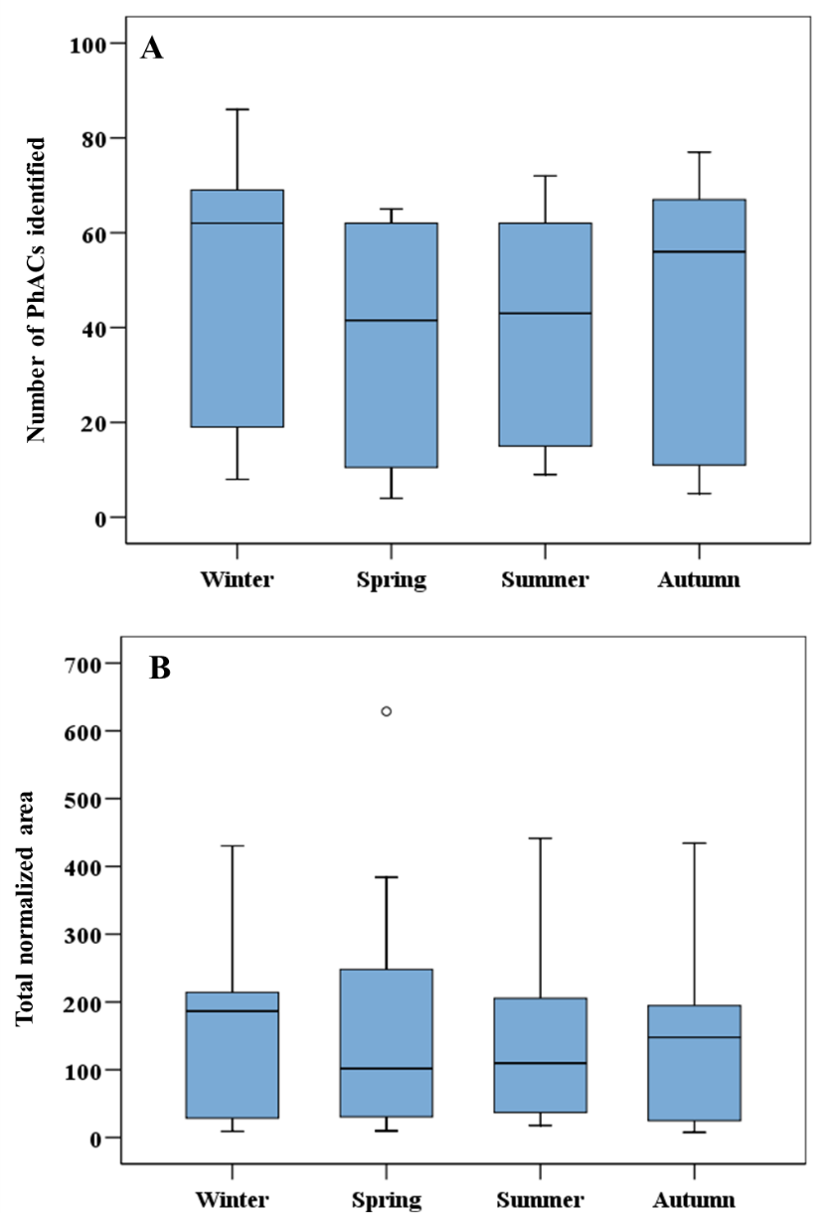
Figure S15. Seasonality variations according to the number of compounds (A) and total normalized area (B) for surface water.

References:
MITECO (2024). Sistemas de saneamiento y depuración. https://www.miteco.gob.es/ca/agua/temas/saneamiento-depuracion/sistemas.html. (Accessed 12 January 2026).

