Influence of an external magnetic field on damage by self-ion irradiation in Fe10%Cr alloy

F.J. Sánchez¹, I. García-Cortés¹, J.F. Marco², D. Jiménez-Rey^{1,3}, A. Maira³, J. Castellanos¹, R. Vila¹ and A. Ibarra¹

¹ Laboratorio Nacional de Fusión, CIEMAT, 28040 Madrid
² Instituto de Química Física “Rocasolano”, CSIC
³CMAM-UAM, Cantoblanco, Madrid

Abstract

The effect of an external magnetic field (B=0.5 T) during Fe ion irradiation on Fe₉₀Cr₁₀ specimens has been investigated by means of Conversion Electron Mössbauer Spectroscopy (CEMS). The analysis has revealed differences in the average hyperfine magnetic field (<∆𝐻> = 0.3 𝑇) between irradiated and un-irradiated samples as well as differences between irradiated with B (w/B) and without B (w/o B) have been found to be significant. These variations can be due to changes in the local environment around the probe nuclei (⁵⁷Fe); where vacancies and Cr distribution play a role. The irradiation w/o B shows a clustering of the Cr atoms meanwhile the sample irradiated w/B presents less Cr clustering. That could point to the external magnetic field as an important parameter to take into account on predictive models for FeCr alloys in Cr behaviour especially in fusion conditions where intense magnetic fields are expected for plasma confinement.

- Introduction

In magnetic confinement fusion reactor devices the vacuum vessel and structural materials will need to withstand intense and hazardous radiation environments in the presence of the strong magnetic fields required for plasma confinement. In principle, the micro-structural and mechanical properties of materials are modified by the propagation of defects produced by irradiation, and it is hypothesized that their propagation may be affected by such magnetic fields. For this reason, expanded experimental knowledge of structural materials is sought with regard the influence of an external magnetic field in mobility, recombination, clustering or dissociation of defects.
High-chromium ferritic/martensitic steels are candidate to structural materials for fusion devices and one of the reasons for these steels to be selected as reactor materials is their superior resistance to irradiation, in terms of low damage accumulation and relatively low swelling [1]. However, the diffusion and clustering properties of Cr in these alloys could be modified by self-ion irradiation in the presence of intense magnetic fields in FeCr alloys [2].
This work discusses first experimental results obtained of a series of Fe10Cr alloy specimens irradiated with 1 MeV Fe⁺ ions under the effect of the magnetic field produced by a permanent magnet (0.5 T) and analysed by Mössbauer Spectroscopy.

- Experimental

  - Specimens and irradiation conditions

A series of experiments related to the influence of magnetic field in damage have been carried out at CMAM [3] irradiation facility. In all the experiments Fe10%Cr alloy samples have been irradiated in couples with B (B=0.5 T) and without B by a dedicated custom sample holder with a permanent magnet embedded behind one of the sample (Fig. 1). The magnetic field lines are oriented normal to the sample surface in order to avoid ion beam spreading. The commissioning of the system was performed at CMAM by the irradiation of a luminescent material deposited on a metal base. It was observed that the ions impacted on the luminescent material showing good magnetic field uniformity. The complete system, i.e. the holder, the permanent magnet and a UHP-Fe test sample was also tested during four hours of irradiation by the 2 MeV H⁺ beam, 231 nA current at a sample temperature in the range of -100ºC, with and without magnetic field, getting a good temperature control during irradiation and a same ion beam footprint in sample w/o B and w/ B. Although the irradiations can be done at low temperature, the analysis techniques are always carry out at room temperature (RT).

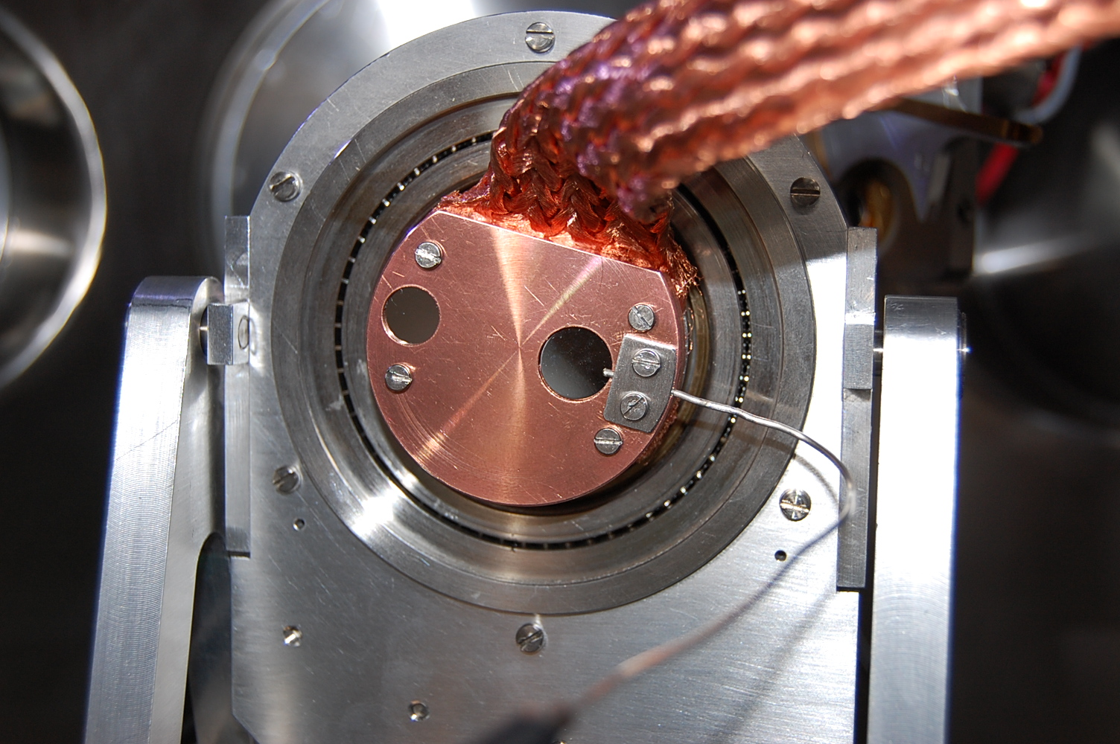 | Fig 1. Experimental two- sample holder which has a permanent magnet behind the right FeCr sample. The set-up is connected to a LN finger to achieve the low temperature if required.
On the other hand, ANSYS simulations have been done for Fe-10Cr slice (1 mm thick) that has been embedded in the centre of a long solenoid (giving 1 T in the central column) to emulate the effect of B in the surface of the sample. Fig. 2 shows that although a high concentration of magnetic field lines are observed at the edge, there is a good magnetic flux uniformity on the irradiated zone (sample central region), thus validating the experimental set-up for use with fusion material samples.
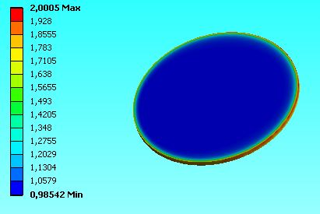 | 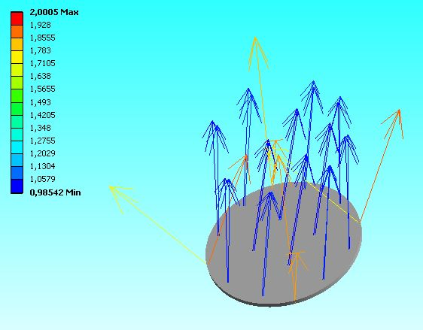  Fig. 2. ANSYS simulations. See text for explanation

Samples investigated here were prepared from EFDA/EURATOM model FeCr alloys (Fe₉₀Cr₁₀). They were delivered in the form of bars 10.9 mm in diameter, in a re-crystalized state after cold reduction of 70% and then heat treated for 1 h under pure argon flow at temperatures of 850ºC followed by air cooling. For these experiments, 1mm thick slices were cut off from each bar by spark erosion and thinned by grinding and polishing in a plane-parallel polishing machine to a final thickness of 300μm each. These specimens have been irradiated in couples with 1 MeV Fe⁺ at -100ºC. The dose reached for each sample was 15 dpa. Details of damage profile calculated by SRIM code are shown in Fig. 3.

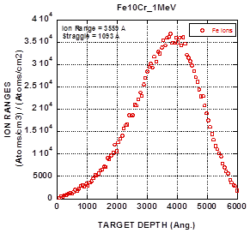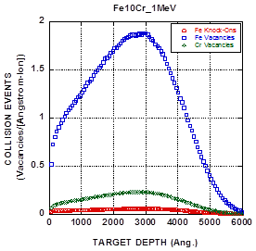
Fig. 3 SRIM 2003 calculations of ion range and damage profile produced by 1MeV Fe¹⁺ ion irradiation in Fe10Cr alloys. Full damage cascade and 40 eV as displacement energy.

  - Measurements

    - Spectrum analysis (CEMS)

As the implantation depth in this experiment is in the range of 350 nm, Mössbauer spectra have been measured recording conversion electrons in backscattering geometry using a conventional constant acceleration spectrometer and a ⁵⁷Co(Rh) source. The γ-rays were perpendicular to the foil plane. The velocity scale was calibrated using a 6 mm α-Fe foil and the isomer shifts were referred to the centroid of the spectrum of α-Fe at R.T.

Spectra of all specimens (as received (A.R.), irradiated without B (w/o B) and irradiated with B (w/ B)) have been analysed following the same procedure than other works [4, 5, 6], i.e. with the two-shell model [7] where it was assumed that only Cr atoms situated within the 1NN and 2NN neighbour-shells cause measurable changes in spectral parameters i.e. the hyperfine field, $H$, and the isomer shift, $IS$. It was also assumed that the changes both in $H$ and $IS$ were additive i.e. $X\left(m,n;x\right)= X\left(0,0;x\right)-m∆X1 –n∆X2$, where $X = H$ or $IS$ and $∆X12$ stands for the change in $X$ due to one Cr atom in 1NN (m) or in 2NN (n). All the spectra recorded on the Fe₉₀Cr₁₀ samples were fitted simultaneously with the following common parameters: $X(0, 0)$ and $∆Xk$. The following parameters were free for each spectrum: G1, G2, G3 (line widths), C2 (Clebsch-Gordan coefficient of the second/fifth line in a sextet), $P(m, n)$ (probability of finding m Cr atoms in 1NN and n ones in 2NN). For a binary alloy with a random distribution of atoms $P(m,n)$ values can be found using the binomial distribution. Within the 1NN–2NN approximation, there are N = 63 possible configurations, $(m, n)$ for the BCC structure, with 8 first neighbours and 6 second neighbours (Fig. 4). In this case, it is taken into account only the most probable ones in order to fulfil the condition: $(m,n; x)$ $P>0.97$, where $x$ refers to the Cr concentration. This condition significantly reduces the possible configurations to $N = 11 (x = 10)$ [7]). Therefore, the spectra of the samples were fitted to a superposition of 11 sextets with different hyperfine parameters, depending on the number of neighbours for the ⁵⁷Fe atom as it is described above. Examples of the spectra are shown in Fig. 5, for the sample un-irradiated and both, irradiated with Fe⁺ w/o B and w/B. It has to be noted that for low source velocity an oxide doublet is present in all the samples, this has been taken into account and subtracted from the probability function in each spectral fit.

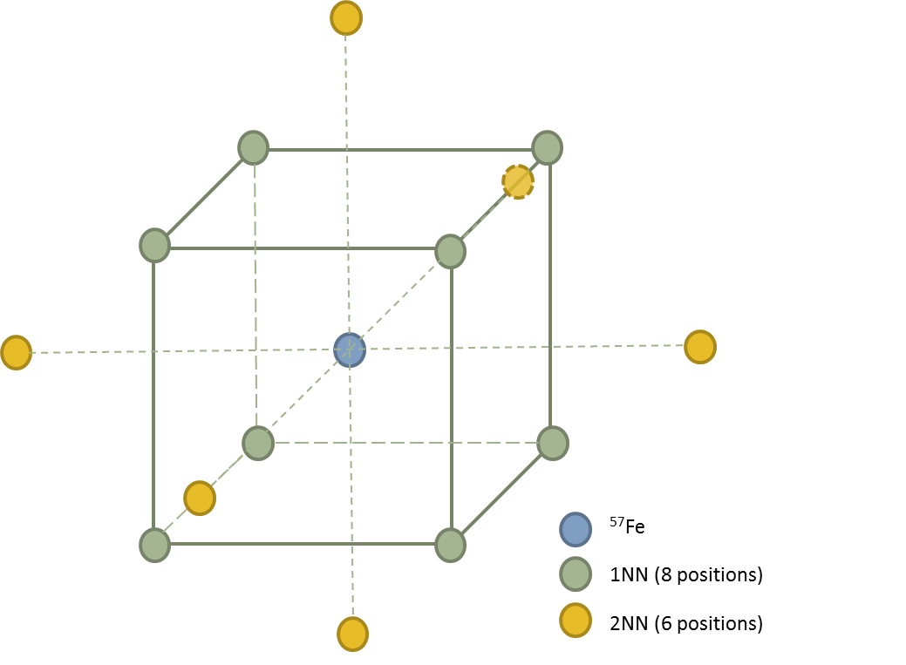
Fig. 4. BCC structure showing 1NN and 2NN atomic positions
Fig. 5. Fitted Mössbauer spectra for Fe₉₀Cr₁₀: un-irradiated (left), irradiated by Fe⁺ w/o B (upper right) and w/ B (lower right). Pink lines are 11 sextets showing different Cr neighbouring groups (see text for explanation).

    - Average hyperfine magnetic field

As it is described above, Mössbauer spectrum can display different components belonging to various sites of the Mössbauer atom probe with different neighbouring groups.
Hence, the average hyperfine field $<H>$ has been calculated as the weighted average of the hyperfine fields associated with particular atomic configurations, using $<H>=\sum_{m,n}{P\left(m,n\right)}H(m,n)$ where $H\left(m,n\right)$is the hyperfine field for $(m,n)$ atomic configuration. The measured spectra are an average over all Mössbauer atoms in a sample. The spectral contribution from the defects is usually overwhelmed by the contribution from Mössbauer atoms in regions of perfect crystal. However it is still possible to detect significant variations in the average hyperfine field after irradiation. These variations are considered to be a combined effect of vacancies generated during the irradiation and the degree of Cr ordering in the alloy, i.e. if the Cr distributes in clusters due to irradiation, the <H> will increase, while the SRO and vacancies will decrease this magnitude [4].
Fig. 6 shows the average hyperfine field of specimens before and after irradiation (both w/ B and w/o B). The increase of $<H>$ for irradiated samples (w/o and w/ B) could be explained in terms of the clustering of Cr atoms which means underlying decrease of Cr concentration as seen by the probe ⁵⁷Fe atoms due to Fe⁺ irradiation. A slight difference however, is observed between w/B and w/o B; pointing to the fact that the external magnetic field could inhibit, in part, the clustering of Cr atoms. That is, the Cr distribution in the sample irradiated w/B is more similar to that of the original un-irradiated sample.

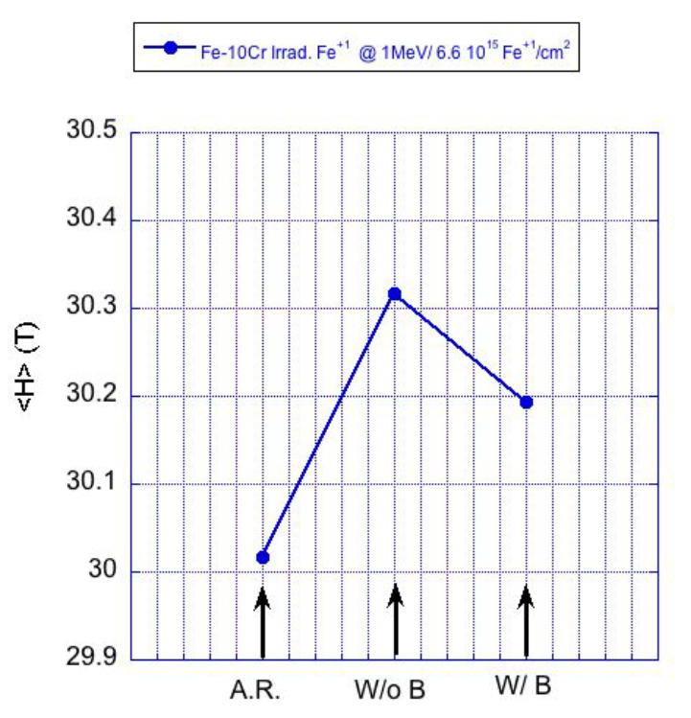
Fig. 6 Average hyperfine fields of specimens in different irradiation conditions.

- Results and summary

The irradiation of the Fe₉₀Cr₁₀ specimens with 1 MeV Fe-ion to a final dose of 15 dpa has been investigated by the effect of an external magnetic field (0.5 T). The irradiation-caused clusters of Cr atoms have been observed in an increase of the average hyperfine field, <H> an effect equivalent to a decrease of the chromium content within the 1NN-2NN volume around the probe nuclei, in samples irradiated w/o B. This effect is also observed in sample irradiated w/ B, although no so strong, pointing to the external B as a parameter that could affect the Cr mobility during irradiation.
In summary, this work presents the first results concerning the influence of an external magnetic field in alloys that are crucial for next future fusion machines. All the studied parameters point that the irradiations of FeCr samples by Fe⁺ induce clustering of Cr and also point that the clusters can be reduced by an external magnetic field. Work is in progress to verify the role of a more intense external magnetic field in different irradiation conditions as well as for different Cr content in alloys. The results will be address in future articles.

- Acknowledgements
The author would like to thank A. Muñoz for fruitful discussions and A. Rodriguez, A. Nakbi, J. Narros and V. Joco for their technical support. This work was supported by national program RADIAFUS III (ENE2012-39787-C06-01) and Madrid regional government through the project TECHNOFUSION II CM (S2013/MAE-2745).

References
[1] L. Malerba, J. Nuc. Mat. 382, 112-125 (2008)
[2] T. Seletskaia et al. Physical Review Letters 94, 046403 (2005) and Physical Review B 78, 134103 (2008)
[3] A. Climent-Font, F. Pászti, G. García, M. Fernández-Jiménez, F. Agulló, Nucl. Instrum. Meth. B 219– 220 (2004) 400-404.
[4] R. Idczak et al. J. Phys. and Chem. of Solids 73 (2012) 1095–1098
[5] S.M. Dubiel et al. Nucl. Instrum. Meth. B 302, 48-50 (2013)
[6] S. S. Huang et al. J. Nuc. Mat. 456 (2015) 266–271
[7] S. M. Dubiel and J. Cieslak Phys. Rev. B 83, 180202(R) (2011)

