A suspect and non-target approach to unveil the chemical fingerprint of a multi-environment indoor dust
Juan Escobar-Arnanz*, Silvia Royano, Covadonga Alonso, Irene Navarro, Adrián de la Torre**, María Ángeles Martínez**
*Corresponding author contact information
**These authors share last authorship
Email: Juan.Escobar@ciemat.es
Unit of POPs and Emerging Pollutants in Environment, Department of Environment, CIEMAT, Avda. Complutense 40, E-28040 Madrid, Spain.

Supplementary material-1

TABLE OF CONTENTS | Page
ACRONYMS | Excel, SM-2
FIGURES
Figure S1. Instrumental setup used in GC-QTOF-HRMS analysis of the current study. | 3
Figure S2. GC-QTOF-HRMS data processing workflow developed in the current study. | 5
Figure S3. Reduction of number of features in the NTS workflow and total number of identified compounds. | 7
Figure S4. Accuracy results of the application of the suspect screening workflow to NIST SRM 2585 dust | 7
Figure S5. Bar plots for the cumulative NIRs and number of identified compounds in samples from homes, offices, kindergartens, and high schools. | 9
Figure S6. Total NIRs and individual profiles of phthalates in homes, offices, kindergartens, and high schools. | 10
Figure S7. Cumulative NIRs in the indoor dust samples excluding phthalate instrumental responses. Significant intergroup differences were observed between groups (I) and (II) (Kruskal-Wallis). | 10
Figure S8. Contributions (median) to the total NIR of all detected compounds excluding the six ubiquitous phthalates (DEHP, DBP, DiBP, DCHP, BBP, and DEP) detected in indoor dust. | 11
Figure S9. Box and whisker plots of the NIR (logarithmic scale) of all compounds (n=269) identified/annotated in indoor dust samples from homes, offices, kindergartens, and high schools. | 12
Figure S10. TIC, EIC, and mass spectra of the PFAS analogues detected in indoor dust. | 18
Figure S11. Loading and score plots of PC1 and PC4 from Principal Component Analysis. | 20
Figure S12. NIRs in floor and elevated-surface settled dust on elevated surfaces from high schools of contaminants showing statistical differences or exclusively detected in one type of dust. | 21
TABLES
Table S1. Analytical conditions (GC). | 4
Table S2. Analytical conditions (MS). | 4
Table S3. Suspect list of the integrated workflow. | Excel, SM-2
Table S4. Frequently detected compounds in blanks. | Excel, SM-2
Table S5. Compounds identified and annotated in the NIST SRM 2585. | Excel, SM-2
Table S6. Compounds identified and annotated (n=269) in indoor dust from homes, offices, kindergartens, and high schools. | Excel, SM-2
Table S7. Spearman’s Rho correlation matrix for synthetic antioxidants (DFs>20%). | 17
Table S8. Rotated component matrix from Principal Component Analysis. | 19
Table S9. Details and physico-chemical properties of the 39 contaminants showing different accumulation profiles in floor and elevated-surface settled dust. | Excel, SM-2
TEXT
Text S1. Sample preparation procedure. | 3
Text S2. Instrumental analysis. | 3
Text S3. Comparison, considerations, and limitations of the analytical workflow. | 6
Text S4. Statistical analysis. | 8
LITERATURE | 22

Text S1. Sample preparation procedure.
Extraction was carried out using a QuEChERS-method with some modifications [1]. In summary, 1 g of dust was weighed in polypropylene tubes, spiked with 50 ng of the internal standard (ISTD, metolachlor-d6) and then extracted with 2 mL of Milli-Q water and 4 mL of acetonitrile (1% acetic acid; v/v). The mixture was mechanically shaken for 30 min to ensure proper mixing. Once finished, salts such as 0.2 g sodium acetate (NaOAc) and 0.8 g magnesium sulfate (MgSO₄) were added to the previous mixture which was vortexed (30s) and centrifuged (5 min, 5,000 rpm) to ensure proper phase separation. The supernatant was evaporated to 1 mL and half of the extract was subjected to an additional cleaning step to remove possible matrix interferents. Hence, 500 µL of the resulting extract were transferred to an eppendorf tube containing an adsorbent mixture (0.3 g MgSO₄, 0.05 g C18, and 0.25 g PSA) and 1 mL of acetonitrile. The sample was mechanically shaken and subsequently centrifuged (15,000 rpm, 5 min). The supernatant was isolated and mixed with 800 µL Milli-Q water and 400 µL isooctane and vortexed (1 min), shaken (5 min), and centrifuged (1,500 rpm, 5 min). Finally, the isooctane supernatant was transferred to a glass amber vial, concentrated to 50 µL and spiked with 1 ng of labelled ¹³C-PCB 15 and ¹³C-PCB 70 as syringe standards (ISS). The vial extracts were stored in the dark at -20 °C until instrumental analysis.
Text S2. Instrumental analysis.
All samples and standards were analyzed under the same analytical conditions using an Agilent GC-QTOF-HRMS system configure two HP-5MS-UI columns (15 m x 0.25 mm x 0.25 µm) as shown in Figure S1.
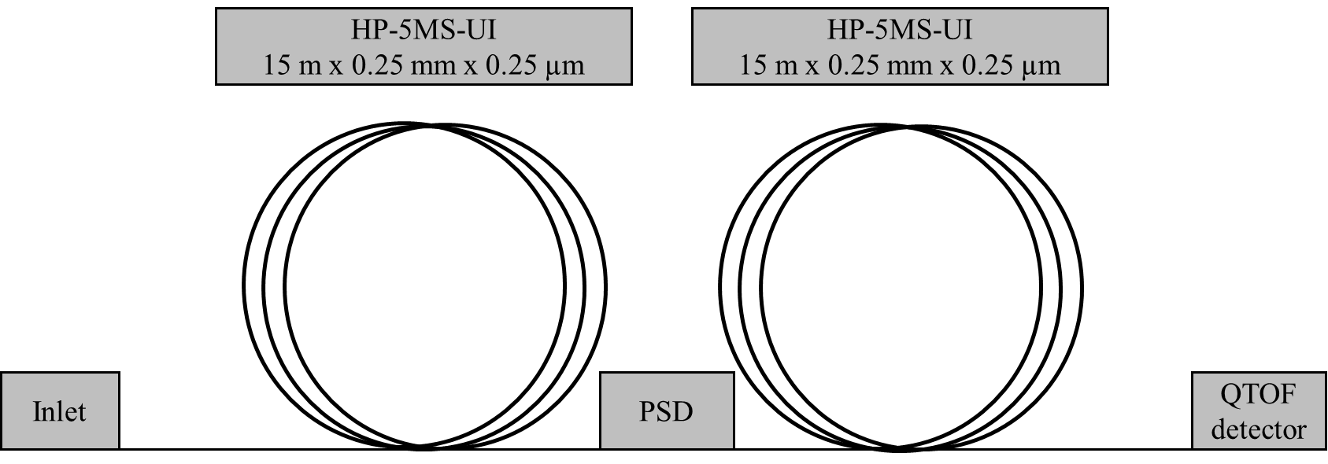
Figure S1. Instrumental setup used in GC-QTOF-HRMS analysis of the current study.
2 µL of each extract were injected at 280 ºC in splitless mode (0.75 min, 30 mL/min). The temperature ramp started at 60 ºC (1 min), then raised at 40 ºC/min to 170 ºC (0 min) and finally reach 310 ºC (8 min) at 10ºC/min. The total analysis time was 25.75 min for each injection with 4 min of solvent delay. The transfer line to the MS system was set at 280 ºC. An ion source based on electron impact (EI) was used at a standard energy of 70 eV. Data acquisition was perform in full scan mode with the first quadrupole acting just as guide of ions to the HRMS time-of-flight analyzer. Full spectra were acquired in the m/z 50-700 range with scan rate of 5 spectra/s. Data were acquired in both profile and centroid mode and additionally converted to SureMass format.
Instrumental solvent blanks (isooctane) were systematically injected between analytical runs to evaluate and prevent potential carryover or cross-contamination. Sample injection orders were fully randomized to prevent systematic errors, retention time drifts or sensitivity losses [2]. Furthermore, instrument stability and performance was periodically monitored using the alkane standards mixture [2]. The GC-QTOF HRMS system was automatically mass calibrated before each injection by the infusion of mass calibration tuning solutions.

Table S1. Analytical conditions (GC).
Instrument | Agilent 8890 gas chromatograph
Injection
Injection volume | 2 μL
Temperature | 280 ºC
Mode | Splitless
Pressure | 8.8817 psi
Total flow | 33.9580 mL/min
Septum purge flow | 3 mL/min
Purge Flow to Split Vent | 30 mL/min (0.75 min)
Column configuration
Column 1: HP-5MS-UI | 15 m x 250 μm x 0.25 μm
Constant flow, He | 0.9575 mL/min
Column 2: HP-5MS-UI | 15 m x 250 μm x 0.25 μm
Constant flow, He | 1.1575 mL/min
Oven
Initial | 60 °C
Hold Time | 1 min
#1 Rate | 40 °C/min
#1 Value | 170 °C
#1 Hold Time | 0 min
#2 Rate | 10 °C/min
#2 Value | 310 °C
#2 Hold Time | 8 min
Total Run Time | 25.75 min
Post Run Time | 3 min
PSD
Flow | Helium
PSD Purge | 1.2 mL/min
Backflush, post run | On
MSD Transfer Line
Temperature | 280 ºC
Table S2. Analytical conditions (MS).
Instrument | Agilent 7250 QTOF MS spectrometer
Source
Temperature | 280 ºC
Ionization mode | EI
Electron energy | 70 eV
Emission | 5 μA
Collision cell
Collision Gas, N₂ | 4 mL/min
Collision Cell Aux, He | 1 mL/min
TOF MS
Mass range | 50 - 700 amu
Acq. Rate | 5 spectra/s
Acq. Time | 200 ms/spectrum
Transients/spectrum | 1939
Others
Solvent delay | 4 min
Time filtering, peak width | 0.7 s

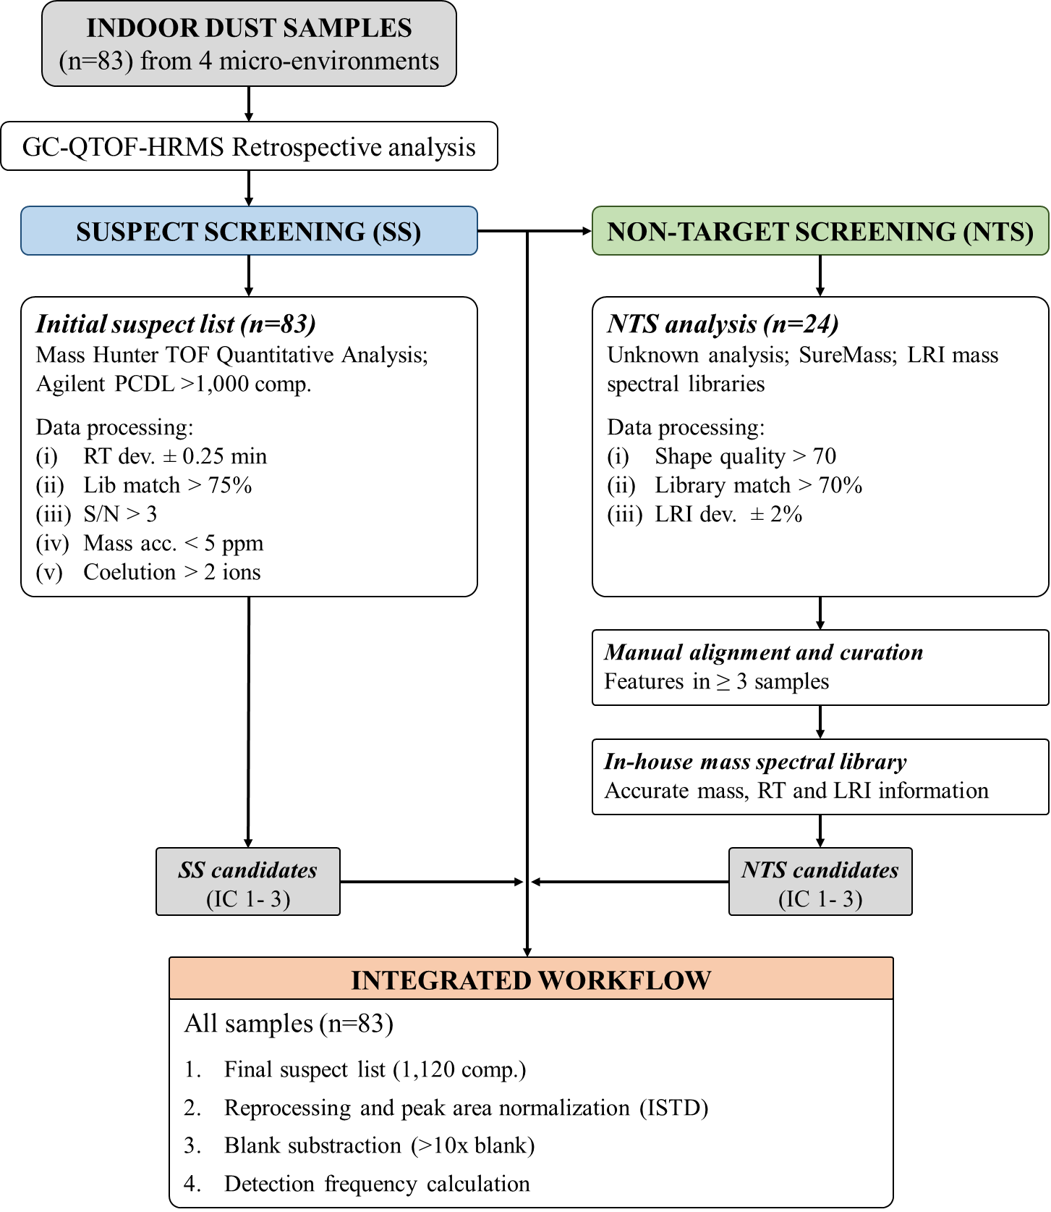
Figure S2. GC-QTOF-HRMS data processing workflow developed in the current study.

Text S3. Comparison, considerations, and limitations of the analytical workflow.
Due to the qualitative and exploratory nature of the proposed workflow, qualitative indicators (i.e. number of detected compounds, DFs, or normalized instrumental responses) have been used to establish general comparisons among samples from different locations [3–5]. All indicators may ultimately reflect the potential contaminant burden of the analyzed samples, as direct and solely comparison of NIRs may vary due to distinct responses of different compounds.
In regard to the above, the use of metolachlor-d6 as the sole ISTD, rather than attempting to be representative of the wide variety of detected compounds, aims to minimize and correct variations in volume and instrumental response [6]. This normalization facilitates general comparisons from a purely qualitative point of view, nonetheless specific-compound comparisons should be done cautiously since different ionization efficiencies, and/or MS responses are possible.
Furthermore, one of the limitations of retrospective analysis is performing qualitative assessments and comparison of compounds unless the procedure had the appropriate standards or the original sample is available to calculate recovery [7]. In that sense, variable and moderate recoveries of different compounds have been reported in wide-scope analyses of dust samples [2, 8, 9]. This may be attributed, on one hand, to the complexity of dust, which can generate a significant matrix effect and/or signal suppression, which may affect detection even when highly selective detectors such as HRMS are used, especially affecting compounds in trace concentrations. On the other hand, a compromise must be reached in sample preparation when performing NTS as, in many cases, it is preferred to perform generic sample treatments to discriminate a small number of compounds [2, 10].
Finally, due to inherent variations in sampling strategies (comprising participant-based composite residential samples versus researcher-controlled fractionated collections in non-residential spaces) cross-environment comparisons are interpreted strictly at a qualitative and exploratory level. In that sense, due to the cross-sectional design and the inherent non-specificity of chemical profiles, source attributions are discussed as plausible hypotheses rather than definitive determinations in the absence of source-apportionment modeling.
Bearing all this in mind, our findings have been limited to assessing the chemical occurrence and distribution patterns in exposure-relevant media.
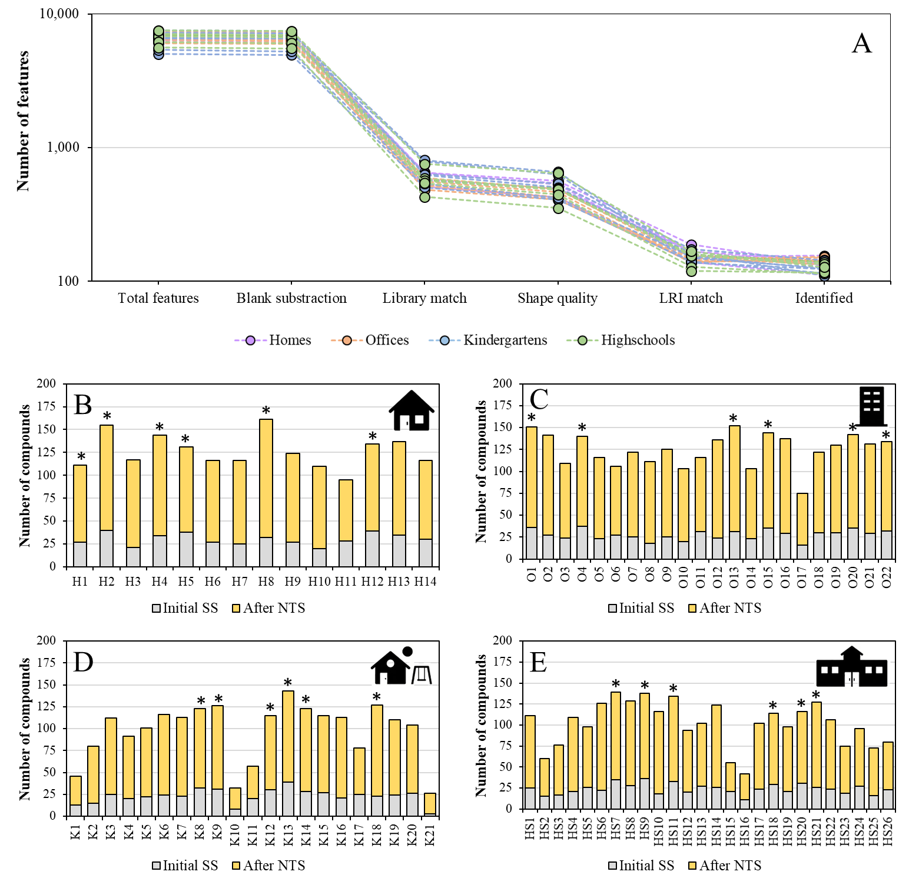
Figure S3. Reduction of number of features in the (A) NTS workflow and total number of identified compounds in samples from (B) homes (n=14), (C) offices (n=22), (D) kindergartens (n=21), and (E) high schools (n=26). Asterisk indicates the 24 representative samples selected for NTS.
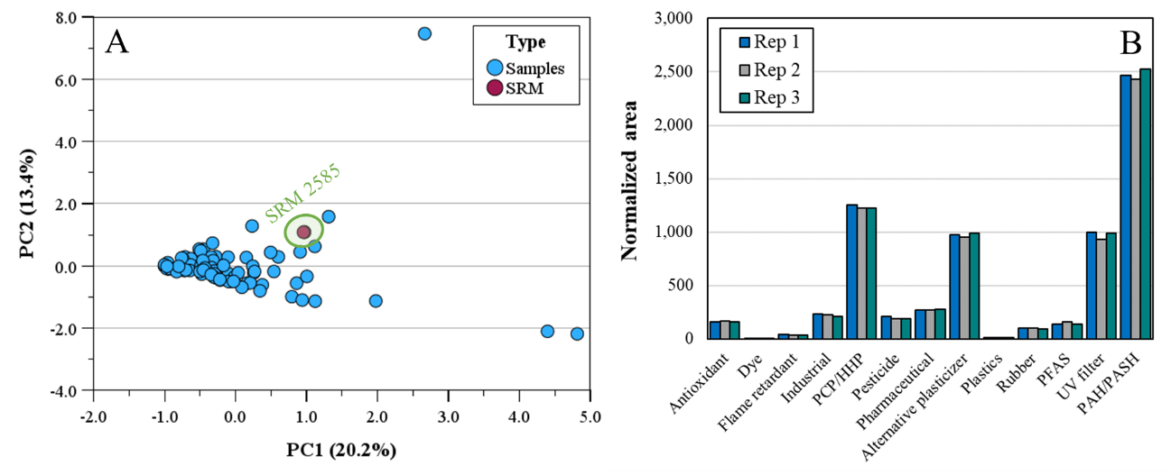
Figure S4. Accuracy results of the application of the suspect screening workflow to NIST SRM 2585 dust (n=3) with (A) Loading plot from Principal Component Analysis of suspect features (DF>50%) in 83 dust samples and (B) Cumulative NIRs by compound use.
Text S4. Statistical analysis.
Statistical analysis was performed on IBM SPSS Statistics (version 31.0, IBM Corp). Output data from suspect screening in terms of number of compounds and NIRs were first submitted to Shapiro-Wilk and Kolmogorov-Smirnov test (p<0.05) to determine if data modeled normal distribution. Then, parametric (one-way ANOVA, Student’s t-test) and non-parametric tests (Kruskal-Wallis and Mann-Whitney) were performed to test for disparities and significant differences (p<0.05) between environments or the type of dust. When significant differences were detected, Tukey’s test (for parametric variables) or pairwise comparisons adjusted with Bonferroni correction (for non-parametric evaluations) were systematically applied to control for multiple testing.
Multivariate analysis of the datasets was performed by Principal Component Analysis (PCA) using a correlation matrix (which automatically applies mean-centering and unit-variance scaling). Missing values were imputed for each variable by half minimum of the detected value to maintain data continuity [11, 12]. The complete dataset was log-transformed to normalize distribution. Furthermore, phthalates were deliberately excluded from the multivariate models prior to analysis due to their disproportionately high NIRs and inherent analytical characteristics, which would otherwise bias structural interpretation. To ensure statistical robustness, a stringent detection frequency filter of 60% was applied, excluding compounds with lower occurrence. Extreme high values were intentionally preserved rather than winsorized to retain true environmental hotspots and localized potential contamination sources. The extraction was followed by an orthogonal varimax rotation with Kaiser normalization, aimed at achieving a simple structure that maximizes the interpretability of factor loadings while ensuring component independence. The representativeness and robustness of the model were evaluated through the Kaiser-Meyer-Olkin (KMO) measure, communalities, and explained variance of the model. Loading and score plots were reconstructed to explore grouping trends and identify those marker compounds presenting the highest loads in each component.
Hierarchical Cluster Analysis (HCA) was performed on the subset marker compounds identified by PCA based on component loadings greater than 0.7. Log-transformed NIRs were standardized using Z-score transformation to ensure that all variables contributed equally to the model, regardless of their absolute instrumental response ranges. Clustering was applied using Ward’s minimum variance method based on squared Euclidean distances to maximize within-cluster homogeneity. The analysis resulted in a dendrogram that shows a hierarchical distribution of individual samples based on their similarities and chemical profiles. This representation was complemented with a dual-axis clustered heatmap, where color gradients represent standardized NIRs (Z-scores), allowing for the identification of specific contamination hot-spots across the individual samples from different settings. The vertical axis of the heatmap represents the chemical markers identified as significant in the PCA, while the horizontal axes display the individual samples. Color intensity reflects the normalized abundance of each compound, ranging from dark blue (high abundance, Z > 0) to light blue (low abundance, Z < 0).

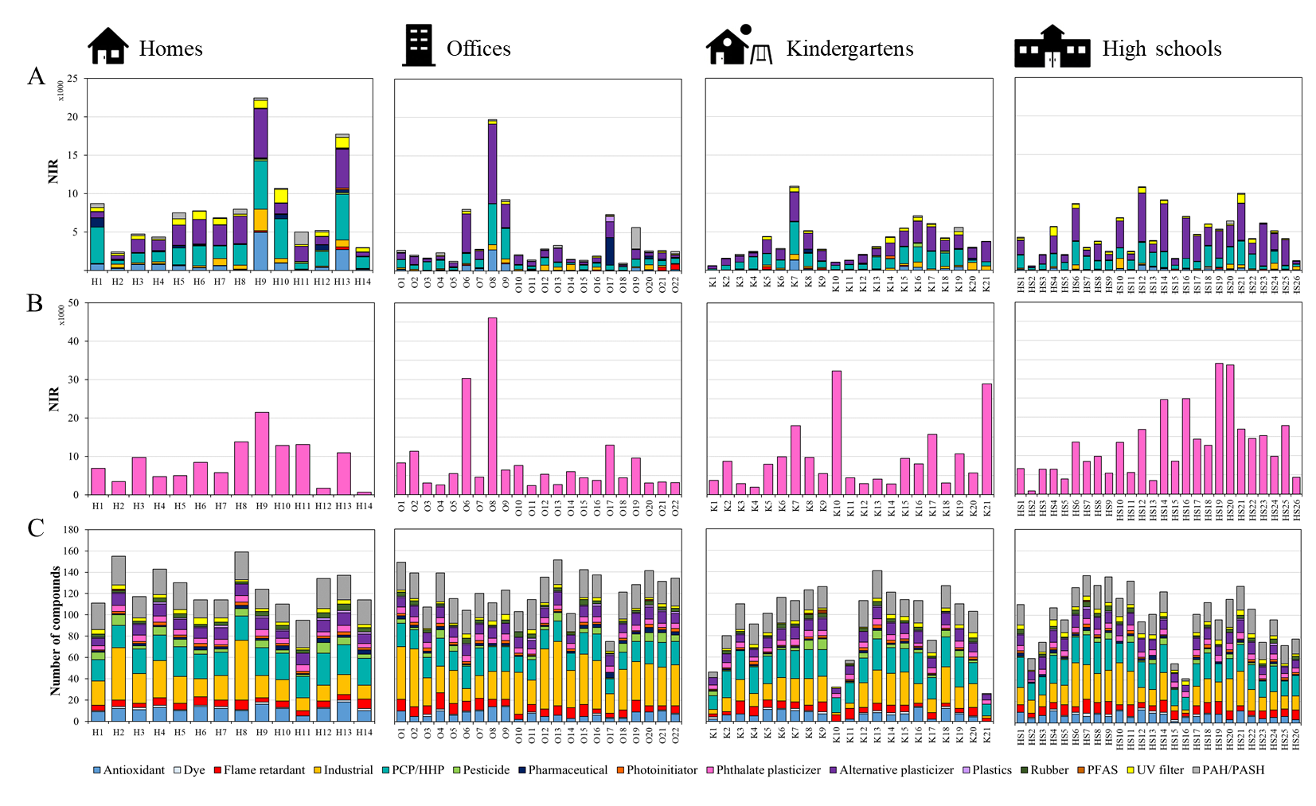
Figure S5. Bar plots for the cumulative (A) NIRs of all families excluding phthalates (n=6), (B) NIRs of phthalates, and (C) number of identified compounds in samples from homes, offices, kindergartens, and high schools.

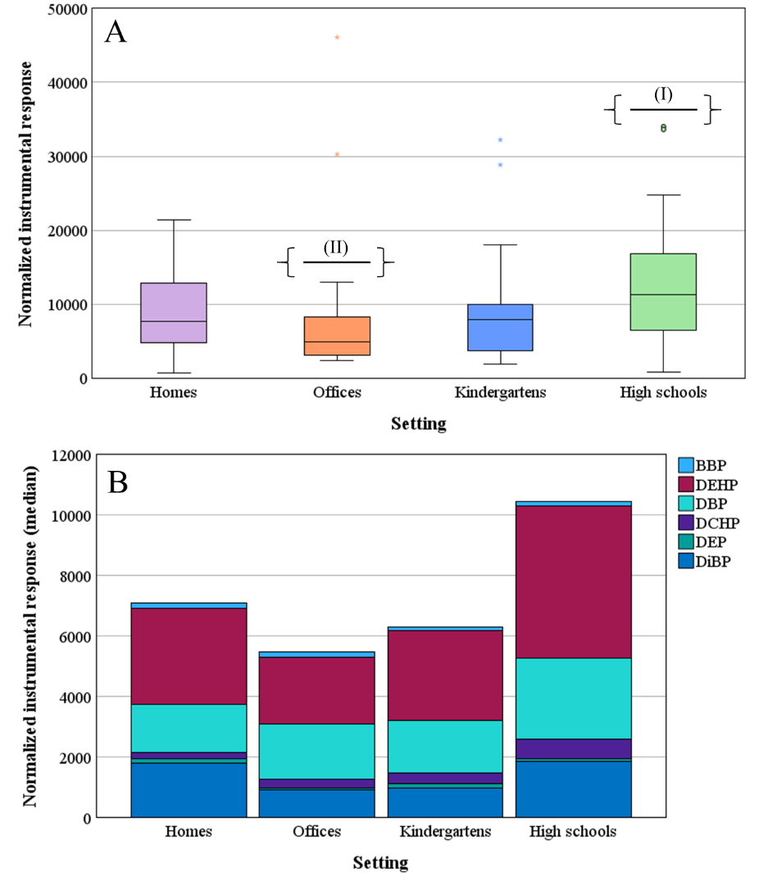
Figure S6. NIRs of phthalates in homes, offices, kindergartens, and high schools including (A) box and whisker plots of total NIRs where significant intergroup differences were observed between high schools (I) and offices (II) (Kruskal-Wallis, p<0.05) and (B) phthalate profiles in different settings. Acronyms (as sorted in the legend): benzyl butyl phthalate (BBP); bis(2-ethylhexyl) phthalate (DEHP); dibutyl phthalate (DBP); dicyclohexyl phthalate (DCHP); diethyl phthalate (DEP); Diisobutyl phthalate (DiBP).
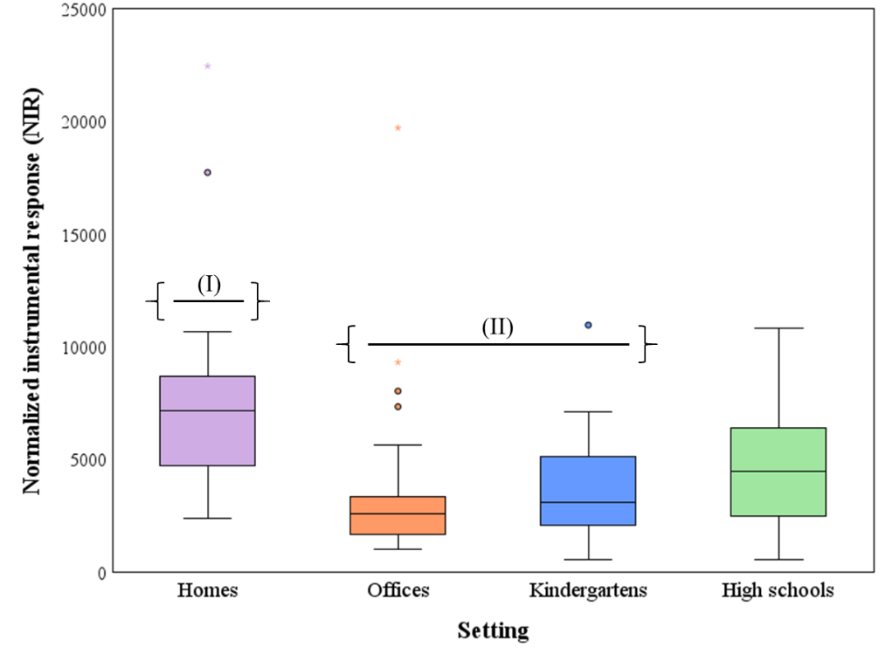
Figure S7. Cumulative NIRs in the indoor dust samples excluding phthalate instrumental responses. Significant intergroup differences were observed between groups (I) and (II) (Kruskal-Wallis).
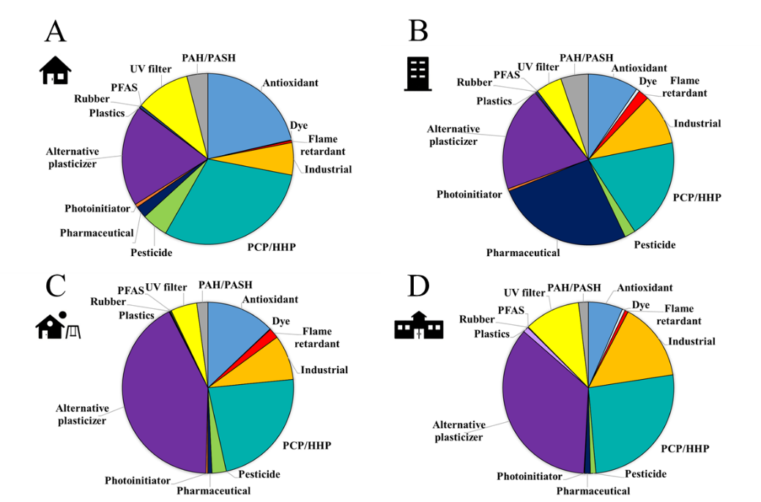
Figure S8. Contributions (%, median) to the total NIR of all detected compounds excluding the six ubiquitous phthalates (DEHP, DBP, DiBP, DCHP, BBP, and DEP) detected in dust from (A) homes, (B) offices, (C) kindergartens, and (D) high schools.

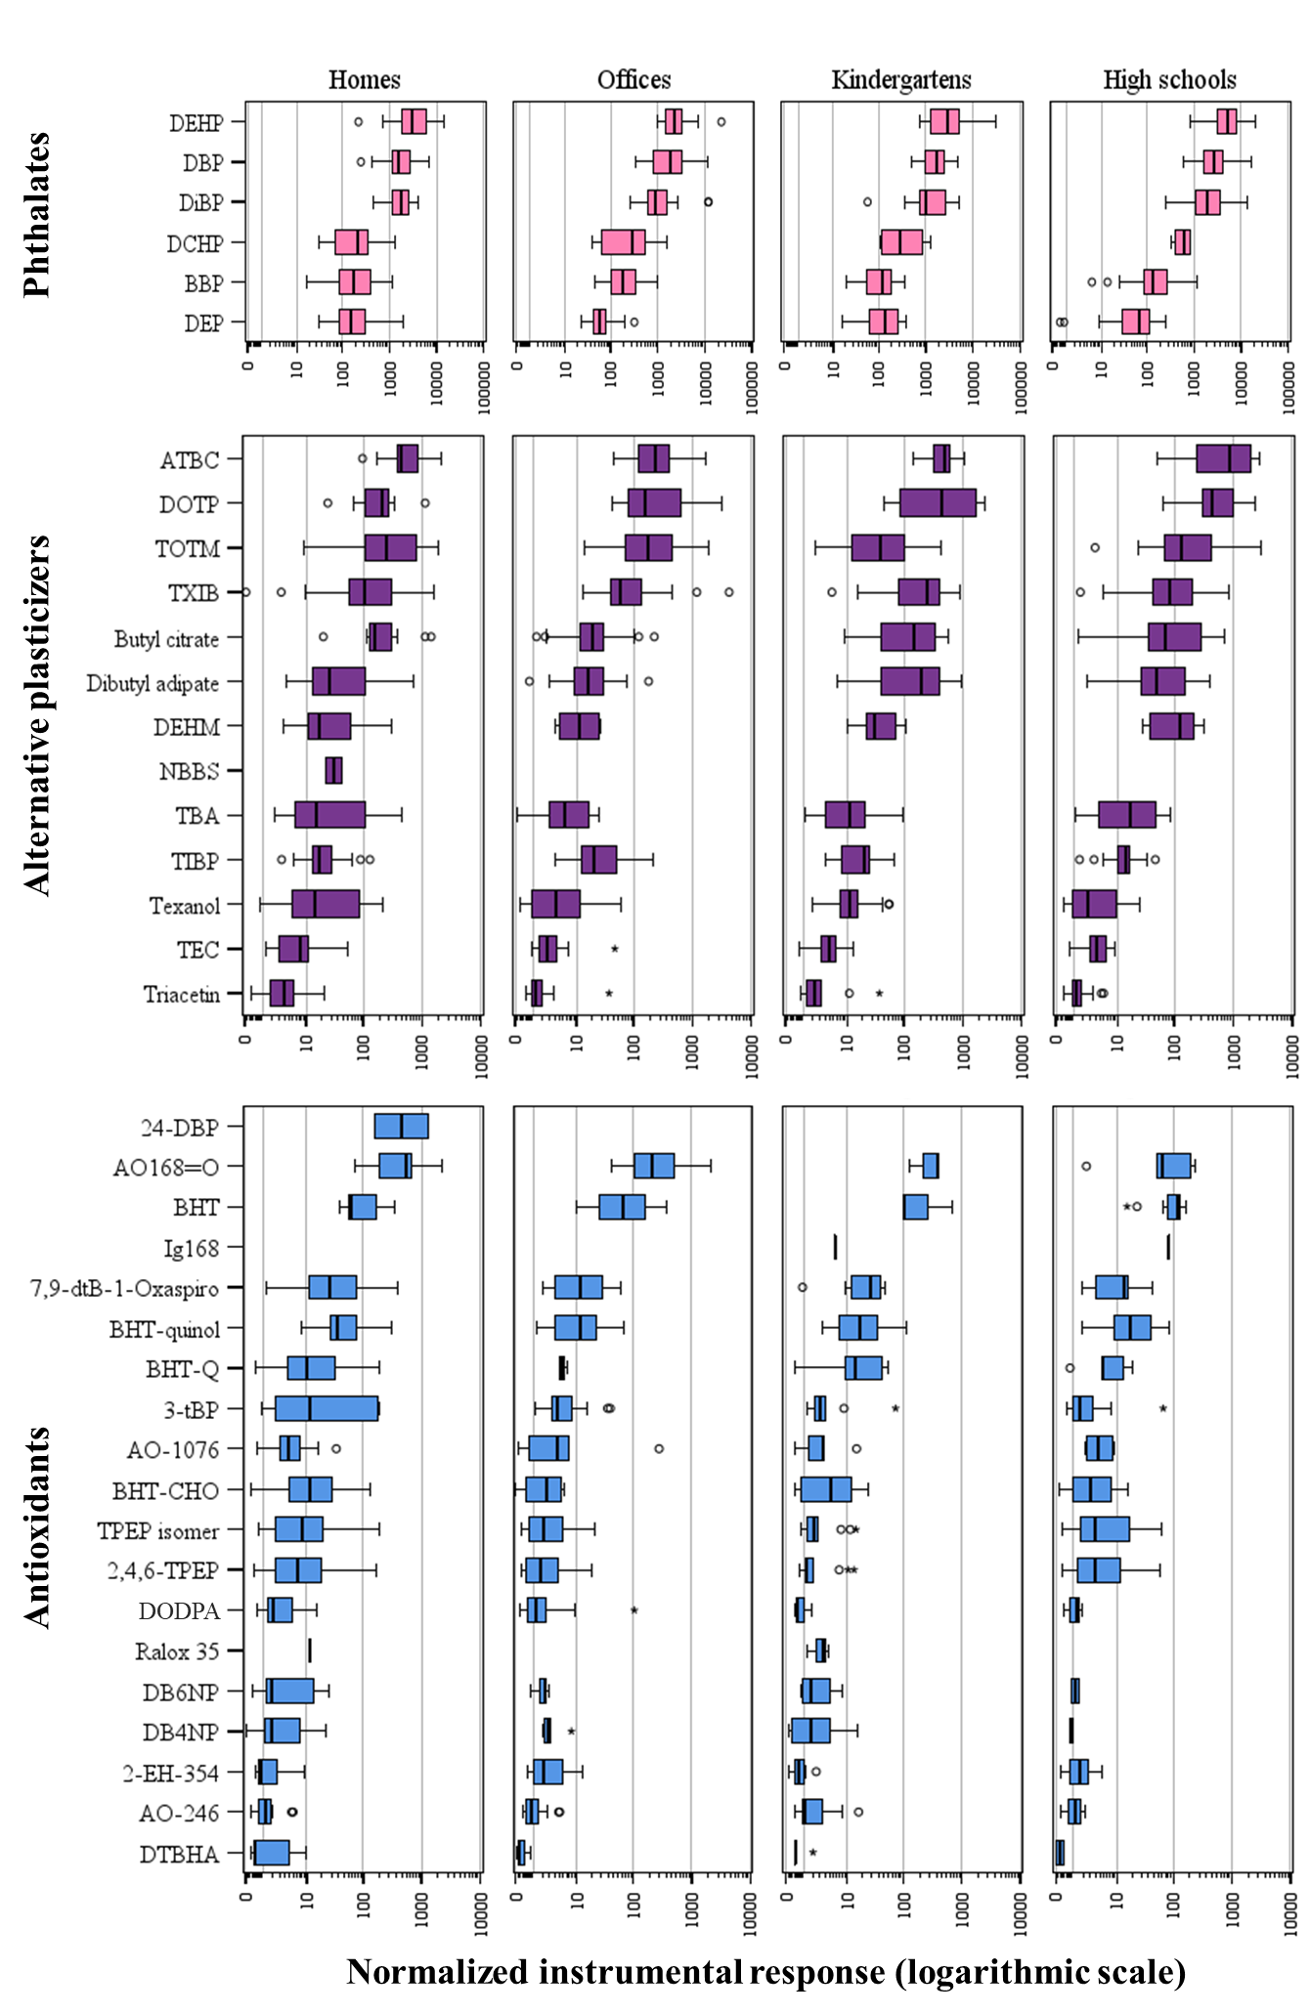
Figure S9. Box and whisker plots of the NIR (logarithmic scale) of all compounds (n=269) identified/annotated in indoor dust samples from homes, offices, kindergartens, and high schools.
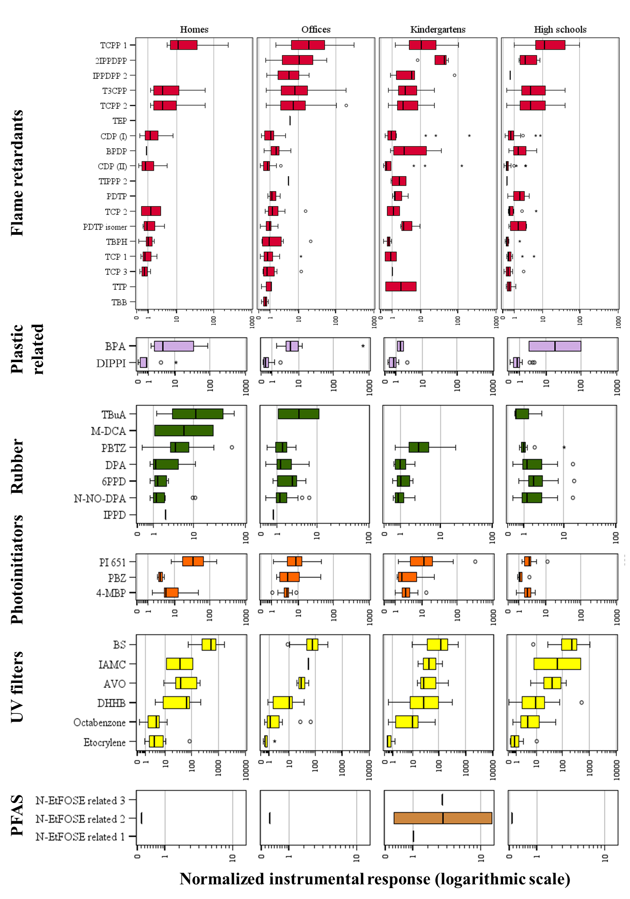
Figure S9 (cont.). Box and whisker plots of the NIR (logarithmic scale) of all compounds (n=269) identified/annotated in indoor dust samples from homes, offices, kindergartens, and high schools.
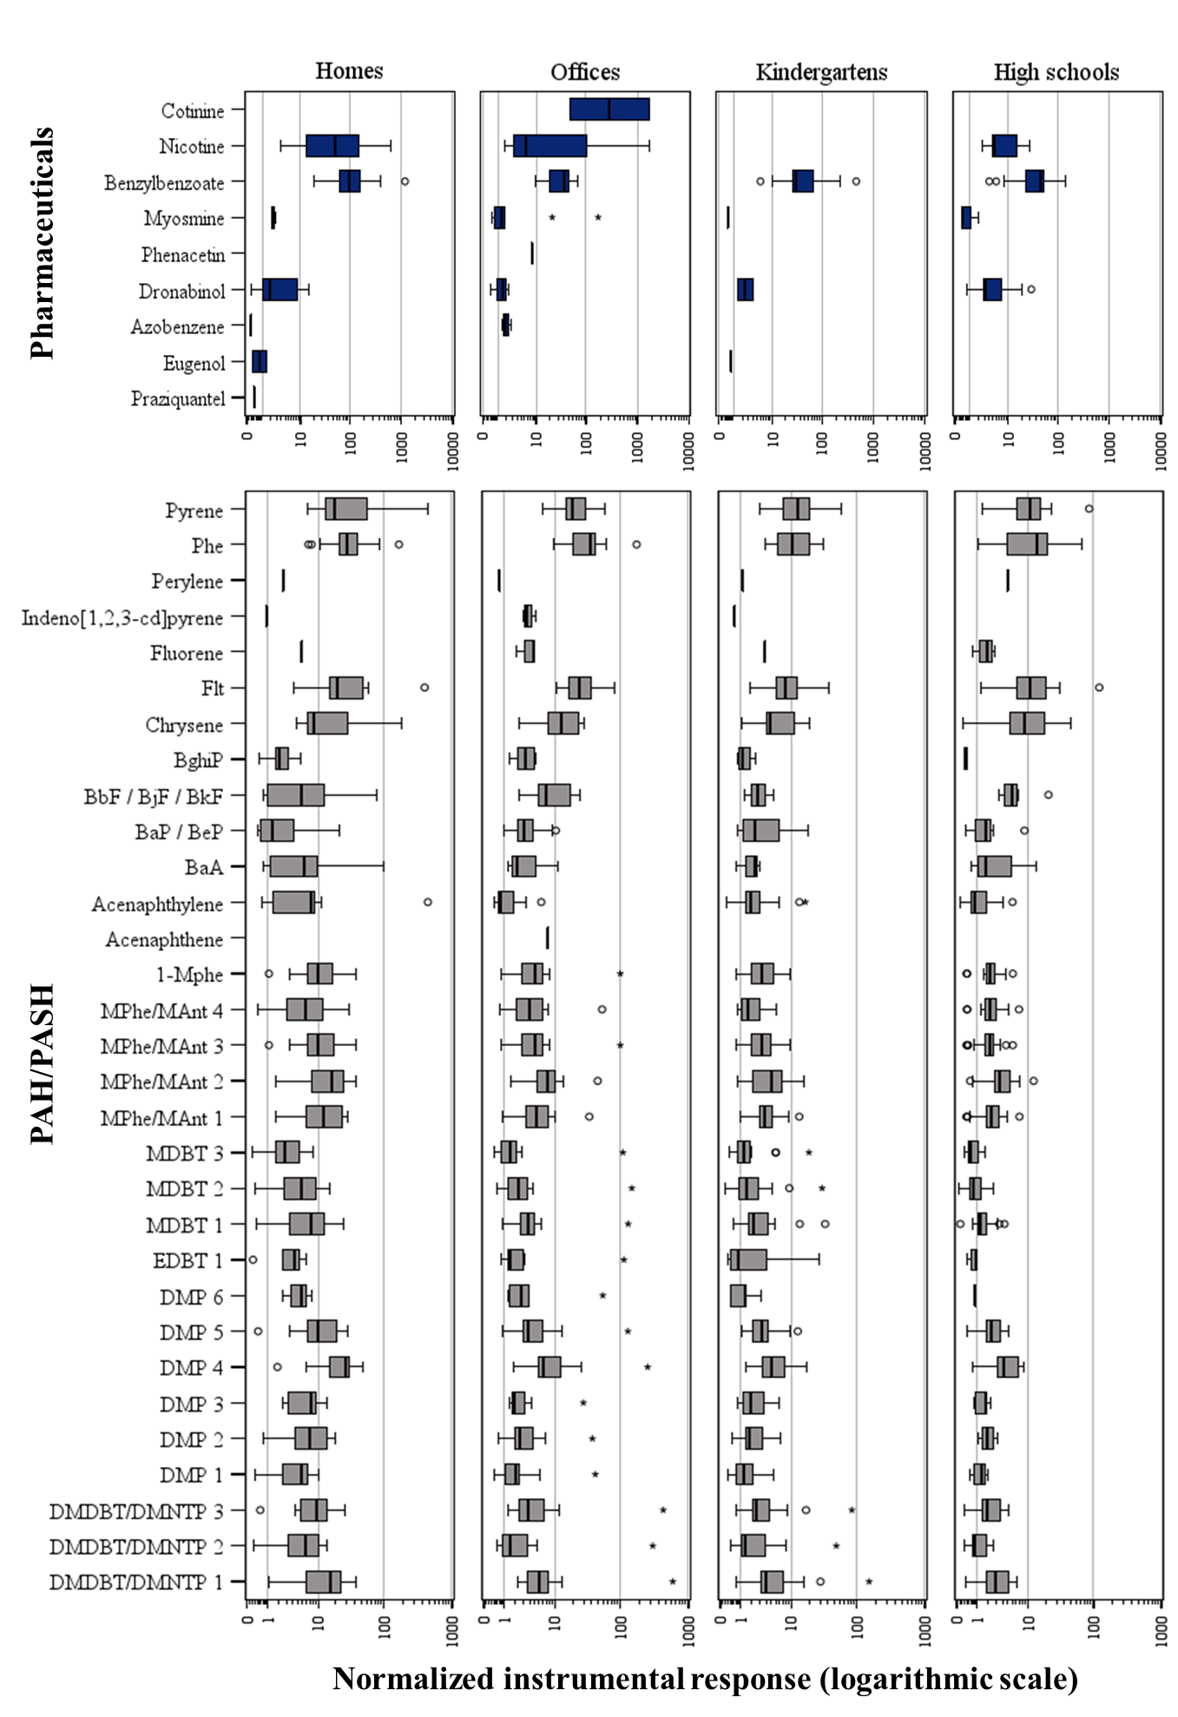
Figure S9 (cont.). Box and whisker plots of the NIR (logarithmic scale) of all compounds (n=269) identified/annotated in indoor dust samples from homes, offices, kindergartens, and high schools.

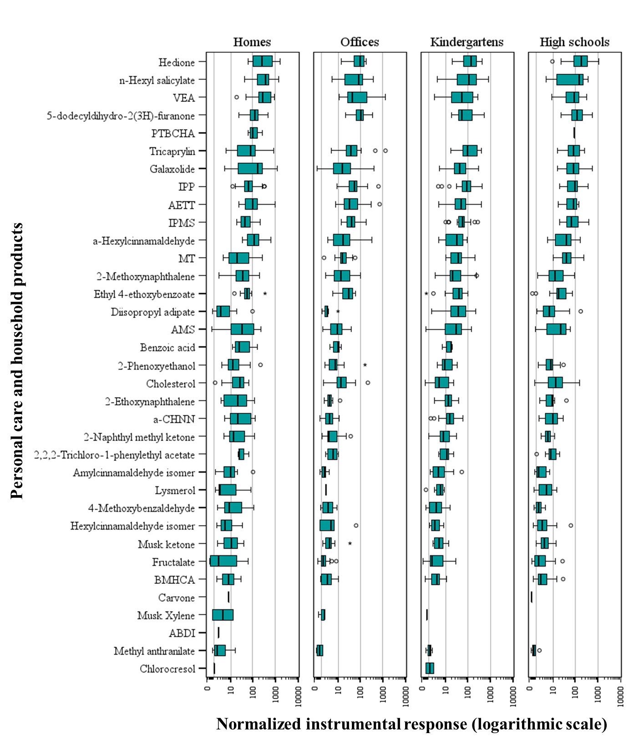
Figure S9 (cont.). Box and whisker plots of the NIR (logarithmic scale) of all compounds (n=269) identified/annotated in indoor dust samples from homes, offices, kindergartens, and high schools.
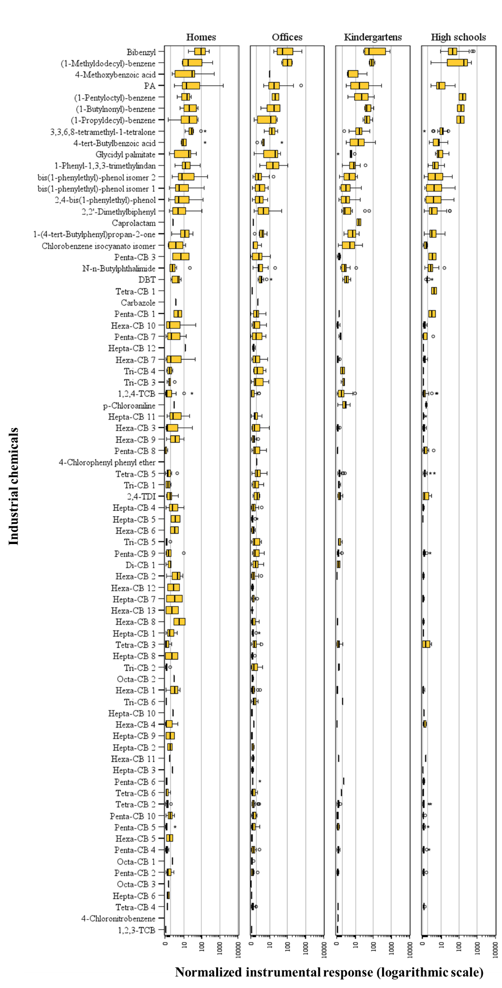
Figure S9 (cont.). Box and whisker plots of the NIR (logarithmic scale) of all compounds (n=269) identified/annotated in indoor dust samples from homes, offices, kindergartens, and high schools.
Table S7. Spearman’s Rho correlation matrix for synthetic antioxidants (DFs>20%).
 | 2,4,6-TPEP | TPEP isomer | AO-246 | 2-EH-354 | DODPA | 3-tBP | BHT | BHT-Q | BHT-quinol | BHT-CHO | DB4NP | DB6NP | AO-1076 | 7,9-dtB-1-Oxaspiro | AO168═O
2,4,6-TPEP | 1.000
TPEP isomer | 0.99 | 1.000
AO-246 | 0.333 | 0.354 | 1.000
2-EH-354 | 0.57 | 0.581 | 0.402 | 1.000
DODPA | 0.403 | 0.39 | -0.038 | 0.301 | 1.000
3-tBP | 0.031 | 0.035 | 0.207 | 0.038 | 0.019 | 1.000
BHT | 0.324 | 0.32 | 0.476 | 0.217 | 0.006 | -0.019 | 1.000
BHT-Q | 0.303 | 0.346 | 0.476 | 0.295 | 0.104 | 0.072 | 0.323 | 1.000
BHT-quinol | 0.453 | 0.482 | 0.508 | 0.395 | 0.189 | 0.135 | 0.472 | 0.689 | 1.000
BHT-CHO | 0.494 | 0.527 | 0.318 | 0.398 | 0.214 | 0.123 | 0.284 | 0.617 | 0.581 | 1.000
DB4NP | 0.229 | 0.245 | 0.151 | 0.248 | 0.234 | 0.169 | 0.107 | 0.440 | 0.396 | 0.562 | 1.000
DB6NP | 0.073 | 0.089 | 0.377 | 0.089 | 0.114 | 0.336 | 0.22 | 0.500 | 0.398 | 0.242 | 0.246 | 1.000
AO-1076 | 0.269 | 0.305 | 0.329 | 0.33 | 0.268 | 0.145 | 0.473 | 0.442 | 0.469 | 0.357 | 0.303 | 0.41 | 1.000
7,9-dtB-1-Oxaspiro | 0.246 | 0.275 | 0.263 | 0.118 | 0.147 | 0.175 | 0.299 | 0.549 | 0.456 | 0.464 | 0.419 | 0.437 | 0.491 | 1.000
AO168═O | 0.243 | 0.258 | 0.304 | 0.119 | 0.343 | 0.035 | 0.383 | 0.43 | 0.469 | 0.228 | 0.258 | 0.481 | 0.668 | 0.588 | 1.000
The correlation is significant at the 0.01 level (bilateral).
The correlation is significant at the 0.05 level (bilateral).

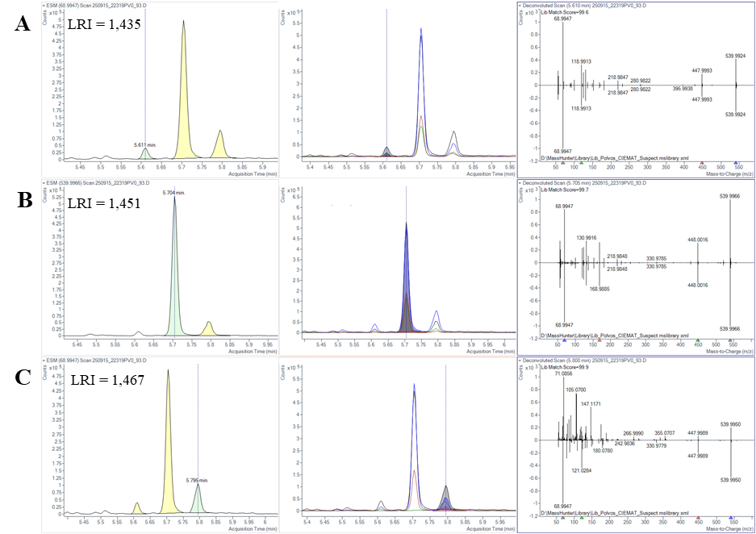
Figure S10. TIC, EIC, and mass spectra of the PFAS analogues detected in indoor dust: (A) N-EtFOSE related 1, (B) N-EtFOSE, and (C) N-EtFOSE related 2.

Table S8. Rotated component matrix from Principal Component Analysis.
Compound | Component
Compound | 1 | 2 | 3 | 4
TXIB | 0.152 | 0.791 | 0.090 | 0.099
ATBC | 0.043 | 0.115 | 0.403 | -0.020
Butyl citrate | 0.099 | 0.468 | 0.352 | -0.163
Dibutyl adipate | -0.142 | 0.356 | 0.161 | 0.049
TOTM | 0.298 | 0.148 | 0.414 | 0.064
Triacetin | 0.342 | 0.276 | 0.268 | 0.189
TBA | 0.088 | -0.031 | 0.510 | -0.054
TEC | 0.141 | 0.537 | 0.213 | 0.027
TIBP | 0.423 | 0.588 | 0.027 | 0.404
2,4,6-TPEP | 0.184 | 0.111 | 0.861 | -0.059
AO-246 | 0.136 | 0.585 | 0.158 | 0.021
BHT-quinol | 0.334 | 0.699 | 0.321 | -0.045
TPEP isomer | 0.196 | 0.139 | 0.864 | -0.077
TCPP 1 | 0.074 | 0.065 | -0.067 | 0.015
TCPP 2 | 0.115 | 0.162 | -0.009 | 0.093
CDP (I) | 0.084 | 0.077 | 0.224 | 0.000
CDP (II) | 0.056 | 0.062 | 0.213 | 0.001
T3CPP | 0.036 | 0.077 | -0.060 | 0.045
1-(4-tert-Butylphenyl)propan-2-one | 0.158 | 0.746 | 0.182 | -0.149
1-Phenyl-1,3,3-trimethylindan | 0.576 | 0.511 | -0.025 | 0.165
2,2'-Dimethylbiphenyl | 0.087 | -0.076 | -0.012 | 0.067
2,4-bis(1-phenylethyl)-phenol | 0.079 | 0.167 | 0.906 | -0.103
3,3,6,8-tetramethyl-1-tetralone | 0.357 | 0.821 | 0.048 | 0.064
bis(1-phenylethyl)-phenol isomer 1 | 0.080 | 0.157 | 0.901 | -0.119
bis(1-phenylethyl)-phenol isomer 2 | 0.201 | 0.157 | 0.846 | -0.178
Hexa-CB 10 | 0.276 | -0.165 | -0.207 | 0.827
Hexa-CB 3 | 0.213 | -0.165 | -0.074 | 0.919
Hexa-CB 7 | 0.248 | -0.138 | -0.095 | 0.862
Penta-CB 9 | 0.192 | -0.061 | -0.081 | 0.921
Tetra-CB 2 | 0.207 | 0.047 | 0.017 | 0.711
Tetra-CB 5 | 0.357 | 0.173 | -0.156 | 0.738
1,2,4-TCB | 0.126 | 0.506 | 0.063 | -0.046
N-n-Butylphthalimide | 0.105 | 0.400 | 0.209 | 0.099
PA | 0.292 | 0.438 | -0.207 | -0.052
DMDBT/DMNTP 1 | 0.867 | 0.156 | 0.222 | 0.152
DMDBT/DMNTP 2 | 0.875 | 0.007 | 0.103 | 0.042
DMDBT/DMNTP 3 | 0.897 | 0.123 | -0.011 | 0.073
DMP 1 | 0.844 | 0.098 | 0.067 | 0.167
DMP 2 | 0.857 | 0.220 | 0.074 | 0.027
DMP 4 | 0.890 | 0.201 | 0.211 | 0.092
DMP 5 | 0.907 | 0.160 | 0.093 | 0.122
MDBT 1 | 0.837 | 0.344 | 0.137 | 0.175
MDBT 2 | 0.854 | 0.176 | 0.163 | 0.167
MDBT 3 | 0.792 | 0.127 | -0.110 | 0.150
MPhe/MAnt 1 | 0.830 | 0.404 | 0.144 | 0.155
MPhe/MAnt 2 | 0.828 | 0.380 | 0.119 | 0.175
MPhe/MAnt 3 | 0.880 | 0.278 | 0.052 | 0.111
MPhe/MAnt 4 | 0.729 | 0.067 | 0.126 | 0.205
1-Mphe | 0.892 | 0.259 | 0.000 | 0.097
Acenaphthylene | 0.393 | 0.544 | -0.051 | -0.176
Flt | 0.200 | -0.078 | -0.161 | 0.300
Phe | 0.593 | 0.328 | 0.014 | 0.283
Pyrene | 0.517 | 0.210 | 0.023 | 0.207
2-Methoxynaphthalene | 0.277 | 0.780 | -0.045 | -0.202
4-Methoxybenzaldehyde | 0.290 | 0.544 | 0.131 | -0.174
5-dodecyldihydro-2(3H)-furanone | 0.076 | -0.062 | -0.252 | 0.111
AETT | 0.085 | 0.423 | 0.283 | -0.057
a-CHNN | 0.252 | 0.774 | 0.186 | -0.163
AMS | 0.276 | 0.863 | 0.082 | -0.013
BMHCA | 0.206 | 0.568 | 0.317 | -0.116
Ethyl 4-ethoxybenzoate | 0.359 | 0.791 | 0.045 | 0.066
MT | -0.209 | 0.289 | 0.026 | -0.017
Fructalate | -0.049 | 0.445 | -0.286 | -0.187
Galaxolide | -0.090 | 0.258 | 0.391 | -0.262
a-Hexylcinnamaldehyde | 0.301 | 0.156 | 0.429 | -0.091
IPMS | 0.019 | 0.149 | -0.150 | 0.071
IPP | -0.025 | 0.293 | -0.022 | 0.095
Hedione | 0.167 | 0.689 | 0.334 | 0.032
n-Hexyl salicylate | 0.304 | 0.831 | 0.108 | -0.068
Tricaprylin | 0.064 | 0.069 | 0.121 | -0.026
VEA | 0.225 | 0.287 | 0.423 | 0.058
Musk ketone | 0.087 | 0.542 | 0.275 | -0.251
Cholesterol | 0.074 | 0.147 | 0.156 | 0.146
Benzylbenzoate | 0.428 | 0.325 | 0.172 | 0.072
4-MBP | 0.531 | 0.569 | 0.085 | -0.090
TMXDI | 0.138 | 0.261 | 0.351 | -0.036
PBTZ | 0.318 | 0.614 | -0.022 | -0.012
N-NO-DPA | 0.301 | 0.264 | 0.143 | 0.138
BS | 0.264 | 0.570 | 0.342 | -0.124
Octabenzone | 0.155 | 0.032 | 0.245 | -0.136
In red, compounds with weights >0.7.

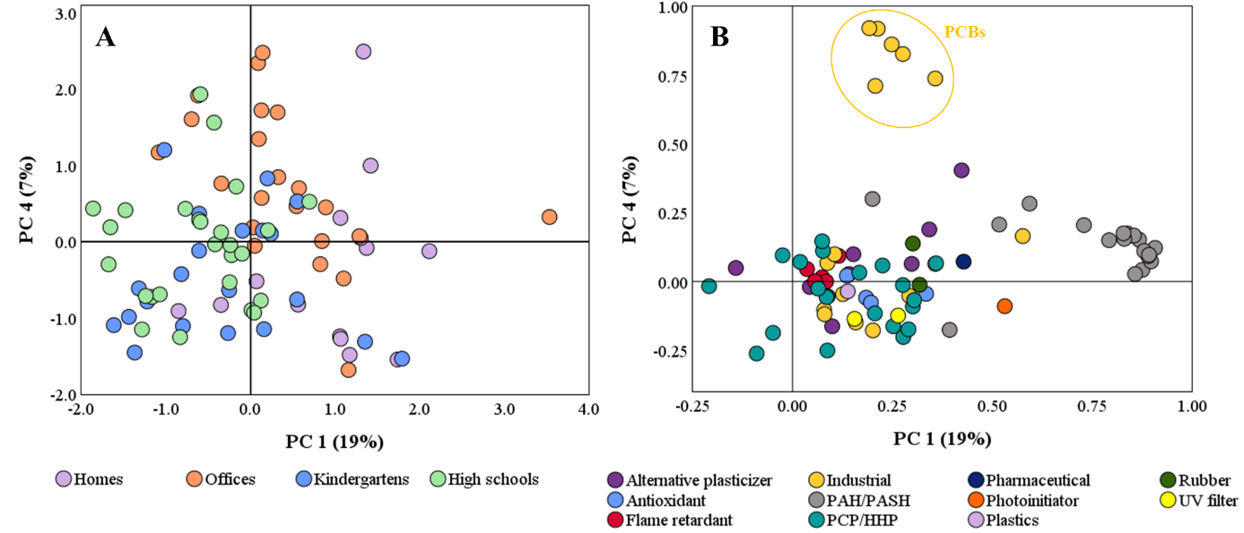
Figure S11. PC1 and PC4 from Principal Component Analysis depicting (A) score plots for each environment and (B) loading plots depicting chemical uses of detected compounds. PCBs (weights higher than 0.7 in PC4) are highlighted in the loading plot.

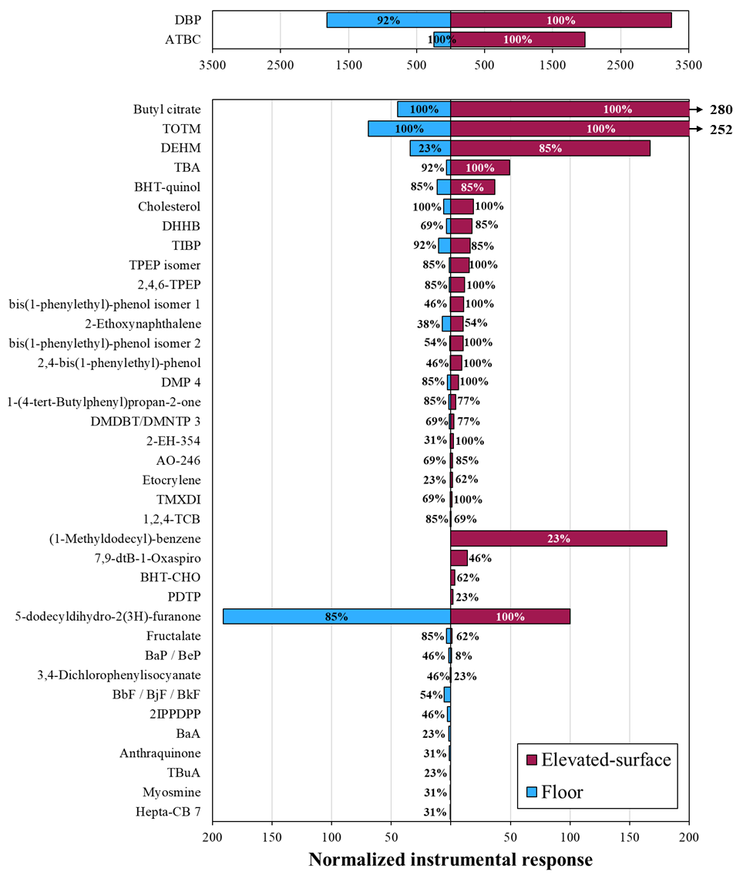
Figure S12. NIRs (mean) in floor and elevated-surface settled dust from high schools of contaminants showing statistical differences (Mann Whitney, p<0.05) or exclusively detected in one type of dust. Only compounds with DFs above 20% in each individual matrix were considered. DFs (%) are depicted next to the bar for each compound.

LITERATURE
[1] Navarro I, de la Torre A, Sanz P, Baldi I, Harkes P, Huerta-Lwanga E, Nørgaard T, Glavan M, Pasković I, Pasković MP, Abrantes N, Campos I, Alcon F, Contreras J, Alaoui A, Hofman J, Vested A, Bureau M, Aparicio V, Mandrioli D, Sgargi D, Mol H, Geissen V, Silva V, Martínez MÁ, 2023. Occurrence of pesticide residues in indoor dust of farmworker households across Europe and Argentina. Sci. Total Environ. 905, 167797. https://doi.org/10.1016/j.scitotenv.2023.167797
[2] Song Z, Shi M, Ren X, Wang L, Wu Y, Fan Y, Zhang Y, Xu Y, 2023. An integrated non-targeted and targeted analysis approach for identification of semi-volatile organic compounds in indoor dust. J. Hazard. Mater. 459, 132202. https://doi.org/10.1016/j.jhazmat.2023.132202
[3] Zhu L, Fauser P, Mikkelsen L, Sanderson H, Vorkamp K, 2023. Suspect and non-target screening of semi-volatile emerging contaminants in indoor dust from Danish kindergartens. Chemosphere 345, 140451. https://doi.org/10.1016/j.chemosphere.2023.140451
[4] Christia C, Poma G, Caballero-Casero N, Covaci A, 2021. Suspect screening analysis in house dust from Belgium using high resolution mass spectrometry; prioritization list and newly identified chemicals. Chemosphere 263, 127817. https://doi.org/10.1016/j.chemosphere.2020.127817
[5] Wang Y, Gao W, Wang Y, Jiang G, 2019. Suspect screening analysis of the occurrence and removal of micropollutants by GC-QTOF MS during wastewater treatment processes. J. Hazard. Mater. 376, 153–159. https://doi.org/10.1016/j.jhazmat.2019.05.031
[6] Castro G, Rodríguez I, Ramil M, Cela R, 2019. Assessment of gas chromatography time-of-flight mass spectrometry for the screening of semi-volatile compounds in indoor dust. Sci. Total Environ. 688, 162–173. https://doi.org/10.1016/j.scitotenv.2019.06.192
[7] Dubocq F, Wang T, 2022. Extended characterization of the indoor dust chemical composition by retrospective suspect and non-target analysis of high resolution mass spectrometric data. J. Environ. Expo. Assess. 1, 22. https://doi.org/10.20517/jeea.2022.23
[8] Castro G, Cobo M, Rodríguez I, 2024. Identification of hazardous organic compounds in e-waste plastic using non-target and suspect screening approaches. Chemosphere 356, 141946. https://doi.org/10.1016/j.chemosphere.2024.141946
[9] Hurtado-Fernández E, Velázquez-Gómez M, Lacorte S, Ramos L, 2021. Exhaustive characterization of (semi-)volatile organic contaminants in car dust using comprehensive two-dimensional gas chromatography ‒ Time-of-flight mass spectrometry. J. Hazard. Mater. 411, 125058. https://doi.org/10.1016/j.jhazmat.2021.125058
[10] Dubocq F, Kärrman A, Gustavsson J, Wang T, 2021. Comprehensive chemical characterization of indoor dust by target, suspect screening and nontarget analysis using LC-HRMS and GC-HRMS. Environ. Pollut. 276, 116701. https://doi.org/10.1016/j.envpol.2021.116701
[11] Gromski P, Xu Y, Kotze H, Correa E, Ellis D, Armitage E, Turner M, Goodacre R, 2014. Influence of missing values substitutes on multivariate analysis of metabolomics data. Metabolites 4, 2, 433–452. https://doi.org/10.3390/metabo4020433
[12] Noblet C, Lestremau F, Collet S, Chatellier C, Beaumont J, Besombes JL, Albinet A, 2024. Aerosolomics based approach to discover source molecular markers: A case study for discriminating residential wood heating vs garden green waste burning emission sources. Chemosphere 352, 141242. https://doi.org/10.1016/j.chemosphere.2024.141242

