Assessing pesticide residues occurrence and risks in the environment across Europe and Argentina
Abdallah Alaoui^{1*}, Florian Christ¹, Nelson Abrantes², Vera Silva³, Neus González⁴, Lingtong Gai³, Paula Harkes³, Irene Navarro⁵, Adrián de la Torre⁵, María Ángeles Martínez⁵, Trine Norgaard⁶, Anne Vested⁷, Vivi Schlünssen⁷, Virginia Carolina Aparicio⁸, Isabel Campos⁹, Igor Pasković¹⁰, Marija Polić Pasković¹⁰, Matjaž Glavan¹¹, Coen Ritsema³, Violette Geissen³

¹Institute of Geography, University of Bern, Hallerstrasse 12, 3012 Bern, Switzerland
²CESAM and Department of Biology, University of Aveiro, Portugal
³Soil Physics and Land Management Group, Wageningen University & Research, Wageningen, Netherlands
⁴Laboratory of Toxicology and Environmental Health, School of Medicine, IISPV, Universitat Rovira i Virgili, Sant Llorenç 21, 43201 Reus, Catalonia, Spain
⁵Unit of POPs and Emerging Pollutants in Environment, Department of Environment, CIEMAT, Madrid, Spain
⁶Department of Agroecology, Aarhus University, Denmark
⁷Department of Public Health, Research Unit for Environment, Occupation and Health, Danish Ramazzini Centre, Aarhus University, Aarhus, Denmark
⁸National Institute of Agricultural Technology (INTA) Balcarce, Buenos Aires, Argentina
⁹CESAM and Department of Environment and Planning, University of Aveiro, Portugal
¹⁰ Department of Agriculture and Nutrition, Institute of Agriculture and Tourism, K. Huguesa 8, 52440 Poreč, Croatia
¹¹Agronomy Department, Biotechnical Faculty, University of Ljubljana, Jamnikarjeva 101, 1000 Ljubljana, Slovenia

Content

SM1 – Sampling
SM2 – Number of compounds considered in this study per type
SM3 – Analytical methods for pesticide determination
SM4 – Cropping system and animal types
SM5 – Quality control (QC) and sensitivity analysis
SM6 – Ecotoxicological risk per matrix
SM7 – Detection frequency of the top 20 substances in soil (%)
SM8 – Concentration of the top 20 substances in soil per farming system (ug/kg)
SM9 – Detection frequency of the top 20 substances in the crop (%)
SM10 – Concentration of the top 20 substances in the crops per farming system (ug/kg)
SM11 – Total number of fields where the substances were detected in the crops per farming systems
SM12 – Risk assessment of pesticide residues in soil, crop/plant, water, and sediment
SM13 – The most frequently found substances in all matrices: soil, plant, water, and sediment according to their risk frequency
SM14 – List of hazard classes for the compounds ranked on the short list (Table 6 of the manuscript) (moderate to high risk); hazard data is from PPDB.

SM1 – Sampling
Soil – One composite soil sample was collected from each field. This sample was created by combining five subsamples gathered at random over the field using an auger. Sample depth differed between case study sites (CSS): 0-5 cm in CSS with permanent crops and 0-20 cm in CSS with arable land and tillage. The composite soil samples were kept at -20°C until they were shipped to the RECETOX laboratory for pesticide testing.
Crop – Each CSS sampled one crop class and one plant species from a field. CSS 1, 2, 3, 6, 7, and 9 examples focused on a single plant species, whereas CSS 4, 5, 8, and 10 focused on several plant species. The field sample was prepared using at least five plants distributed over the field. The plant portion to be sampled was crop-specific, based on the harvesting product (leaves, roots/tuber, grains, grapes, fruits, spikes, seeds, and so on). Plant samples were refrigerated or frozen (in the event of high water content and rapid breakdown) until pesticide analysis at RECETOX facilities.
Water – Water samples were gathered from minor rivers, stream channels, lakes, and ponds throughout the CSS areas. A minimum of three and a maximum of eight water bodies were agreed upon each CSS (because to restricted lab capacity and increased availability of monitoring data for such a matrix). Riverine habitats near organic or conventional agriculture areas were favoured. Each water body received a single composite water sample of about 2L. Water was collected subsurfacely at three spots on the water body (at least ten metres apart) and placed in a plastic bottle. Following sampling, the water samples were deep-frozen and delivered to the CIEMAT laboratory for pesticide analysis.
Sediment – Riverbed sediments were obtained from the same areas as water samples. Sediments could not be collected at all in the CSS owing to waterbody characteristics (e.g., too deep or constructed channel substrate). For each water body, a composite sediment sample was taken. This composite sample was created by combining three sub-samples taken at the sediment surface using a core sampler, stainless-steel scoop, or auger. After thoroughly combining the subsamples, 1kg of composite sediment sample was deposited in a polypropylene container and kept at -20°C until pesticide analysis at Wageningen University's facilities.

SM2 – Number of compounds considered in this study per type

Matrix | Number of samples analyzed | Active substances considered | Insecticides |  | Herbicides |  | Fungicides
Matrix | Number of samples analyzed | Active substances considered | Total | Metabolites | Total | Metabolites | Total | Metabolites
Soil | 215 | 192 | 66 | 19 | 56 | 5 | 69 | 14
Crop | 212 | 192 | 66 | 19 | 57 | 5 | 69 | 13
Water | 64 | 193 | 63 | 16 | 62 | 5 | 68 | 11
Sediment | 38 | 195 | 67 | 20 | 58 | 5 | 69 | 14

SM3 – Analytical methods for pesticide determination
Soil – The soil samples were thawed and homogenised (until a visual homogenous sample was achieved) before being separated into two portions: one of 2 grammes for glyphosate and its primary metabolite AMPA determination, and one of 5 grammes for multi-residue analyses (LC-MS/MS and GC-MS/MS). The first aliquot was analysed according to the methods described by Bento et al. (2016) and Yang et al. (2015), with KOH 0.6 M as the extraction solvent, isotopically labelled standards, and FMOC-Cl as the derivatization agent. The second aliquot was analysed in a manner similar to that reported by Silva et al. (2019), with the QuEChERS methodology, acetonitrile as the extraction solvent, and a PSA-based clean-up step added to a portion of the extraction supernatant utilised for the GC analyses.
Crop – The plant samples were also thawed, homogenised, and separated into two groups: one for glyphosate AMPA determination and another for multi-residue analysis. The former weighs 5g (2g for wet samples), whereas the latter weighs 10g (2g for wet samples). The improved approach reported by Yang et al. (2015), Goscinny et al. (2012), and Kaczyński et al. (2015) used isotopically labelled standards, 0.1% formic acid and dichloromethane extraction, and FMOC-Cl derivatization. The remaining pesticide residues were extracted using a modification of the QuEChERS method published by Silva et al. (2019). Acetonitrile was utilised as an extraction solvent, and dispersive sorbents were used for further cleaning prior to GC analysis.
Water – Water samples were thawed, filtered, and spiked with the appropriate labelled standards before being tested using three separate techniques for multi-residue analysis of pesticides, glyphosate and AMPA, and organochlorinated pesticides. Multi-residue analysis was performed using Oasis HLB Solid-Phase Extraction (SPE) cartridges that had been conditioned with methanol and ultrapure water before being eluted with methanol. The extract was evaporated under a nitrogen stream and separated into two aliquots for HPLC-MS/MS and GC-MS/MS. To test glyphosate and AMPA, water samples were treated with 0.1 M KH2PO4 and 0.1 M K3B4O7˙10H2O, and derivatized with 6.5 mM FMOC-Cl. The extract was then run through an Oasis HLB cartridge, eluted with methanol, and analysed using HPLC-MS/MS. Organochlorine pesticides were extracted using liquid-liquid extraction with dichloromethane and analysed using GC-HRMS.
Sediment – The sediment samples were analysed similarly to soil samples, with two minor changes. The sample was prepared by centrifuging at 3500 rpm for 5 minutes, then decanting the solid component and discarding the water. The glyphosate and AMPA aliquots, as well as the multi-residue aliquot, each included 2 grammes. The methodologies utilised were those stated by Bento et al. (2016), Yang et al. (2015), and Silva et al. (2019).
SM4 – Cropping system and animal types for SPRINT Case Study Sites (CSS)
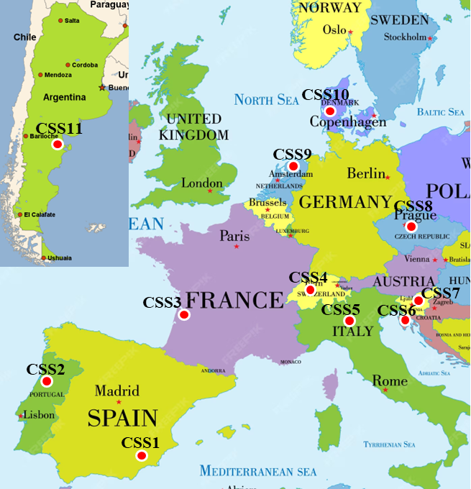
CSS (country) | Crops | Plant(s) | Animals
- Spain | Vegetables | Broccoli | Goats
- Portugal | Wine | Grape | Pigs, chickens
- France | Wine | Grape | Pigs, chickens
- Switzerland | Fruits | Apple, pear, cherry,  plum, strawberry | Dairy cows
- Italy | Vegetables | Cabbage, capsicum, lettuce, broccoli | No Livestock
- Croatia | Olives | Olives | Sheep
- Slovenia | Cereals | Maize | Dairy cows, cattle
- Czech Republic | Oil plants | Rapeseed, sunflower, poppy, mustard | Dairy cows, chickens
- Netherlands | Vegetables | Potatoes | Dairy cows
- Denmark | Cereals | Mix of spring barley, winter wheat, winter rye, and oat | Dairy cows
- Argentina | Cereals | Soybean | Dairy cows, cattle

SM5 - Quality control (QC) and sensitivity analysis
- Quality control
Blanks were utilised to reduce background contamination by treating empty falcon tubes in the same manner as samples. All standard solutions used for calibration curves were injected before and after each sample set analysis to ensure the equipment' sensitivity and repeatability. Three sets of multi-pesticide calibration standards were developed for LC-MS/MS, GC-HRMS, and glyphosate / Aminomethylphosphonic acid (AMPA) analysis. Each set of calibration standards was made from a mixed solution to be analysed using the appropriate analytical procedure. The calibration standards for LC-MS/MS analysis were produced in a solvent (multi-method: ACN + Millipore water; glyphosate/AMPA: Millipore water), whereas those for GC-HRMS analysis were matrix-matched.
The calibration ranges for multi-method were 1, 2, 5, 10, 20, and 50 ng/mL, for glyphosate/AMPA they were 10, 20, 50, 100, 200, 500, and 10000 ng/mL, and for GC-MS/MS they were 0.5, 2.5, 5, 10, 25, 50, and 100 ng/mL, respectively. The calibration curves showed good linearity of response vs concentration, with correlation coefficients > 0.99 and residuals < ±20%.
Selected Reaction Monitoring (SRM) was chosen as the data collecting method. Each analyte was identified using two ions (one precursor ion and one product ion). Compound identification was based on the relative response of two SRM transitions, their retention durations, and the peak shape of the relevant reference standard (or isotopically labelled internal standard, in the case of glyphosate and AMPA).
For these aims, Agilent Mass Hunter quantification software was employed. The uncertainty of the ratio of the quantification ion to the qualification ion of each analyte was set at 20% of the predicted values using the Agilent MassHunter software's standard assessment technique. The analytes were quantified using a matrix-adapted calibration standard or, in the case of glyphosate and AMPA, an internal standard. All samples were tested using internal standards (deuterated glyphosate and AMPA).
The injected quantities of standard solutions were used to calculate the instrumental limits of quantification, resulting in a signal-to-noise ratio of 10. The detection limits were established using the number of analytes with a signal-to-noise ratio of 3. For this aim, the standard solutions were analysed again (n = 6).
Sample processing after delivery of the frozen crops:
- Grapes were homogenized frozen (including the skins and seeds)
- Broccoli was thawed, cut into smaller pieces, and homogenized
- Vegetables were homogenized frozen (sent cut in small pieces)
- Potatoes were thoroughly cleaned to remove any significant soil residue, thawed, cut into smaller pieces, and homogenized (including the peel)
- Apples and pears were thawed, cut into smaller pieces, and homogenized
- Cherries and plums were thawed, pitted, and homogenized
- Strawberries were homogenized frozen
- Olives were thawed, pitted, and homogenized
- Seeds were removed from plant and homogenized
- Grains were homogenized frozen
- Sensitivity analysis by left-censored data imputation
Pesticide residues found in at least 40% of the samples were imputed at the matrix level. Imputation analyses are unnecessary for residues found in all samples (100% detection). The Mann Whitney U test was used to compare the medians of truncated distributions (non-imputed data with values > limit of detection) to those of complete distributions (non-imputed + imputed data). Pesticide residue names in red show a significant difference (p-value <0.05) between imputed and non-imputed data medians.
For more information on sensitivity analysis, refer to (i) Silva et al., 2023.
For more information on sampling and laboratory analysis, refer to Alaoui et al., 2021.
References
Alaoui, A.; Vested, A.; Silva, V.; Schlünssen, V. et al. Monitoring plan for assessing ecosystem, plant, animal, and human health at case study sites. Deliverable D2.1 (Version 2), 2021. Report https://sprint-h2020.eu/index.php/resources/project-milestones (Last access May 2024).
Bento CPM, Yang X, Gort G, Xue S, van Dam R, Zomer P, et al. Persistence of glyphosate and aminomethylphosphonic acid in loess soil under different combinations of temperature, soil moisture and light/darkness. Science of The Total Environment 2016; 572: 301-311.
Goscinny S, Unterluggauer H, Aldrian J, Hanot V, Masselter S. Determination of Glyphosate and Its Metabolite AMPA (Aminomethylphosphonic Acid) in Cereals After Derivatization by Isotope Dilution and UPLC-MS/MS”. Food Analytical Methods 2012; 5: 1177-1185.
Kaczyński P, Łozowicka B. Liquid chromatographic determination of glyphosate and aminomethylphosphonic acid residues in rapeseed with MS/MS detection or derivatization/fluorescence detection. Open Chemistry 2015; 13.
Silva V, Mol HGJ, Zomer P, Tienstra M, Ritsema CJ, Geissen V. Pesticide residues in European agricultural soils – A hidden reality unfolded. Science of The Total Environment 2019; 653: 1532-1545.
Silva, V.; Gai, L.; Harkes, P.; Tan, G.; Ritsema, C. J.; et al. Pesticide residues with hazard classifications relevant to non-target species including humans are omnipresent in the environment and farmer residences. Environment International 2023, 181, 108280, ISSN 0160-4120, DOI 10.1016/j.envint.2023.108280.
Yang X, Wang F, Bento CPM, Xue S, Gai L, van Dam R, et al. Short-term transport of glyphosate with erosion in Chinese loess soil — A flume experiment. Science of The Total Environment 2015; 512-513: 406-414.

SM6 – Ecotoxicological risk per matrix
- Soil Matrix
The eco-toxicological risk induced by pesticides in soils was assessed based on threshold values of chronic toxicity (i.e., non-observable effect concentration (NOEC)) for earthworms collected from the PPDB and verified in the literature (Benfenati et al., 2013; Franco et al., 2024). The PNEC values were calculated by dividing the NOEC values by an evaluation factor of 10, which was modified following the European Commission's Environmental Risk Evaluation guidelines (ECB, 2003).
- Crop Matrix
According to Regulation (EC) No 396/2005, the maximum residue level (MRL) is the upper level at which pesticide residues are legally permitted in or on food or animal feed based on good agricultural practices (GAP). MRLs are legal standards designed to guarantee that residues are controlled both nationally and internationally; they are not toxicological criteria (Codex Alimentarius Commission). Therefore, exceeding such limitations does not always imply that they pose any risk to the customer's health. Nonetheless, MRLs are intended to safeguard consumer health by defining the maximum quantity of pesticide residues in crops that is legally permitted (EFSA, 2022a). Generally, to have an understanding of the level of contamination and its potential toxicological effects, residual pesticide levels are compared to the Maximum Residual Limits (MRL) serving as a reference. The MRLs are fixed based on a comprehensive assessment of the properties of the active substance and the intended uses of the pesticide residue. For all the EFSA’s MRL assessments, both chronic (long-term) and acute (short-term) dietary consumer exposure to PPP residues were estimated using a calculation model developed by the EFSA (PRIMo – Pesticide Residue Intake Model).
The percentage of crop samples exceeding the MRL and the factor by which it exceeds the MRL have been given, differentiated by farming system.
- Water matrix
The European Commission (EC) technical guidelines on risk assessment (ECB, 2003) focus on contaminants in general. Within this framework, the PNEC value for a given PPP is calculated as the lowest LC50/EC50 or the lowest NOEC found and normalized to the appropriate AF. AFs are used to deal with prediction uncertainties related to the extrapolation from single-species toxicity data to ecosystem-level effects, also considering conservative precautionary principles. The assignment of an AF to each PPP strictly followed Table 16 in the ECB (2003). Based on the interpretation of these guidelines and expert judgment, specific conditions were applied in the definition of AFs for some PPPs according to the toxicity data available: (i) NOEC for algae was included as a long-term endpoint; (ii) cyanobacteria were considered as algal surrogates due to their position as producers in aquatic ecosystems; (iii) macrophytes were considered in the PNEC calculation; (iv) NOEC values for benthic insects (e.g. Chironomus sp.) were considered for the PNEC calculation only when information concerning the base-set of indicators was also available; (v) non-exact LC50/EC50 and NOEC values (higher than or lower than a given value) were not considered for the PNEC calculation.
Complying with specific guidelines focused on PPP risk assessment in edge-of-field surface waters (EFSA PPR, 2013), which adheres to Regulation (EC) no. 1107/2009 and the therein quoted Annex VI to Directive 91/414/EEC, Regulatory Acceptable Concentrations (RACs) were calculated as ecological thresholds considering negligible population effects only. Similar to PNEC values, RAC values are calculated by normalizing ecotoxicological endpoints (EC50/LC50, NOEC and EC10) using a defined AF. This AF can assume a value of 100 or 10, depending on whether acute or chronic toxicity data are used. The species that should be considered for RAC calculation depends on the PPP, namely on whether it is an insecticide, an herbicide or another type of PPP, as well as on the availability of acute and/or chronic data (see Table 1-3 in EFSA PPR, 2013). For the present classification protocol, supporting the ranking of PPP for selection of the mixtures undergoing ecotoxicity testing (see section 2.4), only the most conservative Tier 1-RAC was calculated per PPP by normalizing the lowest LC50/EC50 (RACsw;ac) or the lowest NOEC (RACsw:ch) found in the database relevant to the corresponding AF.
- Sediment Matrix
According to the EC technical guidance on risk assessment (ECB, 2003) and the EFSA guidelines for PPP effect assessment on sediment organisms (EFSA PPR, 2015), risk assessments for PPPs should only take into account the sediment biota under specific conditions. The effect assessment based on toxicity records corresponding to chronic tests with benthic organisms was the primary approach followed. As recommended by the ECB (2003), the PNEC sediment (PNECsed) values (mg/kg) were calculated by normalizing the lowest (and in this case the only one found) chronic NOEC values found for sediment-dwelling organisms, namely Chironomus sp. tested with spiked sediment, with an assessment factor of 100. For the majority of pesticides considered in this analysis, appropriate toxicity data allowing PNECsed/RACsed calculations were found and used in this study. For the few remaining compounds, PNECsed/RACsed were calculated based on the Equilibrium Partitioning (EqP) theory using the assessment of the effects for the aquatic compartment (i.e., toxicity records following testing with pelagic organisms) as recommended in both guidance documents. Both the EC technical guidance on risk assessment (ECB, 2003) and the EFSA guidelines for PPP effect assessment on sediment organisms (EFSA PPR, 2015) assume that dedicated assessment concerning the sediments biota should be considered in risk assessment for PPPs only under specific conditions. The ECB (2003) states that sediment effect assessments should only be carried out for substances that are likely to sorb to sediment (based on Koc and Kow values). However, the EFSA PPR (2015) recommends considering criteria such as the estimated persistence of PPPs in sediment after application, PPP annual occurrence patterns in sediments as modelled using FOCUS tools, and toxicity magnitude found for pelagic organisms. For this protocol, considering that we are working with the pesticides found in the SPRINT CSS, we did not restrict threshold calculations by following these criteria.
The ECB recommends that the PNECsed estimation be based on Equation 1, integrating PNECwater values with the a priori defined parameter (standard broadly covering European scenarios) bulk density of wet suspended matter (RHOsusp) and the calculated suspended matter-water partition coefficient (Ksusp-water). The Ksusp-water was calculated by integrating several a priori defined parameters, such as the water fraction in suspended matter (Fwatersusp), the solid fraction in suspended matter (Fsolidsusp) and the density of the solid phase (RHOsolid), plus the solids-water partitioning coefficient in suspended matter (Kpsusp), as indicated in Equation 2. Kpsusp was calculated by multiplying the weight fraction of the organic carbon in suspended matter (Focsusp; a priori defined) by the organic carbon-water partition coefficient (Koc).
PNEC𝑠𝑒𝑑= K𝑠𝑢𝑠𝑝−𝑤𝑎𝑡𝑒𝑟𝑅𝐻𝑂𝑠𝑢𝑠𝑝×PNEC𝑤𝑎𝑡𝑒𝑟 ×1000 (Equation 1)
K𝑠𝑢𝑠𝑝−𝑤𝑎𝑡𝑒𝑟= Fwater𝑠𝑢𝑠𝑝+Fsolid𝑠𝑢𝑠𝑝× Kp𝑠𝑢𝑠𝑝1000×RHO𝑠𝑜𝑙𝑖𝑑 (Equation 2)

SM7 – Detection frequency of the top 20 substances in soil (%)
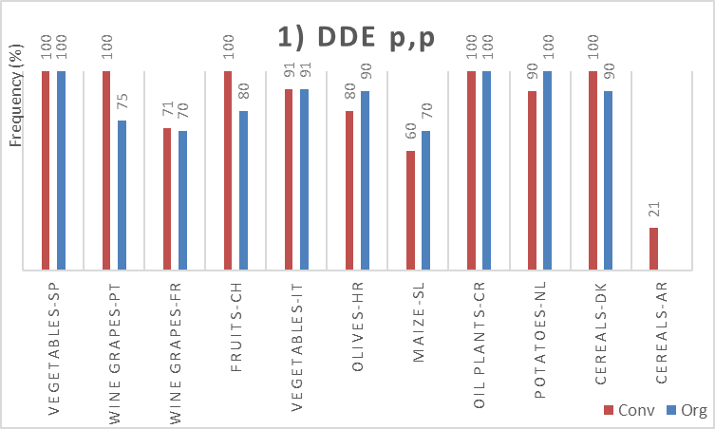 | 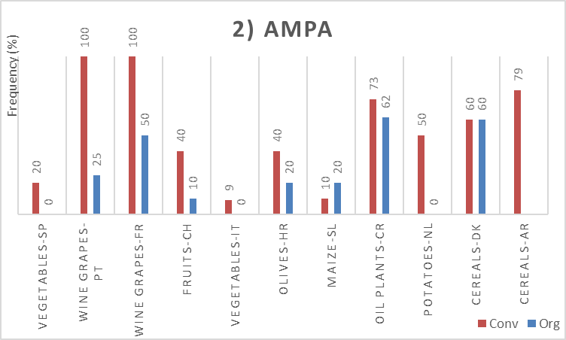
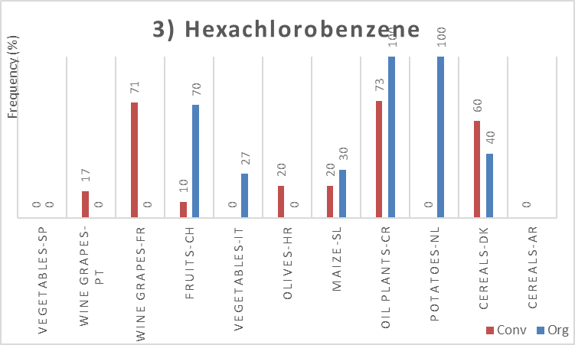 | 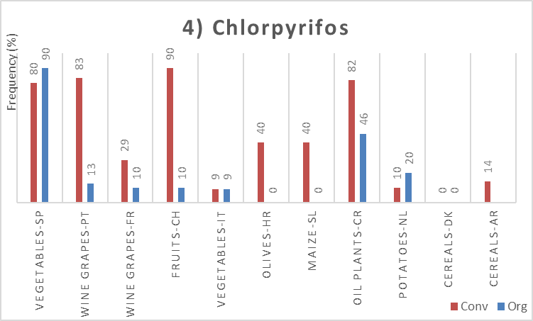
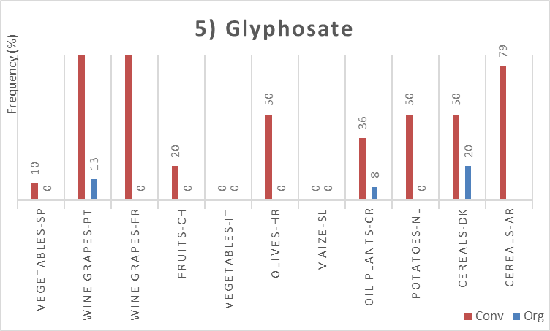 | 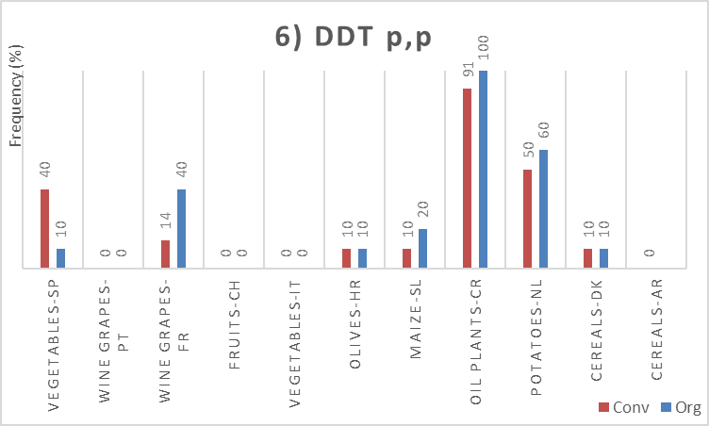
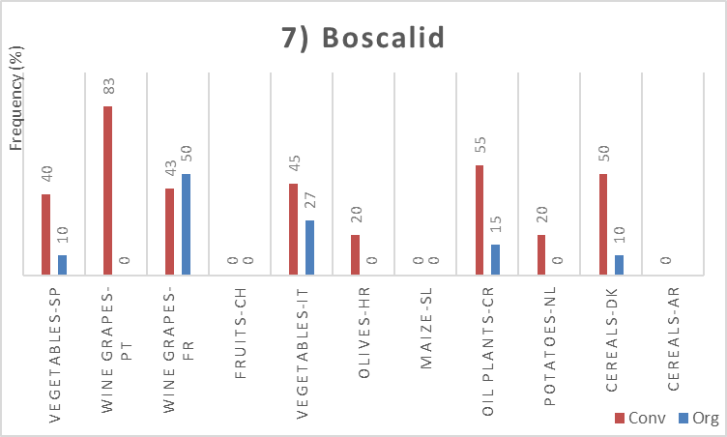 | 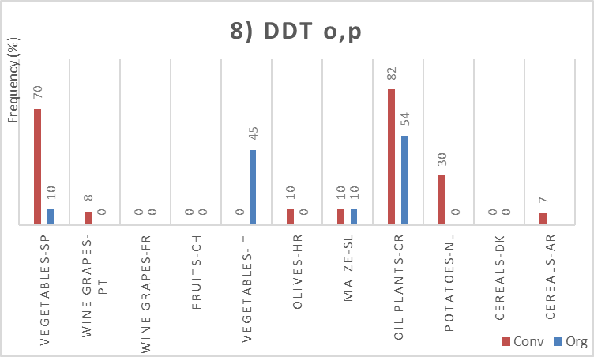
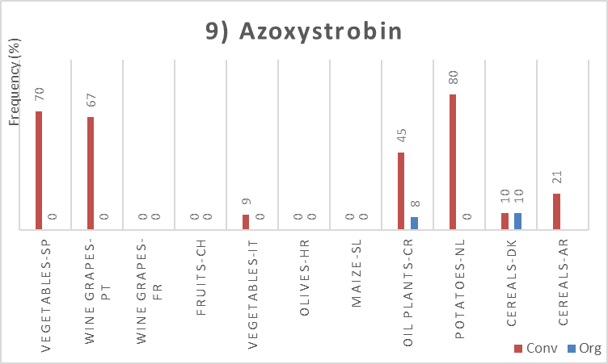 | 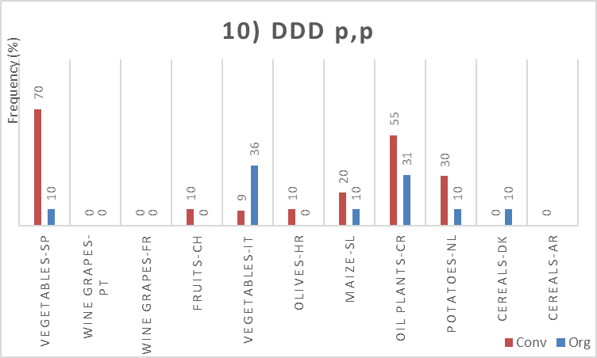
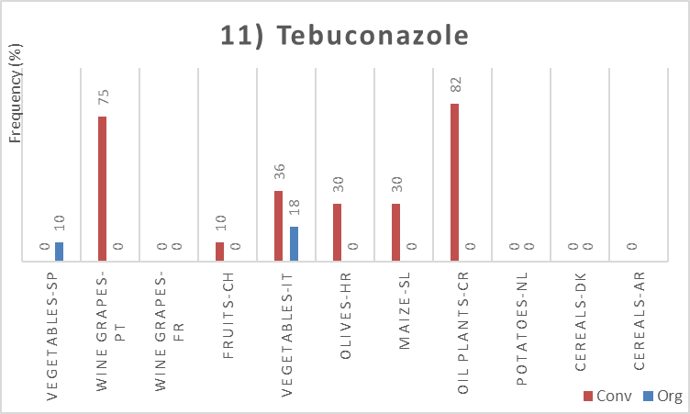 | 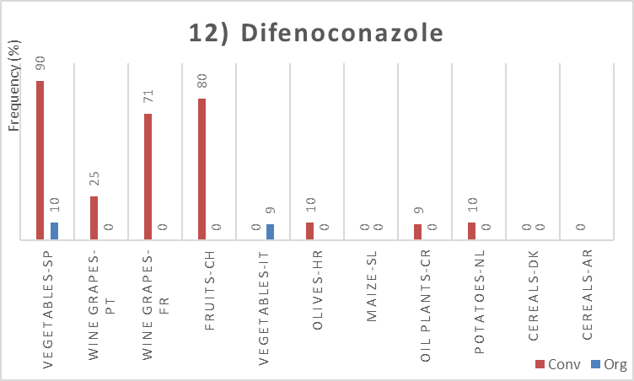
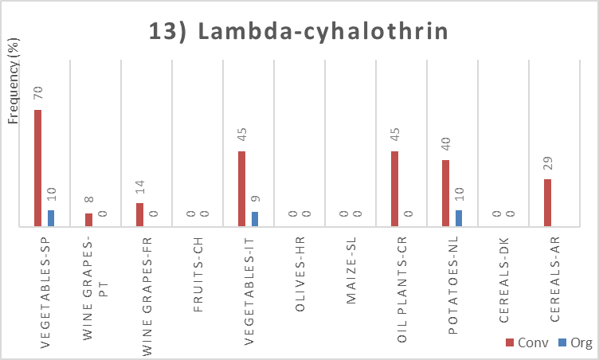 | 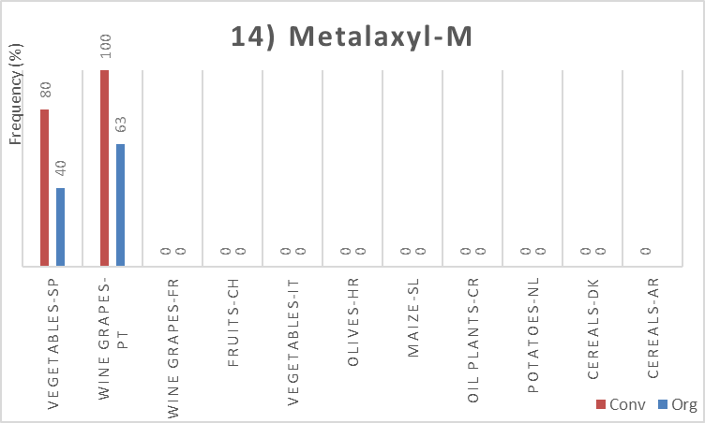
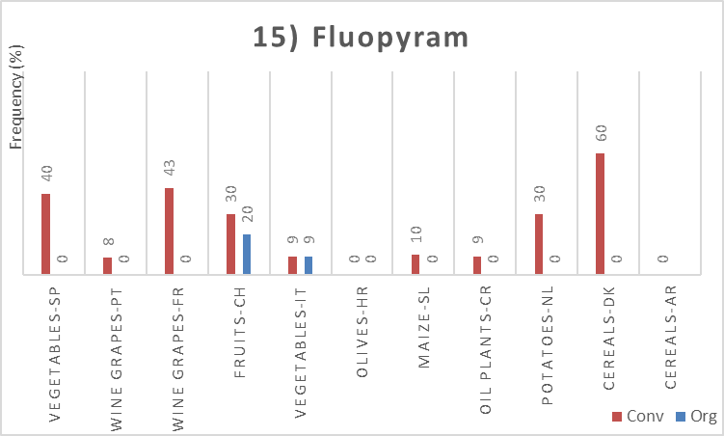 | 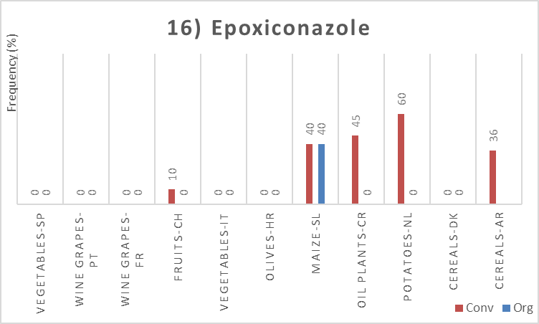
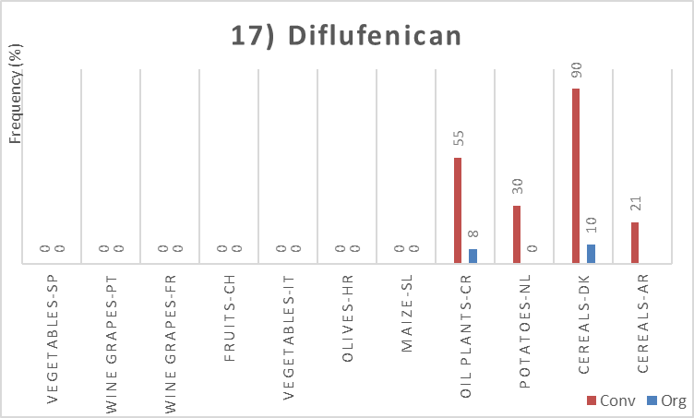 | 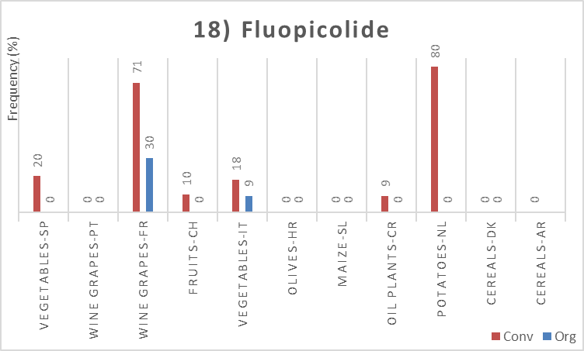
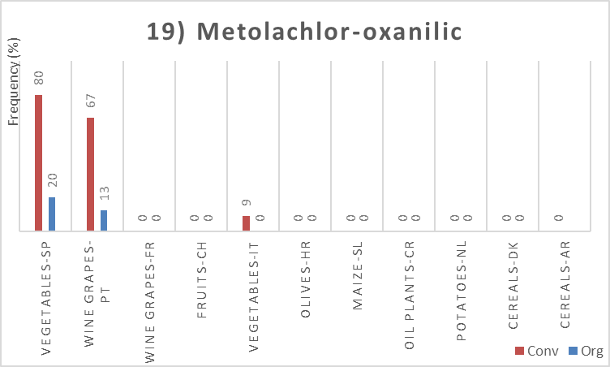 | 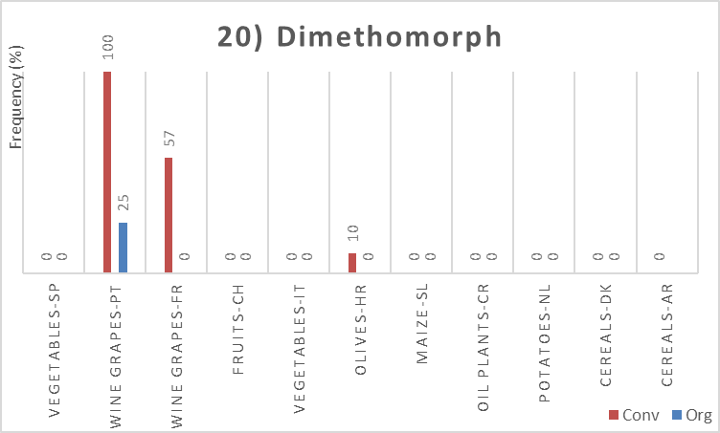
SM8 – Concentrations of the top 20 substances in soil per farming system (µg/kg)
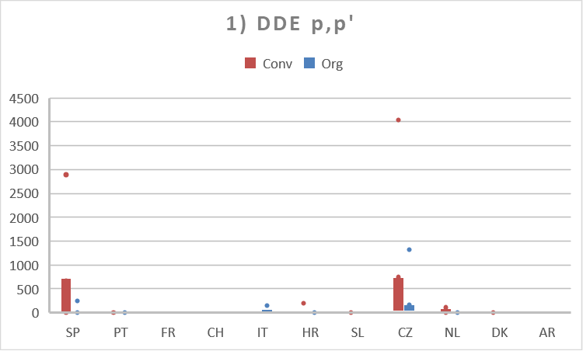 | 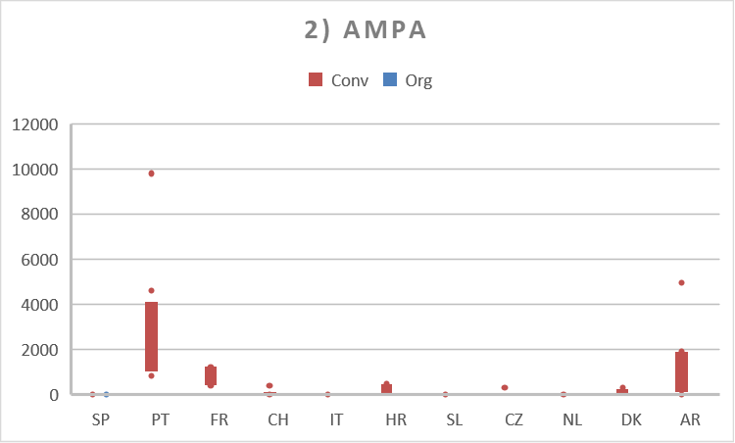
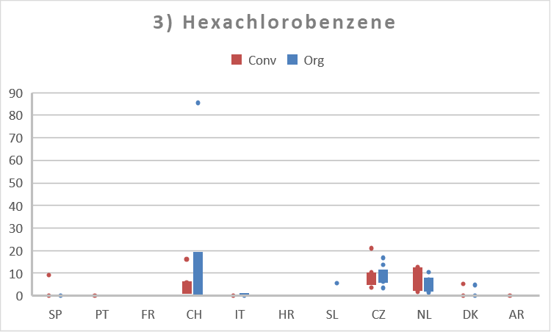 | 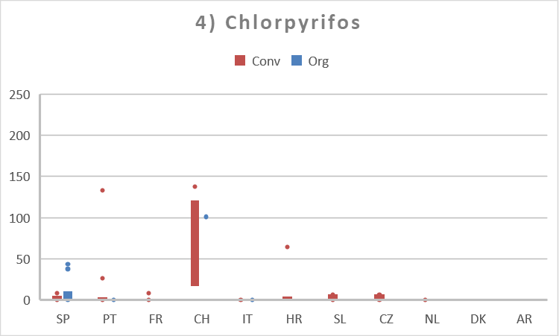
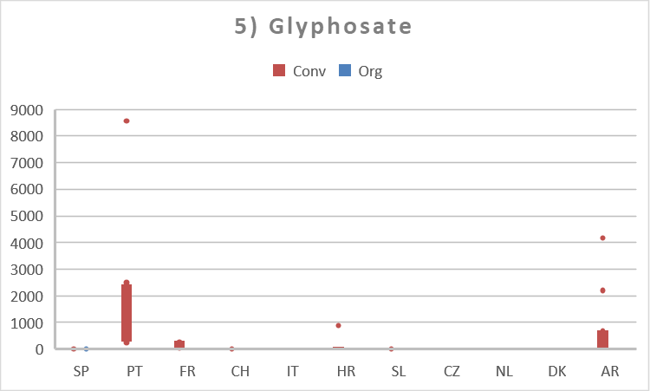 | 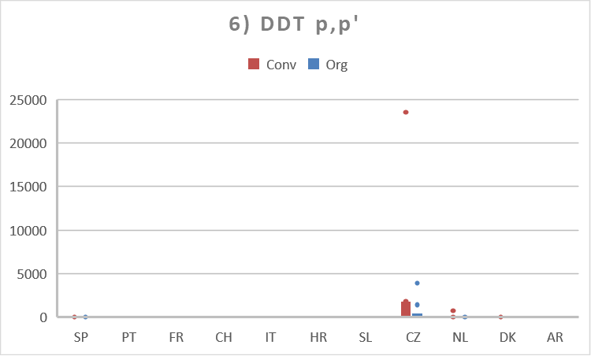
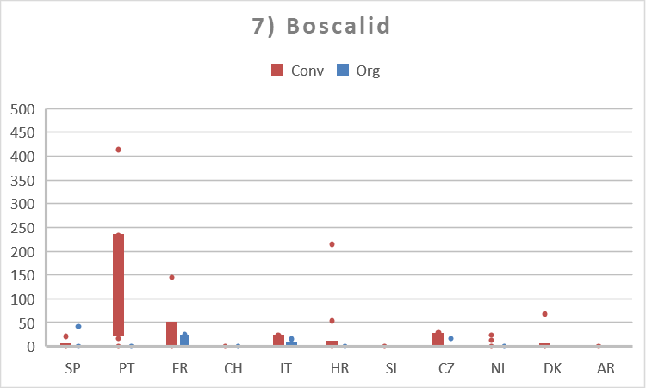 | 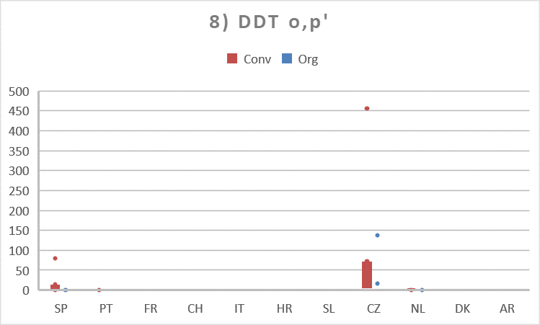
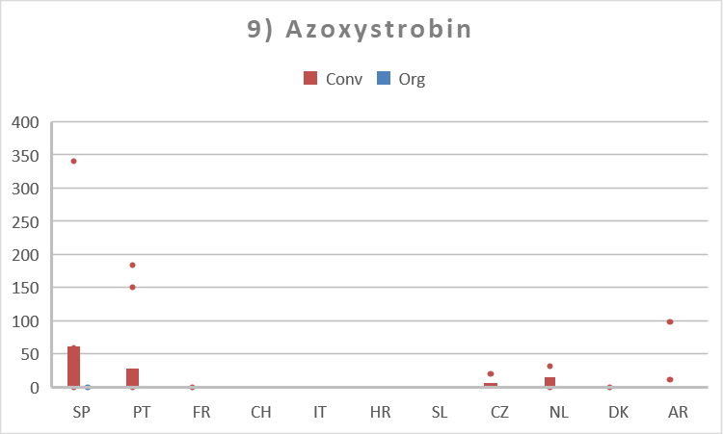 | 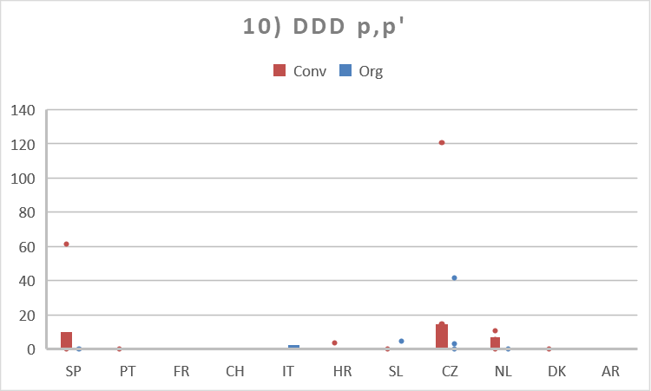
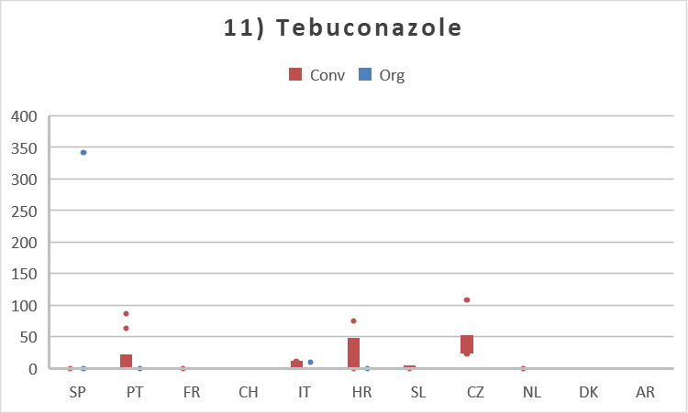 | 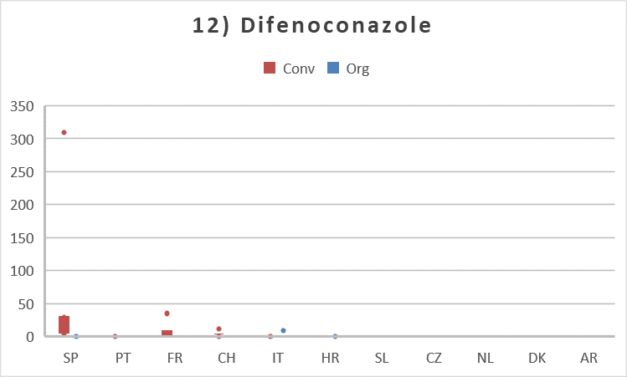
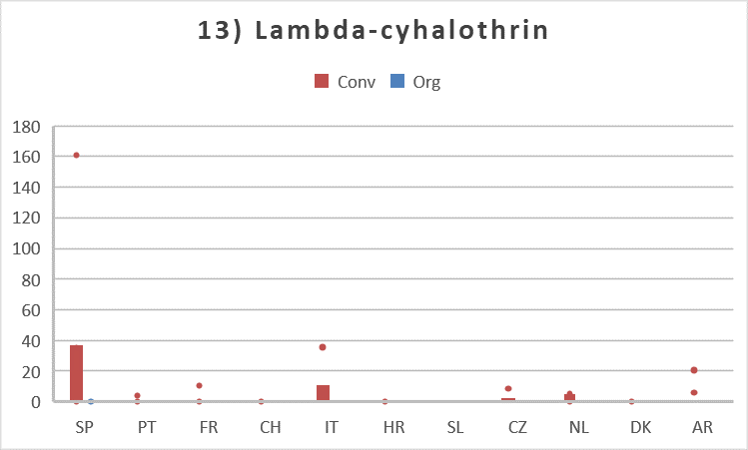 | 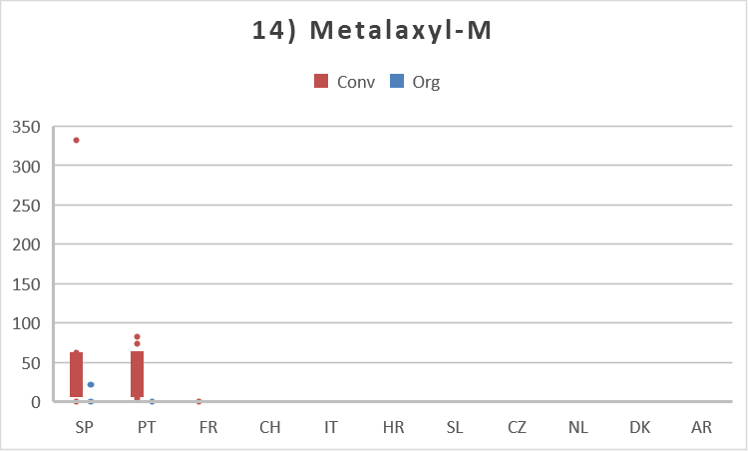
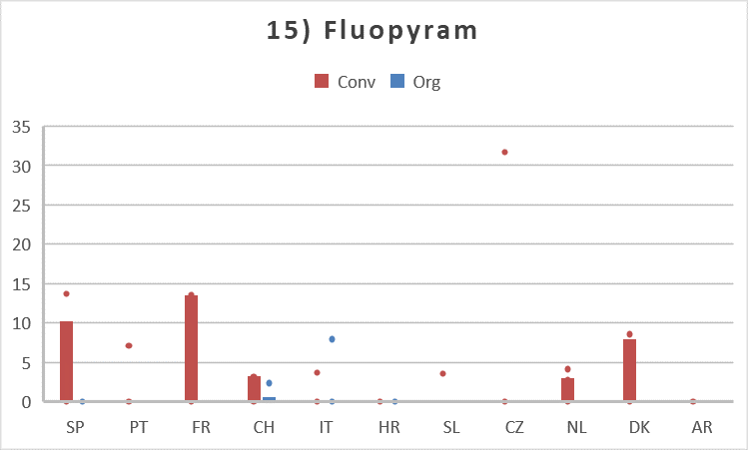 | 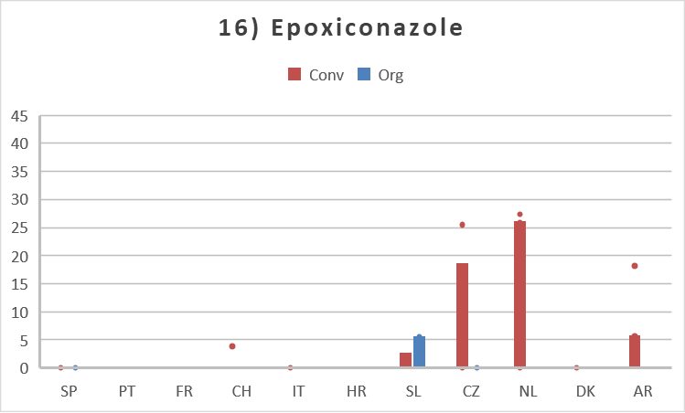
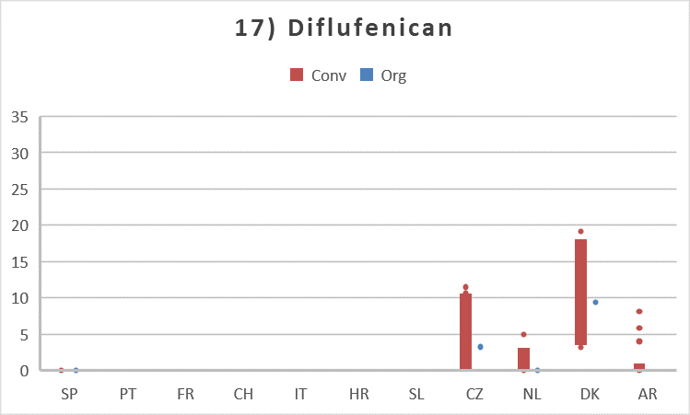 | 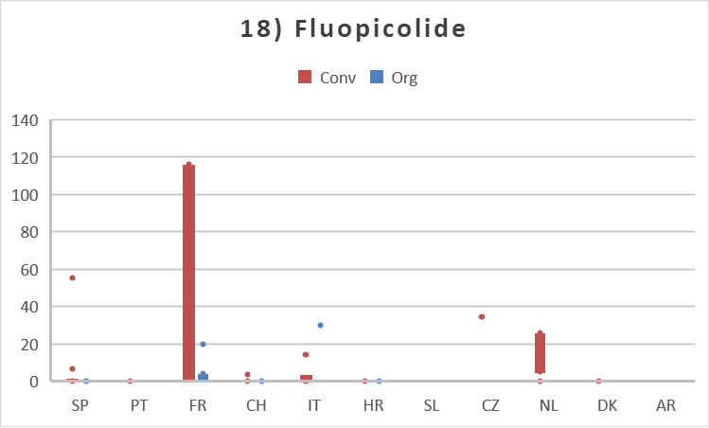
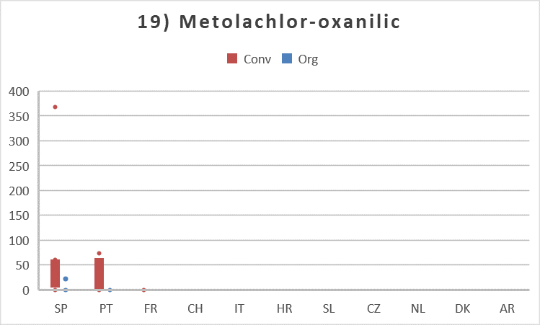 | 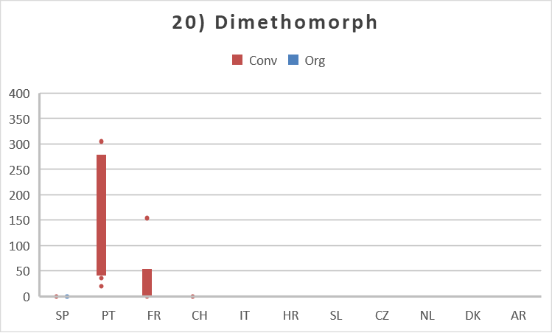

SM9 – Detection frequency of the top 20 substances in the crop
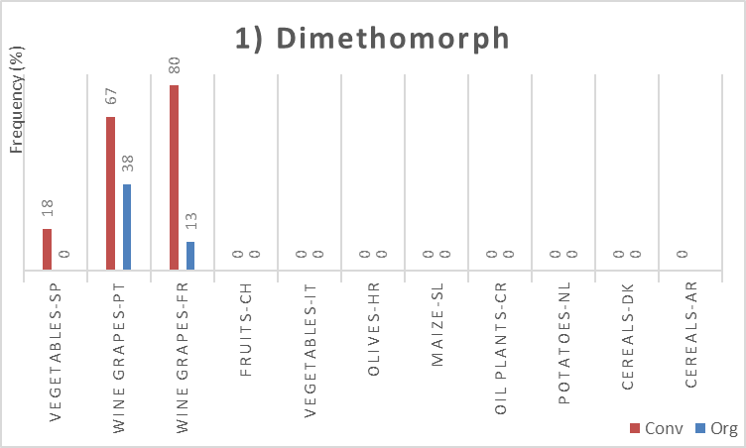 | 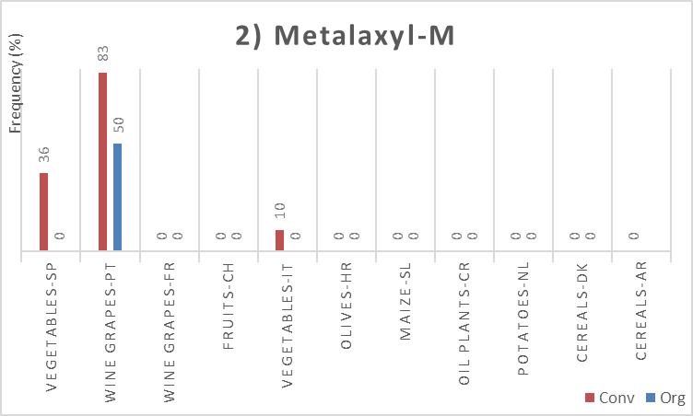
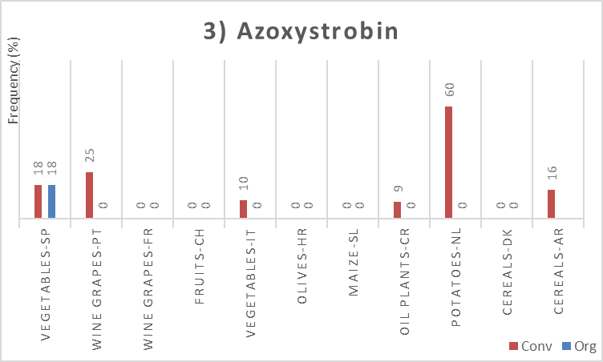 | 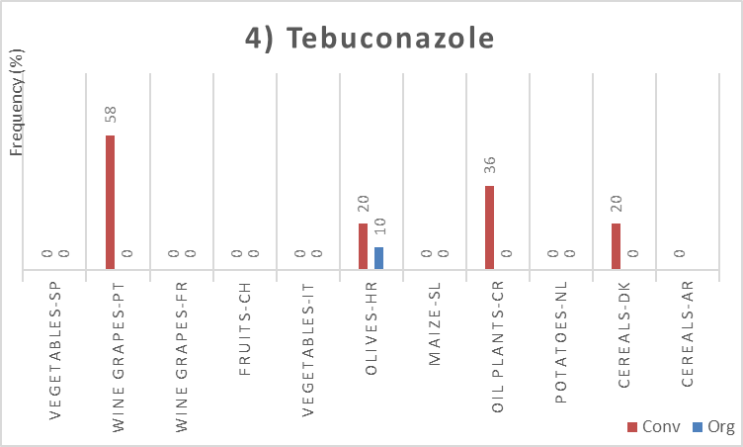
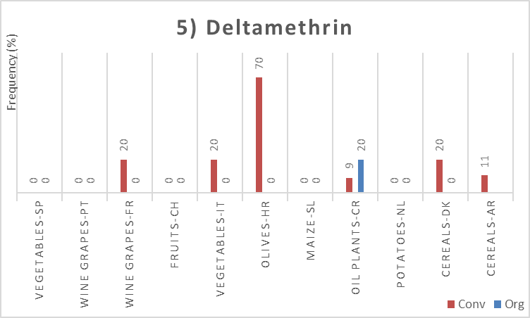 | 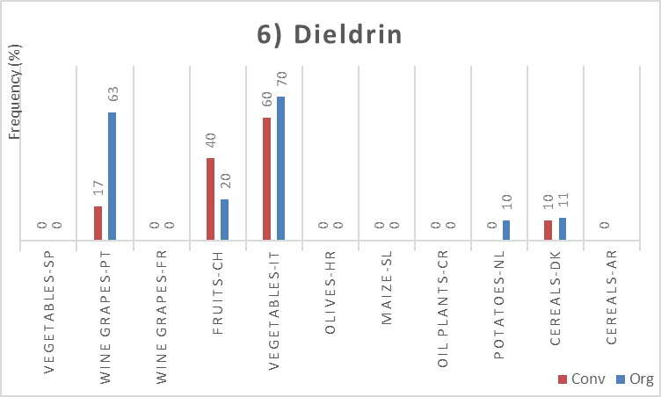
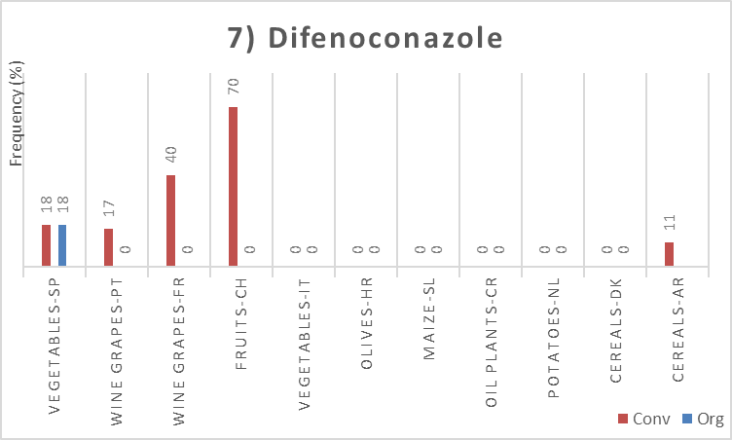 | 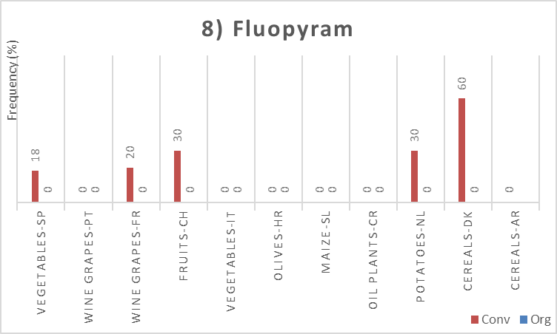
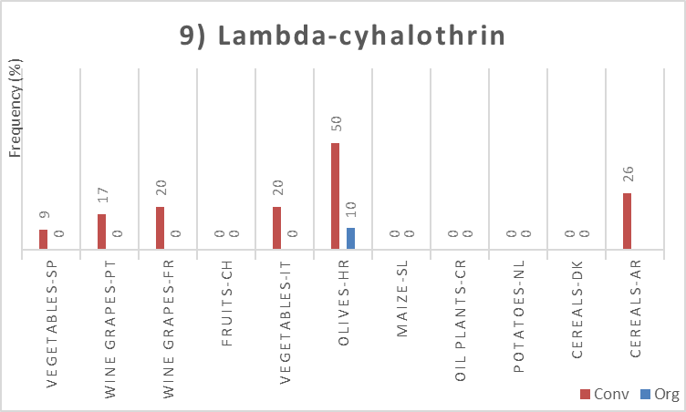 | 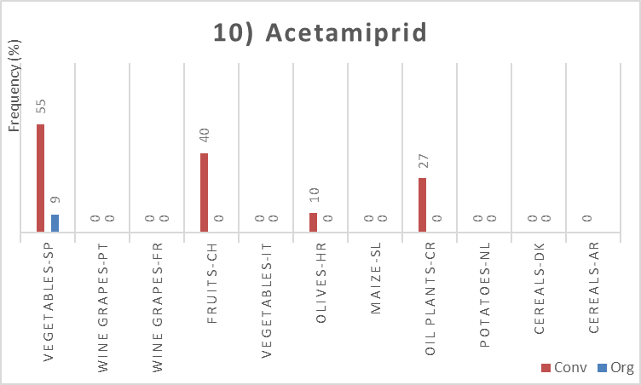
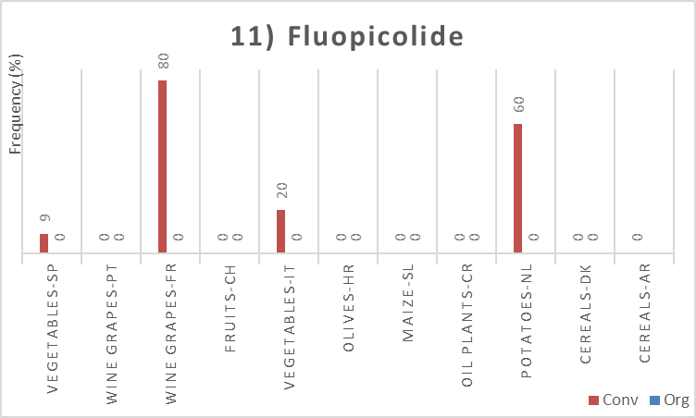 | 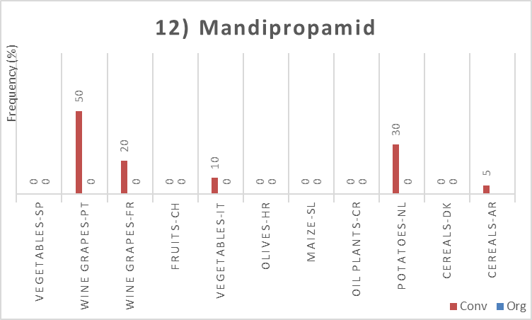
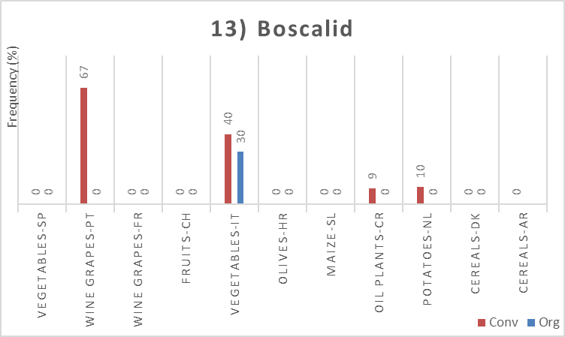 | 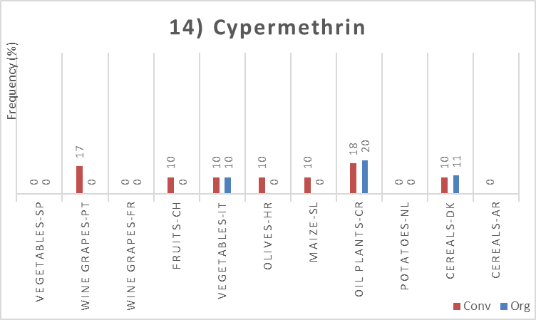
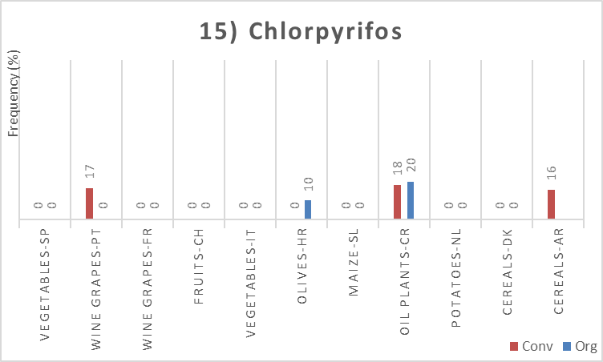 | 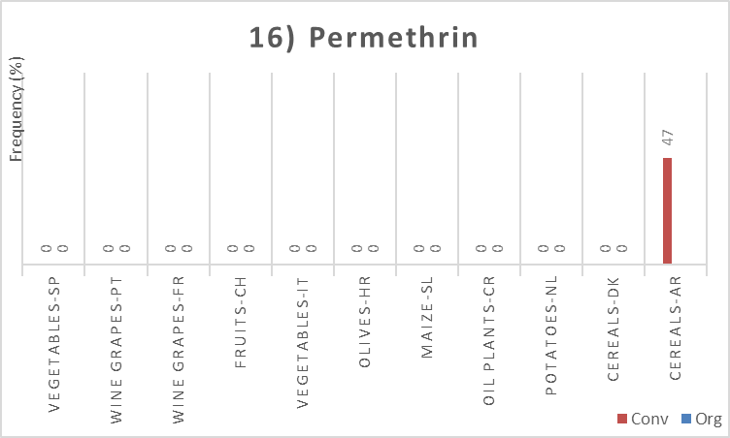
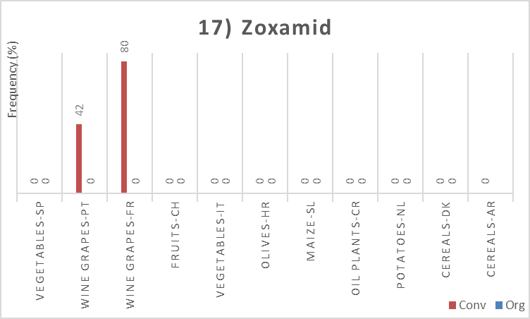 | 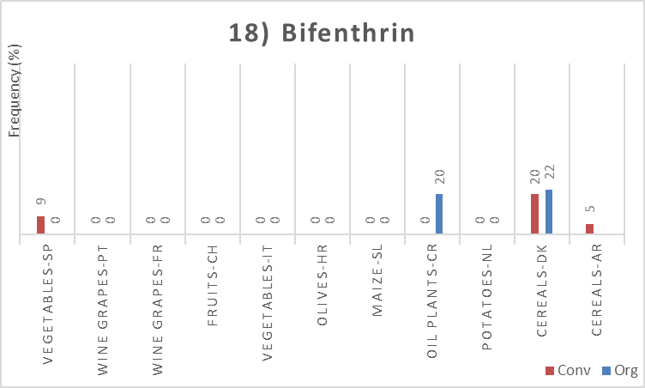
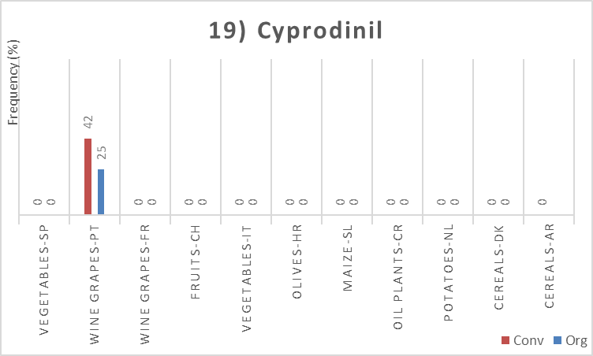 | 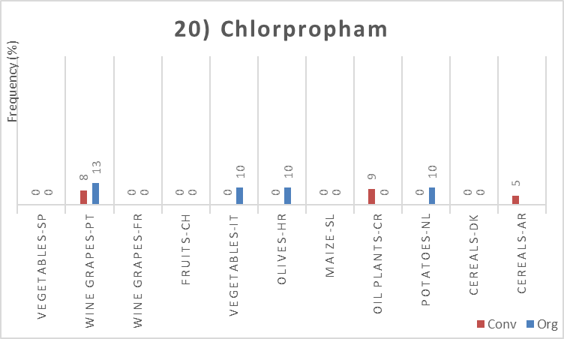

SM10 – Concentrations of the top 20 substances in the crops per farming system (µg/kg)
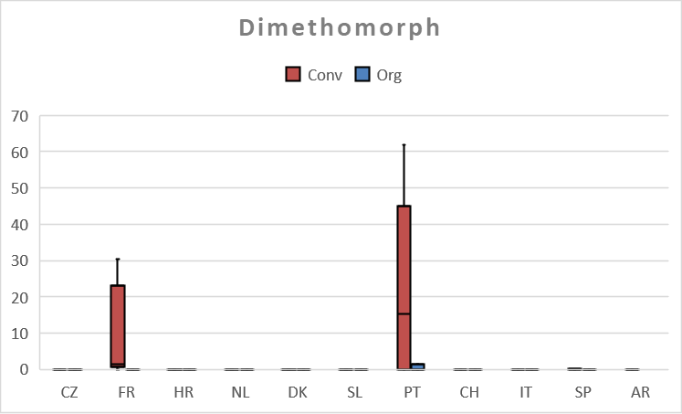 | 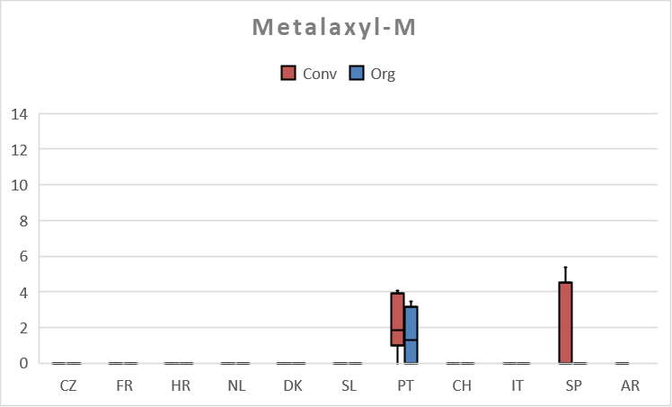
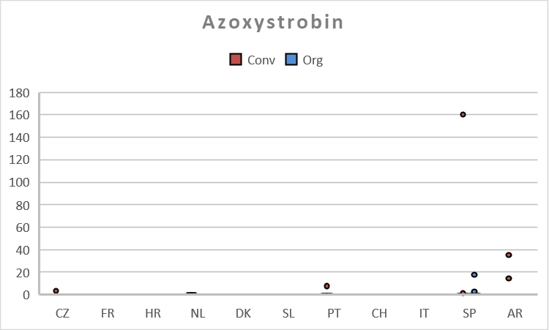 | 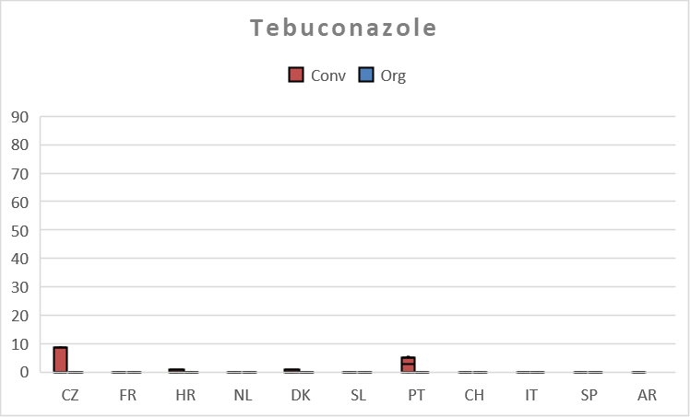
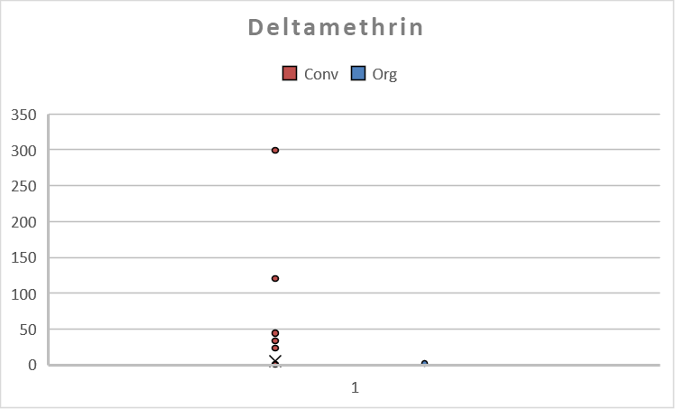 | 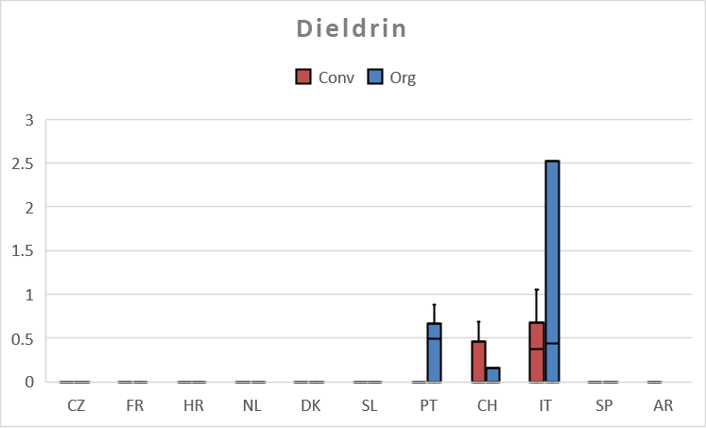
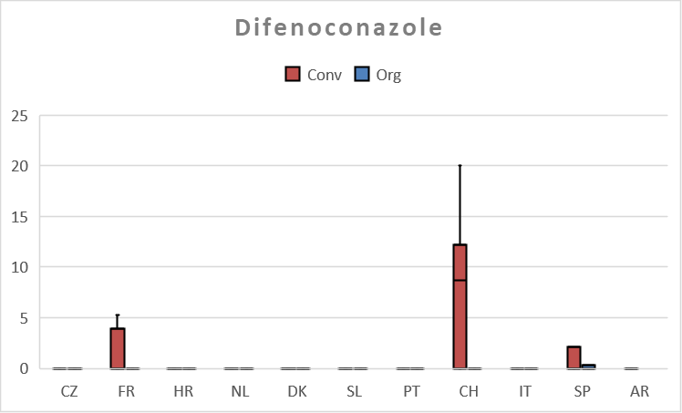 | 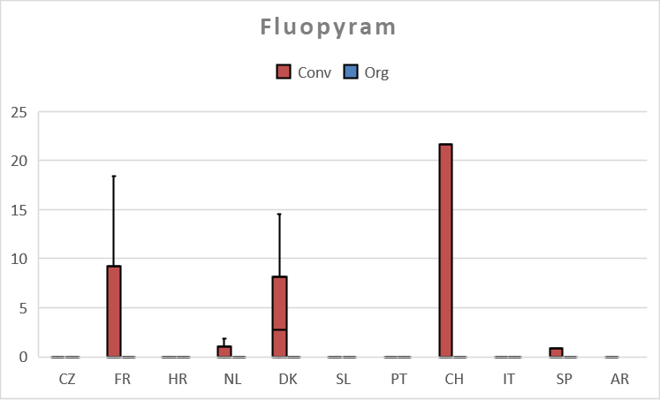
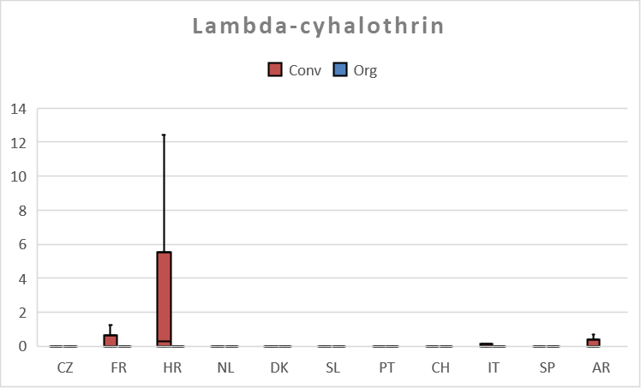 | 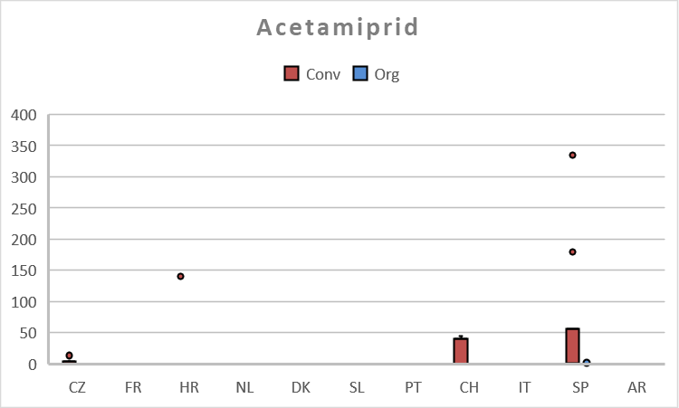
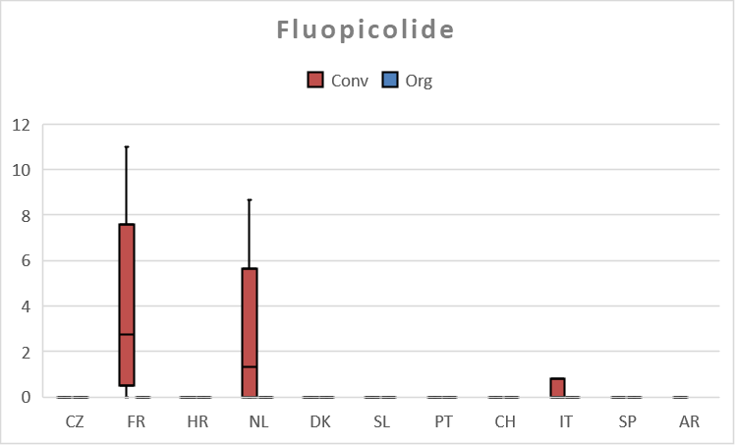 | 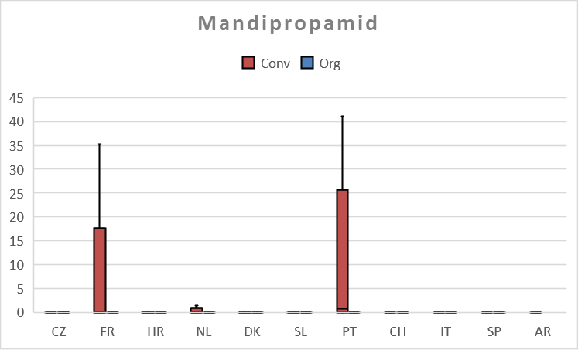
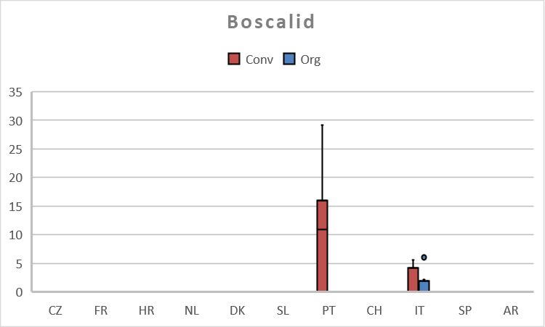 | 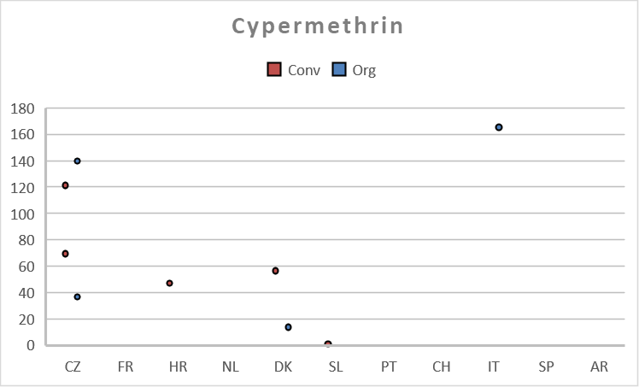
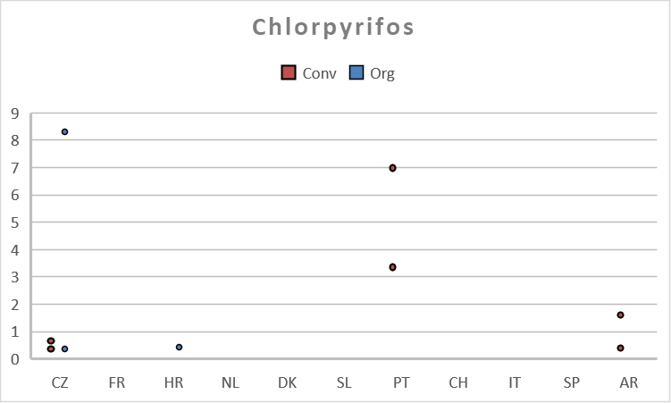 | 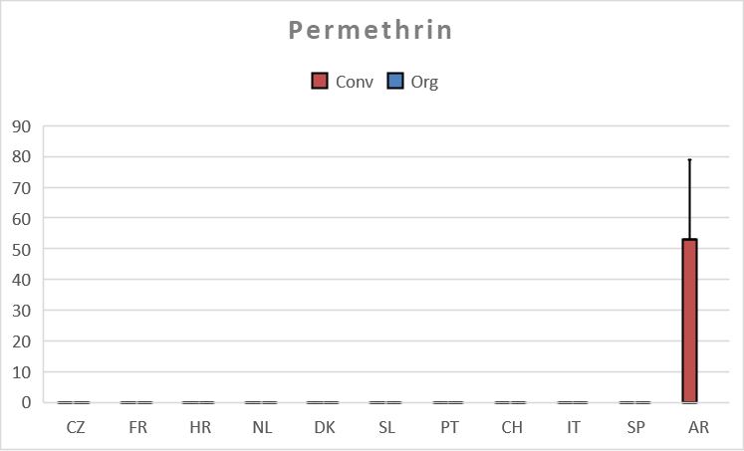
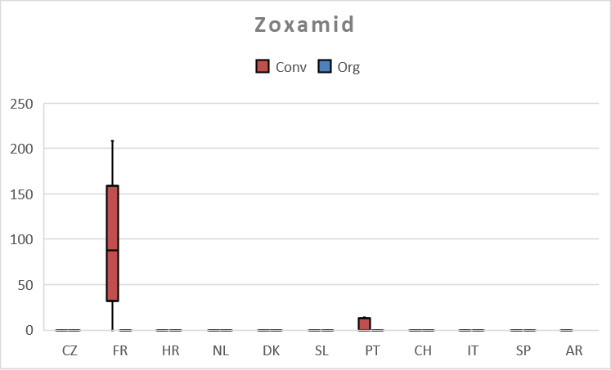 | 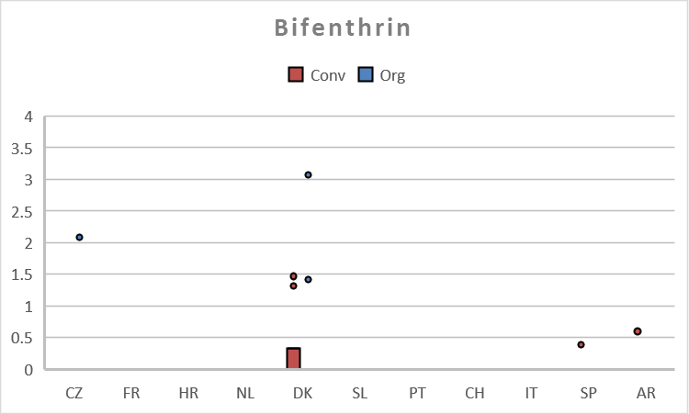
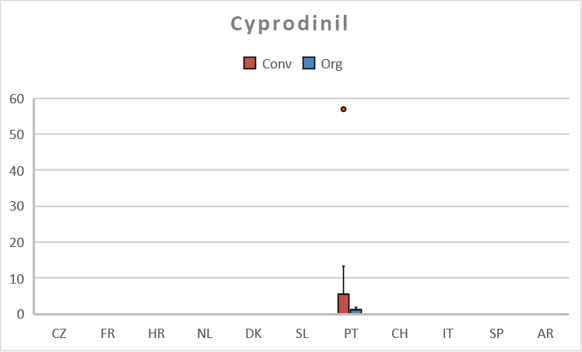 | 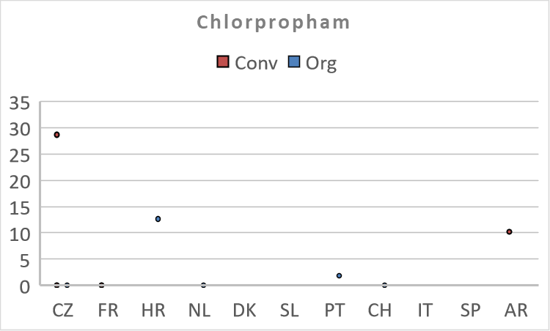

SM11 – Total number of fields where the substances were detected in the crops per farming systems
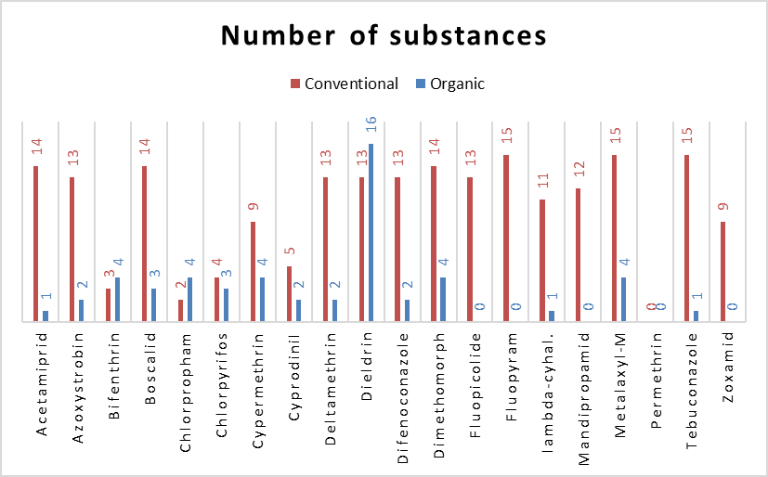

SM12 – Risk assessment of pesticide residues in soil, crop/plant, water, and sediment
PNEC values calculated for soil
DDE.p.p. | 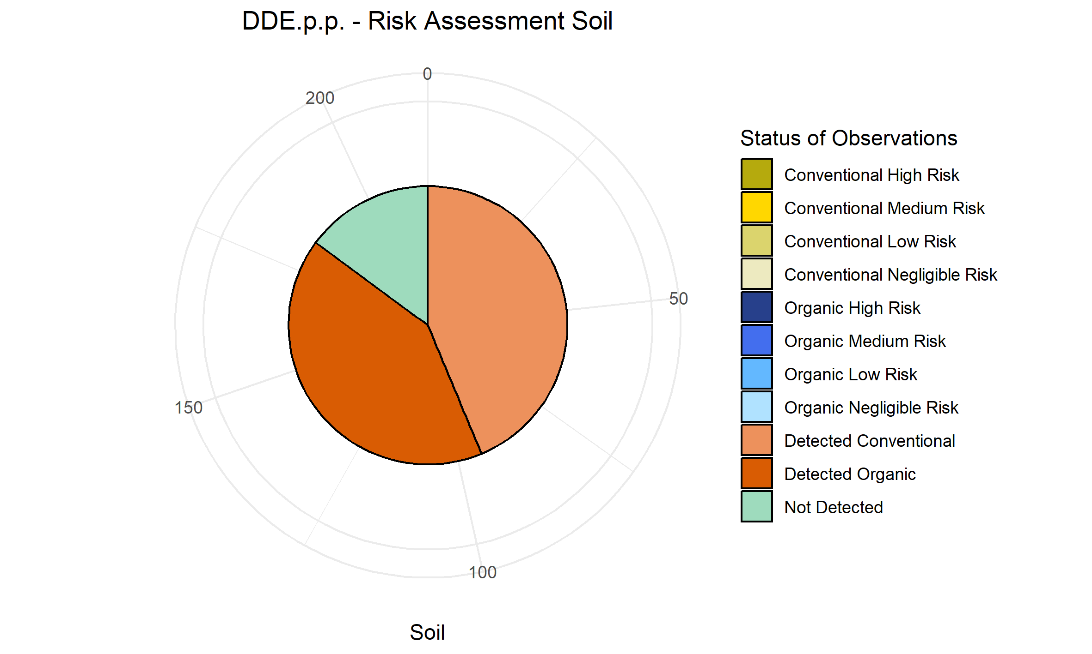
AMPA | 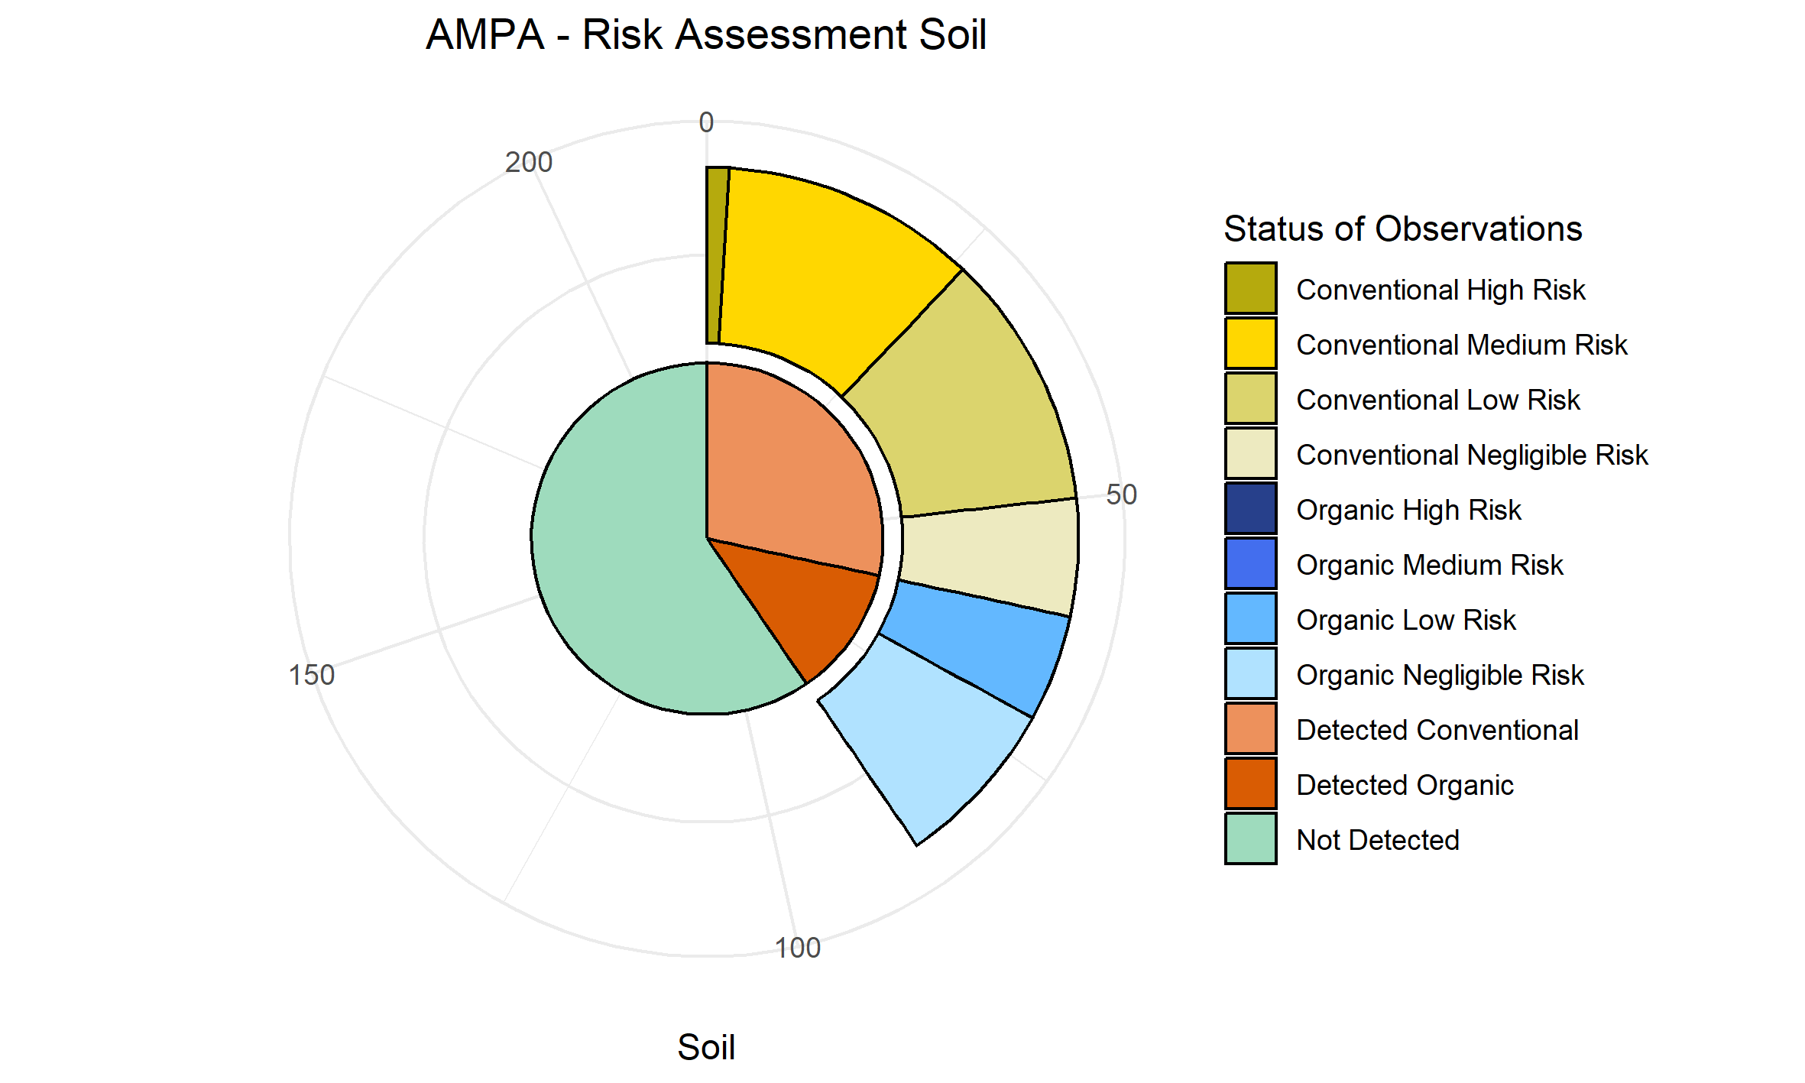
Hexachlorobenzene* | 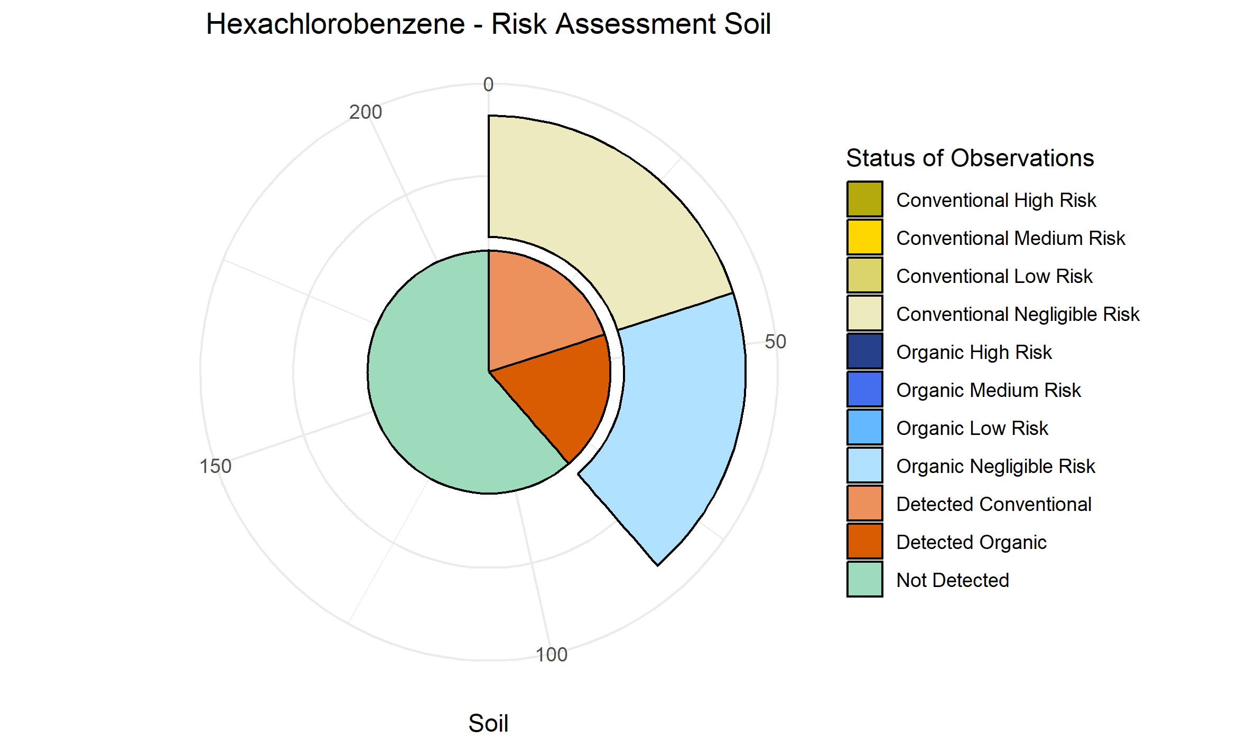
Chlorpyrifos* | 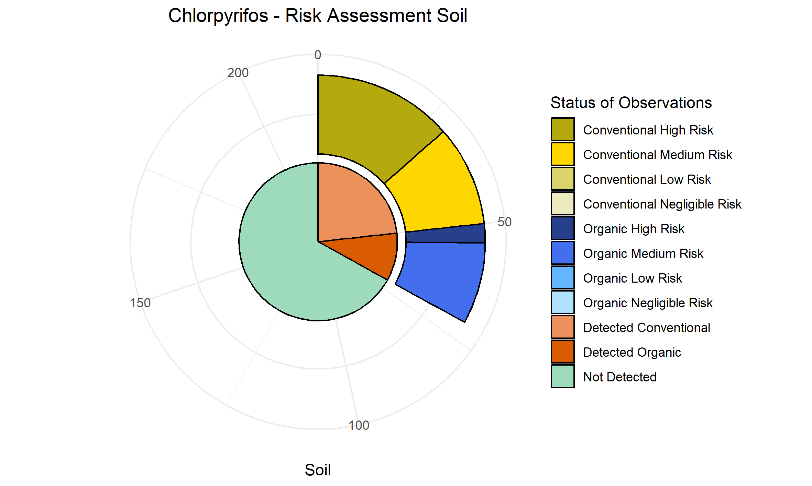
Glyphosate | 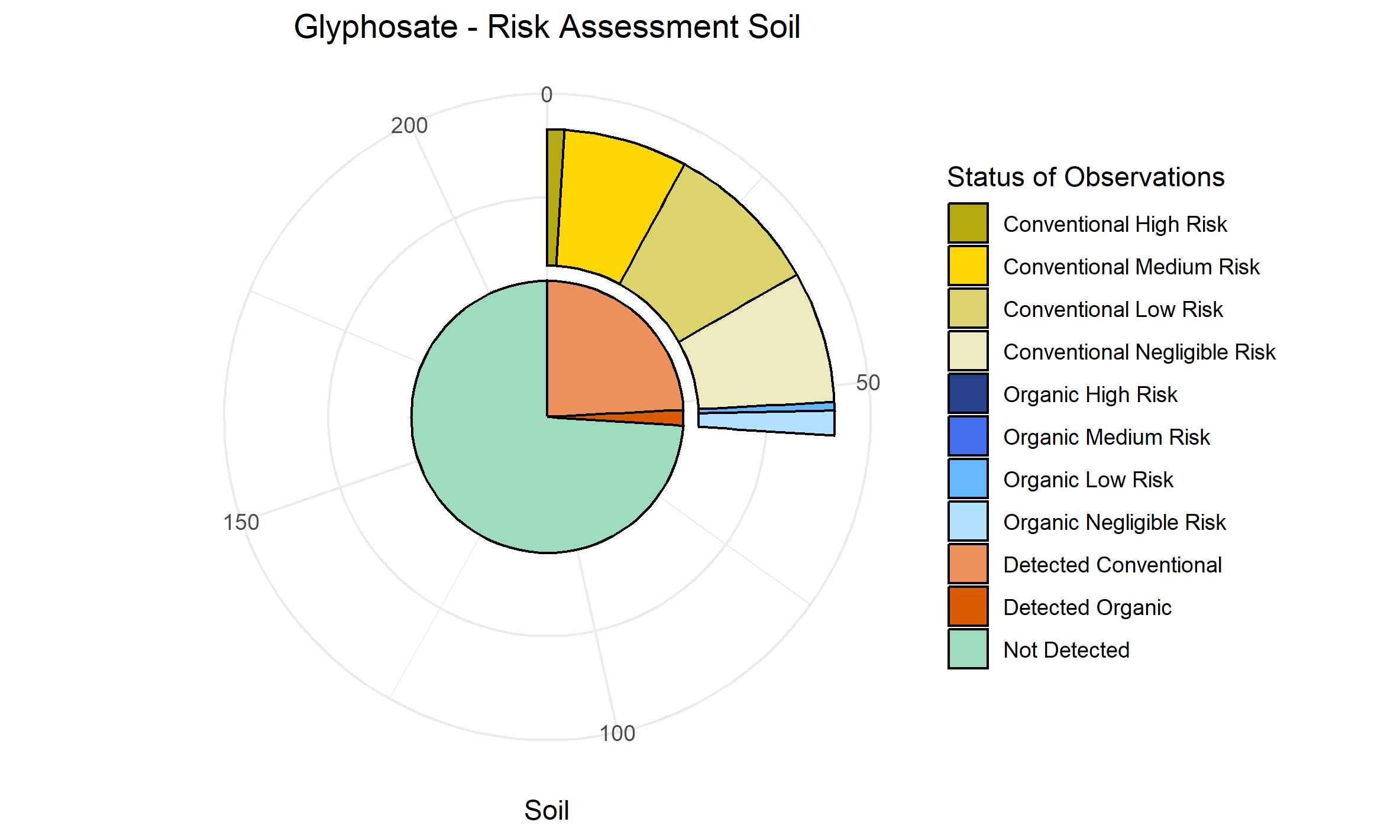
DDT.p.p. | 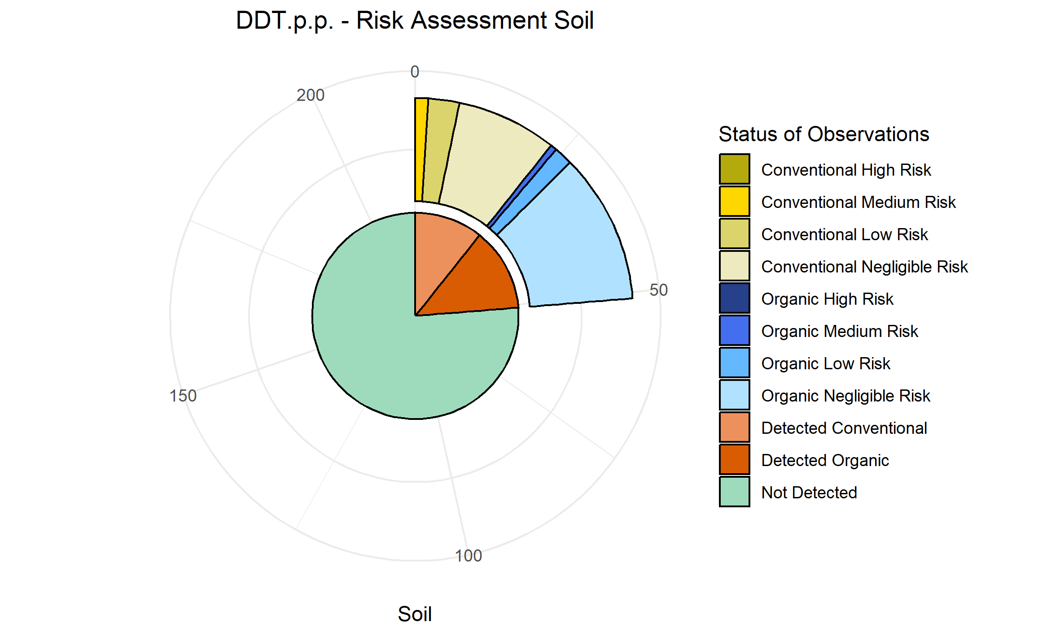
Boscalid | 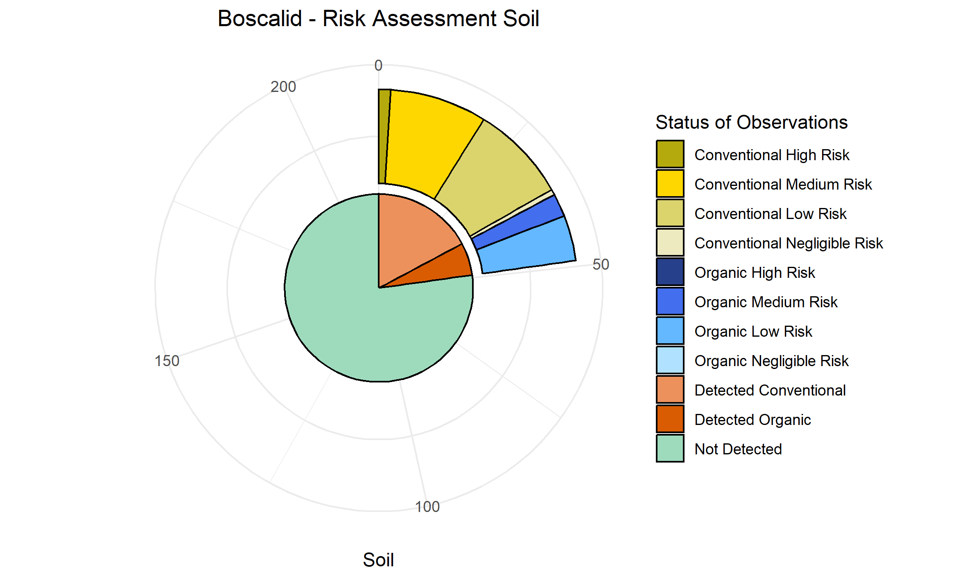
DDT.o.p. | 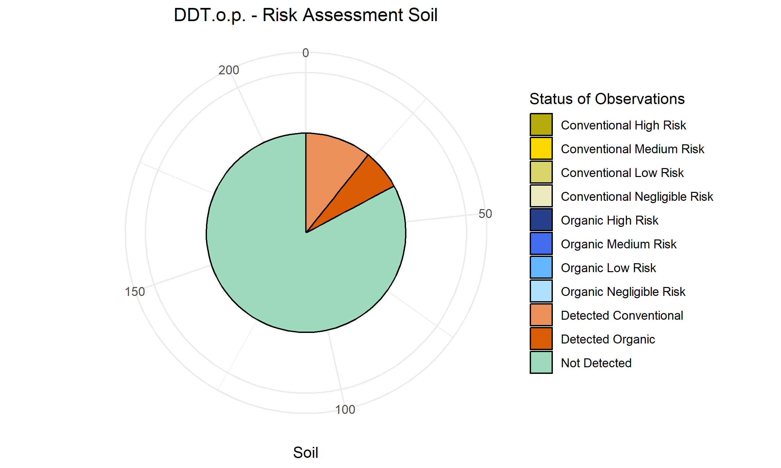
Azoxystrobin | 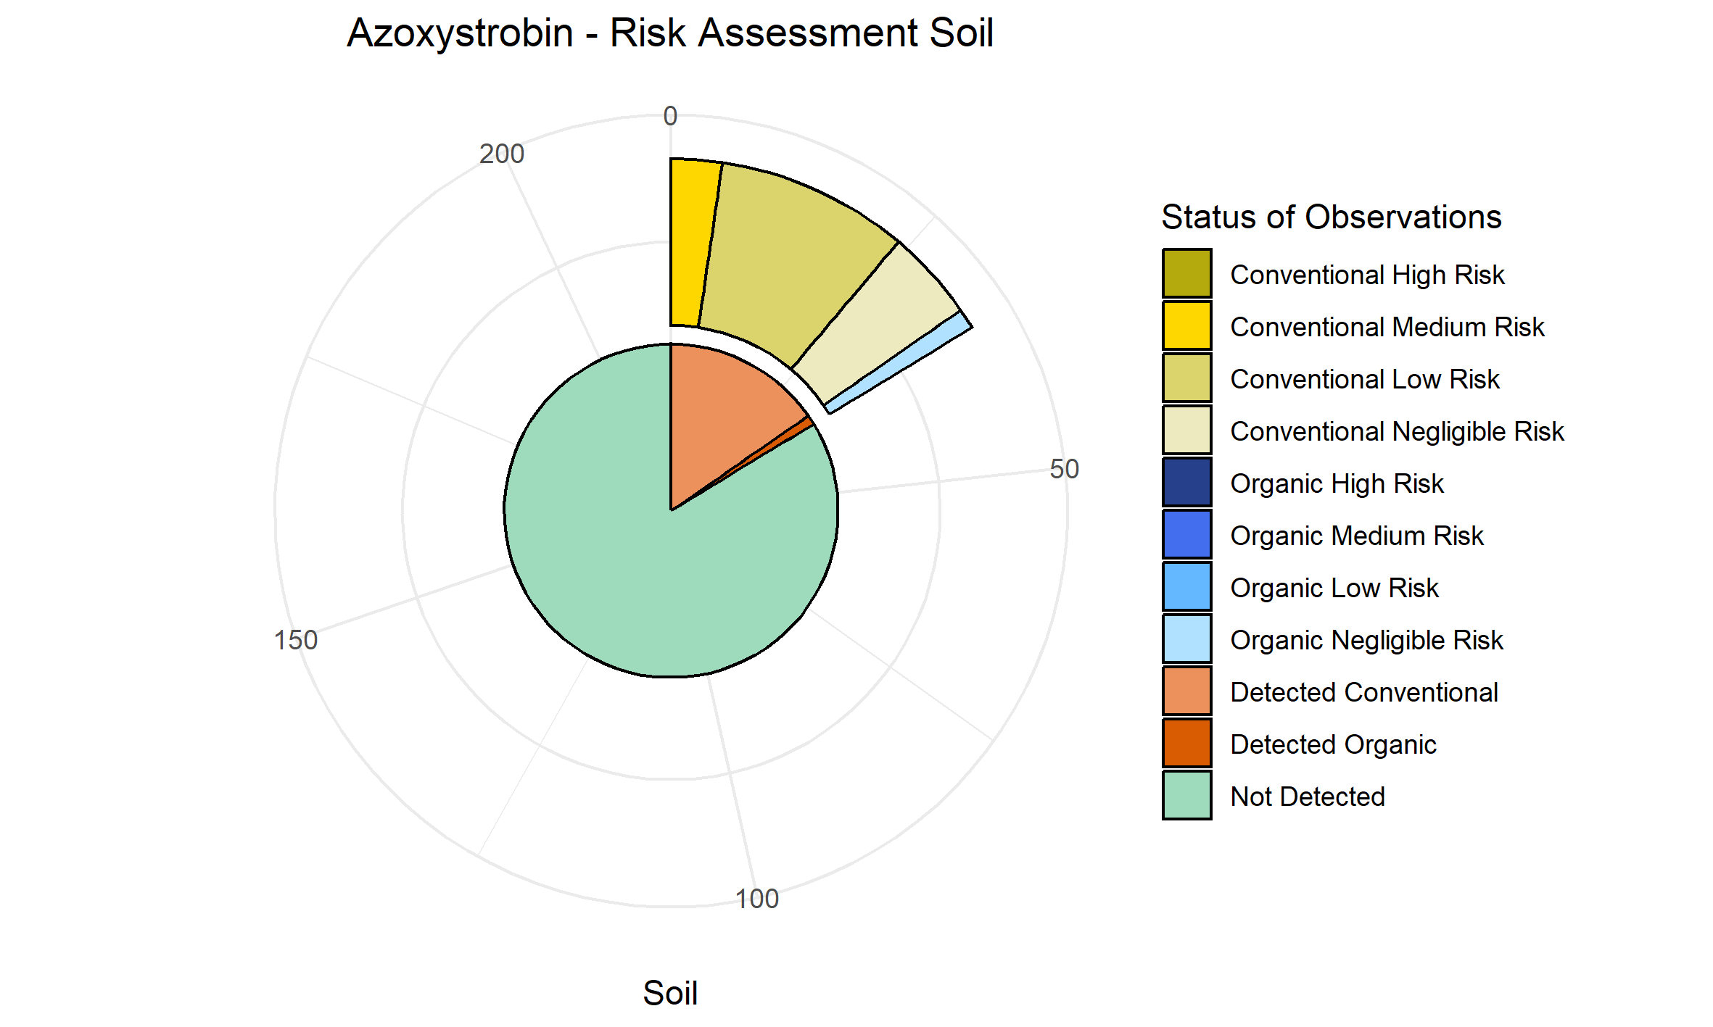
DDD.p.p. | 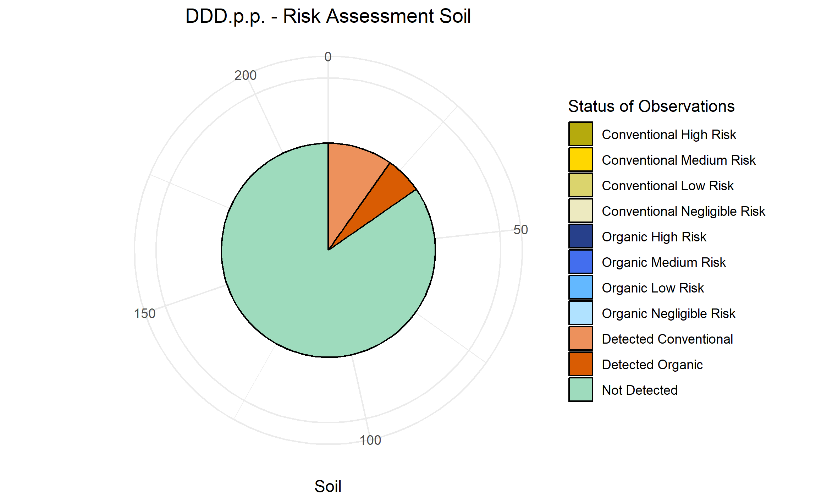
Tebuconazole | 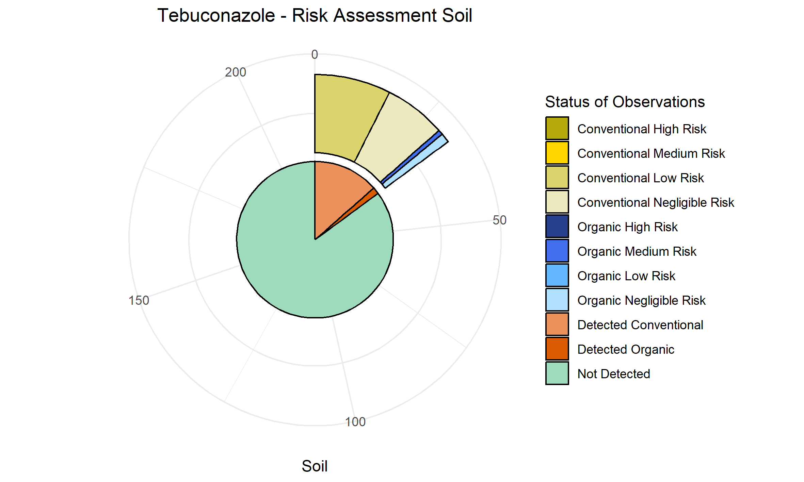
Difenoconazole | 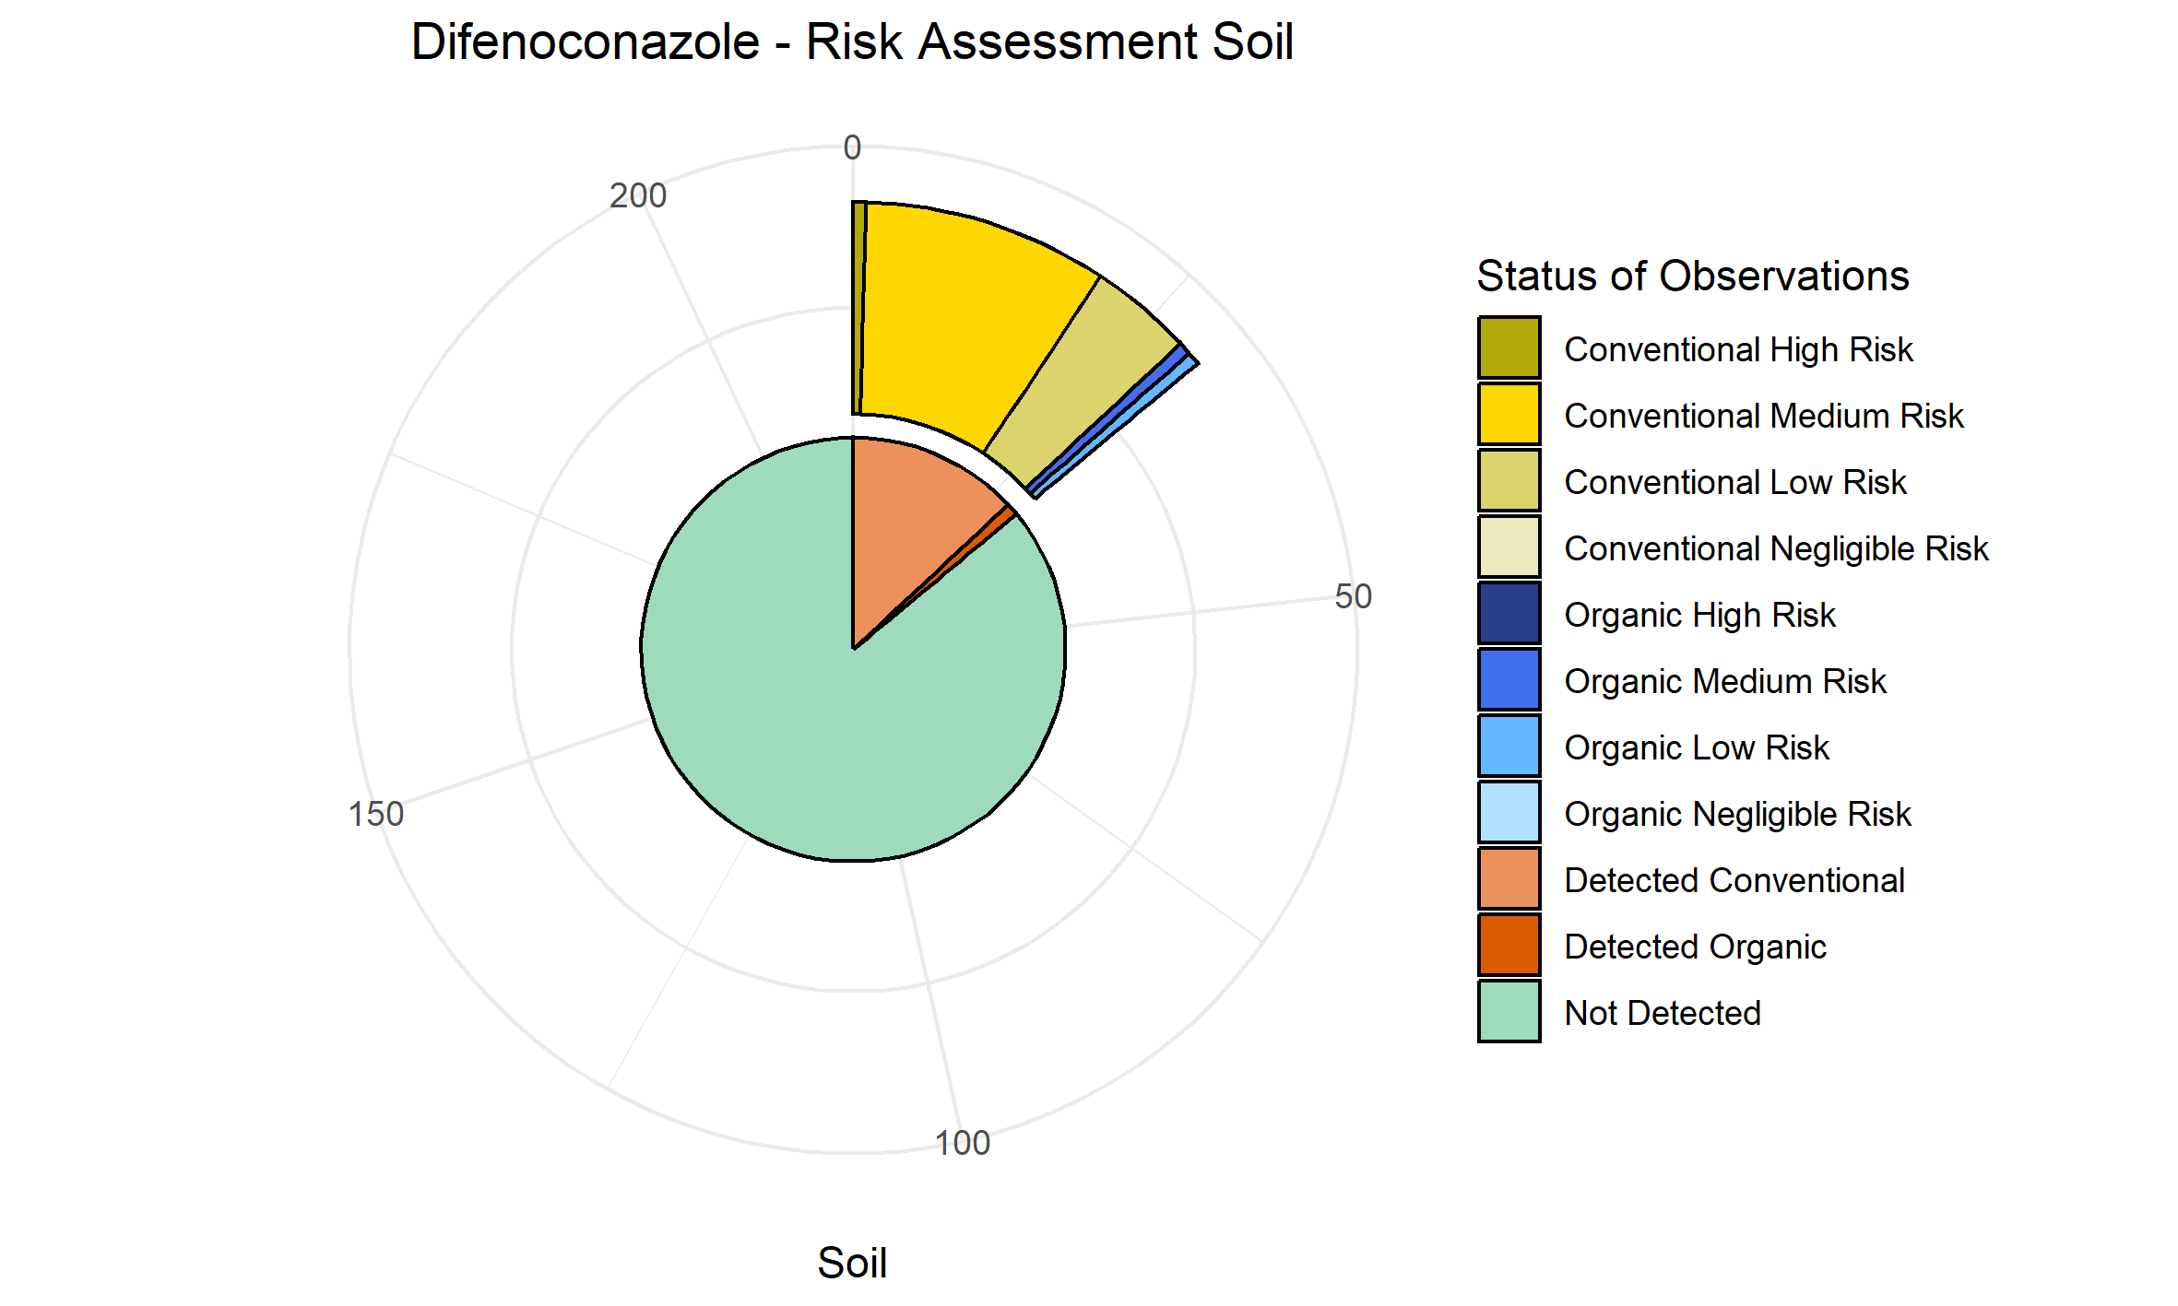
lambda.Cyhalothrin | 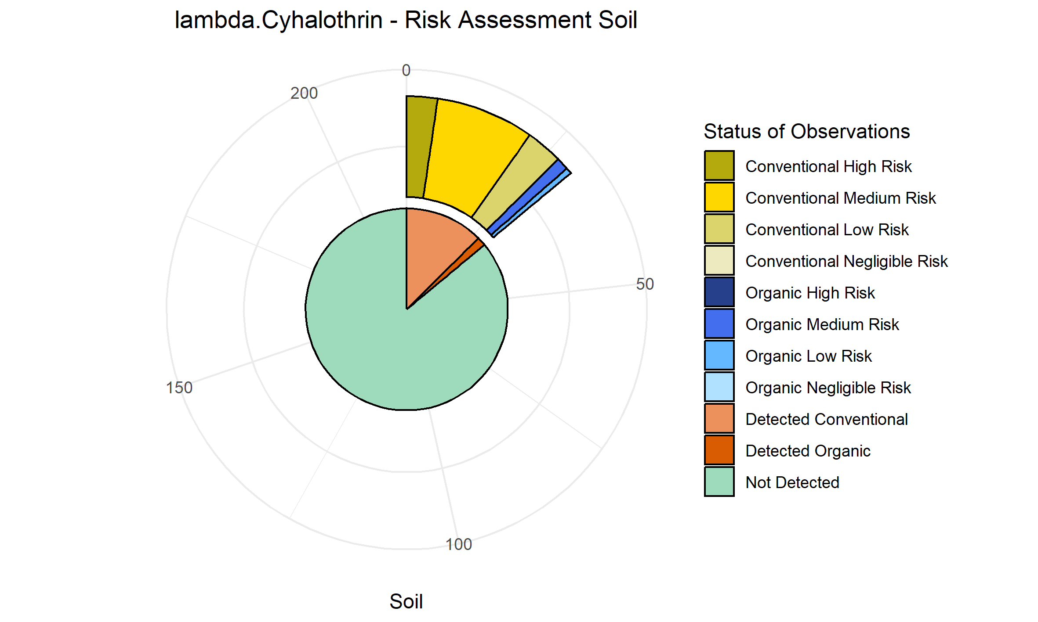
Metalaxyl..M. | 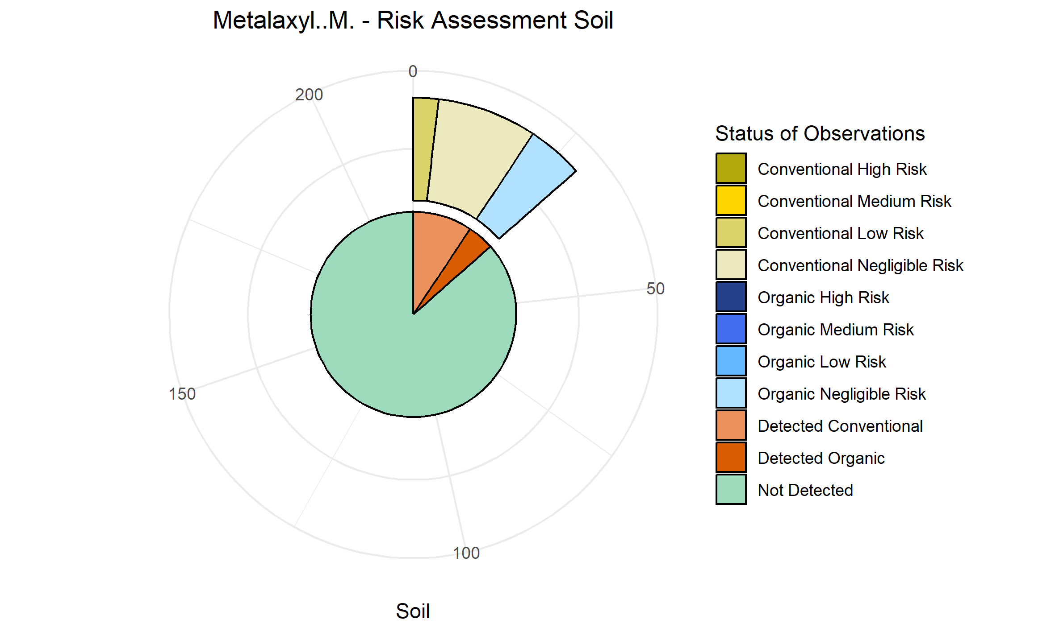
Fluopyram | 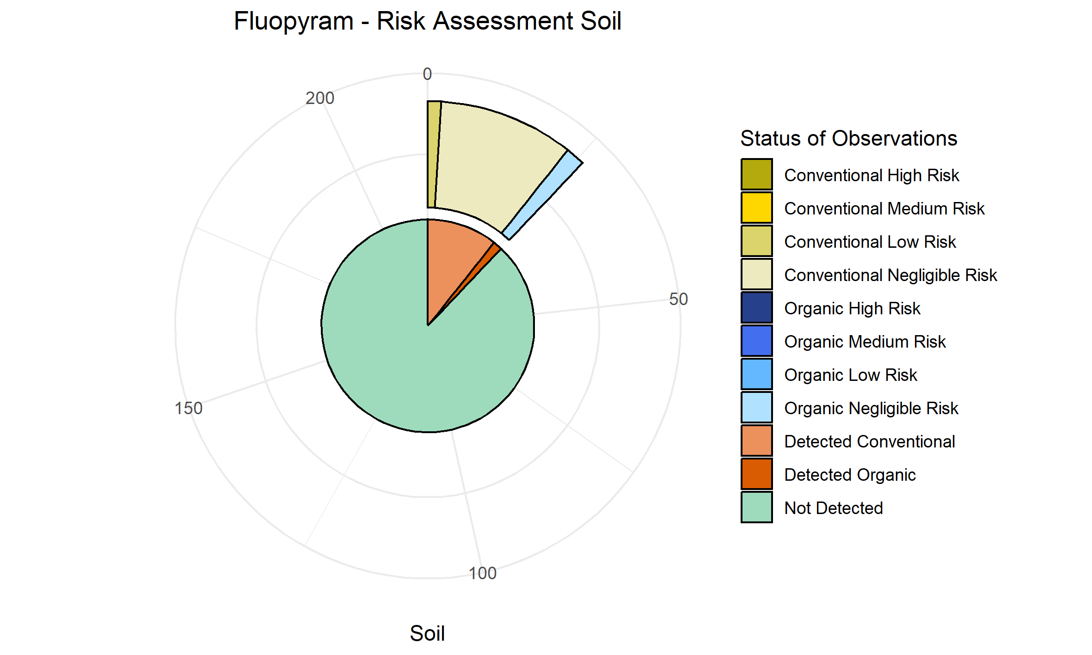
Epoxiconazole | 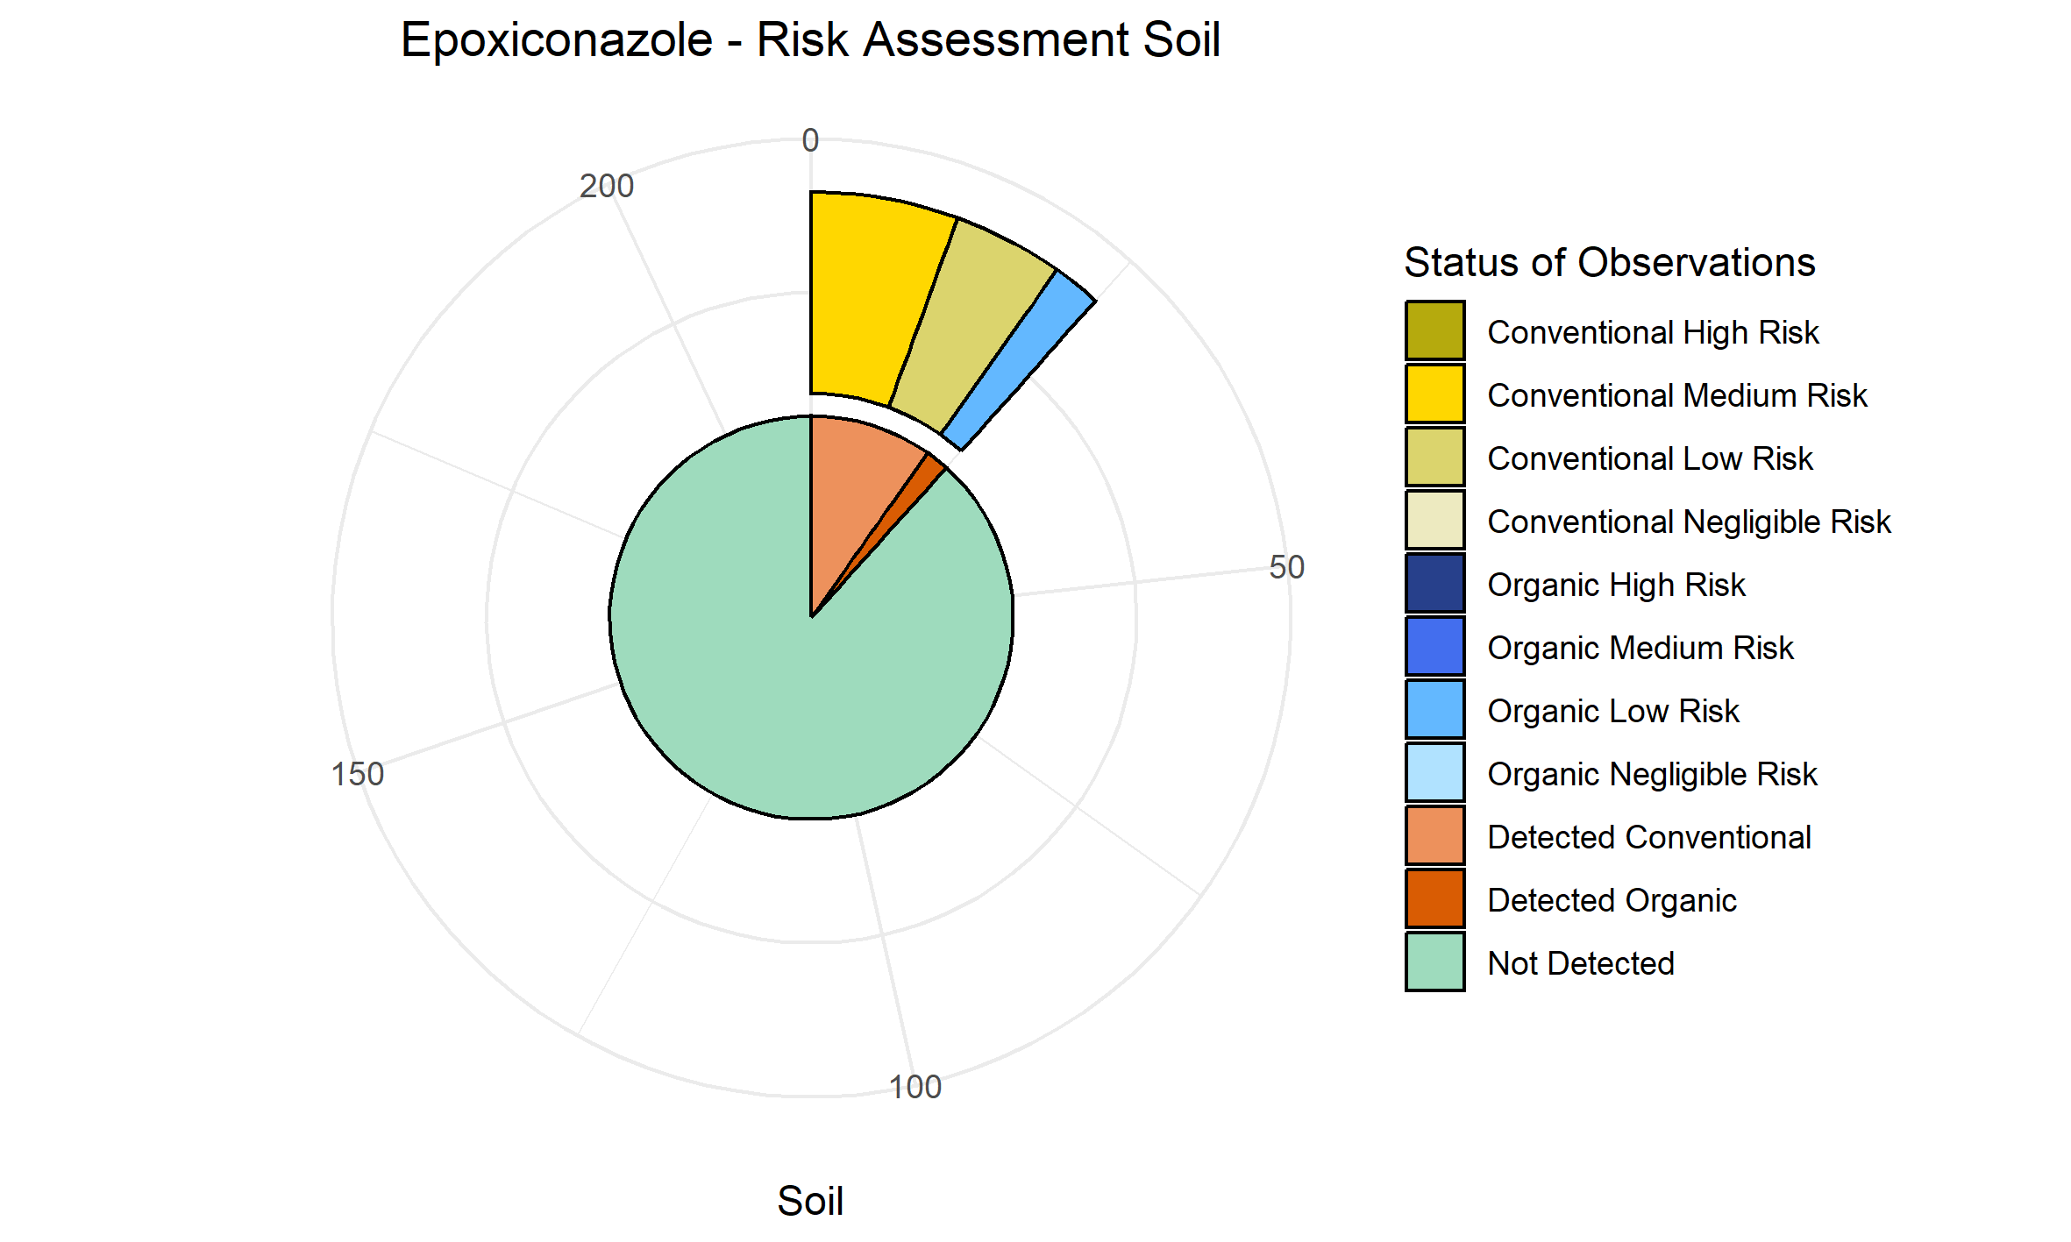
Diflufenican | 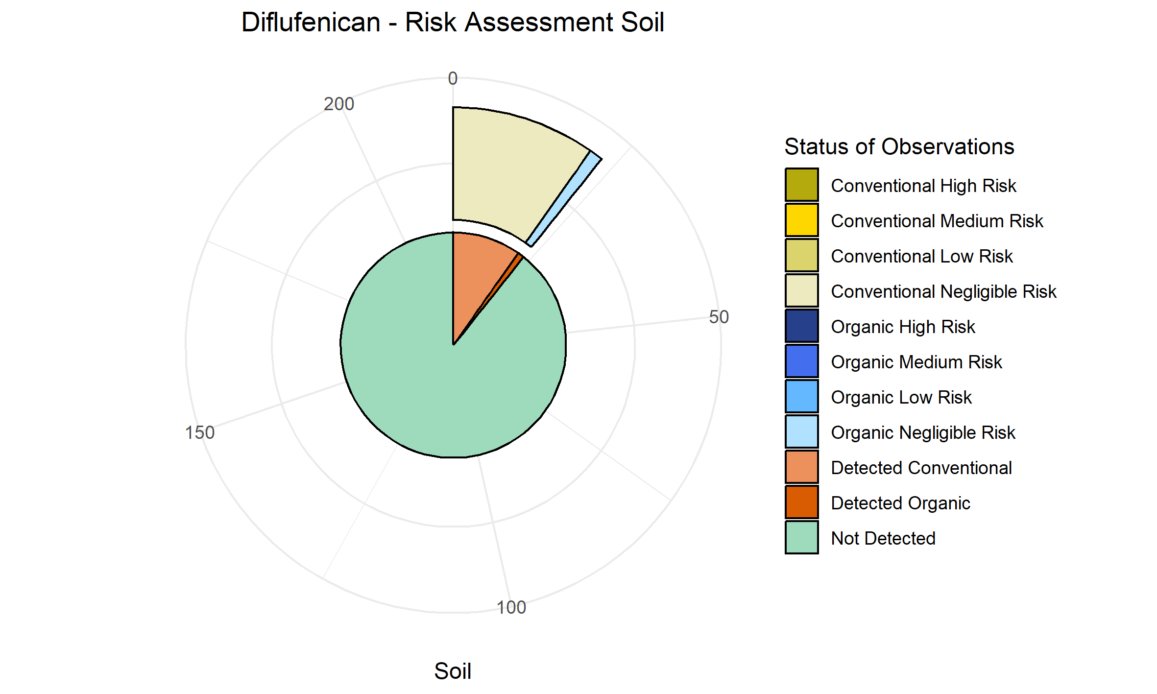
Fluopicolide | 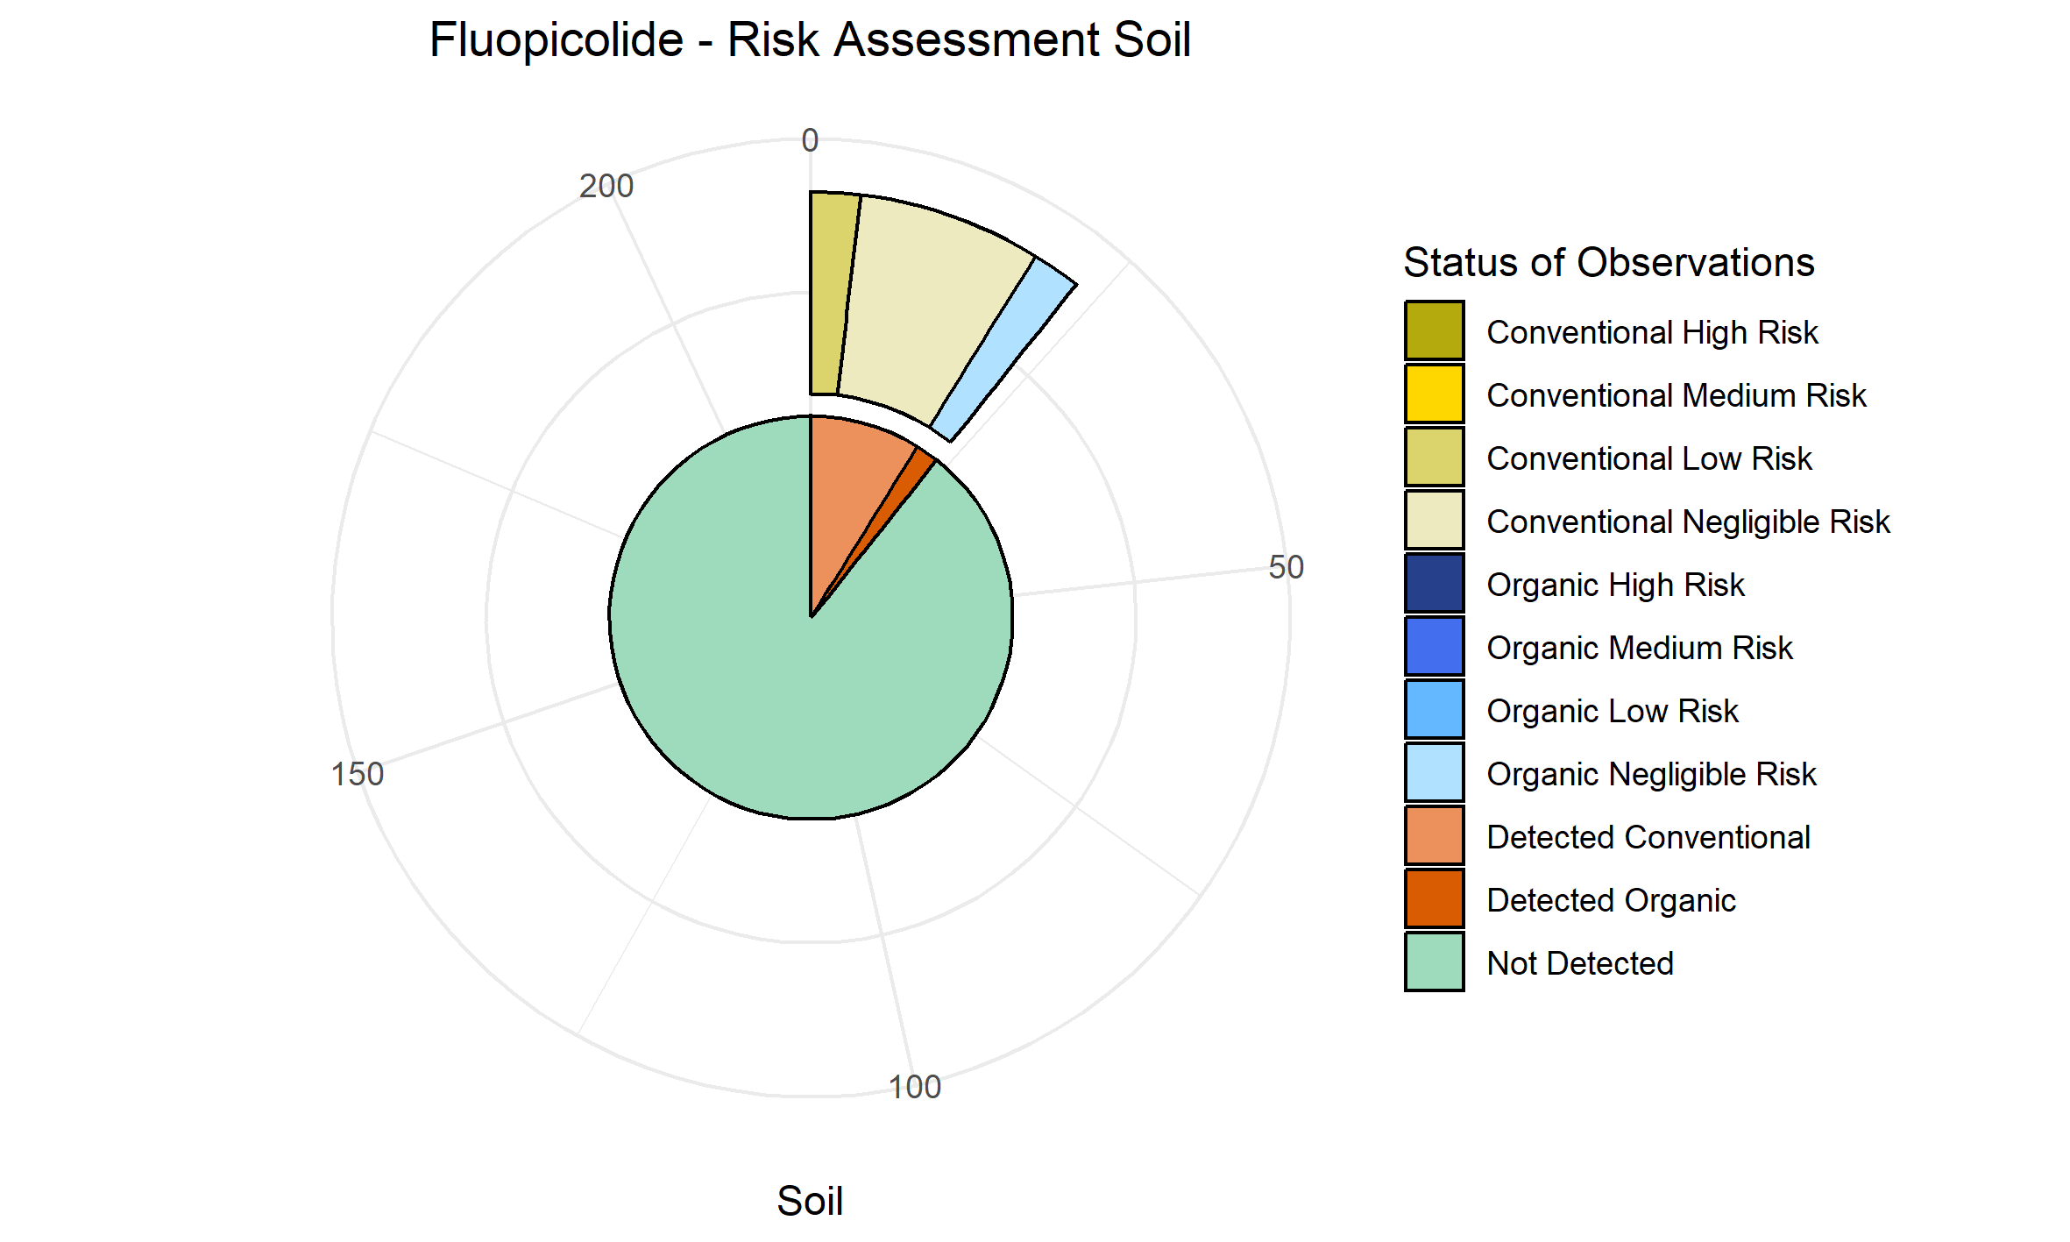
Metolachlor.oxanilic.acid | 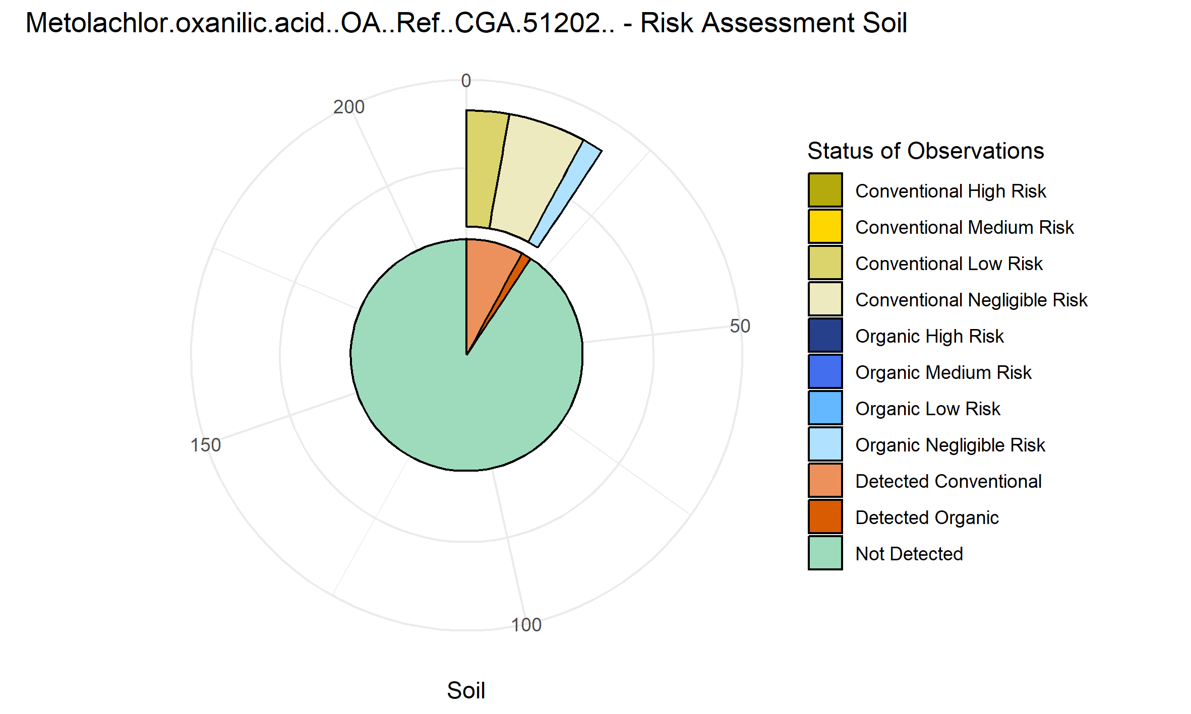
Dimethomorph | 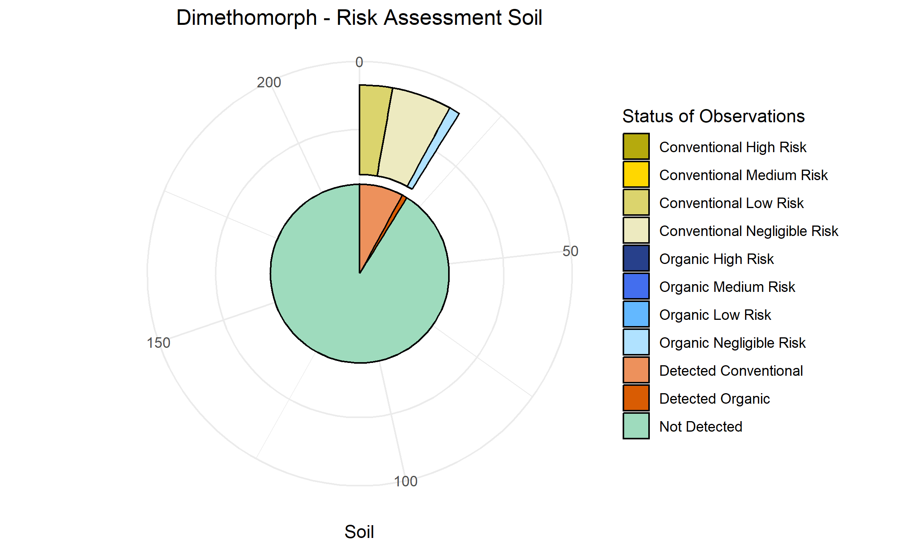

MRL values calculated for crops
Dimethomorph | 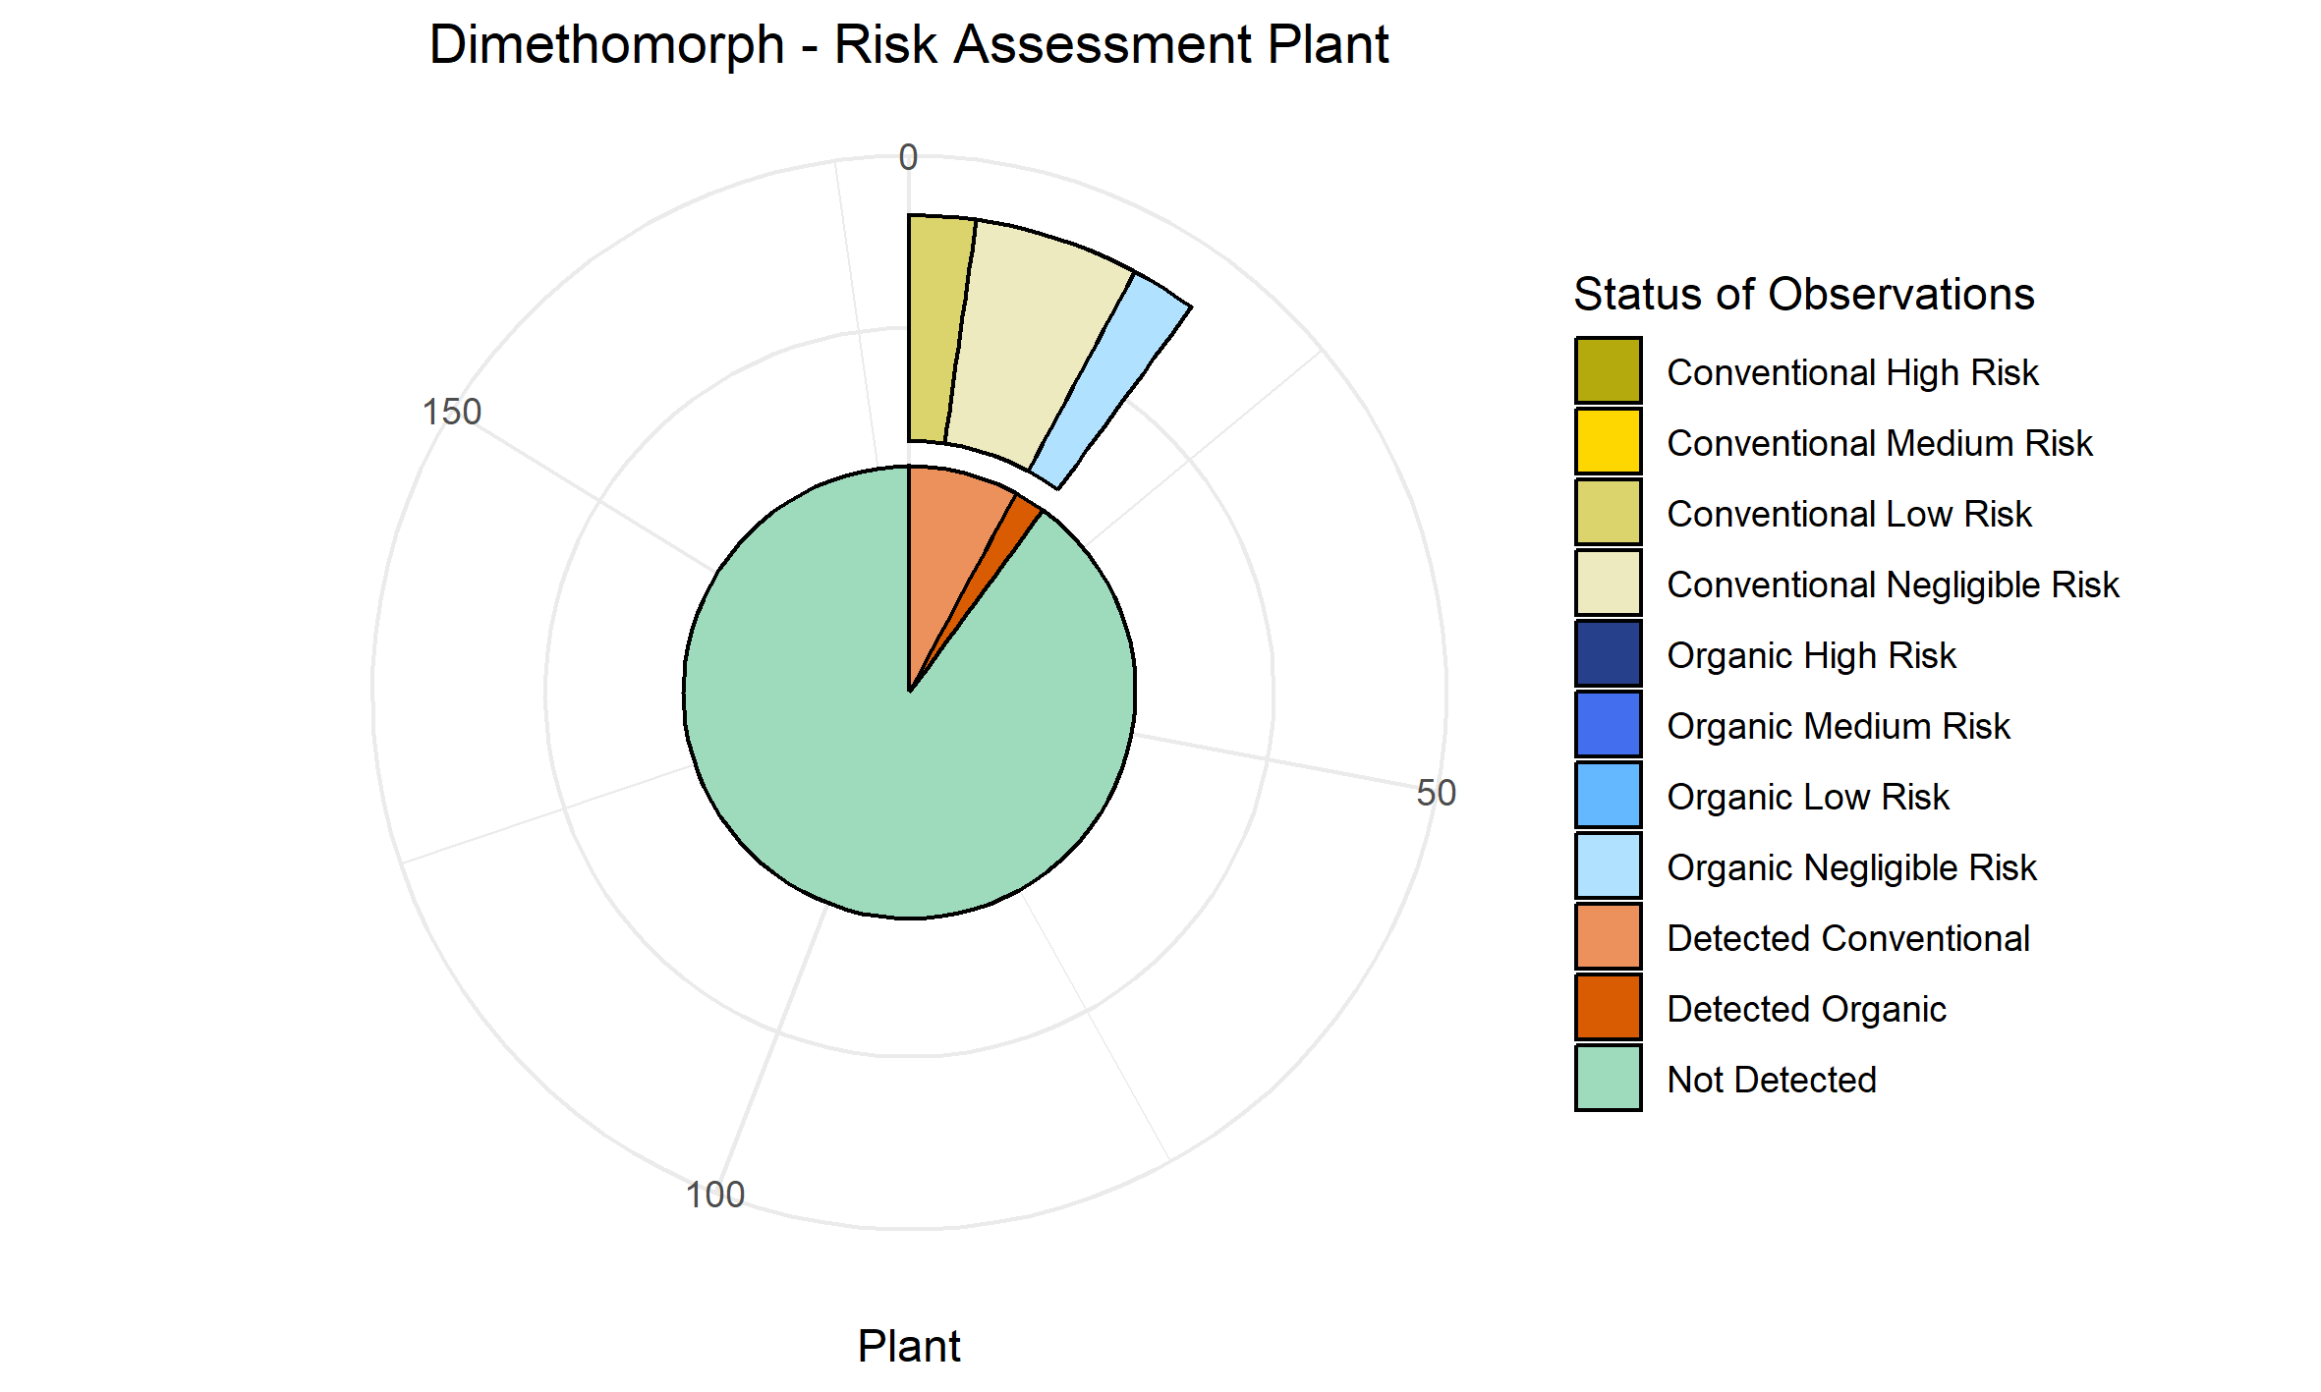
Metalaxyl..M. | 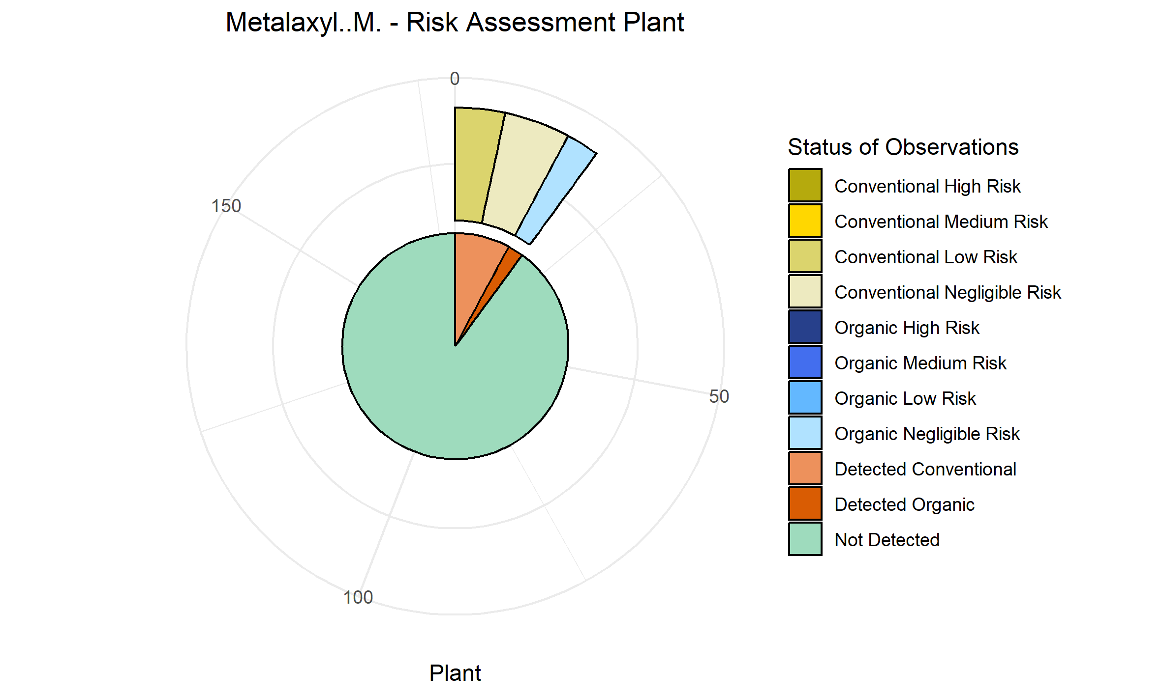
Azoxystrobin | 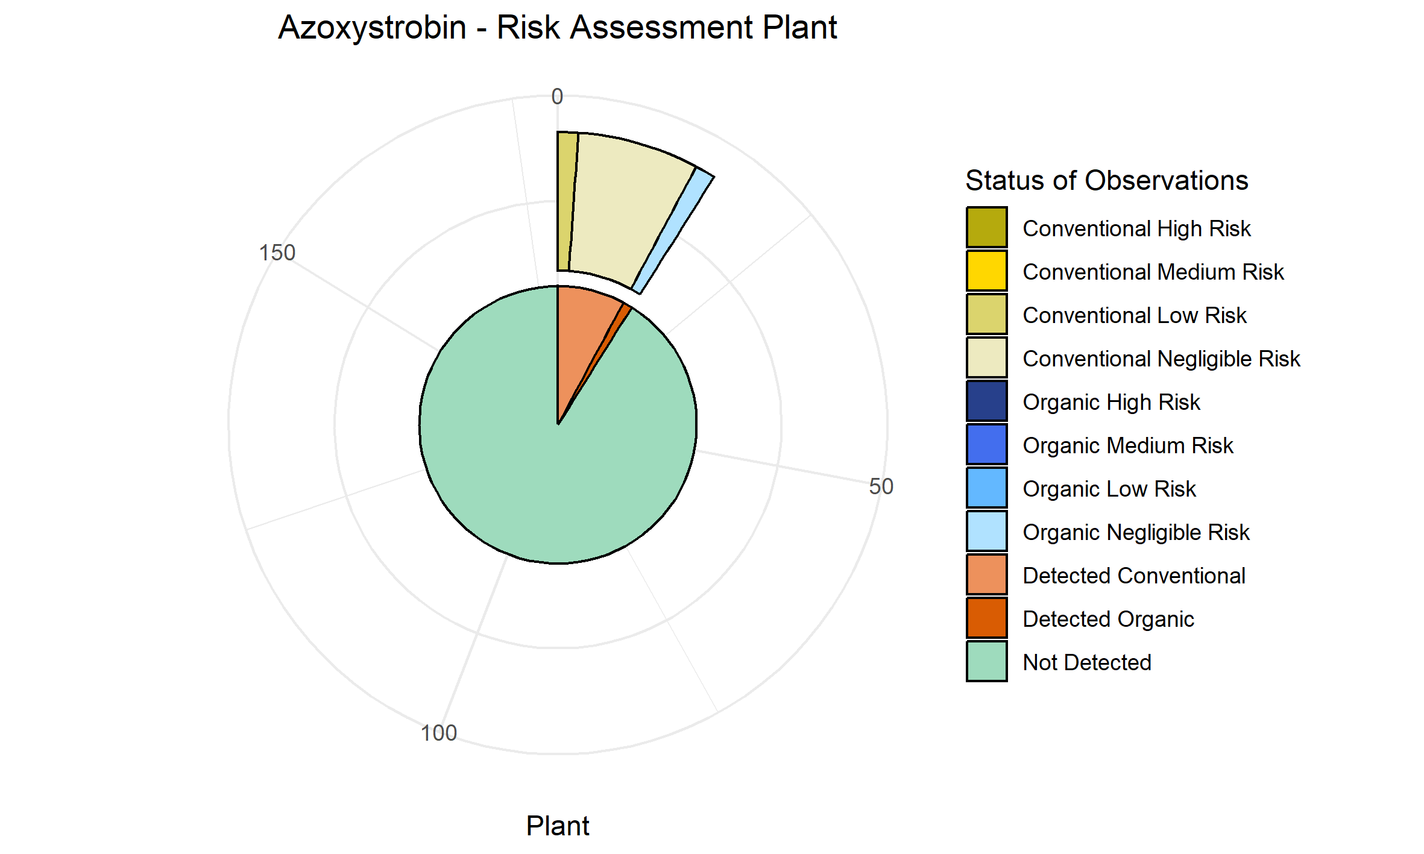
Tebuconazole | 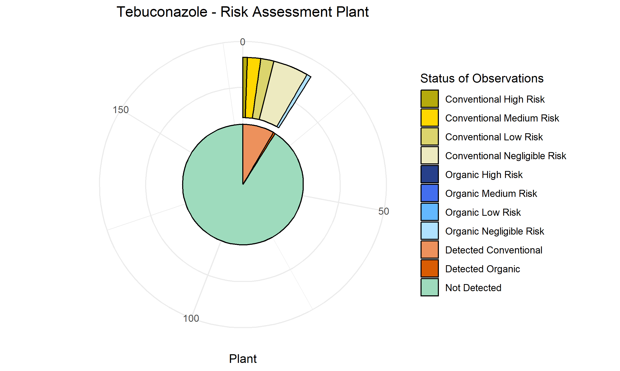
Deltamethrin | 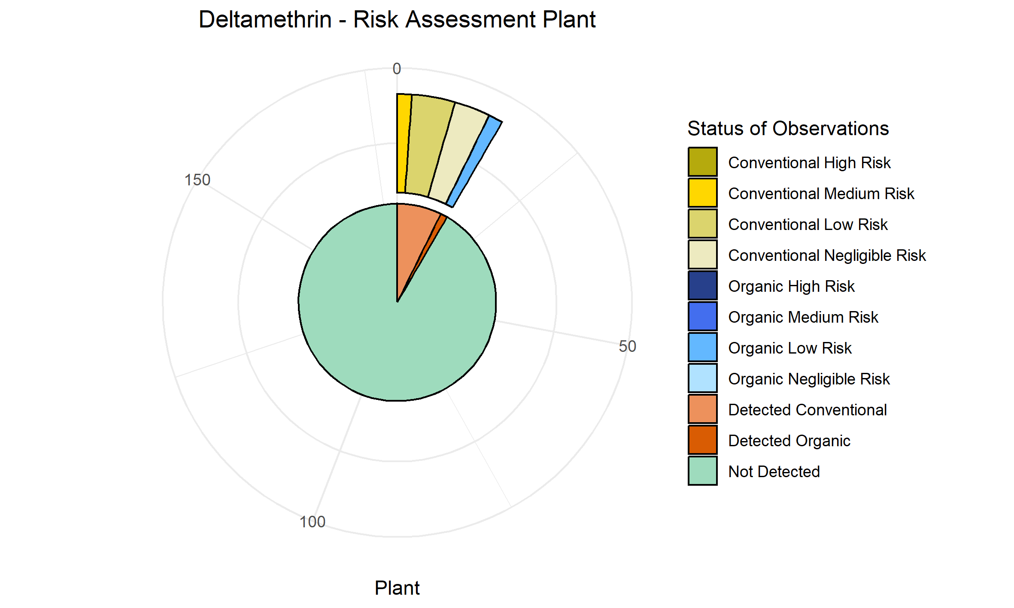
Dieldrin | 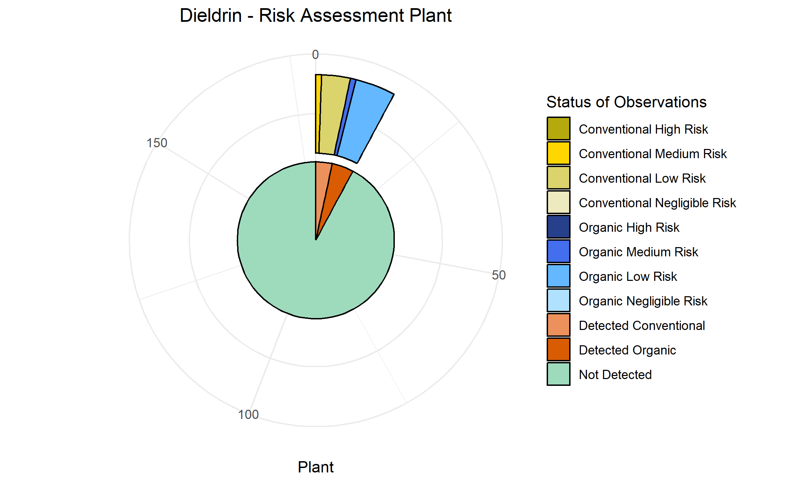
Difenoconazole | 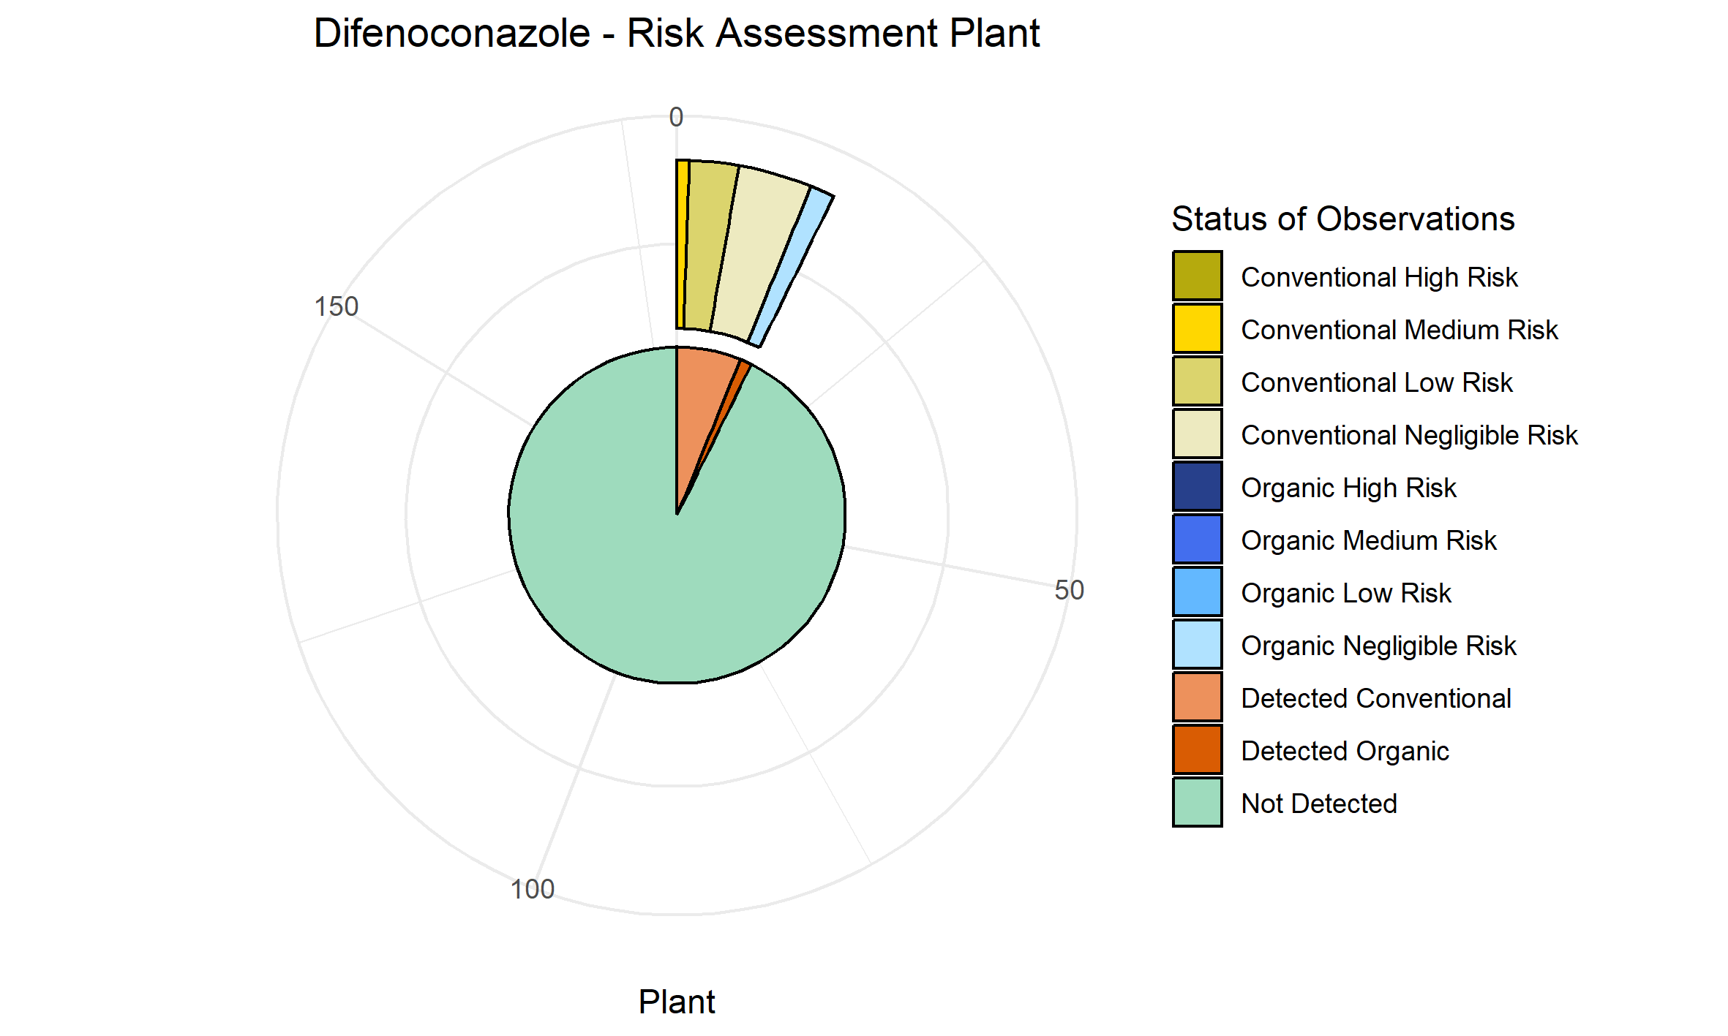
Fluopyram | 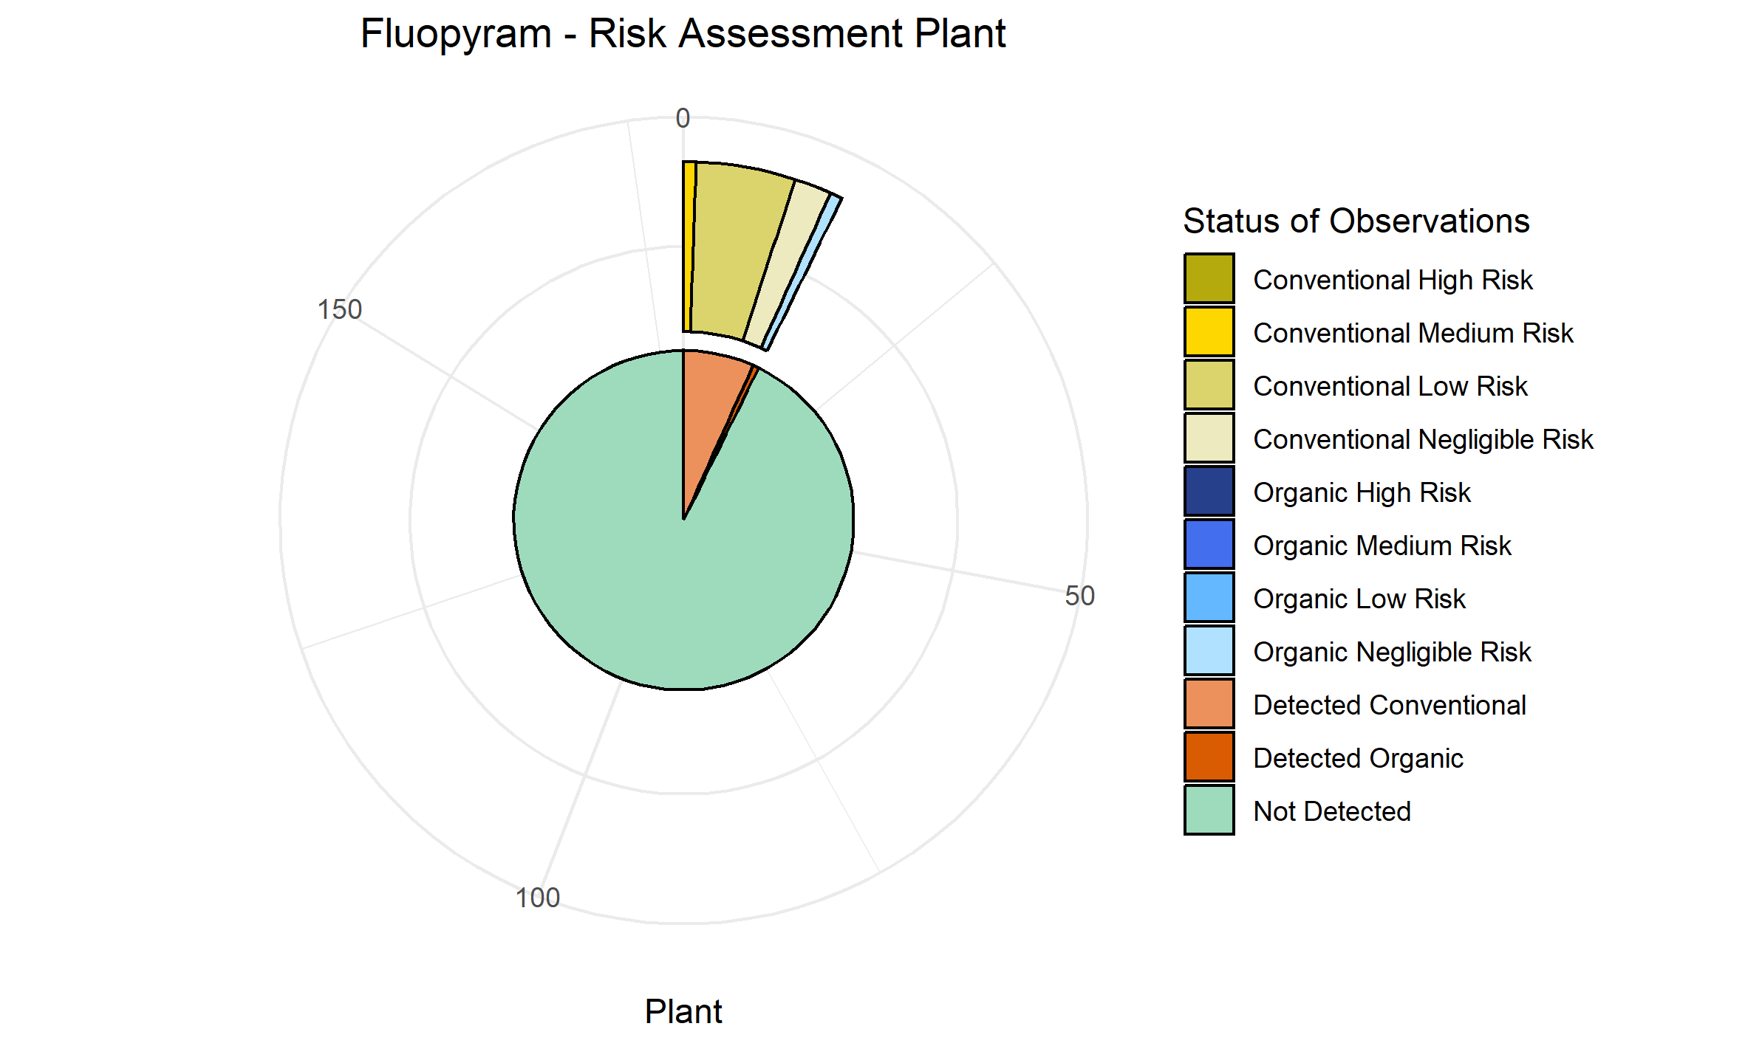
Lambda Cyhalothrin | 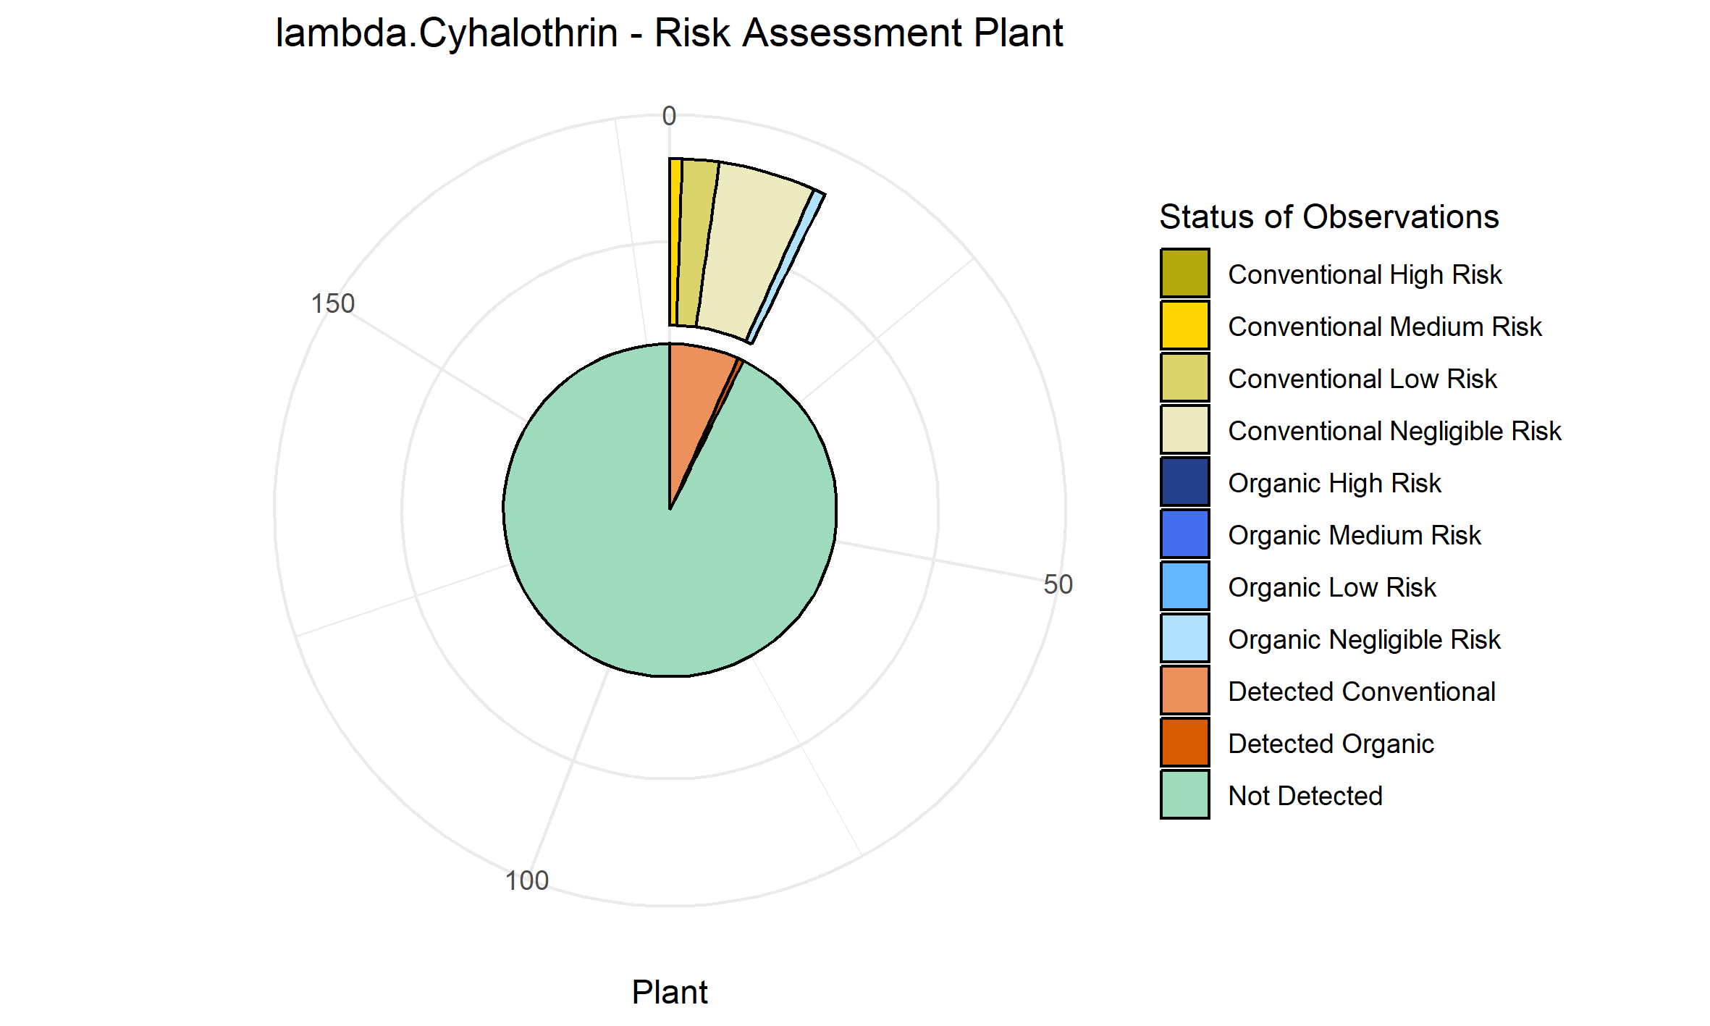
Acetamiprid | 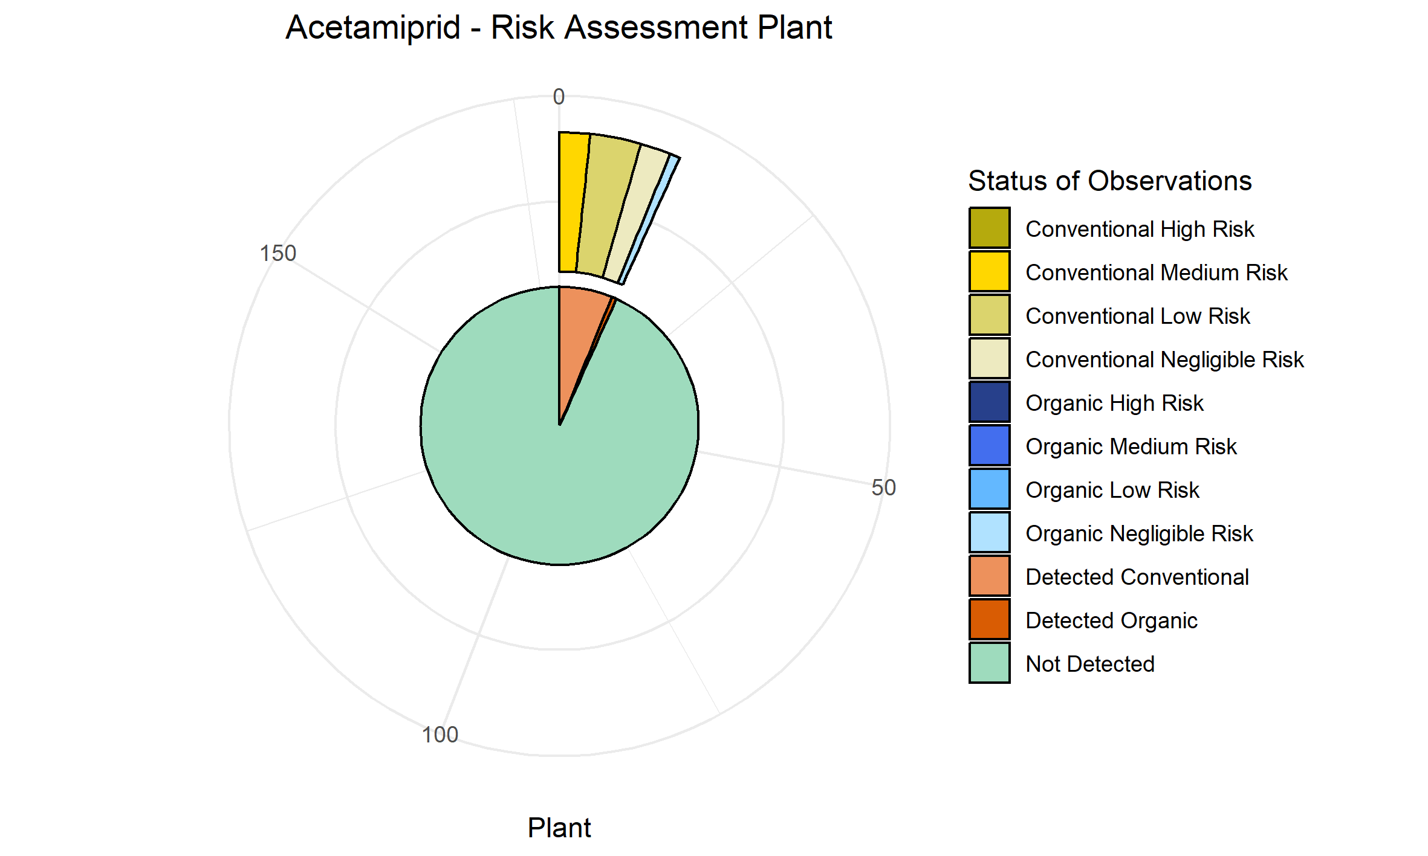
Fluopicolide | 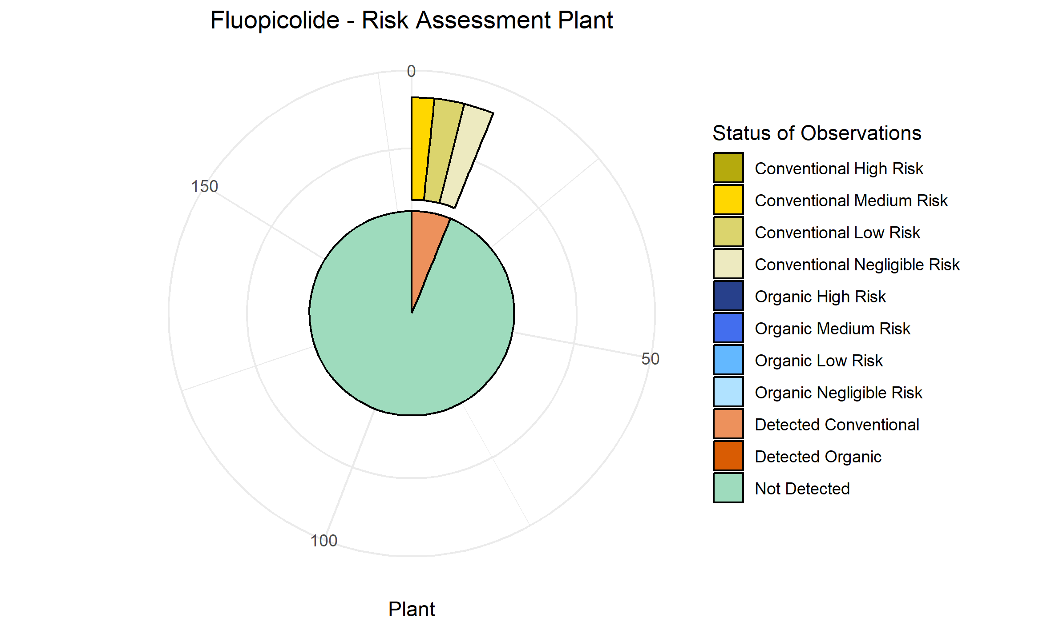
Mandipropamid | 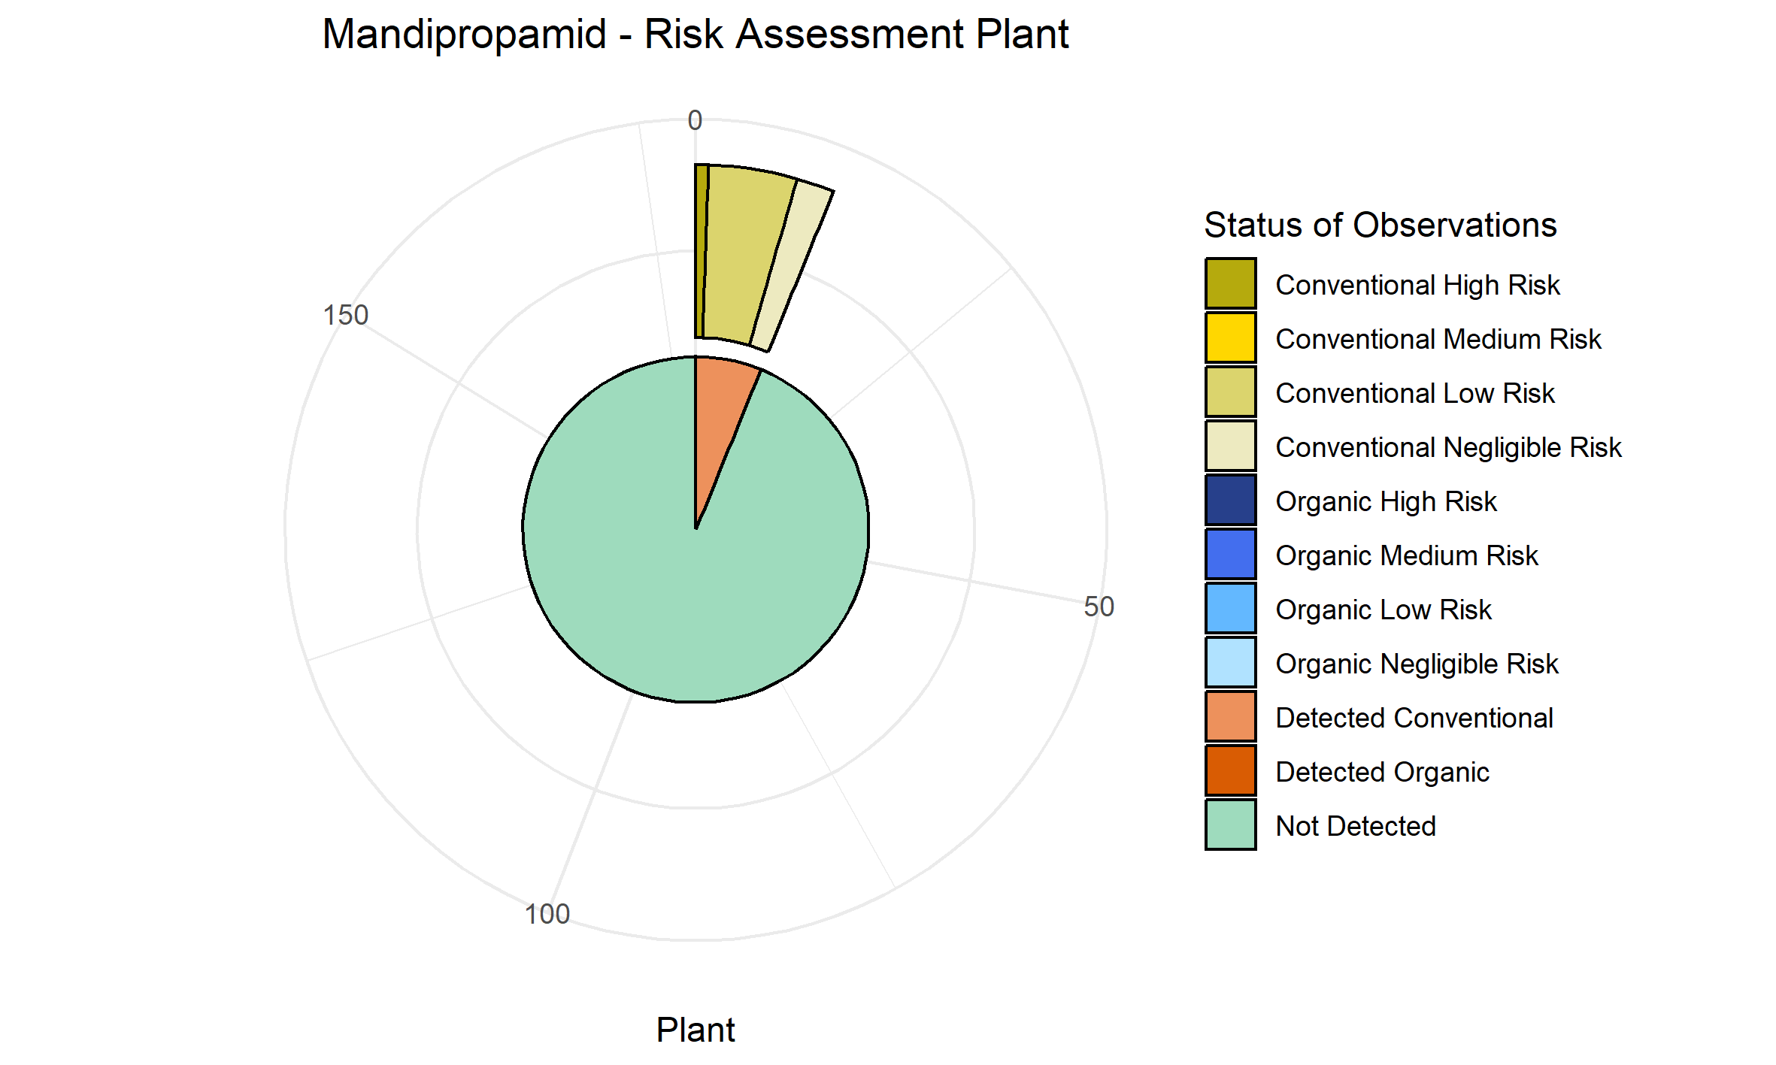
Boscalid | 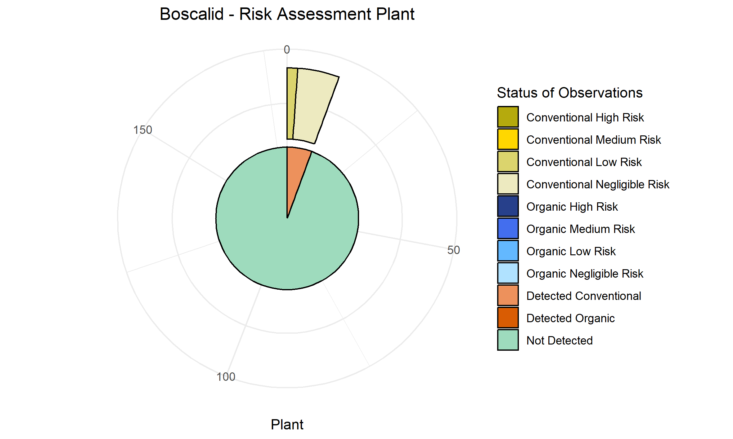
Cypermethrin | 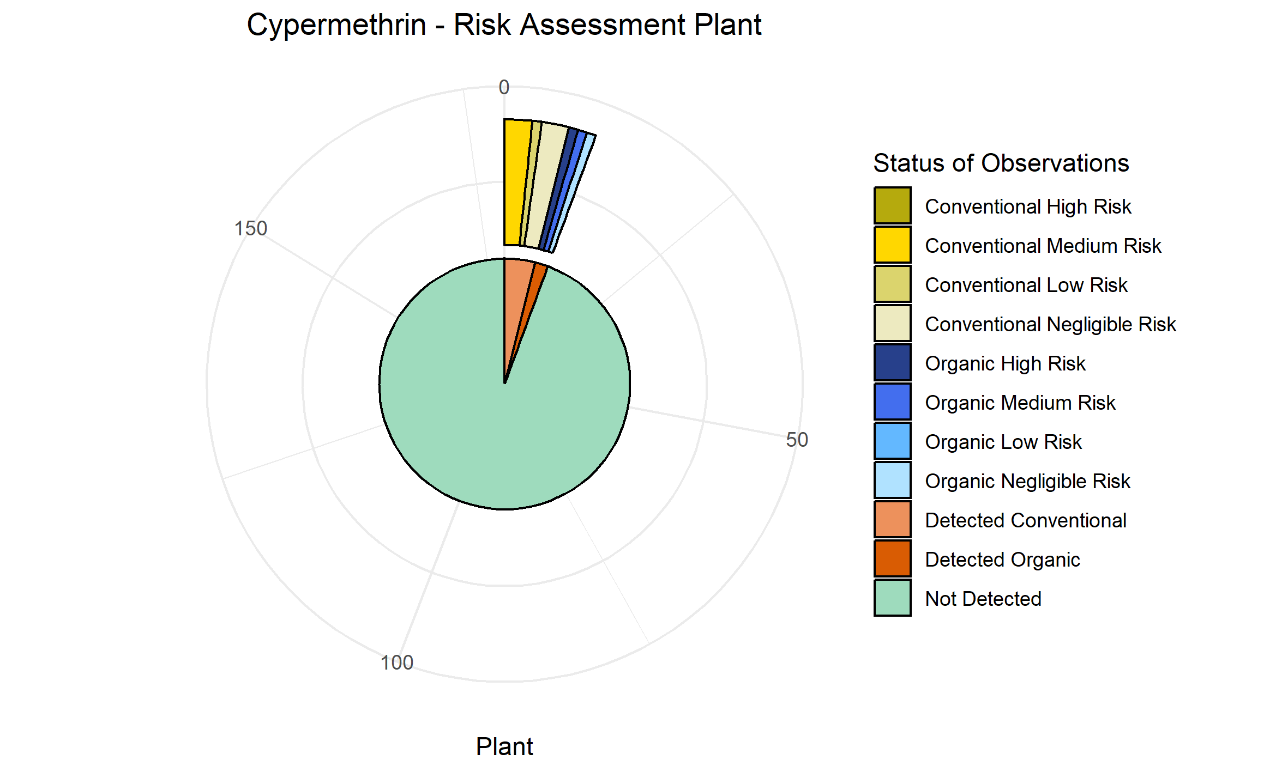
Chlorpyrifos | 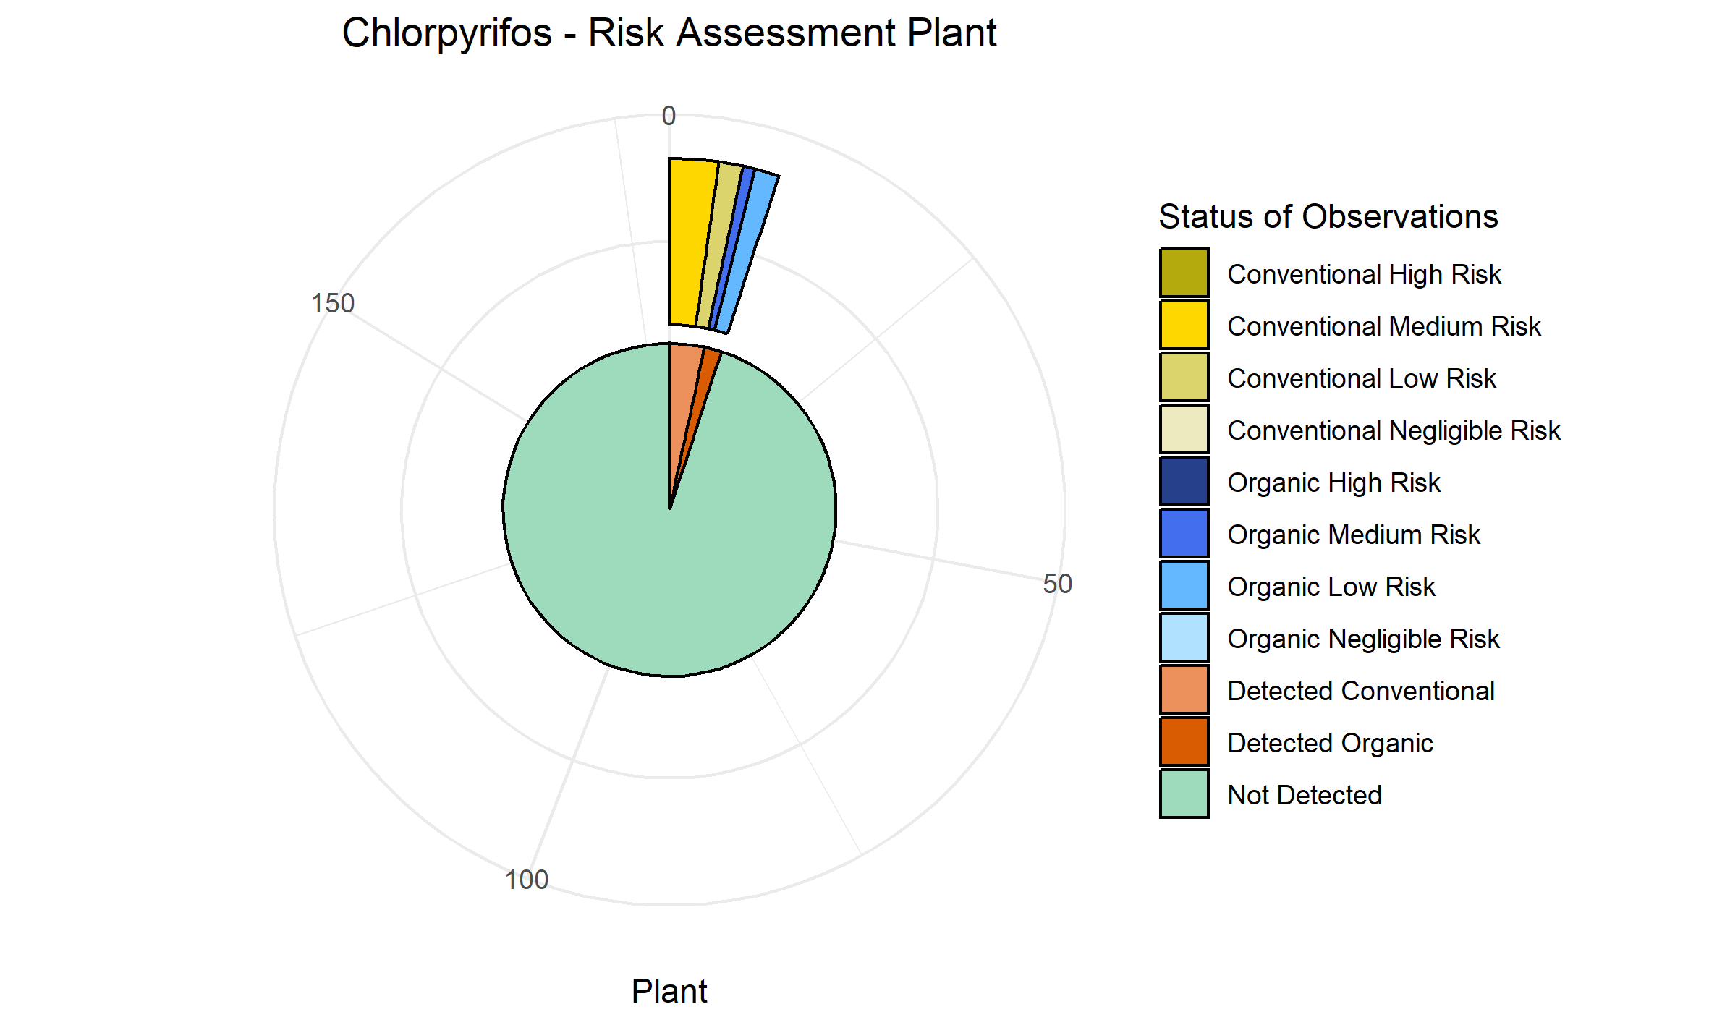
Permethrin | 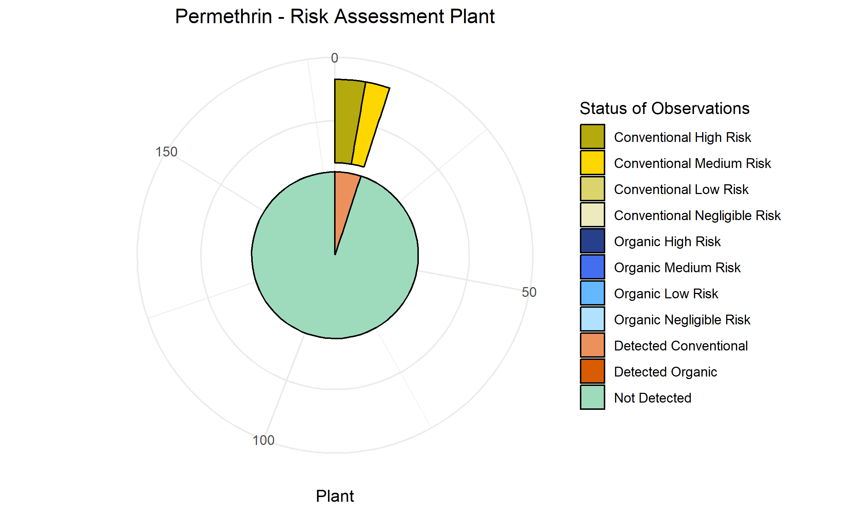
Zoxamid | 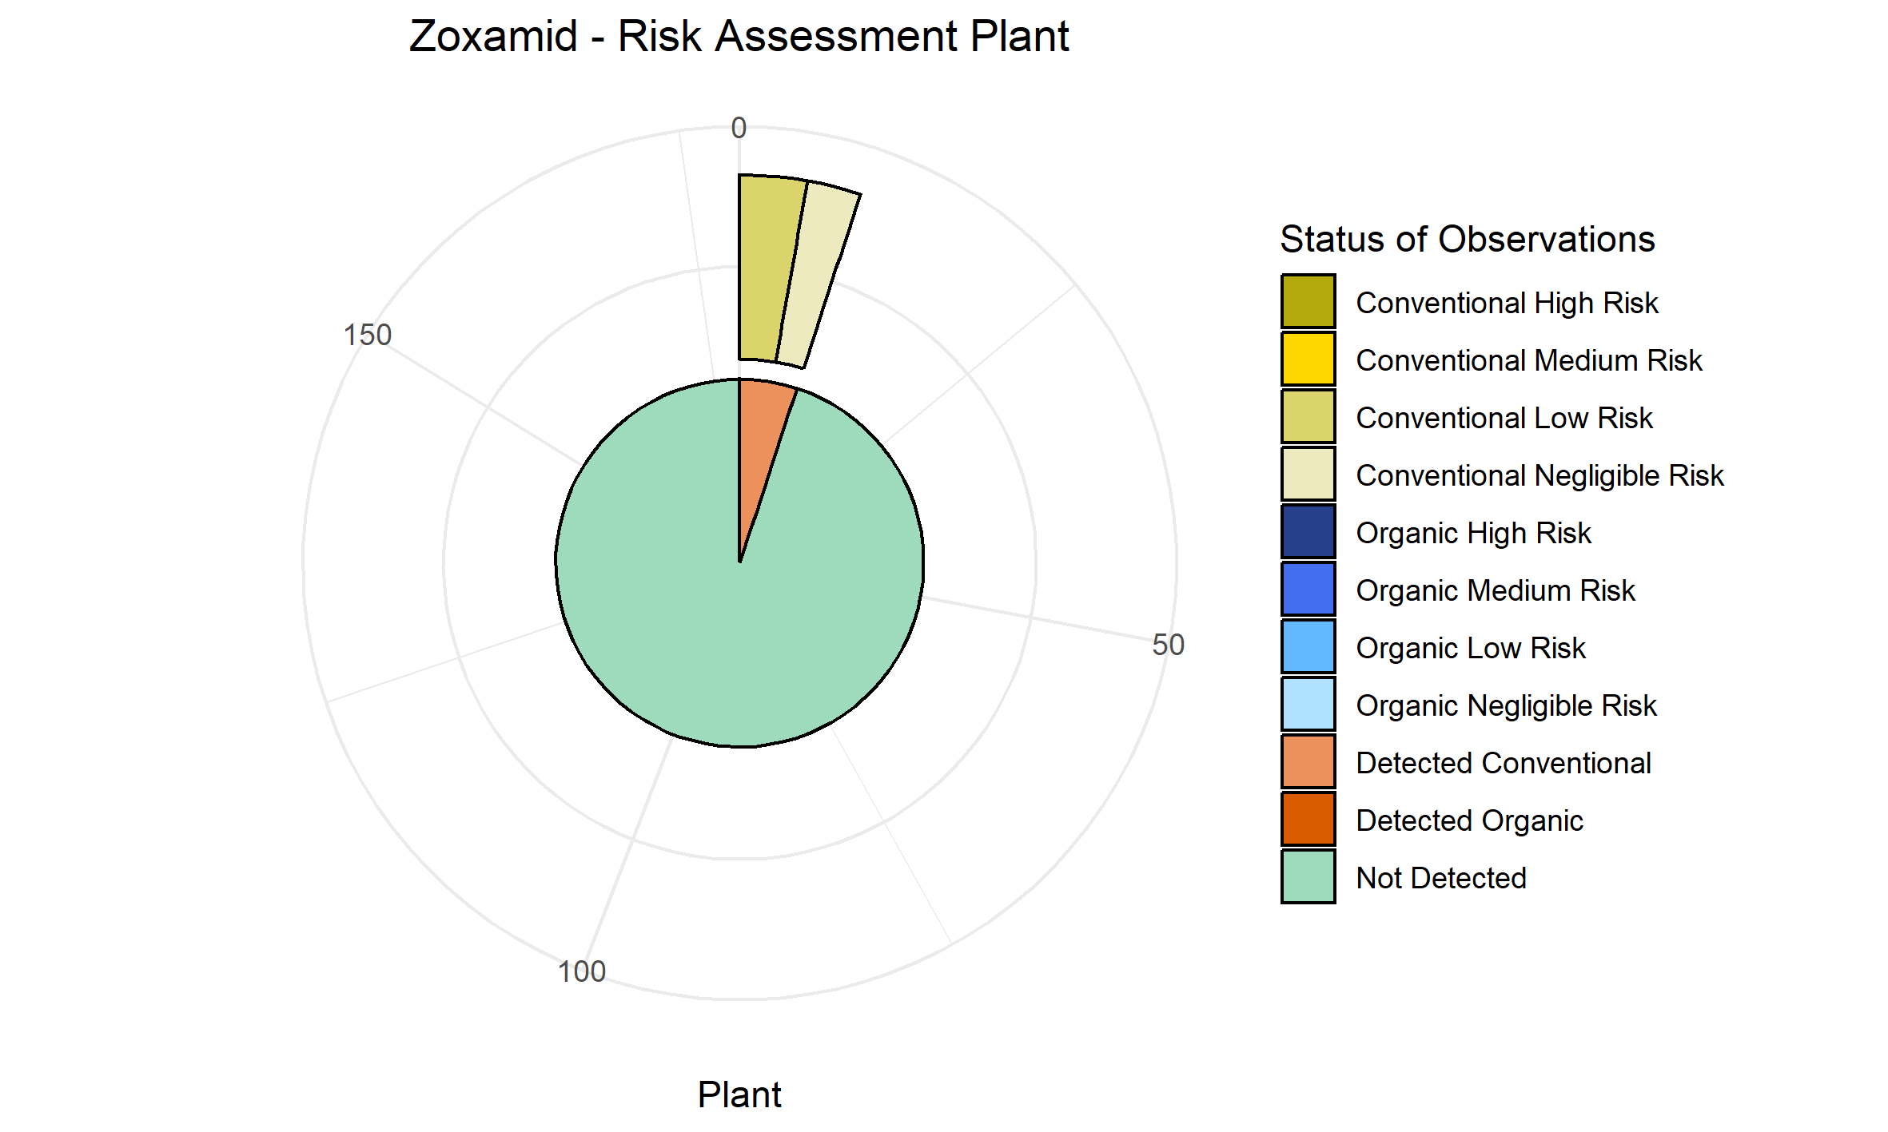
Bifenthrin | 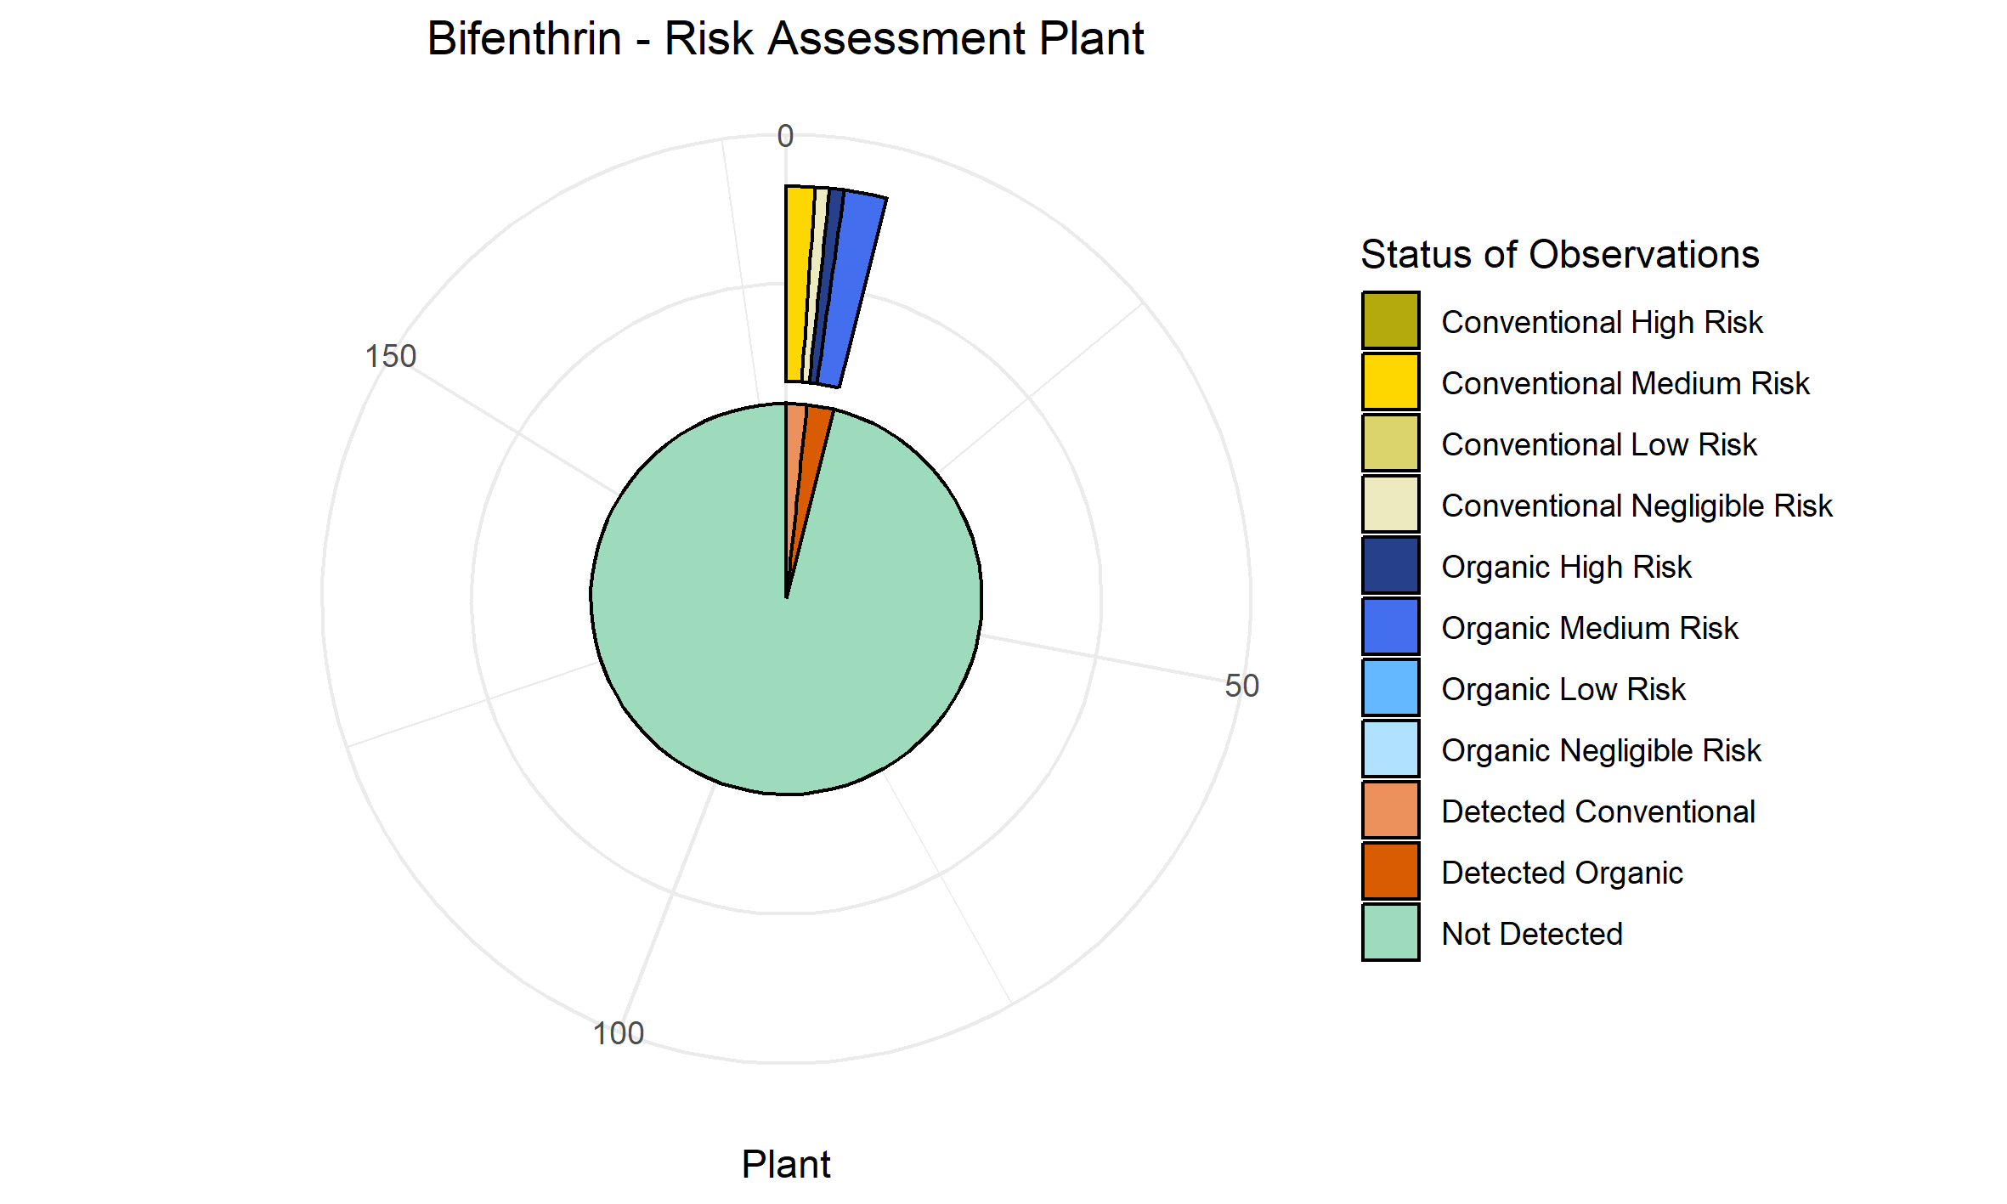
Cyprodinil | NA
Chlorpropham | NA

PNEC values calculated for water
Glyphosate | 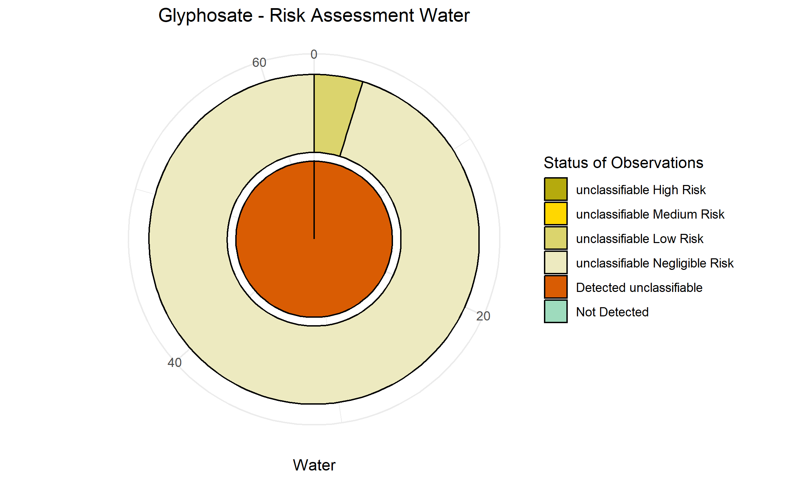
Hexachlorobenzene | 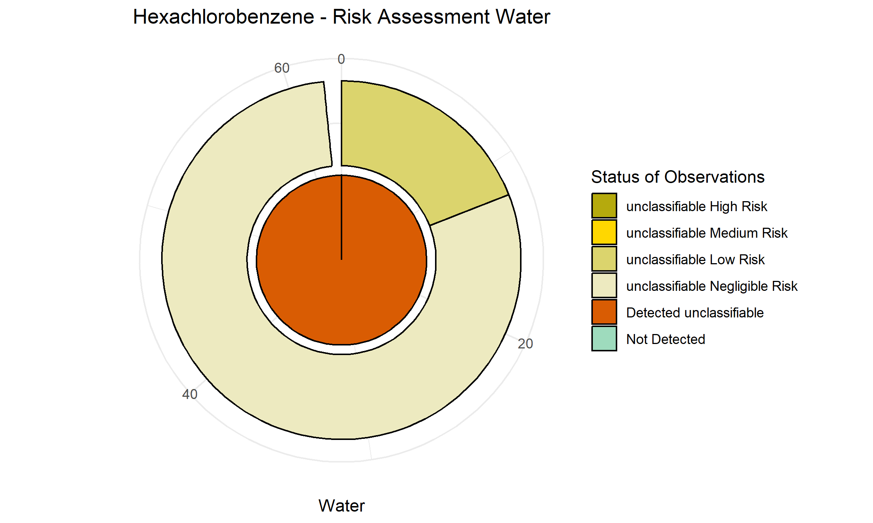
Lindane gamma HCH | 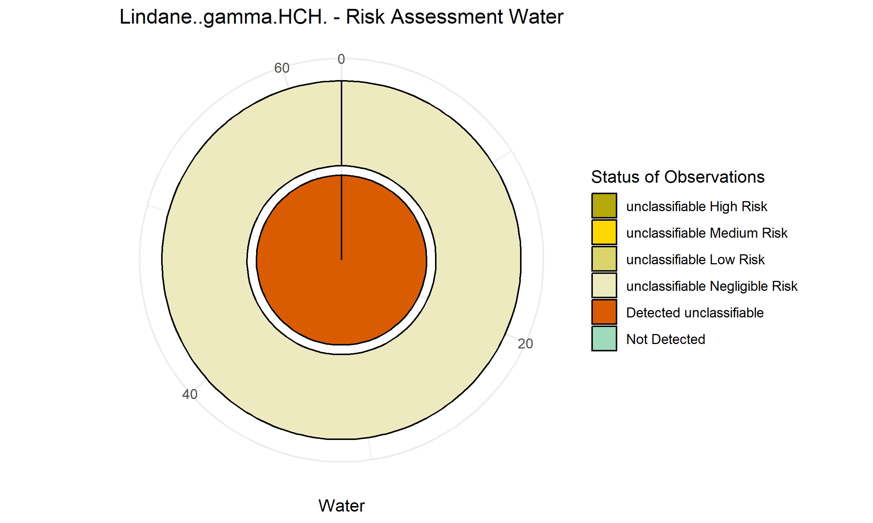
Dieldrin | 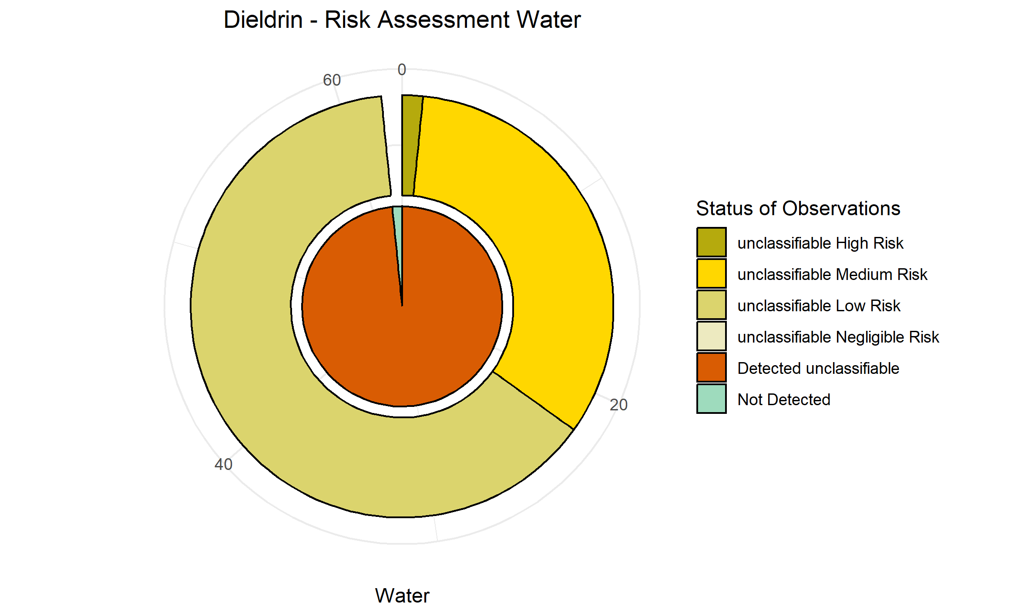
DDE.p.p. | 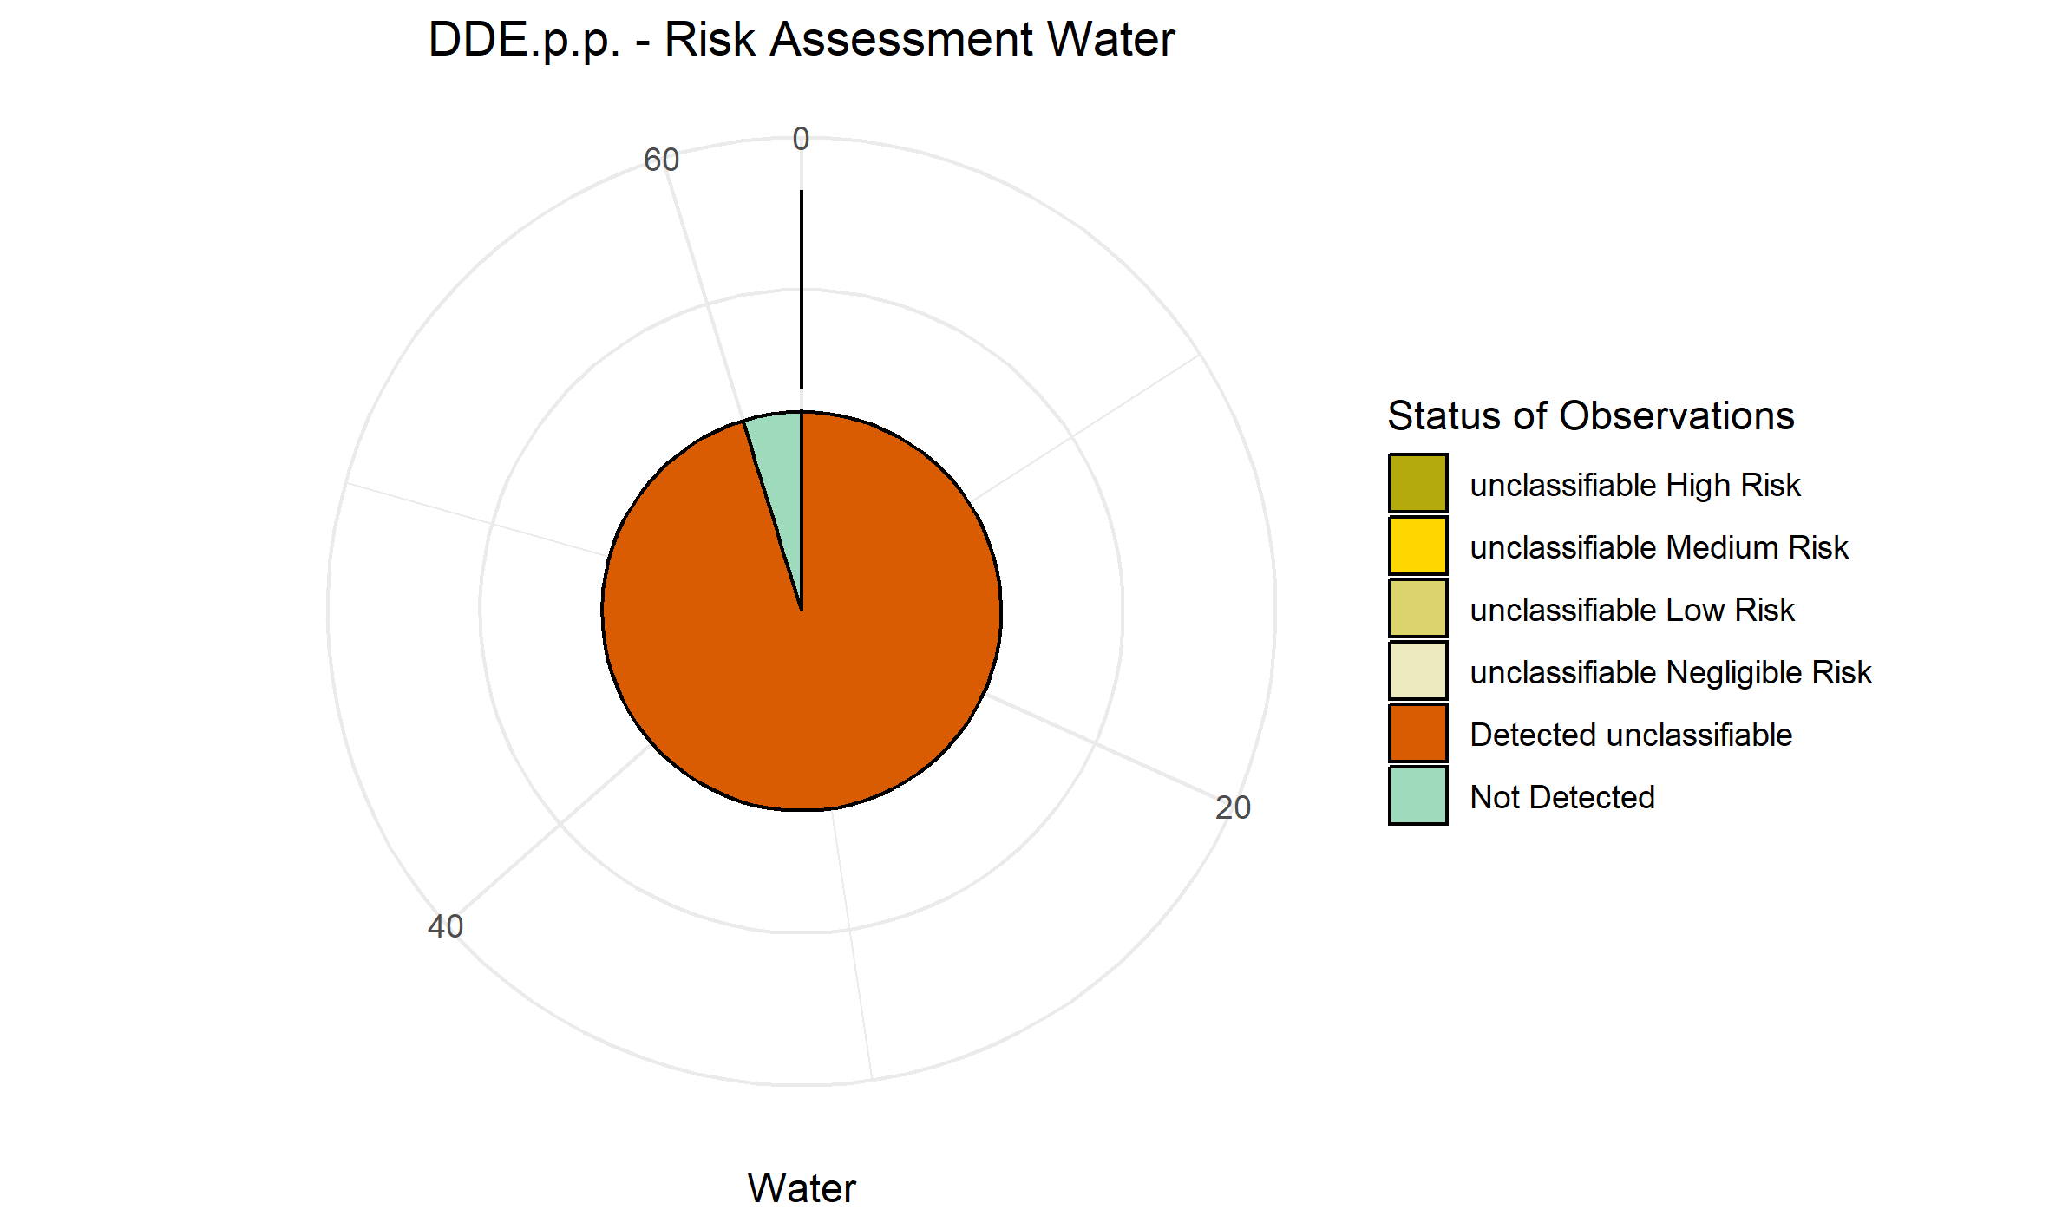
AMPA | 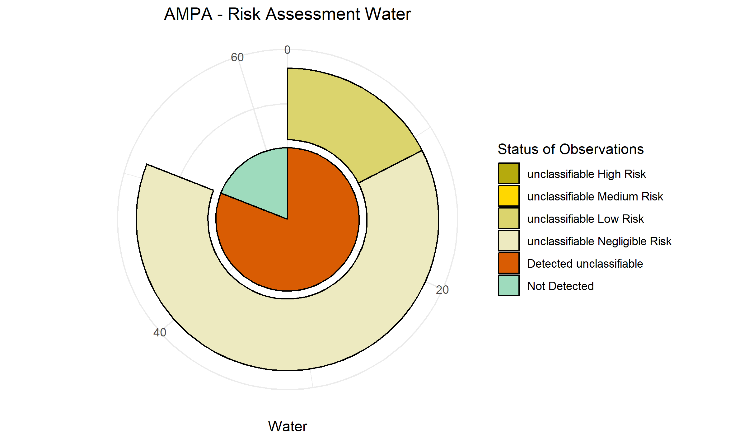
DDD.p.p. | 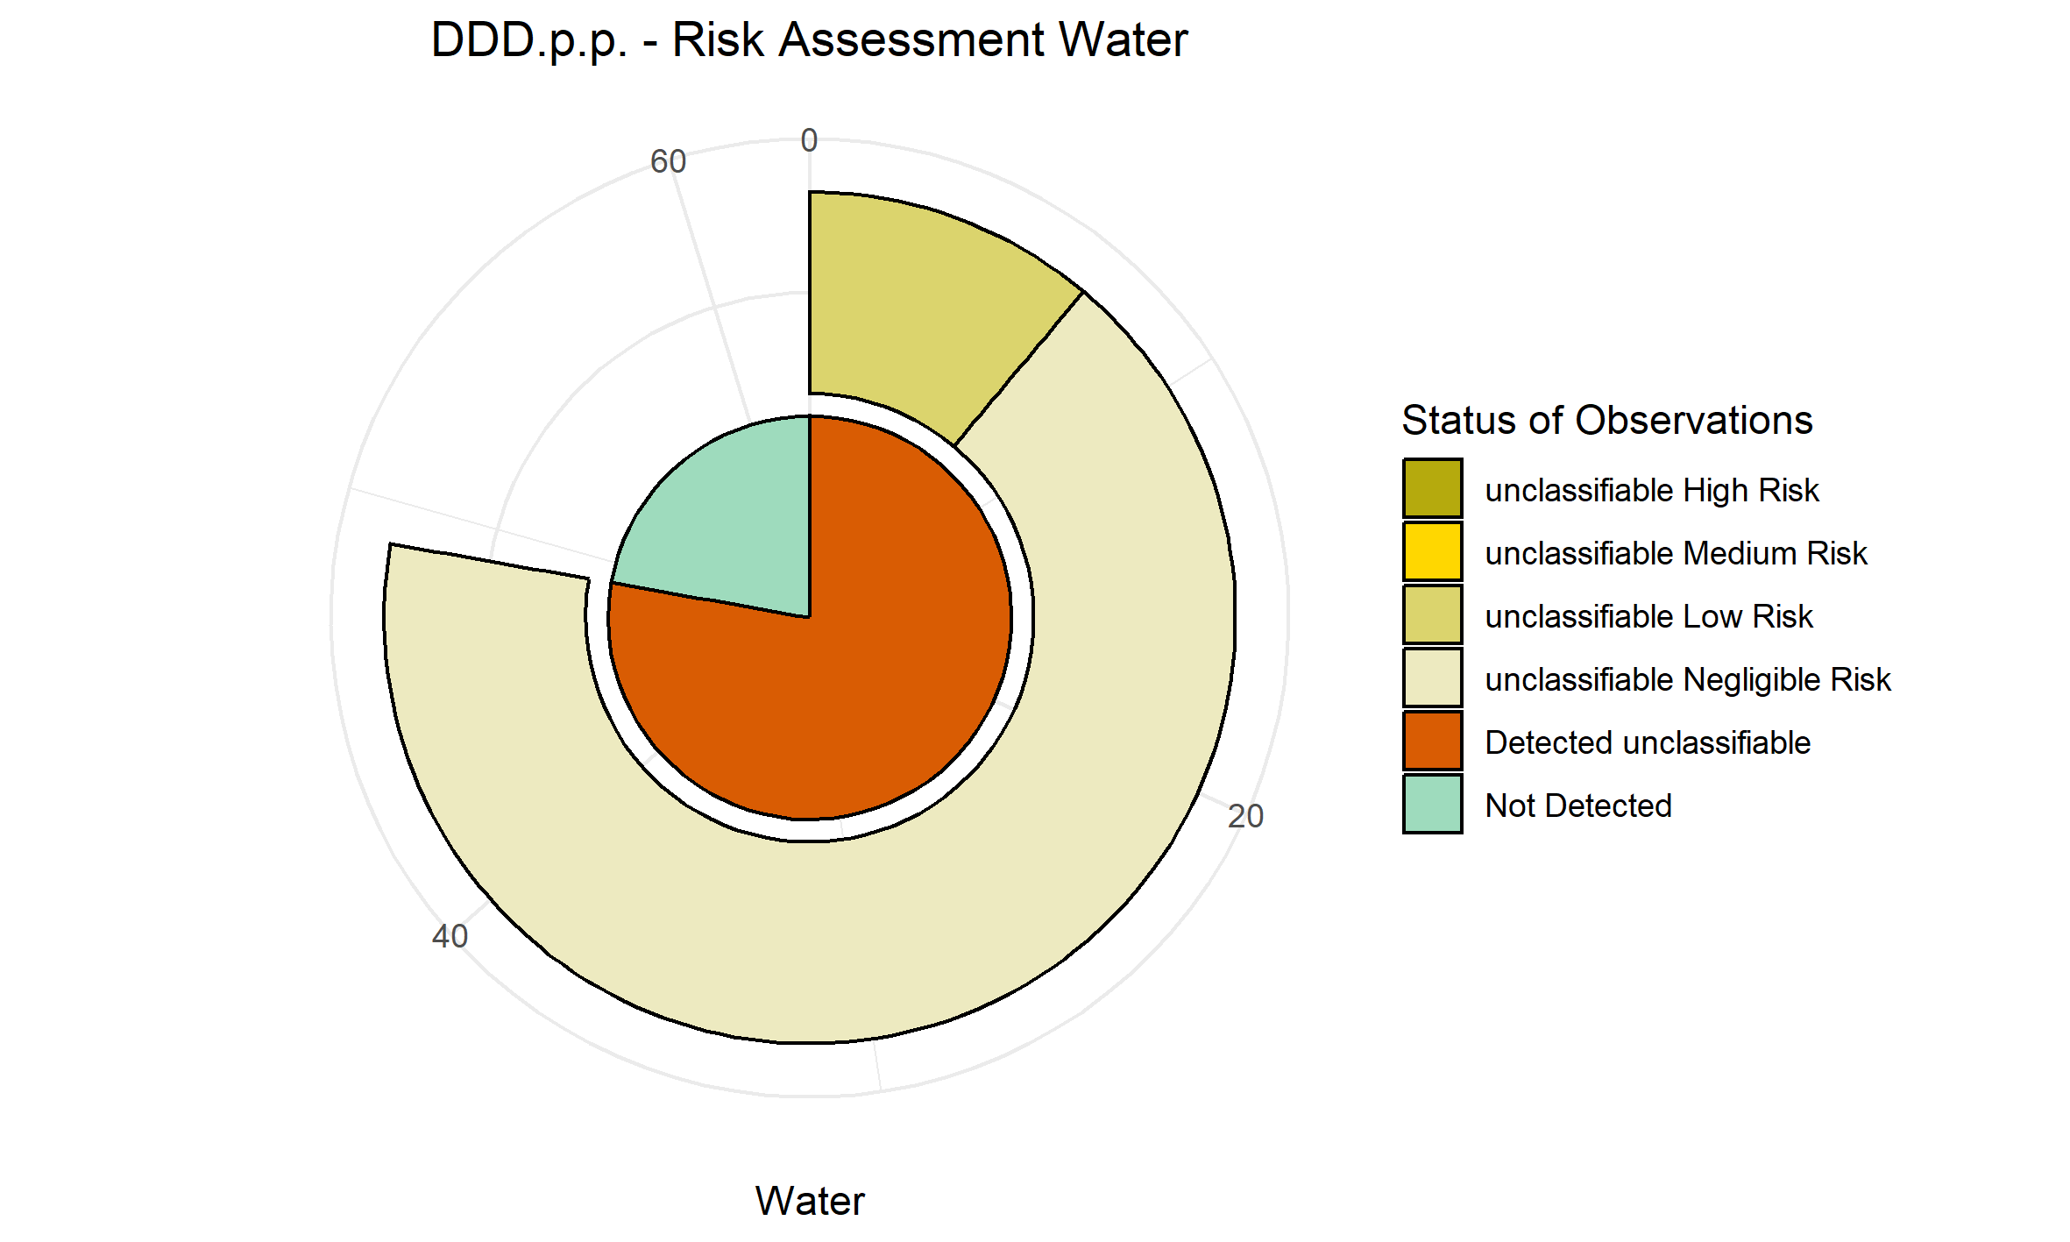
DDT.p.p. | 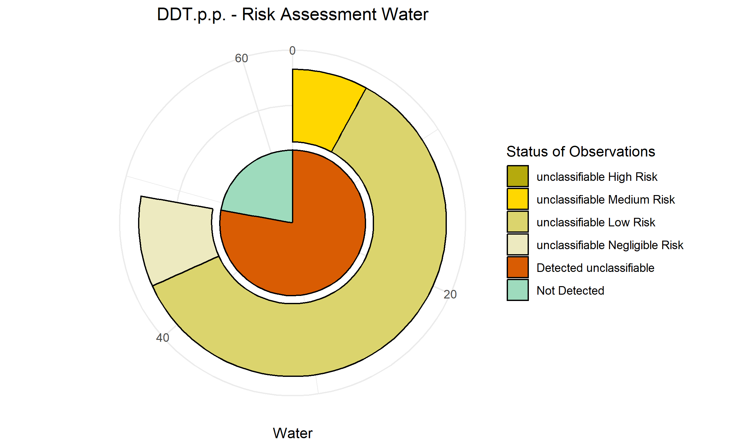
DDD.o.p. | 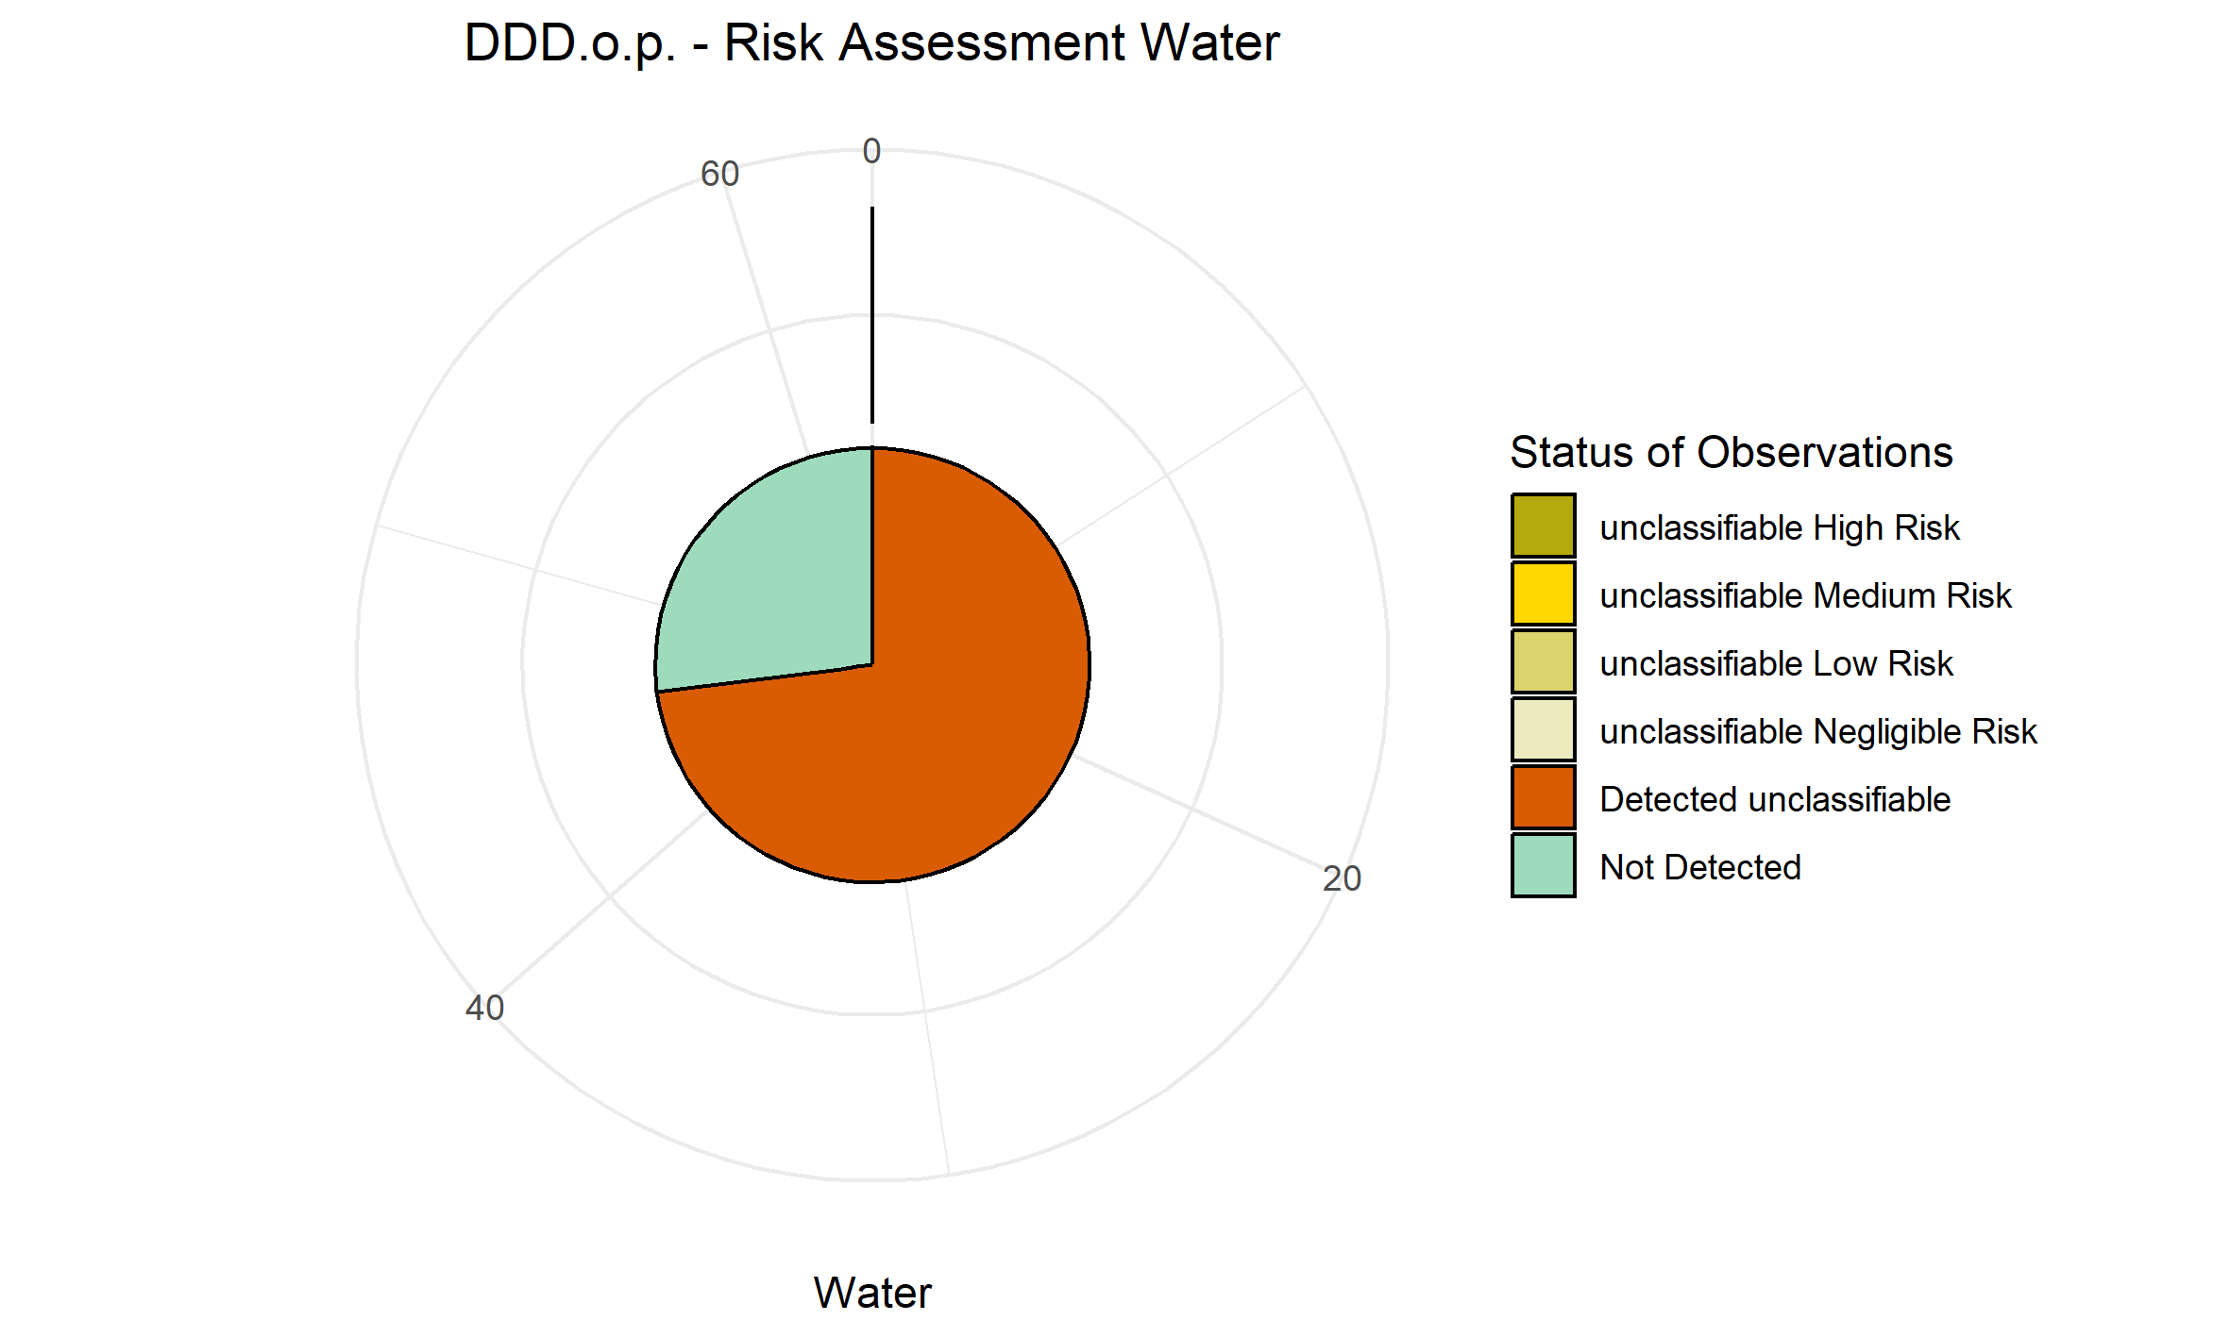
Terbuthylazine | 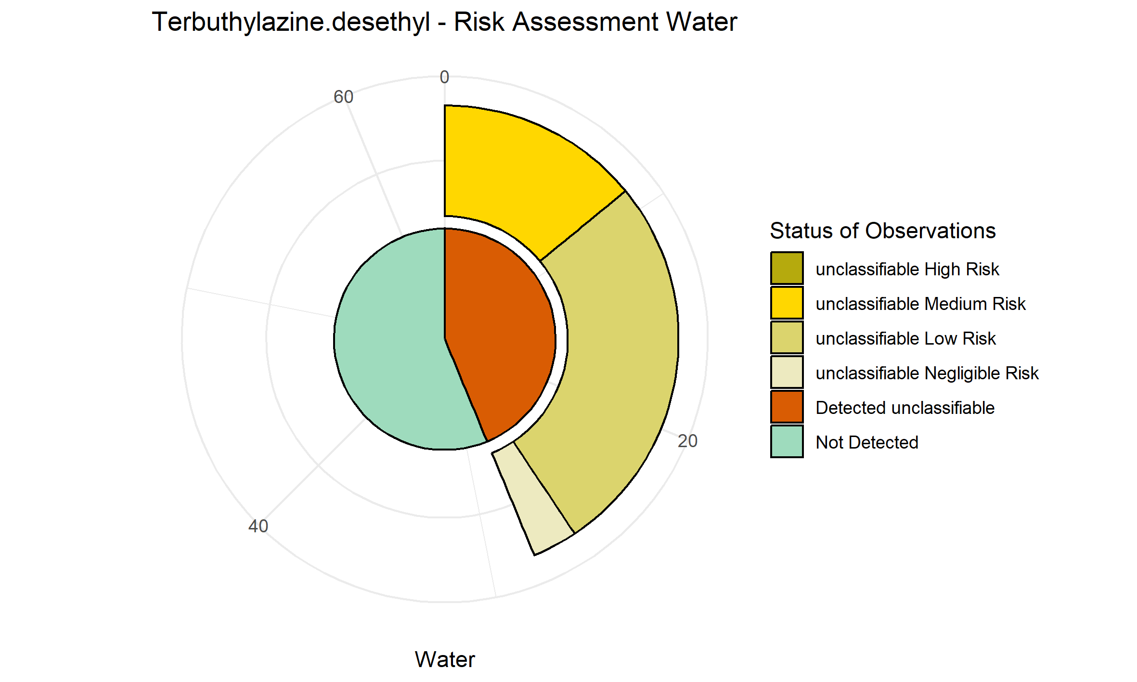
DDT.o.p. | 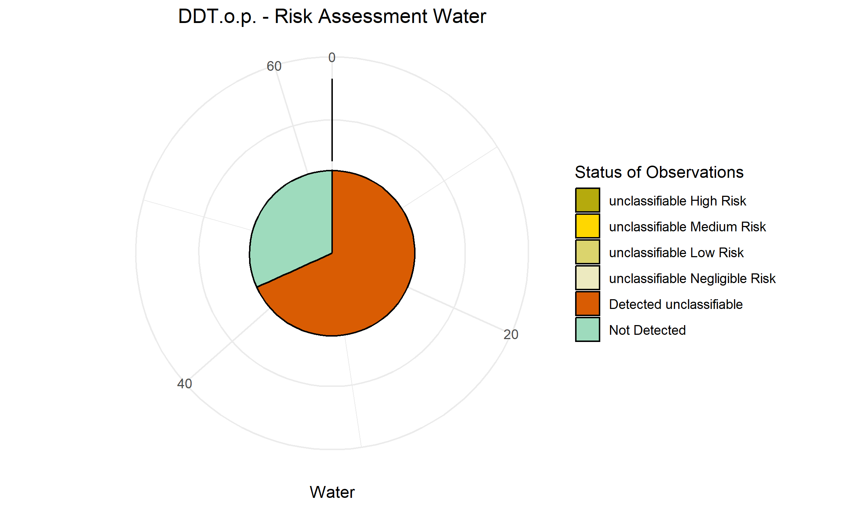
DDE o,p | 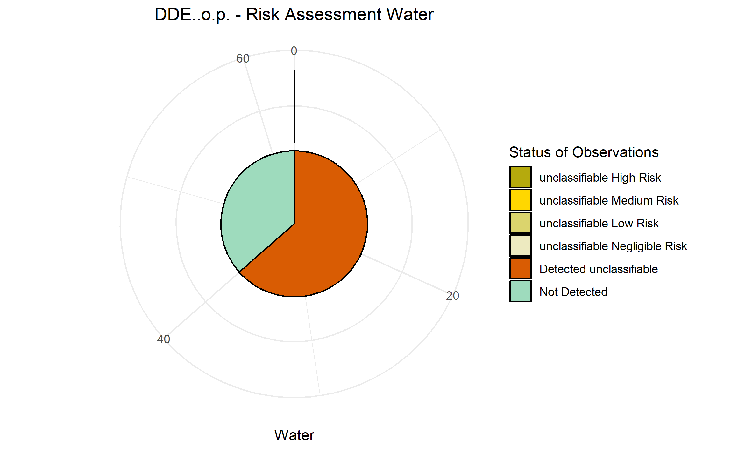
Trifloxystrobin.metabolite.CGA.321113 | 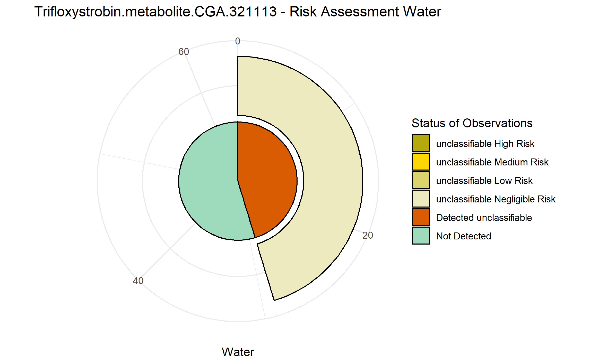
Tebuconazole | 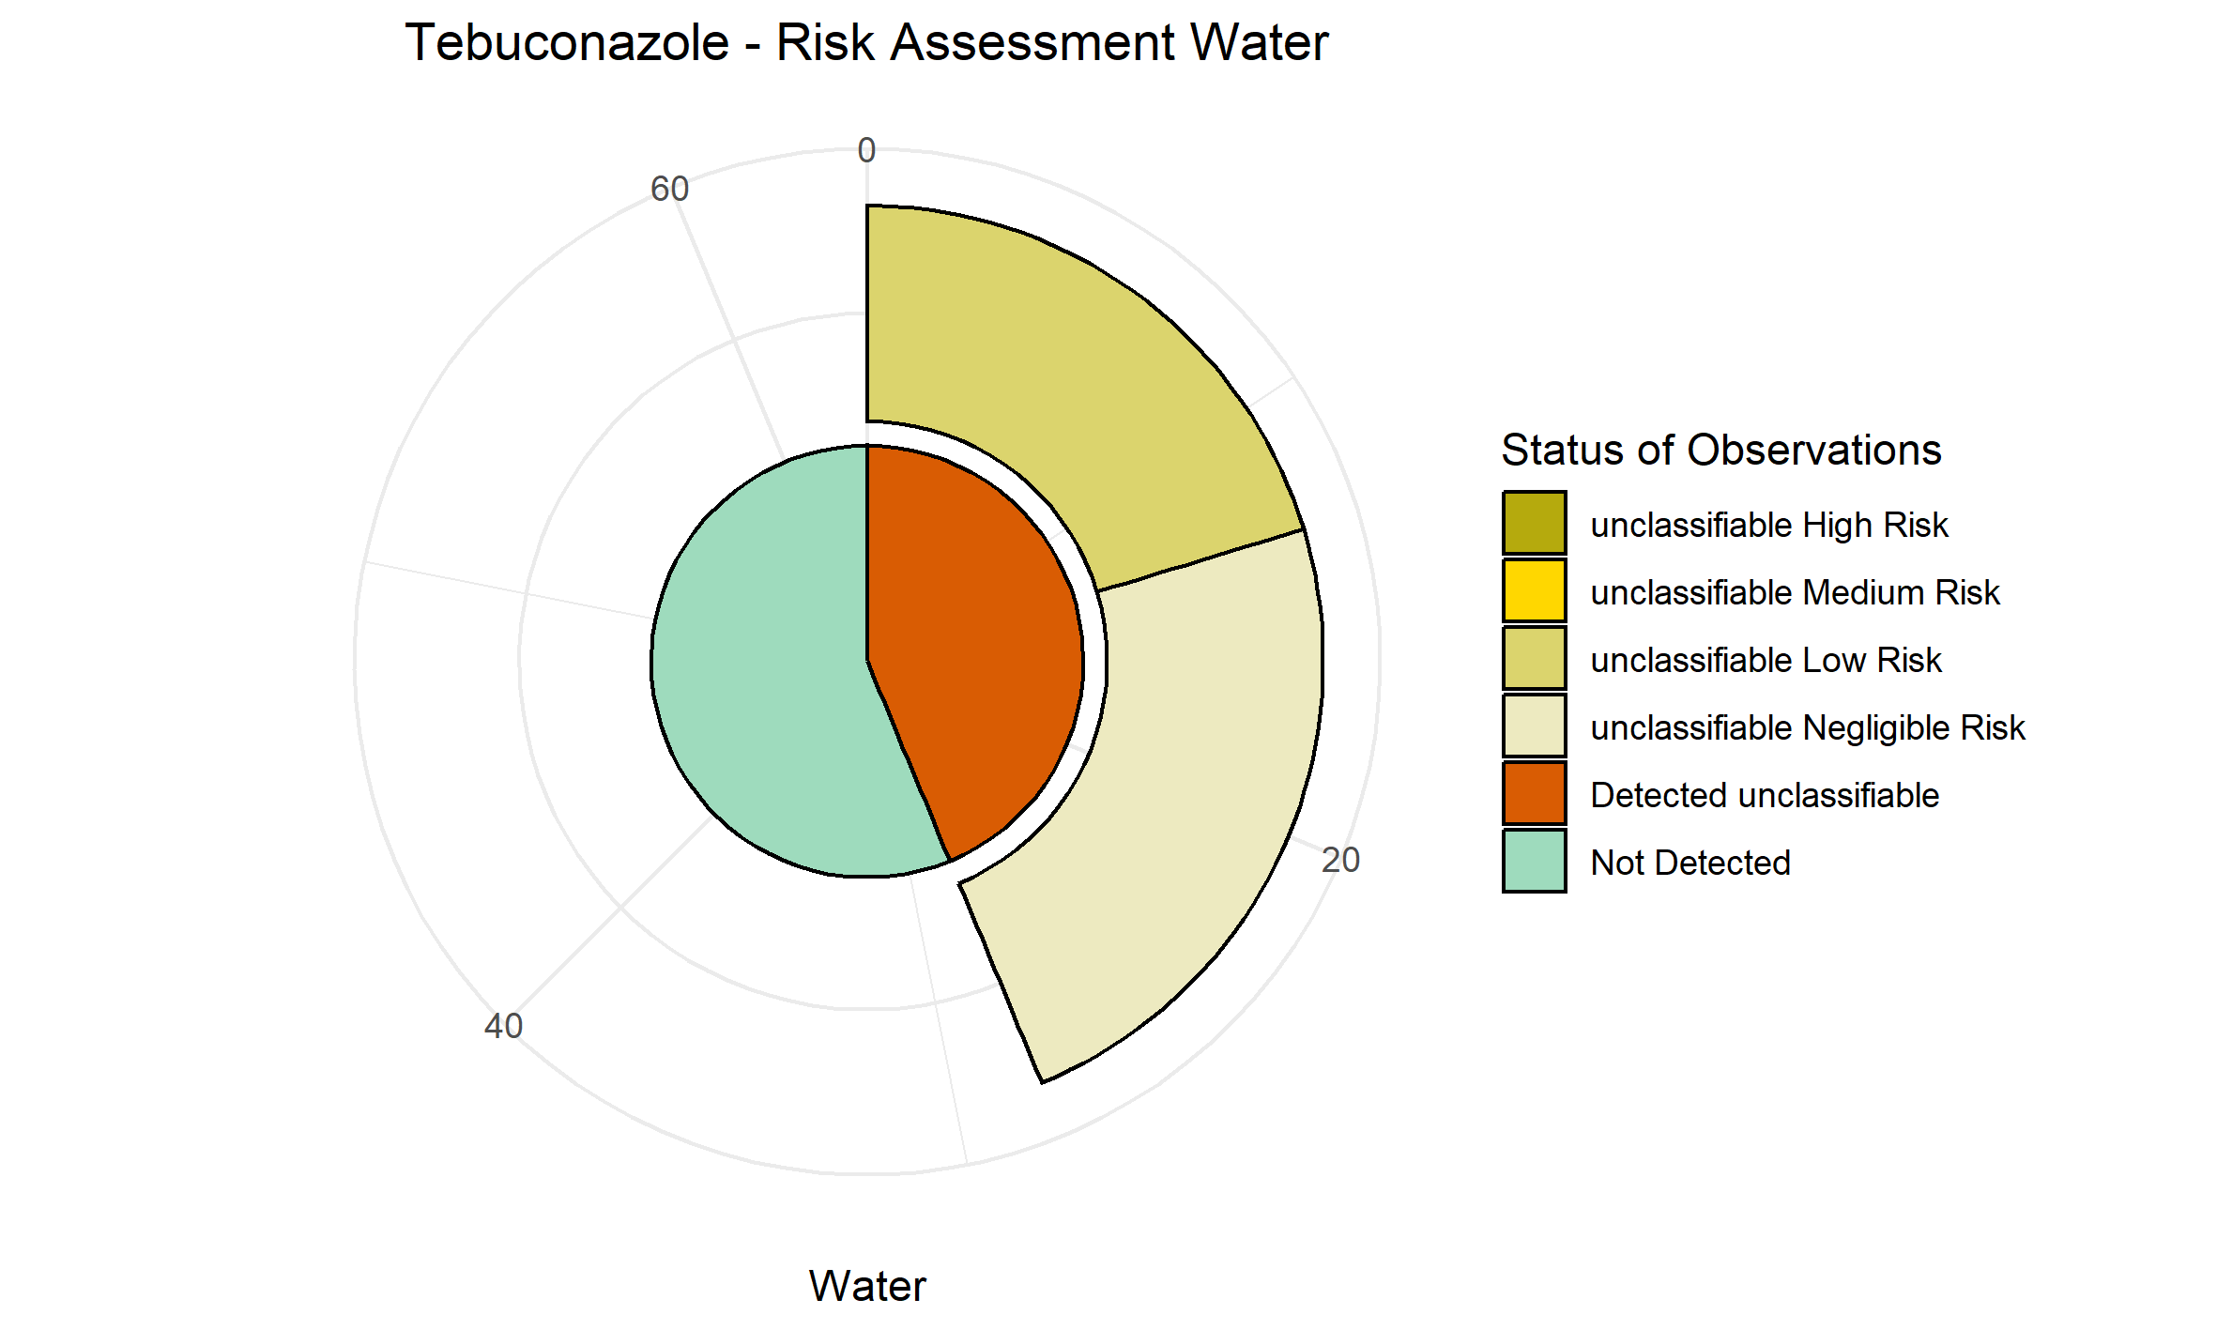
Terbuthylazine desethyl
Atrazine | 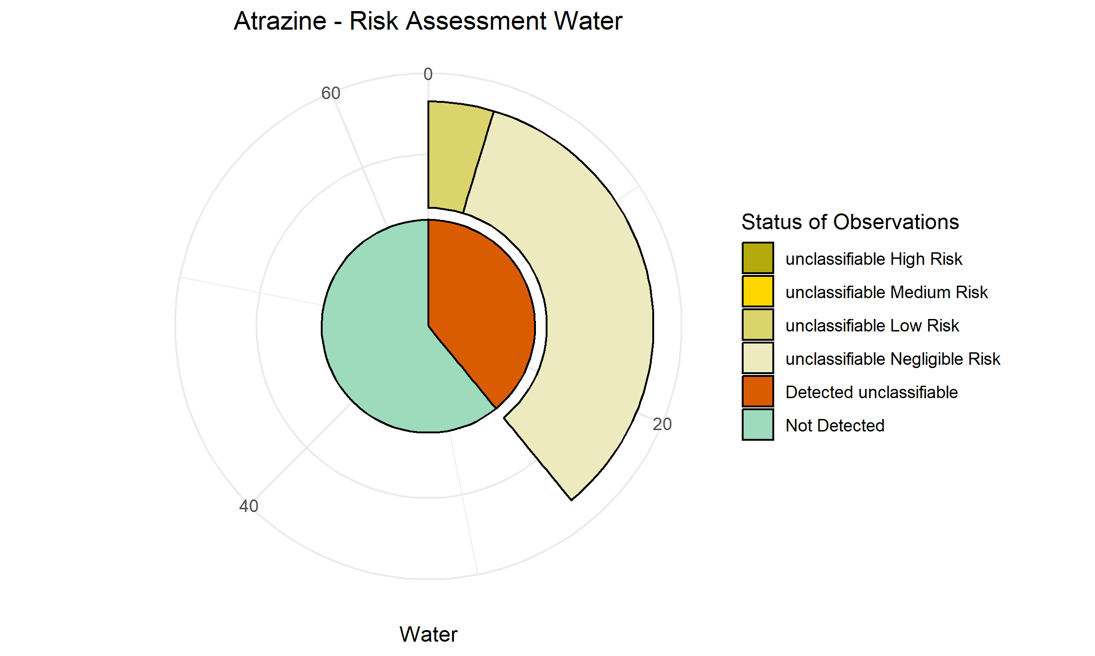
Piperonyl butoxide | 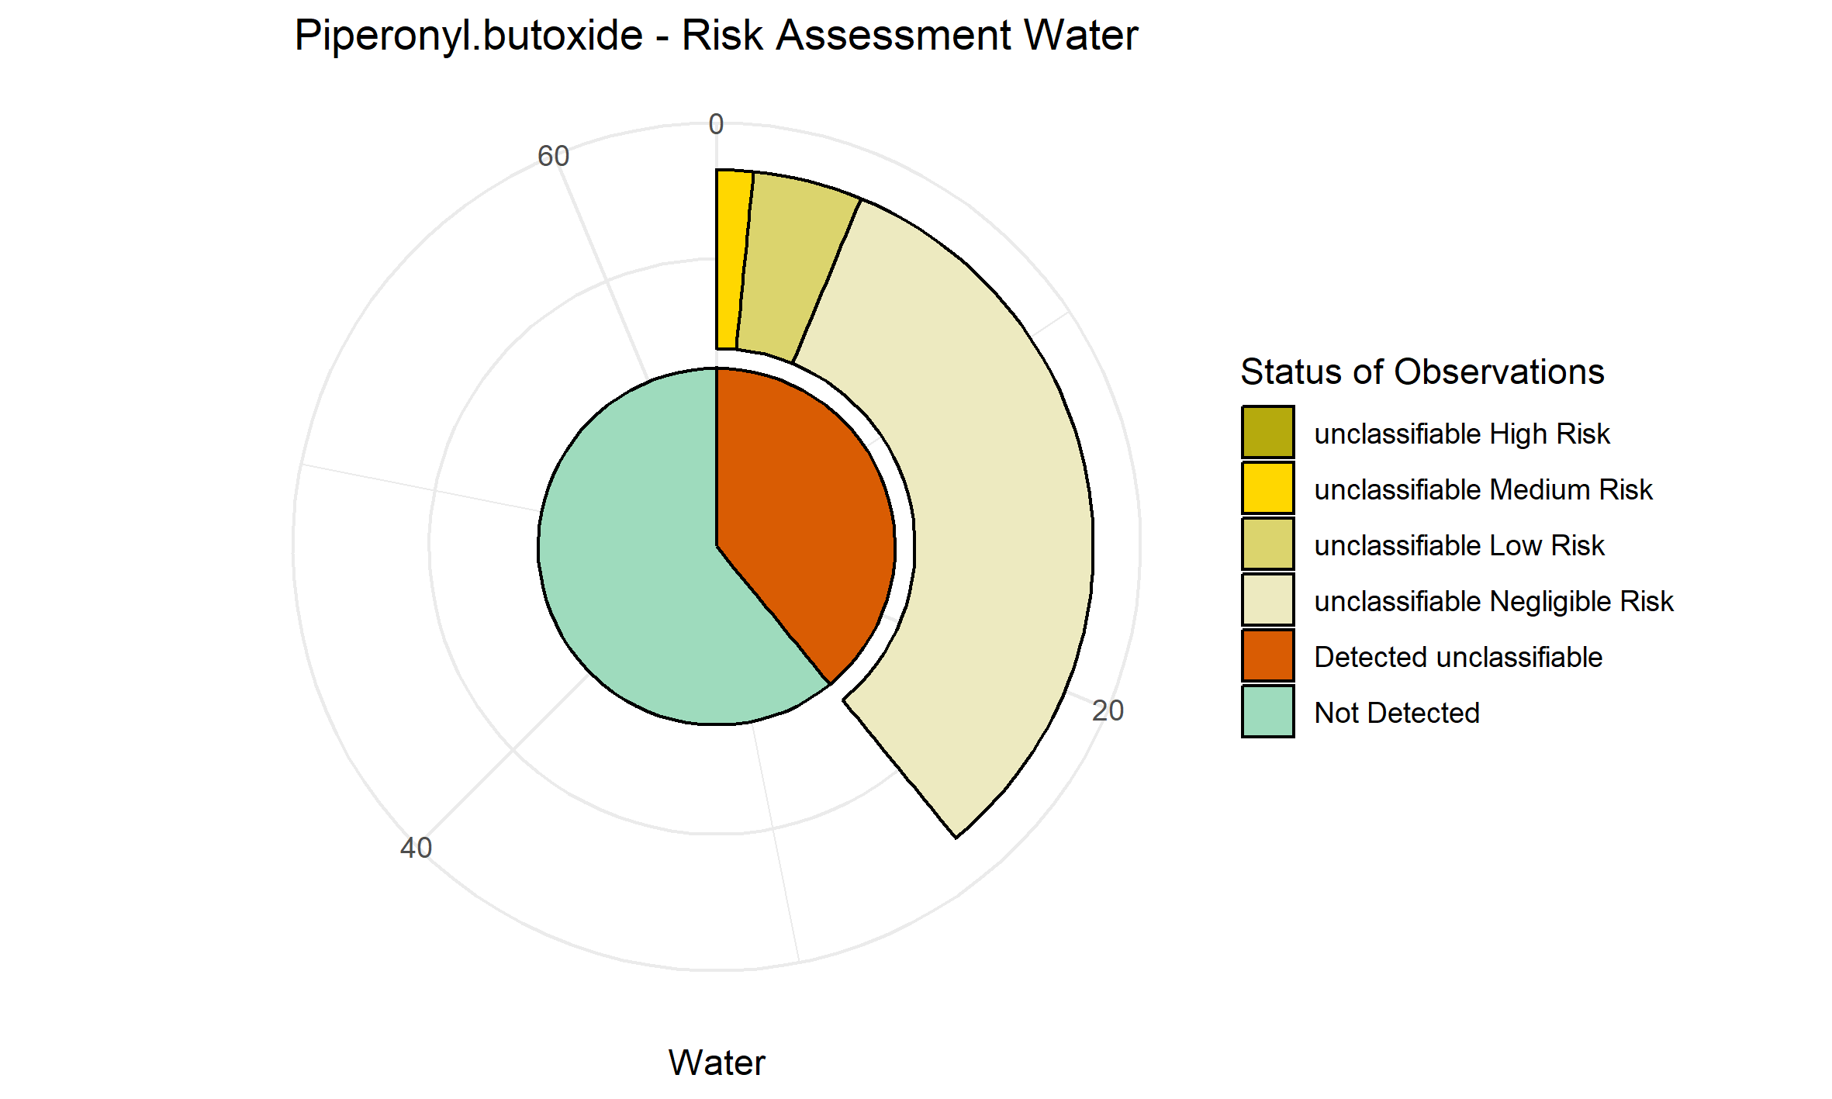
Terbutryn | 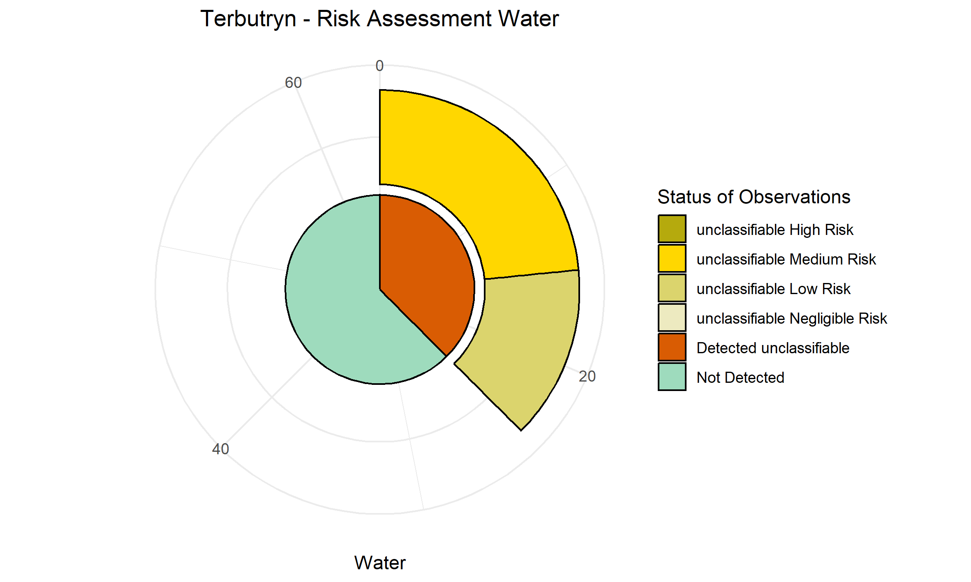
Fluopyram | 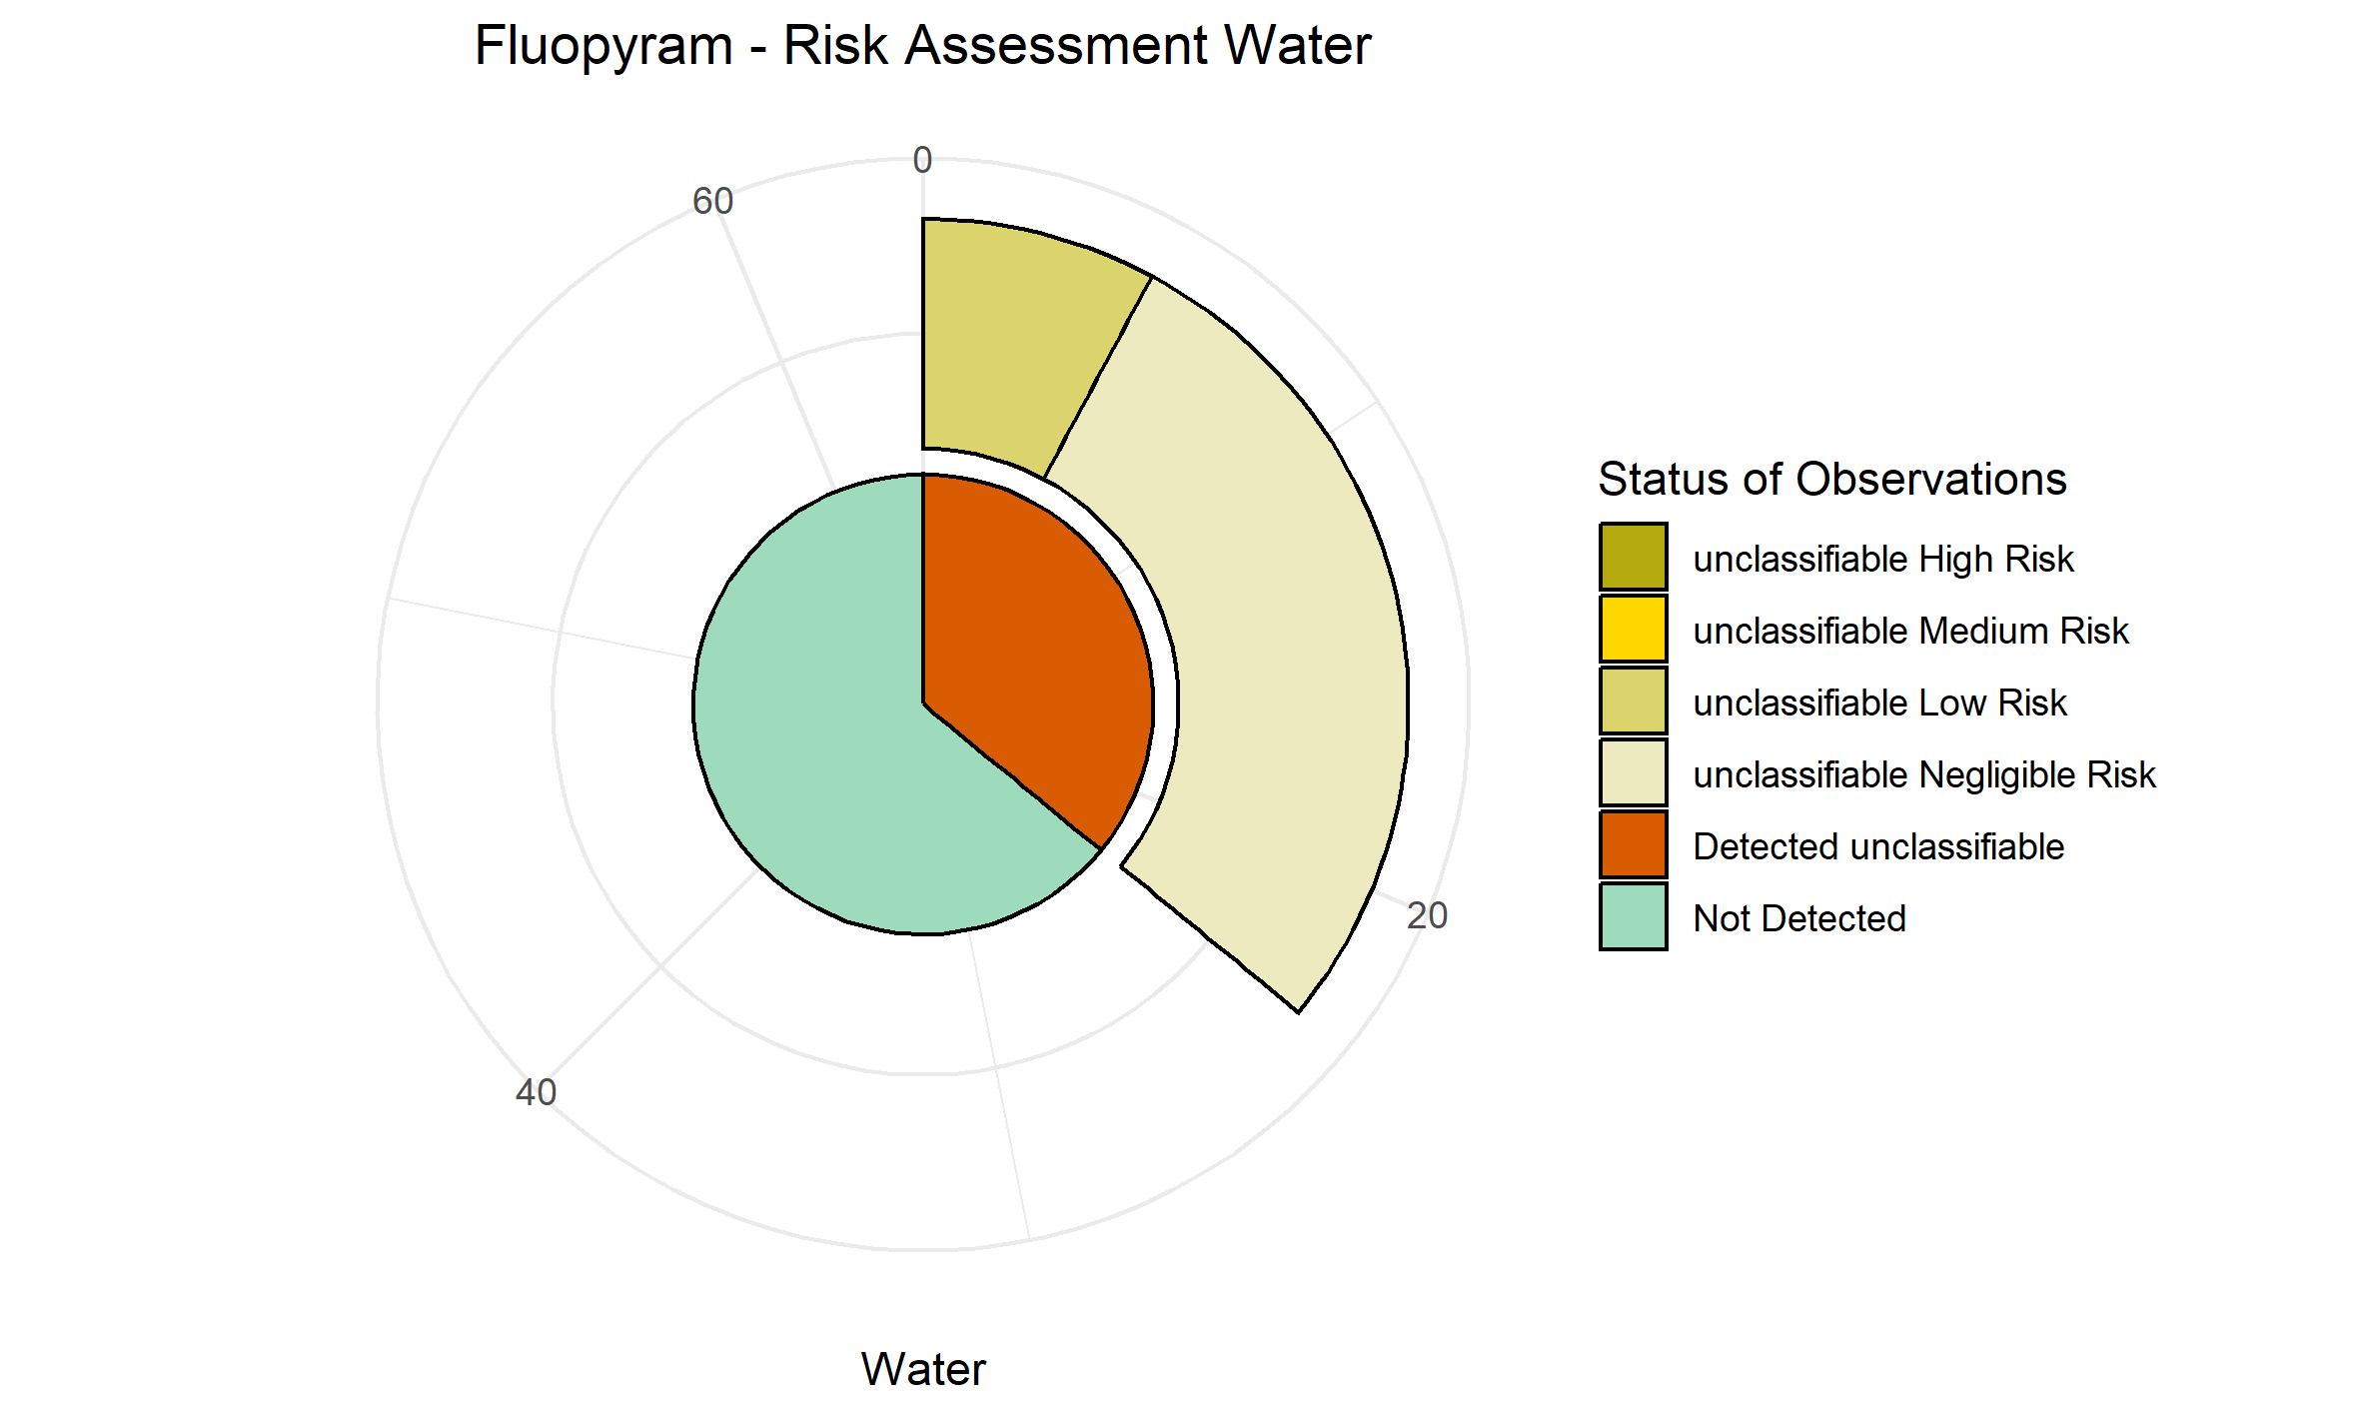
Azoxystrobin | 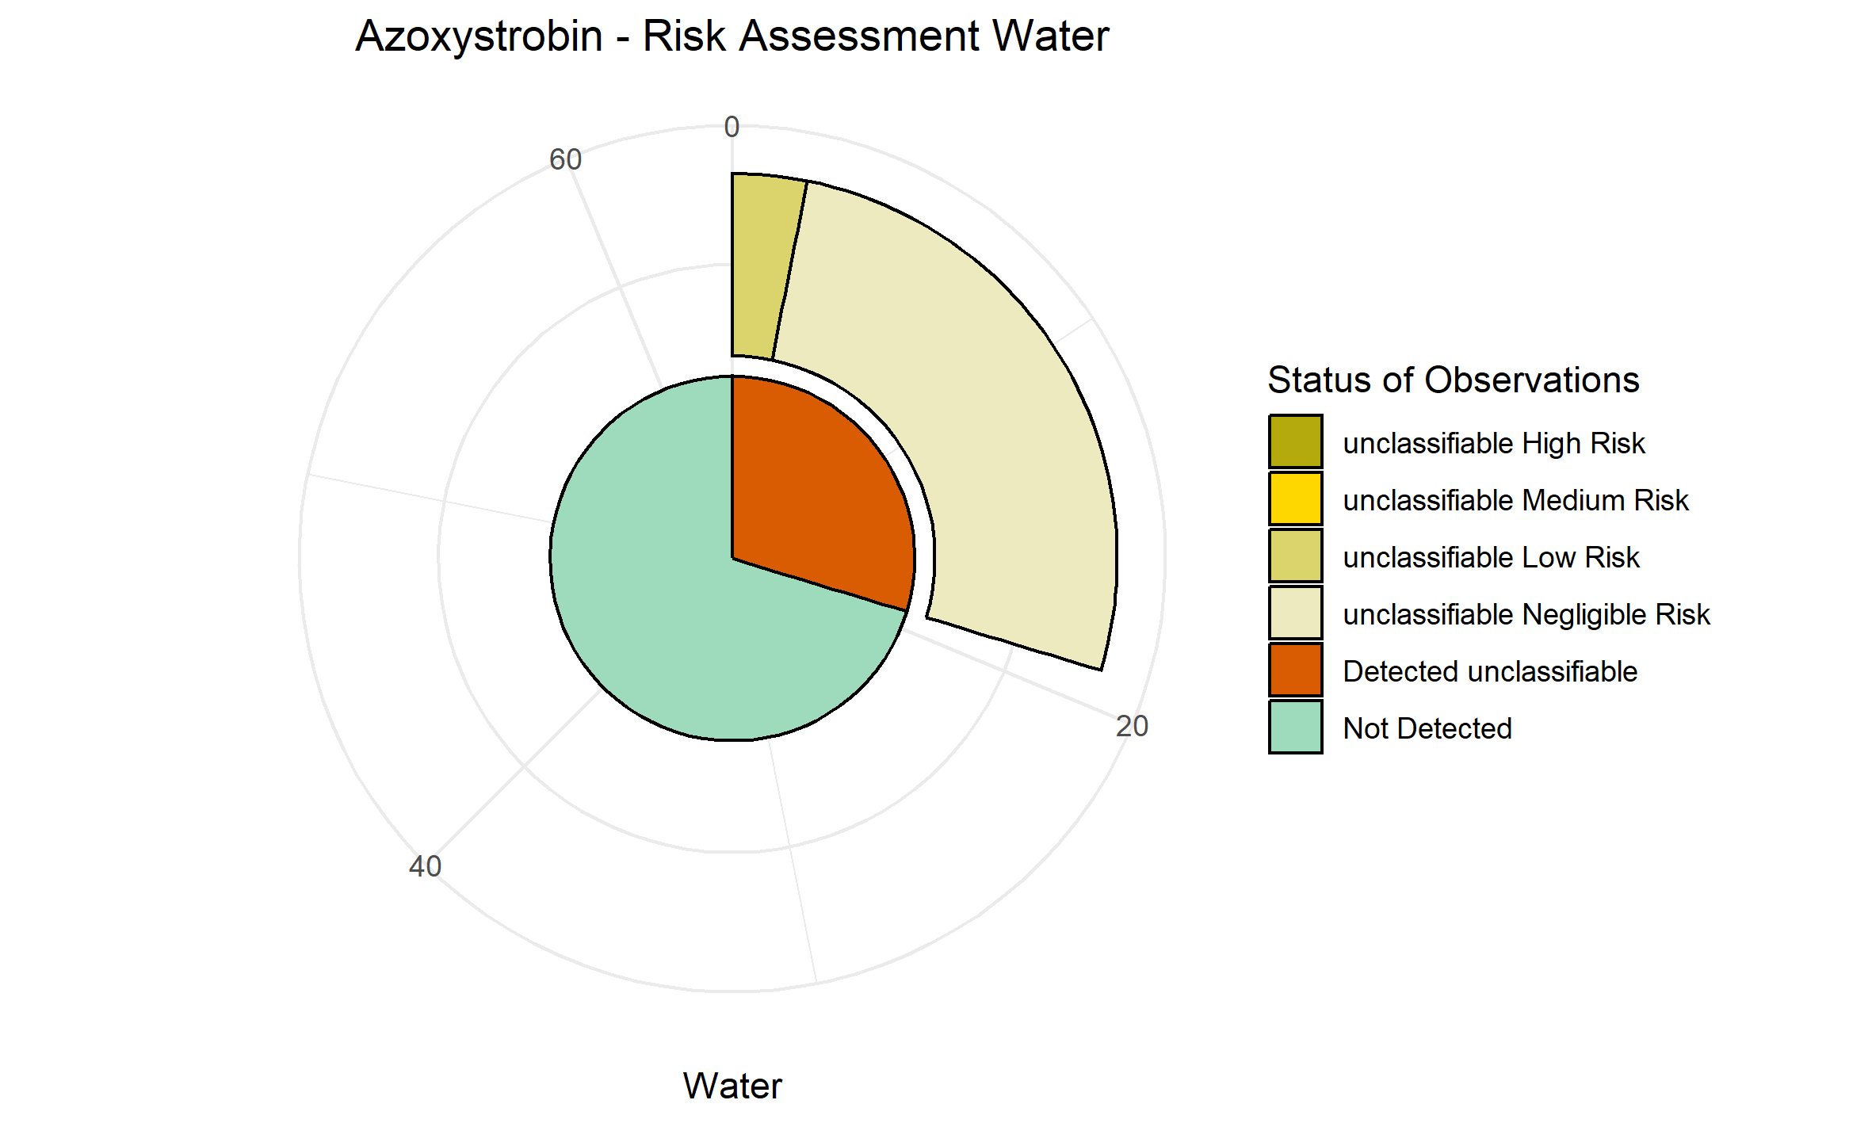

PNEC values calculated for sediment
AMPA | 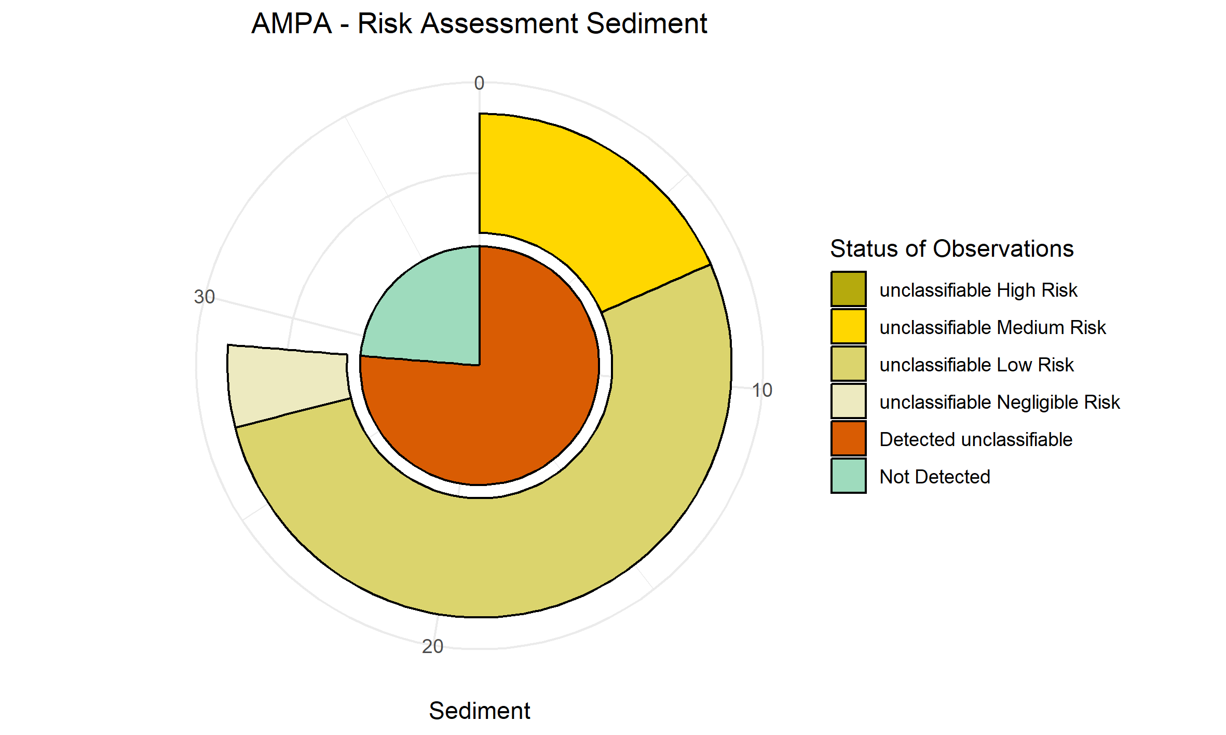
Glyphosate | 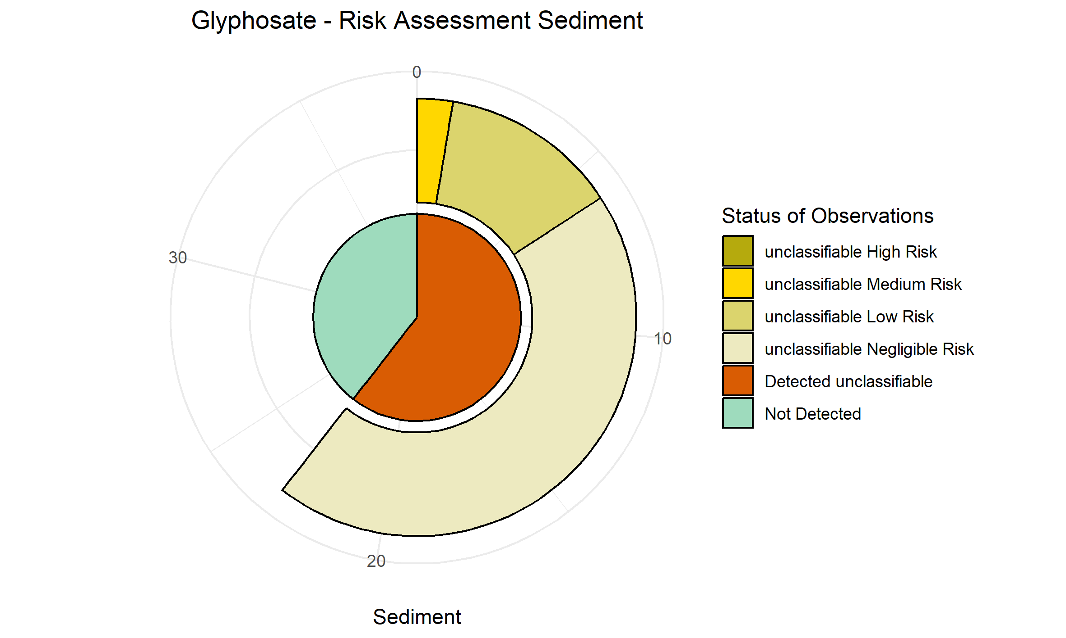
Fludioxonil | 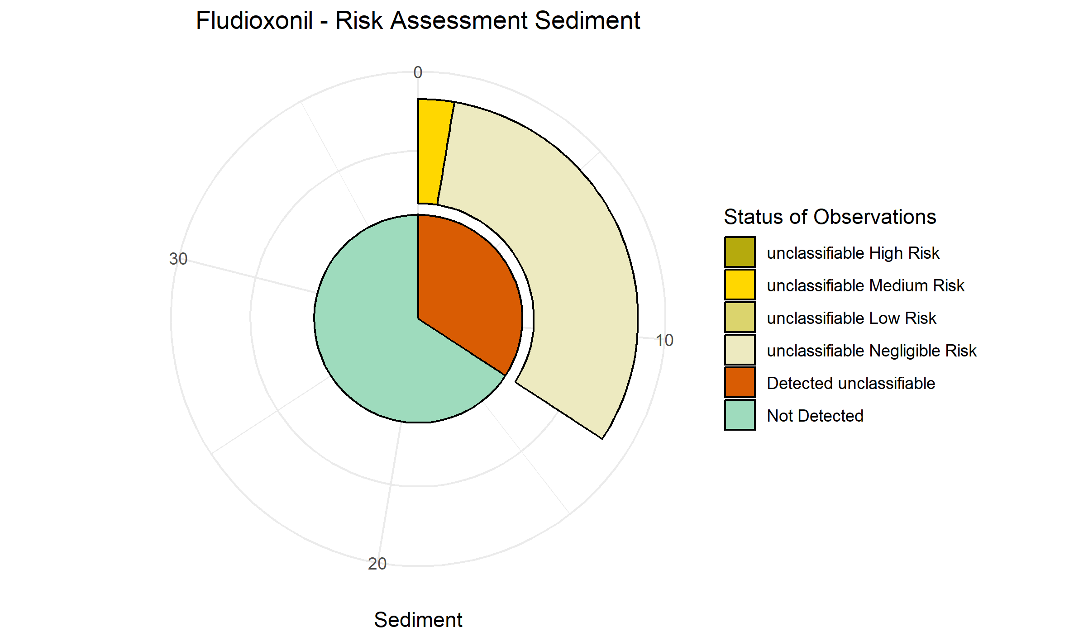
Azoxystrobin | 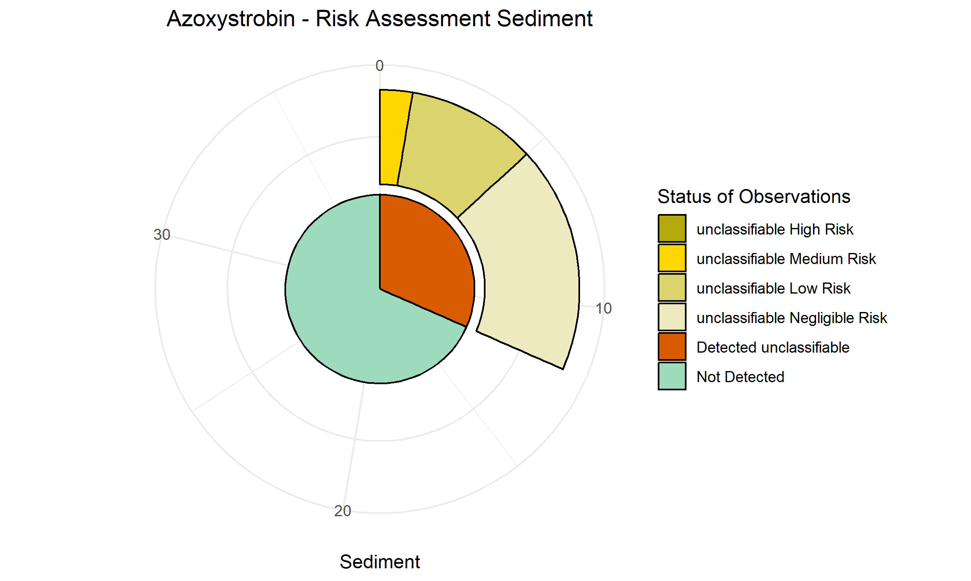
Fluopicolide | 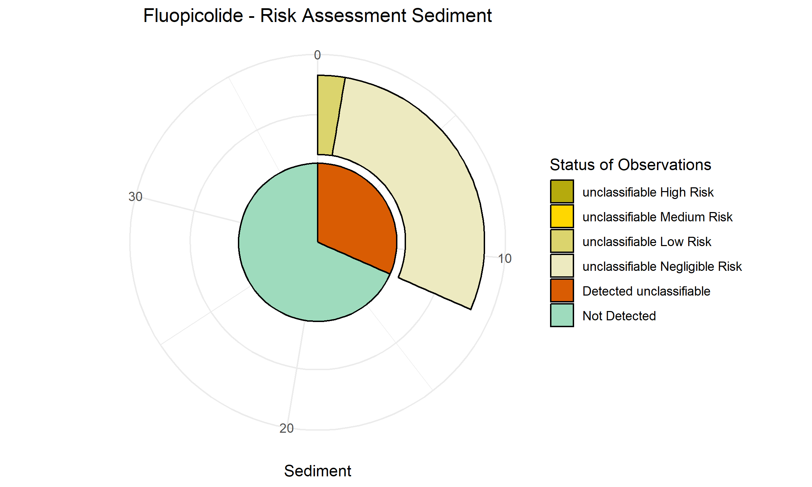
Boscalid | 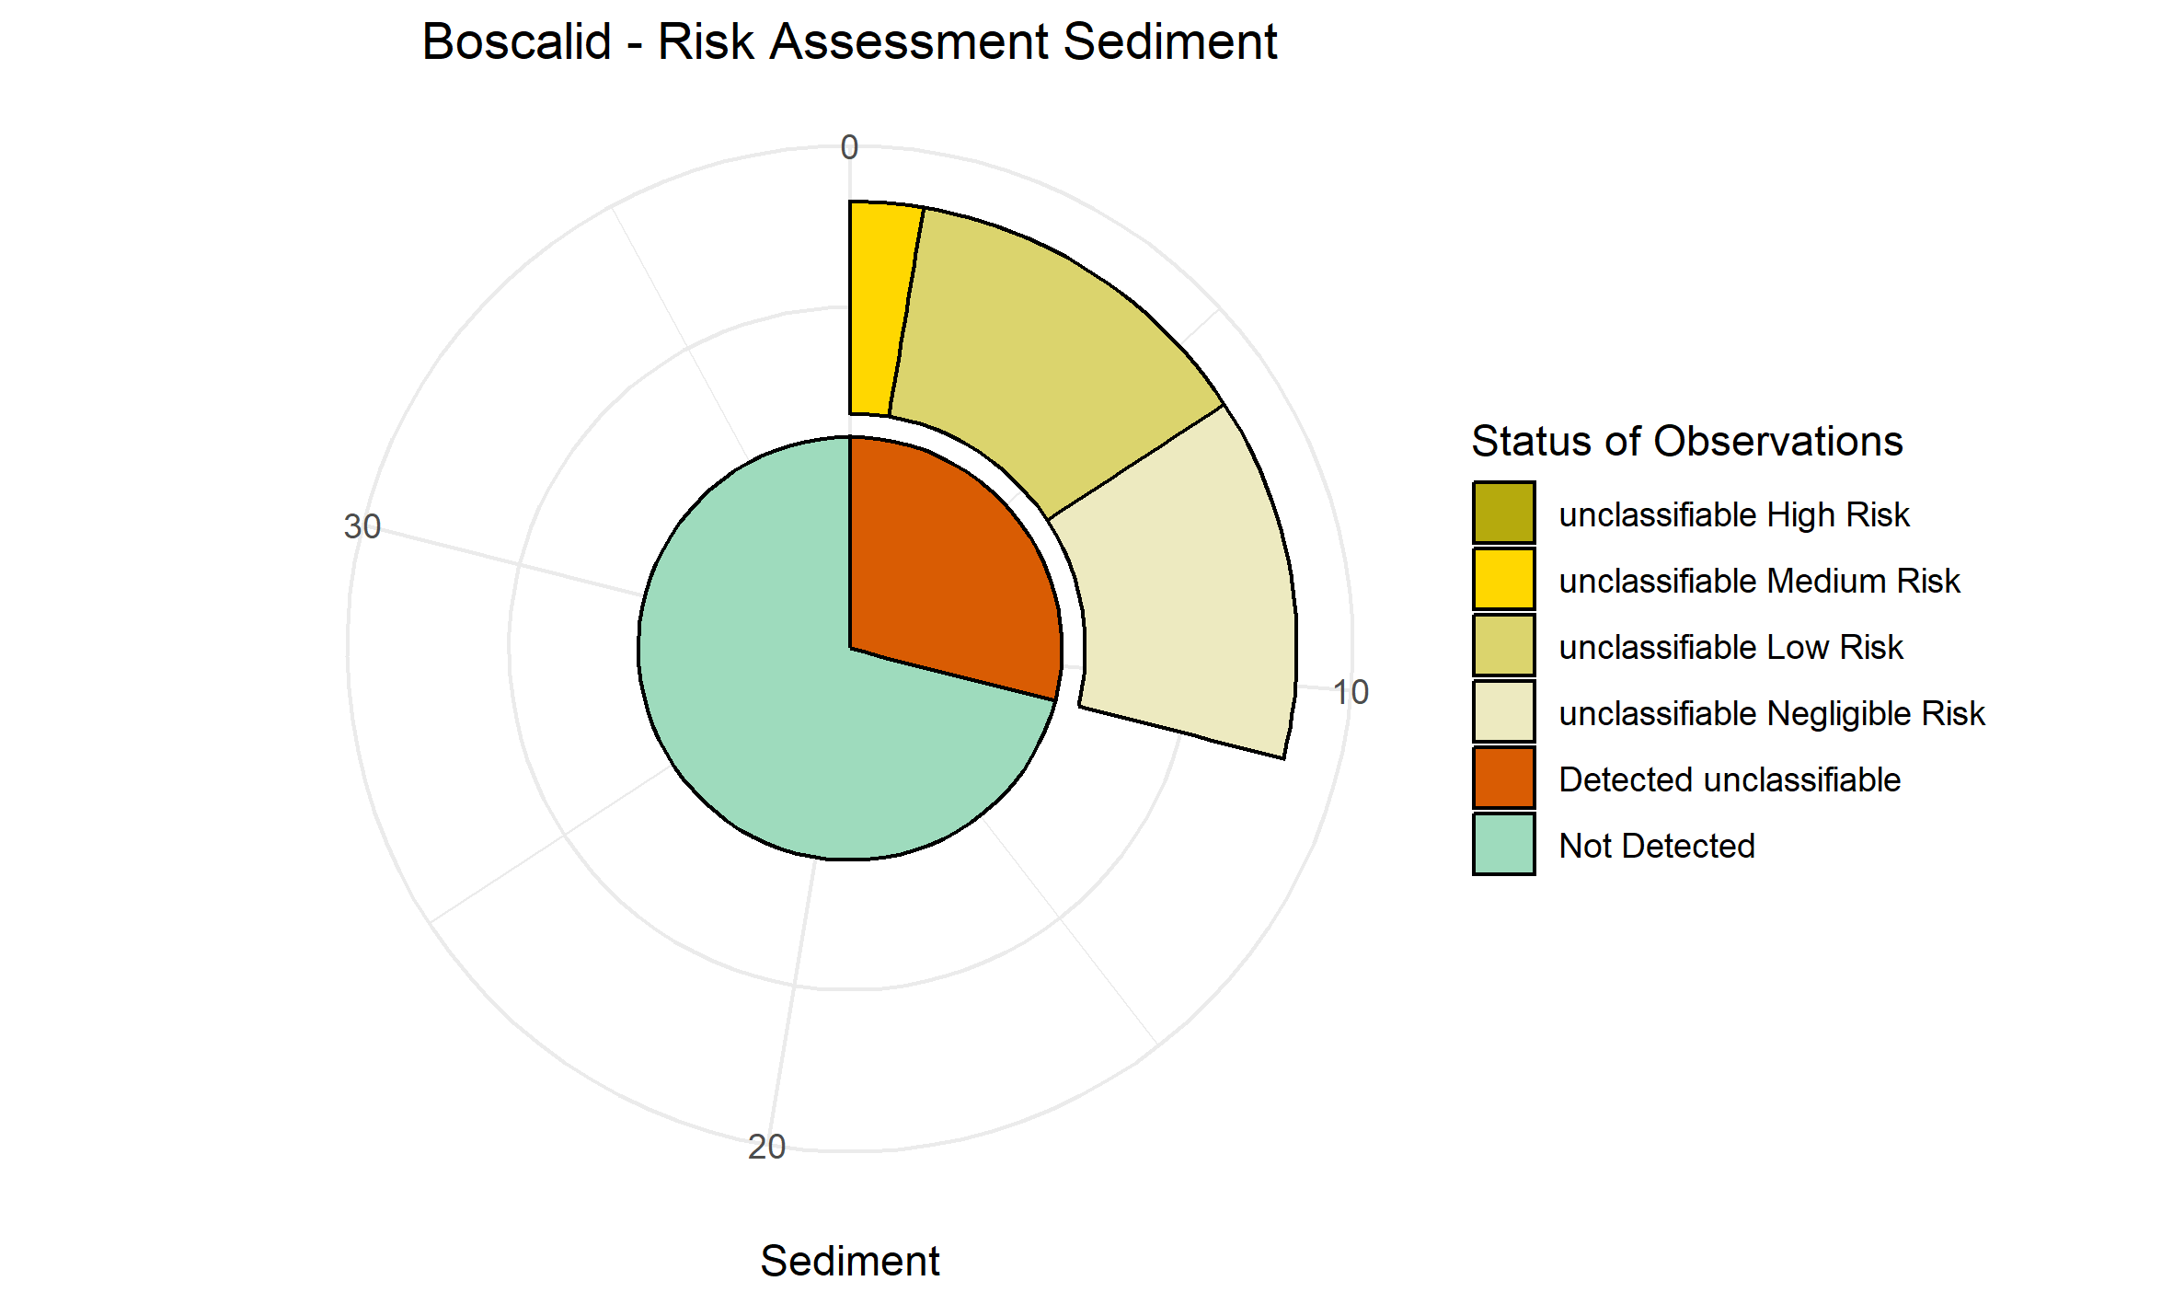
Fluopyram | 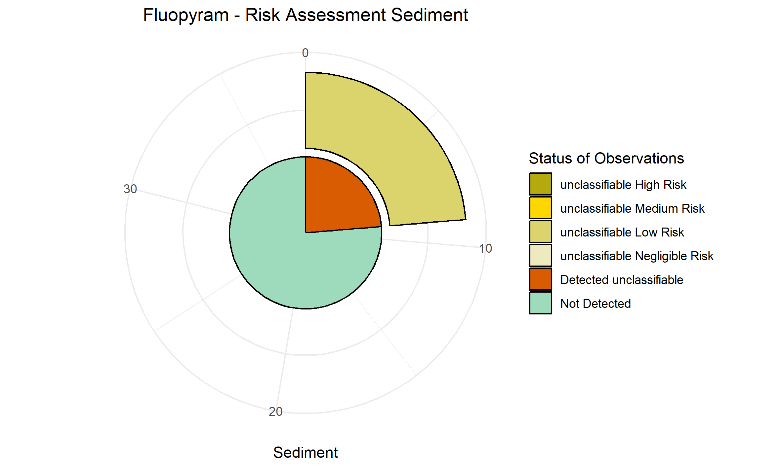
Folpet PHI | 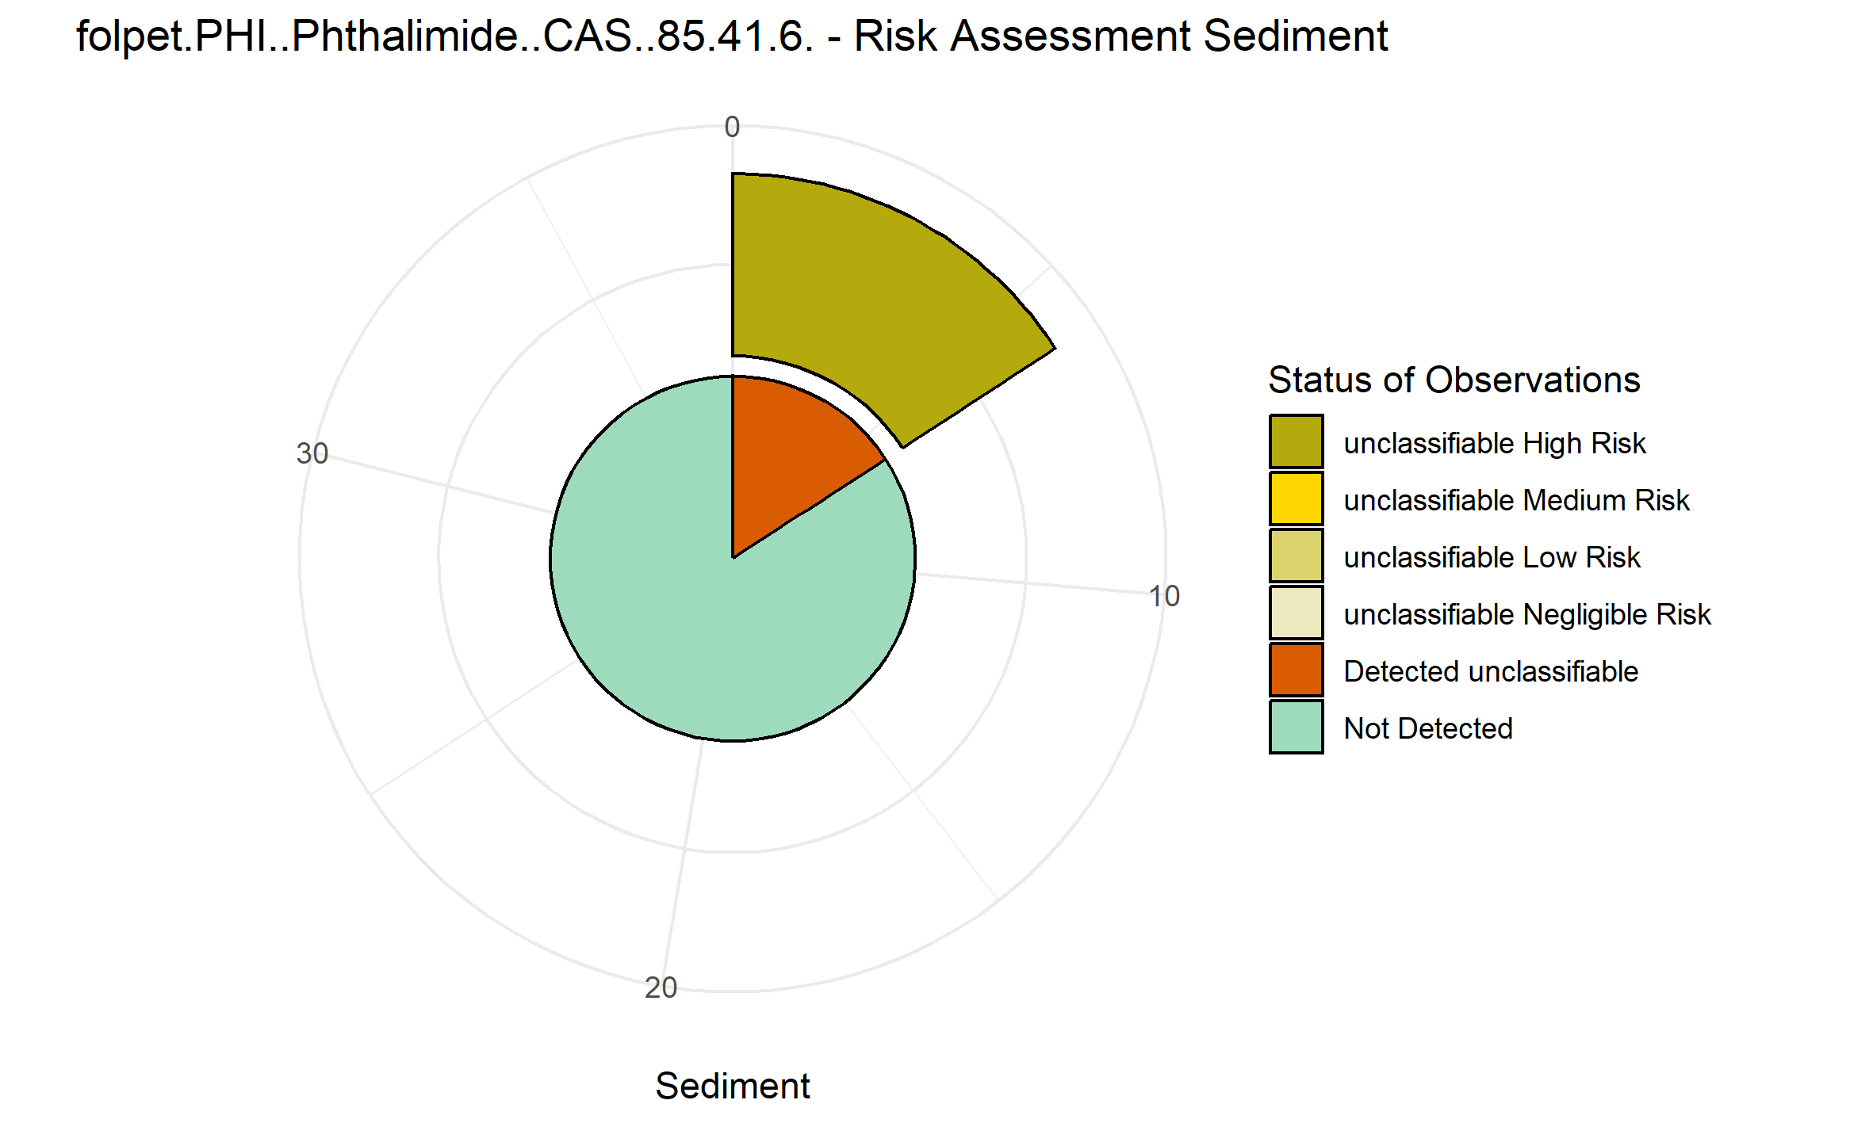
Metalaxyl..M. | 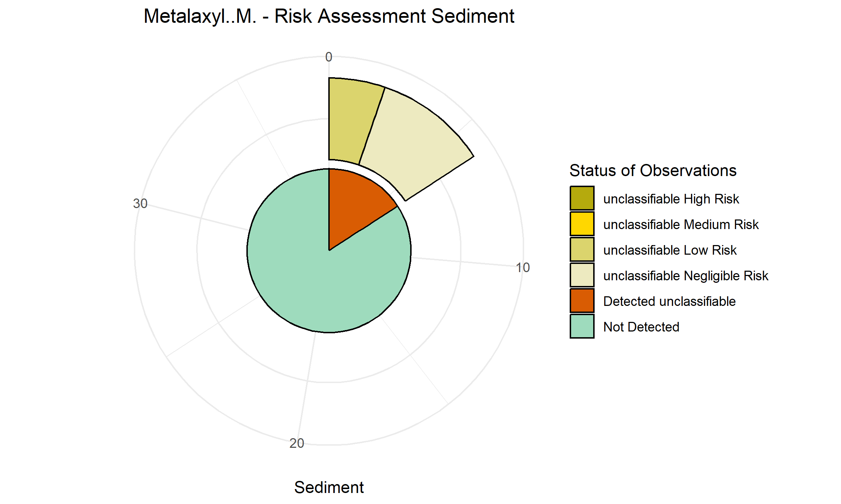
Spiroxamine | 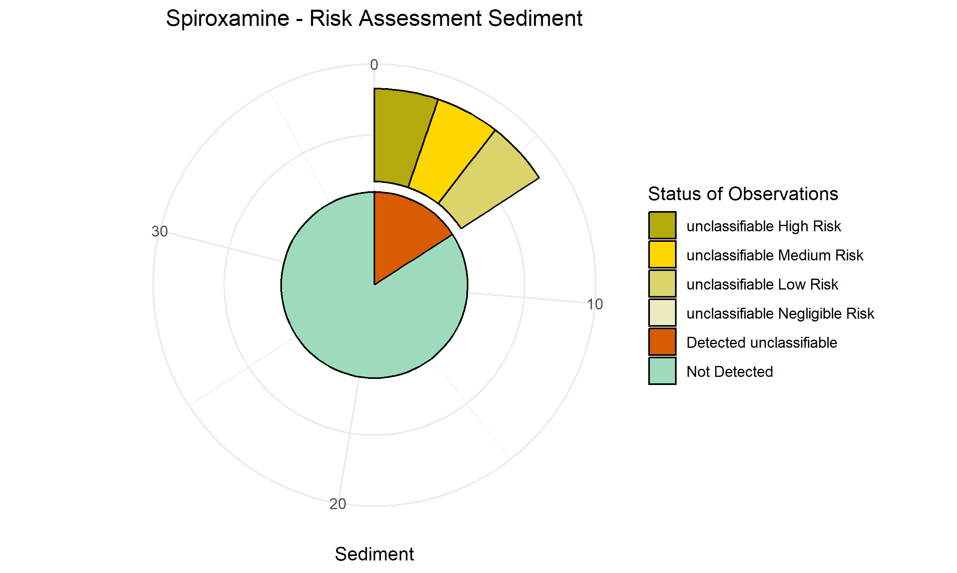
Bixafen | 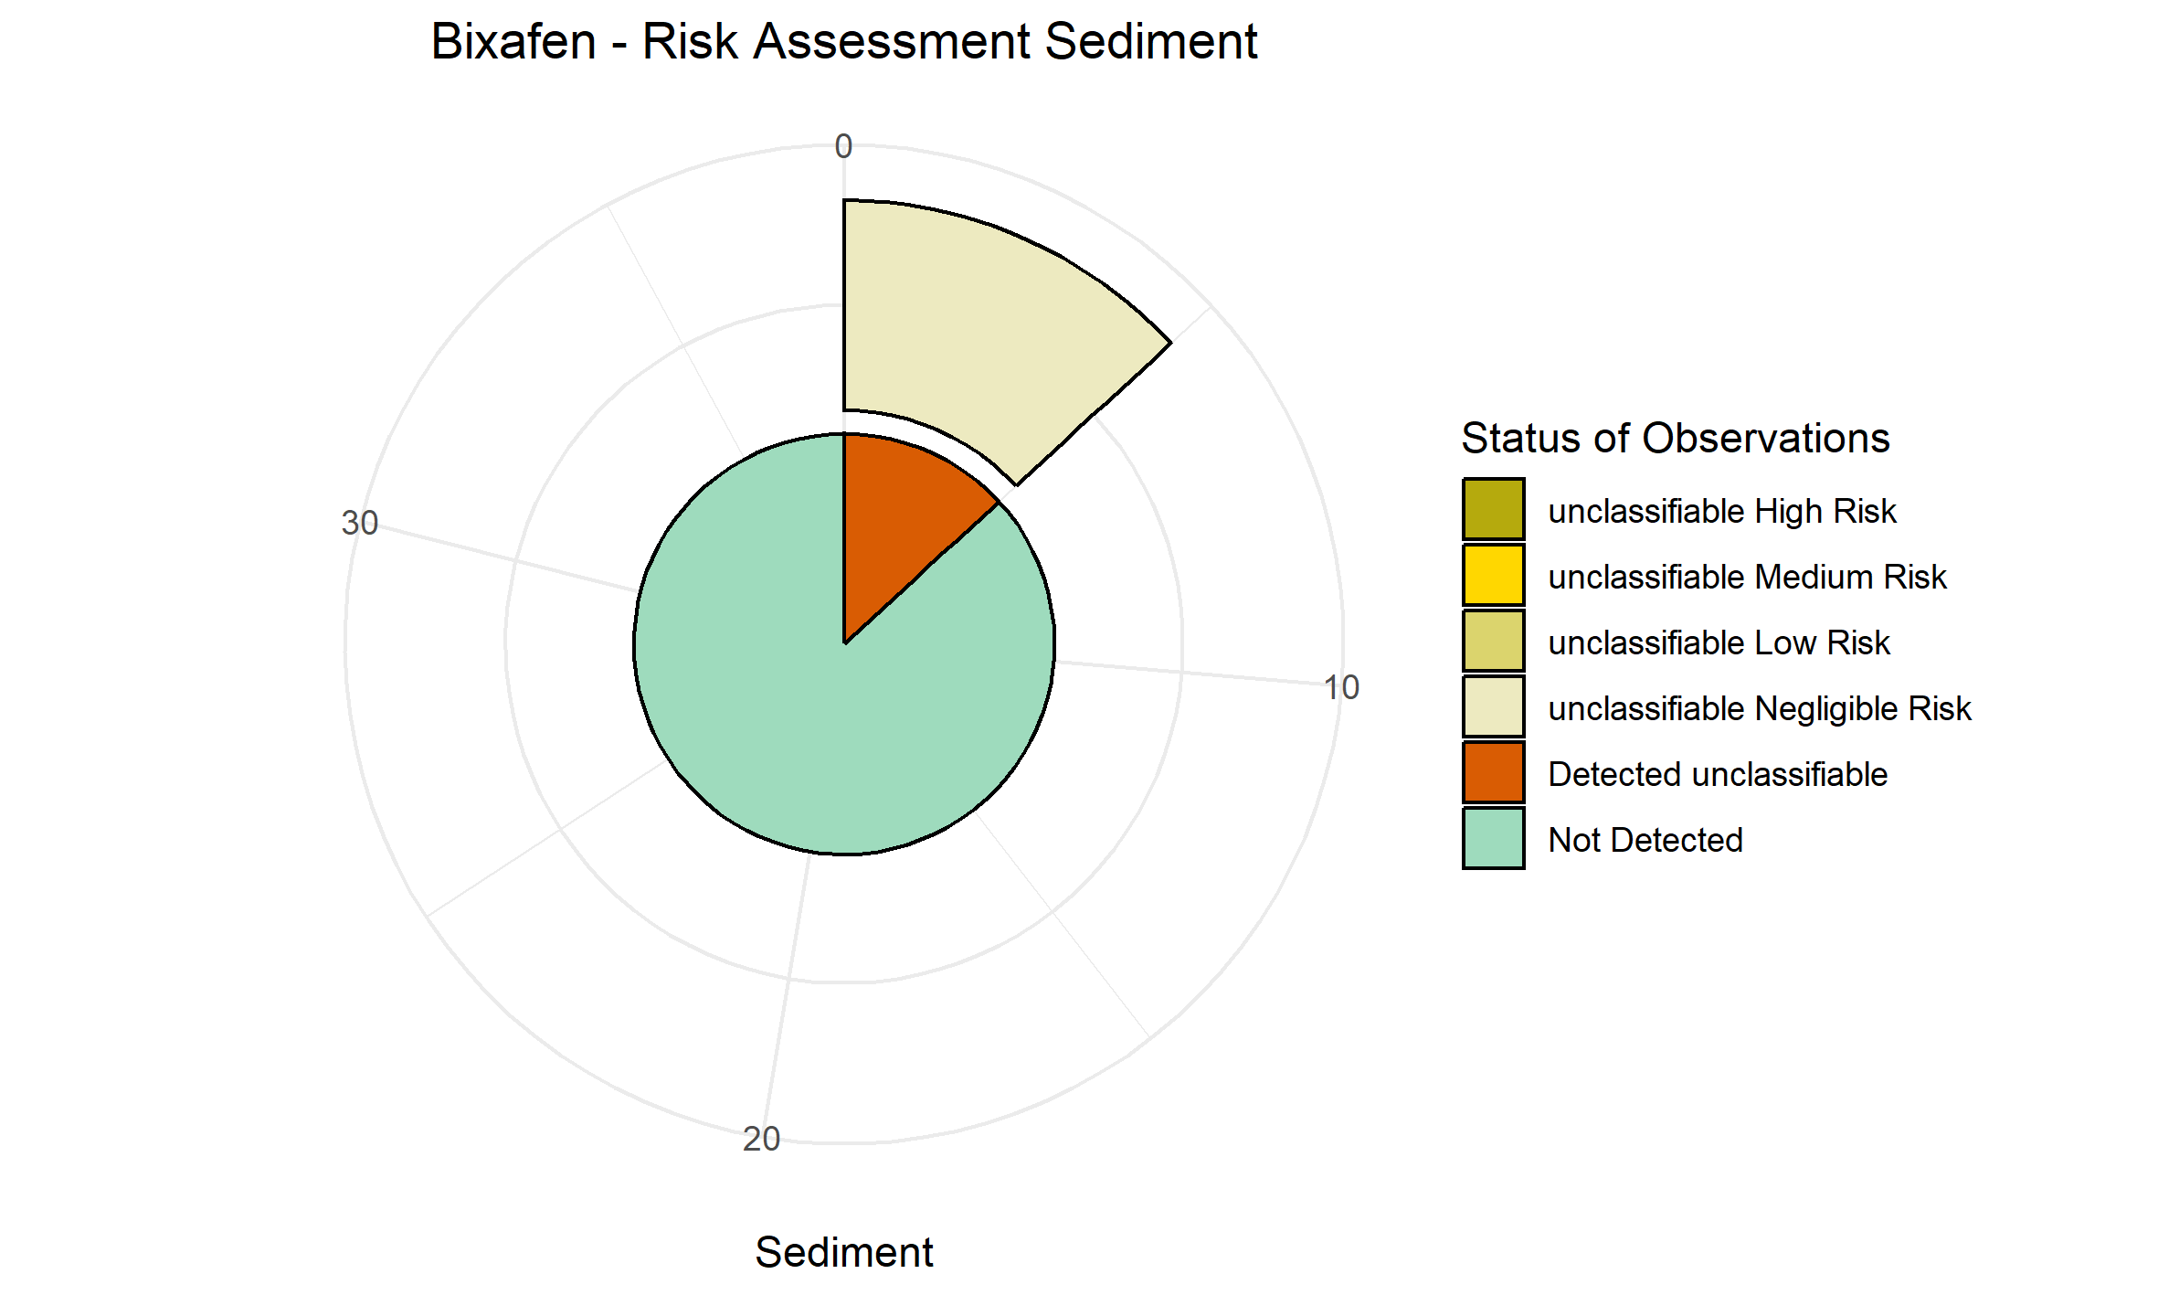
Fenpropidin | NA
Lambda Cyhalothrin | 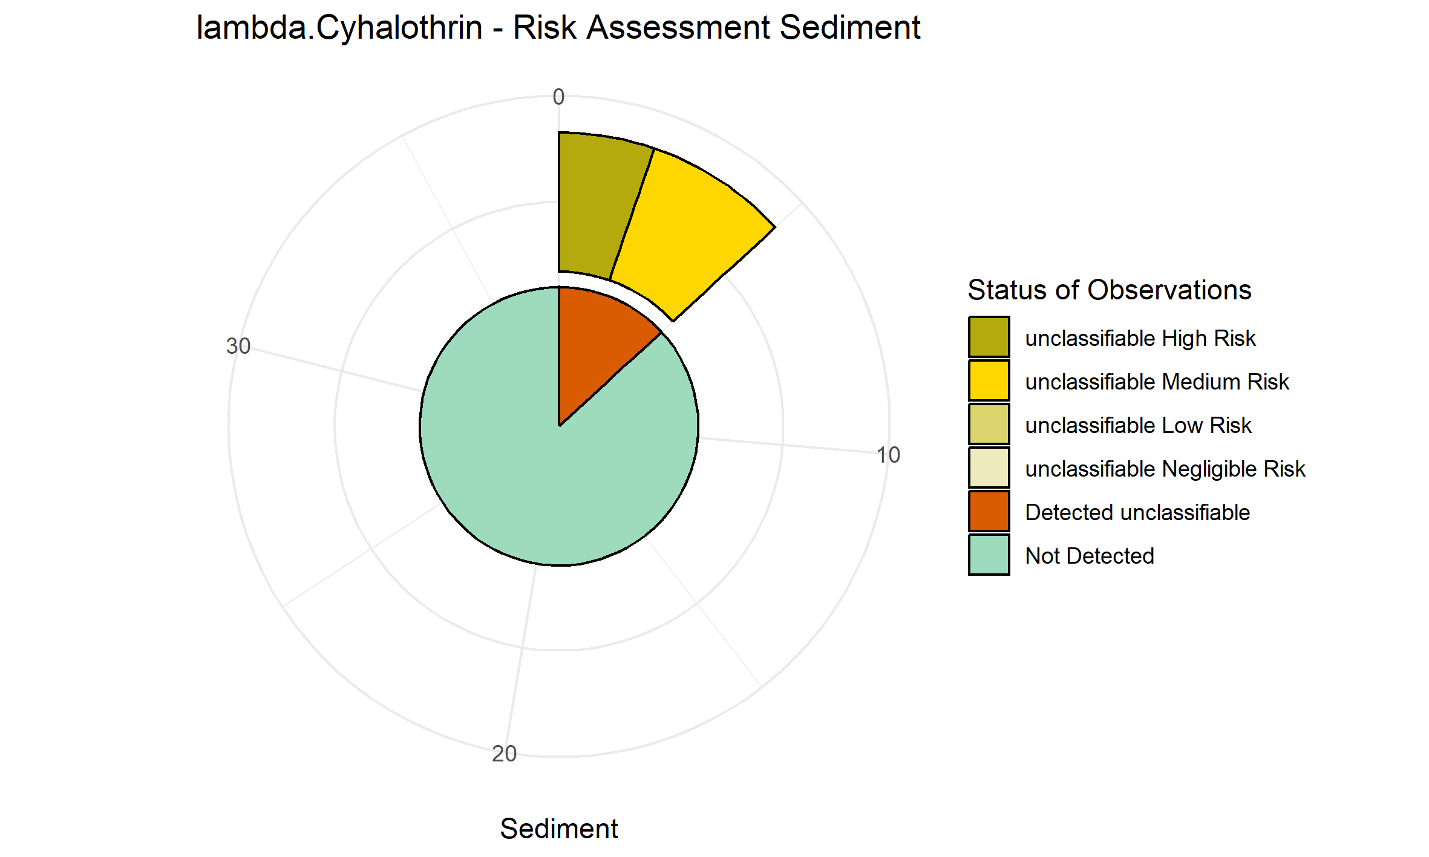
Pendimethalin | NA
Chlorantraniliprole | NA
Cypermethrin | 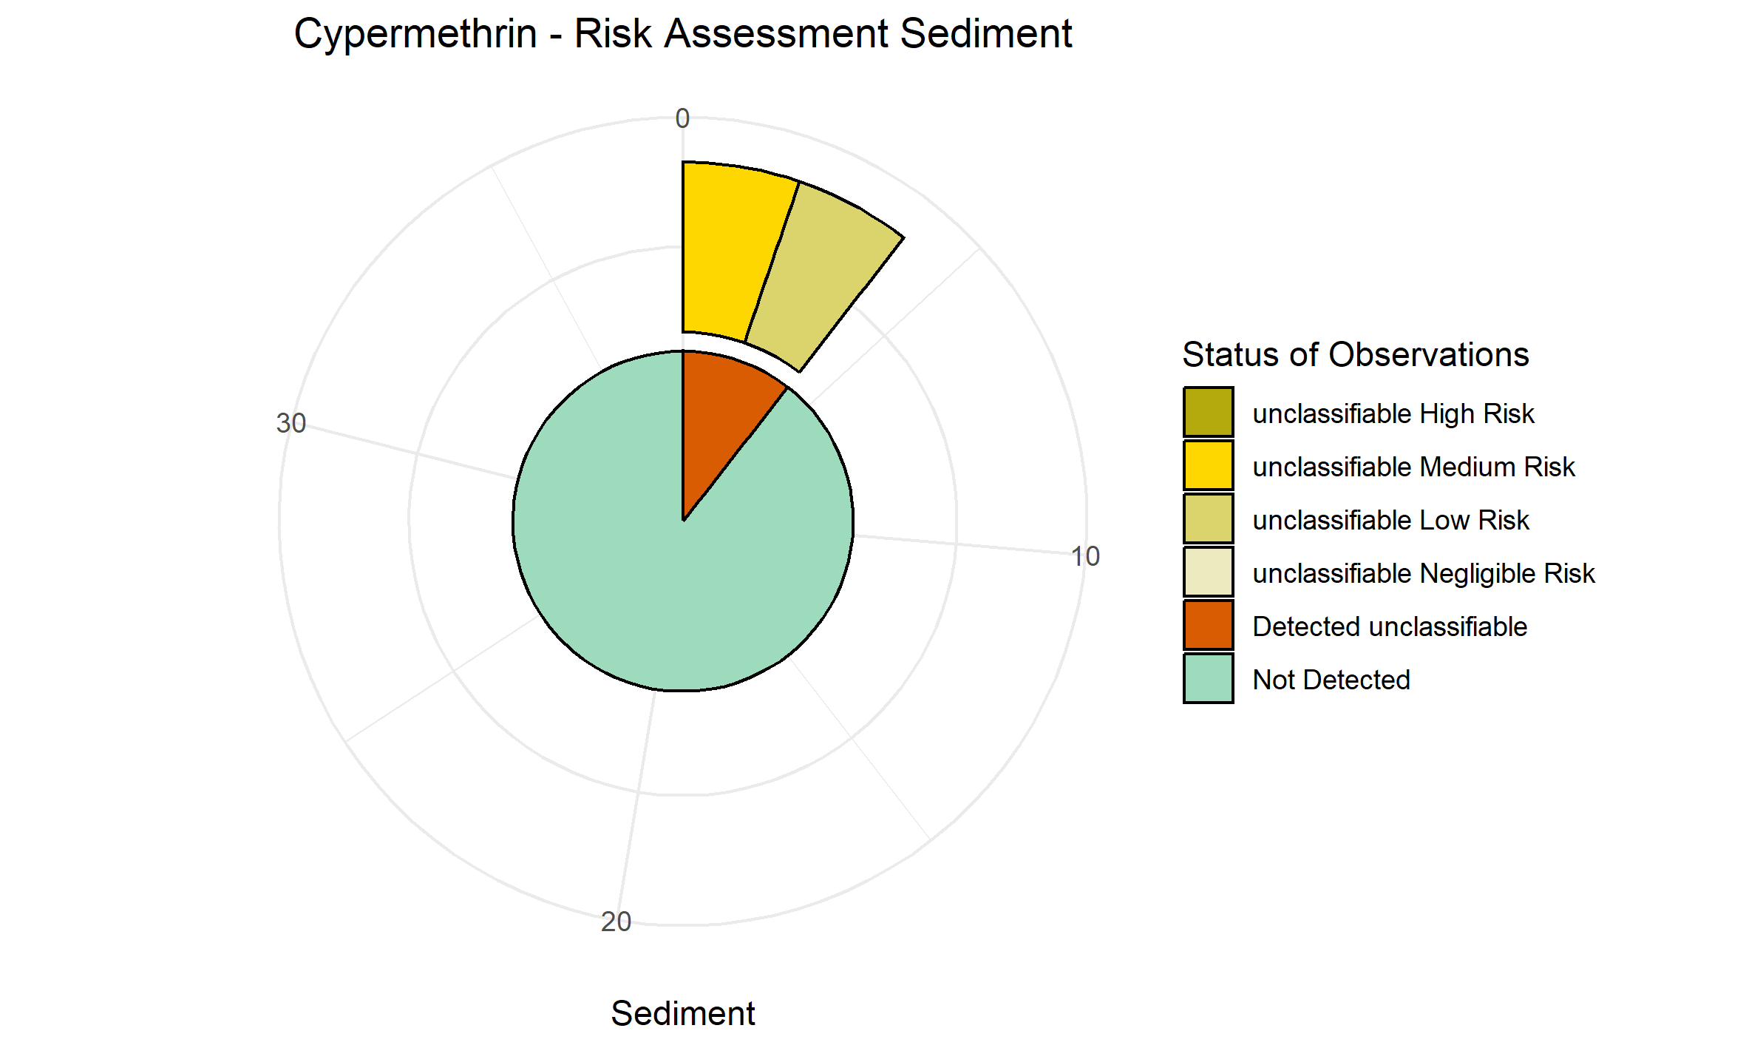
Diflufenican | 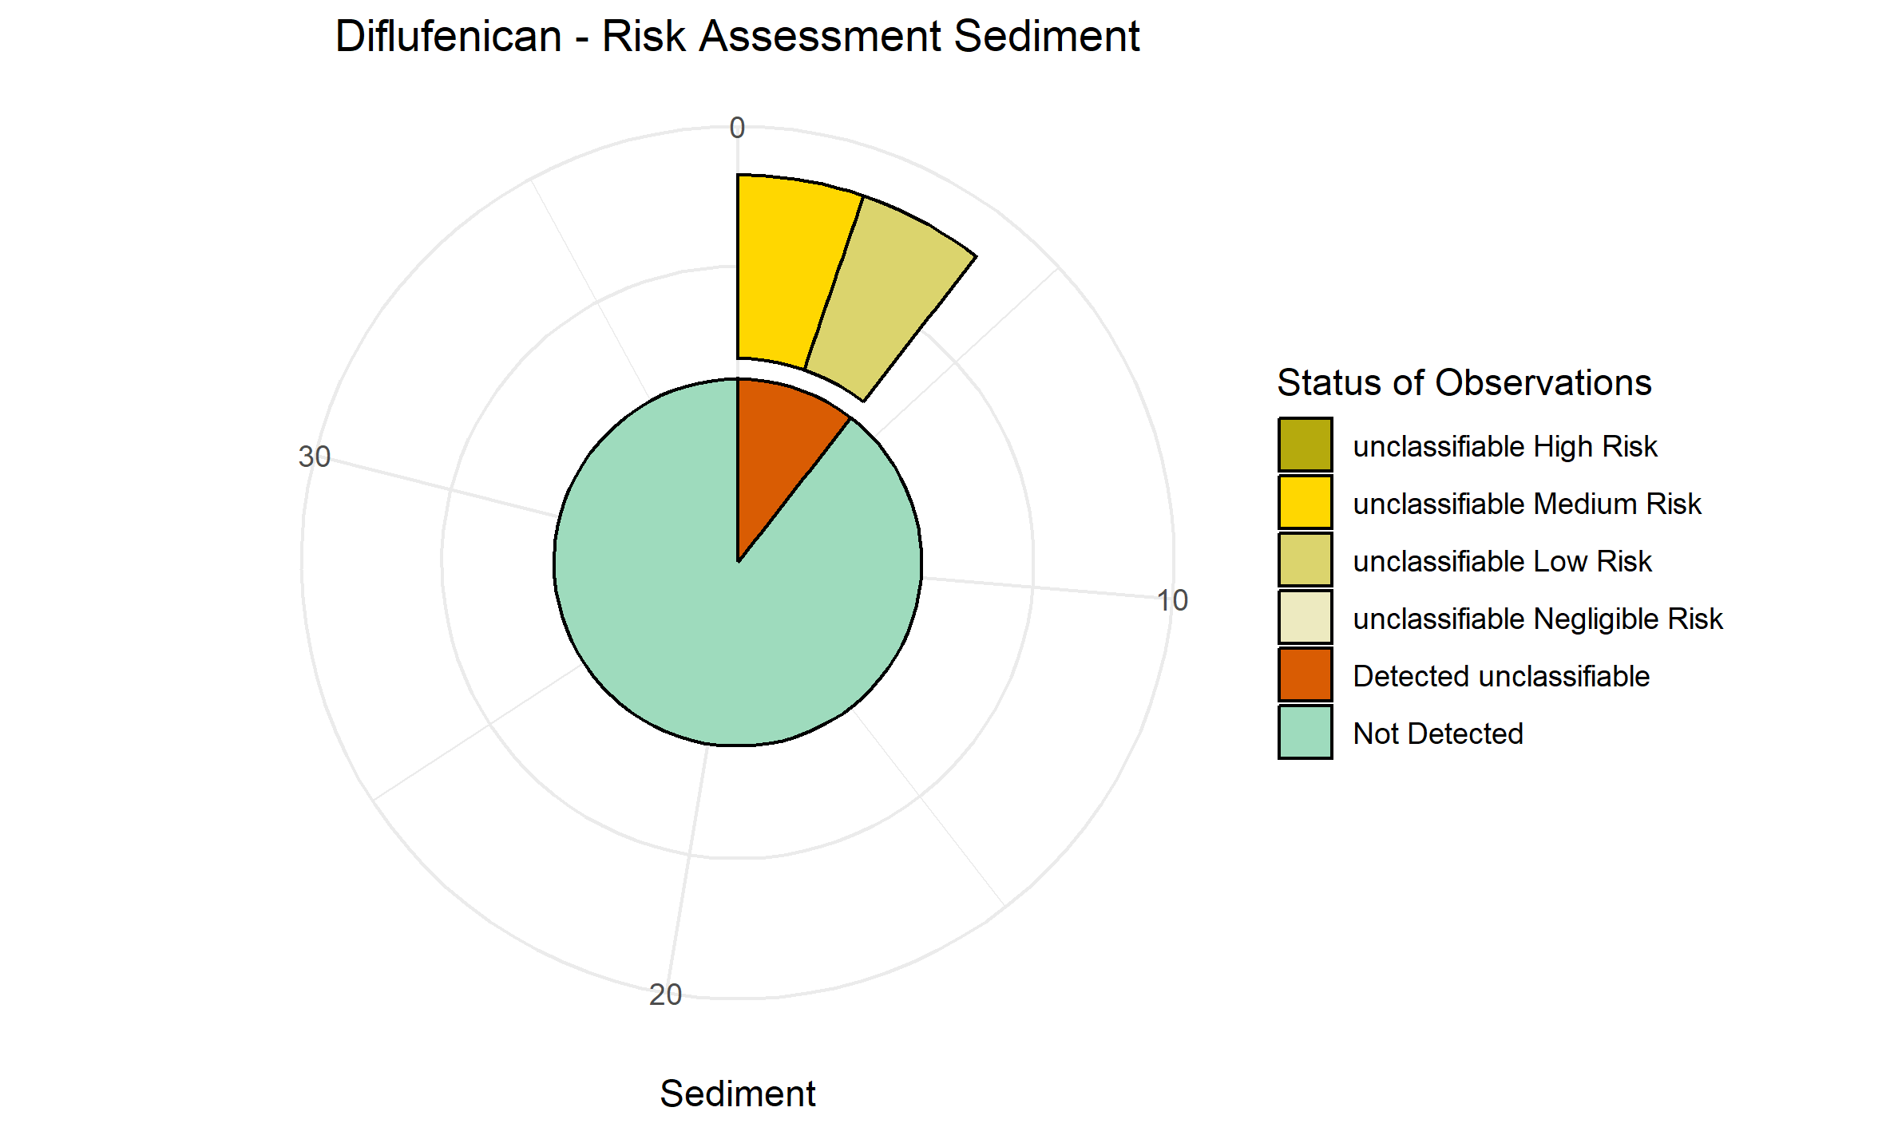
Fluxapyroxad | NA
Imazalil | NA
Metrafenone | NA
NA: not available

SM13 – The most frequently found substances in all matrices: soil, plant, water, and sediment according to their risk frequency
The total percentage of each matrix of both conventional and organic is 100%; substances marked with stars have the sum of the frequencies of occurrence for moderate and high risks greater than 50%; this concerns only the conventional fields except in the case of lindane gamma; The number of stars shows the number of matrices where the substances met the requirement.

SM14 - List of hazard classes for the compounds ranked on the shortlist (moderate to high risk); hazard data is from the PPDB.
Pesticide Resid. | Hazard level | Soil | Crop | Water | Sediment
 |  | Hazard category
Diflufenican | High/yes |  | >Endocrine disruptor  >Neurotoxicant | >Algae - Acute 72hr EC50 growth mg/l  >Algae - Chronic 96hr NOEC mg/l
Diflufenican | Moderate/possible |  | >Carcinogen  >Reproduction/  Development | >Fish - Acute 96hr LC50 mg/l  >Fish - Chronic 21d NOEC mg/l  >Aquatic invertebrates - Acute 48hr EC50 mg/l  > Aquatic invertebrates - Chronic 21d NOEC mg/l  > Aquatic plants - Acute 7d EC50 mg/l | > Bottom-dwelling organisms: Chronic 28d NOEC static water  > Bottom-dwelling organisms: Chronic 28d NOEC sediment
Diflufenican | Low
Diflufenican | Negligible |  | >Mutagen
Difenoconazole | High
Difenoconazole | Moderate/possible | >Earthworms - Acute 14d LC50 mg/kg  >Earthworms - Chronic 14d NOEC reproduction mg/kg |  |  | > Bottom-dwelling organisms: Acute 96hr LC50  > Bottom-dwelling organisms: Chronic 28d NOEC static water  > Bottom-dwelling organisms: Chronic 28d NOEC sediment
Difenoconazole | Low
Difenoconazole | Negligible/no
Terbuthylazine | High
Terbuthylazine | Moderate |  | >Carcinogen  >Reproduction/  Development |  | > Bottom-dwelling organisms: Chronic 28d NOEC static water  > Bottom-dwelling organisms: Chronic 28d NOEC sediment
Terbuthylazine | Low
Terbuthylazine | Negligible |  | >Mutagen
Chlorpyrifos | High | Earthworms - Chronic 14d NOEC reproduction mg/kg |  | >Fish - Acute 96hr LC50 mg/l  >Fish - Chronic 21d NOEC mg/l  >Aquatic invertebrates - Acute 48hr EC50 mg/l  >Aquatic invertebrates - Chronic 21d NOEC mg/l  >Aquatic crustaceans - Acute 96hr LC50 mg/l | > Bottom-dwelling organisms: Acute 96hr LC50  > Bottom-dwelling organisms: Chronic 28d NOEC static water
Chlorpyrifos | Moderate | Earthworms - Acute 14d LC50 mg/kg |  | Aquatic plants - Acute 7d EC50 mg/l  Algae - Acute 72hr EC50 growth mg/l  Algae - Chronic 96hr NOEC mg/l | > Bottom-dwelling organisms: Chronic 28d NOEC sediment
Chlorpyrifos | Low
Chlorpyrifos | Negligible
Lambda-cyhalothrin | High
Lambda-cyhalothrin | Moderate | Earthworms - Acute 14d LC50 mg/kg  Earthworms - Chronic 14d NOEC reproduction mg/kg
Lambda-cyhalothrin | Low
Lambda-cyhalothrin | Negligible
Permethrin | High |  | >Carcinogen  >Endocrine disruptor  >Reproduction/  Development  >Neurotoxicant | >Fish - Acute 96hr LC50 mg/l  > Fish - Chronic 21d NOEC mg/l  >Aquatic invertebrates - Acute 48hr EC50 mg/l  > Aquatic crustaceans - Acute 96hr LC50 mg/l  Algae - Chronic 96hr NOEC mg/l
Permethrin | Moderate |  |  | Algae - Acute 72hr EC50 growth mg/l
Permethrin | Low
Permethrin | Negligible
Acetamiprid | High | Earthworms - Acute 14d LC50 mg/kg
Acetamiprid | Moderate | Earthworms - Chronic 14d NOEC reproduction mg/kg
Acetamiprid | Low
Acetamiprid | Negligible
Deltamethrin | High
Deltamethrin | Moderate | Earthworms - Acute 14d LC50 mg/kg  Earthworms - Chronic 14d NOEC reproduction mg/kg
Deltamethrin | Low
Deltamethrin | Negligible
Hexachlorobenzene | High |  | >Carcinogen  >Endocrine disruptor  >Neurotoxicant
Hexachlorobenzene | Moderate |  | >Mutagen  >Reproduction/  Development
Hexachlorobenzene | Low
Hexachlorobenzene | Negligible
Atrazine | High |  | >Endocrine disruptor
Atrazine | Moderate |  | >Carcinogen  >Reproduction/  Development  >Neurotoxicant
Atrazine | Low
Atrazine | Negligible
Lindane gamma* | High |  | >Endocrine disruptor  >Neurotoxicant
Lindane gamma* | Moderate |  | >Carcinogen  >Reproduction/  Development
Lindane gamma* | Low
Lindane gamma* | Negligible
Prosulfocarb | High |  | >Neurotoxicant
Prosulfocarb | Moderate
Prosulfocarb | Low  Negligible |  | >Carcinogen  >Mutagen  >Reproduction/  Development
Fludioxonil | High |  |  | >Aquatic invertebrates - Chronic 21d NOEC mg/l
Fludioxonil | Moderate |  |  | >Fish - Acute 96hr LC50 mg/l  >Fish - Chronic 21d NOEC mg/l  >Aquatic invertebrates - Acute 48hr EC50 mg/l  >Aquatic crustaceans - Acute 96hr LC50 mg/l  >Aquatic plants - Acute 7d EC50 mg/l  >Algae - Acute 72hr EC50 growth mg/l
Fludioxonil | Low
Fludioxonil | Negligible
Spiroxamine | High
Spiroxamine | Moderate |  |  |  | > Bottom-dwelling organisms: Chronic 28d NOEC static water  > Bottom-dwelling organisms: Chronic 28d NOEC sediment
Spiroxamine | Low
Spiroxamine | Negligible
Zoxamide | High |  |  | >Fish - Chronic 21d NOEC mg/l
Zoxamide | Moderate |  |  | >Fish - Acute 96hr LC50 mg/l  >Aquatic invertebrates - Acute 48hr EC50 mg/l  >Aquatic invertebrates - Chronic 21d NOEC mg/l  >Aquatic plants - Acute 7d EC50 mg/l  >Algae - Acute 72hr EC50 growth mg/l
Zoxamide | Low
Zoxamide | Negligible
Bifenthrin | High |  |  | >Fish - Acute 96hr LC50 mg/l  >Fish - Chronic 21d NOEC mg/l  >Aquatic invertebrates - Acute 48hr EC50 mg/l  >Aquatic invertebrates - Chronic 21d NOEC mg/l  >Aquatic crustaceans - Acute 96hr LC50 mg/l
Bifenthrin | Moderate |  |  | >Algae - Acute 72hr EC50 growth mg/l
Bifenthrin | Low |  |  | Algae - Chronic 96hr NOEC mg/l
Bifenthrin | Negligible
Terbutryn | High
Terbutryn | Moderate |  |  | Fish - Acute 96hr LC50 mg/l  Aquatic invertebrates - Acute 48hr EC50 mg/l
Terbutryn | Low
Terbutryn | Negligible
Cypermethrin | High |  |  |  | > Bottom-dwelling organisms: Acute 96hr LC50
Cypermethrin | Moderate
Cypermethrin | Low
Cypermethrin | Negligible

For some substances, hazard data is not available in the PPDB, in which case it is not reported here either; the hazard level is defined for the ecosystem as hazard class: high, moderate, low), and for humans as evidence level: yes, possible, no.

