Design, integration and manufacturing of the MEBT and DPlate support frames for IFMIF LIPAc

Oriol Nomenª, Jesús Castellanos^{b}, David Jimenez Rey^{b}, Ivan Podadera^{b}

ªIREC, Jardins de les Dones de Negre, 1, 2ª, 08930, Sant Adrià de Besòs, Barcelona, Catalonia, Spain
^{b}CIEMAT, Avenida Complutense, 40, 28040, Madrid, Spain

The International Fusion Materials Irradiation Facility (IFMIF) [1] aims to provide an accelerator-based, D-Li neutron source to produce high energy neutrons at sufficient intensity and irradiation volume for DEMO materials qualification. As part of the Broader Approach (BA) agreement between Japan and EURATOM, the goal of the IFMIF/EVEDA project is to work on the engineering design of IFMIF and to validate the main technological challenges which, among a wide diversity of hardware includes the LIPAC (Linear IFMIF Prototype Accelerator) [2], a 125mA CW deuteron accelerator up to 9 MeV mainly designed and manufactured in Europe.

The Medium Energy Beam Transport line (MEBT) [3, 4] is in charge of the beam transport at 5 MeV/125 mA and matching beam parameters between two acceleration structures, the RadioFrequency Quadrupole (RFQ) and the Superconducting RF linear accelerator (SRF Linac), while the Diagnostic Plate (DPlate) [5] is a movable module with a set of diagnostics and instrumentations in charge of characterize the beam in the different accelerator commissioning stages (RFQ commissioning, SRF Linac commissioning) and provide accelerator operational parameters. Both beamline designs are state of art, being a real engineering (and mechanical) challenge, due to the compactness and alignment requirements from beam dynamics, and the seismic requirements from the accelerator site. An optimized design is critical in order to reduce beam losses and production of radiation at high power beam.

The present paper summarizes the mechanical design and analysis of the MEBT and Diagnostic Plate support frames, as well as their manufacturing solutions and mechanical integration with the components installed both in the MEBT and Diagnostic Plate. The mechanical design and integration shows the engineering development, adopted to fulfill the strict structural, seismic and alignment requirements.

Keywords: IFMIF, LIPAc, mechanical design, integration, manufacturing.

1. Introduction
The aim of this publication is to summarize the mechanical design and analysis of the MEBT and Diagnostic Plate support frames, as well as their manufacturing solutions and the mechanical integration with the components installed in both systems.
First, the mechanical design, integration and analysis are exposed and checked. After that, the manufacturing techniques and assembly solutions, developed to fulfill the design and integration requirements, are shown.
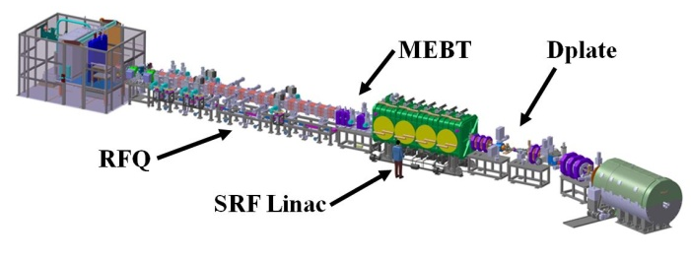
Fig. 1. General view of the MEBT and DPlate in the LIPAc accelerator.

2. Mechanical design and integration
The requirements for the mechanical design of the MEBT and DPlate support frames can be divided in structural, seismic, alignment and compactness of the beamline requirements.
Regarding the structural requirements, the support frames must withstand the weight of the components over the system with small deformations in normal operation of the facility. There, the gravity acceleration applied to the weight of each of the components of the systems is the only load required.
In addition to the structural conditions, a 0.4·g horizontal acceleration and a 0.2·g vertical acceleration applied to the weight of each of the components of the system must be withstood by the support frames in order to fulfill the seismic requirements [6].
The alignment requirements state that all components have to be aligned with an overall accuracy with respect to the Global Coordinate System lower than 100 µm in order to fulfill the performance of focusing magnets, bunchers and diagnostics [7].
In order to achieve the conditions stated above, both MEBT and DPlate contain a structural global frame made of austenitic stainless steel 316 and several supports of components (nine in the MEBT and nine in the DPlate) of the same material distributed along the beam direction and positioned very tight together.
Furthermore, all the components are fixed with locking bolts, avoiding any movement in case of seismic accelerations.
Each component of the system is held by an individual support that can move the component in six degrees of freedom (translation and rotation in three axes) while it is fixed to a common frame that can position all the system in six degrees of freedom as well. The screws that move the alignment supports and the common frame have fine tuning pitches, from 0.5 mm to 1.5 mm, in order to ease the accomplishment of the accuracy requirements.
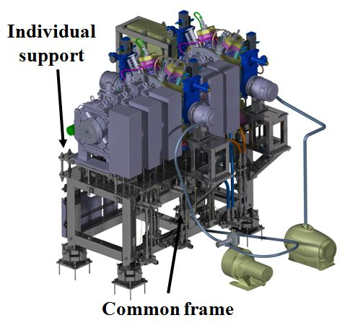
Fig. 2. Common frame and individual supports of the MEBT.
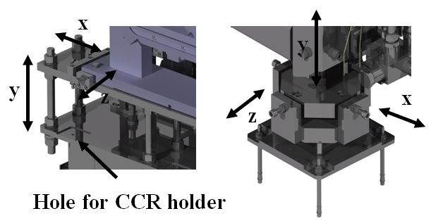
Fig. 3. Alignment screws for individual supports (left) and for the common frames and detail of holes for CCR holders.
Fine machined holes for CCRs (Corner Cube Reflectors) holders have been implemented in each component of the systems, as well as in some areas of the common frames, most importantly in the horizontal plate where the individual supports are fixed. The CCRs in the components are placed in order to know the position of the centerline axis of each component by surveying the position of the CCRs with metrology measurement equipments, while CCRs in the common frames are used to define the Local Control System in the prealignment tasks of the systems and in the movement of whole systems, i. e. installation of the systems in a temporary or final location.
Due to the large amount of components located through the beam axis direction in both systems, the mechanical integration has become a challenging issue, resulting in slim individual supports in beam axis direction that needed a careful review to achieve small deformations.
One particular case of this tight integration is the section of the MEBT containing one quadrupole magnet with a beam position monitor (BPM) located through the beam aperture but fixed to the subjacent scraper. The radial clearance between the quadrupole poles and the BPM is 0.05 mm in nominal and theoretical position. Taking into account that the quadrupole is aligned with its individual support and the BPM is aligned with the scraper support, the assembly of this section needed a careful procedure with the use of laser tracker and metal gauges.
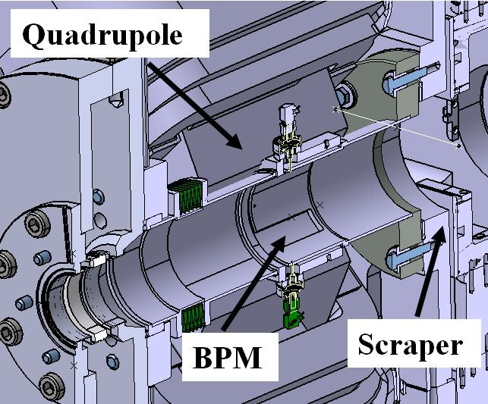
Fig. 4. Cross section of the quadrupole magnet and the beam profile monitor.

3. Mechanical analysis
Structural FEM analyses have been performed to assess the behavior of the MEBT and DPlate support frames.
The boundary conditions for these analyses are as follows:
For normal operation analyses, the foot supports of the frames are fixed, the weight of each component is attached to its individual support and the gravitational acceleration is placed to all the components of the system. While in Seismic Constraints [6], a vertical acceleration of 0.2·g and a horizontal acceleration of 0.4·g is added to the Normal Operation boundary conditions.
The following tables show the results for each individual component support of the systems and for the common frame.
Table 1. Results for the mechanical analysis of the MEBT support table in normal operation.
MEBT Support | Normal Operation
MEBT Support | σ (MPa) | Max. Deformation (mm) | Safety factor
Magnet | 12.8 | 0.015 | 16
Scraper | 26.4 | 0.048 | 7.8
Buncher | 16 | 0.008 | 12.8
Turbo pump | 29.5 | 0.03 | 6.9
Ion pump | 27.9 | 0.03 | 7.3
Vacuum chamber | 3.1 | 0.003 | 66.1
Frame | 89.6 | 0.17 | 2.3

Table 2. Results for the mechanical analysis of the MEBT support table with seismic constraints.
MEBT Support | Seismic Constraints
MEBT Support | σ (MPa) | Max. Deformation (mm) |  | Safety factor
Magnet | 67.4 | 0.132 | 3
Scraper | 45.9 | 0.135 | 4.5
Buncher | 66.5 | 0.045 | 3.1
Turbo pump | 48.3 | 0.09 | 4.2
Ion pump | 79.8 | 0.23 | 2.6
Vacuum chamber | 28.1 | 0.1 | 7.3
Frame | 145.8 | 0.53 | 1.5

Table 3. Results for the mechanical analysis of the DPlate support table in normal operation.
DPlate Support | Normal Operation
DPlate Support | σ (MPa) | Max. Deformation (mm) | Safety factor
DBPM | 4 | 0.004 | 51.3
Slits and Ion Pumps | 63.5 | 0.077 | 3.2
RGBLM-CT | 23.5 | 0.064 | 8.7
DBPM2 | 5.7 | 0.004 | 36
FPM-IPM | 9.8 | 0.001 | 20.9
SEM Grid | 26 | 0.066 | 7.9
Frame | 35.8 | 0.202 | 5.7

Table 4. Results for the mechanical analysis of the DPlate support table with seismic constraints.
DPlate Support | Seismic Constraints
DPlate Support | σ (MPa) | Max. Deformation (mm) | Safety factor
DBPM | 18.9 | 0.032 | 10.8
Slits and Ion Pumps | 79 | 0.106 | 2.6
RGBLM-CT | 59 | 0.150 | 3.5
DBPM2 | 30.4 | 0.018 | 6.7
FPM-IPM | 26.6 | 0.046 | 7.7
SEM Grid | 51.2 | 0.140 | 4
Frame | 73.7 | 0.405 | 2.8

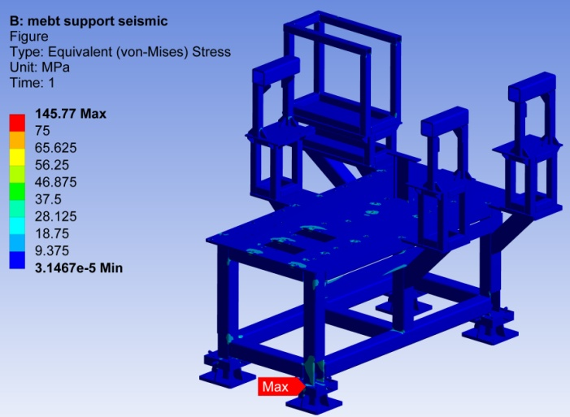
Fig. 5. Equivalent Von Misses Stress for the MEBT support table.
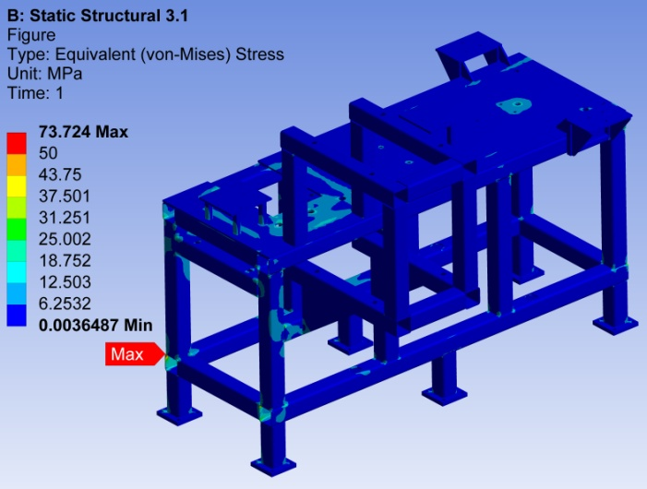
Fig. 6. Equivalent Von Misses Stress for the DPlate support table.
Both support frames show a robust behavior under the loads applied, ensuring their structural performance. In the worst cases, peak tensions of 145.8 MPa in MEBT and 73.7 MPa in DPlate appear. Both tensions are far below from the yield strength of the austenitic stainless steel 316 (205 MPa) [8]. Moreover, these peaks are localized and the vast majority of the frames are under 50 MPa.

4. Manufacturing and assembly
The parts of MEBT and DPlate support frames have been manufactured using standard machining operations, such as lathing, milling and drilling in Nortemecánica and CIEMAT workshops. These manufactured parts have been joined together by TIG welding and bolted joints.
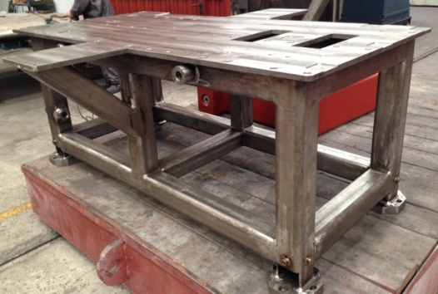
Fig. 7. Manufacturing of the MEBT support table.
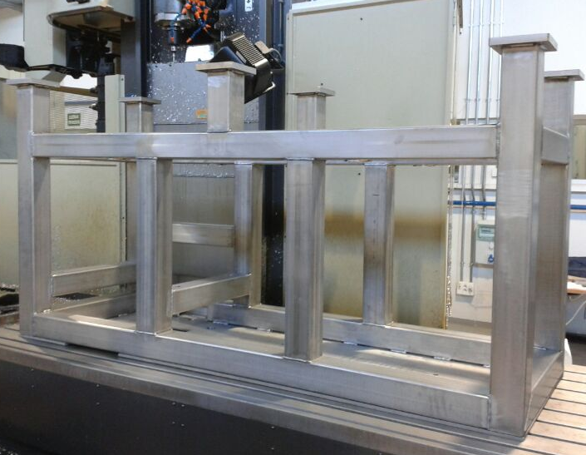
Fig. 8. Manufacturing of the DPlate support table.
All the components to be installed in the MEBT and DPlate support frames have been surveyed with metrology equipments, such as a Coordinate Measuring Machine (CMM) and a metrology arm, in order to know the exact position of the centerline axis of the component in relation to the position of the holes for CCR holders.
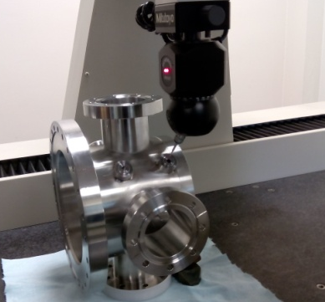
Fig. 9. Survey of a DPlate vacuum chamber with a CMM.
Several assembly campaigns have been carried out demonstrating the feasibility to mount all the components together and to accomplish the accuracy requirements for their position. The assembly of tight sections of the systems, with low clearance between components, was successfully performed too [9].
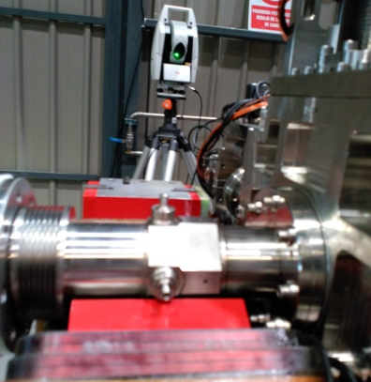
Fig. 10. Quadrupole magnet, vacuum chamber with BPM and scraper during a MEBT assembly campaign.

5. Conclusions
MEBT and DPlate support frames have been designed, analyzed, manufactured and tested successfully. As part of the MEBT and DPlate systems, they will be commissioned at Rokkasho (Japan) in the framework of the Phase B of the IFMIF LIPAc accelerator.
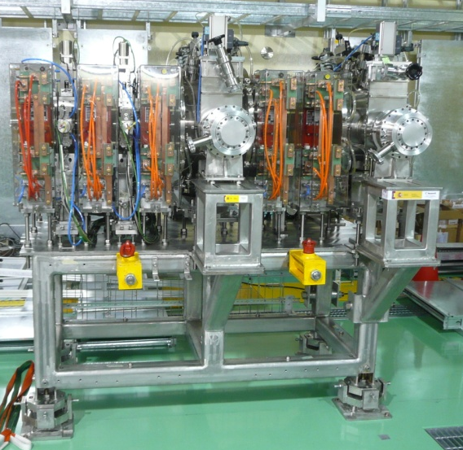
Fig. 11. General view of the MEBT.
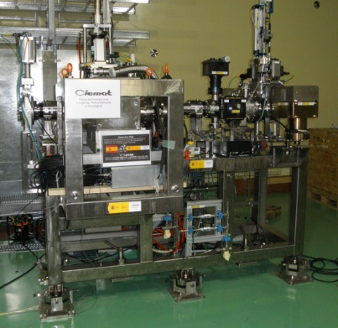
Fig. 12. General view of the DPlate.
The design, integration and manufacturing of the MEBT and DPlate support frames, as well as the assembly and alignment of the MEBT and DPlate whole systems, have led to several lessons learned and future improvements that will be implemented in future facilities such as an Early Neutron Source (ENS) [10] or IFMIF [1].

Acknowledgments
We would like to express our sincere gratitude to Nortemecánica and CIEMAT workshops, involved in the manufacturing, and also to the F4E Metrology Team for their help during assembly campaigns.
This work has been supported by the Spanish Ministry of Economy and Competitiveness in the frame of the BA Agreement Activities.

References
- J. Knaster et al., IFMIF, the European–Japanese efforts under the Broader Approach agreement towards a Li(d,xn) neutron source: Current status and future options, Nuclear Materials and Energy, 000 (2016) 1-9.
- P. Cara et al., The Linear IFMIF Prototype Accelerator (LIPAC) Design Development under the European-Japanese Collaboration, Proceedings of IPAC’16, pp. 985-988.
- I. Podadera et al., Manufacturing, assembly and test of the LIPAc Medium Energy Beam Transport Line (MEBT), presented at LINAC’16, September 2016.
- I. Podadera et al., The Medium Energy Beam Transport Line (MEBT) of IFMIF/EVEDA LIPAc, Proceedings of IPAC’11, pp. 2628-2630.
- J. Marroncle et al., IFMIF-LIPAc diagnostics and its challenges, Proceedings of IBIC’12, Tsukuba, Japan.
- K.. Shinto et al., Aseismic requirements for installation of components in Japan, IFMIF-EVEDA Report BA_D_22MEY3, 2012.
- F. Scantamburlo et al., Alignment of LIPAc, the IFMIF prototype high current deuteron accelerator: requirements and current status, Proceedings of IWAA’2014, Beijing, China.
- 2010 ASME Boiler and Pressure Vessel Code, Section 2, Part D, Properties (Metrics) Materials. July 2010.
- D. Gex et al., Engineering issues of the medium energy beam transport line and SRF Linac for the LIPAc, Proceedings of IPAC’2016, Busan, Korea.
- R. Heidinger et al., Technical analysis of an early fusion neutron source based on the enhancement of the IFMIF/EVEDA accelerator prototype, Nuclear Engineering and Design Fusion 89(9-10), October 2014.

