Supplementary Material

Occurrence of pesticide residues in indoor dust of farmworker households across Europe and Argentina

Irene Navarro^{a*}, Adrián de la Torreª, Paloma Sanzª, Isabelle Baldi^{b}, Paula Harkes^{c}, Esperanza Huerta-Lwanga^{c}, Trine Nørgaard^{d}, Matjaž Glavan^{e}, Igor Pasković^{f}, Marija Polić Pasković^{f}, Nelson Abrantes^{g}, Isabel Campos^{h}, Francisco Alcon^{i}, Josefina Contreras^{j}, Abdallah Alaoui^{k}, Jakub Hofman^{l}, Anne Vested^{m}, Mathilde Bureau^{b}, Virginia Aparicio^{n}, Daniele Mandrioliº, Daria Sgargiº, Hans Mol^{p}, Violette Geissen^{c}, Vera Silva^{c}, María Ángeles Martínezª.

^{a-} Unit of POPs and Emerging Pollutants in Environment, Department of Environment, CIEMAT, Madrid, Spain.
^{b-} University of Bordeaux, INSERM, BPH, U1219, Bordeaux, France.
^{c} Soil Physics and Land Management Group, Wageningen University & Research, Wageningen, Netherlands.
^{d-} Department of Agroecology, Aarhus University, Denmark.
^{e} Agronomy Department, Biotechnical Faculty, University of Ljubljana, Ljubljana, Slovenia.
^{f} Department of Agriculture and Nutrition, Institute of Agriculture and Tourism, Porec, Croatia.
^{g-} Department of Biology and CESAM, University of Aveiro, Aveiro, Portugal.
^{h-} Department of Environment and Planning and CESAM, University of Aveiro, Aveiro, Portugal.
^{i-} Department of Business Economics, Universidad Politécnica de Cartagena, Spain.
^{j-} Department Agricultural Engineering. Universidad Politécnica de Cartagena, Spain.
^{k-} Institute of Geography, University of Bern, Bern, Switzerland.
^{l-} RECETOX, Faculty of Science, Masaryk University, Brno, the Czech Republic.
^{m-} Department of Public Health - Unit for Environment, Occupation, and Health, Danish Ramazzini Centre, Aarhus University, Denmark.
^{n-} EEA INTA Balcarce, Buenos Aires, Argentina.
^{o-} Cesare Maltoni Cancer Research Center, Ramazzini Institute, Bologna, Italy.
^{p-} Wageningen Food Safety Research - part of Wageningen University & Research, Wageningen, Netherlands.

*Corresponding author: Irene Navarro
Address: Av Complutense nº 40, Madrid (28040), Spain.
e-mail: i.navarro@ciemat.es
Telephone: +34 913 466 019

Table of contents

S1. Materials and Methods. S1.1. Sample collection…………………………………………… | S4
Table S1. Characteristics of the fields related to the dust household samples in each case study site (CSS)……………………...……………………………………………………… | S5
Table S2. Details of questionnaire related to home environment, working conditions and use of pesticides from farmworkers (FAR) and neighbours/consumers (control).…………………………………………………………………………..…….. | S6
S1. Materials and Methods. S1.3. Quality assurance..…………………………………………. | S7
Table S3. Validation parameters of pesticides analysed…..…………………………..………….. | S10
Table S4. Physicochemical properties of pesticides found in indoor household dust and the PPP approval status.…………………………………………...….………………….. | S15
Table S5. Descriptive statistics (mean ± S.D.; (median); min-max of positives) obtained for the number of pesticides detected per sample (pesticides/sample) and the pesticide concentration (ng/g) in each case study site.………………………………….……… | S23
Figure S1. Detection frequency (Df, %) of pesticides analysed in farmer household dust…….…………………………………………………………………………...… | S26
Table S6. Detection frequency (Df, %) of the pesticides analysed in each CSS…………....…... | S27
Table S7. Detection frequency (Df, %) and concentrations (mean ± S.D., median, min-max range) of pesticides obtained in farmer household dust…………….…………....…... | S31
Table S8. Concentrations (median of positives, min-max; ng/g) of the most predominant pesticides obtained in household dust related to conventional fields from each CSS……….................................................................................................................... | S35
Table S9. Concentrations (median of positives, min-max; ng/g) of the most predominant pesticides obtained in household dust related to organic fields from each CSS……….……….………………………………………………………..……….... | S39
Table S10. Total pesticide agricultural use (tonnes) and use per area of cropland (kg/ha) in 2020 in the countries evaluated……………………………………………………………. | S43
Table S11. Matrix of significant differences (p < 0.05, Kruskal-Wallis test) between compounds………………………………………………………….………………... | S44
Figure S2. Contribution (%) of each pesticide to the total in household dust from each CSS………………………………………………………………………….………... | S47
Table S12. Correlation matrix (p < 0.01 and p < 0.05, Spearman's rank correlation Test) of the pesticides in household dust………………………….………………………….….... | S49
Figure S3. Diagrams of dispersion related to the three components resulting from a principal components analysis (PCA) derived from the content of pesticides in indoor dust and pesticide distribution……………………………………………………………. | S52
Table S13. Variables of the principal components analysis (PCA) related to the content of pesticides in indoor dust and pesticide distribution……………..…………………… | S53
Table S14. Detection frequency (Df in %) and concentrations (mean ± S.D., median, min-max range of positives) of pesticides obtained in neighbour and consumer (control) household dust.……………………………………………………………….………. | S54
Table S15. Comparison of concentrations (ng/g) of pesticides in indoor dust..………………... | Excel File
References….…………………………………………………………………………………… | S57

S1. Materials and Methods

S1.1. Sample collection
A total of 128 indoor dust samples were collected during the 2021 growing season in households at conventional or non-organic (n=65) and organic (n=63) farms in Spain (case study site 1, CSS1, n=9), Portugal (CSS2, n=5), France (CSS3, n=13), Switzerland (CSS4, n=12), Italy (CSS5, n=7), Croatia (CSS6, n=16), Slovenia (CSS7, n=12), the Czech Republic (CSS8, n=14), the Netherlands (CSS9, n=16), Denmark (CSS10, n=11) and Argentina (CSS11, n=13) of the main EU crops, or of a crop notably imported and used in EU farms, i.e. cereals in rotation with soya from Argentina (Table S1). Furthermore, 40 indoor dust samples were also collected in neighbours and consumers (control) households without direct occupational exposure from CSS3 (n=15) and CSS10 (n=25). The farmers, neighbours and consumers were asked to replace the vacuum bag with a new one and collect the dust from their house during a month. During this month the participants did the vacuum cleaning, as usually, at least once a week, and without changing the bag (Alaoui et al., 2021, Silva et al. 2021). Then, vacuum cleaner bags were covered with aluminum film and introduced in polyethylene sealable bags and sent to CIEMAT labs. Once arrived at the laboratory, dust samples were sieved through a stainless steel sieve (500 μm), homogenized and stored at -20 °C until analysis.

Table S1. Characteristics of the fields related to the dust household samples in each case study site (CSS).

CSS | Country | Crop | Livestock
1 | Spain | Vegetables (broccoli) | Goat
2 | Portugal | Vineyard | Pig, chicken
3 | France | Vineyard | -
4 | Switzerland | Orchards (apple, pear, cherry, plum, strawberry) | Dairy
5 | Italy | Vegetables (radicchio, black and green cabbage) | -
6 | Croatia | Orchards (olive) | Sheep
7 | Slovenia | Cereals (maize) | Dairy and cattle for meat
8 | The Czech Republic | Oil plants (rapeseed, sunflower, poppy, mustard) | Dairy, chicken
9 | The Netherlands | Vegetables (potato) | Dairy
10 | Denmark | Cereals (wheat, barley, rye) | Dairy
11 | Argentina | Cereals (maize, wheat, oat, barley, chickpea, peas) | Dairy and cattle for meat

Table S2. Main results obtained from questionnaire related to home environment, working conditions and use of pesticides from farmworkers (FAR) and neighbours/consumers (control).

S1.2. Chemical analysis
S1.2.1. Multi-residue analysis of pesticides by LC-MS/MS and GC-MS/MS
Indoor dust (1 g) spiked with surrogate labeled standards (acetamiprid-d3, azoxystrobin-d4, boscalid-d4, dimethoate-d6, diuron-d6, epoxiconazole-d4, imidacloprid-d4, metolachlor-d6, prochloraz-d7, terbuthylazine-d5, thiacloprid-d4, thiamethoxam-d3, cypermethrin-d6 and deltamethrin-d6) was added to an extraction tube with 2 mL of water and 4 mL of acetonitrile (ACN) containing 1% of acetic acid. The tubes were shaken for 30 minutes with a mechanical shaker followed by addition of 0.8 g of magnesium sulphate and 0.2 g of sodium acetate. Then, the tubes were vortexed and centrifuged for 5 min at 3500 g. The upper ACN layer (2 mL) was transferred into a TurboVap vessel and blown down, under a stream of nitrogen, to 1 mL. This extract was divided into two aliquots for the GC and HPLC analyses. For the HPLC analysis, 250 µL of the extract were diluted with 250 µL MilliQ water, vortexed, filtered and spiked with internal labeled standards (clothianidin d3 and diazinon d10). For the GC analysis, 500 µL of the extract were added to an eppendorf tube with dSPE (dispersive solid phase extraction) material (300 mg of MgSO₄, 50 mg C18 and 250 mg PSA), then, 1 mL of ACN was added and the extract was vortexed and centrifuged for 5 min at 13000 g. The upper layer (400-450 µL) was transferred to another eppendorf with 800 µL MilliQ water and 400 µL isooctane, vortexed 1 min, agitated 5 min, and centrifuged for 6 min at 13000 g. The upper isooctane layer was transferred to another vial to the GC analysis and spiked with internal labeled standards (¹³C₁₂-PCB 15 and ¹³C₁₂-PCB 70, EC-5350-L from Cambridge Isotope Laboratories Inc.).
LC-MS/MS analyses (for pesticides included see Table S2) were performed on a ultra-high performance liquid chromatography system (ExionLC Shimadzu) connected to a triple quadrupole mass spectrometer (SCIEX Triple Quad 3500), with an analytical column Luna Omega C18, 1.6 µm, 100 x 2.1 mm and a mobile phase composed of water containing 0.1% formic acid and 2 mM ammonium formate (A) and methanol containing 0.1% formic acid and 2 mM ammonium formate (B). GC analyses (for pesticides included see Table S3) were conducted in a Varian CP-3800 gas chromatograph connected to a 320 MS-TQ mass spectrometer with a column DB 5MS 30 m × 0.25 mm × 0.25 μm Agilent. For all pesticides, two transitions were measured. See SM excel for more detail related to instrumental analysis.
S1.2.2. Glyphosate/AMPA
Dust samples (0.1 g) were spiked with ¹³C₂, ¹⁵N-glyphosate and ¹³C,¹⁵N-AMPA labeled standards and extracted with 5 mL of KH₂PO₄/Na₂B₄O₇ buffer solution (0.1 M, pH=9) in an ultrasonic bath during 30 min. Samples were centrifuged at 3500 rpm for 10 min, and then 2 mL of the supernatant was derivatizated overnight (≈15 h) with 2 mL of FMOC (1 mg/mL) in darkness at room temperature. The excess FMOC reagent was removed from the aqueous reaction mixture by adding 5 mL of CH₂Cl₂ and centrifuged (3500 rpm, 10 min). Finally, the aqueous phase was filtered through a 0.45 µm PTFE filter vial and analysed on a ultra-high performance liquid chromatography system (ExionLC Shimadzu) connected to a triple quadrupole mass spectrometer (SCIEX Triple Quad 3500), with an analytical column Luna Omega C18, 1.6 µm, 100 x 2.1 mm and a mobile phase composed of water containing 2 mM ammonium acetate (A) and methanol (B) (Mendez et al., 2017). See SM excel for more details related to instrumental analysis.
S1.2.3. Organochlorinated pesticides by GC-HRMS
Dust samples (0.1 g) were spiked with 7 ¹³C labeled surrogate standards (¹³C₆-hexachlorobenzene, ¹³C₆-gamma-HCH, ¹³C₁₂-2,4’-DDE, ¹³C₁₂-4,4’-DDE, ¹³C₁₂-2,4’-DDD, ¹³C₁₂-4,4’-DDD, ¹³C₁₂-dieldrin; ES-5465-5X from Cambridge Isotope Laboratories Inc.) and extracted by sonication with 4 ml hexane:acetone (3:1) for 5 min followed by centrifugation (10 min x 4000 rpm). The extraction was repeated with fresh solvent three times. The extract was concentrated to 0.5 ml and was purified by a 1 g florisil column eluted with 16 mL of hexane. Prior to analysis, the extract was spiked with 2 internal ¹³C labeled standards (¹³C₁₂-PCB 15, ¹³C₁₂-PCB 70; EC-5350-L from Cambridge Isotope Laboratories Inc.). Instrumental analyses were carried out by high resolution mass spectrometry (MicroMass Autospec Ultima HRMS) coupled to an Agilent 6890 gas chromatograph (de la Torre et al., 2020). See SM excel for more details related to instrumental analysis.

S1.3. Quality assurance
Validation experiments were carried out in dust matrix (n=5; with pesticide residue content < LOD in all cases) that were fortified at three concentration levels (see Table S3). The limit of quantification (LOQ) was defined as the lowest level tested during the validation that met the criteria set in the documents SANTE/2020/12830 (SANTE, 2021a) and SANTE/11312/2021 (SANTE, 2021b). The limit of detection (LOD) was defined as the estimated lowest level at which the analyte can be detected and also identified. LOD was calculated as the level at which S/N for qualifier is at least 3 in dust matrix spiked at LOQ level. The mean recoveries from initial and on-going validations are shown in Table S3 and for the quantitative ranges were within the range 70 - 120%, with an associated repeatability RSDr ≤ 20%, for all analytes within the scope of the method.

Table S3. Validation parameters of pesticides analysed.
Table S3 (cont.). Validation parameters of pesticides analysed.
Table S3 (cont.). Validation parameters of pesticides analysed.
Table S3 (cont.). Validation parameters of pesticides analysed.
Table S3 (cont.). Validation parameters of pesticides analysed.

Table S4. Physicochemical properties of pesticides found in indoor household dust and the PPP approval status.
Table S4. Physicochemical properties of pesticides found in indoor household dust and the PPP approval status.
Table S4 (cont.). Physicochemical properties of pesticides found in indoor household dust and the PPP approval status.
Table S4 (cont.). Physicochemical properties of pesticides found in indoor household dust and the PPP approval status.
Table S4 (cont.). Physicochemical properties of pesticides found in indoor household dust and the PPP approval status.
Table S4 (cont.). Physicochemical properties of pesticides found in indoor household dust and the PPP approval status.
Table S4 (cont.). Physicochemical properties of pesticides found in indoor household dust and the PPP approval status.
Table S4 (cont.). Physicochemical properties of pesticides found in indoor household dust and the PPP approval status.

Table S5. Descriptive statistics (mean ± S.D.; (median); min-max of positives) obtained for the number of pesticides detected per sample (pesticides/sample) and the pesticide concentration (ng/g) in each case study site.
Table S5 (cont.). Descriptive statistics (mean ± S.D.; (median); min-max of positives) obtained for the number of pesticides detected per sample (pesticides/sample) and the pesticide concentration (ng/g) in each case study site.
Table S5 (cont.). Descriptive statistics (mean ± S.D.; (median); min-max of positives) obtained for the number of pesticides detected per sample (pesticides/sample) and the pesticide concentration (ng/g) in each case study site.

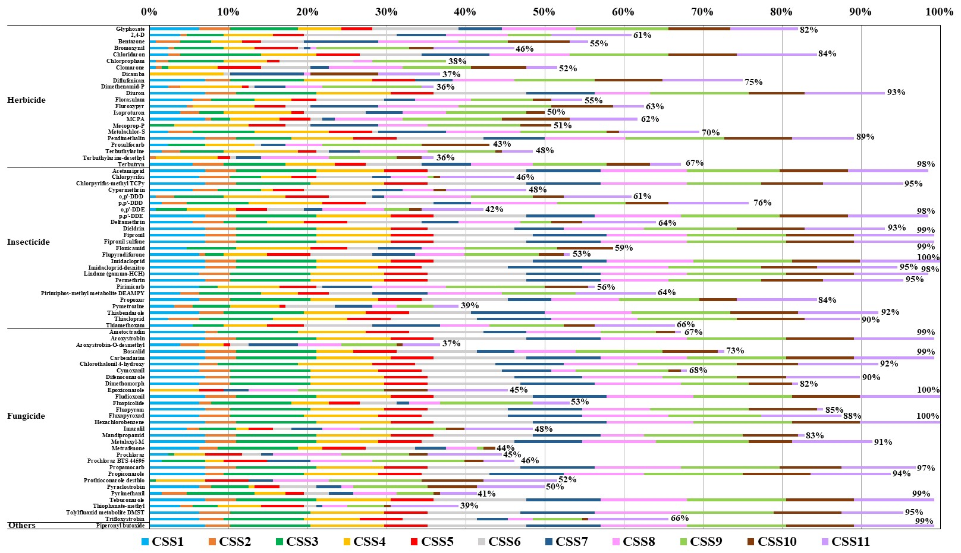
Figure S1. Detection frequency (Df, %) of pesticides analysed in farmer household dust. Only those with Df > 35% have been shown.
Table S6. Detection frequency (Df, %) of the pesticides analysed in each CSS.
Table S6 (cont.) Detection frequency (Df, %) of the pesticides analysed in each CSS.
Table S6 (cont.) Detection frequency (Df, %) of the pesticides analysed in each CSS.

Table S6 (cont.) Detection frequency (Df, %) of the pesticides analysed in each CSS.

Table S7. Detection frequency (Df in %) and concentrations (mean ± S.D., median, min-max range) of pesticides obtained in farmer household dust.

Table S7. (cont). Detection frequency (Df in %) and concentrations (mean ± S.D., median, min-max range) of pesticides obtained in farmer household dust.

Table S7. (cont). Detection frequency (Df in %) and concentrations (mean ± S.D., median, min-max range) of pesticides obtained in farmer household dust.

Table S7. (cont). Detection frequency (Df in %) and concentrations (mean ± S.D., median, min-max range) of pesticides obtained in farmer household dust.

Table S8. Concentrations (median of positives, min-max; ng/g) of the most predominant pesticides obtained in household dust related to conventional farms from each CSS. Coloured cells correspond to pesticides and related metabolites applied in some fields of each CSS.

Table S8. (cont.). Concentrations (median of pesticides, min-max; ng/g) of the most predominant pesticides obtained in household dust related to conventional farms from each CSS. Coloured cells correspond to pesticides and related metabolites applied in some fields of each CSS.

Table S8. (cont.). Concentrations (median of positives, min-max; ng/g) of the most predominant pesticides obtained in household dust related to conventional farms from each CSS. Coloured cells correspond to pesticides and related metabolites applied in some fields of each CSS.

Table S8. (cont.). Concentrations (median of positives, min-max; ng/g) of the most predominant pesticides obtained in household dust related to conventional farms from each CSS. Coloured cells correspond to pesticides and related metabolites applied in some fields of each CSS.
Table S9. Concentrations (median of positives, min-max; ng/g) of the most predominant pesticides obtained in household dust related to organic farms from each CSS.
Table S9. (cont.). Concentrations (median of positives, min-max; ng/g) of the most predominant pesticides obtained in household dust related to organic farms from each CSS.
Table S9. (cont.). Concentrations (median of positives, min-max; ng/g) of the most predominant pesticides obtained in household dust related to organic farms from each CSS.

Table S9. (cont.). Concentrations (median of positives, min-max; ng/g) of the most predominant pesticides obtained in household dust related to organic farms from each CSS.

Table S10. Total pesticide agricultural use (tonnes) and use per area of cropland (kg/ha) in 2020 in the countries evaluated.

Table S11. Matrix of significant differences (p < 0.05, Kruskal-Wallis test) between compounds. Only pesticides with Df > 30% are shown.

Table S11 (cont.). Matrix of significant differences (p < 0.05, Kruskal-Wallis test) between compounds. Only pesticides with Df > 30% are shown.

Table S11 (cont.). Matrix of significant differences (p < 0.05, Kruskal-Wallis test) between compounds. Only pesticides with Df > 30% are shown.

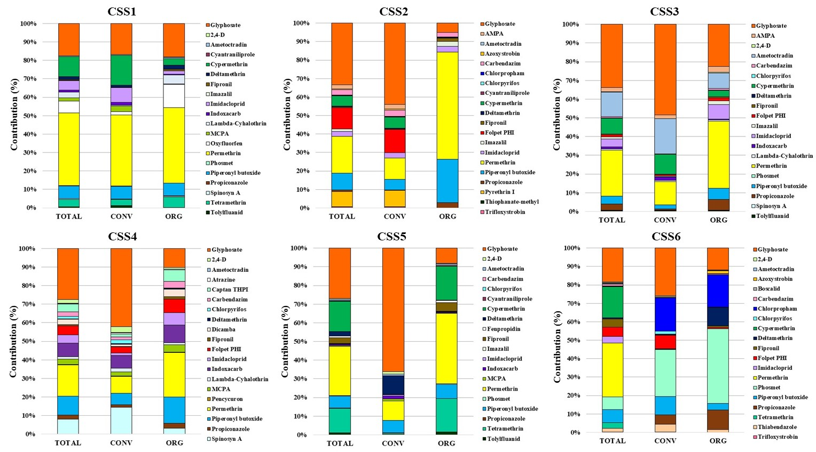
Figure S2. Contribution (%) of each pesticide to the total in household dust from each CSS. Only the first 20 pesticides with higher contribution and Df > 30% in each CSS are shown.
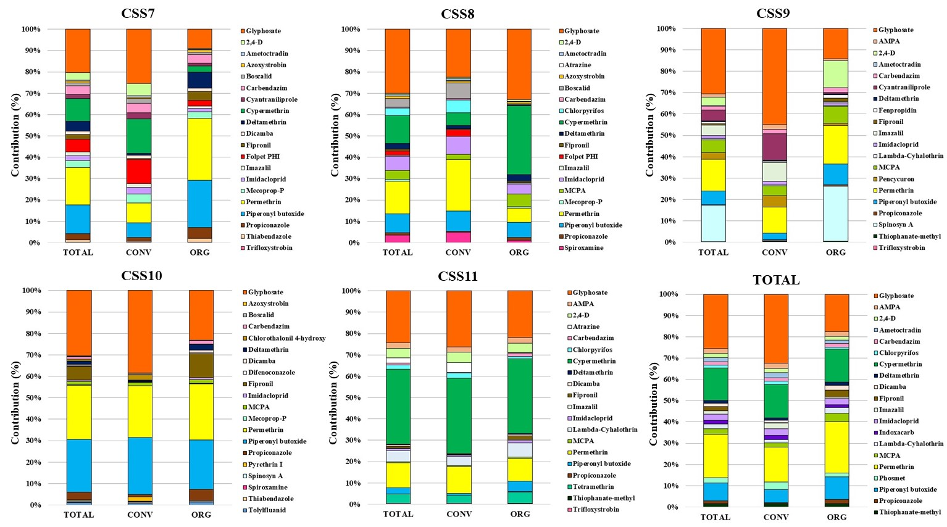
Figure S2 (cont.). Contribution (%) of each pesticide to the total in household dust from each CSS. Only the first 20 pesticides with higher contribution and Df > 30% in each CSS are shown.
Table S12. Correlation matrix (p < 0.01 and p < 0.05, Spearman's rank correlation Test) of the pesticides in household dust. Only pesticides with Df > 30% are shown.

Table S12 (cont.). Correlation matrix (p < 0.01 and p < 0.05, Spearman's rank correlation Test) of the pesticides in household dust. Only pesticides with Df > 30% are shown.

Table S12 (cont.). Correlation matrix (p < 0.01 and p < 0.05, Spearman's rank correlation Test) of the pesticides in household dust. Only pesticides with Df > 30% are shown.

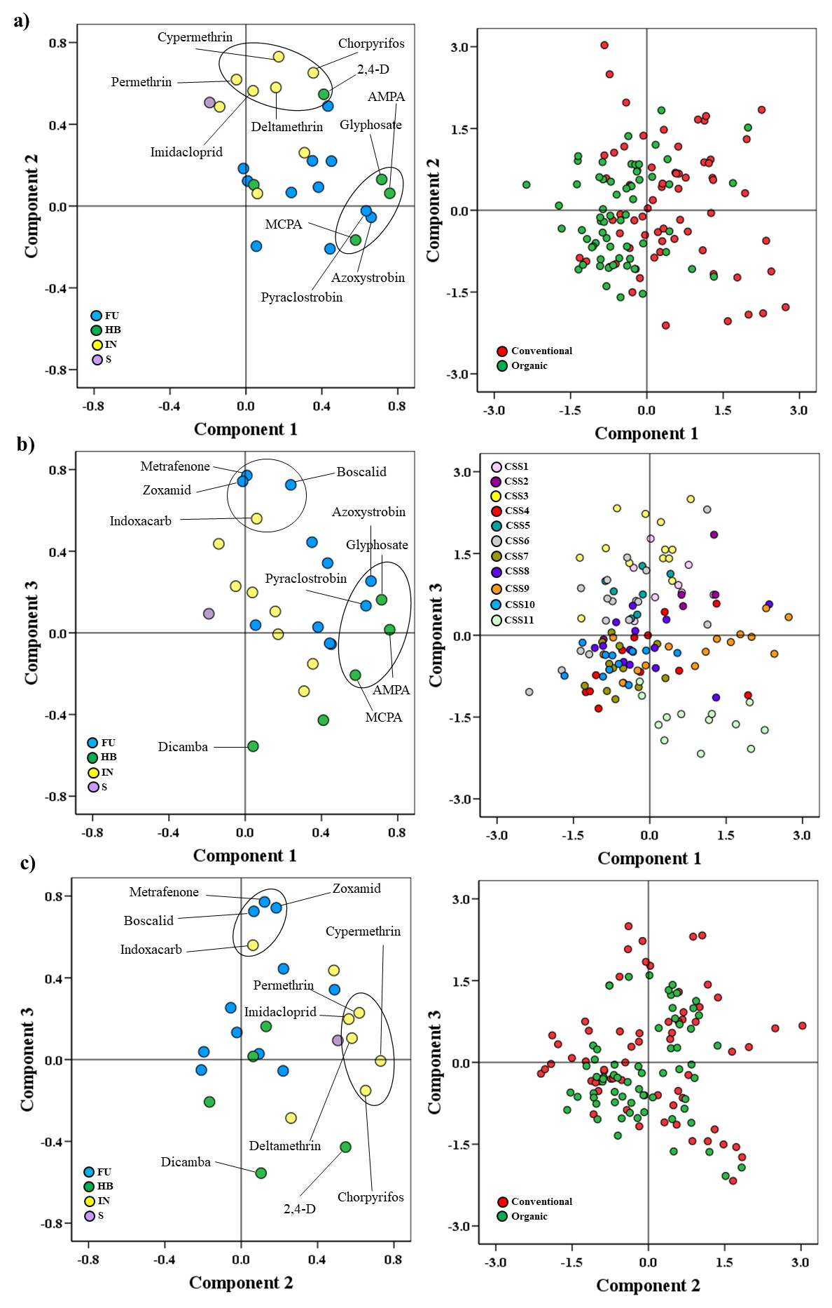
Figure S3. Diagrams of dispersion related to the three components resulting from a principal components analysis (PCA) derived from the content of pesticides in indoor dust and pesticide distribution (type of farming system and CSS): a) PC1 and PC2, b) PC1 and PC3, and c) PC2 and PC3. Loading plots (left) contribution of each variable to each component; FU: fungicide, HB: herbicide IN: insecticide, S: synergist. Score plots (right), markers set by farming system type (a and c) and CSS (b), of all samples on each component.

Table S13. Variables of the principal components analysis (PCA) related to the content of pesticides in indoor dust and pesticide distribution (type of farming system and CSS). Detail of the influence of each variable in each component.

Table S14. Detection frequency (Df in %) and concentrations (mean ± S.D., median, min-max range of positives) of pesticides obtained in neighbour and consumers (control) household dust.

Table S14 (cont.). Detection frequency (Df in %) and concentrations (mean ± S.D., median, min-max range of positives) of pesticides obtained in neighbour and consumer (control) household dust.

Table S14 (cont.). Detection frequency (Df in %) and concentrations (mean ± S.D., median, min-max range of positives) of pesticides obtained in neighbour and consumer (control) household dust.

References
Audy, O., Melymuk, L., Venier, M., Vojta, S., Becanova, J., Romanak, K., Vykoukalova, M., Prokes, R., Kukucka, P., Diamond, M. L., Klanova, J., 2018. PCBs and organochlorine pesticides in indoor environments - A comparison of indoor contamination in Canada and Czech Republic. Chemosphere 206, 622-631. https://doi.org/10.1016/j.chemosphere.2018.05.016
Blanchard, O., Glorennec, P., Mercier, F., Bonvallot, N., Chevrier, C., Ramalho, O., Mandin, C., Le Bot, B., 2014. Semivolatile Organic Compounds in Indoor Air and Settled Dust in 30 French Dwellings. Environ. Sci. Technol. 48, 3959-3969. https://doi.org/10.1021/es405269q
Bradman, A., Whitaker, D., Quirós, L., Castorina, R., Henn, B. C., Nishioka, M., Morgan, J., Barr, D. B., Harnly, M., Brisbin, J. A., Sheldon, L. S., Mckone, T. E., Eskenazi., B., 2007. Pesticides and their Metabolites in the Homes and Urine of Farmworker Children Living in the Salinas Valley, CA. J. Expos. Anal. Env. Epidemiol. 17, 331-346. https://doi.org/10.1038/sj.jes.7500507
Cooper, E. M., Rushing, R., Hoffman, K., Phillips, A. L., Hammel, S. C., Zylka, M. J., Stapleton, H. M., 2019. Strobilurin Fungicides in House Dust: Is Wallboard a Source? J. Expo. Sci. Environ. Epidemiol. 30, 247-252. https://doi.org/10.1038/s41370-019-0180-z
Curl, C. L., Fenske, R. A., Kissel, J.C., Shirai, J.H., Moate, T.F., Griffith, W., Coronado, G., Thompson, B., 2002. Evaluation of take-home organophosphorus pesticide exposure among agricultural workers and their children. Environ. Health Perspect. 110, A787-792. https://doi.org/10.1289/ehp.021100787
Curwin, B. D., Hein, M. J., Sanderson, W. T., Nishioka, M. G., Reynolds, S. J., Ward, E. M., Alavanja, M. C., 2007. Pesticide Contamination Inside Farm and Nonfarm Homes. J. Occup. Environ. Hyg. 2, 357-367. https://doi.org/10.1080/15459620591001606
De la Torre, A., Navarro, I., Sanz, P., Martínez, M.A., 2020. Organophosphate compounds, polybrominated diphenyl ethers and novel brominated flame retardants in European indoor house dust: Use, evidence for replacements and assessment of human exposure. J. Hazard. Mater. 382, 121009. https://doi.org/10.1016/j.jhazmat.2019.121009.
Deziel, N.C., Colt, J.S., Kent, E.E., Gunier, R.B., Reynolds, P., Booth, B., Metayer, C., Ward, M.H., 2015. Associations between self-reported pest treatments and pesticide concentrations in carpet dust. Environ. Health, 14, 1 - 11. https://doi.org/10.1186/s12940-015-0015-x
ECHA, 2017. Guidance on Information Requirements and Chemical Safety Assessment. Chapter R.11: PBT/vPvB assessment Version 3.0. European Chemicals Agency.
FAOSTAT, 2022. Pesticides Use in 2020. Food and Agriculture Organization of the United Nations. Pesticides use, pesticides trade. Global, regional and country trends, 1990 - 2020. https://www.fao.org/3/cc0918en/cc0918en.pdf.
FAOSTAT, 2023. Pesticides Use in 2020. http://www.fao.org/faostat/en/#data/RP
Fenske, R.A., Lu, C., Barr, D., Needham, L., 2002. Children’s exposure to chlorpyrifos and parathion in an agricultural community in central Washington State. Environ. Health Perspect. 110, 549-553. https://doi/10.1289/ehp.02110549
Glorennec, P., Serrano, T., Fravallo, M., Warembourg, C., Monfort C., Cordier, S., Viel, J., Le Gléau, F., Le Bot, B., Chevrier, C., 2017. Determinants of children's exposure to pyrethroid insecticides in western France. Environ. Inter., 104, 76-82. http://dx.doi.org/10.1016/j.envint.2017.04.007
Goss D. and Wauchope R.D., 1990. The SCR/ARS/CES Pesticides Properties Database: II using it with Soils Data in a Screening Procedure. Weigmann, D.L. (Ed)., Pesticides in the Next Decade: The Challenge Ahead, Virginia Water Resources Research Center, Blacksburg, VA, USA, 471-493.
Gooijer Y. M., Hoftijser; G. W., Lageschaar, L. C. C., et al., 2019. Research on exposure of residents to pesticides in the Netherlands: OBO flower bulbs. https://www.rivm.nl/sites/default/files/2019-04/Onderzoeksrapport%20OBO.pdf
Gustafson D.I., 1989. Groundwater ubiquity score: a simple method for assessing pesticide leachability. Environmental Toxicology and Chemistry 8, 339-357. https://doi:10.1002/ETC.5620080411.
Harnly, M. E. Bradman, A., Nishioka, M., McKone, T. E., Smith, D., McLaughlin, R., Kavanagh-Baird, G., Castorina, R., Eskenazi, B., 2009. Pesticides in dust from homes in an agricultural area. Environ. Sci. Technol. 43, 8767-74. https://doi: 10.1021/es9020958.
Hung, C., Huang, F., Yang, Y., Hsieh, C., Tseng, C., Yiin, L., 2018. Pesticides in indoor and outdoor residential dust: pilot study in a rural county of Taiwan. Environ. Sci. Pollut. Res. 25, 23349-23356. https://doi.org/10.1007/s11356-018-2413-4
Hwang, H-M., Park E-K., Young, T. M., Hammock, B. D., 2008. Occurrence of endocrine-disrupting chemicals in indoor dust. Sci. Total Environ. 404, 26-35. https://doi.org/10.1016/j.scitotenv.2008.05.031
Leng, G., Berger-Preiss, E., Levsen, K., Ranft, U., Sugiri, D., Hadnagy, W., Idel, H., 2005. Pyrethroids used indoor-ambient monitoring of pyrethroids following a pest control operation. Int. J. Hyg. Environ. Health., 208, 193-9. https://doi.org/10.1016/j.ijheh.2005.01.016
Mendez, M.J., Aimar, S.B., Aparicio, V.C., Ramirez Haberkon, N.B., Buschiazzo, D.E., De Gerónimo, E., Costa, J.L., 2017. Glyphosate and Aminomethylphosphonic acid (AMPA) contents in the respirable dust emitted by an agricultural soil of the central semiarid region of Argentina. Aeolian Res., 29, 23-29. http://dx.doi.org/10.1016/j.aeolia.2017.09.004.
Morgan, M. K., Sheldon, L. S., Croghan, C. W., Jones, P. A., Robertson, G., L., Chuang, J. C., Wilson, N. K., Lyu, C. W., 2005. Exposures of preschool children to chlorpyrifos and its degradation product 3,5,6-trichloro-2-pyridinol in their everyday environments. J. Expo. Anal. Environ. Epidemiol. 15, 297-309. https://doi.org/10.1038/sj.jea.7500406
Morgan, M.K., Wilson, N.K., Chuang, J.C., 2014. Exposures of 129 preschool children to organochlorines, organophosphates, pyrethroids, and acid herbicides at their homes and daycares in North Carolina. Int J Environ Res Public Health. 11, 3743-3764. https://doi.org/10.3390/ijerph110403743
Mu, H., Zhang, J., Yang, X., Wang, K., Xu, W., Zhang, H., Liu, X, Ritsema, C. J., Geissen, V., Pesticide screening and health risk assessment of residential dust in a rural region of the North China Plain. Chemosphere 303, 135115. https://doi.org/10.1016/j.chemosphere.2022.135115
PANPDB, 2023. PAN Pesticide Database. Pestide Action Network Pesticide Database. http://www.pesticideinfo.org/. Last access September 2023.
PPDB, 2023. Pesticide Properties DataBase (PPDB). University of Hertfordshire https://sitem.herts.ac.uk/aeru/ppdb/en/atoz.htm. Last access September 2023.
Quirós-Alcalá, L., Bradman, A., Nishioka, M., Harnly, M.E., Hubbard, A., McKone, T.E., Ferber, J., Eskenazi, B., 2011. Pesticides in house dust from urban and farmworker households in California: an observational measurement study. Environ. Health, 10, 1-15. https://doi.org/10.1186/1476-069X-10-19
Rothlein, J., Rohlman, D., Lasarev, M., Phillips, J., Muniz, J., McCauley, L., 2006. Organophosphate pesticide exposure and neurobehavioral performance in agricultural and non-agricultural Hispanic workers. Environ. Health Perspect. 114, 691-696. https://doi.org/10.1289/ehp.8182
Rudel, R.A:, Camann, D. E., Spengler, J. D., Korn, L. R., Brody, J. G., 2003. Phthalates, alkylphenols, pesticides, polybrominated diphenyl ethers, and other endocrine-disrupting compounds in indoor air and dust. Environ. Sci, Technol., 37, 4543-4553. https://doi.org/10.1021/es0264596
Salis, S., Testa, C., Roncada, P., Armorini, S., Rubattu, N., Ferrari, A., Miniero, R., Brambilla, G., 2017. Occurrence of imidacloprid, carbendazim, and other biocides in Italian house dust: Potential relevance for intakes in children and pets. J. Environ. Sci. Health B, 52, 699-709. https://doi.org/10.1080/03601234.2017.1331675
SANTE, 2021a. Guidance Document on Pesticide analytical methods for risk assessment and post-approval control and monitoring purposes, SANTE/2020/12830, Rev. 1.
SANTE, 2021b. Analytical quality control and method validation procedures for pesticide residues analysis in food and feed, SANTE 11312/2021.
Saurat, D., Raffy, G., Bonvallot, N., Monfort, N., Fardel, O., Glorennec, P., Chevrier, C., Le Bot, B., 2023. Determination of glyphosate and AMPA in indoor settled dust by hydrophilic interaction liquid chromatography with tandem mass spectrometry and implications for human exposure. J. Hazard. Mater. 446, 130654. https://doi.org/10.1016/j.jhazmat.2022.130654
Smith, M. N., Workman, T., McDonald, K. M.,Vredevoogd, M. A., Vigoren, E. M., Griffith, W. C., Thompson, B., Coronado, G. D., Barr, D., Faustman, E. M., 2017. Seasonal and occupational trends of five organophosphate pesticides in house dust. J. Expo. Sci. Environ. Epidemiol. 27, 372-378. https://doi.org/10.1038/jes.2016.45
Trunnelle, K.J., Bennett, D. H., Tancredi, D. J., Gee, S. J., Stoecklin-Marois M. T., Hennessy-Burt, T. E., Hammock, B. D., Schenker, M. B., Pyrethroids in house dust from the homes of farm worker families in the MICASA study. Environ. Inter. 61, 57-63. https://doi.org/10.1016/j.envint.2013.09.007
Velázquez-Gómez, M., Hurtado-Fernández, E., Lacorte, S., 2019. Differential occurrence, profiles and uptake of dust contaminants in the Barcelona urban area. Sci. Total Environ. 648, 1354–1370. https://doi.org/10.1016/j.scitotenv.2018.08.058
Wang, A., Mahai, G., Wan, Y., Jiang, Y., Meng, Q., Xia, W., He, Z., Xu, S., 2019. Neonicotinoids and carbendazim in indoor dust from three cities in China: Spatial and temporal variations. Sci. Total Enviro. 695, 133790. https://doi.org/10.1016/j.scitotenv.2019.133790
Ward, M.H., Lubin, J., Giglierano, J., Colt, J. S., Wolter, C., Bekiroglu, N., Camann, D., Hartge, P., Nuckols, J. R., 2006. Proximity to crops and residential exposure to agricultural herbicides in Iowa. Environ. Health Perspect. 114, 893-897. https://doi.org/10.1289/ehp.8770

