From titania nanoparticles to Decahedral Anatase Particles: Photocatalytic activity of TiO₂/zeolite hybrids for VOC oxidation

S. Suárez*¹, I. Jansson¹, B. Ohtani², B. Sánchez¹

¹FOTOAir-Ciemat, Unit of Analysis and Photocatalytic Treatment of Pollutants in Air, Avda. Complutense 40, 28040 Madrid, Spain. Tel. +34 91 346 61 77; e-mail: silvia.suarez@ciemat.es
² Institute for Catalysis, Hokkaido University, Sapporo 001-0021, Japan

Abstract

In this work, zeolite/TiO₂ hybrid photocatalysts based on TiO₂ particles of different nature for photooxidation of VOCs in air have been developed. TiO₂ with different morphologies, namely, TiO₂ nanoparticles (Ti-NP) and decahedral anatase particles (DAPs), have been synthetized and characterized. A commercial TiO₂ (Ti-C) catalyst has been used as a reference. Titania has been incorporated on ZSM-5 by different techniques: incipient wetness impregnation, freeze-drying, or mechanical mixing from a TiO₂ sol, DAPs, or commercial TiO₂. The TiO₂ and hybridized photocatalysts were characterized by SEM, TEM, XRD, UV-Vis spectroscopy, N₂ adsorption-desorption and electrophoretic migration. Moreover, the adsorption ability to formaldehyde or trichloroethylene of the composites has been analysed. The photocatalytic performance for the HCHO or C₂HCl₃ photooxidation under UV-A irradiation and continuous air flow has been evaluated. TiO₂ nanoparticles of 5 nm, DAPs of ca. 100 nm, and 1.0 µm clusters of TiO₂ made of 15 nm mean particle size characterized the three types of TiO₂. These characteristics are maintained in the zeolite/TiO₂ composites. In spite of the lower BET area of the DAPs, present the highest VOC reaction rate comparing to the other TiO₂. The incorporation of titanium oxide to the microporous material results in the improvement of the photocatalytic performance, regardless of the actual nature of the TiO₂ particles. Nevertheless, a relationship between the particle size and the improvement of the photocatalytic performance can be established. Thus, the incorporation of TiO₂-NP into the zeolitic material, lead to composites with around ten times more photoactivity that the single titania particles. This effect is less pronounced for larger TiO₂ particles such as DAPs and less evident for TiO₂ aggregates present in commercial material. TiO₂ nanoparticles homogeneous distributed on the hierarchical material shows the highest VOC photooxidation and CO₂ formation rates of the series.

Keywords: TiO₂ nanoparticles; DAPs; photocatalysis; VOC; adsorbent-photocatalyst hybrids; air pollution.

- Introduction

The European Environmental Agency estimates that atmospheric pollution is responsible for 430.000 death/year in Europe. The Goteborg Protocol objective is to reduce the anthropogenic emissions to 40 % of the main pollutants in the air for year 2020. One kind of pollutant is the so-called volatile organic compounds (VOCs) which are responsible of severe atmospheric effects such as photochemical smog, increasing the quantities of ozone in the troposphere []. Thus, strategies to control anthropogenic emissions especially in the emission sources should be implemented. Photocatalytic oxidation is a highly efficient advanced oxidation process for the removal of pollutants. This technology is an alternative to conventional decontamination processes, but the leap to industrial application is required. For this purpose, highly efficient materials should be developed. The combination of sorption and photocatalytic properties in the same material is an interesting option to improve the photoactivity performance. The combination of these two functions in the same composite leads to a novel family of materials, known as adsorbent-photocatalyst hybrids (APHs) []. APHs have been demonstrated to yield higher photooxidation rates than bare semiconductors. Moreover, the adsorbing properties of APHs allow the (re)adsorption of partially oxidized reaction intermediates or products resulting in a higher mineralization. []. The incorporation of TiO₂ into hierarchical microporous materials have shown promising results [2-3]. Highly hydrophobic ZSM-5 has shown excellent photocatalytic properties for the degradation of VOCs []. ZSM-5/TiO₂ hybrids with high Si/Al ratio, have displayed an enhancement of the photocatalytic performance, improving the mineralization compared to bare TiO₂. Zeolite is the perfect host to titania particles. The high surface area and the adequate surface net charge improve its dispersion. Moreover a synergistic effect was demonstrated when these two compounds are in intimate contact [19]. A moderate adsorption strength of the VOC onto the zeolite, and the direct-indirect diffusion of the pollutant and reaction products for the zeolite to TiO₂ active sites and vice versa are determinant factors of the final properties of the composites [11]. Nevertheless, the influence of the TiO₂ nature, and how to incorporate it into the adsorbent, are important parameters to design an efficient and scalable method to prepare materials at large scale.
Incipient wetness impregnation, ionic exchange, hydrothermal synthesis, and mechanical mixing are among the most used methods reported in the literature for preparation of zeolite/TiO₂ composites [,,,]. The preparation of TiO₂ nanoparticles can be achieved by the synthesis of a TiO₂ sol []. Then, these nanoparticles can be deposited onto the adsorbent by incipient wetness impregnation. Decahedral anatase particles (DAPs) with a high fraction of {101} and {001} facets and low crystal defects confers TiO₂ with superior catalytic properties []. The incorporation of DAPs into hierarchical microporous materials is a novel strategy []. The freeze-drying technique allows the preparation of hybrid composites without the need for thermal treatment. Finally, the mechanical mixing method is generally used for the preparation of pellets, monolithic structures, or cylinders at industrial scale []. The incorporation of a binder and water during the synthesis provides the final material with optimized rheological properties to prepare shaped materials. In this case, commercial titania is the most convenient option.

In this work, TiO₂ particles with different particle size, textural and chemical properties were incorporated into hierarchical ZSM-5 with high SiO₂:Al₂O₃ ratio. TiO₂ nanoparticles (Ti-NP) and decahedral anatase particles (DAPs) were synthetized and deposited onto zeolite by incipient wetness impregnation and freeze-drying, respectively. Commercial TiO₂ (Ti-C) was incorporated into the zeolite by mechanical mixing. Raw materials and composites were characterized by XRD, HRTEM, SEM, N₂ adsorption-desorption, and UV-Vis spectroscopy. The molar fraction of TiO₂ covering the zeolite surface was determined from zeta potential measurements. The photocatalytic performance for the degradation of two model VOC pollutants under UV-A irradiation was evaluated. The photodegradation of formaldehyde, a pollutant characteristic of indoor air and trichloroethylene, an organochloride compound used in the solvent industry, was studied. The results obtained will be discussed taking into account the photochemical and chemical-physics properties.

- Experimental

2.1 Catalysts preparation

MFI type zeolite NH₄-ZSM-5, denoted as “Z” with SiO₂:Al₂O₃ ratio of 280 from Zeolyst were used as received. TiO₂ nanoparticles were deposited onto the zeolite by incipient wetness impregnation. A TiO₂ sol was synthetized as described elsewhere [3]. A TiO₂-sol volume equal to the total pore volume of Z was added to the zeolite. The TiO₂ loading of the final Z/Ti-NP sample was 8 wt%, according to this study. Moreover, for characterization purposes, TiO₂ nanoparticles (Ti-NP) were obtained by drying the TiO₂ sol at room temperature until a xerogel was formed. Then, the material was thermally treated at 500 ºC for 3 h.
Decahedral anatase particles (DAPs) were prepared by a gas-phase process in a quartz tubular reactor using titanium (IV) chloride (TiCl₄) as a TiO₂ precursor as reported elsewhere [11]. The DAPs synthetized were collected by filtration and washed. The incorporation of DAPs into the zeolite was performed by the freezing-drying technique. A suspension of the zeolite in water was prepared and the desired content of DAPs corresponding to 8 wt% in the hybrid was added. Water was removed under vacuum for 24 h at P < 10 Pa and -80 ºC leading to the Z/DAPs sample.
Zeolite/Ti-C extrudates, prepared with commercial TiO₂ (TiO₂-G5, Millenium /Crystal), were prepared by mechanical mixing. Then, the samples were extruded to a cylindrical shape using a syringe. After drying at ambient temperature, the extrudates were thermally treated at 500 ºC for 3 h. The final zeolite:TiO₂ ratio was set to 1:1 according to previous results [2].

The AHPs obtained are labelled as Z/X where “X” designates the TiO₂ nature, Ti-NP for nanoparticles, DAP for decahedral anatase particles, and Ti-C for commercial TiO₂ G5. Table 1 summarizes the main characteristics of the raw materials and the AHPs.

  - Physicochemical characterization

Specific surface areas and total pore volumes of the raw materials and AHPs were measured by N₂ adsorption-desorption isotherms at -196 ºC in a Micrometrics ASAP 2020 analyser using the Brunauer-Emmett-Teller (BET) method. The mesopore size distributions and pore volume were calculated from the N₂ desorption branch using the Barrett- Joyner- Halenda (BJH) method []. The analysis of the microporosity was performed from the N₂ adsorption branch at the low partial pressure range (P/P₀ = 0-0.1) using the Horvath and Kawazoe method with the Saito and Foley approximation for cylindrical pores [].
The X-Ray Powder Diffraction (XRD) patterns were collected at room temperature with a PANalytical X’Pert PRO X-ray diffractometer using CuKα₁ radiation (λ = 1.54060 Å) operating at 45 kV and 40 mA. The data were collected in a stepwise fashion with 2θ ranging from 20 to 80 with a step size of 0.02º and 50 s per step. The mean crystal sizes of the TiO₂–anatase, rutile and brookite phases were estimated by the Debye-Scherer’s equation (Eq. 1) using the diffraction peaks at 25.0º, 27.4º, and 31,0º respectively [],
$\text{= }\frac{\text{K}}{{\text{d}}_{\text{hkl}}\text{cos}{}}$ Eq. 1
where β is the full width at half maximum intensity of the selected peak, K = 0.9 assuming crystal spherical particles, d_{hkl} is the mean crystal size at the normal direction to the hkl plane selected and λ is the wavelength of the CuKα₁ radiation. The Kα₂ was removed from the analysis and the instrumental broadening corrected.
Diffuse reflectance spectra of the samples were obtained on a double beam UV–Vis spectrophotometer (PerkinElmer Lambda 650 UV/Vis) equipped with a diffuse reflectance accessory. The reflectance spectra were analyzed according to the Kulbelka–Munk (KM) function and the band gap energy was calculated by the Tauc plot [].
The isoelectric points (IEPs) were estimated by microeelectrophoresis laser Doppler, analysing the changes of the zeta potential with the pH using a Malvern Zetasizer Nano ZS90 with MPT-2 autotitrator. Experiments were carried out using 15 mg of power sample suspended in 100 ml of 10⁻³ M KCl solutions, adjusting the pH valued with 0.25 M and 0.025 M HCl or KOH solutions. The measurements were repeated tree times to ensure reproducibility. The isoelectric point (IEP) of the samples were calculated using Henry´s law with Smoluchowski's approximation []. The modified Park´s equation was used to calculate the apparent molar fraction of exposed TiO₂ [].
Scanning electron microscopy (SEM) (JEOL JSM-7600F) was used to analyse the morphology of the particles. High resolution transmission electron microscopy (HRTEM, JEOL JEM3000F) operated at 300 kV, was used to examine the particle size and dispersion of TiO₂ into the zeolites as well as determining structure information of the materials.

2.3 Photocatalytic experiments

The photocatalytic activity experiments were evaluated in a continuous-flow flat reactor, at different total gas flows between 700-900 mL min⁻¹ and residence times tr between 0.55-0.43 s []. A stainless steel reactor with external dimensions of 120 mm × 50 mm × 10 mm (length × wide × depth) was covered with a borosilicate glass window of 37 cm² [11]. 30 mg of material was placed on a borosilicate glass slide (70 mm × 26 mm) and was introduced in the photoreactor. Gas cylinders (Air Liquide) with controlled compositions of HCHO/N₂ (50 ppm) or C₂HCl₃/N₂ (250 ppm) were used to obtain the desired concentration of pollutant in the reactor inlet by means of mass flow controllers (MFC). Experiments were performed with inlet concentrations of formaldehyde (HCHO) of 15 ppm or of trichloroethylene (C₂HCl₃) of 25 ppm in CO₂ and moisture free air. Two UV-A lamps (8 W Philips and 6.5 mW cm⁻² irradiance) were used as the irradiation source. The oxygen content in the gas flow ranged between 15-20 % in all experiments. The gas composition at the reactor inlet and outlet was analyzed with FTIR spectroscopy using a Thermo-Nicolet 5700 spectrometer equipped with a gas cell at 110 ºC. The evolution of reactants and reaction products during the photocatalytic reaction was monitored by following the characteristic vibrational bands of the desired molecules. Before each experiment, and in order to eliminate impurities, every sample was irradiated with UVA lamps for 12 h under air atmosphere.
The photocatalytic reaction was performed according to the following steps:
- Air flow at by-pass mode, to obtain a zero reference point.
- Incorporation of the pollutant to the total gas flow and stabilization of the VOC signal at by-pass mode.
- Flow of the total gas containing the pollutant through the photocatalytic reactor where the sample was placed at dark conditions, until stabilization of the inlet VOC signal.
- UV-A irradiation of the sample and evaluation of the photocatalytic activity,
The amount of HCHO or C₂HCl₃ adsorbed by the materials at dynamic conditions was estimated at stage 3, considering the total gas flow (700 mL min⁻¹) and the concentration of the pollutant at the inlet ([HCHO] = 15 ppm or [C₂CHCl₃]= 25 ppm).

- Result and discussion

The physicochemical properties of the hybrids are influenced by the nature of the TiO₂ used as semiconductor. Table 1 collects the main properties of the materials selected for this study. According to XRD analysis (figure not shown) Ti-NP is composed of particles exhibiting the three crystal phases of TiO₂ (-anatase, -rutile and -brookite) with a high surface area around 150 m²g⁻¹. The percent of each phase was calculated following Zhang et al. [], resulting in 59 % anatase, 28 % rutile, and 14% brookite with crystallite sizes of 8, 20, and 5 nm, respectively. TiO₂-anatase was the only crystalline phase observed on commercial TiO₂ with a BET area value similar to that of Ti-NP and a crystallite size of ca. 15 nm. On the contrary, the surface area of DAP was 14 m²g⁻¹ and TiO₂-anatase and rutile were detected as the main crystal phases. Moreover, these particles present a high fraction of {101} and {001} facets. The analysis of the crystalline and amorphous phase was performed using nickel oxide as an internal standard and the Rietveld quantitative analysis. The results show a composition of 88 % of anatase, 6 % to rutile, and less than 5 % of the amorphous phase. In this case, the mean crystallite size was around 100 nm. The incorporation of titania into ZSM-5 leads to materials with properties between those of the raw materials. Thus, the hybrid systems combine the microporosity of the zeolitic material and the mesoporosity generated by the interparticular separation of TiO₂ particles or aggregates.
Ti-C and Z/Ti-C exhibit the highest mesoporosity, probably arising from the interparticle space between the TiO₂ clusters with a bimodal pore size distribution.

Table 1. Textural properties and amount of VOC adsorbed for the studied materials
 | BET | V_{p} |  |  |  | Mean pore size |  |  | Adsorption
Sample | Area | V_{T} | micro | meso |  | micro | meso |  | HCHO | C₂HCl₃
 | m² g⁻¹ | cm³ g⁻¹ |  |  |  | nm |  |  | µmol g⁻¹_{cat}
Ti-NP | 149 | 0.28 | 0.01 | 0.28 |  | - | 7 |  | 540 | 10
DAP | 14 | 0.17 | - | 0.17 |  | - | 100 |  | 443 | 12
Ti-C | 152 | 0.39 | - | 0.26 |  | - | 7/13 |  | 1.940 | 18
Zeolite | 445 | 0.17 | 0.14 | 0.03 |  | 0.6 | - |  | 50 | 300
Z/Ti-NP | 338 | 0.24 | 0.15 | 0.09 |  | 0.5 | 7 |  | 300 | 380
Z/DAP | 392 | 0.18 | 0.14 | 0.04 |  | 0.6 | - |  | 318 | 327
Z/Ti-C | 253 | 0.23 | 0.09 | 0.14 |  | 0.5 | 7/13 |  | 380 | 175

In Figure 1 representative HRTEM or SEM micrographs of Ti-NP, DAP, TiO₂-C and of the zeolite/TiO₂ hybrids are shown. As observed, Ti-NP from the TiO₂ is composed by homogeneous nanoparticles of ca. 5 nm. The mean particle size of DAP ranges between 70 and 100 nm, in agreement with the XRD results. The micrographs of commercial TiO₂ show clusters of several microns of titania nanoparticles around 15 nm. The incorporation of the different TiO₂ particles on the zeolite leads to different configurations. Z/Ti-NP exhibits TiO₂ nanoparticles homogeneously distributed on the zeolite surface. A heterogeneous dispersion of DAP on the zeolite is observed for Z/DAP. Large zeolite particles around 1.0 µm are mixed with DAP particles of around 100 nm. Finally, Z/Ti-C is characterized by the adsorbent covered with the titania particles along to aggregates of TiO₂ and isolated zeolite particles.
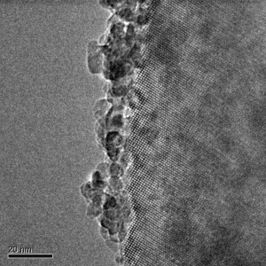
Z/Ti-NP
Ti-NP

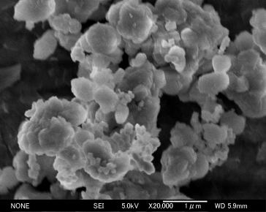
Z/DAP
DAP

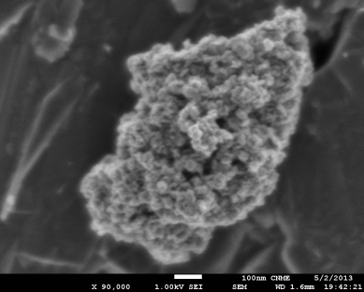
Z/Ti-C
Ti-C
Figure 1. HRTEM (Ti-NP, Z/Ti-NP, Z/Ti-C) and SEM micrographs (DAP, Z/DAP, Ti-C for TiO₂ (left) and zeolite/TiO₂ hybrids (right).

The TiO₂ content in the hybrids for each series of hybrid was identified in previous studies [4,11,19]. The maximum photocatalytic activity was achieved with APHs with TiO₂ loadings of 8 wt%. for Z/Ti-NP, and 50 wt% for Z/Ti-C. Thus, the results shown below compare the properties of the most active photocatalysts of each series.

The influence of the TiO₂ nature on the HCHO degradation rate and CO₂ formation is represented in Figure 2. The hybrid synthetized with TiO₂ nanoparticles by incipient wetness impregnation presents the higher HCHO photodegradation and CO₂ formation rate, followed by Z/DAP. The TiO₂-C containing material shows the lower reaction rate of the series. Thus, the HCHO reaction rate follows the order: Z/Ti-NP > Z/DAP > Z/Ti-C. In the case of Z/Ti-NP and Z/DAP composites, the amount of CO₂ produced is lower than that of the HCHO converted, indicating that a fraction of HCHO remains adsorbed in the hybrid system. This effect was not detected for the Z/Ti-C, where the quantity of HCHO converted corresponds well with the CO₂ released. These results can be rationalized by taking into account the lower content of adsorbent in this composite. Reaction products other than CO₂ were not detected. The photocatalytic performance of the single TiO₂ materials was measured as a reference. TiO₂-NP and TiO₂–C thermally treated at 500°C, records 0.45 µmol s⁻¹ g⁻¹ and 0.25 µmol s⁻¹ g⁻¹, respectively for HCHO photodegradation. On the other hand, synthetized DAPs presented values around 1.45 µmol s⁻¹ g⁻¹.
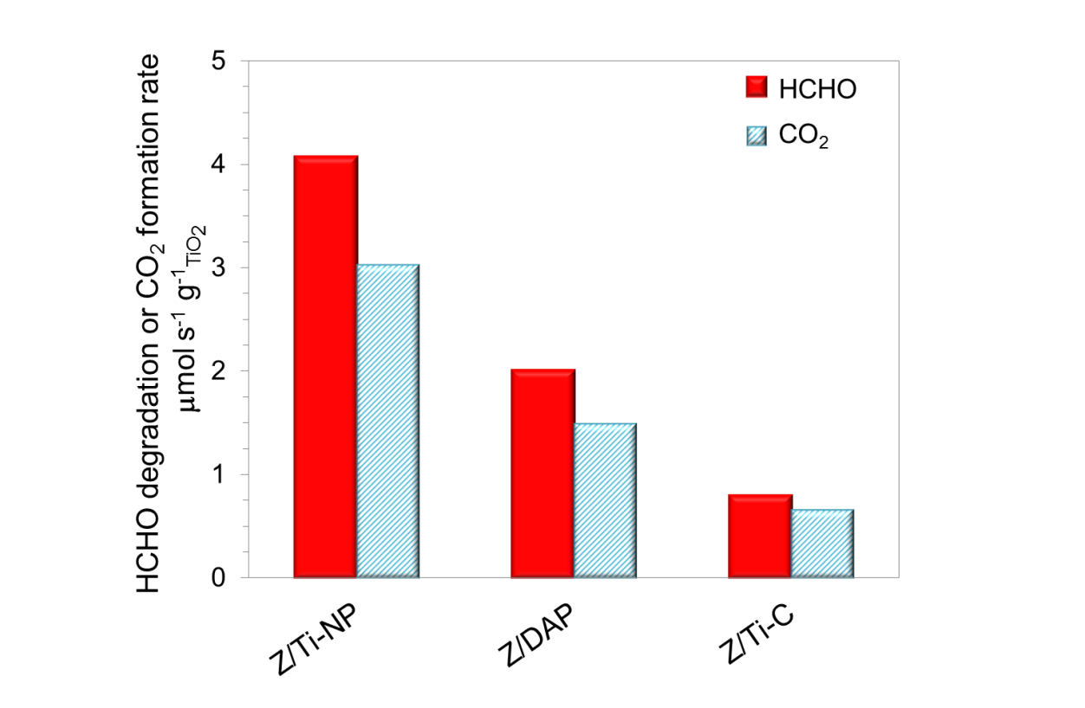
Figure 2. Influence of the TiO₂ nature on the photodegradation of formaldehyde. Operating conditions: F = 900 mL min⁻¹, [HCHO] = 15 ppm, tr = 0.43 s.

As shown in Figure 3, the performance of Z/Ti-NP and Z/DAP for the photodegradation of trichloroethylene (a more difficult to oxidize VOC) was similar in terms of C₂HCl₃ degradation rate. Nevertheless, the Z/Ti-NP hybrid shows a higher amount of CO₂ than Z/DAP. As in the previous case, Z/Ti-C shows the lowest degradation rate per gram of TiO₂ in the series. Irrespectively of the TiO₂ nature, all catalysts exhibited a C₂HCl₃ conversion of around 70 %. The photocatalyst containing TiO₂ nanoparticles, exhibited a higher reaction rate per active site than the ones prepared with commercial TiO₂ and a higher mineralization to CO₂ than the ones prepared with DAP by freezing-drying. Considering the reference materials, DAP shows around 2.0 µmol s⁻¹ g⁻¹ of C₂HCl₃ removed, followed by TiO₂-NP and TiO₂-C with values of ca. 0.50 µmol s⁻¹ g⁻¹. As previously reported, the incorporation of titanium oxide to the microporous material results in the improvement of the photocatalytic performance, regardless of the actual nature of the TiO₂ particles [4]. Nevertheless, a relationship between the mean TiO₂ particle size and the improvement of the photocatalytic performance can be established. Thus, the incorporation of TiO₂-NP into the zeolitic materials, leads to materials ten times more photoactive that the single titania nanoparticles. This effect is less pronounced for larger TiO₂ particles such as DAPs where the reaction rate was around two times higher for hybrid compared to individual DAPs. In the case of composites based on commercial TiO₂ the positive effect is less evident than in the previous cases.

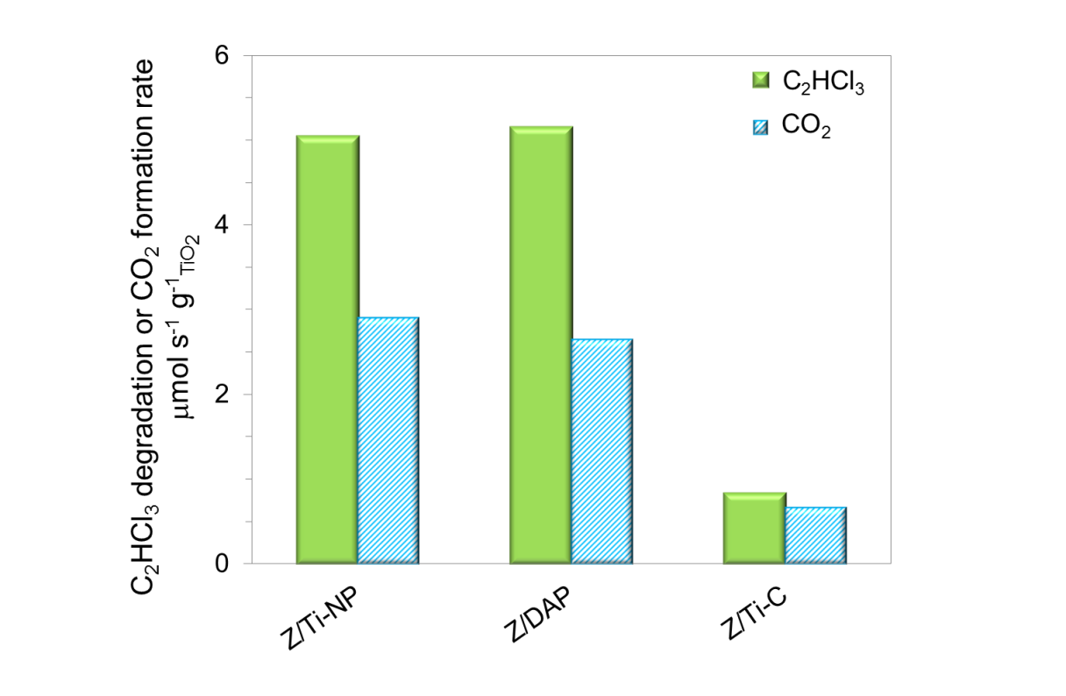
Figure 3. Influence of TiO₂ incorporation method on the photodegradation of trichloroethylene. Operating conditions: F = 700 mL min⁻¹, [C₂HCl₃] = 25 ppm, tr = 0.55 s.

In order to explain the differences in photocatalytic performance of the samples, the physicochemical properties were compared. The crystal structure of the zeolite was not modified in the APHs. On the other hand, the TiO₂ particles in the APHs display the anatase phase only. In addition, the size of the TiO₂ particles is not modified after incorporation in the Z/Ti-C and Z/DAP. As shown above, see XRD results and TEM images, TiO₂ particles in Z/Ti-NP are the smallest in the series and are homogeneously distributed onto the hierarchical material. The reaction mechanism for the photooxidation of VOCs on isolated nanoparticles highly dispersed on silicates is different from that on bulk semiconductor particles []. Thus, the differences between the photocatalytic behaviors of the AHPs could be related to the TiO₂ mean particle size and its dispersion on the adsorbent.

All AHPs show Type I/Type II N₂ adsorption-desorption isotherms. Z/Ti-NP and Z/DAP hybrid show higher specific surface areas than Z/Ti-C, mainly due to the lower amount of zeolite on the composite. On the other hand, the incorporation of large aggregates of TiO₂ on the samples prepared by mechanical mixture, leads to an increase of the mesopore volume with a bimodal pore size distribution (Table 1). This porous structure could promote the diffusion phenomena of the reactant and products to the active sites.

The nature of TiO₂ on the AHPs also affected the amount of HCHO or C₂HCl₃ adsorbed (Table 1). Despite the different zeolite:TiO₂ ratio in the APHs, the amount of adsorbed HCHO is similar in all samples. This is because HCHO adsorbs preferentially on TiO₂. Taking into account the actual TiO₂ loading, the maximum amount of HCHO adsorbed on Z/Ti-C would be 1000 µmol g⁻¹, far from the 400 µmol g⁻¹ obtained experimentally. This result suggests a low dispersion of titania on the zeolite, and the formation of large clusters. Despite the large difference in their specific surface areas, DAP shows similar HCHO adsorption values to Ti-NP. On the other hand, the trichloroethylene adsorption follows a different pattern. Thus, C₂HCl₃ is mainly adsorbed on the aluminosilicates and the amount C₂HCl₃ adsorbed on the APHs is in line with the zeolite loading in the composite.

The optical properties of the zeolite/TiO₂ hybrids and raw materials were studied. Figure 4 shows the UV-Vis diffuse reflectance spectra according to the Kubelka-Munk function of the samples.
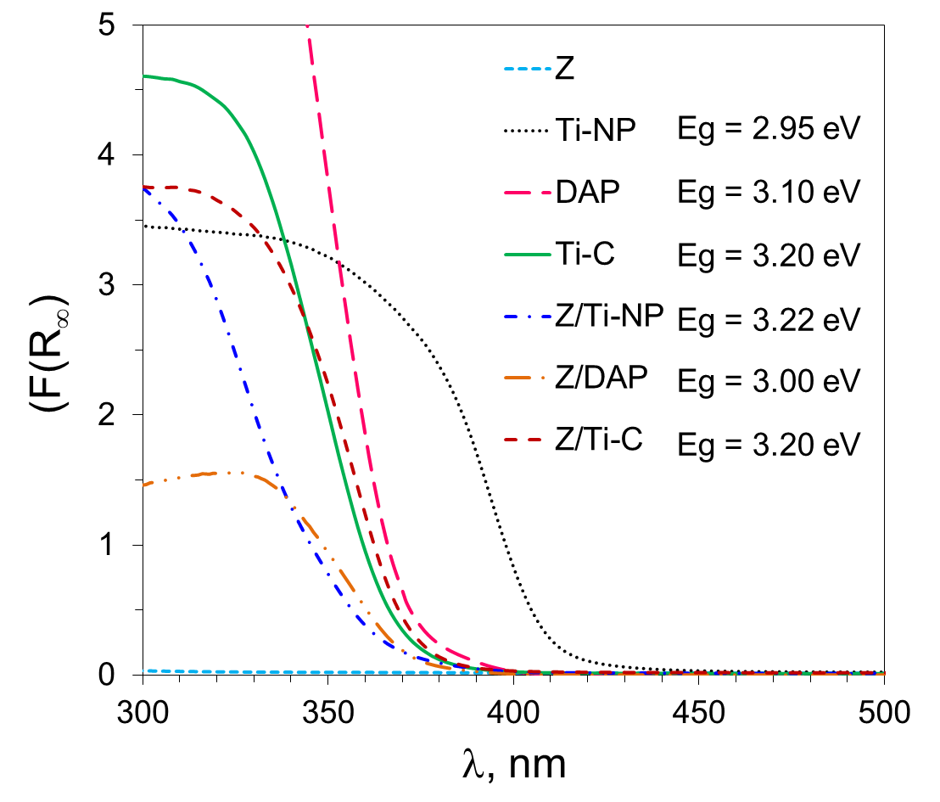
Figure 4. Kubelka-Munk function for the TiO₂ and zeolite/TiO₂ materials selected.

Zeolites are transparent materials to UV-Vis irradiation. The spectra of Ti-NP is clearly shifted to higher wavelengths compared to the other raw materials. The band-gap for Ti-C calculated from the Tauc plot considering allowed indirect transitions (γ = 2) is of 3.2 eV []. In the case of Ti-NP, where anatase and rutile crystal phases were detected, the band gap energy was calculated assuming allowed indirect and forbidden direct transitions (γ = 2 and γ = 3/2) with values of 2.9 and 3.0 eV. Nevertheless, a value of 3.3 eV was obtained for TiO₂ thin films on borosilicate glass prepared by dip coating technique, starting from a TiO₂-sol similar to the ones synthetized in this work []. These differences were related to the different sample nature (thin films vs. powders) and the treatment temperature (500ºC vs. 350ºC). Finally, DAP band gap is slightly shifted to lower energy with respect to that of Ti-C, with values of 3.1 eV. The band bap energy is affected by the exposed facets following the order: {010} > {101} > {001}[]. This shift could be related to the presence of {001} facets of the decahedral structure. Z/Ti-NP showed a UV-Vis curve similar to TiO₂-anatase. Thus, a blue shift for the composite with respect to Ti-NP is observed. The hybridation of the Ti-NP with the aluminosilicate could avoid the formation of rutile or brookite phases characteristic of the Ti-NP particles. Durgakamai et al. ascribed the blue shift to the formation of Ti-O-Si bonds at low TiO₂ loading. These authors suggested that the formation of new bonds between TiO₂ nanoparticles and the zeolite occurred by dehydroxylation of the surface during the calcination process []. On the contrary, Glässer et al. failed to observe any apparent modification of the optical properties of samples prepared with high TiO₂ loading []. Finally, the curves obtained for TiO₂-C and Z/Ti-C were similar, suggesting an absence of chemical interactions between commercial TiO₂ and the zeolite.

Finally, the influence of the TiO₂ nature on the exposed fraction of the semiconductor on the composites was analyzed by electrophoretic mobility. Figure 5 represents the variation of the zeta potential with the pH for TiO₂ and Z/Ti composites. The isoelectric point (IEP), i.e., the pH at which the net surface charge is zero, was calculated. The IEP at for Ti-NP is at pH = 5 being 6.5 for Ti-C and DAP. Isoelectric point values reported in the literature range between 5 and 7 []. The changes in IEP values are generally ascribed to the different titania crystal phases where anatase presents higher values than rutile []. Thus, the low IEP of Ti-NP can be related to the presence of the TiO₂-rutile phase. The mean acid strength of the OH- surface groups follows the order: Ti-NP > Ti-DAP ≈ Ti-C. The IEP of ZSM-5 is at pH ~ 1 a value clearly lower than that of the semiconductor. Thus, the negative charged surface species of the zeolite (i.e., –O⁻), should have higher electric affinity for the positively charge species of the TiO₂ surface (Ti–OH₂⁺) at pH values between 2 and 6, promoting the interaction between both phases.

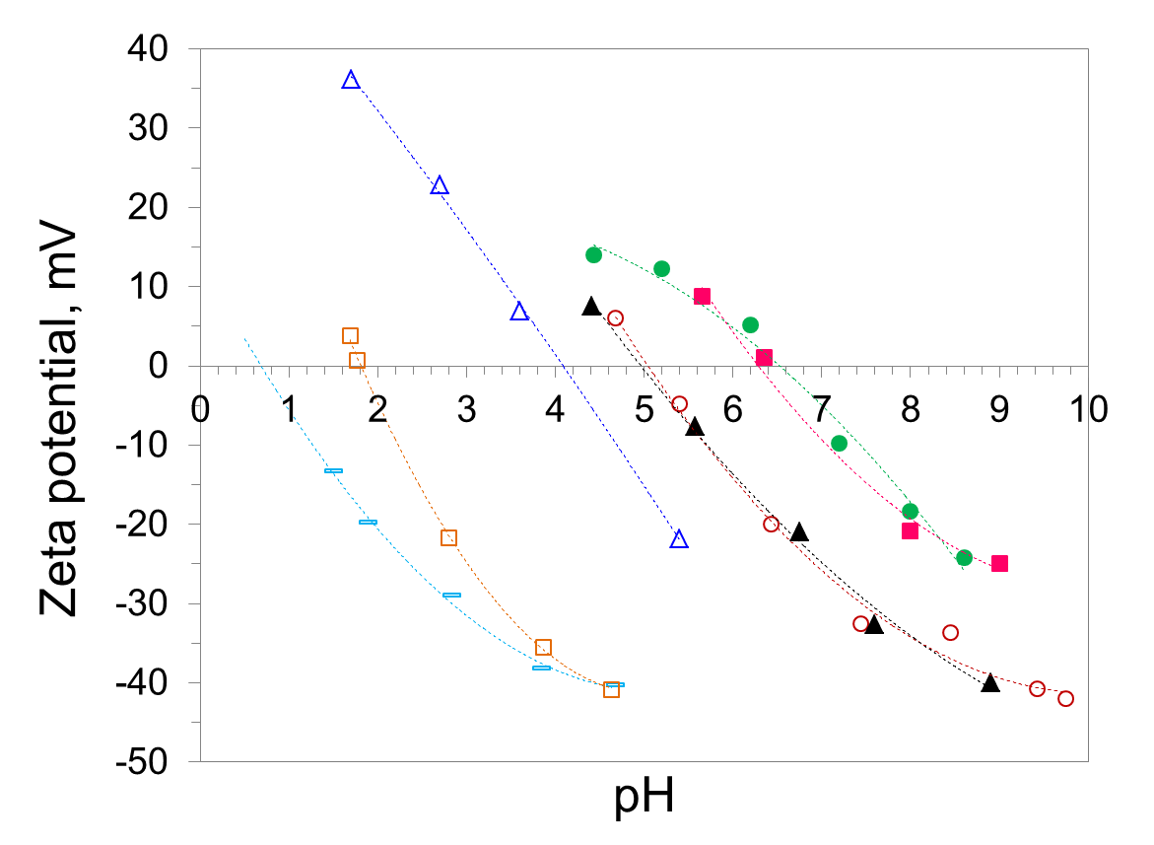
Figure 5. Influence of the TiO₂ nature on the zeta potential curves for TiO₂ (closed symbols) and zeolite/TiO₂ (open symbols). () Z, (,) Z/Ti-NP (, ) DAP (,) Ti-C.

The curves obtained for the Z/Ti hybrids lie between the ones obtained for the raw materials. The molar fraction of TiO₂ on the hybrid (X_{Ti}) was calculated by the modified Park’s equation, which considered the IEP of the raw materials (IEP_{Z/Ti} = (1-X_{Ti}) IEP_{Z} +X_{Ti} IEP_{Ti}). The values obtained for Z/Ti-NP and Z/Ti-C are of 79% and 74 %, respectively. These results explain the similar HCHO and C₂HCl₃ adsorption values and photocatalytic behavior of both samples in spite of the low amount of TiO₂ in Z/Ti-NP. The value of X_{Ti} in Z/DAP was around 20 %. The particle size of the decahedral anatase particles and their heterogeneous distribution on the hierarchical material, could explain this low value. However, and in spite of the lower molar fraction of titania, the Z/DAP shows higher reaction rate than Z/Ti-C. These results are consistent with the ones reported in the literature, where DAP showed higher photoactivity than other TiO₂ particles []. The unique characteristics of DAP with a preferential exposure of {101} an {001} facets, high crystallinity and low defect density endows the DAP with superior activity. The {001} facets are able to promote the direct photocatalytic oxidation as well as the ones related to OH species []. Moreover, the (001) planes promote the efficient separation of the electron-hole pairs. Other methods, should be explored in order to improve the dispersion of the DAP into the hierarchical material.

- Conclusions

The results obtained in this work show that highly active materials can be prepared by the three synthesis processes. Homogeneously dispersed TiO₂ nanoparticles of around 5 nm on ZSM-5 can be obtained by incipient wetness impregnation starting from a TiO₂-sol. Heterogeneous distributed decahedral anatase particles, with size of ca. 100 nm, and a large fraction of {101} and {001} faces, on the hierarchical microporous material, can be prepared by freezing-drying. Finally, a mechanical mixing method using commercial TiO₂ leads to the formation of large aggregates (1µm) made of TiO₂ nanoparticles. The photodegradation reaction rate for oxidation of formaldehyde or trichloroethylene, and the CO₂ selectivity follows the series: Z/Ti-NP > Z/DAP > Z/TiO₂-C. The nature of TiO₂ particles shows substantially different surface area, mean particle size and crystal phases depending on its nature. The dispersion of TiO₂ particles on the zeolitic substrate shows a clear dependence on the TiO₂ nature. Highly dispersed TiO₂ nanoparticles on the zeolitic material are obtained by synthesis of a TiO₂ sol and deposition by incipient wetness impregnation with the highest selectivity to CO₂ of the series. DAPs of low surface area with high particle size incorporated into the microporous material by freezing-drying, improves the reaction rates of hybrids prepared by mechanical mixing with commercial titania. The mean particle size of TiO₂ in the composite is a key factor in the improvement of the photocatalytic properties observed respect to bare TiO₂.

Acknowledgements: The authors acknowledge the Spanish Ministry of Economy and Competitiveness and for the financial support (projects CTM-2011-25093); Mss. Jansson thanks the Spanish Ministry for the PhD grant (BES-2012-055758 and EEBB-I-1408837).

References

[] EEA Report No 13/2017, Air quality in Europe ISBN 978-92-9213-920-9
[] S. Suárez, J.M. Coronado, R. Portela, J.C. Martín, M. Yates, P. Ávila, B. Sánchez, Environ. Sci. Technol. 42 (2008) 5892-5896.
[] F. Fresno, P. Portela, S. Suárez, J.M. Coronado, J. Mater. Chem A 2 (2014) 2863-2884
[] I. Jansson, S. Suárez, F.J. García-García, B. Sánchez, Appl. Catal. B 178 (2015) 100-107.
[] S. Zhang, N. Fujii, Y. Nosaka, J. Mol. Catal. A: Chem. 129 (1998) 219-224.
[] K. Hashimoto, K. Wasada, M. Osaki, E. Shono, K. Adachi, N. Toukai, H. Kominami, Y. Kera, Appl. Catal. B 30 (2001) 429-436.
[] H. Chen, A. Matsumoto, N. Nishimiya, K. Tsutsumi, Colloid Surf. A 157 (1999) 295-305.
[] H. Yamashita, Y. Ichihashi, M. Anpo, M. Hashimoto, C. Louis, M. Che, J. Phys. Chem. 100 (1996) 16041-16044.
[] Q. Xy, M.A. Anderson, J. Am. Ceram. Soc.77 (1991) 1939.
[] F. Amano, O.-O. Prieto-Mahaney, Y. Terada, T. Yasumoto, T. Shibayama, B. Ohtani, Chem. Mater 21 (2009) 2601-2603.
[] I. Jansson, K. Kobayashi, H. Hori B. Sánchez, B. Ohtani, S. Suárez, Catal. Today 287 (2017) 22-29.
[] S. Suárez, M. Yates, P. Avila, J. Blanco, Catal. Today, 105, 3-4 (2005) 499-506.
[] E.P. Barrett, L.G. Joyner, P.P. Halenda, J. Am. Chem. Soc. 73 (1951) 373-380.
[] A. Saito, H.C. Foley, AIChE J. 37 (1991) 429-436.
[] A.L. Patterson, Phys. Rev. 56 (1939) 978-982.
[] P. Kubelka, Z tech Phys 12 (1931) 593-603.
[] M.V. Smoluchowski, Ann Phys 326 (1906) 756-780.
[] F.J. Gil-Llambias, A.M. Escudey-Castro, J. Chem. Soc., Chem. Commun. (1982) 478-479.
[] I. Jansson, S. Suárez, F.J. García-García, B. Sánchez, Top. Catal. 60 (2017) 1171-1182.
[] H. Zhang, J.F. Banfield, J. Phys. Chem. B 104 (2000) 3481-3487.
[] J. Zhang, Y. Hu, M. Matsuoka, H. Yamashita, M. Minagawa, H. Hidaka, M. Anpo, J. Phys. Chem. B 105(35) (2001) 8395-8398.
[] L. Kavan, M. Grätzel, S.E. Gilbert, C. Klemenz, H.J. Scheel, J. Am. Chem. Soc. 118 (1996) 6716-6723.
[] M.D. Hernández-Alonso, I. Tejedor-Tejedor, J.M. Coronado, J. Soria, M.A. Anderson, Thin Solid Films 502 (2006) 125-131.
[] J. Pan, G. Liu, G.Q. Lu, H.-M. Cheng, Angew. Chem. Int. Ed. Engl. 50 (2011) 2133-2137.
[] V. Durgakumari, M. Subrahmanyam, K.V. Subba Rao, A. Ratnamala, M. Noorjahan, K. Tanaka, Appl. Catal. A 234 (2002) 155-165.
[] A. Tawari, W.-D. Einicke, R. Gläser, Catalysts 6 (2016) 31.
[] N. Spanos, I. Georgiadou, A. Lycourghiotis, J. Colloid Interface Sci. 172 (1995) 374-382.
[] M. Kosmulski, Adv. Colloid Interface Sci. 99 (2002) 255-264.
[] F. Amano, O.-O. Prieto-Mahaney, Y. Terada, T. Yasumoto, T. Shibayama, B. Ohtani, Chem. Mater. 21 (2009) 2601-2603.
[] M. Maisano, M.V. Dozzi, M. Coduri, L. Artiglia, G. Granozzi, E. Selli, Appl. Mater. Interfaces 8 (2016) 9745-9754.

